**Project Management**

The application of knowledge, skills, tool, and techniques to meet the project requirements and achieve the desired outcome

**Focuses on topic like**

* Project management fundamentals
* Goals, objectives, and deliverable
* Risk management
* Team dynamics
* Project management methodologies
* Data-driven decision making

**Methodologies**

* Agile
* Scrum
* Waterfall

**Software**

* Kanban
* Asana

Program and course overview

Hello! Welcome to the first of the six courses in the [Google Project Management Certificate](https://www.coursera.org/professional-certificates/google-project-management) program. In this reading, you will learn about the program structure and course functionality. We’ve specifically designed the program you’re about to explore to help every type of learner successfully finish the certificate and get ready for a role in project management. No previous experience is required.

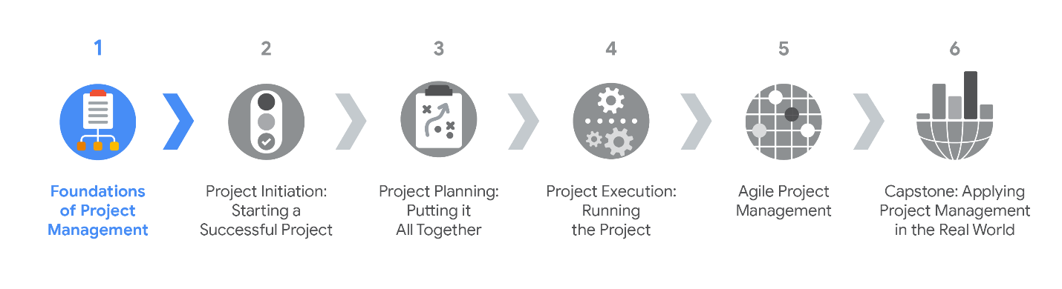

In the first course, you will learn the fundamentals of project management and how this program will prepare you for project management roles in numerous types of industries. You will explore the different types of career paths you might pursue, the responsibilities and essential skills of a project manager, the importance of the project life cycle, common project management methodologies, and how organizational structure and culture impact project management. In this course, and throughout the program, you will get a rare inside look at project management within Google. Current Google project managers will offer a multi-dimensional educational experience that will provide you with tools you can apply on the job.

**Become job-ready**

Throughout the [Google Project Management Certificate program](https://www.coursera.org/professional-certificates/google-project-management), you will learn the foundations of traditional project management and gain insight into Agile project management. According to the Project Management Institute, the project management labor force in seven project-oriented sectors is expected to grow by 33 percent, or nearly 22 million new jobs, by 2027*.We are excited to join you on this journey as you learn the skills to begin a career in one of today’s most in-demand professions.

Course 1 covers four weeks of material. Each week includes a series of lessons with many types of learning opportunities, such as:

* **Videos** with a Google employee as your instructor.
* **Readings** to introduce new ideas and case studies and to build on the concepts from the videos.
* **Discussion forums** to explore course topics for better understanding and chat with peers in the program.
* **In-video questions** that will pop up from time to time. They’re designed for you to check your learning as you go!
* **Practice quizzes** to check your understanding and give you valuable feedback. **Practice activities** will provide you with a hands-on opportunity to apply skills you are working to master. You will assess your work by answering quiz questions about it or by comparing it to an exemplar built by our course team. *Note: these activities will not count towards your final course grade, but you are strongly encouraged to complete them as they will help prepare you for the graded quizzes and peer reviews.*
* **Graded quizzes** on video and reading content to measure your progress.
* Ungraded **peer-review activities** on video and reading content that provide you the opportunity to practice applying skills you are working to master. Other learners in your course will see the work you submit and give you feedback based on a rubric.
* **Graded peer-review activities** on video and reading content that assess your ability to apply skills you are working to master. Other learners in your course will grade your work and give you feedback based on a rubric.

Everyone learns differently, so we designed this program to let you work at your own pace. Although your personalized deadlines start when you enroll, they’re just a guide. Feel free to move through the program however it works best for you. Keep in mind, you can always reset your deadlines by clicking the blue **reset my deadlines** button. There’s no penalty for late assignments. To earn your certificate, all you have to do is complete all of the work.

**Tips**

* We strongly recommend you take all six courses—and complete the items in each lesson—in the order they appear, as new information and concepts build on previous ones.
* Make the most of the readings and additional resources throughout the program. They’re designed to support your learning.
* If something is confusing, don’t hesitate to re-watch a video, go through a reading again, or ask your classmates for advice in the discussion forum.
* Take part in all learning opportunities to gain as much knowledge and experience possible.

Congratulations on choosing to take this first step toward becoming a part of the wonderful world of project management. Enjoy the journey!

*\*Source: PMI (2017). Project Management Job Growth and Talent Gap 2017–2027.*