QUALITY ASSURANCE · NATIVE TICKETING
Ticket Pulse v3.0 — QA Test Plan
Ticket Pulse can now create and run its own tickets — not just read them from FreshService. This plan proves the new ticketing experience works end to end, and that the dashboards, analytics and assignment tools you already rely on still do too.
Test on ticketpulse.bgcsaas.com Pilot workspace: IT Roles: Coordinator · Agent · Admin Version: 3.0.2-preview
Before you start
- Where: production, IT workspace — native ticketing is on there and intentionally off for the other teams.
- Sign in with your work account — where you can, repeat tests as a Coordinator, an Agent (their home is now the ticket queue), and an Admin.
- Live data warning: creating a ticket in IT creates a real copy in FreshService — that is the point of the sync tests. Name test tickets clearly (e.g. “QA TEST — please ignore”) and delete them when done.
- How to report: note the test number, what you did, what you saw vs. expected, the ticket number, your role, and a screenshot.
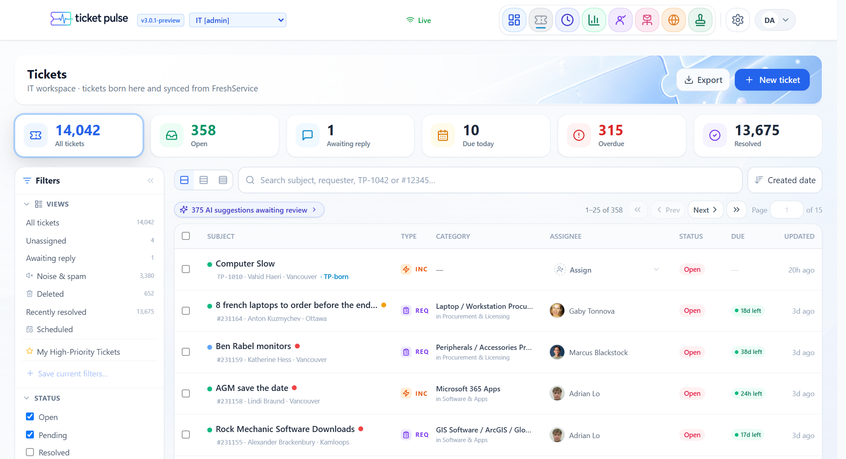
The Tickets queue — segments, filters, and saved views
01 Creating a ticket in Ticket Pulse
The headline feature: raising a ticket without ever leaving Ticket Pulse.
# | What you do | Expected result
1.1 | Create a basic ticket  From Tickets → New ticket, pick a requester, add a subject and description, create it. | It saves, gets a number like TP-1234, opens its own page, and shows a “Ticket Pulse” origin badge.
1.2 | Requester lookup works  While creating, type part of a colleague’s name or email. | Matching people appear with name, photo and title; picking one fills the requester.
1.3 | Assign to a person  Create a ticket and choose an assignee. | The ticket shows that person as the assignee.
1.4 | Let AI assess it  Create a ticket with “Classify & assess with AI” on, assignee left empty. | An AI run assesses category / priority / type. It does not silently reassign the ticket.
1.5 | Clone a ticket  Open a ticket, use Clone. | A confirmation explains it makes a new draft; the new ticket is “Copy of: …”, unassigned; the original is untouched.
1.6 | Edit title and fields  Change the subject, status, priority, category, group. | Each change saves and survives a refresh.
02 FreshService two-way sync
The important one — Ticket Pulse tickets mirror into FreshService, and deletes flow through too.
# | What you do | Expected result
2.1 | New TP ticket appears in FreshService  Create “QA TEST — sync check”, wait a minute, search for it in FreshService. | A matching ticket exists in FreshService with the same subject and description.
2.2 | Link to the FreshService copy  Look at the TP ticket header. | A “View FS mirror #…” link opens the FreshService copy.
2.3 | Delete flows through  Delete the test ticket in Ticket Pulse (Delete → confirm). | It leaves the Ticket Pulse queue, and the FreshService copy is trashed shortly after.
2.4 | FreshService-born ticket is read-mostly  Open a ticket that originated in FreshService. | A banner says “FreshService owns this ticket”; you can reply and reassign, but it’s clearly not fully editable.
2.5 | Closure syncs back  Resolve/close a FreshService-mirrored ticket in FreshService, then reopen it here. | Ticket Pulse reflects the resolved/closed status.
03 The conversation
Every ticket has a chat-style thread: public replies, private internal notes, and forwards.
# | What you do | Expected result
3.1 | Reply to the requester  Use Reply to requester, write a message, send. | It appears on the agent side of the thread and the requester is emailed.
3.2 | Add an internal note  Use Internal note. | It appears as an amber “Internal note” — clearly private, never emailed.
3.3 | Author names are correct  Look at notes/replies synced from FreshService. | Every entry shows a real person or “Ticket Pulse” — never “Unknown.”
3.4 | Automated notes are branded  Find an auto-assignment note. | It shows the Ticket Pulse logo avatar and an “AUTO” label, distinct from human notes.
3.5 | Paste a screenshot  Copy an image, paste into the editor, send. | The image attaches and a clickable “🖼 [name]” reference appears in the text.
3.6 | Click an image to preview  Click an image reference or an image attachment. | A preview lightbox opens. You can zoom (buttons, scroll, +/− keys) and drag to pan. Non-image files still download.
3.7 | Admin deletes a note  As an admin, hover a note, use the trash, confirm. | The note and its attachments are removed. Approval / system notes are protected.
3.8 | Drafts & templates  Start a reply, navigate away, come back. | Your draft is preserved; reply templates are available to insert.
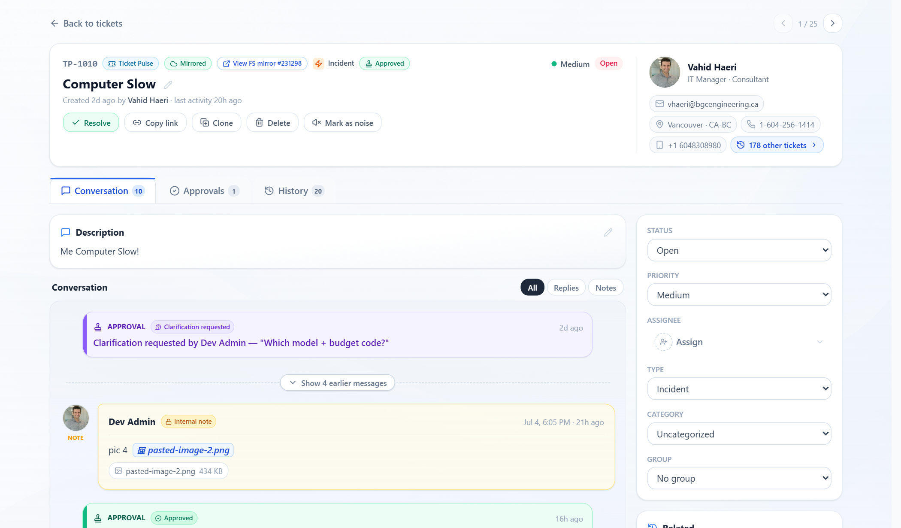
Ticket conversation — replies, internal notes, and colour-coded approval events
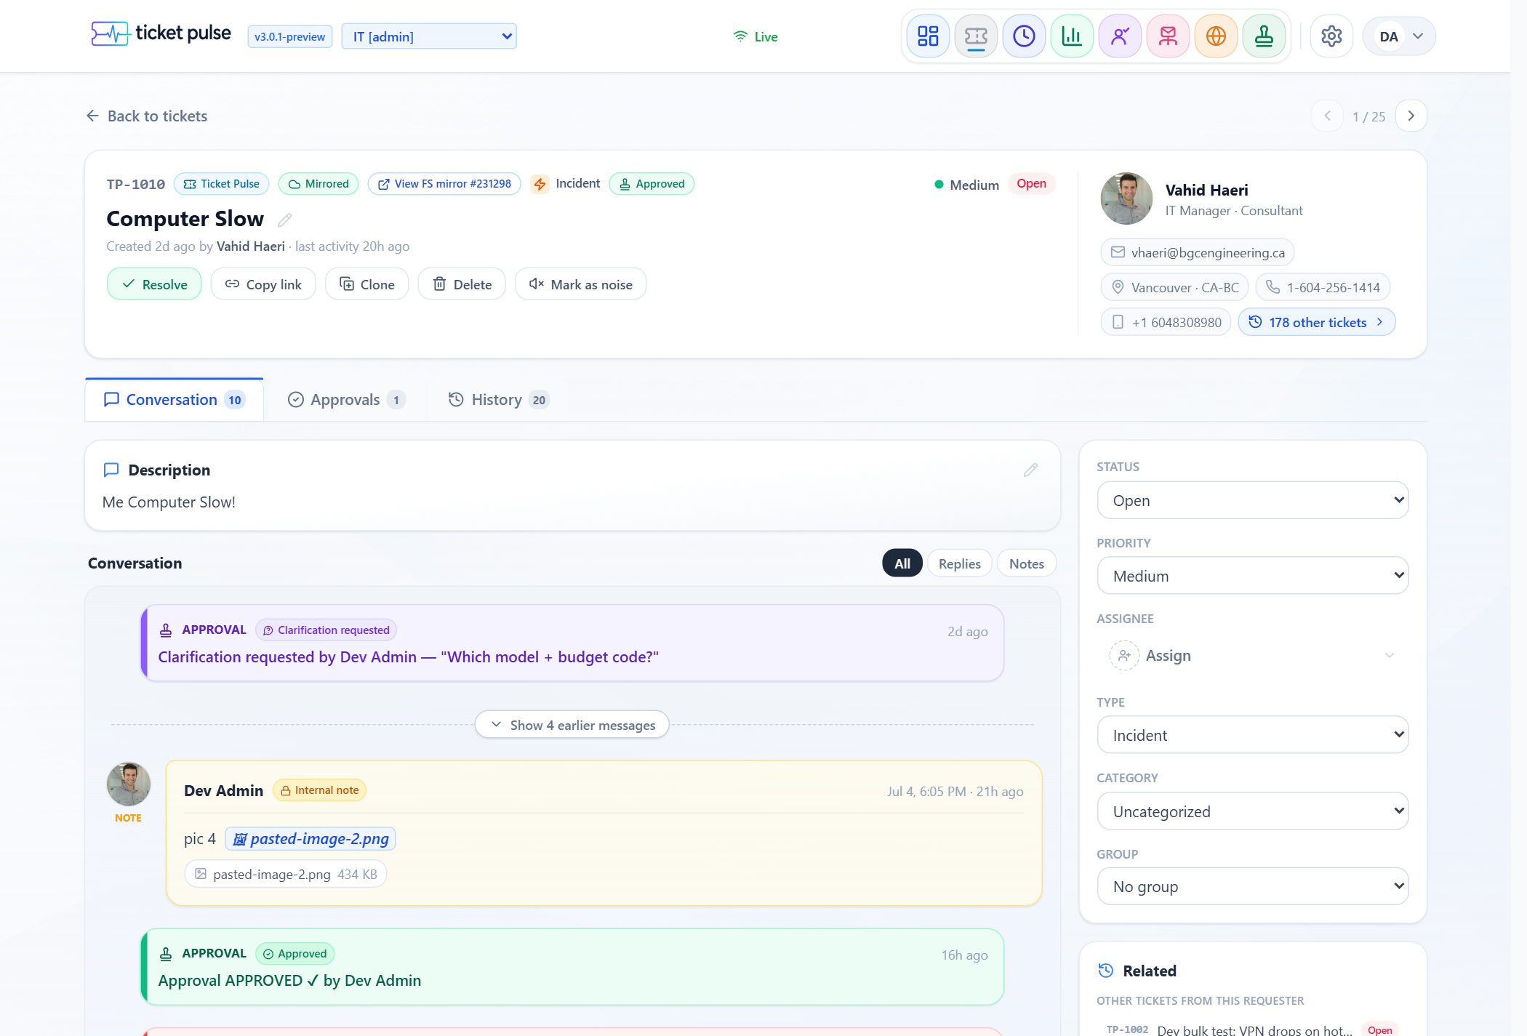
Click any image to preview it with zoom (not a download)
04 Approvals
Route a ticket to an approval category; its managers approve or reject — any one can decide.
# | What you do | Expected result
4.1 | Set up a category (admin)  In Settings → Approval Categories, create one (e.g. “Laptop purchase”) with 1–2 managers. | It saves with its managers shown as avatar chips. Managers must be app members.
4.2 | Request approval  On a ticket’s Approvals tab, click Request approval. | A clear popup lists categories with approver avatars and “any one can approve”, plus an optional context box.
4.3 | Approve / reject  As a manager, decide from the ticket or the Approvals inbox. | The verdict shows green (approved) or red (rejected), summarised as “Approved by … · time”. Other managers auto-cancel.
4.4 | Clarify & resubmit  As a manager choose Clarify and ask a question; as the requester, add info and Resubmit. | It bounces back as “needs info”, then returns to pending after resubmitting.
4.5 | Change a decision  On a decided approval, use Change to approved/rejected. | A confirmation explains the flip with an optional “why the change?” note; confirming flips the verdict and records it.
4.6 | Cancel vs delete  As requester/admin, try Cancel and Delete. | Delete warns the approval status will be lost; Cancel keeps the record as “cancelled.”
4.7 | Inbox & badge  Check the Approvals item in the top nav. | A count badge shows approvals awaiting you; the inbox lists them with quick approve/reject.
4.8 | Magic-link decision  An approver who isn’t logged in gets an email link. | The link opens a page to approve, reject, or request clarification without signing in.
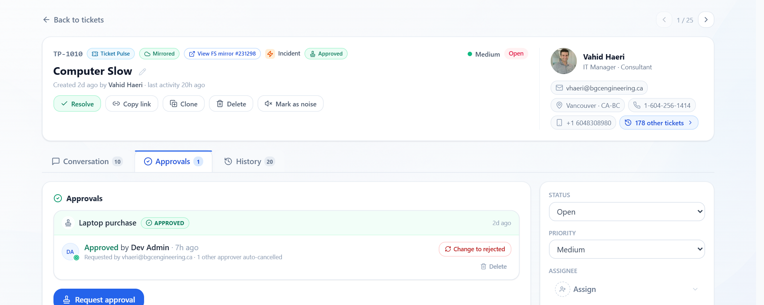
The approval timeline — who decided, when, tinted by verdict
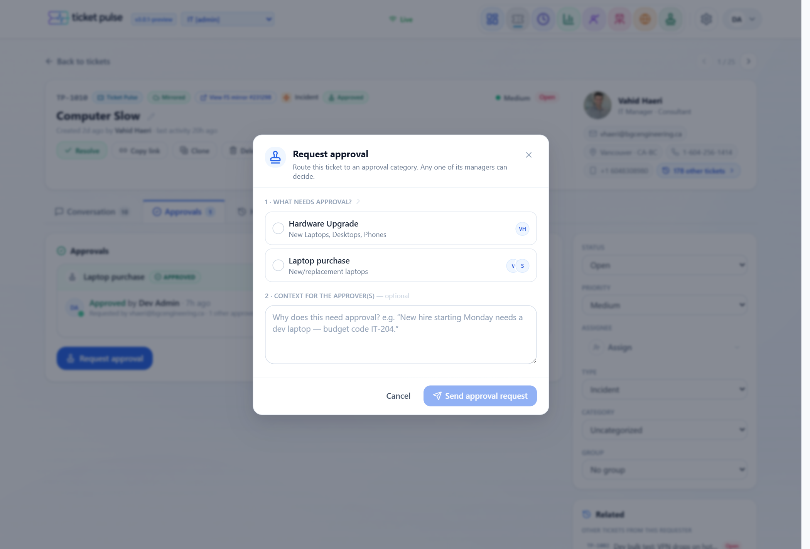
Requesting approval — pick a category and see who will be notified
05 Email to ticket
Emails become tickets, and replies update existing ones (IT pilot mailbox).
# | What you do | Expected result
5.1 | Email creates a ticket  Send an email to the configured IT mailbox. | A new ticket appears with the email’s subject/body and the sender as requester.
5.2 | Reply updates the ticket  Reply to the notification email thread. | The reply lands on the same ticket as a new conversation entry — not a new ticket.
06 Queue, filters & views
The queue is where agents live all day.
# | What you do | Expected result
6.1 | Stat cards & segments  Look at the cards on top (All, Open, Awaiting reply, Due today, Overdue, Resolved). | Clicking one filters the list; counts look sensible.
6.2 | Filter rail  Filter by category (type-to-search), group, source, created date, member. | The list narrows; category search finds partial matches (e.g. “licens” finds “Licensing”).
6.3 | Saved views  Apply filters, save a view, reload, reopen it; try a shared view (admin). | The view saves (personal / shared) and re-applies your filters.
6.4 | Preview peek  Click a row’s preview affordance (desktop). | A side preview opens without leaving the list; on mobile it opens the full ticket.
6.5 | Bulk actions  Select several Ticket-Pulse-born tickets, bulk-assign or bulk-change status. | The change applies to all selected.
6.6 | Export & density  Export to CSV; toggle Comfortable / Compact / Dense. | CSV downloads the visible tickets; density changes rows-per-screen.
6.7 | Noise & Deleted views  Check the “Noise & spam” and “Deleted” views. | Noise/spam and deleted tickets live here and stay out of the default queue.
07 Ticket header & requester
The person and their history, at a glance.
# | What you do | Expected result
7.1 | Requester contact card  Open a ticket, look at the requester panel (top-right). | Photo, name, title·department, and compact contact chips — tidy, no big empty space.
7.2 | “N other tickets” is accurate & clickable  Click the “N other tickets” pill. | It shows a real count and opens the queue filtered to that requester, with a “Showing tickets from [name] · Clear” banner.
08 Analytics & Insights
A new explorable analytics area — deterministic, no AI guesses.
# | What you do | Expected result
8.1 | Sections load  Visit Analytics → Overview, Demand & Flow, Team Balance, Quality, Automation Ops, Insights. | Each loads with charts, no errors. People data is framed as team balance, never a leaderboard.
8.2 | Category map  Open the Category / Subcategory map (treemap). | Boxes sized by volume, coloured by “pressure”; clicking a category drills in smoothly; hot cells stand out.
8.3 | CSAT shows sample size  Anywhere satisfaction/CSAT appears. | It always shows the response count (N) — never implies a rate is more reliable than its sample.
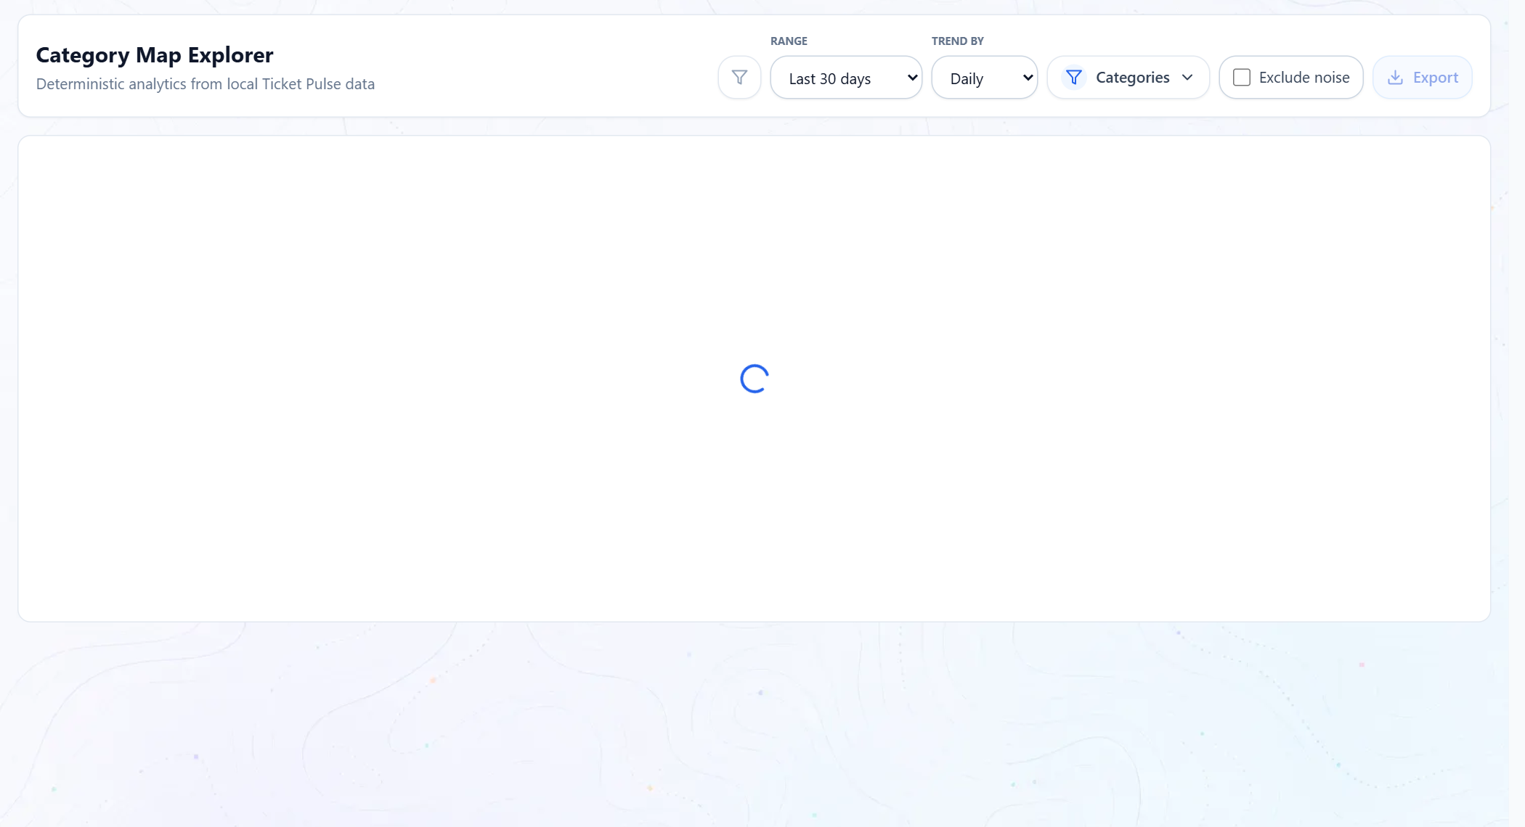
The Category / Subcategory map — sized by volume, coloured by pressure
09 Local agents & internal groups (admin)
People and groups that don’t come from FreshService.
# | What you do | Expected result
9.1 | Create a local agent  In Settings, add an agent that isn’t from FreshService. | It saves and can be used for native tickets/approvals.
9.2 | Internal group with members  Create an internal group and add members. | The group and membership save; it can be used for routing.
10 Mobile
Agents check tickets on their phones.
# | What you do | Expected result
10.1 | Tickets on a phone  Open the queue and a ticket on a phone (or narrow browser). | Toolbar wraps cleanly, filters open as a bottom sheet, a row-tap opens the full mobile ticket, and “Create ticket” sticks to the bottom.
11 New in this build (v3.0.2) — assignee clarity & quick-assign
Recent refinements: the queue now always shows the real assignee, flags assignments made in FreshService, syncs categories back, and lets you pick any AI candidate straight from the queue.
# | What you do | Expected result
11.1 | The real assignee always shows  In the queue, find a ticket assigned in FreshService to someone who isn’t an active Ticket Pulse member (e.g. an external group we triage for). | The real person shows by name and photo with a small amber read-only tag — never “unassigned” or a stale “AI: …”.
11.2 | “Read-only” means FreshService-only  Hover the read-only tag on such an assignee. | It explains the person can only be (re)assigned in FreshService. You can still reassign the ticket to an active member from here.
11.3 | “Handled in FreshService” badge  Find a ticket our AI was going to assign, but a person grabbed or reassigned it in FreshService first. | An amber ↱ badge sits beside the assignee. Hovering explains it — who took it, and who the AI would have picked — and clicking it opens the assignment history.
11.4 | Category syncs to FreshService  On a Ticket-Pulse ticket, set a Category / Subcategory, wait a minute for the mirror, then open the FreshService copy. | The FreshService copy shows the matching Ticket Pulse Category / Subcategory — not “none.”
11.5 | Quick-assign shows every AI pick  On a ticket awaiting AI approval, open the assignee dropdown. | The “AI suggests” card lists the top candidates (2nd and 3rd too) with match %, top pre-selected. Pick one and Approve. “Review…” opens the full detail with the AI’s reasoning.
12 Regression — day-one features must still work
v3.0 adds a lot; confirm the existing tools are untouched.
# | What you do | Expected result
12.1 | Dashboard  Open /dashboard. | Technicians + workload, daily/weekly/monthly, live updates all work.
12.2 | Technician detail  Open a technician’s page. | Their tickets and stats load.
12.3 | Assignment Review  Open Assignment Review. | Review queue, history, daily review, competencies, prompts all work.
12.4 | Timeline, Visuals, Mail Workflows  Open Timeline Explorer, Visuals (map), and the Mail Workflows editor. | All load and function.
12.5 | Other workspaces unaffected  Switch to Accounting / H&S / Field Equipment. | They behave exactly as before v3.0 — native ticketing is off there, so no new Tickets behaviour appears.
What NOT to expect (known scope)
- Native ticketing is only on for IT right now — the other teams are unchanged by design.
- Analytics is deterministic — no AI-written summaries or predictions.
- People metrics are framed as team balance — there are no winner/loser leaderboards.
- Requesters don’t log in — external approvers decide through an emailed magic link.
Reporting an issue
- For anything that fails, capture: the test number (e.g. 2.3), what you did, what you saw vs. expected, the ticket number if relevant, your role, and a screenshot. Group reports by section so fixes can be batched.

