1.6.2 Packet Tracer - Configure Basic Router Settings
Physical Mode Lab Report

Topology
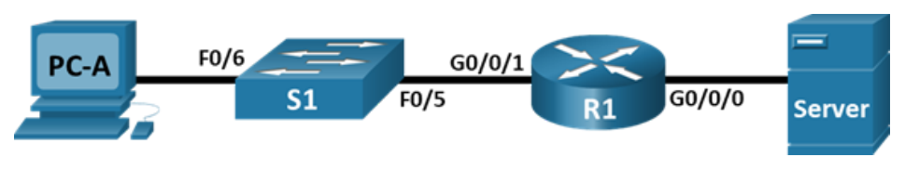
Network topology: PC-A -> S1 -> R1 -> Server

Addressing Table
Device | Interface | IP Address / Prefix | Default Gateway
R1 | G0/0/0 | 192.168.0.1 /24  2001:db8:acad::1 /64  fe80::1 | N/A
R1 | G0/0/1 | 192.168.1.1 /24  2001:db8:acad:1::1 /64  fe80::1 | N/A
R1 | Loopback0 | 10.0.0.1 /24  2001:db8:acad:2::1 /64  fe80::1 | N/A
PC-A | NIC | 192.168.1.10 /24  2001:db8:acad:1::10 /64 | 192.168.1.1  fe80::1
Server | NIC | 192.168.0.10 /24  2001:db8:acad::10 /64 | 192.168.0.1  fe80::1
Original addressing table image:
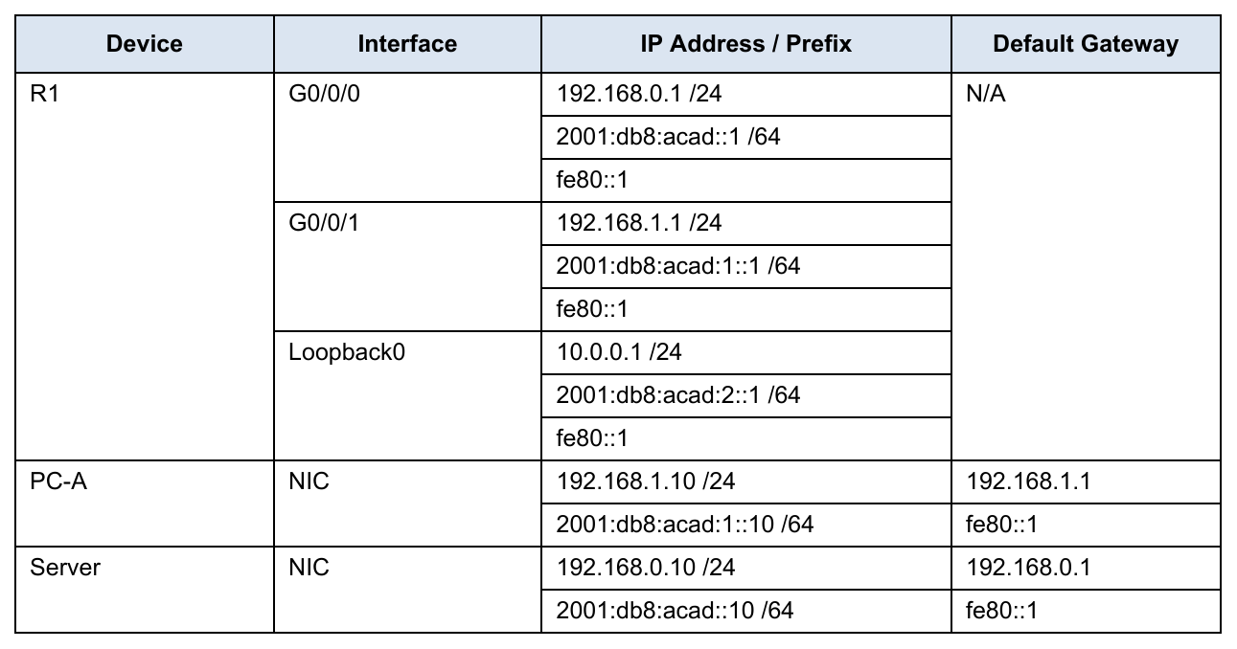

R1 Configuration Commands
Use these commands on R1 after cabling PC-A RS232 to the router Console port.
enable
configure terminal
hostname R1
ip domain-name ccna-lab.com
service password-encryption
security passwords min-length 12
username SSHadmin secret 55Hadm!n2020
crypto key generate rsa general-keys modulus 1024
enable secret $cisco!PRIV*
line console 0
password $cisco!!CON*
exec-timeout 4 0
login
exit
line vty 0 4
password $cisco!!VTY*
transport input ssh
exec-timeout 4 0
login local
exit
banner motd #Unauthorized access is prohibited.#
login block-for 120 attempts 3 within 60
ipv6 unicast-routing
interface gigabitEthernet0/0/0
description Link to Server
ip address 192.168.0.1 255.255.255.0
ipv6 address 2001:db8:acad::1/64
ipv6 address fe80::1 link-local
no shutdown
exit
interface gigabitEthernet0/0/1
description Link to S1 / PC-A LAN
ip address 192.168.1.1 255.255.255.0
ipv6 address 2001:db8:acad:1::1/64
ipv6 address fe80::1 link-local
no shutdown
exit
interface loopback0
description Loopback interface
ip address 10.0.0.1 255.255.255.0
ipv6 address 2001:db8:acad:2::1/64
ipv6 address fe80::1 link-local
exit
end
clock set 18:00:00 25 Jun 2026
copy running-config startup-config

Verification Commands
show ip interface brief
show ipv6 interface brief
show ip route
show version
show startup-config
show running-config | section vty
show version | include register

Task Questions - Answers
- What would be the result of reloading the router prior to completing the copy running-config startup-config command?
Any changes made in the running configuration would be lost. The router would reload using the last saved startup configuration.
- Were the pings from PC-A to the Server successful?
Yes. After PC-A, Server, and R1 are configured correctly, both IPv4 and IPv6 pings from PC-A to Server should be successful.
- Was remote access to R1 using the Loopback IPv4 address successful?
Yes. SSH access to the R1 Loopback0 IPv4 address should be successful when using username SSHadmin and password 55Hadm!n2020.
- Was remote access to R1 using the Loopback IPv6 address successful?
Yes. SSH access to the R1 Loopback0 IPv6 address should be successful when using username SSHadmin and password 55Hadm!n2020.
- Why is the Telnet protocol considered to be a security risk?
Telnet sends data, including usernames and passwords, in clear text. SSH is safer because it encrypts the remote session.
- What is the name of the IOS image that the router is running?
Use show version to verify the exact image. A common Packet Tracer Cisco 4321 ISR image is isr4300-universalk9.16.06.04.SPA.bin.
- How much NVRAM does the router have?
Use show version to verify the exact value. A common Packet Tracer Cisco 4321 ISR value is 32768K bytes of NVRAM.
- How much Flash memory does the router have?
Use show version to verify the exact value. A common Packet Tracer Cisco 4321 ISR value is about 3223551K bytes of flash memory.
- What would be the boot process if the configuration register was 0x2142?
The router would ignore the startup configuration in NVRAM during the next reload. This setting is commonly used for password recovery.
- How are passwords presented in the startup configuration output?
Passwords are shown in encrypted form. Plaintext line passwords are encrypted by service password-encryption, and secret passwords appear as hashed secret values.
- What is the result of using show running-config | section vty?
It filters the running configuration and displays only the VTY line configuration section.
- What code is used in the routing table to indicate a directly connected network?
The code C is used for directly connected networks.
- How many route entries are coded with a C code in the routing table?
There should be three C routes: 192.168.0.0/24, 192.168.1.0/24, and 10.0.0.0/24.
- What command changed the status of the Gigabit Ethernet ports from administratively down to up?
The no shutdown command changed the interfaces from administratively down to up.
- What is the meaning of the [up/up] part of the show ipv6 int brief output?
The first up means the physical interface is active. The second up means the line protocol is active.
- What is the IPv6 address assigned to Server after changing it from static IPv6?
The server receives a SLAAC IPv6 address in the 2001:db8:acad::/64 network. In this activity, it is commonly 2001:db8:acad:0:207:ecff:fea5:6286, based on the Server MAC address. Verify with ipconfig on Server.
- What is the default gateway assigned to Server after changing it from static IPv6?
The IPv6 default gateway is fe80::1.
- From PC-B/PC-A, was the ping to the R1 default gateway link-local address successful?
Yes. The ping to the R1 link-local gateway address fe80::1 should be successful from a host on the same local link.
- From Server, was the ping to the R1 IPv6 unicast address 2001:db8:acad::1 successful?
Yes. The ping from Server to 2001:db8:acad::1 should be successful.

Reflection Questions - Answers
- If a technician suspects that an interface was not enabled, what show command could be used?
Use show ip interface brief. This command shows whether interfaces are up/up, down/down, or administratively down.
- If a technician suspects that an interface was assigned an incorrect subnet mask, what show command could be used?
Use show running-config. This command displays the IP address and subnet mask configured on each interface.

Original Task Pages

Tasks Page 1
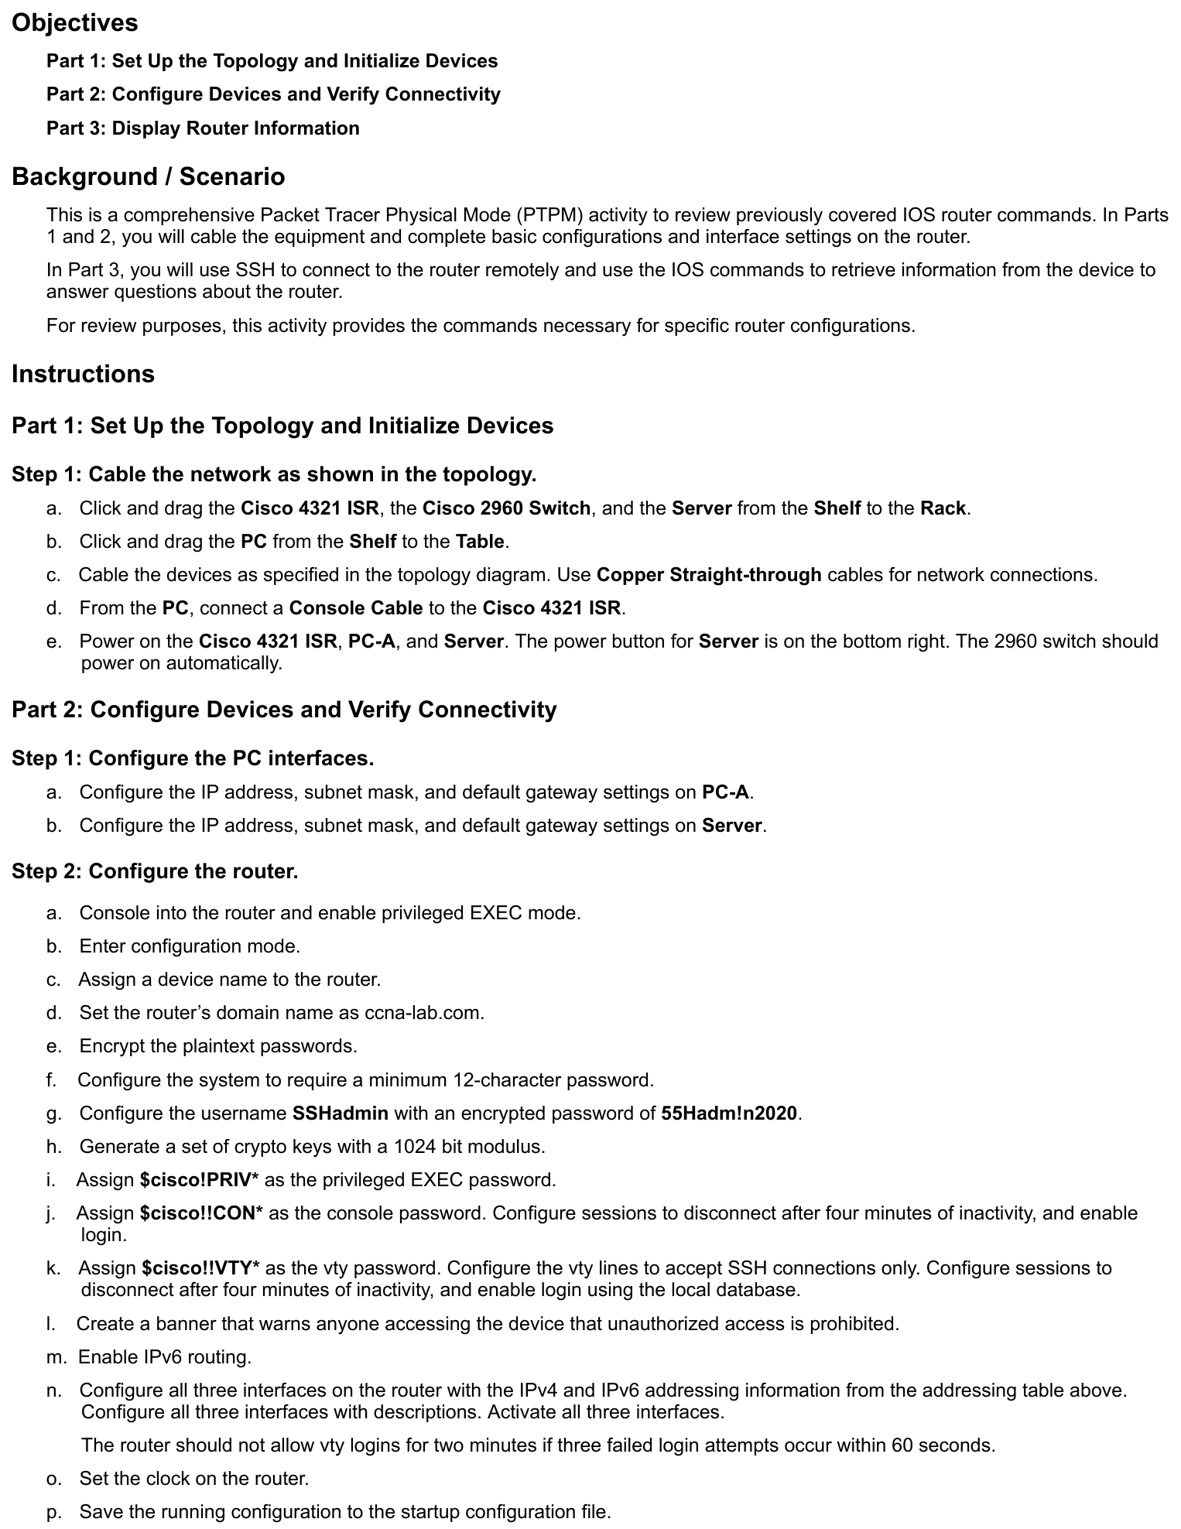

Tasks Page 2
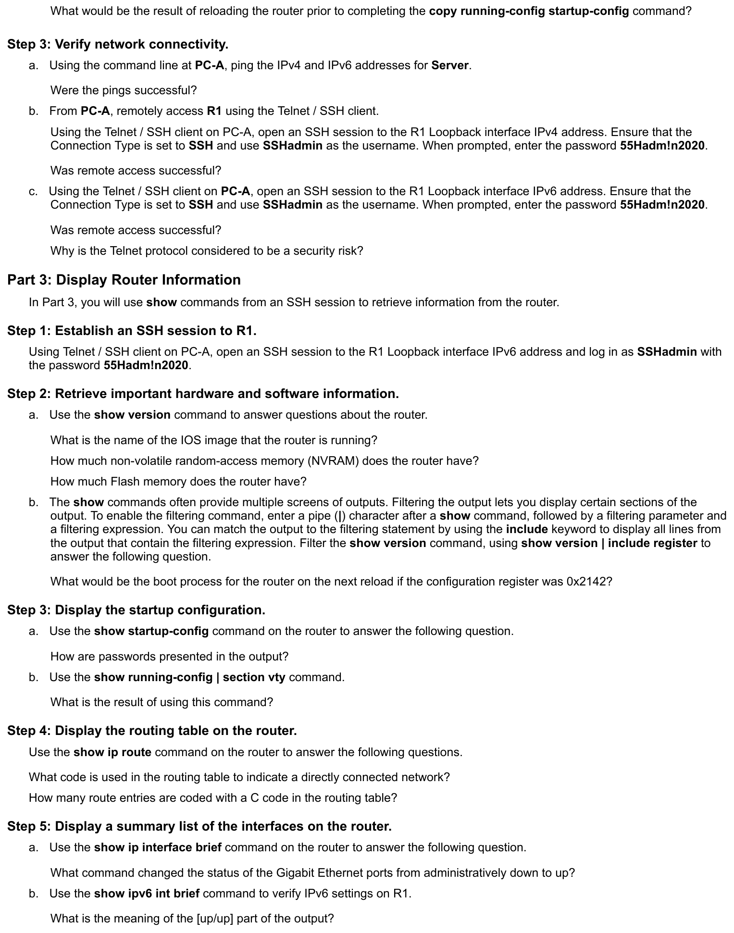

Tasks Page 3
