http://www.1001fonts.com/users/typodermic/

Crack Man Font Family

Made by Raymond Larabie
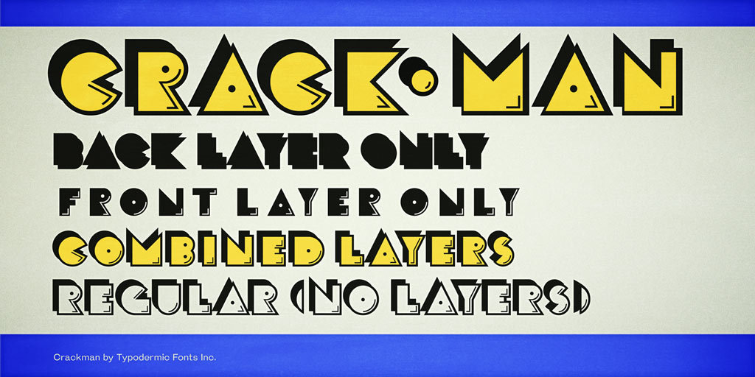

Crack Man is an art deco style, counterless headliner with an early 1980’s video game slant.
This font includes a license that allows free commercial use: sometimes referred to as a desktop license. This allows you to install the font on a computer and use it to create posters, web graphics, game graphics, t-shirts, videos, signs, logos and more. Read the license agreement for details.
If you'd like to embed this font in an app, ebook, on the web or anything that's not covered by the desktop license agreement, visit the link below. You'll find distributors who offer different types of licenses or you can contact me for help.
typodermicfonts.com/crack-man/
Tags:

