|  |
| --- |
| Functional Specification Document  <Infiinty & Beyond> |

**DOCUMENT VERSION <V1>**

**<14.05.2019>**

**AUTHORS**

|  |  |  |
| --- | --- | --- |
| **Name** | **Role** | **Department** |
| Justine Domingo | Business Analyst | Digital Development |

**DOCUMENT HISTORY**

|  |  |  |  |
| --- | --- | --- | --- |
| **Date** | **Version** | **Document Revision Description** | **Document Author** |
| 14-05-2019 | V1 | Draft Version | Justine Domingo |
|  |  |  |  |
|  |  |  |  |
|  |  |  |  |
|  |  |  |  |

**APPROVALS**

|  |  |  |  |
| --- | --- | --- | --- |
| **Approval Date** | **Approved Version** | **Approver Role** | **Approver** |
| 01-01-1990 | V1 | Development Team Leader |  |
|  |  |  |  |
|  |  |  |  |

**Table of Contents**

1. Introduction (give a brief description of the company) 6

1.2 Purpose of the document 6

1.3 Project Scope 7

1.4 Scope of the document 7

2.2 System Actors 9

2.3 Dependencies and Change Impacts 10

3. Functional Specifications 10

3.1 Develop an online site and mobile app 10

6. Reporting Requirements 12

7. Integration Requirements 12

8. References 15

# **Introduction**

Infinity & Beyond is a microsite for the giant corporation SpaceX/NASA. This microsite will display space program activity around the world. The site will also include a live feed from the ISS (International Space Station)

# **Purpose of the document**

# The purpose of this document is to document the business requirements and functional rules of the Infinity & Beyond Company. This document will include a basic mockup of the website and the mobile. All system requirements and restraints will be documented.

# **Risks and Assumptions**

|  |  |  |  |
| --- | --- | --- | --- |
| **Risk** | **Level** | **Impact** | **Responsible** |
| User will not be redirected to the live feed User can not search for a launch | High Medium | Users will not be able watch the live feed through the site. Users will not be able to find a specific launch easily | Development Team |

# **System/ Solution Overview**

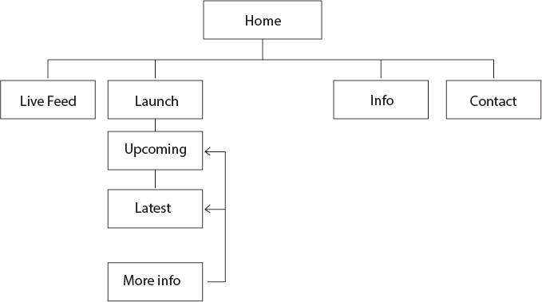

# **Functional Specifications**

### Develop microsite for SpaceX/NASA

### Purpose/Description

Develop microsite to raise awareness about the space program activity for users.

### Use Case

|  |  |
| --- | --- |
| **Name** | **Create Microsite** |
| **Primary Actor(s)** | Users |
| **Stakeholders and Interest** | CEOBusiness Owner |
| **Trigger** | Create a microsite |
| **Pre-conditions** | Microsite is not created |
| **Post-conditions** | Create the microsite |
| **Main Success Scenario** | 1. I enter the homepage 2. The page shows different categories – live feed, launches 3. I enter live feed    1. The page redirects to NASA Live Feed page. 4. I enter the launches    1. The page displays launches |
| **Alternate Scenario** | A: @3, if no live feed. A01 User must wait until launch day  A02 Resume @3 |
| **Priority** | High |
| **Special Requirements** | Live Feed, Launch Schedule |
| **Open Questions** | <Notes and questions> |

# **Mock-up**

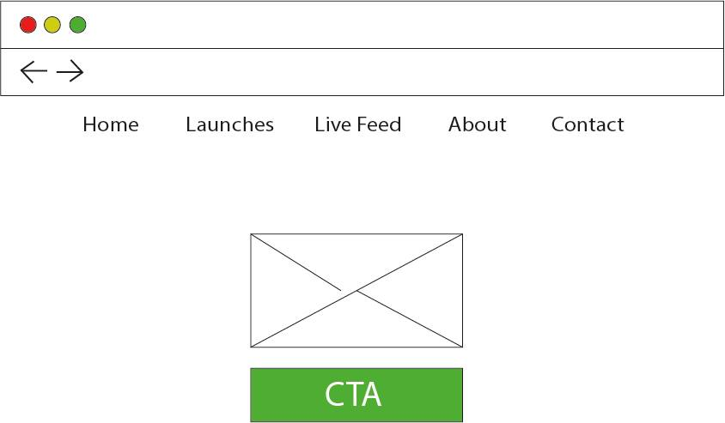

Mock Up Laptop

## 

## Mock Up Mob