AMLPrototypes

Structural Report

Author: Author

Revision: 0.2

|  |  |
| --- | --- |
| No Magic |  |
| One Allen Center, 700 Central Expressway South, Suite 110 Allen, Texas 75013 USA | Date: July 05, 2016 |

**Revision History**

|  |  |  |  |
| --- | --- | --- | --- |
| **Revision** | **Date** | **Reason For Changes** | **Author** |
| 0.1 | <date 1> | <draft> | <Author name> |
| 0.2 | <date 2> | <release> | <Author name> |
|  |  |  |  |

**Table of Contents**

Microsoft Word users please click here and press F9 to create Table of Contents.

OpenOffice.org users please remove this text and select Insert Table of Content from menu.

**Table of Figures**

Microsoft Word users please click here and press F9 to create Table of Contents.

OpenOffice.org users please remove this text and select Insert Table of Content from menu.

# Introduction

## Purpose

<This document provides an overview of structural view>

## Scope

<Provide a short description of the system being specified and its purpose, including relevant benefits, objectives, and goals>

## Overview

<Describe what the document contains and explain how document is organized>

# ReferenceArchetypeLibrary

## ReferenceArchetypeLibrary

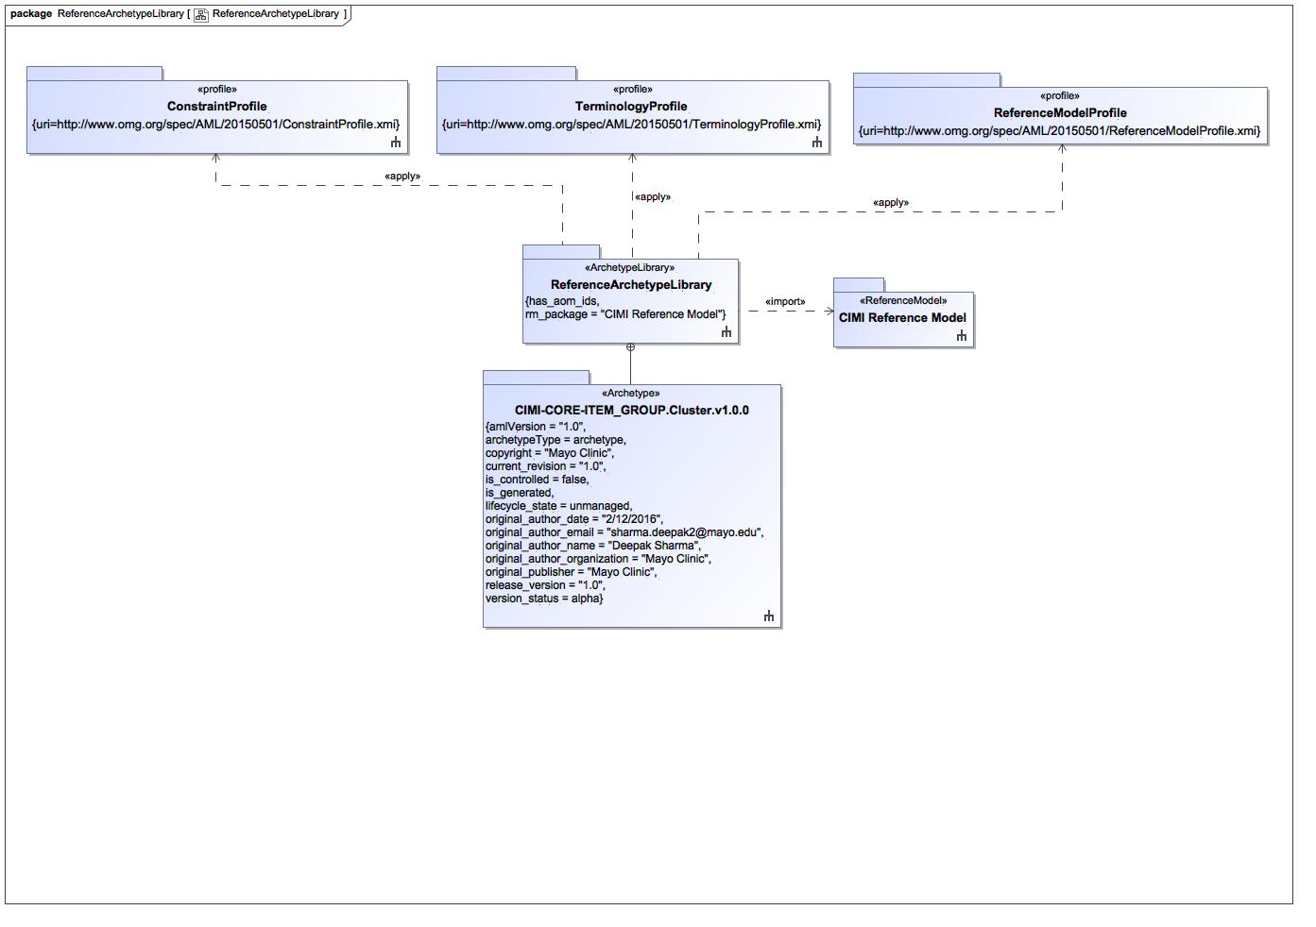

1. ReferenceArchetypeLibrary

# ReferenceArchetypeLibrary::CIMI-CORE-ITEM_GROUP.Cluster.v1.0.0

## Cluster_Archetype

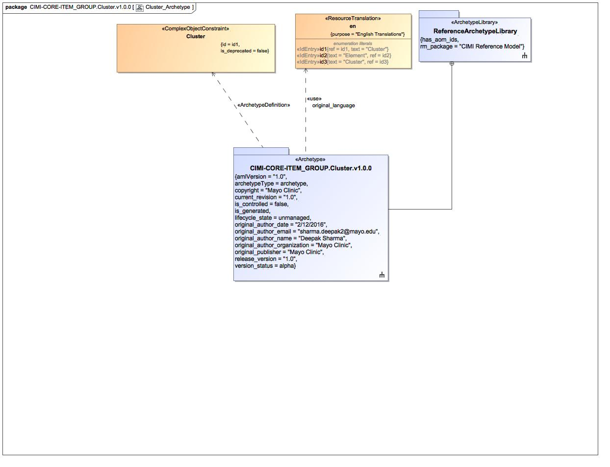

1. Cluster_Archetype

### Class Cluster

#### Direct Known Superclasses

ITEM_GROUP

package ReferenceArchetypeLibrary::CIMI-CORE-ITEM_GROUP.Cluster.v1.0.0

public class Cluster

extends

ITEM_GROUP

#### Associations

1802007256.jpg public cluster : Cluster_id3 [0..*]

1802007256.jpg public element : Element [0..*]

### Enumeration en

package ReferenceArchetypeLibrary::CIMI-CORE-ITEM_GROUP.Cluster.v1.0.0::Terminology::translations

public enum en

{id1, id2, id3}

#### Literals

-1252509891.jpg id1

-1252509891.jpg id2

-1252509891.jpg id3

## Cluster_Definiton

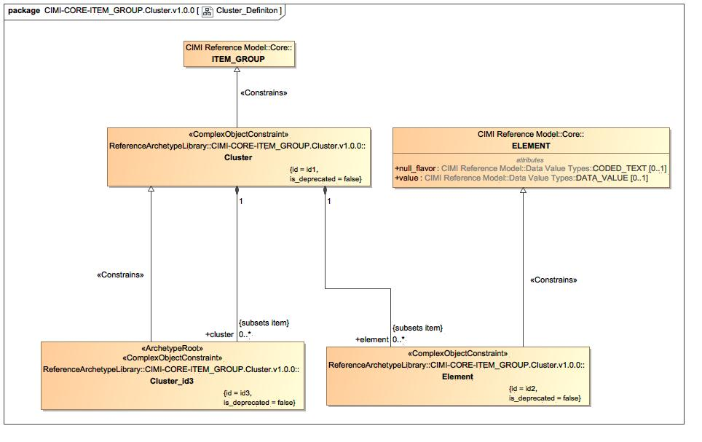

1. Cluster_Definiton

### Class Cluster_id3

#### Direct Known Superclasses

Cluster

package ReferenceArchetypeLibrary::CIMI-CORE-ITEM_GROUP.Cluster.v1.0.0

public class Cluster_id3

extends

Cluster

#### Associations

1802007256.jpg public : Cluster [1]

### Class Element

#### Direct Known Superclasses

ELEMENT

package ReferenceArchetypeLibrary::CIMI-CORE-ITEM_GROUP.Cluster.v1.0.0

public class Element

extends

ELEMENT

#### Associations

1802007256.jpg public : Cluster [1]

### Class ELEMENT

#### Direct Known Superclasses

ITEM

package CIMI Reference Model::Core

public class ELEMENT

extends

ITEM

### Class ITEM_GROUP

#### Direct Known Superclasses

ITEM

package CIMI Reference Model::Core

public class ITEM_GROUP

extends

ITEM

#### Associations

-2616899.jpg public item : ITEM [1..*]

-2616899.jpg public participation : PARTICIPATION [0..*]

### Known other classes

Class Cluster

## terms

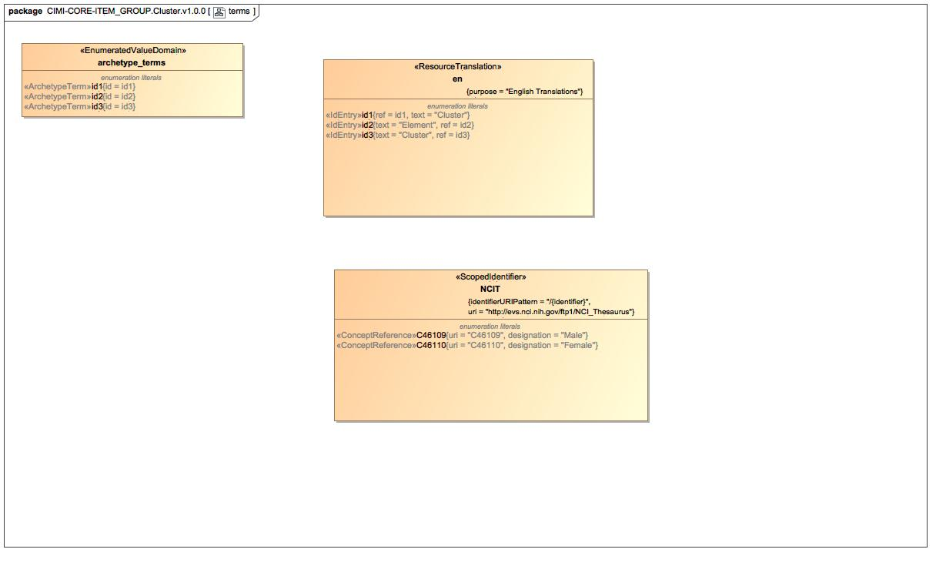

1. terms

### Enumeration archetype_terms

package ReferenceArchetypeLibrary::CIMI-CORE-ITEM_GROUP.Cluster.v1.0.0::Terminology::terms

public enum archetype_terms

{id1, id2, id3}

#### Literals

-1252509891.jpg id1

-1252509891.jpg id2

-1252509891.jpg id3

### Enumeration NCIT

package ReferenceArchetypeLibrary::CIMI-CORE-ITEM_GROUP.Cluster.v1.0.0::Terminology::references

public enum NCIT

{C46109, C46110}

#### Literals

-1252509891.jpg C46109

-1252509891.jpg C46110

### Known other enumerations

Enumeration en

# ReferenceArchetypeLibrary::CIMI-CORE-ITEM_GROUP.Cluster.v1.0.0::Terminology::references

## Known other enumerations

Enumeration NCIT

# ReferenceArchetypeLibrary::CIMI-CORE-ITEM_GROUP.Cluster.v1.0.0::Terminology::terms

## Known other enumerations

Enumeration archetype_terms

# ReferenceArchetypeLibrary::CIMI-CORE-ITEM_GROUP.Cluster.v1.0.0::Terminology::translations

## Known other enumerations

Enumeration en

# TCGA Reference Model::OCGShared

## OCGShared_datatypes

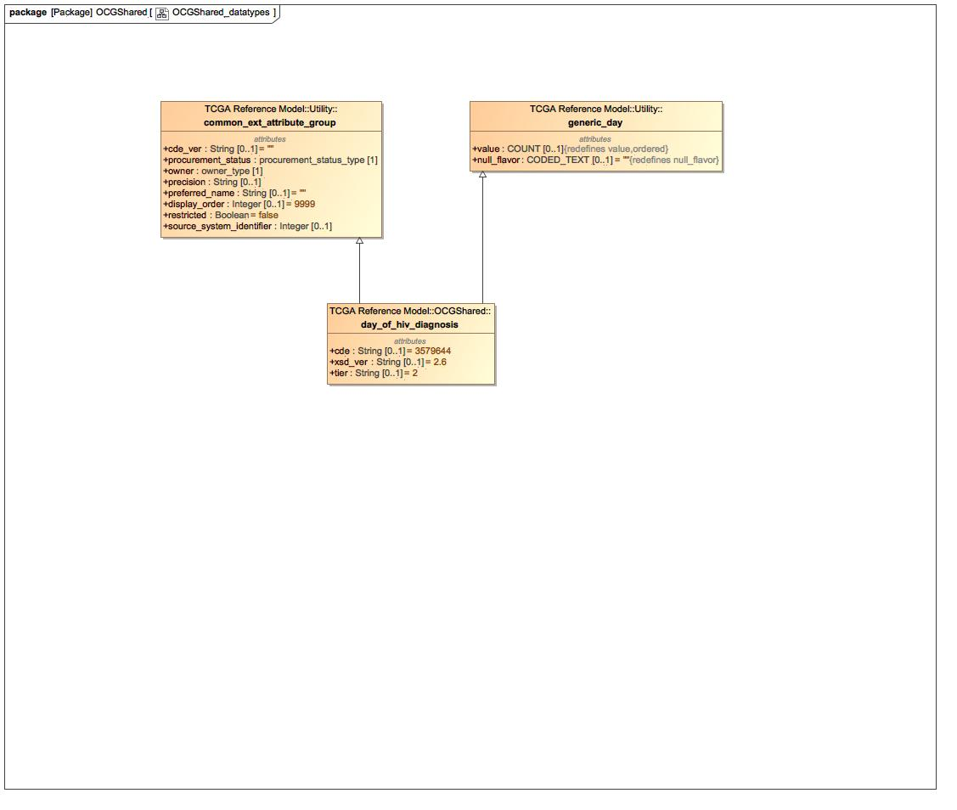

1. OCGShared_datatypes

### Class common_ext_attribute_group

package TCGA Reference Model::Utility

public class common_ext_attribute_group

### Class day_of_hiv_diagnosis

#### Direct Known Superclasses

common_ext_attribute_group, generic_day

package TCGA Reference Model::OCGShared

public class day_of_hiv_diagnosis

extends

common_ext_attribute_group,

generic_day

### Class generic_day

#### Direct Known Superclasses

ELEMENT

package TCGA Reference Model::Utility

public class generic_day

extends

ELEMENT

# TCGA Reference Model::Utility

## Utility_constrained_datatypes

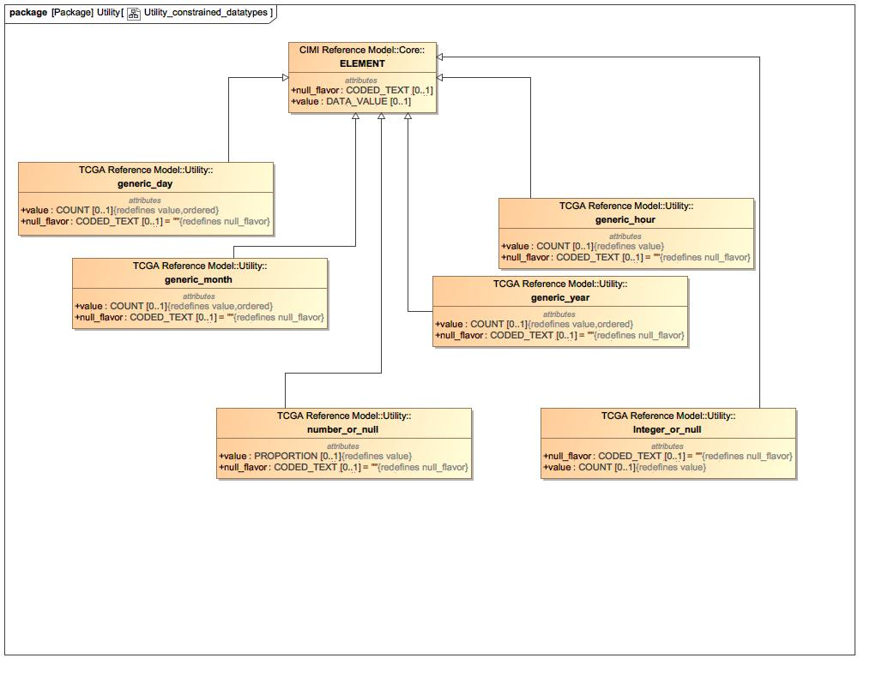

1. Utility_constrained_datatypes

### Class generic_hour

#### Direct Known Superclasses

ELEMENT

package TCGA Reference Model::Utility

public class generic_hour

extends

ELEMENT

### Class generic_month

#### Direct Known Superclasses

ELEMENT

package TCGA Reference Model::Utility

public class generic_month

extends

ELEMENT

### Class generic_year

#### Direct Known Superclasses

ELEMENT

package TCGA Reference Model::Utility

public class generic_year

extends

ELEMENT

### Class Integer_or_null

#### Direct Known Superclasses

ELEMENT

package TCGA Reference Model::Utility

public class Integer_or_null

extends

ELEMENT

### Class number_or_null

#### Direct Known Superclasses

ELEMENT

package TCGA Reference Model::Utility

public class number_or_null

extends

ELEMENT

### Known other classes

Class ELEMENT, Class generic_day

## Utility_datatypes

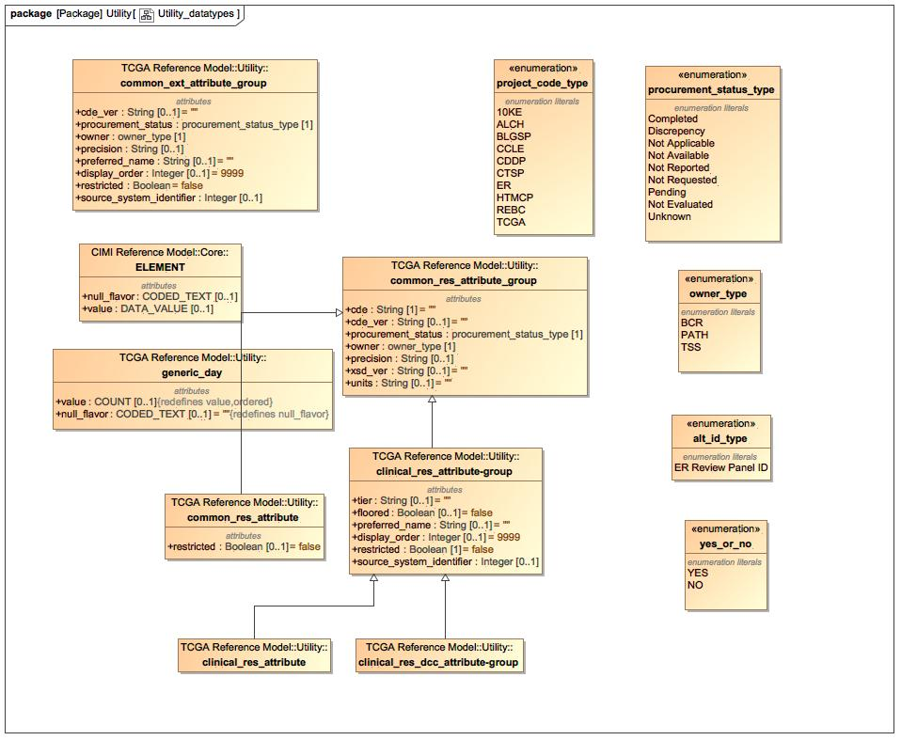

1. Utility_datatypes

### Class clinical_res_attribute

#### Direct Known Superclasses

clinical_res_attribute-group

package TCGA Reference Model::Utility

public class clinical_res_attribute

extends

clinical_res_attribute-group

### Class clinical_res_attribute-group

#### Direct Known Superclasses

common_res_attribute_group

package TCGA Reference Model::Utility

public class clinical_res_attribute-group

extends

common_res_attribute_group

### Class clinical_res_dcc_attribute-group

#### Direct Known Superclasses

clinical_res_attribute-group

package TCGA Reference Model::Utility

public class clinical_res_dcc_attribute-group

extends

clinical_res_attribute-group

### Class common_res_attribute

#### Direct Known Superclasses

common_res_attribute_group

package TCGA Reference Model::Utility

public class common_res_attribute

extends

common_res_attribute_group

### Class common_res_attribute_group

package TCGA Reference Model::Utility

public class common_res_attribute_group

### Known other classes

Class common_ext_attribute_group, Class ELEMENT, Class generic_day

### Enumeration alt_id_type

package TCGA Reference Model::Utility

public enum alt_id_type

{ER Review Panel ID}

#### Literals

-1252509891.jpg ER Review Panel ID

### Enumeration owner_type

package TCGA Reference Model::Utility

public enum owner_type

{BCR, PATH, TSS, }

#### Literals

-1252509891.jpg BCR

-1252509891.jpg PATH

-1252509891.jpg TSS

-1252509891.jpg

### Enumeration procurement_status_type

package TCGA Reference Model::Utility

public enum procurement_status_type

{Completed, Discrepency, Not Applicable, Not Available, Not Reported, Not Requested, Pending, Not Evaluated, Unknown, }

#### Literals

-1252509891.jpg Completed

-1252509891.jpg Discrepency

-1252509891.jpg Not Applicable

-1252509891.jpg Not Available

-1252509891.jpg Not Reported

-1252509891.jpg Not Requested

-1252509891.jpg Pending

-1252509891.jpg Not Evaluated

-1252509891.jpg Unknown

-1252509891.jpg

### Enumeration project_code_type

package TCGA Reference Model::Utility

public enum project_code_type

{10KE, ALCH, BLGSP, CCLE, CDDP, CTSP, ER, HTMCP, REBC, TCGA}

#### Literals

-1252509891.jpg 10KE

-1252509891.jpg ALCH

-1252509891.jpg BLGSP

-1252509891.jpg CCLE

-1252509891.jpg CDDP

-1252509891.jpg CTSP

-1252509891.jpg ER

-1252509891.jpg HTMCP

-1252509891.jpg REBC

-1252509891.jpg TCGA

### Enumeration yes_or_no

package TCGA Reference Model::Utility

public enum yes_or_no

{YES, NO, }

#### Literals

-1252509891.jpg YES

-1252509891.jpg NO

-1252509891.jpg

# TCGAArchetypes::TCGAOCGSharedCELibrary

## TCGAOCGSharedCELibrary

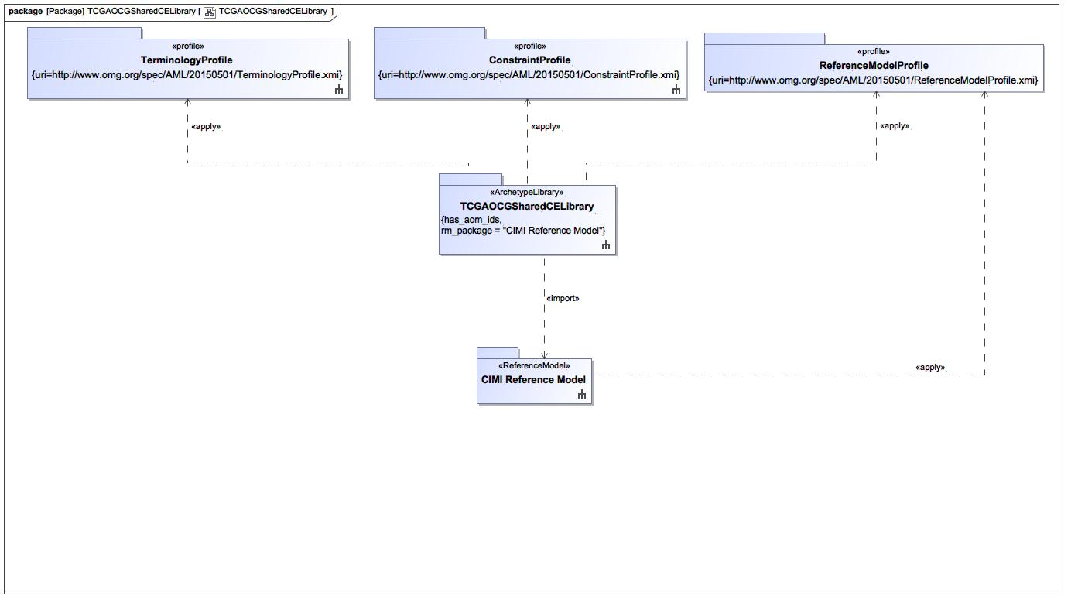

1. TCGAOCGSharedCELibrary

# TCGAArchetypes::TCGAOCGSharedCELibrary::CIMI-TCGA-generic_day.day_of_hiv_diagnosis.v2.7

## DayOfHivDiagnosis

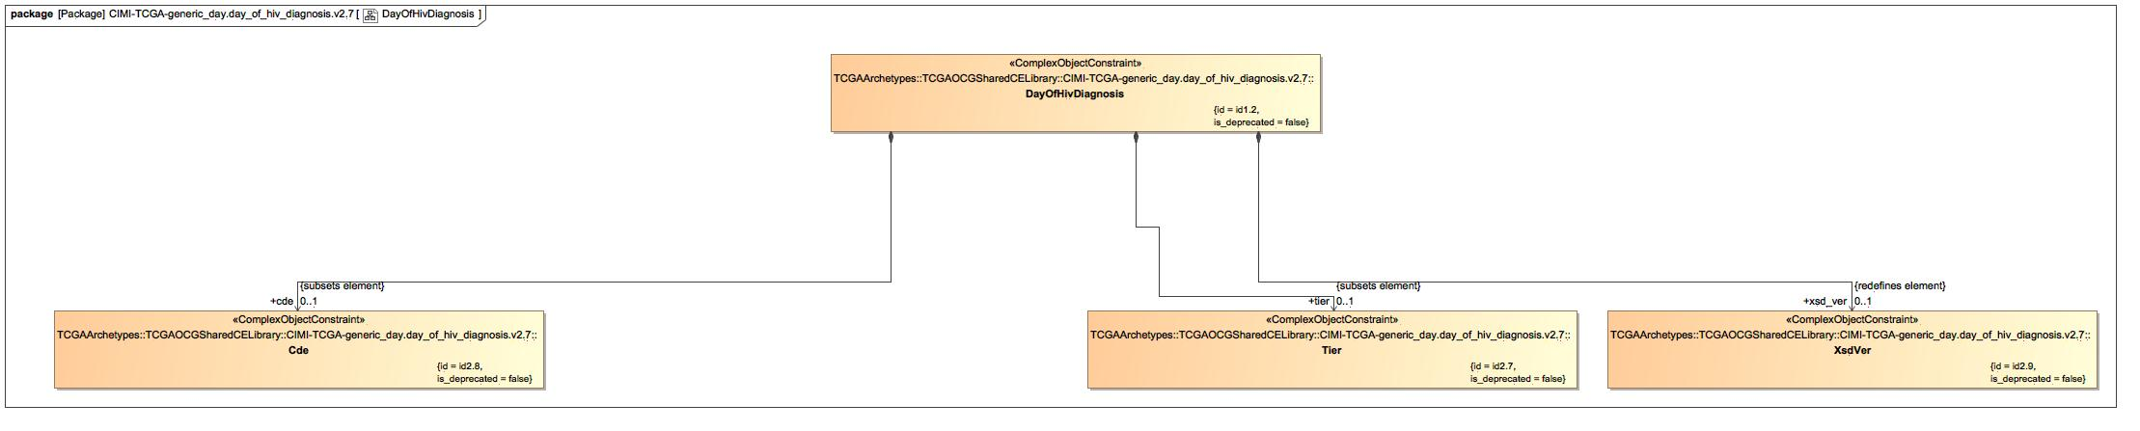

1. DayOfHivDiagnosis

### Class Cde

#### Direct Known Superclasses

Element

package TCGAArchetypes::TCGAOCGSharedCELibrary::CIMI-TCGA-generic_day.day_of_hiv_diagnosis.v2.7

public class Cde

extends

Element

#### Associations

-2616899.jpg public value_2.8 : String [1] = 3579644

### Class DayOfHivDiagnosis

#### Direct Known Superclasses

Cluster, CommonExtAttributeGroup, GenericDay

package TCGAArchetypes::TCGAOCGSharedCELibrary::CIMI-TCGA-generic_day.day_of_hiv_diagnosis.v2.7

public class DayOfHivDiagnosis

extends

GenericDay,

CommonExtAttributeGroup,

Cluster

#### Associations

-2616899.jpg public cde : Cde [0..1]

-2616899.jpg public xsd_ver : XsdVer [0..1]

-2616899.jpg public tier : Tier [0..1]

### Class Tier

#### Direct Known Superclasses

Element

package TCGAArchetypes::TCGAOCGSharedCELibrary::CIMI-TCGA-generic_day.day_of_hiv_diagnosis.v2.7

public class Tier

extends

Element

#### Associations

-2616899.jpg public value_2.7 : String [1] = 2

### Class XsdVer

#### Direct Known Superclasses

Element

package TCGAArchetypes::TCGAOCGSharedCELibrary::CIMI-TCGA-generic_day.day_of_hiv_diagnosis.v2.7

public class XsdVer

extends

Element

#### Associations

-2616899.jpg public value_2.9 : String [1] = 2.6

## DayOfHivDiagnosis_Archetype

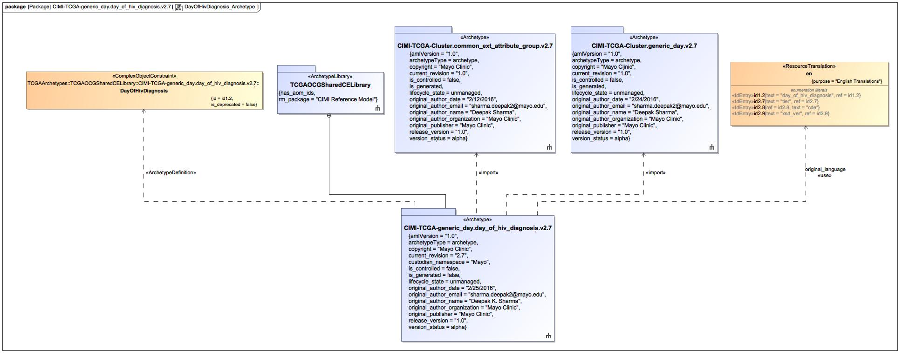

1. DayOfHivDiagnosis_Archetype

### Known other classes

Class DayOfHivDiagnosis

### Enumeration en

package TCGAArchetypes::TCGAOCGSharedCELibrary::CIMI-TCGA-generic_day.day_of_hiv_diagnosis.v2.7::Terminology::term-definitions

public enum en

{id1.2, id2.7, id2.8, id2.9}

#### Literals

-1252509891.jpg id1.2

-1252509891.jpg id2.7

-1252509891.jpg id2.8

-1252509891.jpg id2.9

## DayOfHivDiagnosis_cde

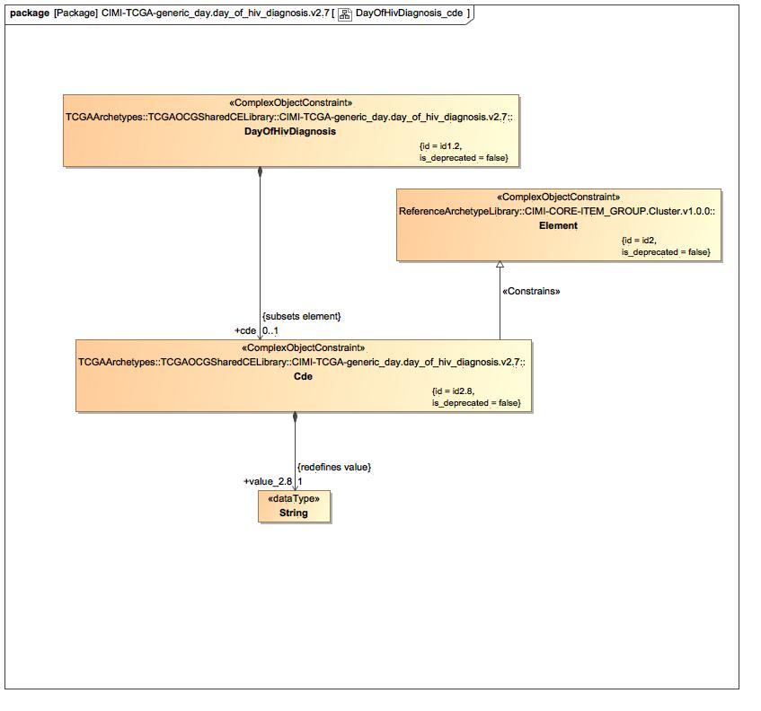

1. DayOfHivDiagnosis_cde

### Known other classes

Class Cde, Class DayOfHivDiagnosis, Class Element

## DayOfHivDiagnosis_Definition

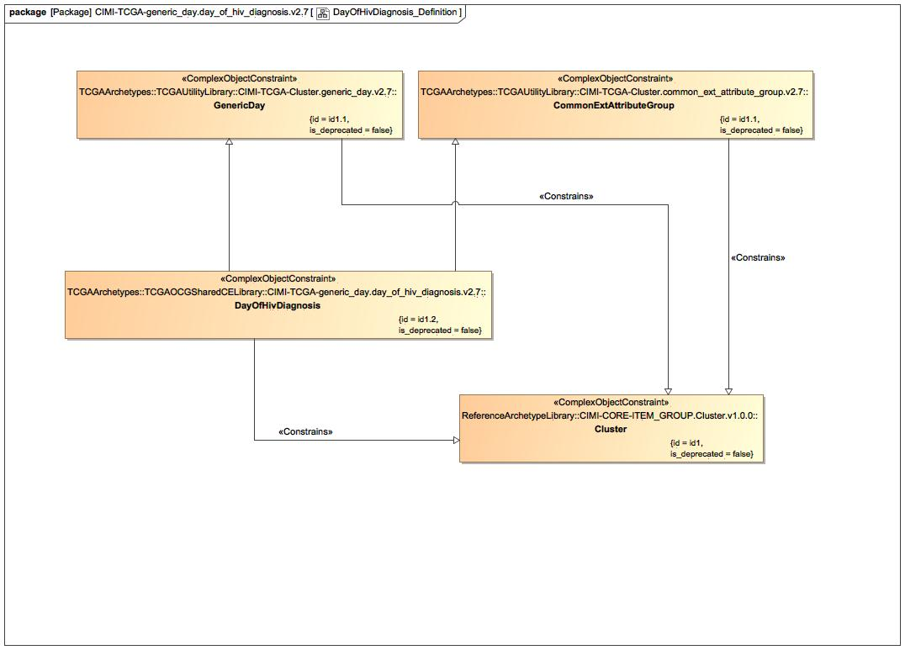

1. DayOfHivDiagnosis_Definition

### Class CommonExtAttributeGroup

#### Direct Known Superclasses

Cluster

package TCGAArchetypes::TCGAUtilityLibrary::CIMI-TCGA-Cluster.common_ext_attribute_group.v2.7

public class CommonExtAttributeGroup

extends

Cluster

#### Associations

-2616899.jpg public cde_ver : CdeVer [0..1]

-2616899.jpg public procurement_status : ProcurementStatus [1]

### Class GenericDay

#### Direct Known Superclasses

Cluster

package TCGAArchetypes::TCGAUtilityLibrary::CIMI-TCGA-Cluster.generic_day.v2.7

public class GenericDay

extends

Cluster

#### Associations

-2616899.jpg public id2.1 : Id2.1 [1]

### Known other classes

Class Cluster, Class DayOfHivDiagnosis

## DayOfHivDiagnosis_Terms

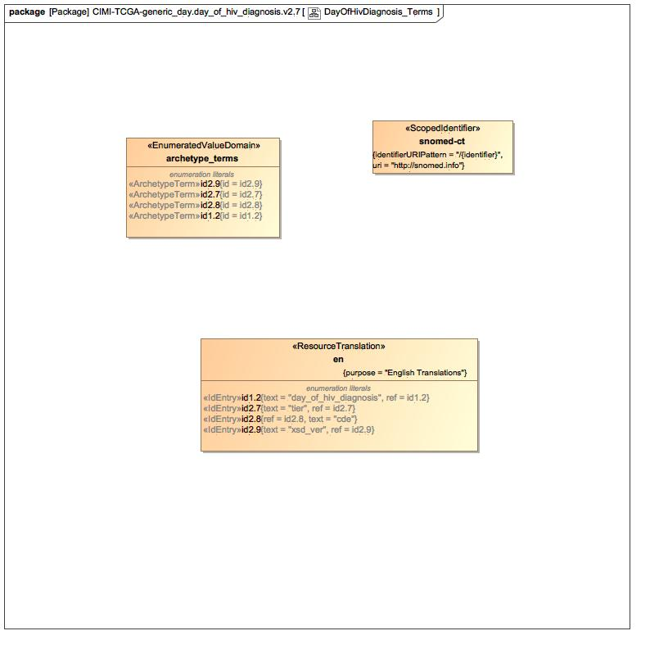

1. DayOfHivDiagnosis_Terms

### Enumeration archetype_terms

package TCGAArchetypes::TCGAOCGSharedCELibrary::CIMI-TCGA-generic_day.day_of_hiv_diagnosis.v2.7::Terminology::terms

public enum archetype_terms

{id2.9, id2.7, id2.8, id1.2}

#### Literals

-1252509891.jpg id2.9

-1252509891.jpg id2.7

-1252509891.jpg id2.8

-1252509891.jpg id1.2

### Enumeration snomed-ct

package TCGAArchetypes::TCGAOCGSharedCELibrary::CIMI-TCGA-generic_day.day_of_hiv_diagnosis.v2.7::Terminology::term-bindings

public enum snomed-ct

### Known other enumerations

Enumeration en

## DayOfHivDiagnosis_tier

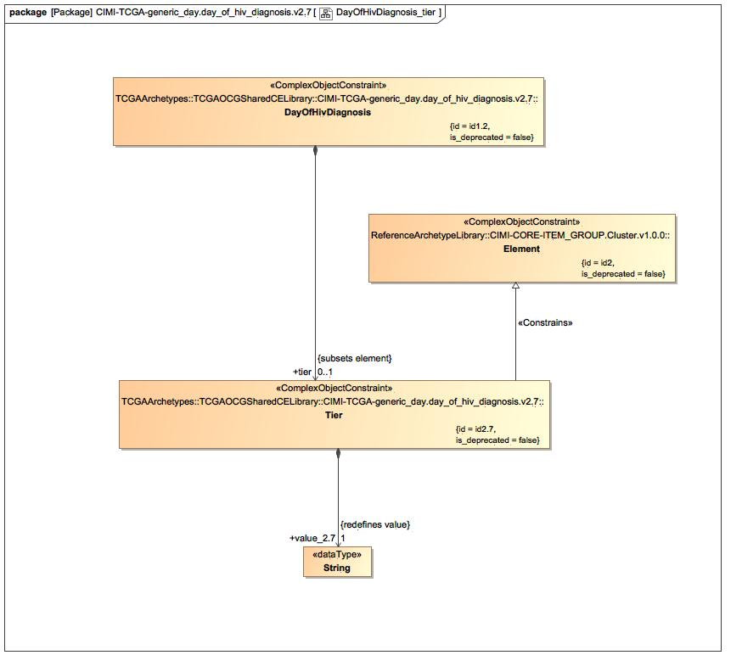

1. DayOfHivDiagnosis_tier

### Known other classes

Class DayOfHivDiagnosis, Class Element, Class Tier

## DayOfHivDiagnosis_xsd_ver

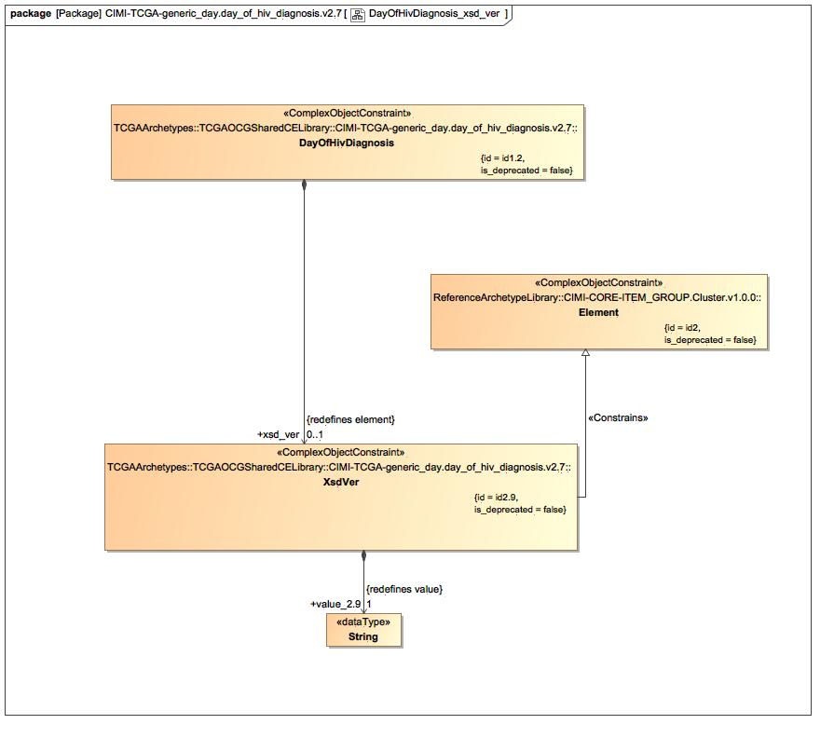

1. DayOfHivDiagnosis_xsd_ver

### Known other classes

Class DayOfHivDiagnosis, Class Element, Class XsdVer

# TCGAArchetypes::TCGAOCGSharedCELibrary::CIMI-TCGA-generic_day.day_of_hiv_diagnosis.v2.7::Terminology::term-bindings

## Known other enumerations

Enumeration snomed-ct

# TCGAArchetypes::TCGAOCGSharedCELibrary::CIMI-TCGA-generic_day.day_of_hiv_diagnosis.v2.7::Terminology::term-definitions

## Known other enumerations

Enumeration en

# TCGAArchetypes::TCGAOCGSharedCELibrary::CIMI-TCGA-generic_day.day_of_hiv_diagnosis.v2.7::Terminology::terms

## Known other enumerations

Enumeration archetype_terms

# TCGAArchetypes::TCGAOCGSharedCELibrary::CIMI-TCGA-generic_day.days_to_hiv_diagnosis.v2.7

## DaysToHivDiagnosis

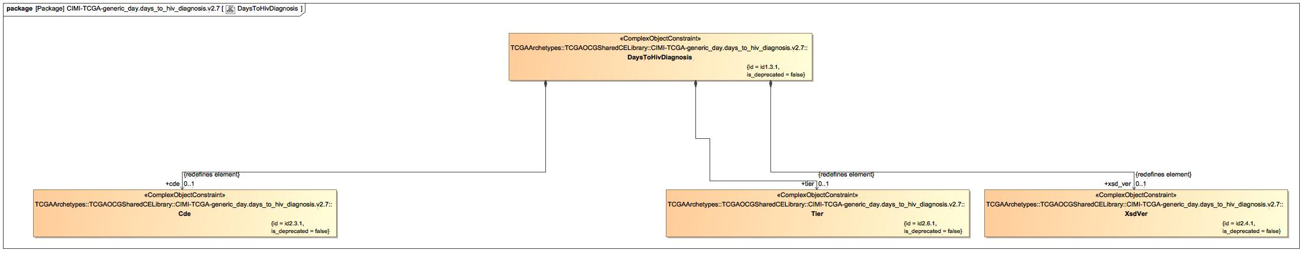

1. DaysToHivDiagnosis

### Class Cde

#### Direct Known Superclasses

Cde

package TCGAArchetypes::TCGAOCGSharedCELibrary::CIMI-TCGA-generic_day.days_to_hiv_diagnosis.v2.7

public class Cde

extends

Cde

#### Associations

-2616899.jpg public value_2.3.1 : String [1] = 4618491

### Class DaysToHivDiagnosis

#### Direct Known Superclasses

ClinicalResAttributes

package TCGAArchetypes::TCGAOCGSharedCELibrary::CIMI-TCGA-generic_day.days_to_hiv_diagnosis.v2.7

public class DaysToHivDiagnosis

extends

ClinicalResAttributes

#### Associations

-2616899.jpg public cde : Cde [0..1]

-2616899.jpg public xsd_ver : XsdVer [0..1]

-2616899.jpg public tier : Tier [0..1]

### Class Tier

#### Direct Known Superclasses

Tier

package TCGAArchetypes::TCGAOCGSharedCELibrary::CIMI-TCGA-generic_day.days_to_hiv_diagnosis.v2.7

public class Tier

extends

Tier

#### Associations

-2616899.jpg public value_2.6.1 : String [1] = 2

### Class XsdVer

#### Direct Known Superclasses

XsdVer

package TCGAArchetypes::TCGAOCGSharedCELibrary::CIMI-TCGA-generic_day.days_to_hiv_diagnosis.v2.7

public class XsdVer

extends

XsdVer

#### Associations

-2616899.jpg public value_2.4.1 : String [1] = 2.6

## DaysToHivDiagnosis_Archetype

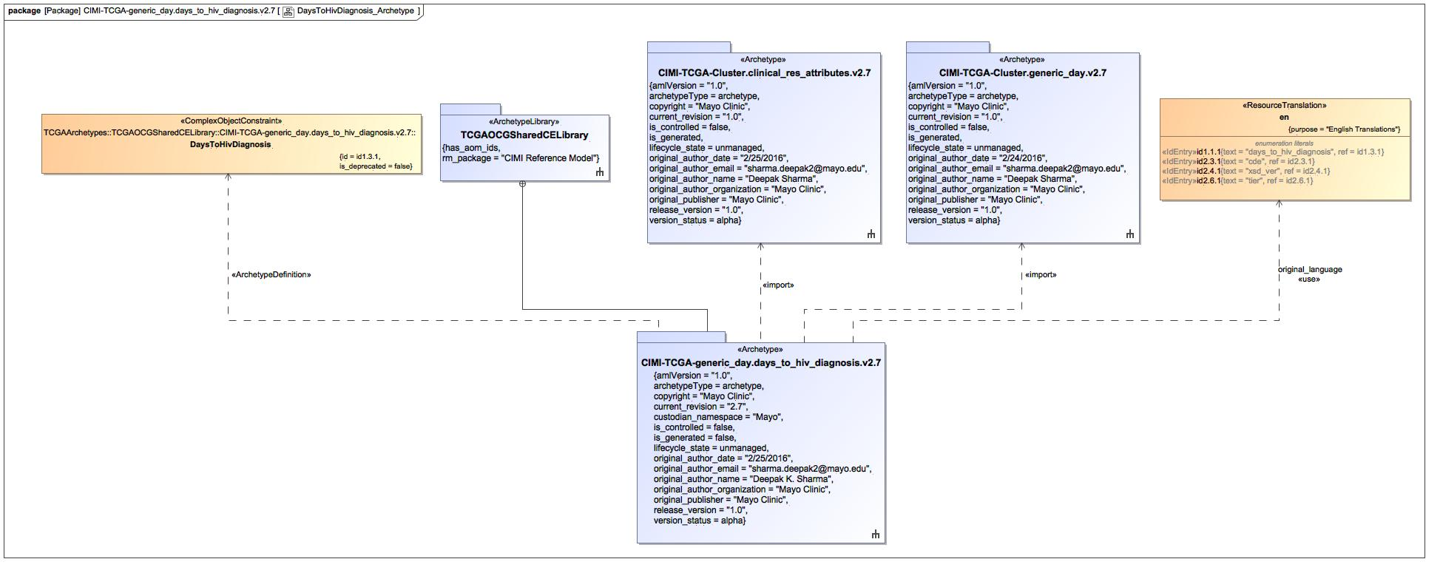

1. DaysToHivDiagnosis_Archetype

### Known other classes

Class DaysToHivDiagnosis

### Enumeration en

package TCGAArchetypes::TCGAOCGSharedCELibrary::CIMI-TCGA-generic_day.days_to_hiv_diagnosis.v2.7::Terminology::term-definitions

public enum en

{id1.1.1, id2.3.1, id2.4.1, id2.6.1}

#### Literals

-1252509891.jpg id1.1.1

-1252509891.jpg id2.3.1

-1252509891.jpg id2.4.1

-1252509891.jpg id2.6.1

## DaysToHivDiagnosis_cde

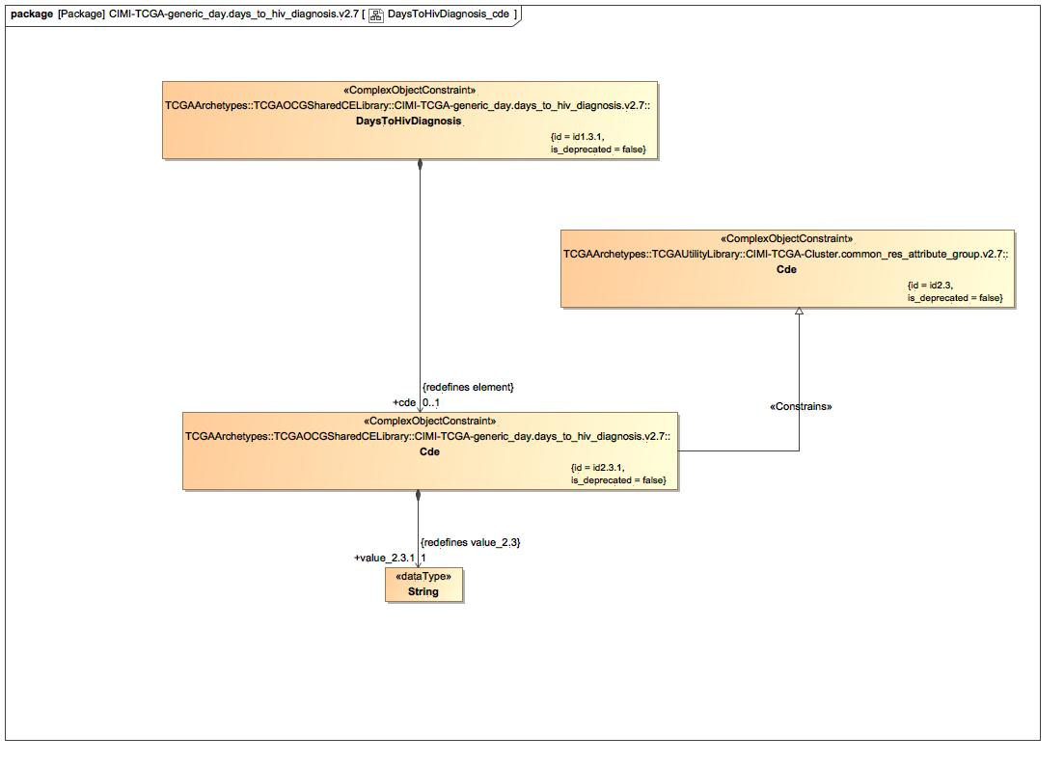

1. DaysToHivDiagnosis_cde

### Class Cde

#### Direct Known Superclasses

Element

package TCGAArchetypes::TCGAUtilityLibrary::CIMI-TCGA-Cluster.common_res_attribute_group.v2.7

public class Cde

extends

Element

#### Associations

-2616899.jpg public value_2.3 : String [1]

### Known other classes

Class Cde, Class DaysToHivDiagnosis

## DaysToHivDiagnosis_Definition

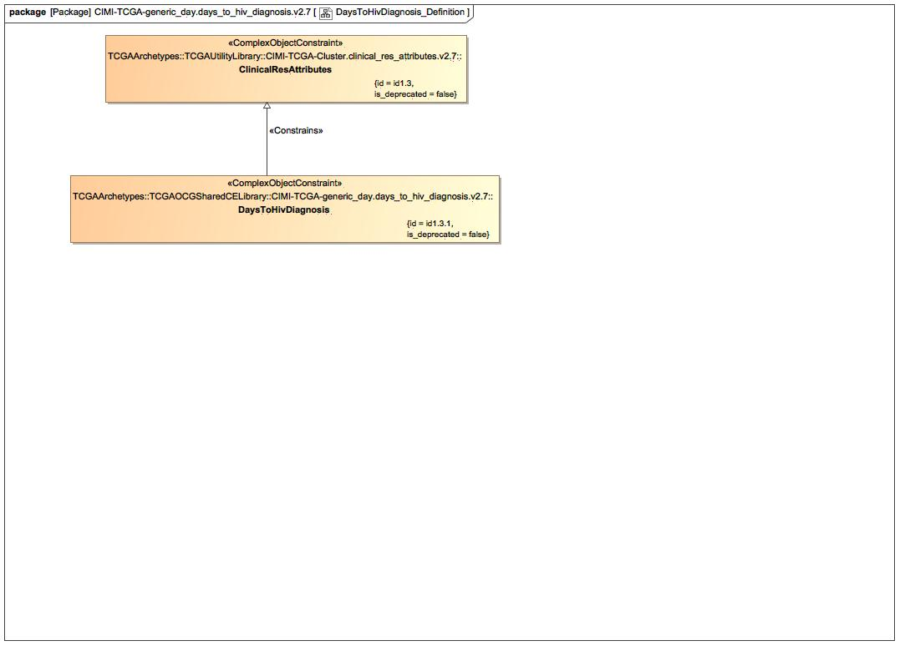

1. DaysToHivDiagnosis_Definition

### Class ClinicalResAttributes

#### Direct Known Superclasses

ClinicalResAttributeGroup, Cluster

package TCGAArchetypes::TCGAUtilityLibrary::CIMI-TCGA-Cluster.clinical_res_attributes.v2.7

public class ClinicalResAttributes

extends

Cluster,

ClinicalResAttributeGroup

#### Associations

-2616899.jpg public id2.7 : Id2.7 [1]

### Known other classes

Class DaysToHivDiagnosis

## DaysToHivDiagnosis_Terms

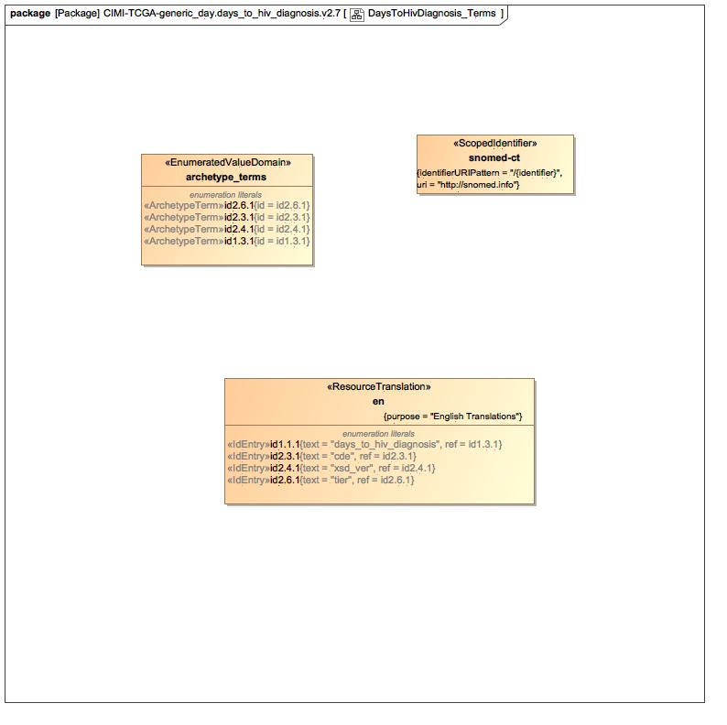

1. DaysToHivDiagnosis_Terms

### Enumeration archetype_terms

package TCGAArchetypes::TCGAOCGSharedCELibrary::CIMI-TCGA-generic_day.days_to_hiv_diagnosis.v2.7::Terminology::terms

public enum archetype_terms

{id2.6.1, id2.3.1, id2.4.1, id1.3.1}

#### Literals

-1252509891.jpg id2.6.1

-1252509891.jpg id2.3.1

-1252509891.jpg id2.4.1

-1252509891.jpg id1.3.1

### Enumeration snomed-ct

package TCGAArchetypes::TCGAOCGSharedCELibrary::CIMI-TCGA-generic_day.days_to_hiv_diagnosis.v2.7::Terminology::term-bindings

public enum snomed-ct

### Known other enumerations

Enumeration en

## DaysToHivDiagnosis_tier

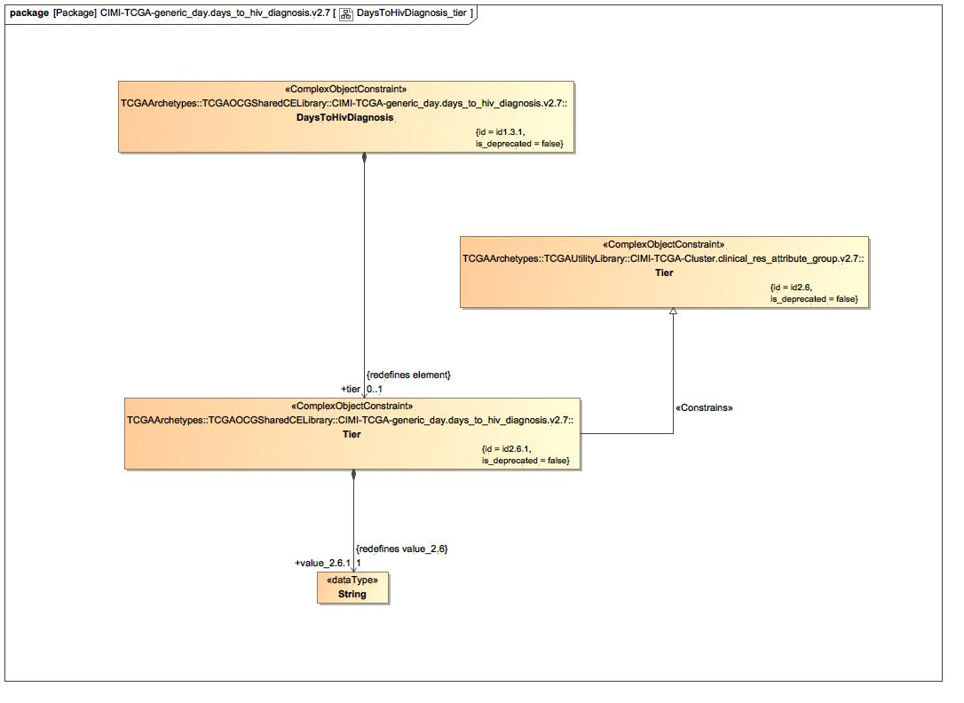

1. DaysToHivDiagnosis_tier

### Class Tier

#### Direct Known Superclasses

Element

package TCGAArchetypes::TCGAUtilityLibrary::CIMI-TCGA-Cluster.clinical_res_attribute_group.v2.7

public class Tier

extends

Element

#### Associations

-2616899.jpg public value_2.6 : String [0..1] = ""

### Known other classes

Class DaysToHivDiagnosis, Class Tier

## DaysToHivDiagnosis_xsd_ver

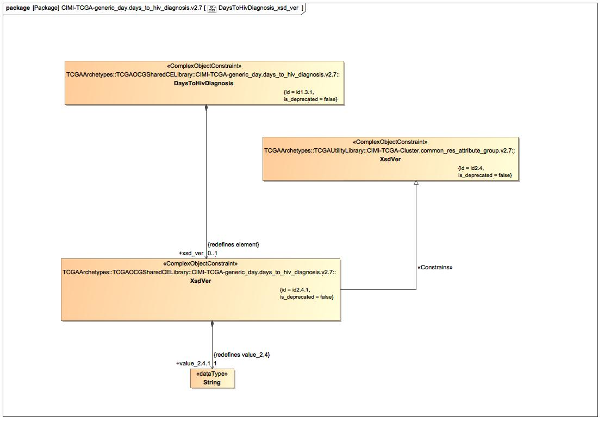

1. DaysToHivDiagnosis_xsd_ver

### Class XsdVer

#### Direct Known Superclasses

Element

package TCGAArchetypes::TCGAUtilityLibrary::CIMI-TCGA-Cluster.common_res_attribute_group.v2.7

public class XsdVer

extends

Element

#### Associations

-2616899.jpg public value_2.4 : String [0..1]

### Known other classes

Class DaysToHivDiagnosis, Class XsdVer

# TCGAArchetypes::TCGAOCGSharedCELibrary::CIMI-TCGA-generic_day.days_to_hiv_diagnosis.v2.7::Terminology::term-bindings

## Known other enumerations

Enumeration snomed-ct

# TCGAArchetypes::TCGAOCGSharedCELibrary::CIMI-TCGA-generic_day.days_to_hiv_diagnosis.v2.7::Terminology::term-definitions

## Known other enumerations

Enumeration en

# TCGAArchetypes::TCGAOCGSharedCELibrary::CIMI-TCGA-generic_day.days_to_hiv_diagnosis.v2.7::Terminology::terms

## Known other enumerations

Enumeration archetype_terms

# TCGAArchetypes::TCGAUtilityLibrary

## TCGAUtilityLibrary

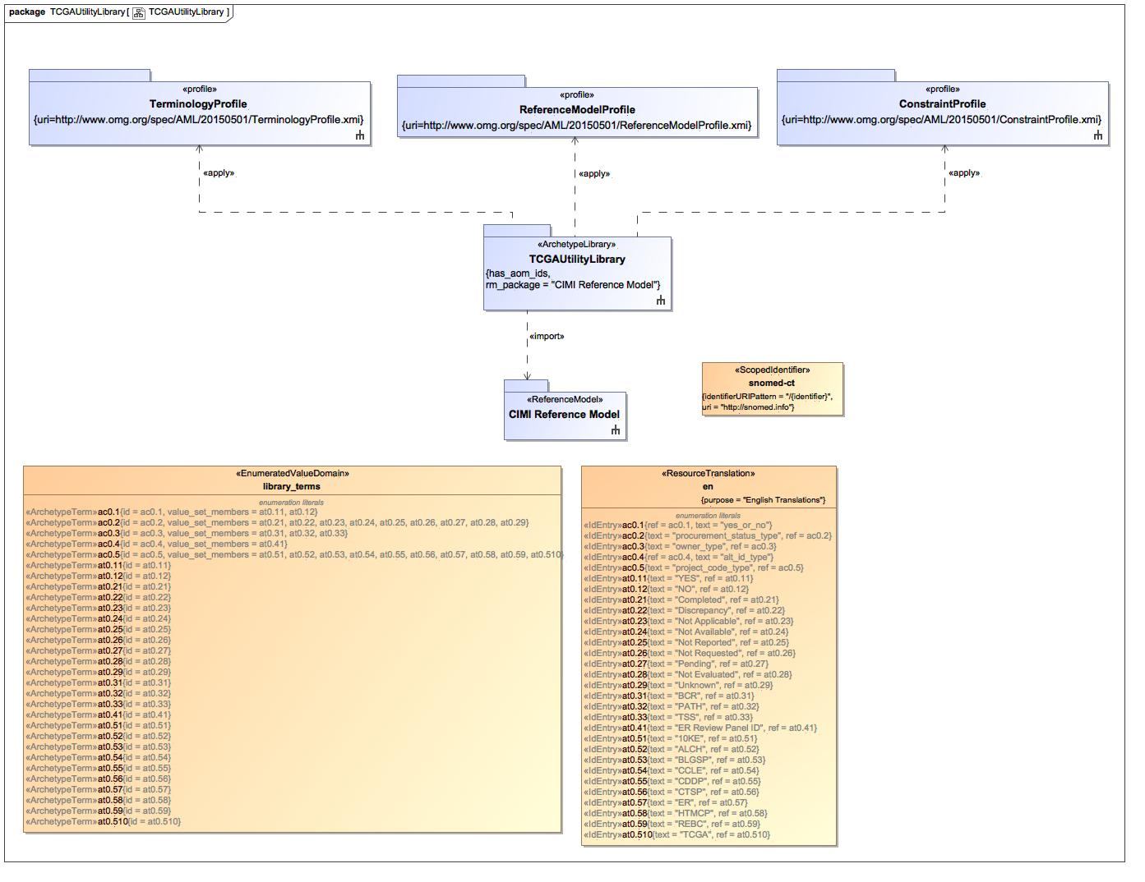

1. TCGAUtilityLibrary

### Enumeration en

package TCGAArchetypes::TCGAUtilityLibrary::Terminology::term-definitions

public enum en

{ac0.1, ac0.2, ac0.3, ac0.4, ac0.5, at0.11, at0.12, at0.21, at0.22, at0.23, at0.24, at0.25, at0.26, at0.27, at0.28, at0.29, at0.31, at0.32, at0.33, at0.41, at0.51, at0.52, at0.53, at0.54, at0.55, at0.56, at0.57, at0.58, at0.59, at0.510}

#### Literals

-1252509891.jpg ac0.1

-1252509891.jpg ac0.2

-1252509891.jpg ac0.3

-1252509891.jpg ac0.4

-1252509891.jpg ac0.5

-1252509891.jpg at0.11

-1252509891.jpg at0.12

-1252509891.jpg at0.21

-1252509891.jpg at0.22

-1252509891.jpg at0.23

-1252509891.jpg at0.24

-1252509891.jpg at0.25

-1252509891.jpg at0.26

-1252509891.jpg at0.27

-1252509891.jpg at0.28

-1252509891.jpg at0.29

-1252509891.jpg at0.31

-1252509891.jpg at0.32

-1252509891.jpg at0.33

-1252509891.jpg at0.41

-1252509891.jpg at0.51

-1252509891.jpg at0.52

-1252509891.jpg at0.53

-1252509891.jpg at0.54

-1252509891.jpg at0.55

-1252509891.jpg at0.56

-1252509891.jpg at0.57

-1252509891.jpg at0.58

-1252509891.jpg at0.59

-1252509891.jpg at0.510

### Enumeration library_terms

package TCGAArchetypes::TCGAUtilityLibrary::Terminology::terms

public enum library_terms

{ac0.1, ac0.2, ac0.3, ac0.4, ac0.5, at0.11, at0.12, at0.21, at0.22, at0.23, at0.24, at0.25, at0.26, at0.27, at0.28, at0.29, at0.31, at0.32, at0.33, at0.41, at0.51, at0.52, at0.53, at0.54, at0.55, at0.56, at0.57, at0.58, at0.59, at0.510}

#### Literals

-1252509891.jpg ac0.1

-1252509891.jpg ac0.2

-1252509891.jpg ac0.3

-1252509891.jpg ac0.4

-1252509891.jpg ac0.5

-1252509891.jpg at0.11

-1252509891.jpg at0.12

-1252509891.jpg at0.21

-1252509891.jpg at0.22

-1252509891.jpg at0.23

-1252509891.jpg at0.24

-1252509891.jpg at0.25

-1252509891.jpg at0.26

-1252509891.jpg at0.27

-1252509891.jpg at0.28

-1252509891.jpg at0.29

-1252509891.jpg at0.31

-1252509891.jpg at0.32

-1252509891.jpg at0.33

-1252509891.jpg at0.41

-1252509891.jpg at0.51

-1252509891.jpg at0.52

-1252509891.jpg at0.53

-1252509891.jpg at0.54

-1252509891.jpg at0.55

-1252509891.jpg at0.56

-1252509891.jpg at0.57

-1252509891.jpg at0.58

-1252509891.jpg at0.59

-1252509891.jpg at0.510

### Enumeration snomed-ct

package TCGAArchetypes::TCGAUtilityLibrary::Terminology::term-bindings

public enum snomed-ct

# TCGAArchetypes::TCGAUtilityLibrary::CIMI-TCGA-Cluster.clinical_res_attribute_group.v2.7

## ClinicalResAttributeGroup_Archetype

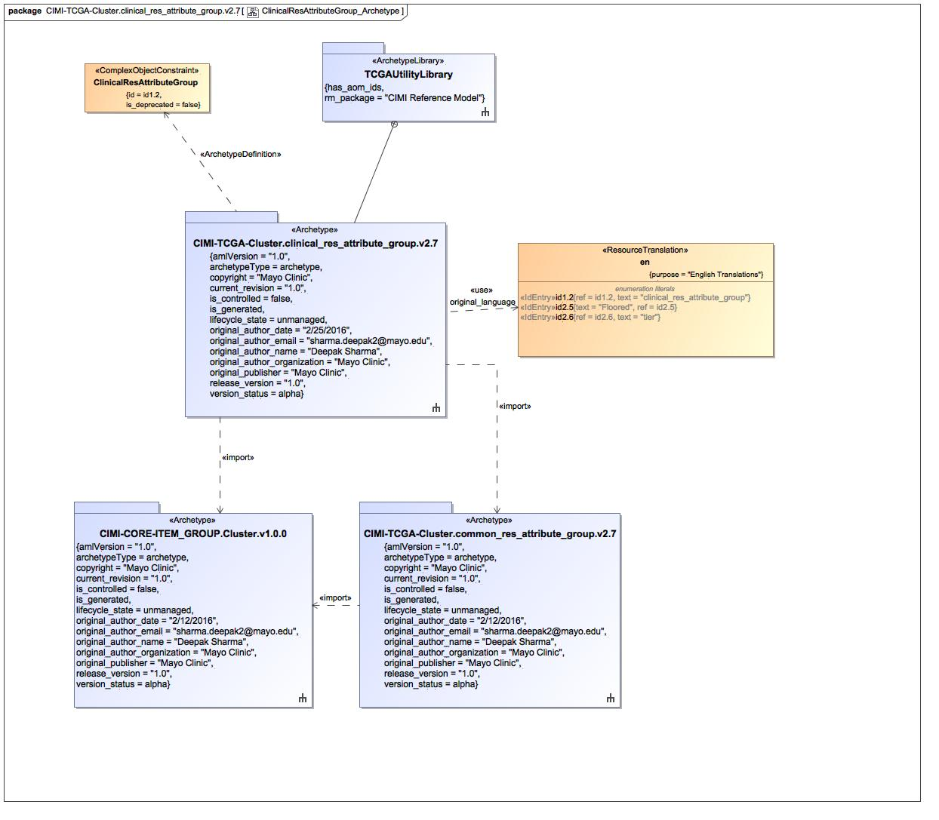

1. ClinicalResAttributeGroup_Archetype

### Class ClinicalResAttributeGroup

#### Direct Known Superclasses

Cluster, CommonResAttributeGroup

package TCGAArchetypes::TCGAUtilityLibrary::CIMI-TCGA-Cluster.clinical_res_attribute_group.v2.7

public class ClinicalResAttributeGroup

extends

CommonResAttributeGroup,

Cluster

#### Associations

-2616899.jpg public tier : Tier [0..1]

-2616899.jpg public floored : Floored [1]

### Enumeration en

package TCGAArchetypes::TCGAUtilityLibrary::CIMI-TCGA-Cluster.clinical_res_attribute_group.v2.7::Terminology::term-definitions

public enum en

{id1.2, id2.5, id2.6}

#### Literals

-1252509891.jpg id1.2

-1252509891.jpg id2.5

-1252509891.jpg id2.6

## ClinicalResAttributeGroup_Definition_common_res_attribute_group

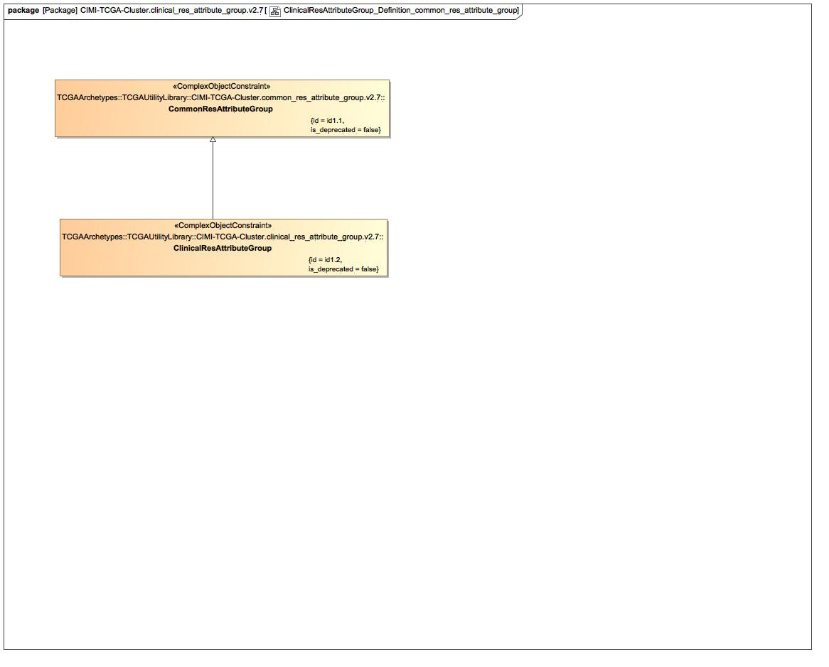

1. ClinicalResAttributeGroup_Definition_common_res_attribute_group

### Class CommonResAttributeGroup

#### Direct Known Superclasses

Cluster

package TCGAArchetypes::TCGAUtilityLibrary::CIMI-TCGA-Cluster.common_res_attribute_group.v2.7

public class CommonResAttributeGroup

extends

Cluster

#### Associations

-2616899.jpg public cde_ver : CdeVer [0..1]

-2616899.jpg public procurement_status : ProcurementStatus [1]

-2616899.jpg public xsd_ver : XsdVer [1]

-2616899.jpg public cde : Cde [1]

### Known other classes

Class ClinicalResAttributeGroup

## ClinicalResAttributeGroup_Definition_floored

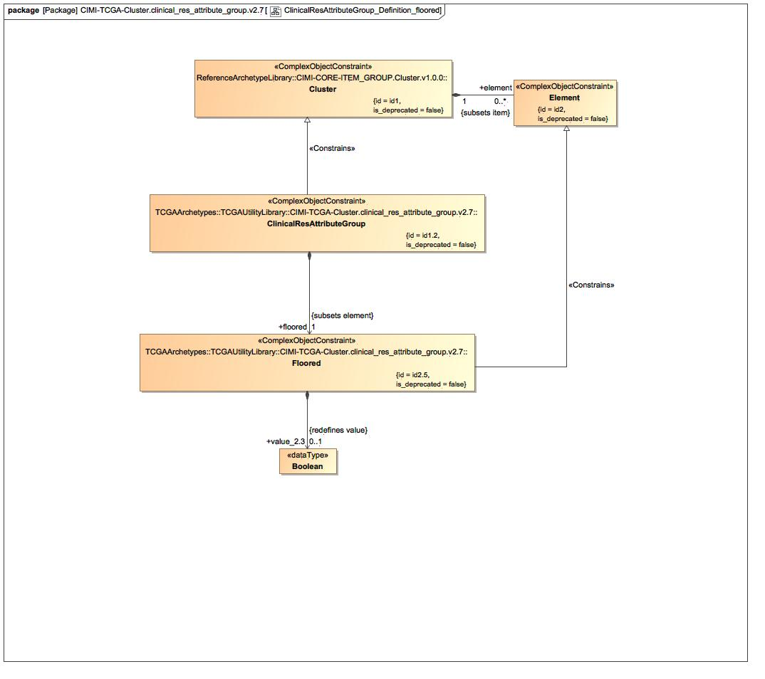

1. ClinicalResAttributeGroup_Definition_floored

### Class Floored

#### Direct Known Superclasses

Element

package TCGAArchetypes::TCGAUtilityLibrary::CIMI-TCGA-Cluster.clinical_res_attribute_group.v2.7

public class Floored

extends

Element

#### Associations

-2616899.jpg public value_2.3 : Boolean [0..1] = false

### Known other classes

Class ClinicalResAttributeGroup, Class Cluster, Class Element

## ClinicalResAttributeGroup_Definition_tier

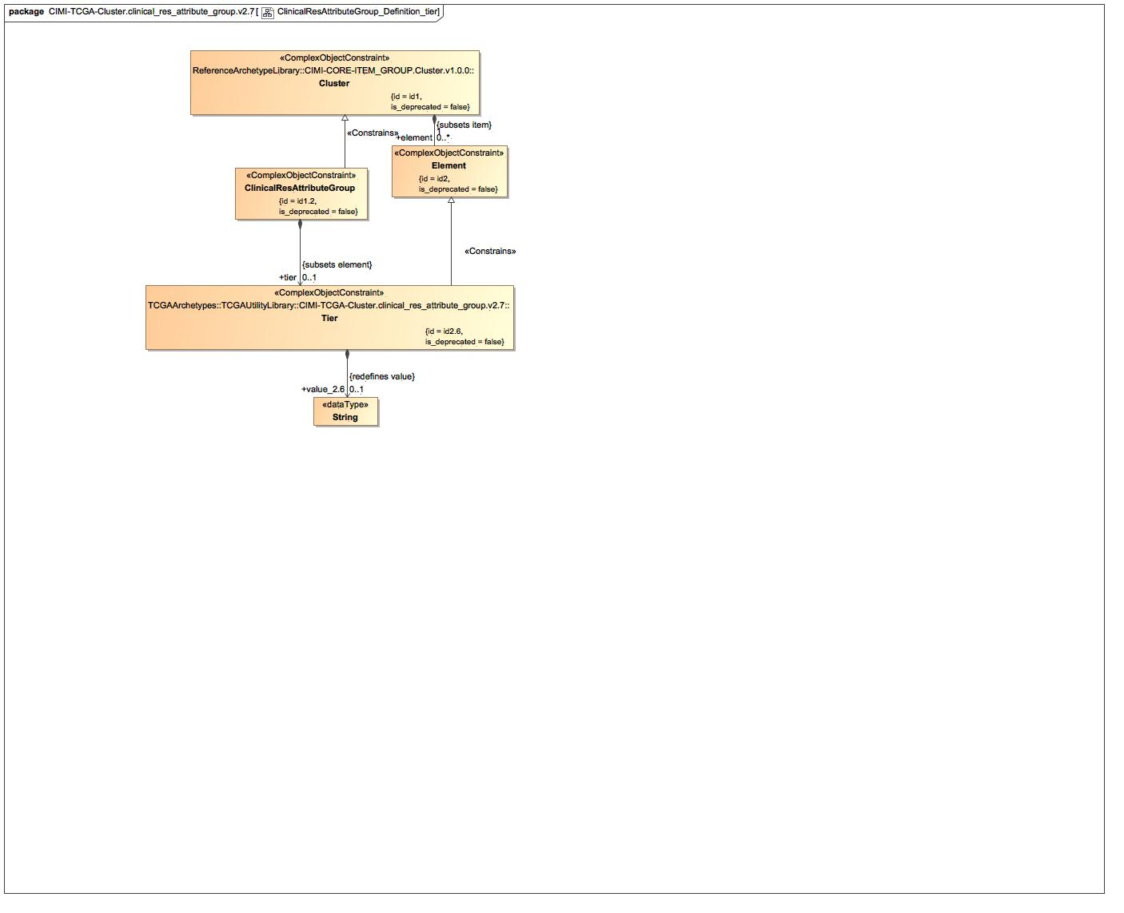

1. ClinicalResAttributeGroup_Definition_tier

### Known other classes

Class ClinicalResAttributeGroup, Class Cluster, Class Element, Class Tier

## ClinicalResAttributeGroup_Terms

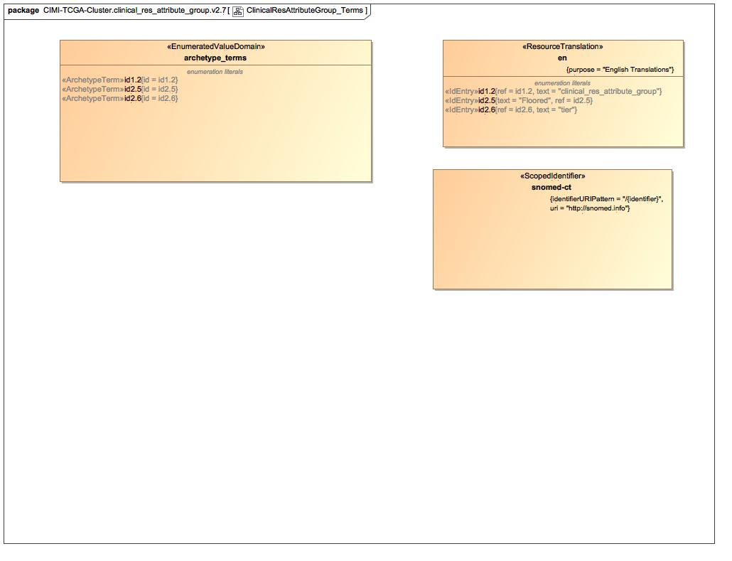

1. ClinicalResAttributeGroup_Terms

### Enumeration archetype_terms

package TCGAArchetypes::TCGAUtilityLibrary::CIMI-TCGA-Cluster.clinical_res_attribute_group.v2.7::Terminology::terms

public enum archetype_terms

{id1.2, id2.5, id2.6}

#### Literals

-1252509891.jpg id1.2

-1252509891.jpg id2.5

-1252509891.jpg id2.6

### Enumeration snomed-ct

package TCGAArchetypes::TCGAUtilityLibrary::CIMI-TCGA-Cluster.clinical_res_attribute_group.v2.7::Terminology::term-bindings

public enum snomed-ct

### Known other enumerations

Enumeration en

# TCGAArchetypes::TCGAUtilityLibrary::CIMI-TCGA-Cluster.clinical_res_attribute_group.v2.7::Terminology::term-bindings

## Known other enumerations

Enumeration snomed-ct

# TCGAArchetypes::TCGAUtilityLibrary::CIMI-TCGA-Cluster.clinical_res_attribute_group.v2.7::Terminology::term-definitions

## Known other enumerations

Enumeration en

# TCGAArchetypes::TCGAUtilityLibrary::CIMI-TCGA-Cluster.clinical_res_attribute_group.v2.7::Terminology::terms

## Known other enumerations

Enumeration archetype_terms

# TCGAArchetypes::TCGAUtilityLibrary::CIMI-TCGA-Cluster.clinical_res_attributes.v2.7

## ClinicalResAttributes_Archetype

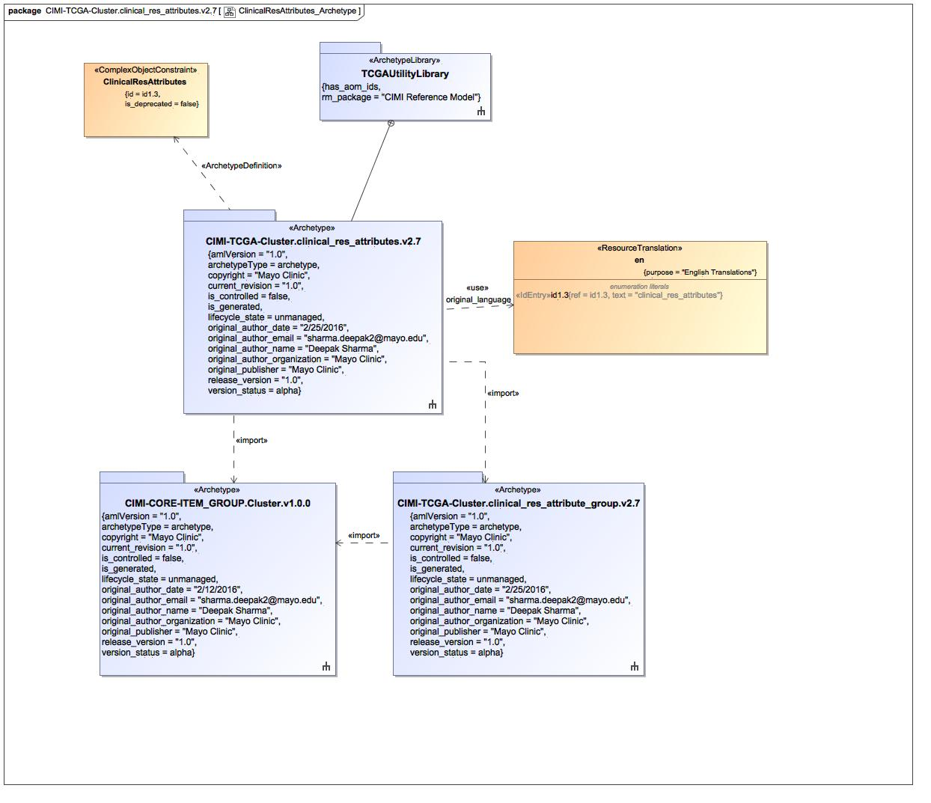

1. ClinicalResAttributes_Archetype

### Known other classes

Class ClinicalResAttributes

### Enumeration en

package TCGAArchetypes::TCGAUtilityLibrary::CIMI-TCGA-Cluster.clinical_res_attributes.v2.7::Terminology::term-definitions

public enum en

{id1.3}

#### Literals

-1252509891.jpg id1.3

## ClinicalResAttributes_Definition_clinical_res_attribute_group

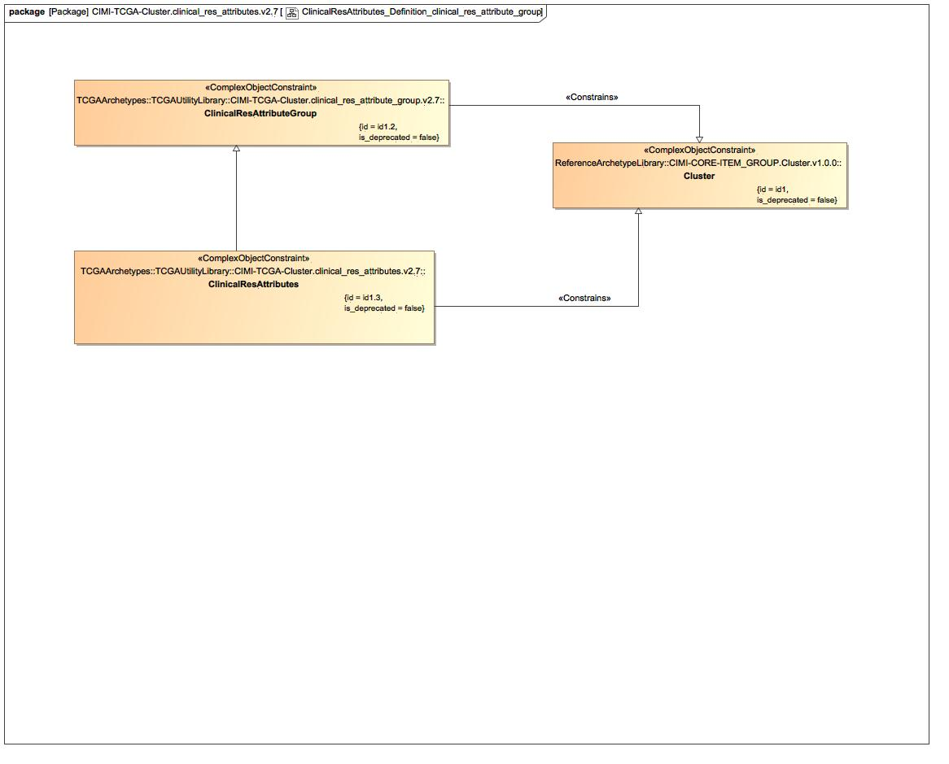

1. ClinicalResAttributes_Definition_clinical_res_attribute_group

### Known other classes

Class ClinicalResAttributeGroup, Class ClinicalResAttributes, Class Cluster

## ClinicalResAttributes_Definition_StringValue

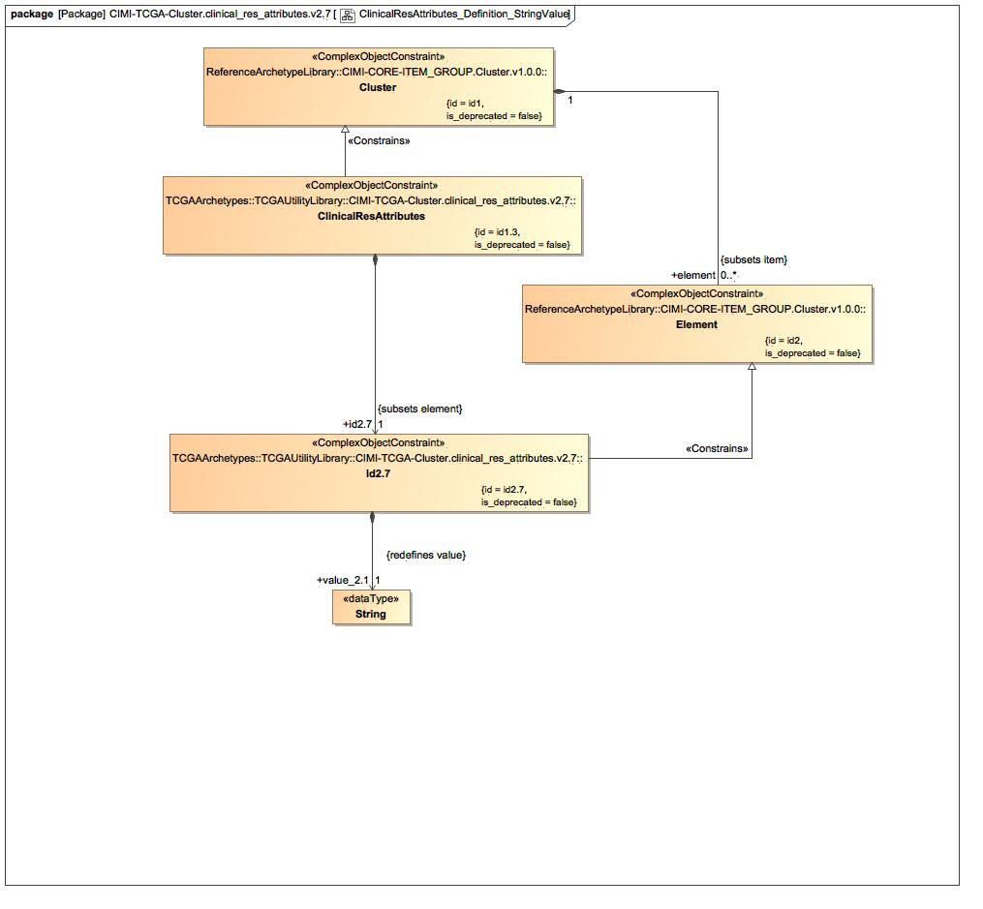

1. ClinicalResAttributes_Definition_StringValue

### Class Id2.7

#### Direct Known Superclasses

Element

package TCGAArchetypes::TCGAUtilityLibrary::CIMI-TCGA-Cluster.clinical_res_attributes.v2.7

public class Id2.7

extends

Element

#### Associations

-2616899.jpg public value_2.1 : String [1]

### Known other classes

Class ClinicalResAttributes, Class Cluster, Class Element

## ClinicalResAttributes_Terms

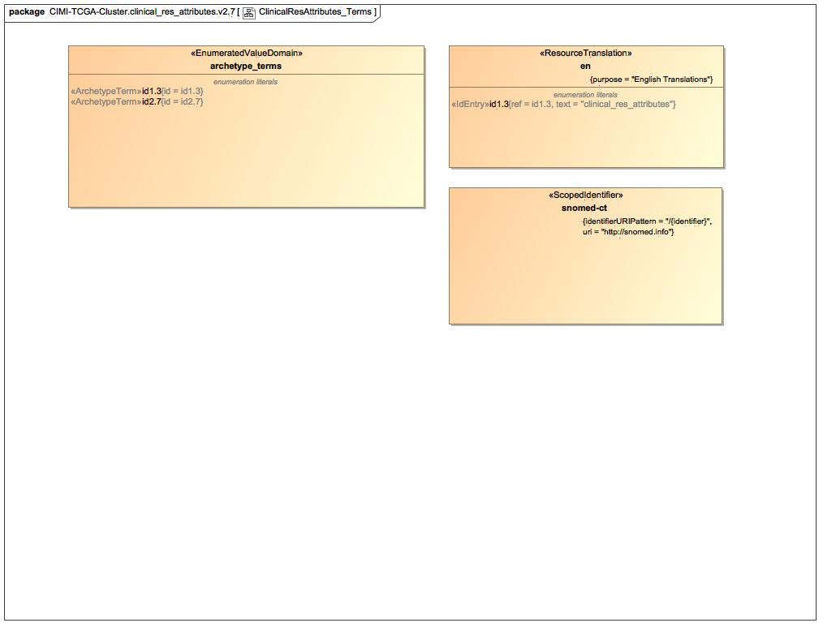

1. ClinicalResAttributes_Terms

### Enumeration archetype_terms

package TCGAArchetypes::TCGAUtilityLibrary::CIMI-TCGA-Cluster.clinical_res_attributes.v2.7::Terminology::terms

public enum archetype_terms

{id1.3, id2.7}

#### Literals

-1252509891.jpg id1.3

-1252509891.jpg id2.7

### Enumeration snomed-ct

package TCGAArchetypes::TCGAUtilityLibrary::CIMI-TCGA-Cluster.clinical_res_attributes.v2.7::Terminology::term-bindings

public enum snomed-ct

### Known other enumerations

Enumeration en

# TCGAArchetypes::TCGAUtilityLibrary::CIMI-TCGA-Cluster.clinical_res_attributes.v2.7::Terminology::term-bindings

## Known other enumerations

Enumeration snomed-ct

# TCGAArchetypes::TCGAUtilityLibrary::CIMI-TCGA-Cluster.clinical_res_attributes.v2.7::Terminology::term-definitions

## Known other enumerations

Enumeration en

# TCGAArchetypes::TCGAUtilityLibrary::CIMI-TCGA-Cluster.clinical_res_attributes.v2.7::Terminology::terms

## Known other enumerations

Enumeration archetype_terms

# TCGAArchetypes::TCGAUtilityLibrary::CIMI-TCGA-Cluster.clinical_res_dcc_attribute_group.v2.8

## ClinicalResDccAttributeGroup_Archetype

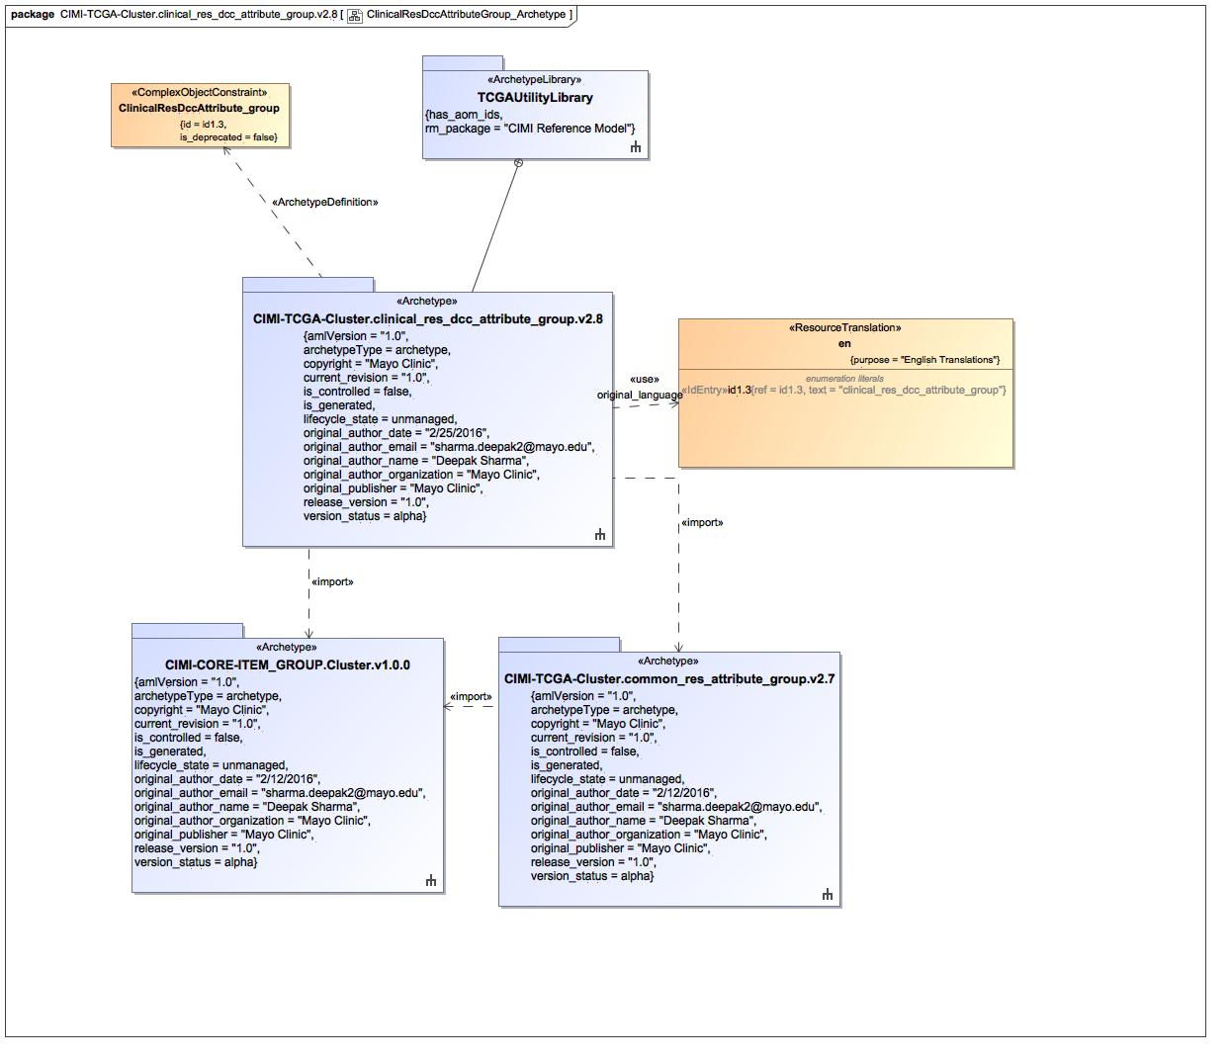

1. ClinicalResDccAttributeGroup_Archetype

### Class ClinicalResDccAttribute_group

#### Direct Known Superclasses

ClinicalResAttributeGroup, Cluster

package TCGAArchetypes::TCGAUtilityLibrary::CIMI-TCGA-Cluster.clinical_res_dcc_attribute_group.v2.8

public class ClinicalResDccAttribute_group

extends

Cluster,

ClinicalResAttributeGroup

### Enumeration en

package TCGAArchetypes::TCGAUtilityLibrary::CIMI-TCGA-Cluster.clinical_res_dcc_attribute_group.v2.8::Terminology::term-definitions

public enum en

{id1.3}

#### Literals

-1252509891.jpg id1.3

## ClinicalResDccAttributeGroup_clinical_res_attribute_group

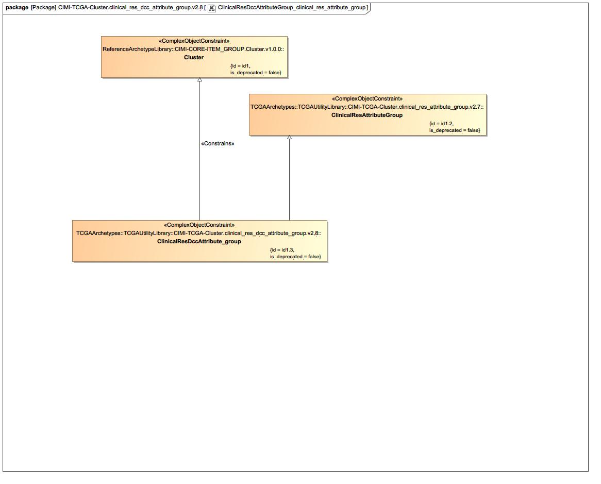

1. ClinicalResDccAttributeGroup_clinical_res_attribute_group

### Known other classes

Class ClinicalResAttributeGroup, Class ClinicalResDccAttribute_group, Class Cluster

## ClinicalResDccAttributeGroup_Terms

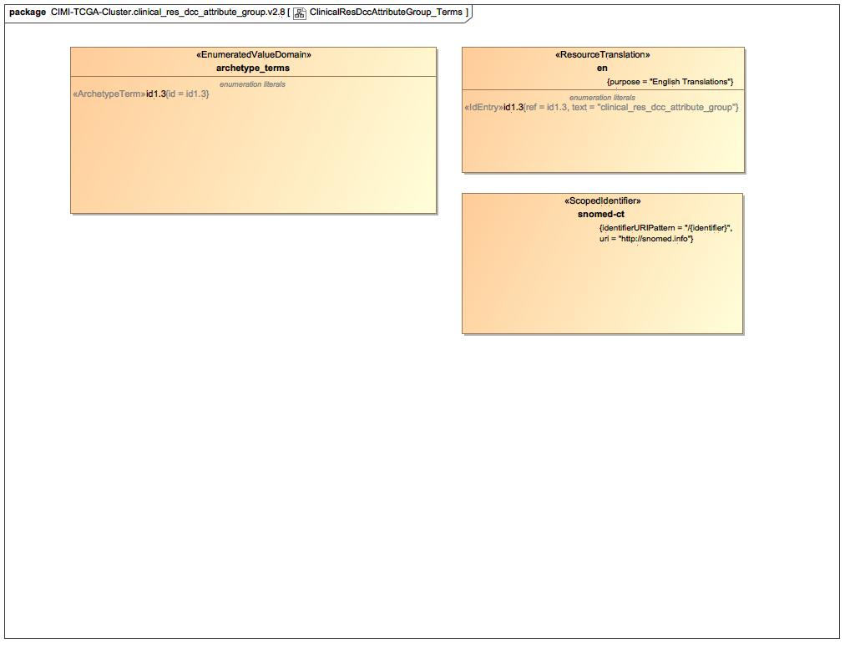

1. ClinicalResDccAttributeGroup_Terms

### Enumeration archetype_terms

package TCGAArchetypes::TCGAUtilityLibrary::CIMI-TCGA-Cluster.clinical_res_dcc_attribute_group.v2.8::Terminology::terms

public enum archetype_terms

{id1.3}

#### Literals

-1252509891.jpg id1.3

### Enumeration snomed-ct

package TCGAArchetypes::TCGAUtilityLibrary::CIMI-TCGA-Cluster.clinical_res_dcc_attribute_group.v2.8::Terminology::term-bindings

public enum snomed-ct

### Known other enumerations

Enumeration en

# TCGAArchetypes::TCGAUtilityLibrary::CIMI-TCGA-Cluster.clinical_res_dcc_attribute_group.v2.8::Terminology::term-bindings

## Known other enumerations

Enumeration snomed-ct

# TCGAArchetypes::TCGAUtilityLibrary::CIMI-TCGA-Cluster.clinical_res_dcc_attribute_group.v2.8::Terminology::term-definitions

## Known other enumerations

Enumeration en

# TCGAArchetypes::TCGAUtilityLibrary::CIMI-TCGA-Cluster.clinical_res_dcc_attribute_group.v2.8::Terminology::terms

## Known other enumerations

Enumeration archetype_terms

# TCGAArchetypes::TCGAUtilityLibrary::CIMI-TCGA-Cluster.common_ext_attribute_group.v2.7

## CommonExtAttributeGroup_Archetype

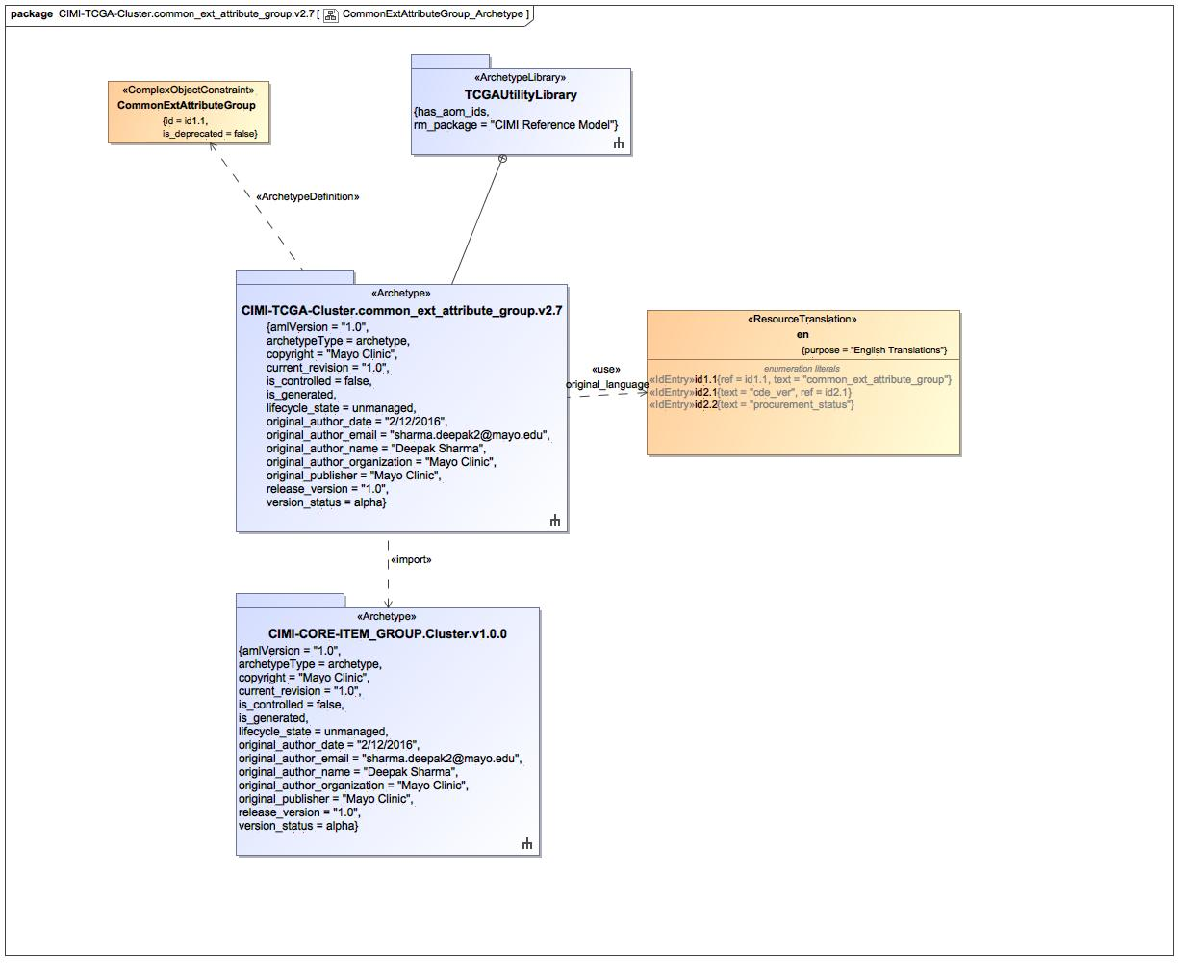

1. CommonExtAttributeGroup_Archetype

### Known other classes

Class CommonExtAttributeGroup

### Enumeration en

package TCGAArchetypes::TCGAUtilityLibrary::CIMI-TCGA-Cluster.common_ext_attribute_group.v2.7::Terminology::term-definitions

public enum en

{id1.1, id2.1, id2.2}

#### Literals

-1252509891.jpg id1.1

-1252509891.jpg id2.1

-1252509891.jpg id2.2

## CommonExtAttributeGroup_Definition_cde_ver

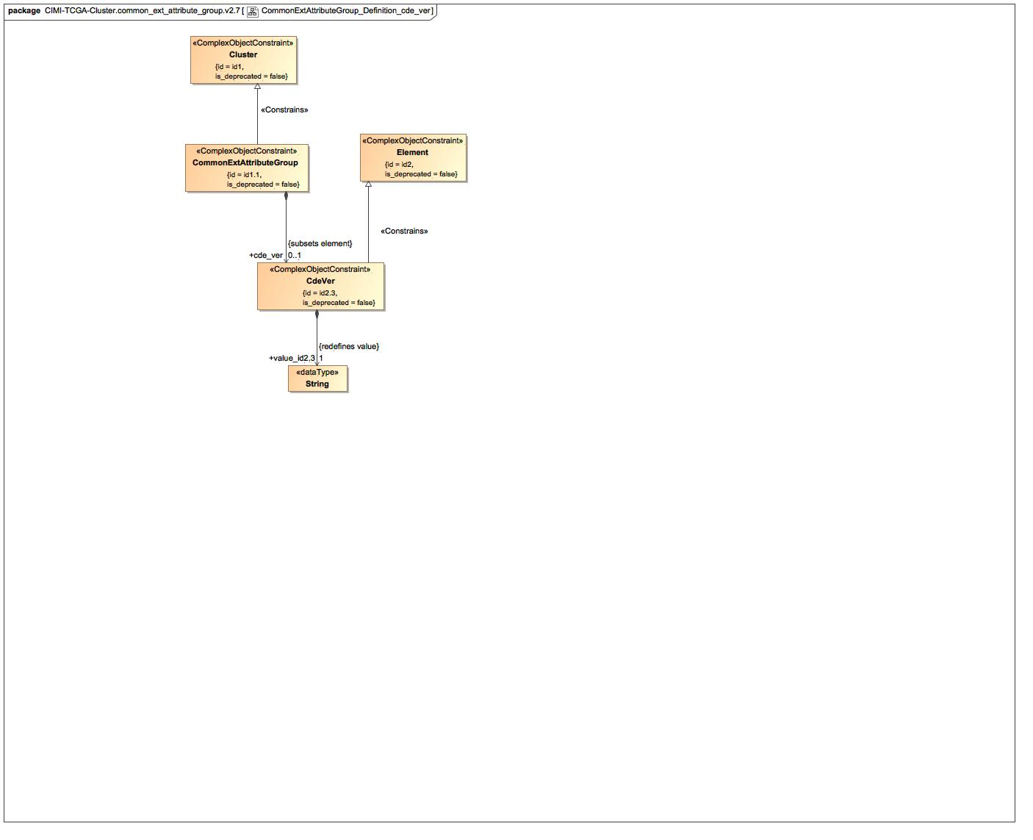

1. CommonExtAttributeGroup_Definition_cde_ver

### Class CdeVer

#### Direct Known Superclasses

Element

package TCGAArchetypes::TCGAUtilityLibrary::CIMI-TCGA-Cluster.common_ext_attribute_group.v2.7

public class CdeVer

extends

Element

#### Associations

-2616899.jpg public value_id2.3 : String [1] = ""

### Known other classes

Class Cluster, Class CommonExtAttributeGroup, Class Element

## CommonExtAttributeGroup_Definition_procurement_status

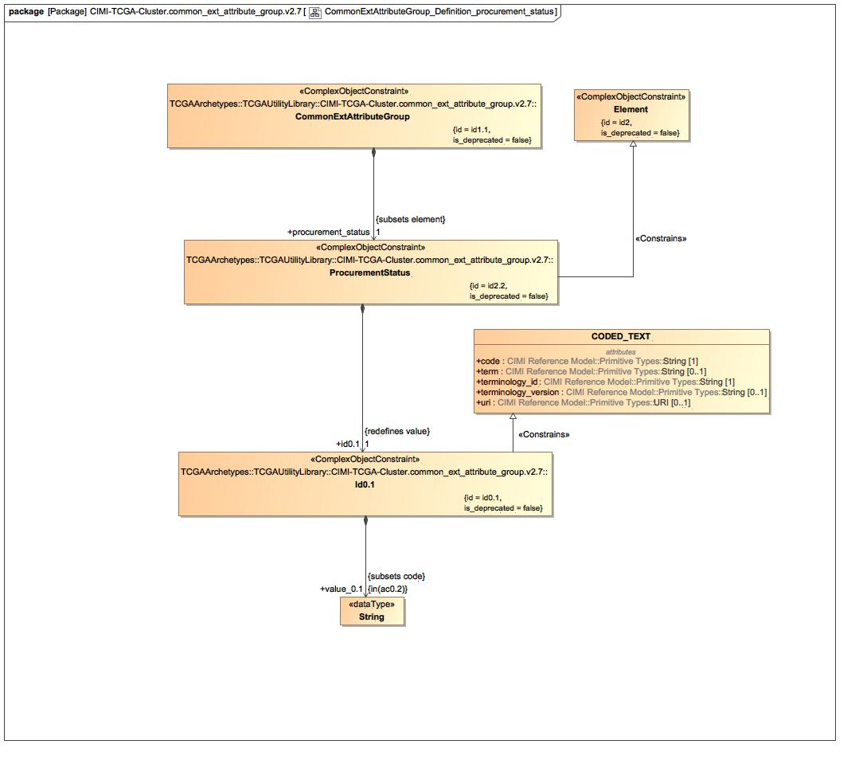

1. CommonExtAttributeGroup_Definition_procurement_status

### Class CODED_TEXT

#### Direct Known Superclasses

TEXT

package CIMI Reference Model::Data Value Types

public class CODED_TEXT

extends

TEXT

### Class Id0.1

#### Direct Known Superclasses

CODED_TEXT

package TCGAArchetypes::TCGAUtilityLibrary::CIMI-TCGA-Cluster.common_ext_attribute_group.v2.7

public class Id0.1

extends

CODED_TEXT

#### Associations

-2616899.jpg public value_0.1 : String

### Class ProcurementStatus

#### Direct Known Superclasses

Element

package TCGAArchetypes::TCGAUtilityLibrary::CIMI-TCGA-Cluster.common_ext_attribute_group.v2.7

public class ProcurementStatus

extends

Element

#### Associations

-2616899.jpg public id0.1 : Id0.1 [1]

### Known other classes

Class CommonExtAttributeGroup, Class Element

## CommonExtAttributeGroup_Terms

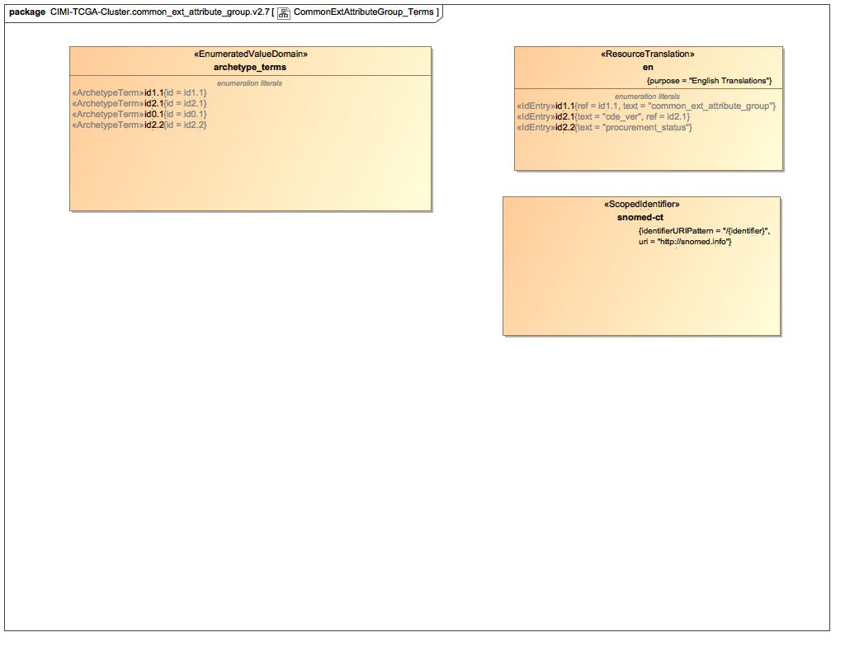

1. CommonExtAttributeGroup_Terms

### Enumeration archetype_terms

package TCGAArchetypes::TCGAUtilityLibrary::CIMI-TCGA-Cluster.common_ext_attribute_group.v2.7::Terminology::terms

public enum archetype_terms

{id1.1, id2.1, id0.1, id2.2}

#### Literals

-1252509891.jpg id1.1

-1252509891.jpg id2.1

-1252509891.jpg id0.1

-1252509891.jpg id2.2

### Enumeration snomed-ct

package TCGAArchetypes::TCGAUtilityLibrary::CIMI-TCGA-Cluster.common_ext_attribute_group.v2.7::Terminology::term-bindings

public enum snomed-ct

### Known other enumerations

Enumeration en

# TCGAArchetypes::TCGAUtilityLibrary::CIMI-TCGA-Cluster.common_ext_attribute_group.v2.7::Terminology::term-bindings

## Known other enumerations

Enumeration snomed-ct

# TCGAArchetypes::TCGAUtilityLibrary::CIMI-TCGA-Cluster.common_ext_attribute_group.v2.7::Terminology::term-definitions

## Known other enumerations

Enumeration en

# TCGAArchetypes::TCGAUtilityLibrary::CIMI-TCGA-Cluster.common_ext_attribute_group.v2.7::Terminology::terms

## Known other enumerations

Enumeration archetype_terms

# TCGAArchetypes::TCGAUtilityLibrary::CIMI-TCGA-Cluster.common_res_attribute_group.v2.7

## CommonResAttributeGroup_Archetype

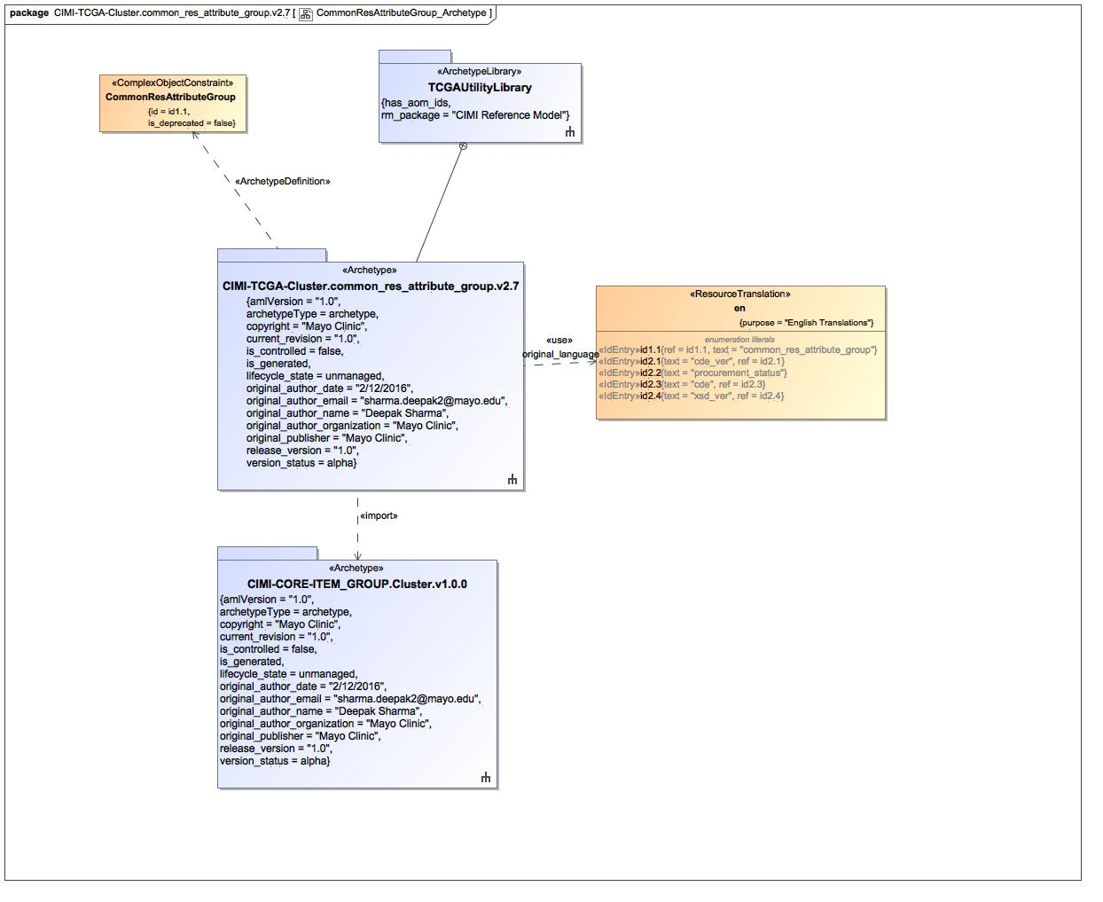

1. CommonResAttributeGroup_Archetype

### Known other classes

Class CommonResAttributeGroup

### Enumeration en

package TCGAArchetypes::TCGAUtilityLibrary::CIMI-TCGA-Cluster.common_res_attribute_group.v2.7::Terminology::term-definitions

public enum en

{id1.1, id2.1, id2.2, id2.3, id2.4}

#### Literals

-1252509891.jpg id1.1

-1252509891.jpg id2.1

-1252509891.jpg id2.2

-1252509891.jpg id2.3

-1252509891.jpg id2.4

## CommonResAttributeGroup_Definition_cde

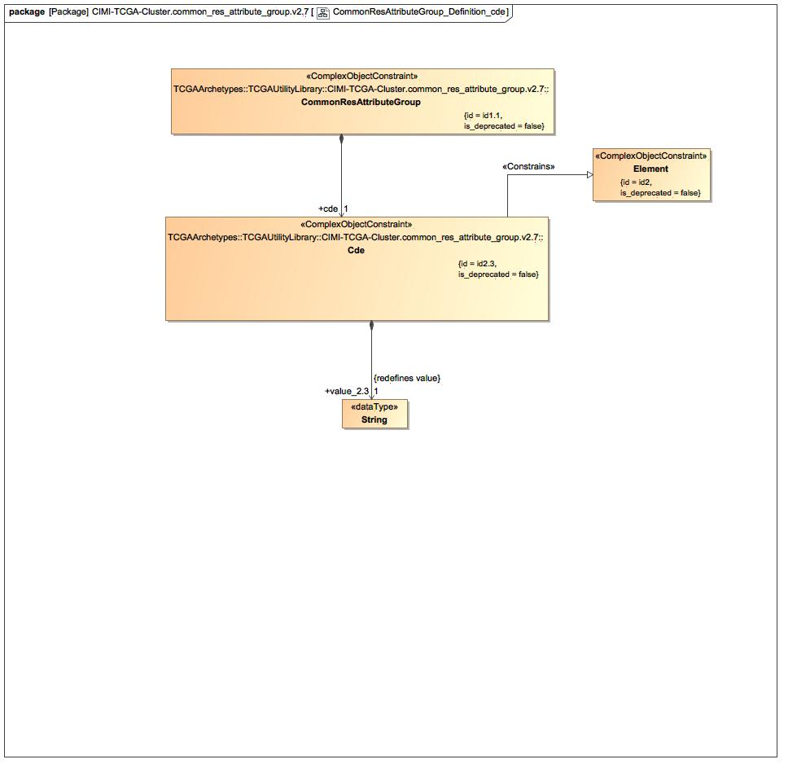

1. CommonResAttributeGroup_Definition_cde

### Known other classes

Class Cde, Class CommonResAttributeGroup, Class Element

## CommonResAttributeGroup_Definition_cde_ver

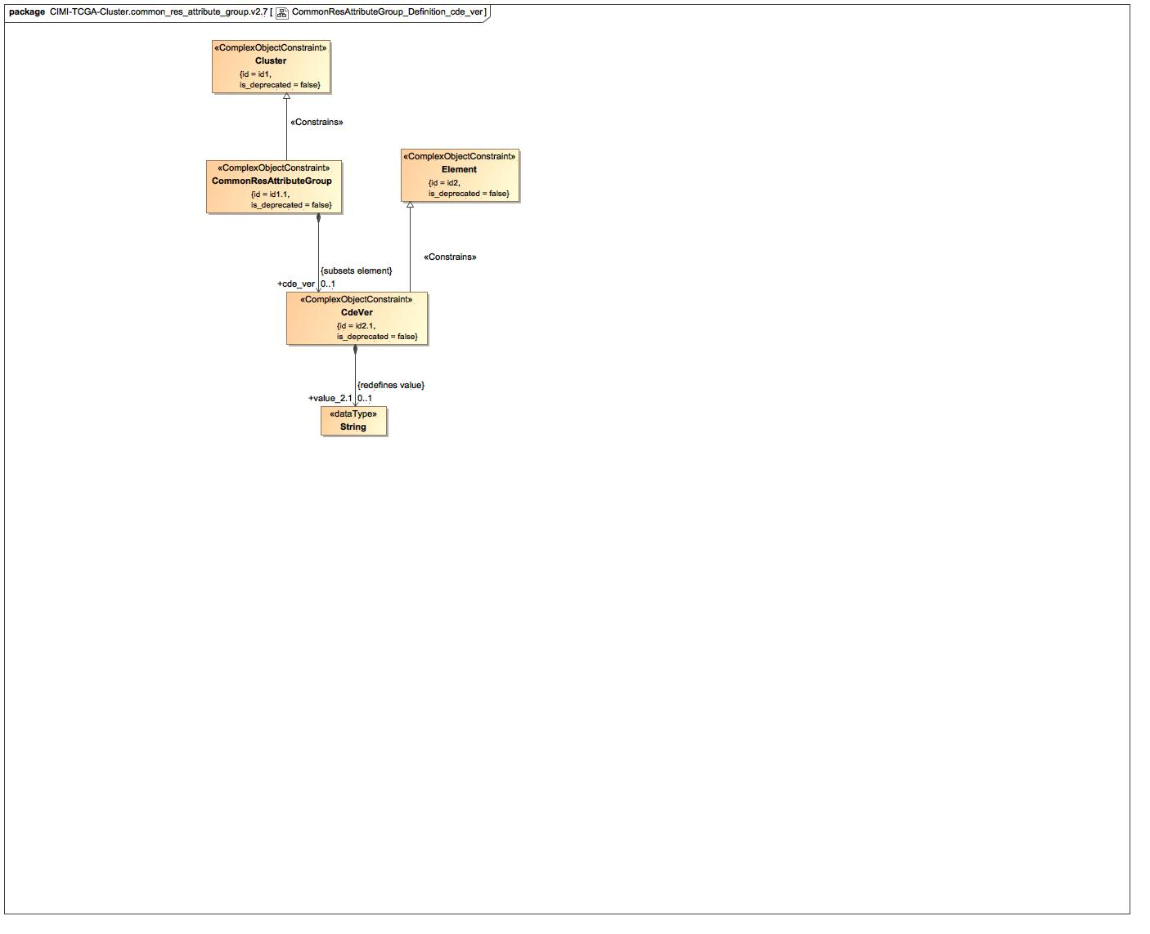

1. CommonResAttributeGroup_Definition_cde_ver

### Class CdeVer

#### Direct Known Superclasses

Element

package TCGAArchetypes::TCGAUtilityLibrary::CIMI-TCGA-Cluster.common_res_attribute_group.v2.7

public class CdeVer

extends

Element

#### Associations

-2616899.jpg public id0.1 : Id0.1 [1]

-2616899.jpg public value_2.1 : String [0..1] = ""

### Known other classes

Class Cluster, Class CommonResAttributeGroup, Class Element

## CommonResAttributeGroup_Definition_procurement_status

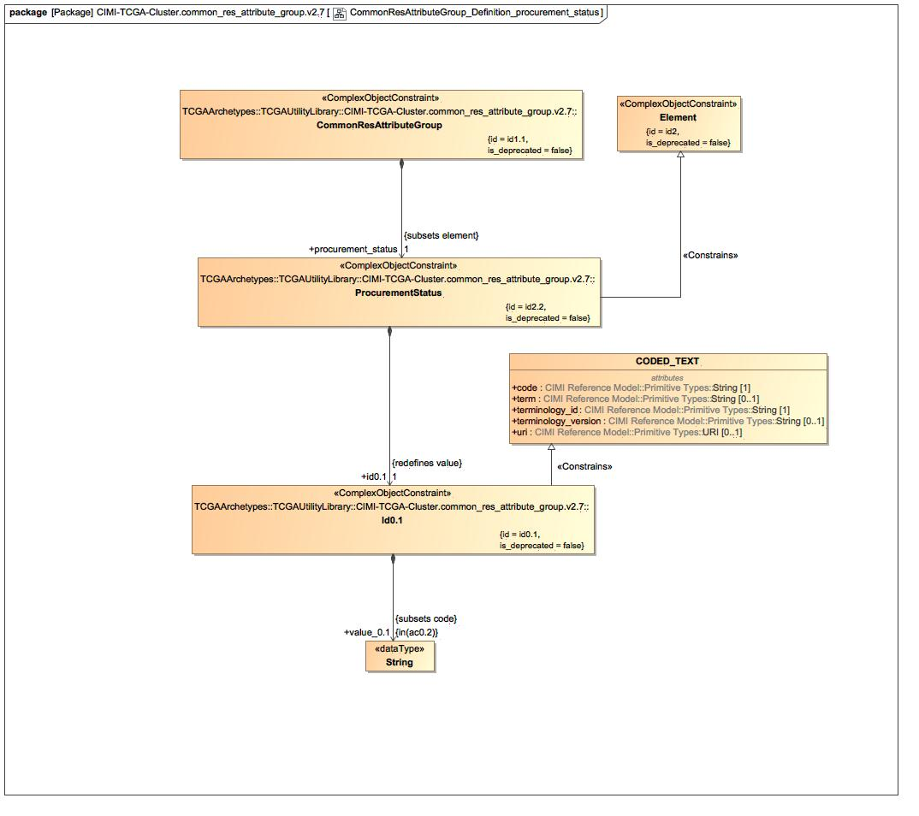

1. CommonResAttributeGroup_Definition_procurement_status

### Class Id0.1

#### Direct Known Superclasses

CODED_TEXT

package TCGAArchetypes::TCGAUtilityLibrary::CIMI-TCGA-Cluster.common_res_attribute_group.v2.7

public class Id0.1

extends

CODED_TEXT

#### Associations

-2616899.jpg public value_0.1 : String

### Class ProcurementStatus

#### Direct Known Superclasses

Element

package TCGAArchetypes::TCGAUtilityLibrary::CIMI-TCGA-Cluster.common_res_attribute_group.v2.7

public class ProcurementStatus

extends

Element

#### Associations

-2616899.jpg public id0.1 : Id0.1 [1]

### Known other classes

Class CODED_TEXT, Class CommonResAttributeGroup, Class Element

## CommonResAttributeGroup_Definition_xsd_ver

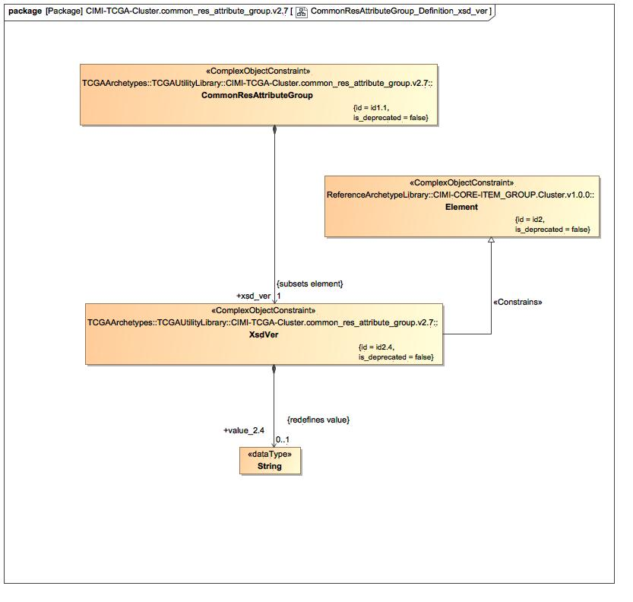

1. CommonResAttributeGroup_Definition_xsd_ver

### Known other classes

Class CommonResAttributeGroup, Class Element, Class XsdVer

## CommonResAttributeGroup_Terms

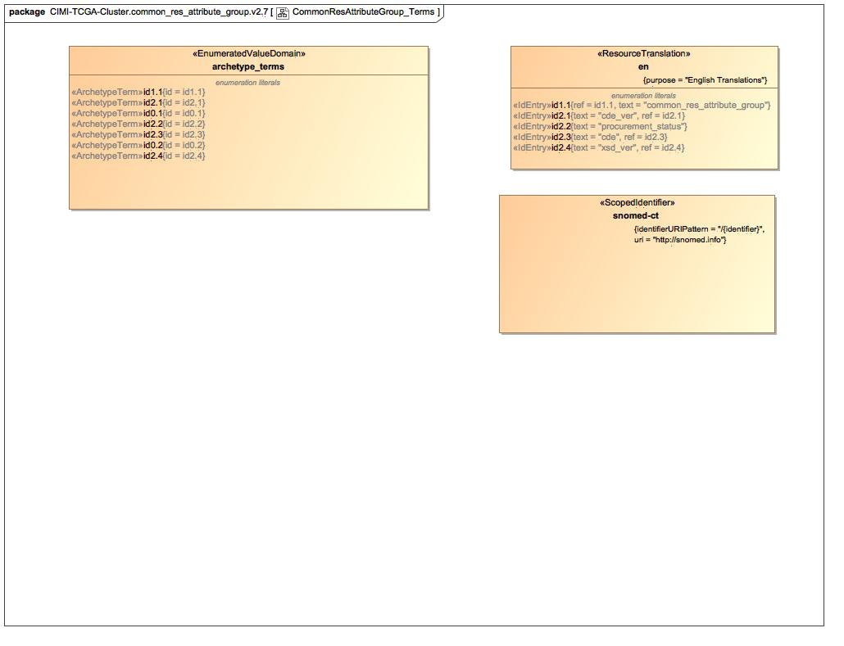

1. CommonResAttributeGroup_Terms

### Enumeration archetype_terms

package TCGAArchetypes::TCGAUtilityLibrary::CIMI-TCGA-Cluster.common_res_attribute_group.v2.7::Terminology::terms

public enum archetype_terms

{id1.1, id2.1, id0.1, id2.2, id2.3, id0.2, id2.4}

#### Literals

-1252509891.jpg id1.1

-1252509891.jpg id2.1

-1252509891.jpg id0.1

-1252509891.jpg id2.2

-1252509891.jpg id2.3

-1252509891.jpg id0.2

-1252509891.jpg id2.4

### Enumeration snomed-ct

package TCGAArchetypes::TCGAUtilityLibrary::CIMI-TCGA-Cluster.common_res_attribute_group.v2.7::Terminology::term-bindings

public enum snomed-ct

### Known other enumerations

Enumeration en

# TCGAArchetypes::TCGAUtilityLibrary::CIMI-TCGA-Cluster.common_res_attribute_group.v2.7::Terminology::term-bindings

## Known other enumerations

Enumeration snomed-ct

# TCGAArchetypes::TCGAUtilityLibrary::CIMI-TCGA-Cluster.common_res_attribute_group.v2.7::Terminology::term-definitions

## Known other enumerations

Enumeration en

# TCGAArchetypes::TCGAUtilityLibrary::CIMI-TCGA-Cluster.common_res_attribute_group.v2.7::Terminology::terms

## Known other enumerations

Enumeration archetype_terms

# TCGAArchetypes::TCGAUtilityLibrary::CIMI-TCGA-Cluster.common_res_attributes.v2.7

## CommonResAttributes_Archetype

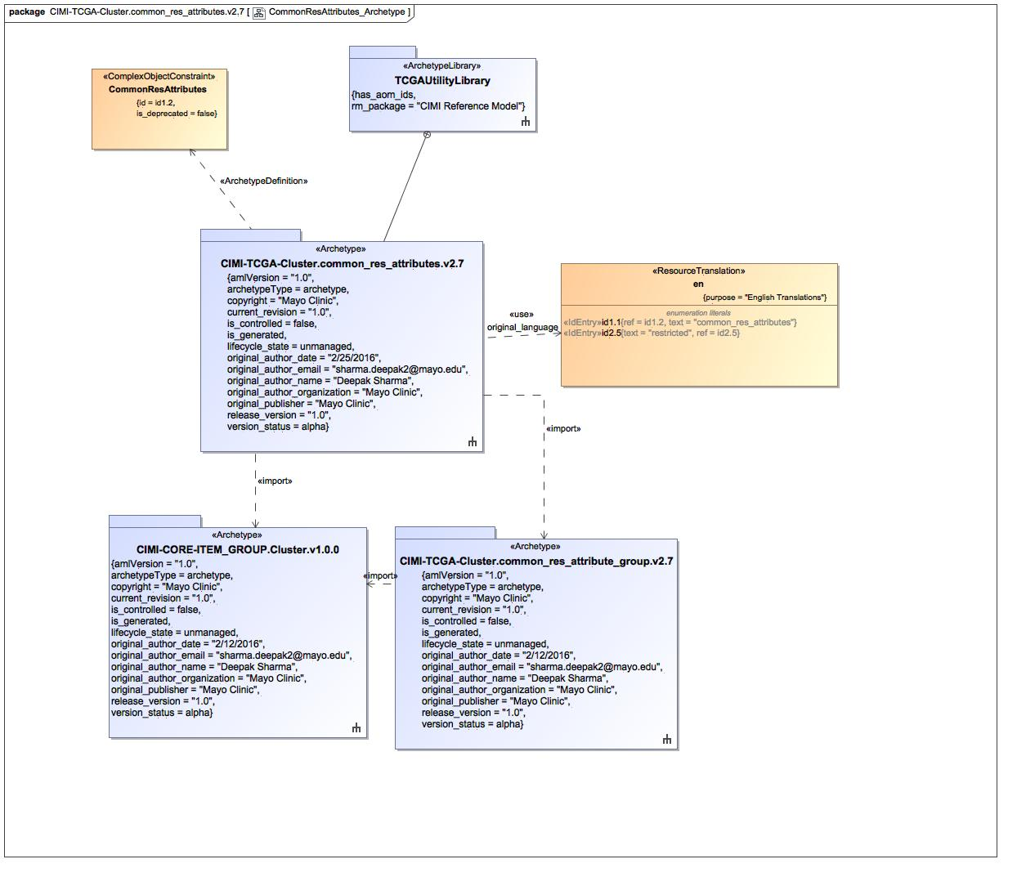

1. CommonResAttributes_Archetype

### Class CommonResAttributes

#### Direct Known Superclasses

Cluster, CommonResAttributeGroup

package TCGAArchetypes::TCGAUtilityLibrary::CIMI-TCGA-Cluster.common_res_attributes.v2.7

public class CommonResAttributes

extends

Cluster,

CommonResAttributeGroup

#### Associations

-2616899.jpg public restricted : Restricted [1]

-2616899.jpg public id2.6 : Id2.6 [1]

### Enumeration en

package TCGAArchetypes::TCGAUtilityLibrary::CIMI-TCGA-Cluster.common_res_attributes.v2.7::Terminology::term-definitions

public enum en

{id1.1, id2.5}

#### Literals

-1252509891.jpg id1.1

-1252509891.jpg id2.5

## CommonResAttributes_Definition_common_res_attribute_group

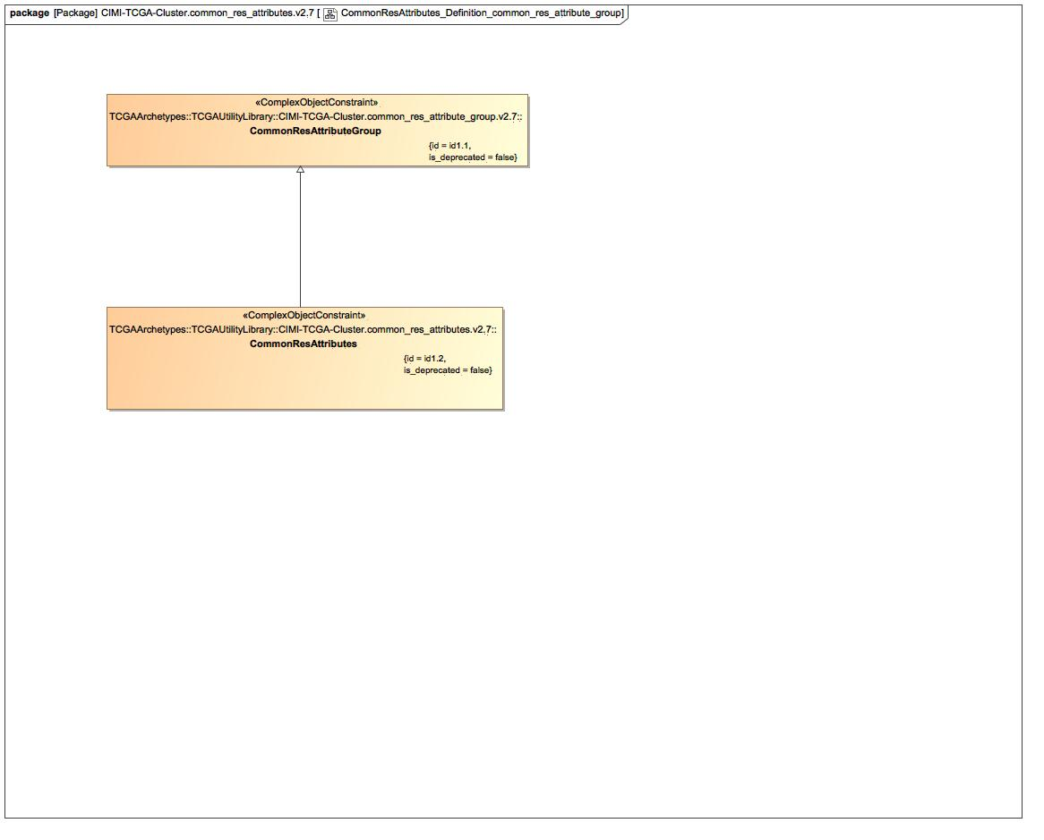

1. CommonResAttributes_Definition_common_res_attribute_group

### Known other classes

Class CommonResAttributeGroup, Class CommonResAttributes

## CommonResAttributes_Definition_restriction

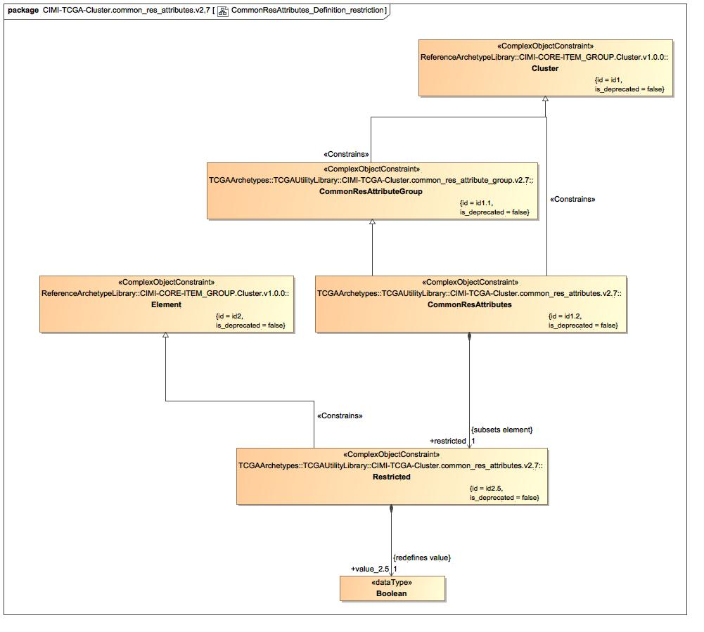

1. CommonResAttributes_Definition_restriction

### Class Restricted

#### Direct Known Superclasses

Element

package TCGAArchetypes::TCGAUtilityLibrary::CIMI-TCGA-Cluster.common_res_attributes.v2.7

public class Restricted

extends

Element

#### Associations

-2616899.jpg public value_2.5 : Boolean [1] = false

### Known other classes

Class Cluster, Class CommonResAttributeGroup, Class CommonResAttributes, Class Element

## CommonResAttributes_Definition_StringValue

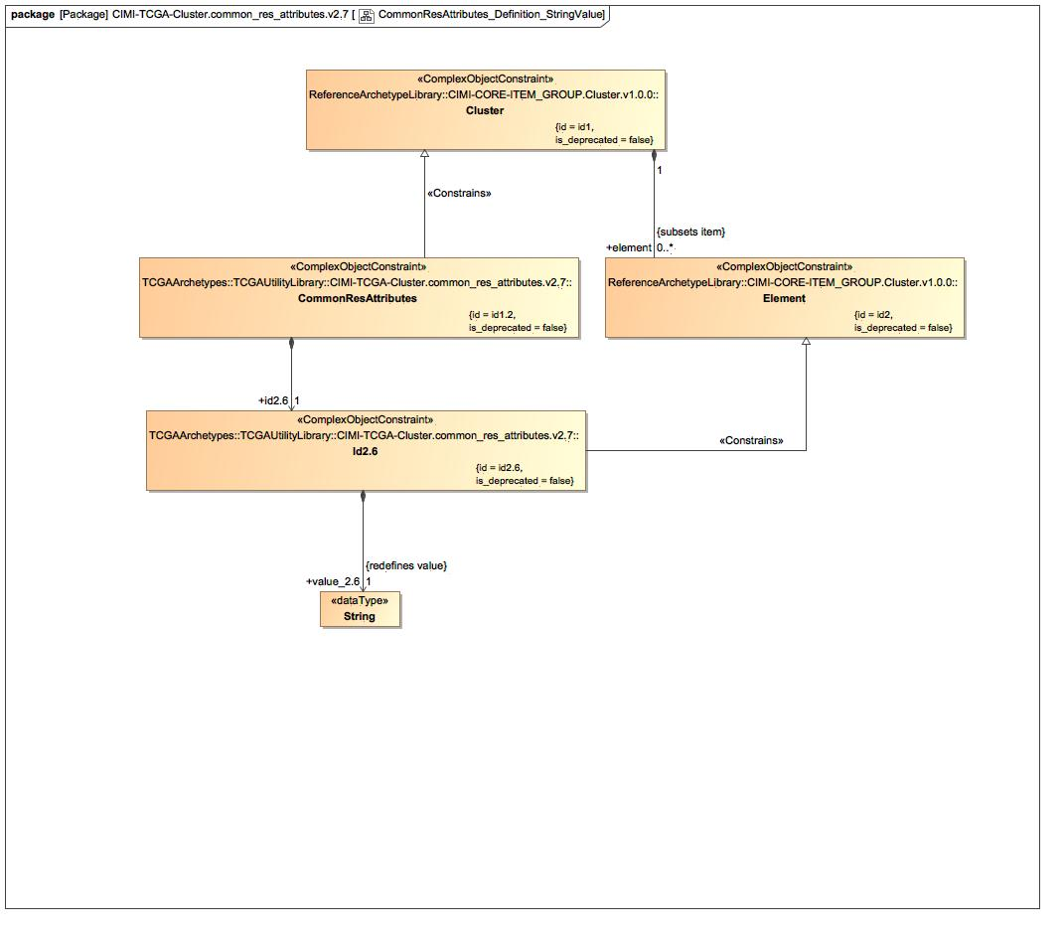

1. CommonResAttributes_Definition_StringValue

### Class Id2.6

#### Direct Known Superclasses

Element

package TCGAArchetypes::TCGAUtilityLibrary::CIMI-TCGA-Cluster.common_res_attributes.v2.7

public class Id2.6

extends

Element

#### Associations

-2616899.jpg public value_2.6 : String [1]

### Known other classes

Class Cluster, Class CommonResAttributes, Class Element

## CommonResAttributes_Terms

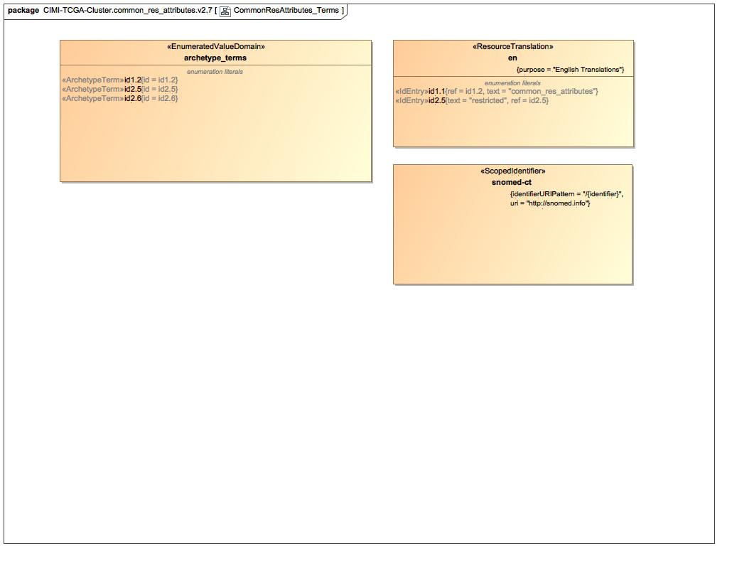

1. CommonResAttributes_Terms

### Enumeration archetype_terms

package TCGAArchetypes::TCGAUtilityLibrary::CIMI-TCGA-Cluster.common_res_attributes.v2.7::Terminology::terms

public enum archetype_terms

{id1.2, id2.5, id2.6}

#### Literals

-1252509891.jpg id1.2

-1252509891.jpg id2.5

-1252509891.jpg id2.6

### Enumeration snomed-ct

package TCGAArchetypes::TCGAUtilityLibrary::CIMI-TCGA-Cluster.common_res_attributes.v2.7::Terminology::term-bindings

public enum snomed-ct

### Known other enumerations

Enumeration en

# TCGAArchetypes::TCGAUtilityLibrary::CIMI-TCGA-Cluster.common_res_attributes.v2.7::Terminology::term-bindings

## Known other enumerations

Enumeration snomed-ct

# TCGAArchetypes::TCGAUtilityLibrary::CIMI-TCGA-Cluster.common_res_attributes.v2.7::Terminology::term-definitions

## Known other enumerations

Enumeration en

# TCGAArchetypes::TCGAUtilityLibrary::CIMI-TCGA-Cluster.common_res_attributes.v2.7::Terminology::terms

## Known other enumerations

Enumeration archetype_terms

# TCGAArchetypes::TCGAUtilityLibrary::CIMI-TCGA-Cluster.generic_day.v2.7

## GenericDay_Archetype

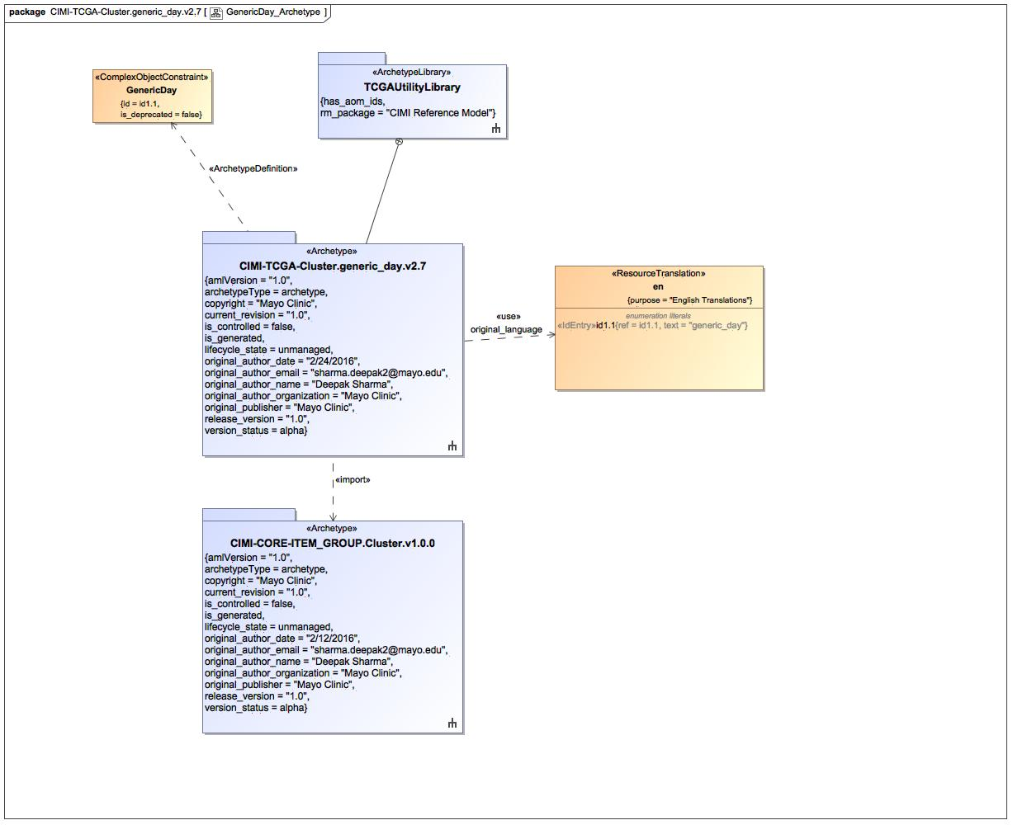

1. GenericDay_Archetype

### Known other classes

Class GenericDay

### Enumeration en

package TCGAArchetypes::TCGAUtilityLibrary::CIMI-TCGA-Cluster.generic_day.v2.7::Terminology::term-definitions

public enum en

{id1.1}

#### Literals

-1252509891.jpg id1.1

## GenericDay_Definition

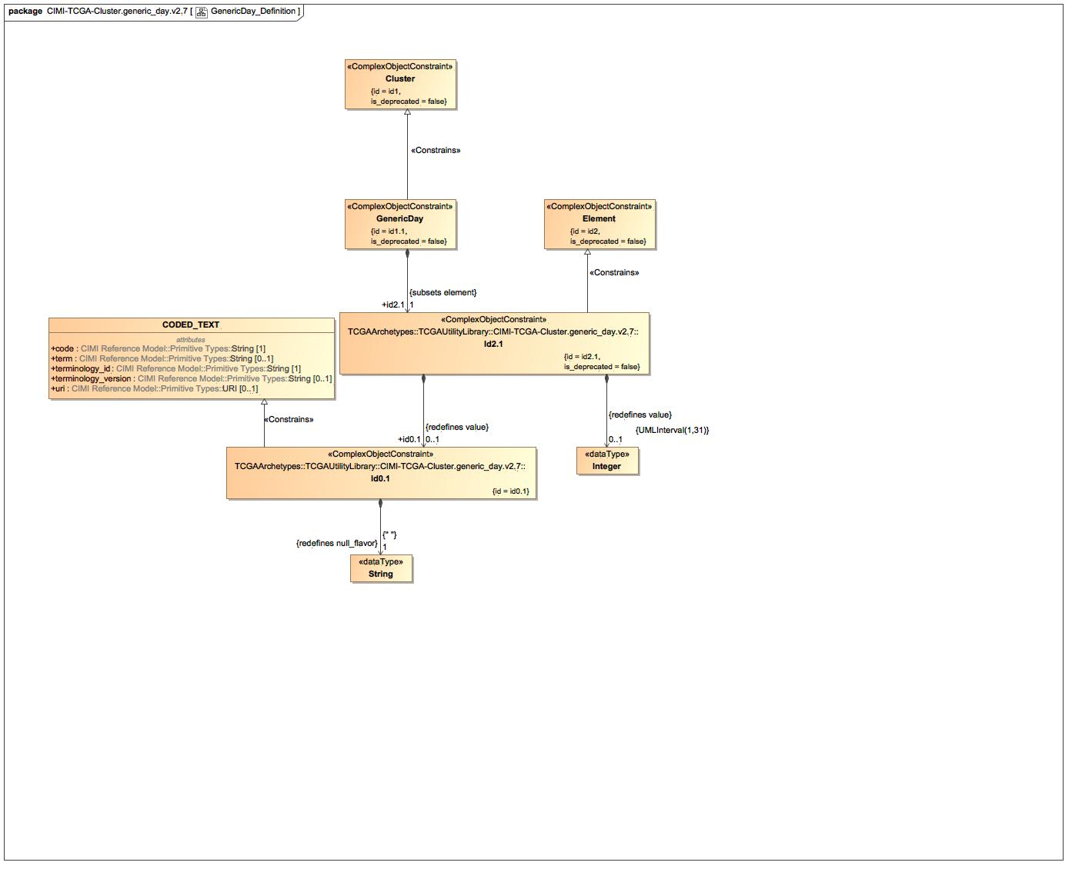

1. GenericDay_Definition

### Class Id0.1

#### Direct Known Superclasses

CODED_TEXT

package TCGAArchetypes::TCGAUtilityLibrary::CIMI-TCGA-Cluster.generic_day.v2.7

public class Id0.1

extends

CODED_TEXT

#### Associations

-2616899.jpg public : String [1]

### Class Id2.1

#### Direct Known Superclasses

Element

package TCGAArchetypes::TCGAUtilityLibrary::CIMI-TCGA-Cluster.generic_day.v2.7

public class Id2.1

extends

Element

#### Associations

-2616899.jpg public value_id2.1 : Real [0..1]

-2616899.jpg public id0.1 : Id0.1 [0..1]

-2616899.jpg public : Integer [0..1]

### Known other classes

Class Cluster, Class CODED_TEXT, Class Element, Class GenericDay

## GenericDay_Terms

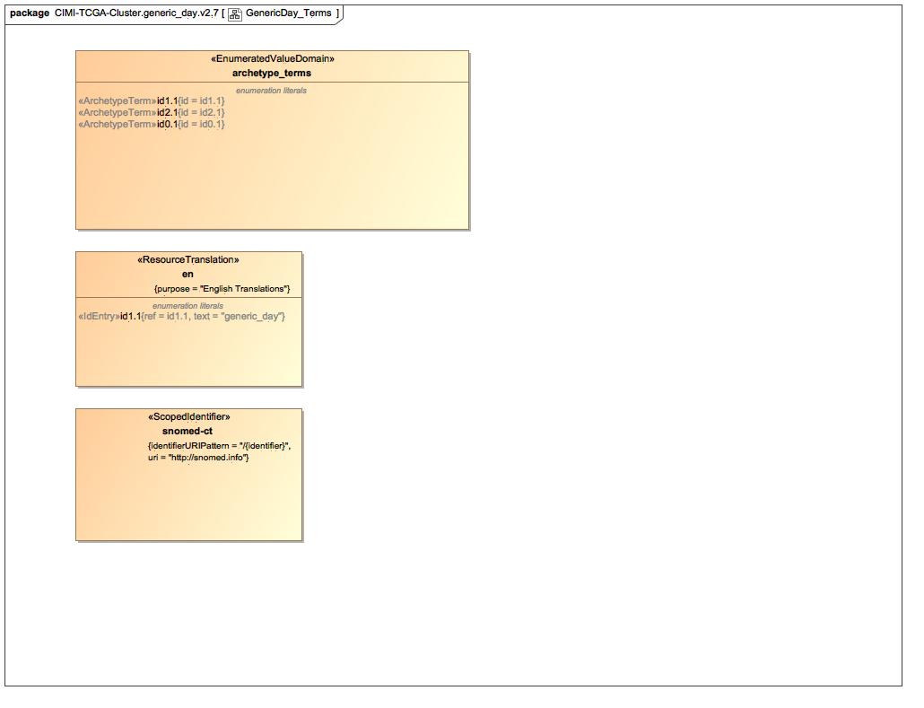

1. GenericDay_Terms

### Enumeration archetype_terms

package TCGAArchetypes::TCGAUtilityLibrary::CIMI-TCGA-Cluster.generic_day.v2.7::Terminology::terms

public enum archetype_terms

{id1.1, id2.1, id0.1}

#### Literals

-1252509891.jpg id1.1

-1252509891.jpg id2.1

-1252509891.jpg id0.1

### Enumeration snomed-ct

package TCGAArchetypes::TCGAUtilityLibrary::CIMI-TCGA-Cluster.generic_day.v2.7::Terminology::term-bindings

public enum snomed-ct

### Known other enumerations

Enumeration en

# TCGAArchetypes::TCGAUtilityLibrary::CIMI-TCGA-Cluster.generic_day.v2.7::Terminology::term-bindings

## Known other enumerations

Enumeration snomed-ct

# TCGAArchetypes::TCGAUtilityLibrary::CIMI-TCGA-Cluster.generic_day.v2.7::Terminology::term-definitions

## Known other enumerations

Enumeration en

# TCGAArchetypes::TCGAUtilityLibrary::CIMI-TCGA-Cluster.generic_day.v2.7::Terminology::terms

## Known other enumerations

Enumeration archetype_terms

# TCGAArchetypes::TCGAUtilityLibrary::CIMI-TCGA-Cluster.generic_hour.v2.7

## GenericHour_Archetype

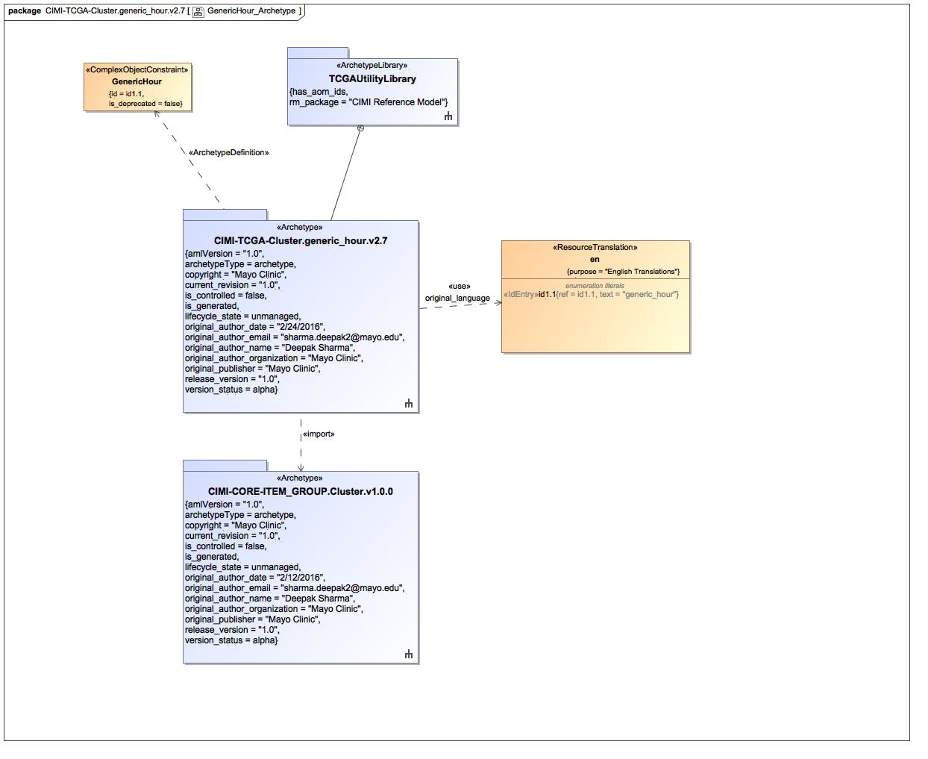

1. GenericHour_Archetype

### Class GenericHour

#### Direct Known Superclasses

Cluster

package TCGAArchetypes::TCGAUtilityLibrary::CIMI-TCGA-Cluster.generic_hour.v2.7

public class GenericHour

extends

Cluster

#### Associations

-2616899.jpg public : Id2.1 [1]

### Enumeration en

package TCGAArchetypes::TCGAUtilityLibrary::CIMI-TCGA-Cluster.generic_hour.v2.7::Terminology::term-definitions

public enum en

{id1.1}

#### Literals

-1252509891.jpg id1.1

## GenericHour_Definition

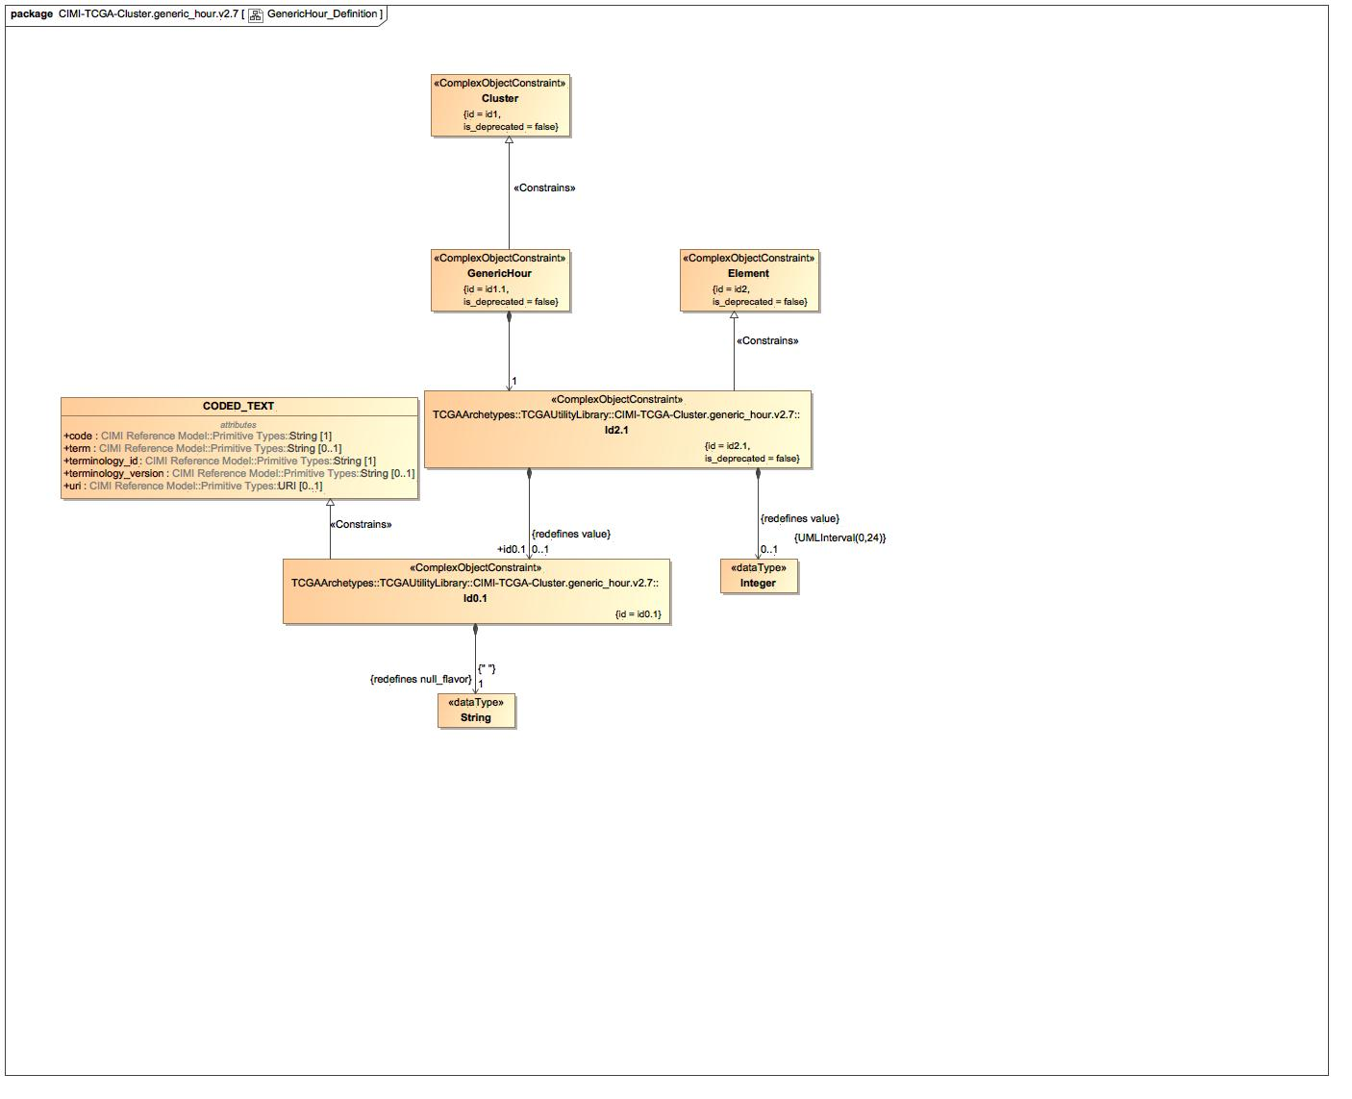

1. GenericHour_Definition

### Class Id0.1

#### Direct Known Superclasses

CODED_TEXT

package TCGAArchetypes::TCGAUtilityLibrary::CIMI-TCGA-Cluster.generic_hour.v2.7

public class Id0.1

extends

CODED_TEXT

#### Associations

-2616899.jpg public : String [1]

### Class Id2.1

#### Direct Known Superclasses

Element

package TCGAArchetypes::TCGAUtilityLibrary::CIMI-TCGA-Cluster.generic_hour.v2.7

public class Id2.1

extends

Element

#### Associations

-2616899.jpg public value_id2.1 : Real [0..1]

-2616899.jpg public id0.1 : Id0.1 [0..1]

-2616899.jpg public : Integer [0..1]

### Known other classes

Class Cluster, Class CODED_TEXT, Class Element, Class GenericHour

## GenericHour_Terms

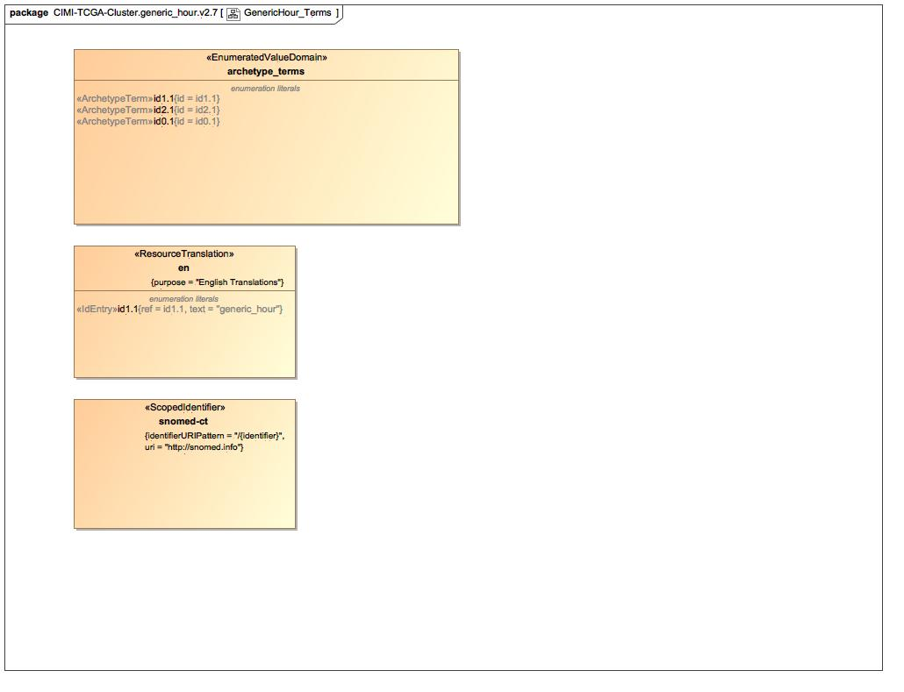

1. GenericHour_Terms

### Enumeration archetype_terms

package TCGAArchetypes::TCGAUtilityLibrary::CIMI-TCGA-Cluster.generic_hour.v2.7::Terminology::terms

public enum archetype_terms

{id1.1, id2.1, id0.1}

#### Literals

-1252509891.jpg id1.1

-1252509891.jpg id2.1

-1252509891.jpg id0.1

### Enumeration snomed-ct

package TCGAArchetypes::TCGAUtilityLibrary::CIMI-TCGA-Cluster.generic_hour.v2.7::Terminology::term-bindings

public enum snomed-ct

### Known other enumerations

Enumeration en

# TCGAArchetypes::TCGAUtilityLibrary::CIMI-TCGA-Cluster.generic_hour.v2.7::Terminology::term-bindings

## Known other enumerations

Enumeration snomed-ct

# TCGAArchetypes::TCGAUtilityLibrary::CIMI-TCGA-Cluster.generic_hour.v2.7::Terminology::term-definitions

## Known other enumerations

Enumeration en

# TCGAArchetypes::TCGAUtilityLibrary::CIMI-TCGA-Cluster.generic_hour.v2.7::Terminology::terms

## Known other enumerations

Enumeration archetype_terms

# TCGAArchetypes::TCGAUtilityLibrary::CIMI-TCGA-Cluster.generic_month.v2.7

## GenericMonth_Archetype

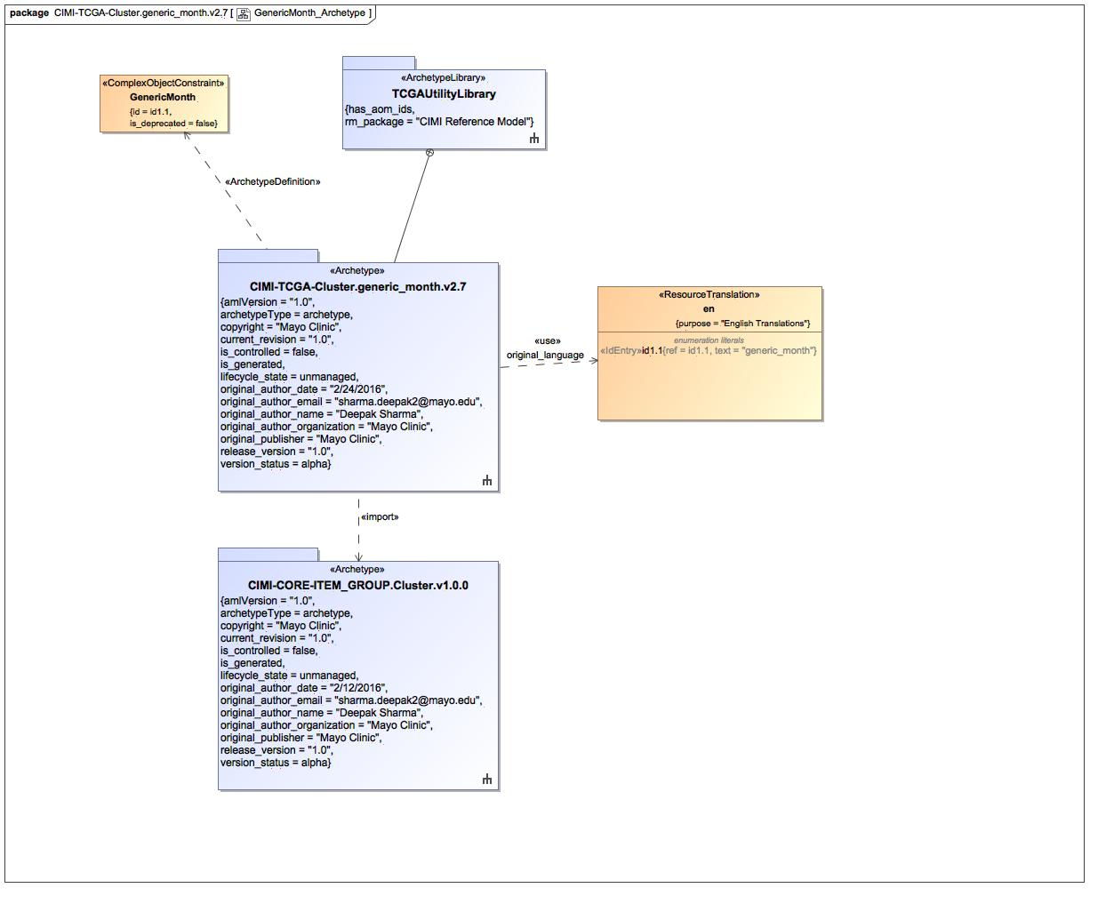

1. GenericMonth_Archetype

### Class GenericMonth

#### Direct Known Superclasses

Cluster

package TCGAArchetypes::TCGAUtilityLibrary::CIMI-TCGA-Cluster.generic_month.v2.7

public class GenericMonth

extends

Cluster

#### Associations

-2616899.jpg public : Id2.1 [1]

### Enumeration en

package TCGAArchetypes::TCGAUtilityLibrary::CIMI-TCGA-Cluster.generic_month.v2.7::Terminology::term-definitions

public enum en

{id1.1}

#### Literals

-1252509891.jpg id1.1

## GenericMonth_Definition

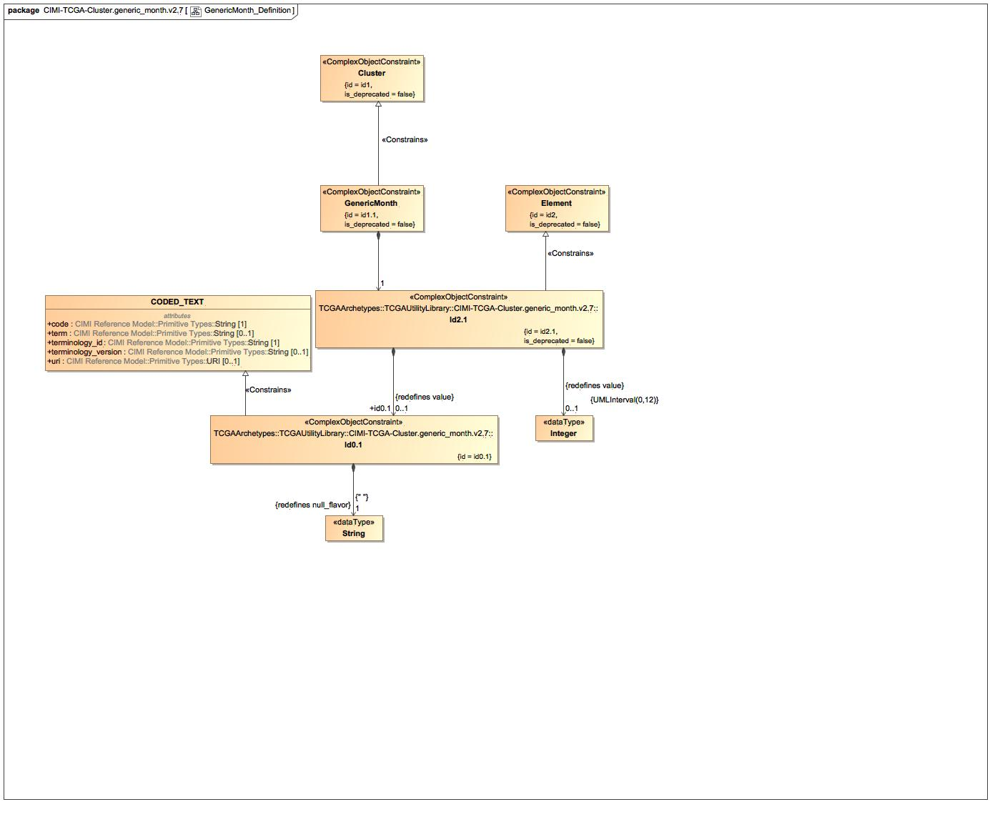

1. GenericMonth_Definition

### Class Id0.1

#### Direct Known Superclasses

CODED_TEXT

package TCGAArchetypes::TCGAUtilityLibrary::CIMI-TCGA-Cluster.generic_month.v2.7

public class Id0.1

extends

CODED_TEXT

#### Associations

-2616899.jpg public : String [1]

### Class Id2.1

#### Direct Known Superclasses

Element

package TCGAArchetypes::TCGAUtilityLibrary::CIMI-TCGA-Cluster.generic_month.v2.7

public class Id2.1

extends

Element

#### Associations

-2616899.jpg public value_id2.1 : Real [0..1]

-2616899.jpg public id0.1 : Id0.1 [0..1]

-2616899.jpg public : Integer [0..1]

### Known other classes

Class Cluster, Class CODED_TEXT, Class Element, Class GenericMonth

## GenericMonth_Terms

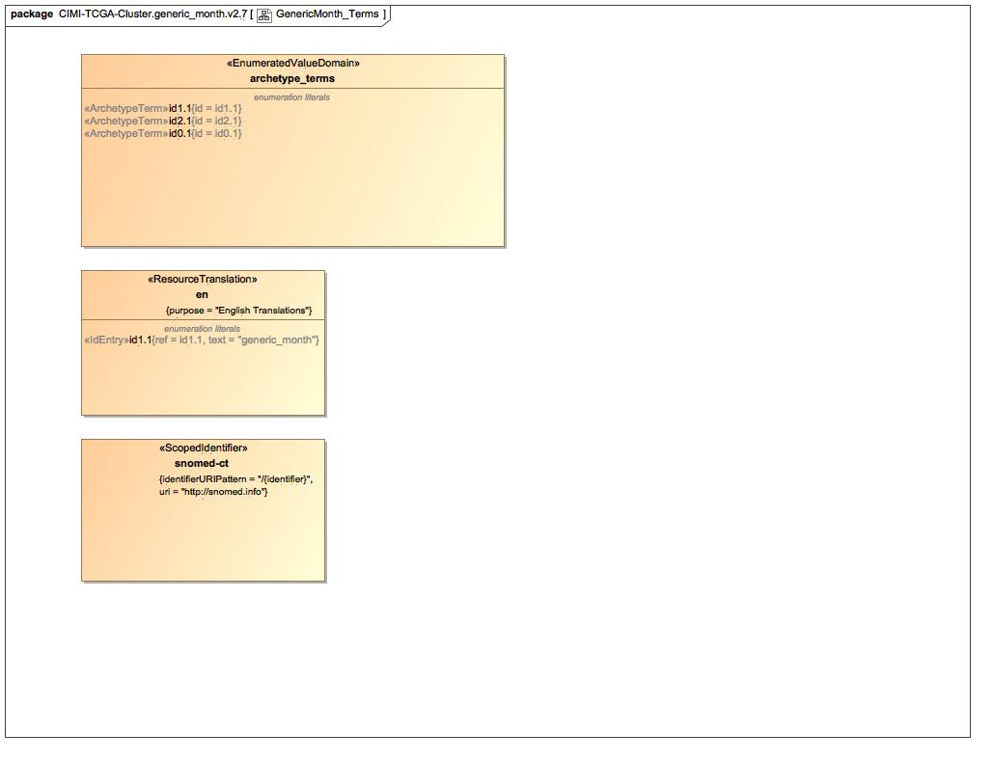

1. GenericMonth_Terms

### Enumeration archetype_terms

package TCGAArchetypes::TCGAUtilityLibrary::CIMI-TCGA-Cluster.generic_month.v2.7::Terminology::terms

public enum archetype_terms

{id1.1, id2.1, id0.1}

#### Literals

-1252509891.jpg id1.1

-1252509891.jpg id2.1

-1252509891.jpg id0.1

### Enumeration snomed-ct

package TCGAArchetypes::TCGAUtilityLibrary::CIMI-TCGA-Cluster.generic_month.v2.7::Terminology::term-bindings

public enum snomed-ct

### Known other enumerations

Enumeration en

# TCGAArchetypes::TCGAUtilityLibrary::CIMI-TCGA-Cluster.generic_month.v2.7::Terminology::term-bindings

## Known other enumerations

Enumeration snomed-ct

# TCGAArchetypes::TCGAUtilityLibrary::CIMI-TCGA-Cluster.generic_month.v2.7::Terminology::term-definitions

## Known other enumerations

Enumeration en

# TCGAArchetypes::TCGAUtilityLibrary::CIMI-TCGA-Cluster.generic_month.v2.7::Terminology::terms

## Known other enumerations

Enumeration archetype_terms

# TCGAArchetypes::TCGAUtilityLibrary::CIMI-TCGA-Cluster.generic_year.v2.7

## GenericYear_Archetype

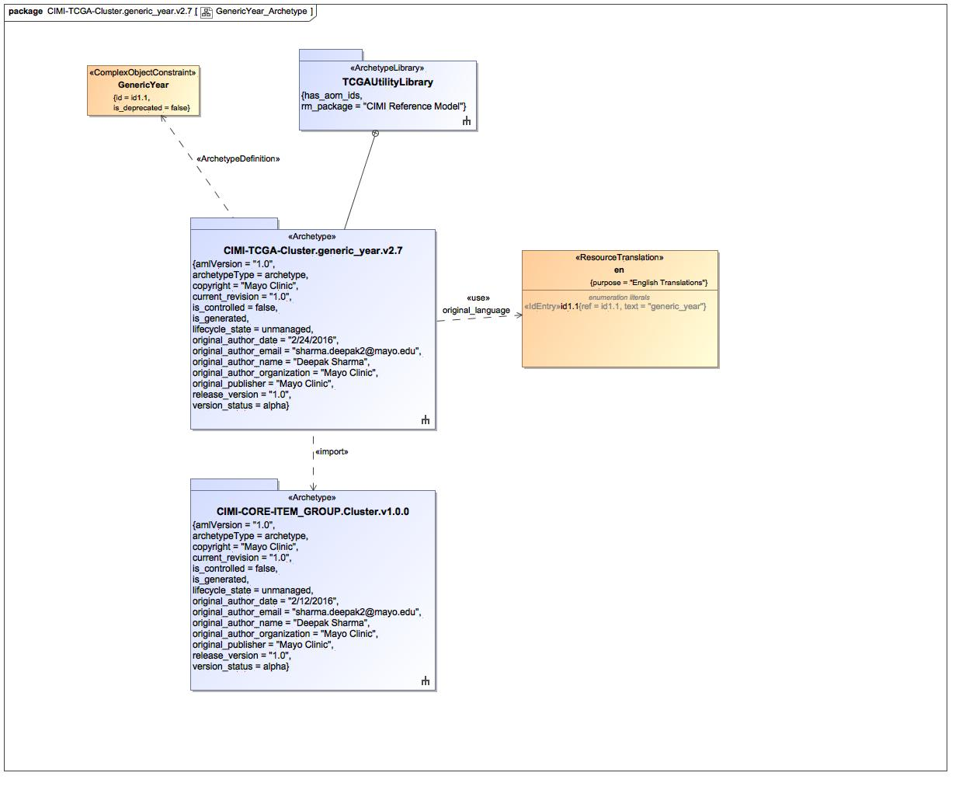

1. GenericYear_Archetype

### Class GenericYear

#### Direct Known Superclasses

Cluster

package TCGAArchetypes::TCGAUtilityLibrary::CIMI-TCGA-Cluster.generic_year.v2.7

public class GenericYear

extends

Cluster

#### Associations

-2616899.jpg public : Id2.1 [1]

### Enumeration en

package TCGAArchetypes::TCGAUtilityLibrary::CIMI-TCGA-Cluster.generic_year.v2.7::Terminology::term-definitions

public enum en

{id1.1}

#### Literals

-1252509891.jpg id1.1

## GenericYear_Definition

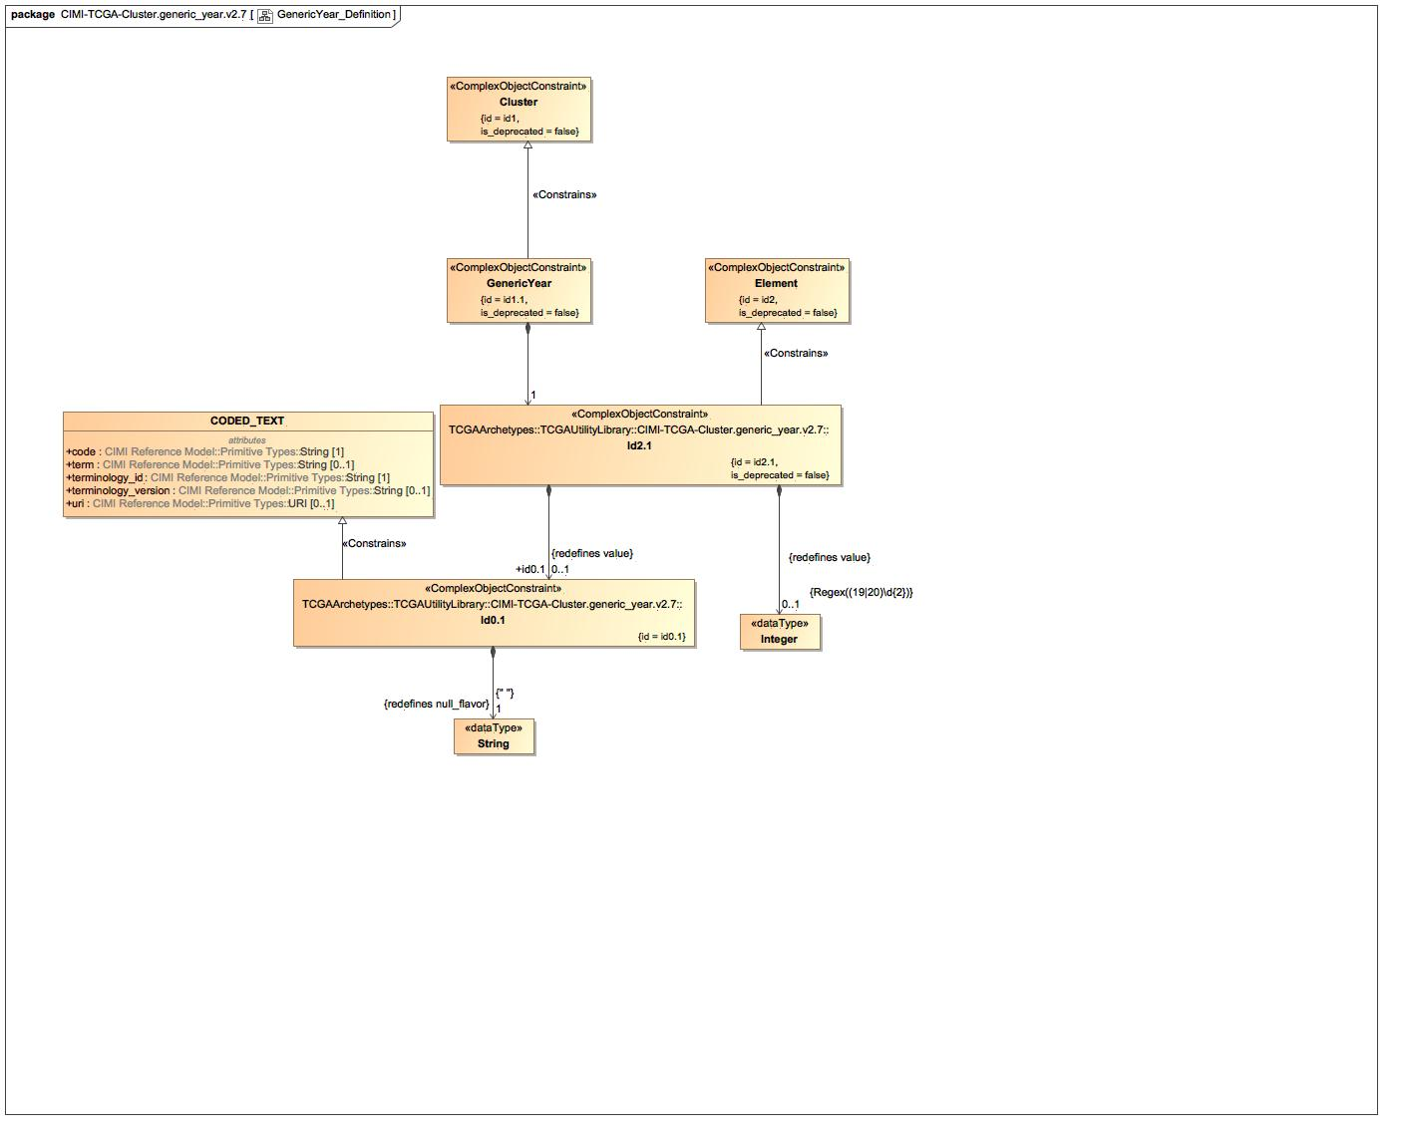

1. GenericYear_Definition

### Class Id0.1

#### Direct Known Superclasses

CODED_TEXT

package TCGAArchetypes::TCGAUtilityLibrary::CIMI-TCGA-Cluster.generic_year.v2.7

public class Id0.1

extends

CODED_TEXT

#### Associations

-2616899.jpg public : String [1]

### Class Id2.1

#### Direct Known Superclasses

Element

package TCGAArchetypes::TCGAUtilityLibrary::CIMI-TCGA-Cluster.generic_year.v2.7

public class Id2.1

extends

Element

#### Associations

-2616899.jpg public value_id2.1 : Real [0..1]

-2616899.jpg public id0.1 : Id0.1 [0..1]

-2616899.jpg public : Integer [0..1]

### Known other classes

Class Cluster, Class CODED_TEXT, Class Element, Class GenericYear

## GenericYear_Terms

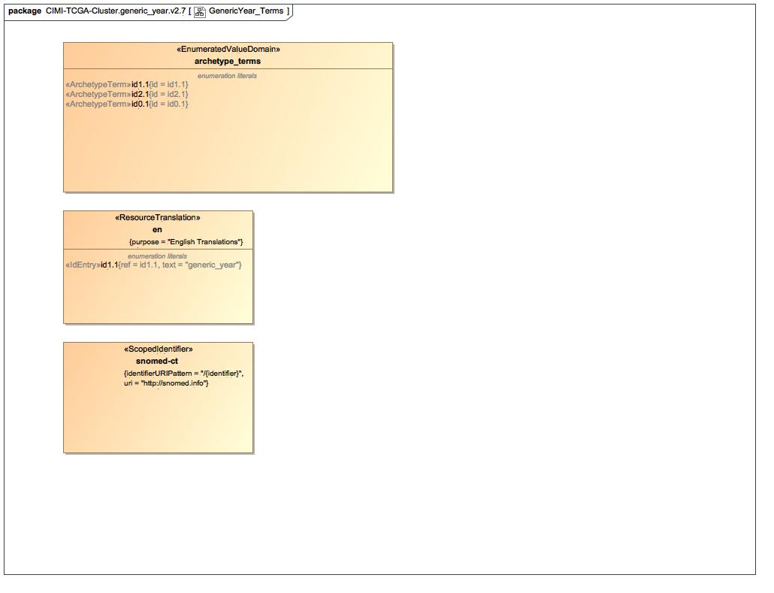

1. GenericYear_Terms

### Enumeration archetype_terms

package TCGAArchetypes::TCGAUtilityLibrary::CIMI-TCGA-Cluster.generic_year.v2.7::Terminology::terms

public enum archetype_terms

{id1.1, id2.1, id0.1}

#### Literals

-1252509891.jpg id1.1

-1252509891.jpg id2.1

-1252509891.jpg id0.1

### Enumeration snomed-ct

package TCGAArchetypes::TCGAUtilityLibrary::CIMI-TCGA-Cluster.generic_year.v2.7::Terminology::term-bindings

public enum snomed-ct

### Known other enumerations

Enumeration en

# TCGAArchetypes::TCGAUtilityLibrary::CIMI-TCGA-Cluster.generic_year.v2.7::Terminology::term-bindings

## Known other enumerations

Enumeration snomed-ct

# TCGAArchetypes::TCGAUtilityLibrary::CIMI-TCGA-Cluster.generic_year.v2.7::Terminology::term-definitions

## Known other enumerations

Enumeration en

# TCGAArchetypes::TCGAUtilityLibrary::CIMI-TCGA-Cluster.generic_year.v2.7::Terminology::terms

## Known other enumerations

Enumeration archetype_terms

# TCGAArchetypes::TCGAUtilityLibrary::CIMI-TCGA-Cluster.integer_or_null.v2.7

## IntegerOrNull_Archetype

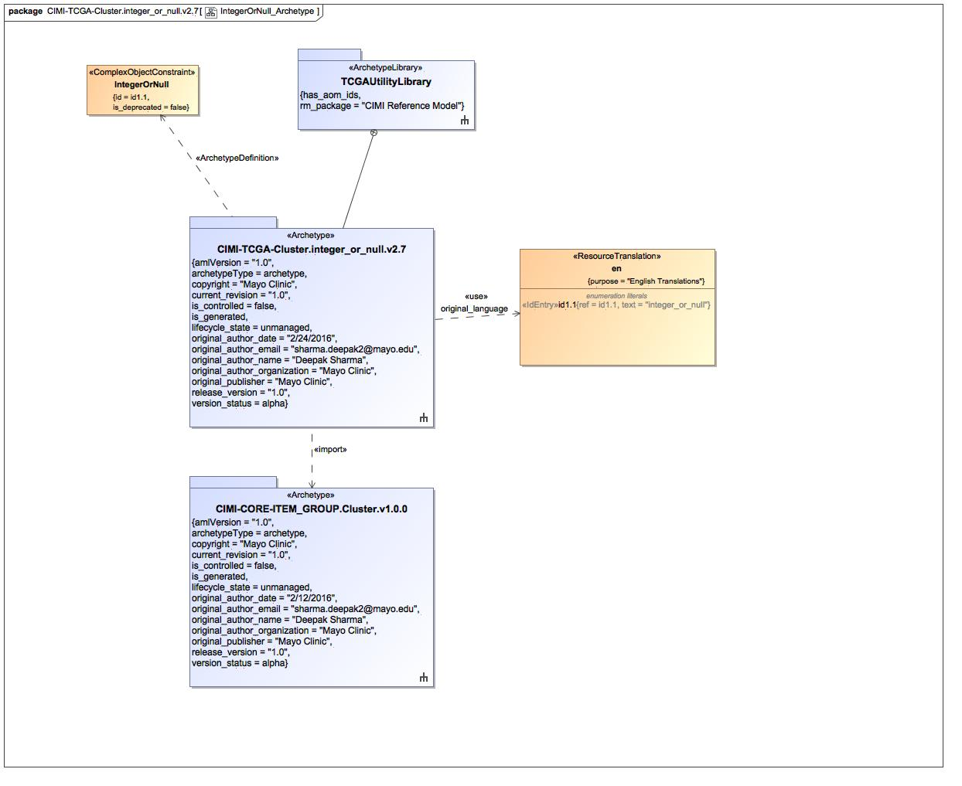

1. IntegerOrNull_Archetype

### Class IntegerOrNull

#### Direct Known Superclasses

Cluster

package TCGAArchetypes::TCGAUtilityLibrary::CIMI-TCGA-Cluster.integer_or_null.v2.7

public class IntegerOrNull

extends

Cluster

#### Associations

-2616899.jpg public : Id2.1 [1]

### Enumeration en

package TCGAArchetypes::TCGAUtilityLibrary::CIMI-TCGA-Cluster.integer_or_null.v2.7::Terminology::term-definitions

public enum en

{id1.1}

#### Literals

-1252509891.jpg id1.1

## IntegerOrNull_Definition

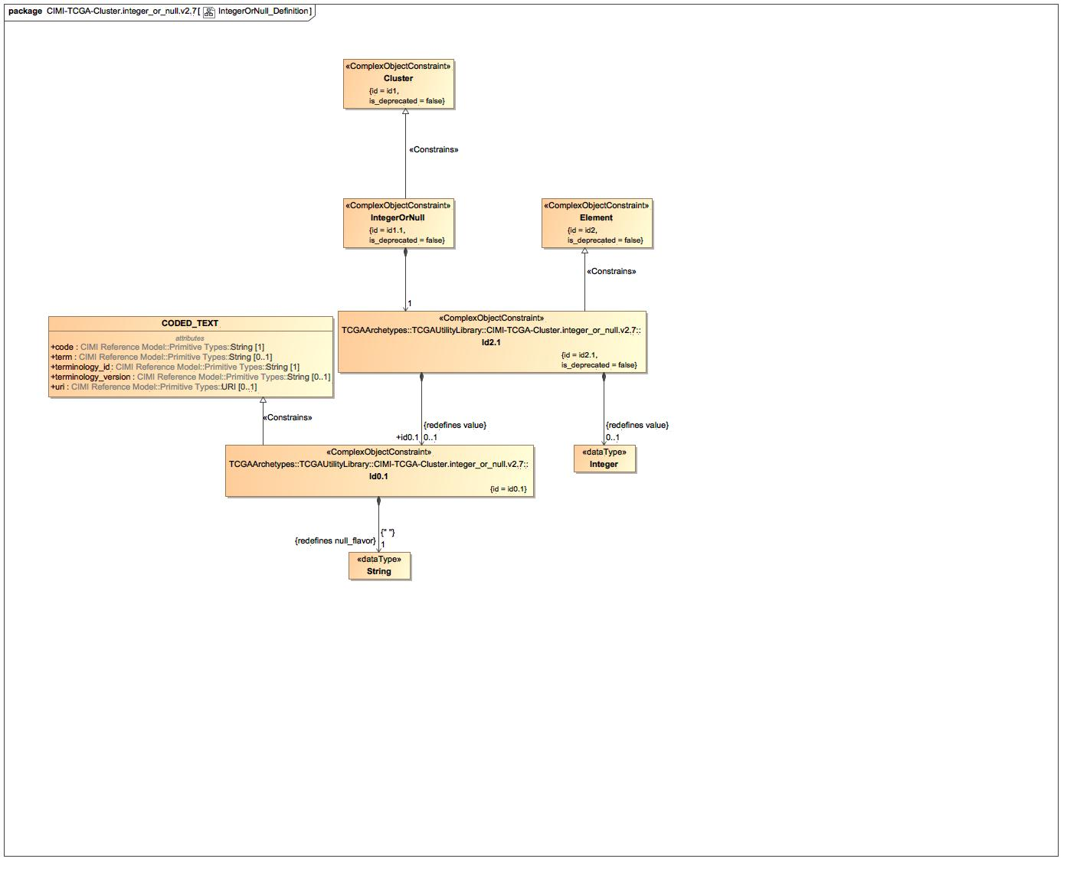

1. IntegerOrNull_Definition

### Class Id0.1

#### Direct Known Superclasses

CODED_TEXT

package TCGAArchetypes::TCGAUtilityLibrary::CIMI-TCGA-Cluster.integer_or_null.v2.7

public class Id0.1

extends

CODED_TEXT

#### Associations

-2616899.jpg public : String [1]

### Class Id2.1

#### Direct Known Superclasses

Element

package TCGAArchetypes::TCGAUtilityLibrary::CIMI-TCGA-Cluster.integer_or_null.v2.7

public class Id2.1

extends

Element

#### Associations

-2616899.jpg public value_id2.1 : Real [0..1]

-2616899.jpg public id0.1 : Id0.1 [0..1]

-2616899.jpg public : Integer [0..1]

### Known other classes

Class Cluster, Class CODED_TEXT, Class Element, Class IntegerOrNull

## IntegerOrNull_Terms

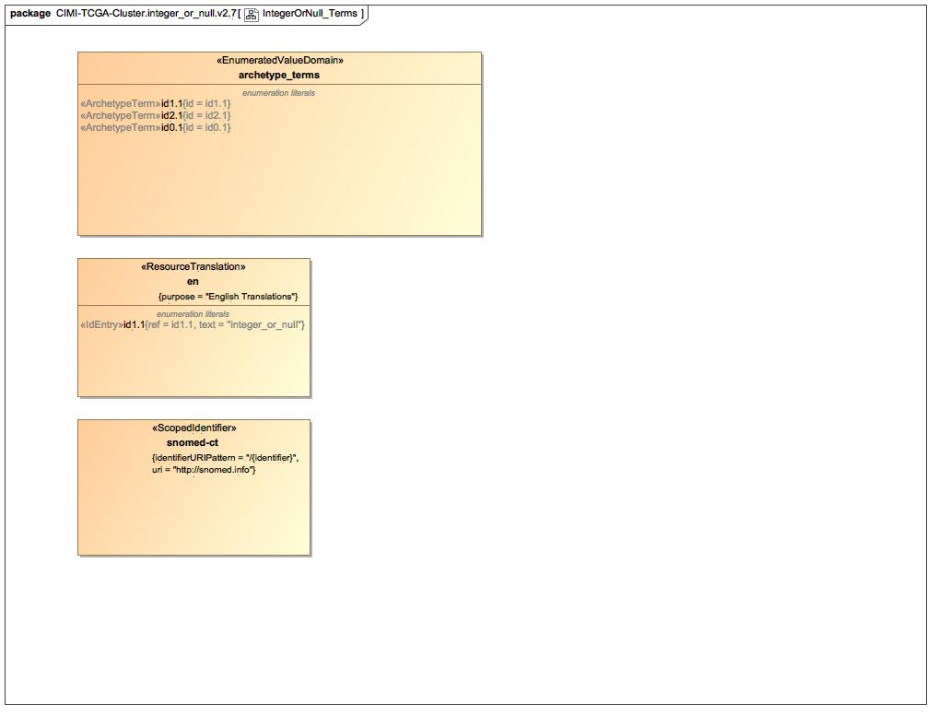

1. IntegerOrNull_Terms

### Enumeration archetype_terms

package TCGAArchetypes::TCGAUtilityLibrary::CIMI-TCGA-Cluster.integer_or_null.v2.7::Terminology::terms

public enum archetype_terms

{id1.1, id2.1, id0.1}

#### Literals

-1252509891.jpg id1.1

-1252509891.jpg id2.1

-1252509891.jpg id0.1

### Enumeration snomed-ct

package TCGAArchetypes::TCGAUtilityLibrary::CIMI-TCGA-Cluster.integer_or_null.v2.7::Terminology::term-bindings

public enum snomed-ct

### Known other enumerations

Enumeration en

# TCGAArchetypes::TCGAUtilityLibrary::CIMI-TCGA-Cluster.integer_or_null.v2.7::Terminology::term-bindings

## Known other enumerations

Enumeration snomed-ct

# TCGAArchetypes::TCGAUtilityLibrary::CIMI-TCGA-Cluster.integer_or_null.v2.7::Terminology::term-definitions

## Known other enumerations

Enumeration en

# TCGAArchetypes::TCGAUtilityLibrary::CIMI-TCGA-Cluster.integer_or_null.v2.7::Terminology::terms

## Known other enumerations

Enumeration archetype_terms

# TCGAArchetypes::TCGAUtilityLibrary::CIMI-TCGA-Cluster.number_or_null.v2.7

## NumberOrNull_Archetype

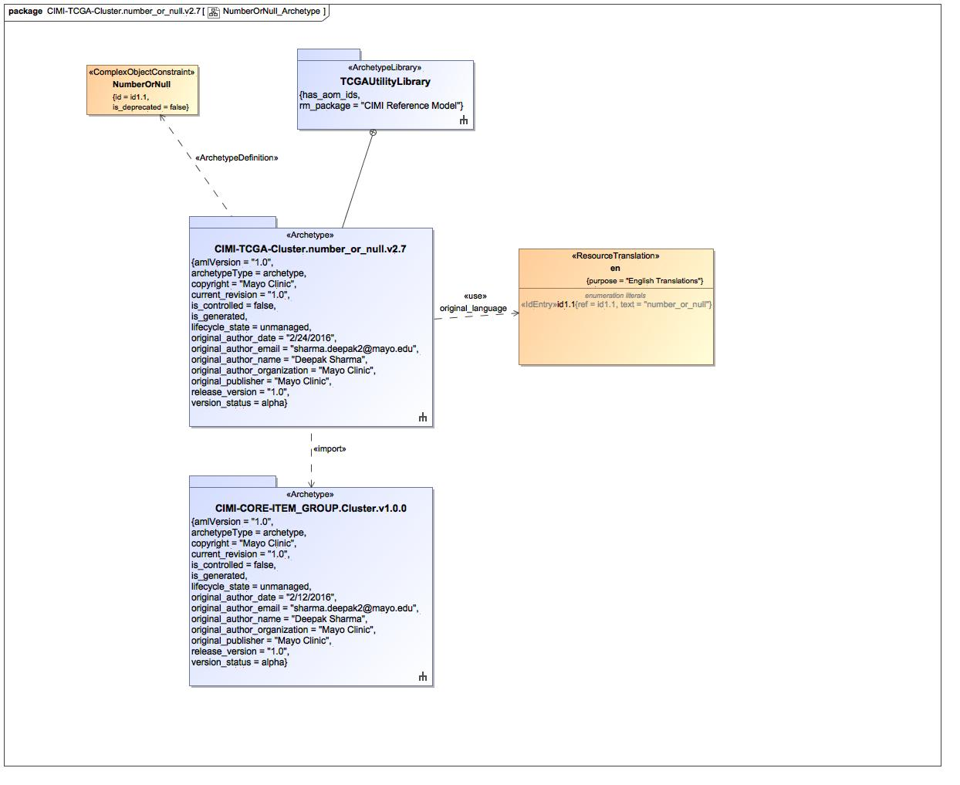

1. NumberOrNull_Archetype

### Class NumberOrNull

#### Direct Known Superclasses

Cluster

package TCGAArchetypes::TCGAUtilityLibrary::CIMI-TCGA-Cluster.number_or_null.v2.7

public class NumberOrNull

extends

Cluster

#### Associations

-2616899.jpg public : Id2.1 [1]

### Enumeration en

package TCGAArchetypes::TCGAUtilityLibrary::CIMI-TCGA-Cluster.number_or_null.v2.7::Terminology::term-definitions

public enum en

{id1.1}

#### Literals

-1252509891.jpg id1.1

## NumberOrNull_Definition

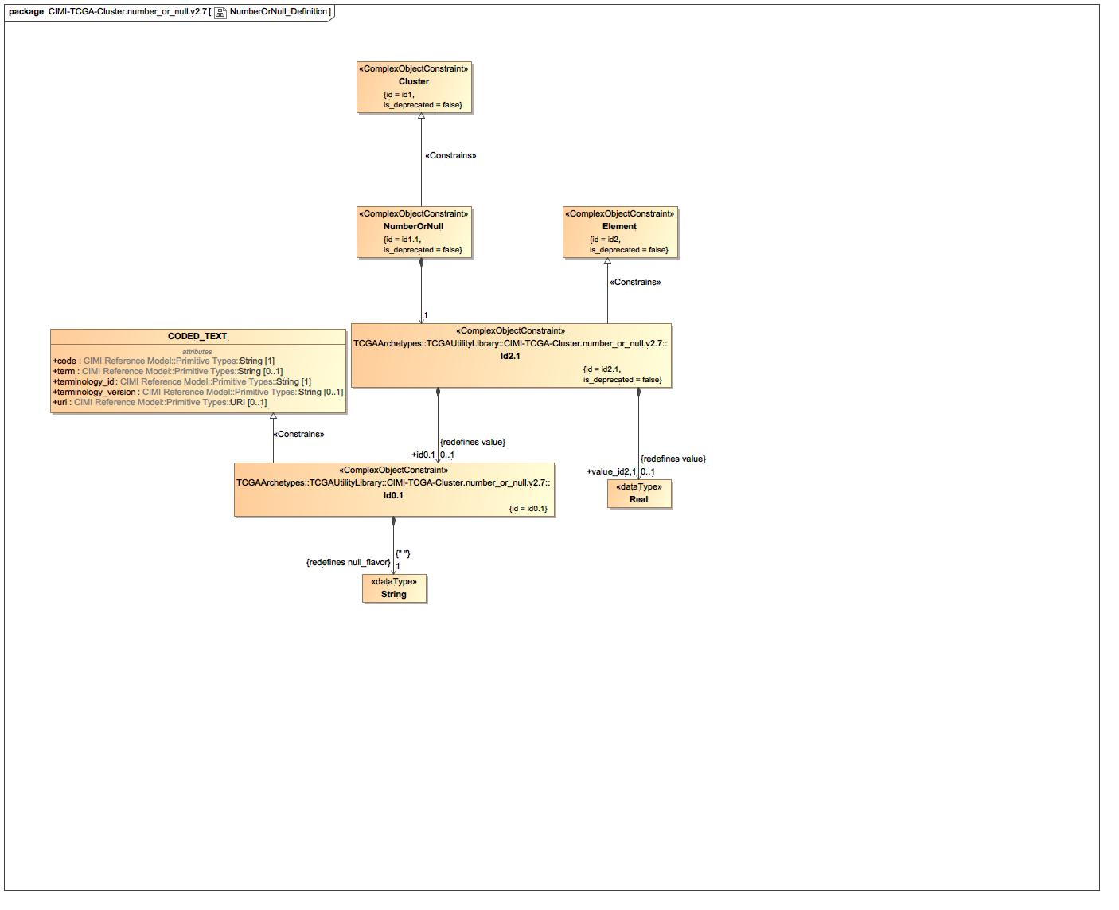

1. NumberOrNull_Definition

### Class Id0.1

#### Direct Known Superclasses

CODED_TEXT

package TCGAArchetypes::TCGAUtilityLibrary::CIMI-TCGA-Cluster.number_or_null.v2.7

public class Id0.1

extends

CODED_TEXT

#### Associations

-2616899.jpg public : String [1]

### Class Id2.1

#### Direct Known Superclasses

Element

package TCGAArchetypes::TCGAUtilityLibrary::CIMI-TCGA-Cluster.number_or_null.v2.7

public class Id2.1

extends

Element

#### Associations

-2616899.jpg public value_id2.1 : Real [0..1]

-2616899.jpg public id0.1 : Id0.1 [0..1]

### Known other classes

Class Cluster, Class CODED_TEXT, Class Element, Class NumberOrNull

## NumberOrNull_Terms

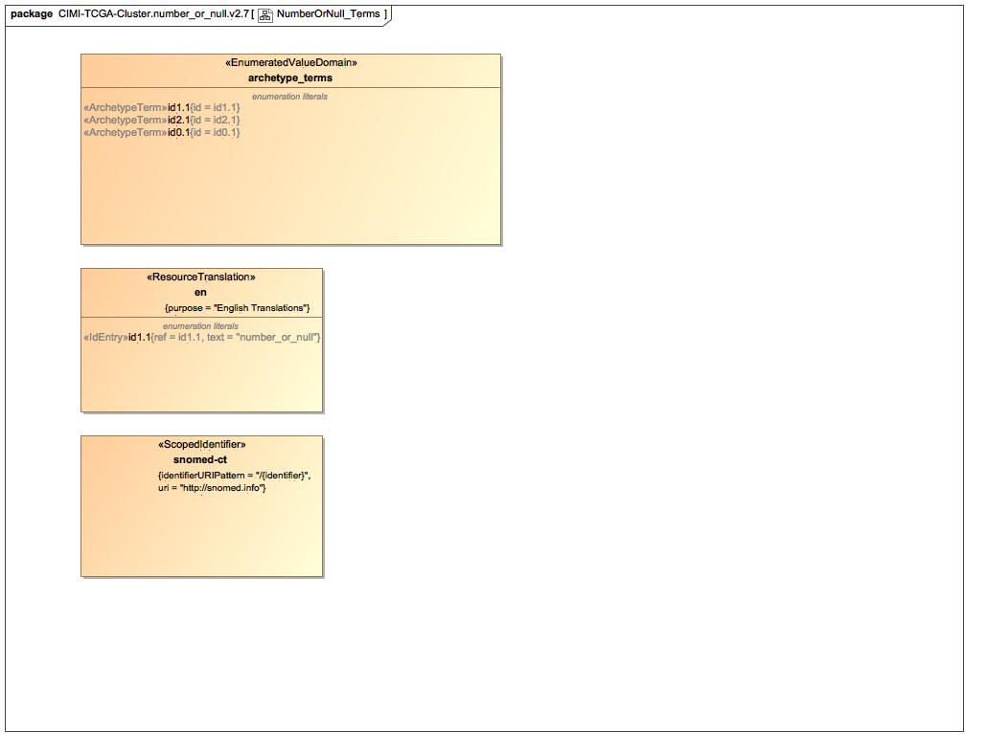

1. NumberOrNull_Terms

### Enumeration archetype_terms

package TCGAArchetypes::TCGAUtilityLibrary::CIMI-TCGA-Cluster.number_or_null.v2.7::Terminology::terms

public enum archetype_terms

{id1.1, id2.1, id0.1}

#### Literals

-1252509891.jpg id1.1

-1252509891.jpg id2.1

-1252509891.jpg id0.1

### Enumeration snomed-ct

package TCGAArchetypes::TCGAUtilityLibrary::CIMI-TCGA-Cluster.number_or_null.v2.7::Terminology::term-bindings

public enum snomed-ct

### Known other enumerations

Enumeration en

# TCGAArchetypes::TCGAUtilityLibrary::CIMI-TCGA-Cluster.number_or_null.v2.7::Terminology::term-bindings

## Known other enumerations

Enumeration snomed-ct

# TCGAArchetypes::TCGAUtilityLibrary::CIMI-TCGA-Cluster.number_or_null.v2.7::Terminology::term-definitions

## Known other enumerations

Enumeration en

# TCGAArchetypes::TCGAUtilityLibrary::CIMI-TCGA-Cluster.number_or_null.v2.7::Terminology::terms

## Known other enumerations

Enumeration archetype_terms

# TCGAArchetypes::TCGAUtilityLibrary::Terminology::term-bindings

## Known other enumerations

Enumeration snomed-ct

# TCGAArchetypes::TCGAUtilityLibrary::Terminology::term-definitions

## Known other enumerations

Enumeration en

# TCGAArchetypes::TCGAUtilityLibrary::Terminology::terms

## Known other enumerations

Enumeration library_terms

# TCGAArchetypesWithTCGARM::TCGAOCGSharedCELibrary

## TCGAOCGSharedCELibrary



1. TCGAOCGSharedCELibrary

# TCGAArchetypesWithTCGARM::TCGAOCGSharedCELibrary::CIMI-TCGA-clinical_res_attribute.days_to_hiv_diagnosis.v2.7

## DaysToHivDiagnosis_Archetype

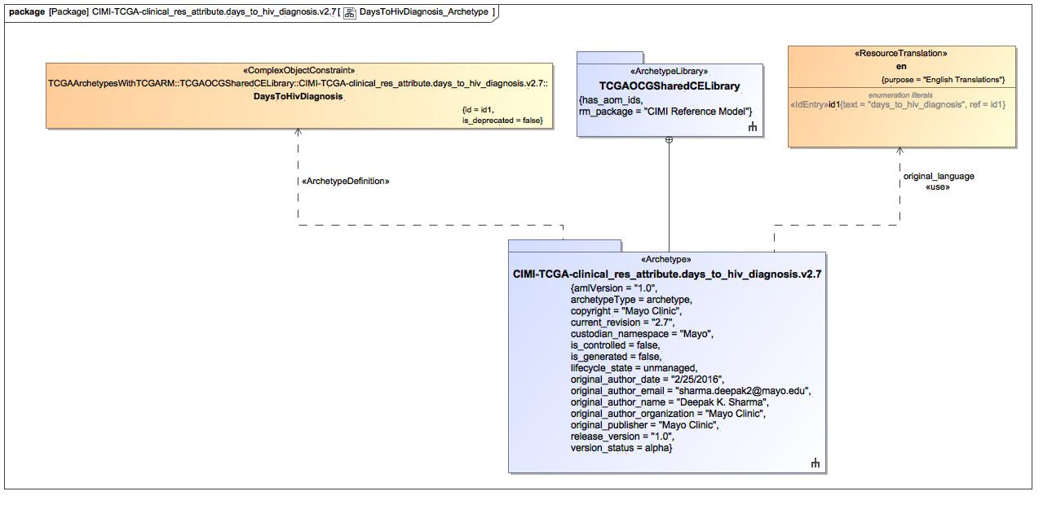

1. DaysToHivDiagnosis_Archetype

### Class DaysToHivDiagnosis

#### Direct Known Superclasses

clinical_res_attribute

package TCGAArchetypesWithTCGARM::TCGAOCGSharedCELibrary::CIMI-TCGA-clinical_res_attribute.days_to_hiv_diagnosis.v2.7

public class DaysToHivDiagnosis

extends

clinical_res_attribute

#### Associations

-2616899.jpg public cde : String [0..1] = 4618491

-2616899.jpg public xsd_ver : String [0..1] = 2.6

-2616899.jpg public tier : String [0..1] = 2

### Enumeration en

package TCGAArchetypesWithTCGARM::TCGAOCGSharedCELibrary::CIMI-TCGA-clinical_res_attribute.days_to_hiv_diagnosis.v2.7::Terminology::term-definitions

public enum en

{id1}

#### Literals

-1252509891.jpg id1

## DaysToHivDiagnosis_Definition

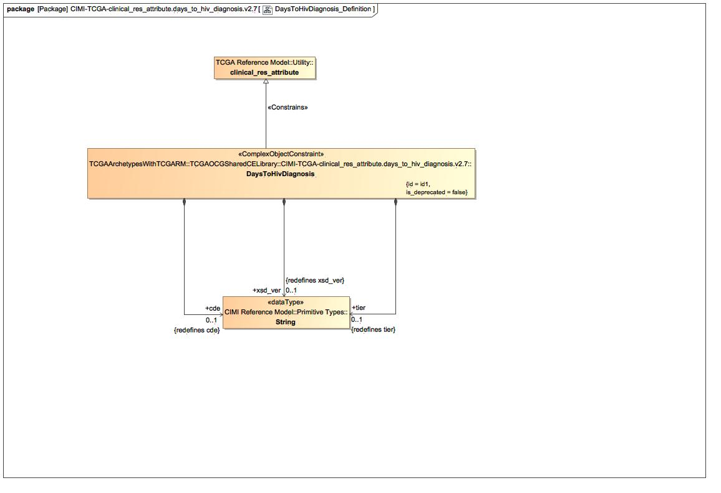

1. DaysToHivDiagnosis_Definition

### Known other classes

Class clinical_res_attribute, Class DaysToHivDiagnosis

## DaysToHivDiagnosis_Terms

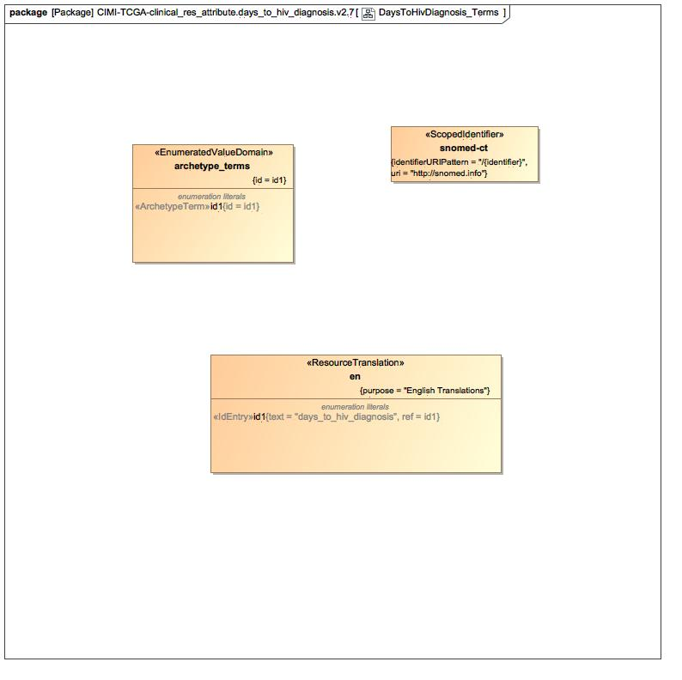

1. DaysToHivDiagnosis_Terms

### Enumeration archetype_terms

package TCGAArchetypesWithTCGARM::TCGAOCGSharedCELibrary::CIMI-TCGA-clinical_res_attribute.days_to_hiv_diagnosis.v2.7::Terminology::terms

public enum archetype_terms

{id1}

#### Literals

-1252509891.jpg id1

### Enumeration snomed-ct

package TCGAArchetypesWithTCGARM::TCGAOCGSharedCELibrary::CIMI-TCGA-clinical_res_attribute.days_to_hiv_diagnosis.v2.7::Terminology::term-bindings

public enum snomed-ct

### Known other enumerations

Enumeration en

# TCGAArchetypesWithTCGARM::TCGAOCGSharedCELibrary::CIMI-TCGA-clinical_res_attribute.days_to_hiv_diagnosis.v2.7::Terminology::term-bindings

## Known other enumerations

Enumeration snomed-ct

# TCGAArchetypesWithTCGARM::TCGAOCGSharedCELibrary::CIMI-TCGA-clinical_res_attribute.days_to_hiv_diagnosis.v2.7::Terminology::term-definitions

## Known other enumerations

Enumeration en

# TCGAArchetypesWithTCGARM::TCGAOCGSharedCELibrary::CIMI-TCGA-clinical_res_attribute.days_to_hiv_diagnosis.v2.7::Terminology::terms

## Known other enumerations

Enumeration archetype_terms

# dbGAPArchetypeLibrary

## dbGAPArchetypeLibrary

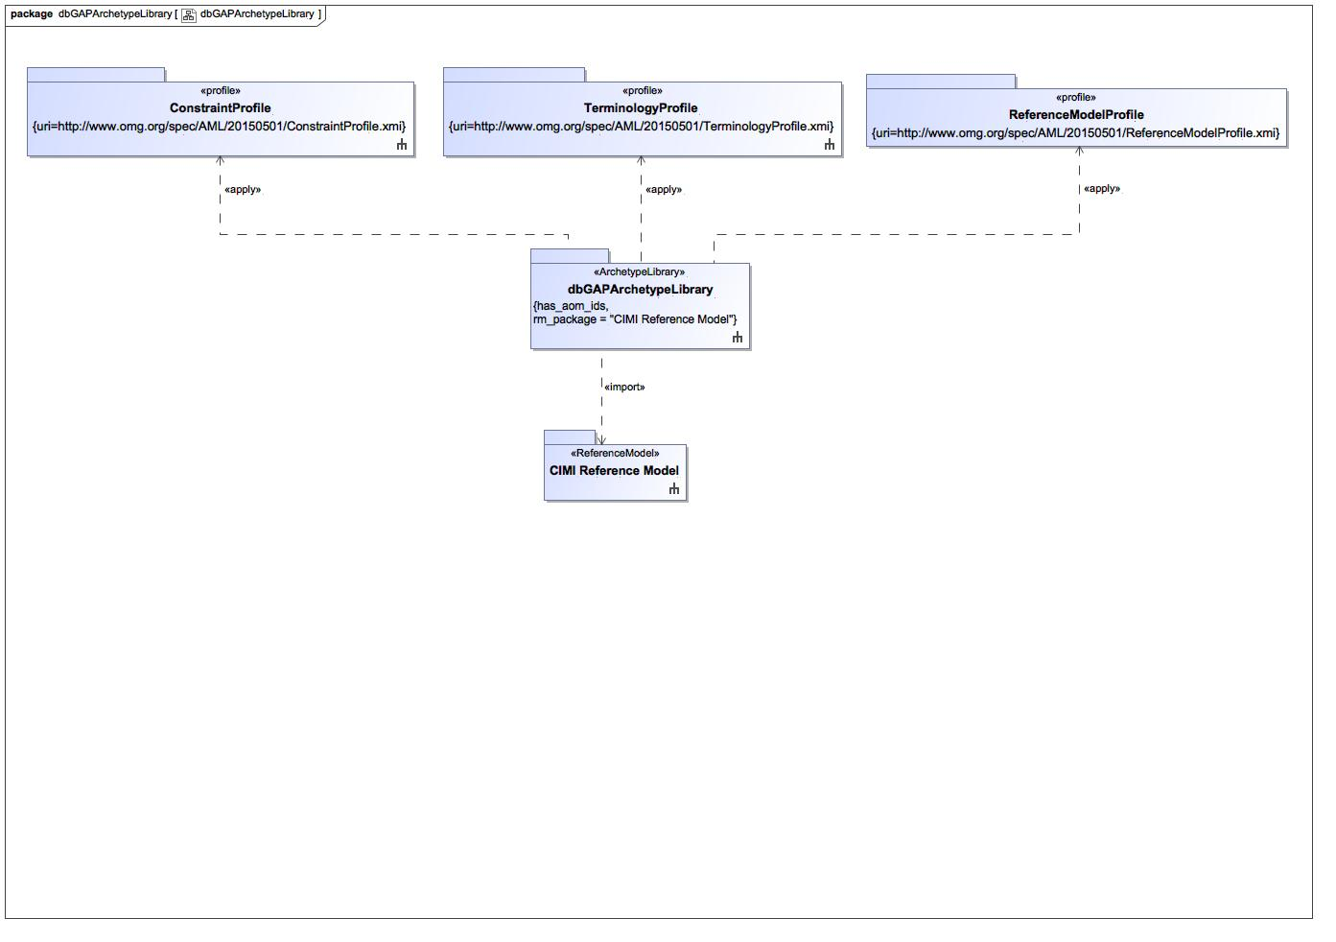

1. dbGAPArchetypeLibrary

# dbGAPArchetypeLibrary::CIMI-dbGAP-Cluster.pht123.v1.0.0

## pht123_Archetype

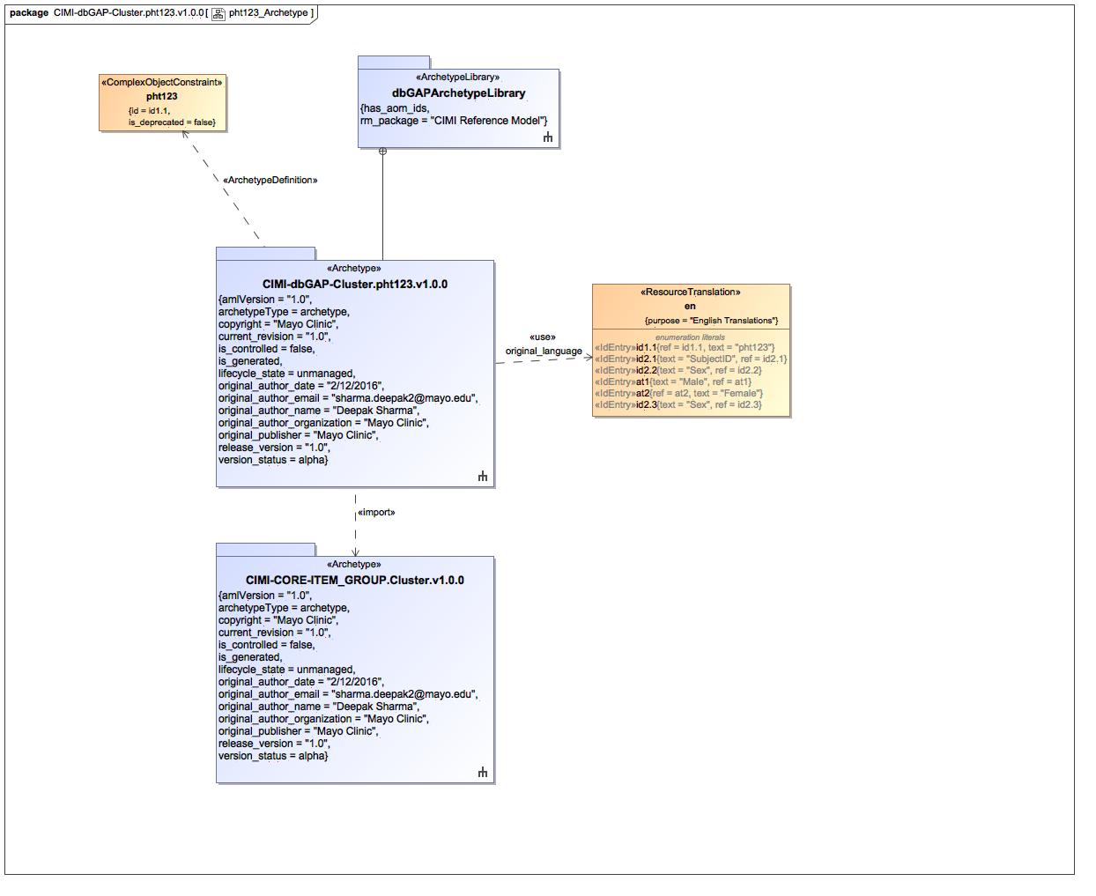

1. pht123_Archetype

### Class pht123

#### Direct Known Superclasses

Cluster

package dbGAPArchetypeLibrary::CIMI-dbGAP-Cluster.pht123.v1.0.0

public class pht123

extends

Cluster

#### Associations

-2616899.jpg public sex : Sex [0..1]

-2616899.jpg public patientAge : PatientAge [0..1]

-2616899.jpg public subId : SUBJID [1]

### Enumeration en

package dbGAPArchetypeLibrary::CIMI-dbGAP-Cluster.pht123.v1.0.0::Terminology::term-definitions

public enum en

{id1.1, id2.1, id2.2, at1, at2, id2.3}

#### Literals

-1252509891.jpg id1.1

-1252509891.jpg id2.1

-1252509891.jpg id2.2

-1252509891.jpg at1

-1252509891.jpg at2

-1252509891.jpg id2.3

## pht123_Definition

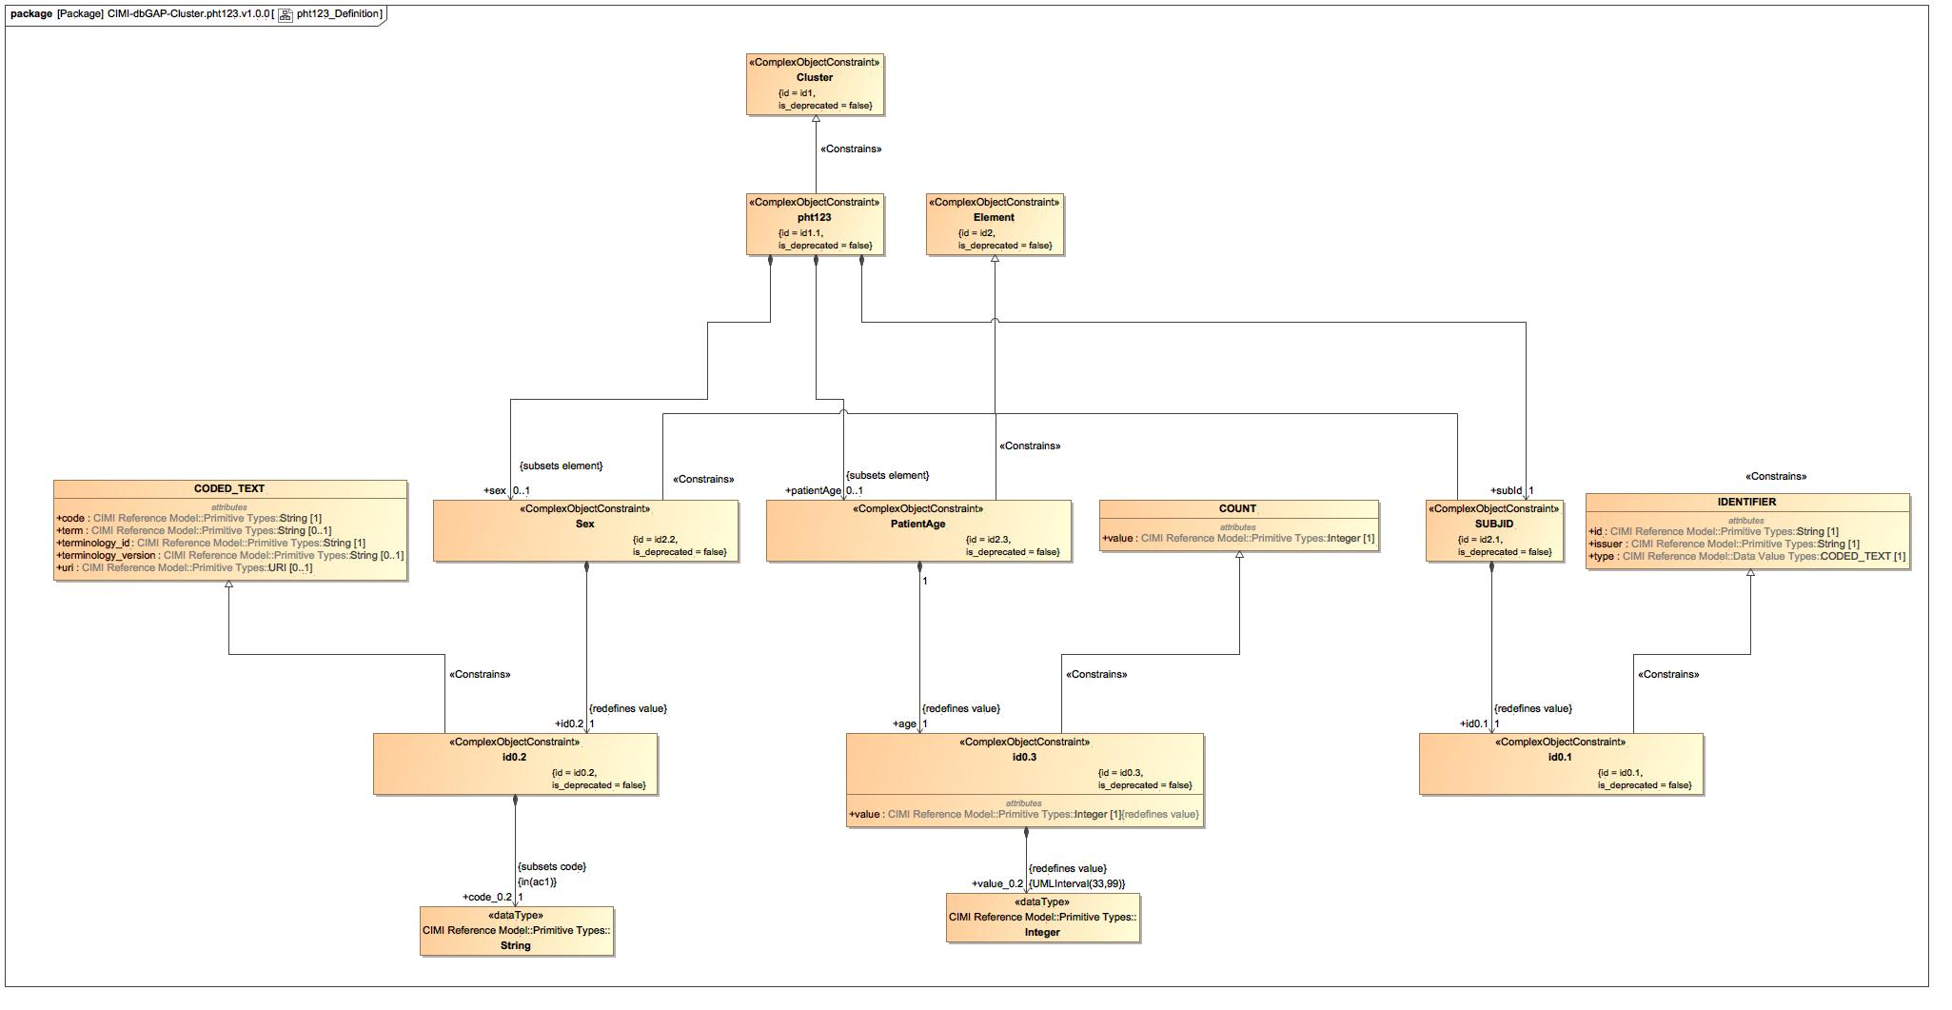

1. pht123_Definition

### Class COUNT

#### Direct Known Superclasses

AMOUNT

package CIMI Reference Model::Data Value Types

public class COUNT

extends

AMOUNT

### Class id0.1

#### Direct Known Superclasses

IDENTIFIER

package dbGAPArchetypeLibrary::CIMI-dbGAP-Cluster.pht123.v1.0.0

public class id0.1

extends

IDENTIFIER

### Class id0.2

#### Direct Known Superclasses

CODED_TEXT

package dbGAPArchetypeLibrary::CIMI-dbGAP-Cluster.pht123.v1.0.0

public class id0.2

extends

CODED_TEXT

#### Associations

-2616899.jpg public code_0.2 : String [1] = *

### Class id0.3

#### Direct Known Superclasses

COUNT

package dbGAPArchetypeLibrary::CIMI-dbGAP-Cluster.pht123.v1.0.0

public class id0.3

extends

COUNT

#### Associations

-2616899.jpg public value_0.2 : Integer

### Class IDENTIFIER

#### Direct Known Superclasses

DATA_VALUE

package CIMI Reference Model::Data Value Types

public class IDENTIFIER

extends

DATA_VALUE

### Class PatientAge

#### Direct Known Superclasses

Element

package dbGAPArchetypeLibrary::CIMI-dbGAP-Cluster.pht123.v1.0.0

public class PatientAge

extends

Element

#### Associations

-2616899.jpg public age : id0.3 [1]

### Class Sex

#### Direct Known Superclasses

Element

package dbGAPArchetypeLibrary::CIMI-dbGAP-Cluster.pht123.v1.0.0

public class Sex

extends

Element

#### Associations

-2616899.jpg public id0.2 : id0.2 [1]

### Class SUBJID

#### Direct Known Superclasses

Element

package dbGAPArchetypeLibrary::CIMI-dbGAP-Cluster.pht123.v1.0.0

public class SUBJID

extends

Element

#### Associations

-2616899.jpg public id0.1 : id0.1 [1]

### Known other classes

Class Cluster, Class CODED_TEXT, Class Element, Class pht123

## pht123_Terms

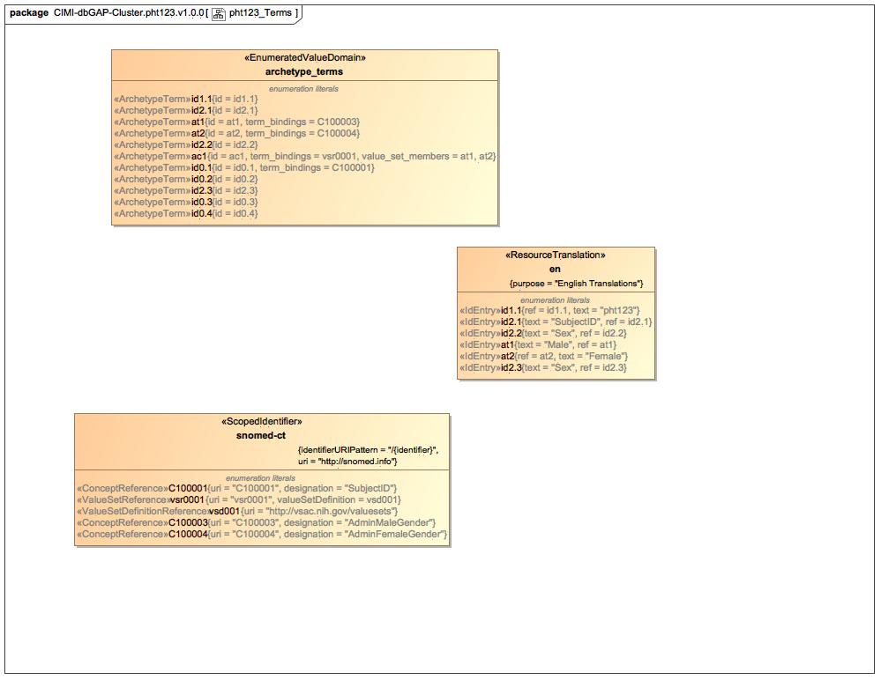

1. pht123_Terms

### Enumeration archetype_terms

package dbGAPArchetypeLibrary::CIMI-dbGAP-Cluster.pht123.v1.0.0::Terminology::terms

public enum archetype_terms

{id1.1, id2.1, at1, at2, id2.2, ac1, id0.1, id0.2, id2.3, id0.3, id0.4}

#### Literals

-1252509891.jpg id1.1

-1252509891.jpg id2.1

-1252509891.jpg at1

-1252509891.jpg at2

-1252509891.jpg id2.2

-1252509891.jpg ac1

-1252509891.jpg id0.1

-1252509891.jpg id0.2

-1252509891.jpg id2.3

-1252509891.jpg id0.3

-1252509891.jpg id0.4

### Enumeration snomed-ct

package dbGAPArchetypeLibrary::CIMI-dbGAP-Cluster.pht123.v1.0.0::Terminology::term-bindings

public enum snomed-ct

{C100001, vsr0001, vsd001, C100003, C100004}

#### Literals

-1252509891.jpg C100001

-1252509891.jpg vsr0001

-1252509891.jpg vsd001

-1252509891.jpg C100003

-1252509891.jpg C100004

### Known other enumerations

Enumeration en

# dbGAPArchetypeLibrary::CIMI-dbGAP-Cluster.pht123.v1.0.0::Terminology::term-bindings

## Known other enumerations

Enumeration snomed-ct

# dbGAPArchetypeLibrary::CIMI-dbGAP-Cluster.pht123.v1.0.0::Terminology::term-definitions

## Known other enumerations

Enumeration en

# dbGAPArchetypeLibrary::CIMI-dbGAP-Cluster.pht123.v1.0.0::Terminology::terms

## Known other enumerations

Enumeration archetype_terms

# dbGAPArchetypeLibrary::CIMI-dbGAP-Cluster.pht003255.v2

## pht003255_Archetype

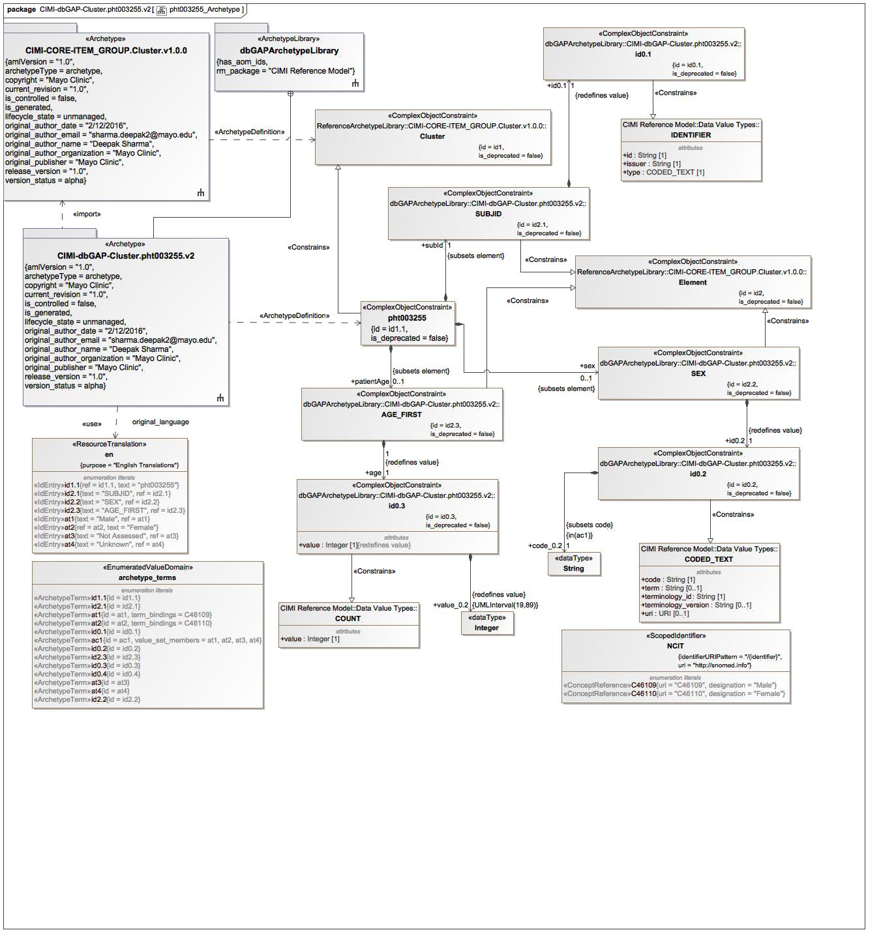

1. pht003255_Archetype

### Class AGE_FIRST

#### Direct Known Superclasses

Element

package dbGAPArchetypeLibrary::CIMI-dbGAP-Cluster.pht003255.v2

public class AGE_FIRST

extends

Element

#### Associations

-2616899.jpg public age : id0.3 [1]

### Class id0.1

#### Direct Known Superclasses

IDENTIFIER

package dbGAPArchetypeLibrary::CIMI-dbGAP-Cluster.pht003255.v2

public class id0.1

extends

IDENTIFIER

### Class id0.2

#### Direct Known Superclasses

CODED_TEXT

package dbGAPArchetypeLibrary::CIMI-dbGAP-Cluster.pht003255.v2

public class id0.2

extends

CODED_TEXT

#### Associations

-2616899.jpg public code_0.2 : String [1] = *

### Class id0.3

#### Direct Known Superclasses

COUNT

package dbGAPArchetypeLibrary::CIMI-dbGAP-Cluster.pht003255.v2

public class id0.3

extends

COUNT

#### Associations

-2616899.jpg public value_0.2 : Integer = "."

### Class pht003255

#### Direct Known Superclasses

Cluster

package dbGAPArchetypeLibrary::CIMI-dbGAP-Cluster.pht003255.v2

public class pht003255

extends

Cluster

#### Associations

-2616899.jpg public sex : SEX [0..1]

-2616899.jpg public patientAge : AGE_FIRST [0..1]

-2616899.jpg public subId : SUBJID [1]

### Class SEX

#### Direct Known Superclasses

Element

package dbGAPArchetypeLibrary::CIMI-dbGAP-Cluster.pht003255.v2

public class SEX

extends

Element

#### Associations

-2616899.jpg public id0.2 : id0.2 [1]

### Class SUBJID

#### Direct Known Superclasses

Element

package dbGAPArchetypeLibrary::CIMI-dbGAP-Cluster.pht003255.v2

public class SUBJID

extends

Element

#### Associations

-2616899.jpg public id0.1 : id0.1 [1]

### Known other classes

Class Cluster, Class CODED_TEXT, Class COUNT, Class Element, Class IDENTIFIER

### Enumeration archetype_terms

package dbGAPArchetypeLibrary::CIMI-dbGAP-Cluster.pht003255.v2::Terminology::terms

public enum archetype_terms

{id1.1, id2.1, at1, at2, id0.1, ac1, id0.2, id2.3, id0.3, id0.4, at3, at4, id2.2}

#### Literals

-1252509891.jpg id1.1

-1252509891.jpg id2.1

-1252509891.jpg at1

-1252509891.jpg at2

-1252509891.jpg id0.1

-1252509891.jpg ac1

-1252509891.jpg id0.2

-1252509891.jpg id2.3

-1252509891.jpg id0.3

-1252509891.jpg id0.4

-1252509891.jpg at3

-1252509891.jpg at4

-1252509891.jpg id2.2

### Enumeration en

package dbGAPArchetypeLibrary::CIMI-dbGAP-Cluster.pht003255.v2::Terminology::term-definitions

public enum en

{id1.1, id2.1, id2.2, id2.3, at1, at2, at3, at4}

#### Literals

-1252509891.jpg id1.1

-1252509891.jpg id2.1

-1252509891.jpg id2.2

-1252509891.jpg id2.3

-1252509891.jpg at1

-1252509891.jpg at2

-1252509891.jpg at3

-1252509891.jpg at4

### Enumeration NCIT

package dbGAPArchetypeLibrary::CIMI-dbGAP-Cluster.pht003255.v2::Terminology::term-bindings

public enum NCIT

{C46109, C46110}

#### Literals

-1252509891.jpg C46109

-1252509891.jpg C46110

## pht003255_Definition

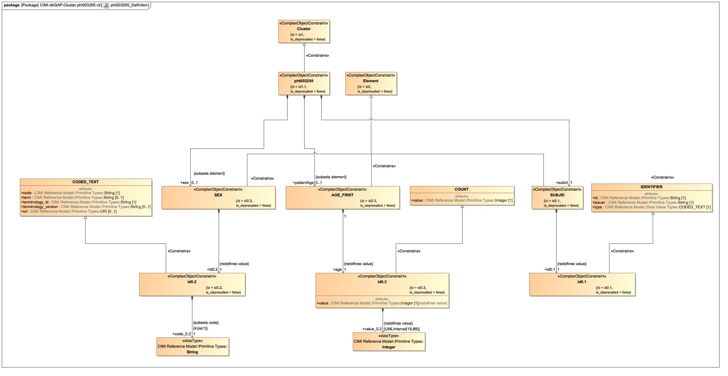

1. pht003255_Definition

### Known other classes

Class AGE_FIRST, Class Cluster, Class CODED_TEXT, Class COUNT, Class Element, Class id0.1, Class id0.2, Class id0.3, Class IDENTIFIER, Class pht003255, Class SEX, Class SUBJID

## pht003255_Terms

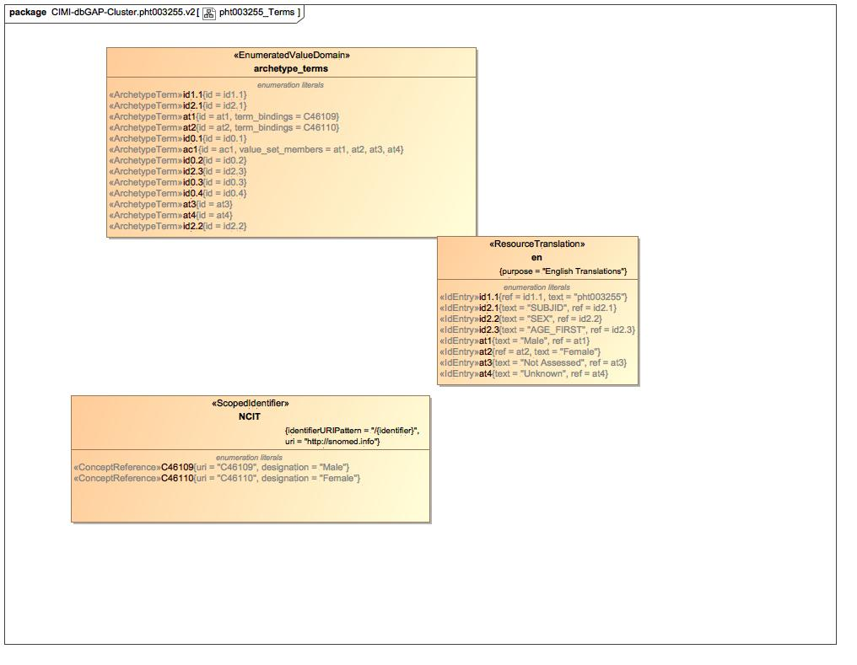

1. pht003255_Terms

### Known other enumerations

Enumeration archetype_terms, Enumeration en, Enumeration NCIT

# dbGAPArchetypeLibrary::CIMI-dbGAP-Cluster.pht003255.v2::Terminology::term-bindings

## Known other enumerations

Enumeration NCIT

# dbGAPArchetypeLibrary::CIMI-dbGAP-Cluster.pht003255.v2::Terminology::term-definitions

## Known other enumerations

Enumeration en

# dbGAPArchetypeLibrary::CIMI-dbGAP-Cluster.pht003255.v2::Terminology::terms

## Known other enumerations

Enumeration archetype_terms

# Tree

## Class Hierarchy

## Enumeration Hierarchy