Cybersecurity Practical Activities
Ahmed Mohamed Farah

1. Malware Testing – EICAR
I tested my antivirus/security software using the EICAR test file, a harmless file designed to simulate malware detection without containing actual malware.
Tool used: [Windows Defender]
I downloaded the EICAR test file from the official EICAR test-file source. When I tried to download or open it, my security software detected it as a threat and either blocked, quarantined, or removed it. The purpose of this practical was to verify that the antivirus/security system was working correctly.
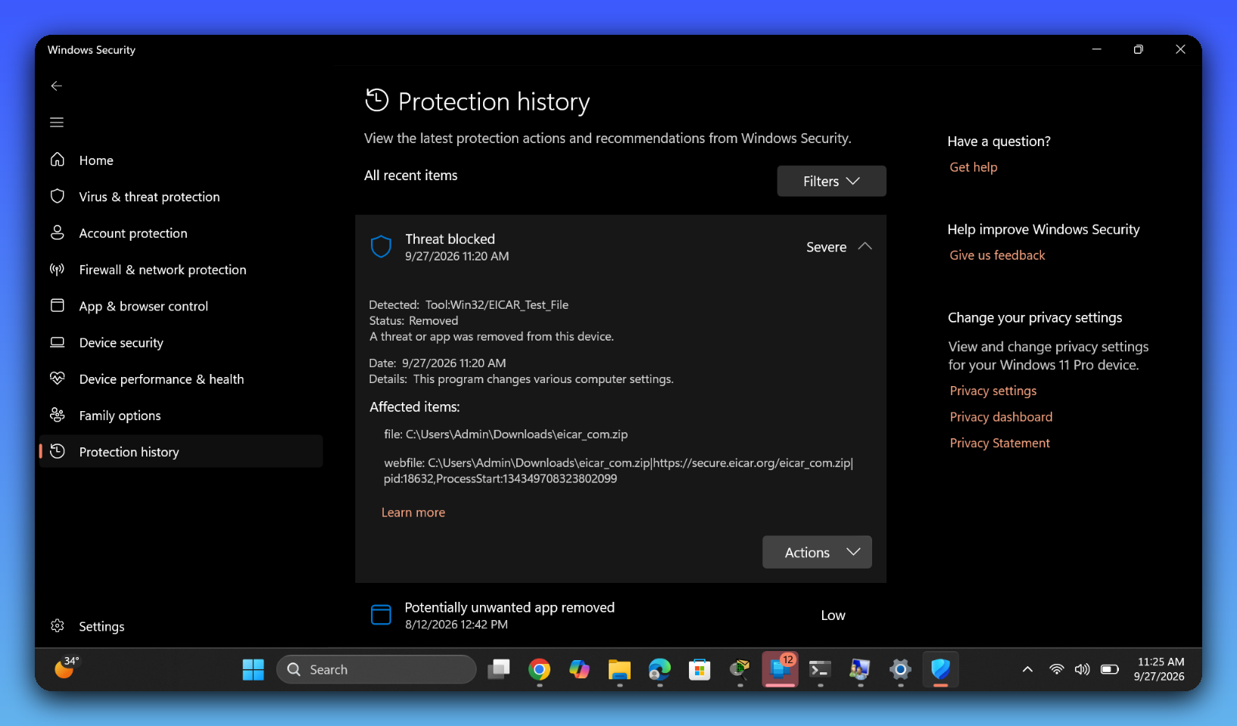

2. Restore Point
I created a System Restore Point in Windows:
- Searched for "Create a restore point"
- Opened System Properties
- Selected the System Protection tab
- Selected the system drive
- Clicked Create
- Gave the restore point a name
- Created the restore point
A restore point saves important system settings and configuration information. If a system problem occurs later, I can use System Restore to return Windows to an earlier configuration.
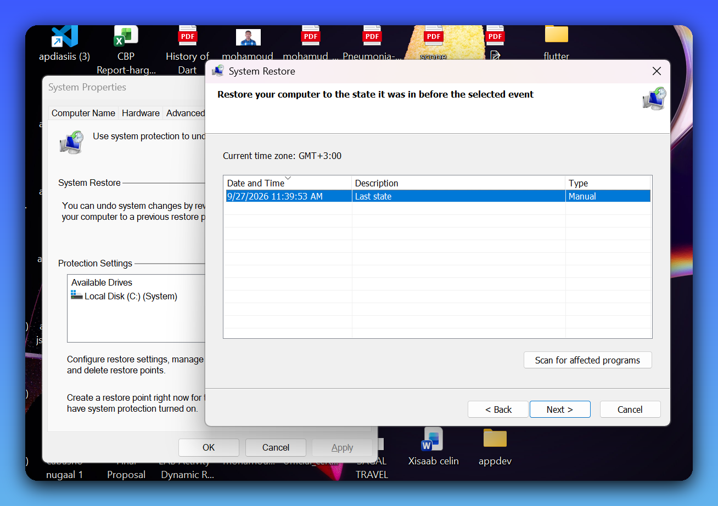

3. Encrypting Files – Locking Files/Folders
Tool used: [Windows]
I selected the file or folder I wanted to protect and used an encryption method available on my computer. The purpose was to prevent unauthorized people from reading the contents of the protected files.
Encryption changes readable data (plaintext) into unreadable data (ciphertext). Decrypting it back to readable form requires the correct password or key — without it, the file stays unreadable.
Readable File → Encryption → Encrypted File → Decryption (requires key/password) → Readable File
The main purpose of encryption is to protect the confidentiality of information.
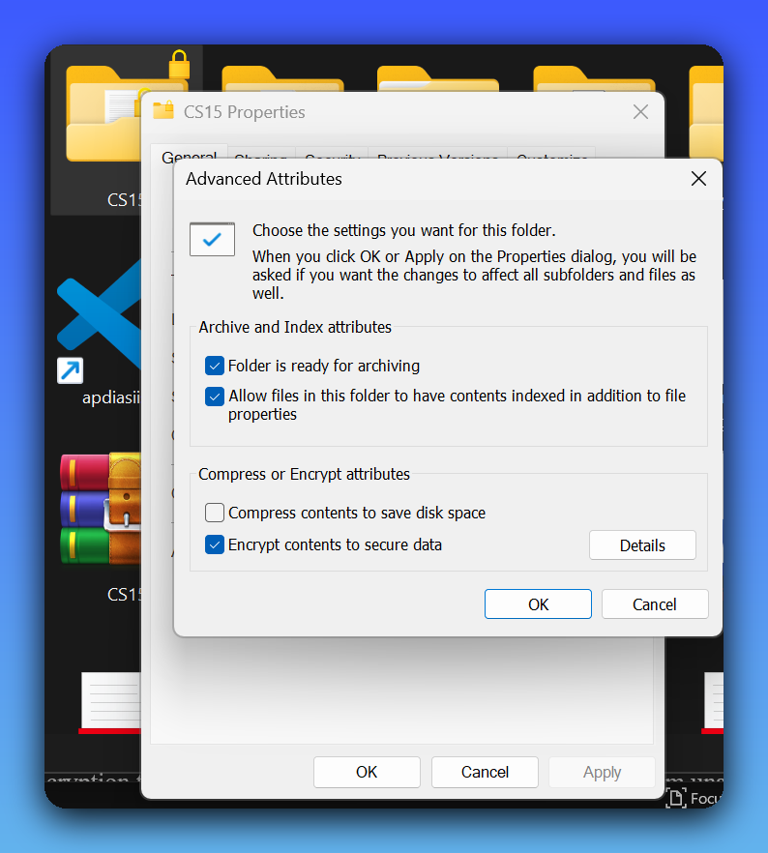

4. Using an Encryption Tool
Tool used: [VeraCrypt ]
I selected a file and used the encryption tool to protect it, setting a password. I then used the same password/key to decrypt the file and recover the original contents.
This practical helped me understand how encryption tools can be used to protect sensitive information from unauthorized access.
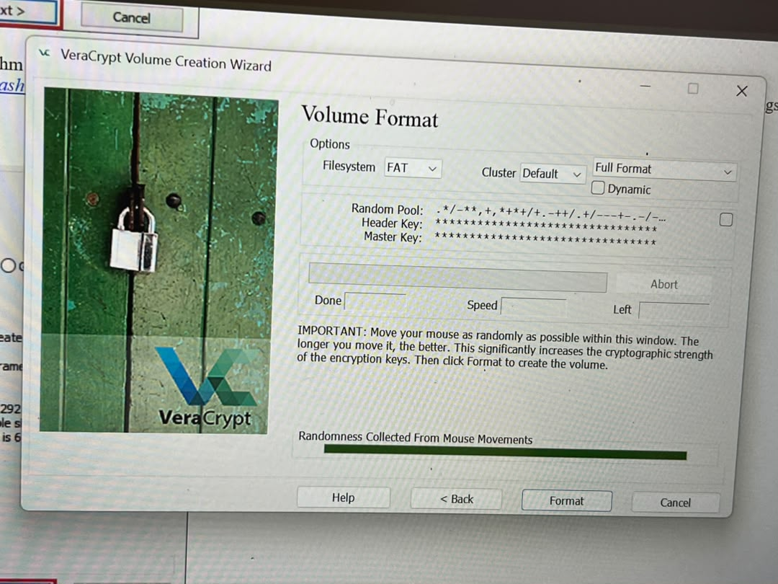

5. MySQL – MD5 Hashing
I practiced password hashing using MySQL/phpMyAdmin. Hashing and encryption are not the same thing: encryption is designed to be reversible with the correct key, while a cryptographic hash is designed to be one-way.
For example, MD5 can be used in MySQL with:
SELECT MD5('password123');
This produces an MD5 hash of the text. I also learned that MD5 should not be used for storing real user passwords in modern applications because it is considered insecure for password storage. Modern systems should use dedicated password-hashing algorithms such as Argon2id, bcrypt, or scrypt, preferably with a unique salt.
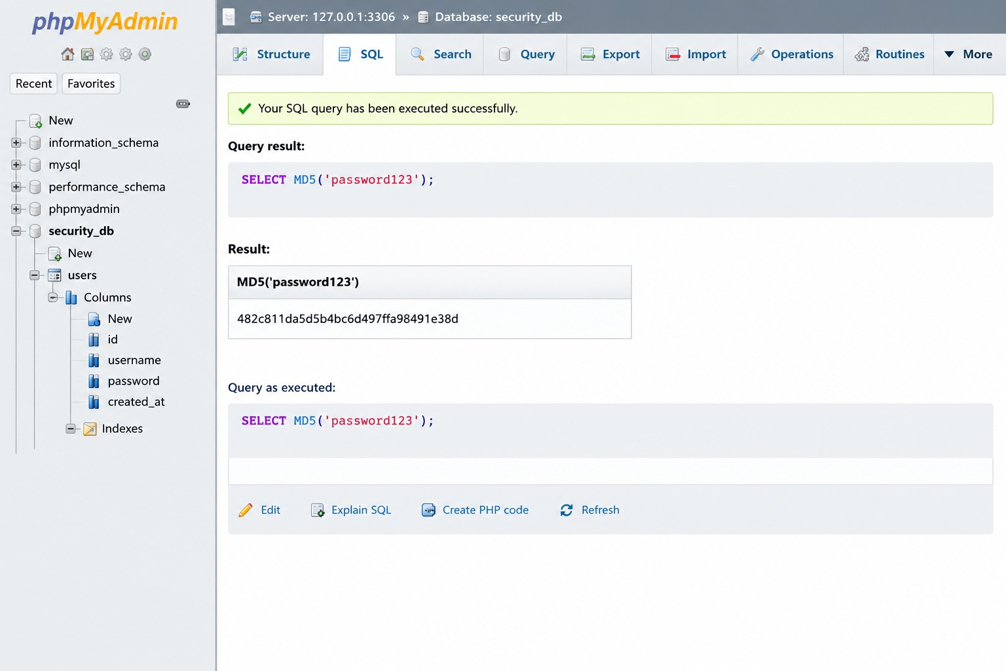

6. Email Security – Recovery and Multi-Factor Authentication
Provider used: [Gmail]
First, I added a recovery email address and/or recovery phone number so that I could recover my account if I lost access to it. Then I enabled Multi-Factor Authentication (MFA).
MFA provides an additional layer of security because logging in requires more than just a password:
Password + Verification Code / Authenticator → Account Access
This means that even if someone obtains my password, they may still be unable to access the account without the additional authentication factor.
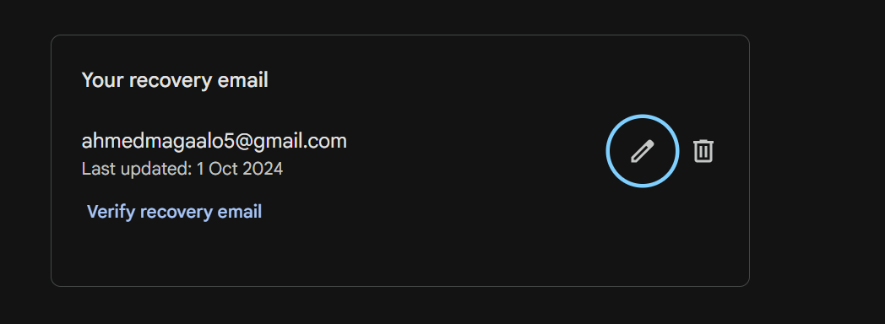
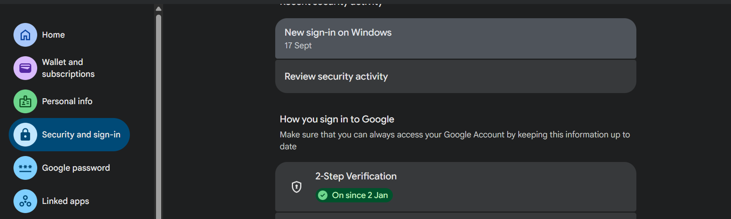

7. Password Security – Checking Password Strength
Tool used: [https://www.security.org/how-secure-is-my-password/].
I practiced password security by checking how strong a password is. I learned that a strong password should generally:
- Be long
- Be unique to the account
- Avoid easily guessed personal information
- Avoid common passwords
- Not be reused across multiple accounts
- Preferably be a long passphrase or generated password
Password strength is not only about using uppercase letters, lowercase letters, numbers, and symbols — length and uniqueness are very important. For real accounts, I should not enter an actual password into an unknown password-checking website. Instead, I can use a password manager's built-in strength assessment or test a deliberately fake/example password.
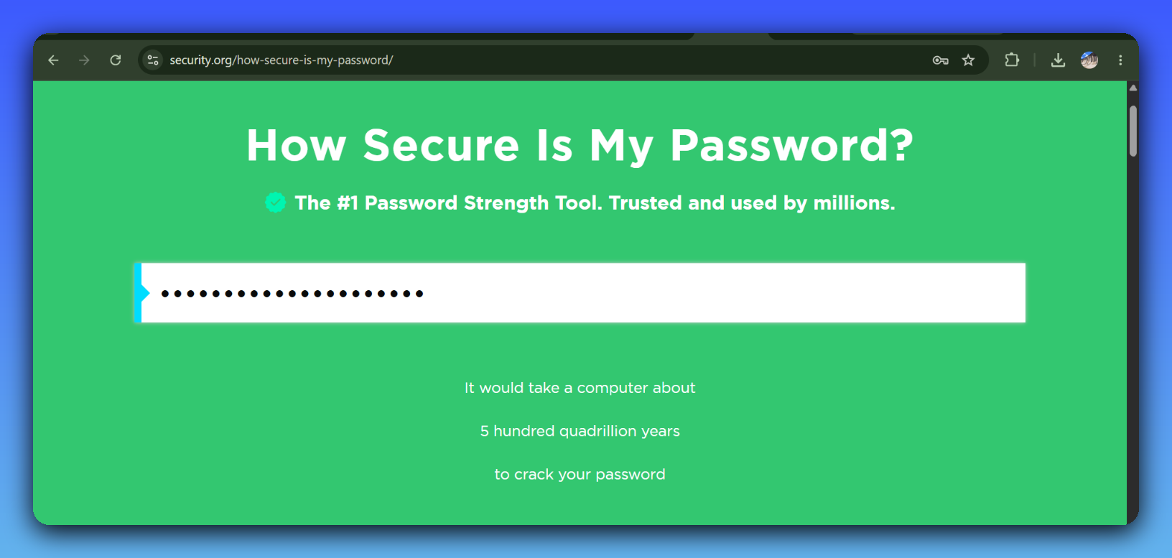

Conclusion
Through these practical activities, I learned how to apply several basic cybersecurity controls, including malware detection, system recovery, encryption, hashing, email security, MFA, and password security. These activities helped me understand how different security mechanisms protect the confidentiality, integrity, and availability of information.

