1. Get your API keys
- Go to newsapi.org → register for a free account → copy your API key
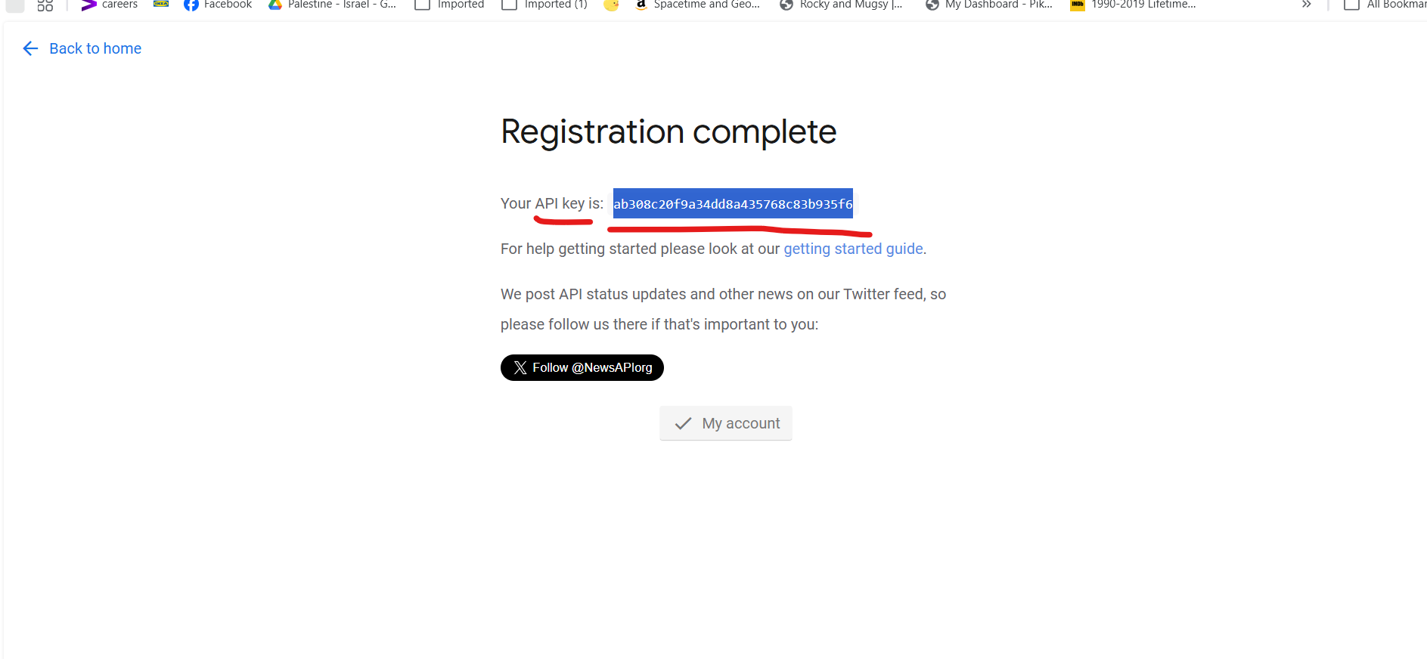

‘ab308c20f9a34dd8a435768c83b935f6’
- Go to https://console.groq.com/ → API Keys → create a new key → copy it

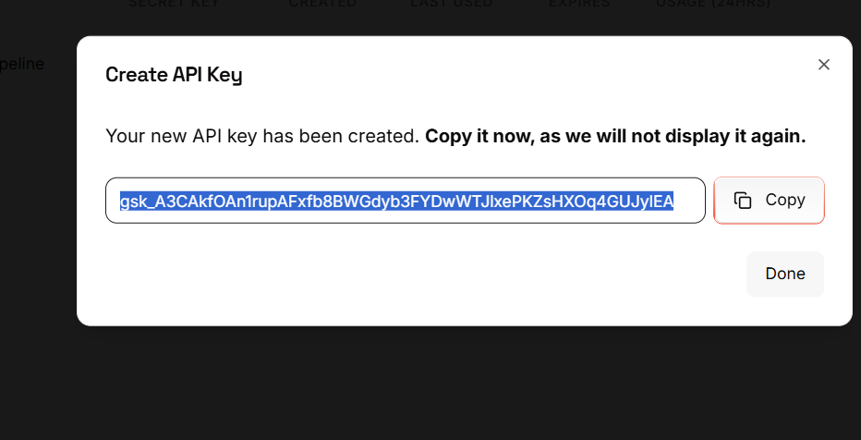

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
- Paste both into your .env file now while you're thinking about it
2. Set up your GCP project
- Go to console.cloud.google.com
- Create a new project called financial-sentiment-pipeline
- Enable the BigQuery API
- Create a BigQuery dataset called sentiment_data
- Create a service account, give it BigQuery Editor role, and download the JSON key file
- Drop that JSON key file into your project folder and add it to .gitignore
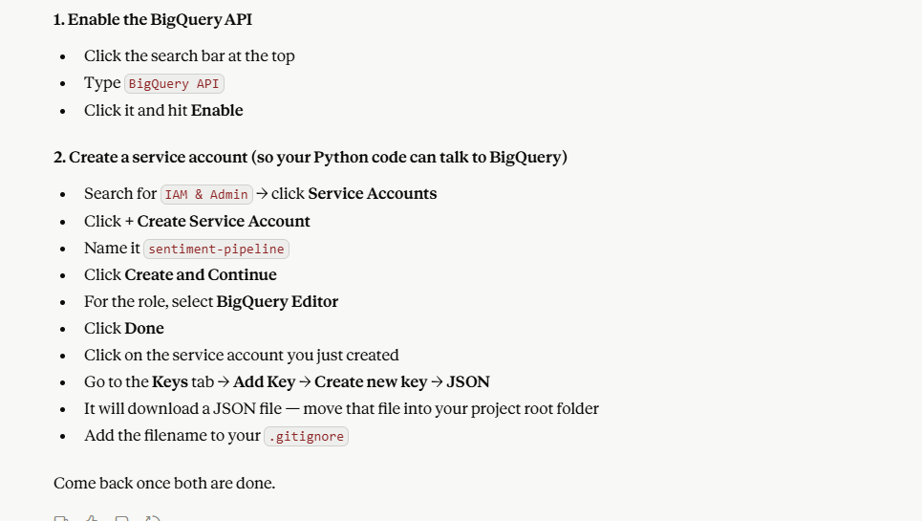
3. Set up your Python environment
- Open the terminal in VS Code
- Create a virtual environment: python -m venv venv
- Activate it
- Add a requirements.txt file to the project root
4. Initialize Git
- git init in the terminal
- Create a .gitignore that excludes .env and your GCP key file
- Make your first commit
- Create the repo on GitHub and push it up
Come back once all four of those are done and we'll write fetch_news.py together.

