CanopyIQ: An AI-Assisted Decision Support System for Urban Tree Management and Community Prioritization

CSCN8040 - Case Studies in AI and ML
Final Report

Team Name: CanopyIQ

Emmanuel Ihejiamaizu - 9080005
Liggia Elena Taboada Cruz - 9085905
Chao-Chung Liu - 9067679
Zhuoran Zhang - 9048508
Ce Chen - 9007166

Date: August 2026

Abstract
Municipal forestry departments need defensible ways to decide where limited planting, pruning, and inspection resources should go. This project developed CanopyIQ, an AI-assisted decision-support prototype that integrates open municipal tree inventories, Kitchener planning-community boundaries, canopy information, Landsat-derived land surface temperature context, and 2021 Census socio-economic data to support urban tree management and community prioritization. The final system combines a transparent community-level CanopyIQ Index with a secondary tree-removal classifier. The index ranks currently scoreable Kitchener planning communities using four equal components: tree-density deficit, observed attrition, genus monoculture, and inspection backlog. The final scored output contains 51 rankable communities after reconciling 55 planning boundaries, 52 communities with eligible tree records, and one community excluded because the inspection-backlog feature was unavailable. Civic Centre ranked first, with a CanopyIQ score of 0.765. Sensitivity testing showed strong index stability, with a median Spearman rank correlation of 0.996 across 1,000 Monte Carlo weight perturbations. For the tree-level classifier, the pooled Random Forest improved over simple baselines, reaching F1 = 0.589, ROC-AUC = 0.835, and PR-AUC = 0.692. However, the model remains influenced by pest and species history, especially the Fraxinus / Emerald Ash Borer signal. The main conclusion is that CanopyIQ is useful as an advisory planning tool, but final field decisions must remain with certified arborists and municipal staff.

1. Introduction
Urban forestry is a practical climate, infrastructure, and public-health issue for growing municipalities. Trees provide shade, reduce heat stress, improve streetscape quality, absorb stormwater, and create more livable neighbourhoods. At the same time, municipal forestry teams operate with constrained budgets, uneven inventory quality, and competing demands from planting, pruning, inspection, storm response, pest damage, and resident service requests. Without a consistent decision framework, work can become reactive: the loudest complaints, emergency failures, or historically better-documented areas may receive more attention than the places with the greatest combined environmental and operational need.
CanopyIQ addresses this problem as a decision-support system for urban tree management in the Waterloo Region context, with the final ranked output focused on Kitchener planning communities and cross-city modelling experiments using Kitchener and Waterloo tree inventories. The project does not claim to replace arborists, planners, or municipal policy decisions. Instead, it provides a transparent evidence layer that helps planners explain why one community should receive attention before another, what data support that recommendation, and where the system's own limitations require human review.
The research question guiding the project was: How can open municipal tree inventory and environmental datasets be integrated into a reproducible data-driven model to identify high-priority areas for urban forestry intervention? The final hypothesis was that combining tree asset condition, canopy and environmental context, and operational maintenance indicators into a centralized prioritization model would improve the defensibility of resource allocation and help planners identify communities where intervention may have greater ecological, equity, and infrastructure value.
The project evolved across several assignments. Early prototypes explored macro-level canopy and heat analysis, constructed budget forecasting, synthetic storm-risk scoring, and a GenAI-assisted development comparison. Those pieces remain useful as project history and prototype evidence. However, the final research report treats the transparent CanopyIQ community index as the primary empirical contribution, and the observed tree-removal classifier as a secondary machine-learning experiment. This distinction is important because models trained on constructed formula targets can demonstrate workflow feasibility, but they should not be treated as independent empirical discoveries.

2. Literature Review
Research on urban forestry consistently shows that tree benefits are not distributed evenly. Urban canopy cover is linked to heat mitigation, but the cooling benefit depends on local context such as impervious surface, tree density, and spatial scale (Ziter et al., 2019). This matters because a tree management system should not only count trees; it should also consider where tree canopy is missing and where environmental stress is likely to be higher. Studies of urban vegetation equity also show that access to urban greenness often differs by income, race, and neighbourhood conditions (Nesbitt et al., 2019). For CanopyIQ, this supports the decision to treat equity and data coverage as governance issues rather than cosmetic add-ons.
Urban forest management literature also emphasizes that street trees are infrastructure assets requiring proactive management. Vogt, Hauer, and Fischer (2015) argue that urban forest programs need asset-management approaches that connect inventory data to maintenance decisions. In the municipal setting, a useful model must therefore answer operational questions: where should staff inspect, prune, plant, and allocate budget first? The CanopyIQ Index follows this logic by combining density deficit, attrition, monoculture, and inspection backlog. Each component reflects a different practical risk: lack of trees, loss of trees, lack of species diversity, and insufficient recency of field assessment.
Machine-learning literature also shaped the final evaluation design. Random Forest models are useful for tabular data with nonlinear relationships and mixed feature types (Breiman, 2001), but they can also learn shortcuts from dominant historical patterns. In this project, the Fraxinus signal is a clear example: ash trees were strongly affected by Emerald Ash Borer, so a model can appear effective partly because it recognizes a species and pest-history pattern rather than a general theory of tree mortality. For imbalanced classification, accuracy alone is misleading because a model can achieve high accuracy by predicting the majority class. Therefore, this project reports F1, ROC-AUC, and PR-AUC, with particular attention to baselines and prevalence (Saito & Rehmsmeier, 2015).
The project also follows the CRISP-DM tradition of framing data science as an iterative process moving from business understanding through data preparation, modelling, evaluation, and deployment planning (Wirth & Hipp, 2000). This is appropriate because the project is not only a model-training exercise. It is a decision-support case study involving public data, municipal planning, stakeholder trust, accessibility, privacy, and operational adoption. The literature therefore supports three design principles used throughout the final system: keep the index explainable, evaluate predictive models against simple baselines, and treat AI output as advisory unless it has been validated in field operations.

3. Methodology
The methodology combined data integration, geospatial aggregation, transparent index construction, model evaluation, and prototype deployment. The analysis used Python notebooks for data processing and experimentation, with pandas, GeoPandas, Shapely, scikit-learn, XGBoost, PyTorch, Earth Engine/geemap, Matplotlib, Plotly, and Folium included in the project environment. The final demonstration layer was implemented as a lightweight Streamlit application so that the team could show code running and the application in use during the final presentation.
Dataset or artifact | Source / role | Use in final project
Kitchener Tree Inventory | City of Kitchener open data; 98,734 raw local records verified in the project copy. | Primary municipal tree asset source for index construction and classifier training.
Waterloo Street Tree Inventory | City of Waterloo open data; 53,499 raw local records verified in the project copy. | Cross-city tree records used for harmonized classifier experiments and transfer testing.
Kitchener planning communities | GeoJSON planning-community boundaries; 55 boundary polygons. | Spatial unit for community-level CanopyIQ ranking.
2021 Census and income data | Statistics Canada 2021 Census population, boundary, and income data. | Socio-economic context and equity discussion; joins are interpreted at aggregated areas.
Landsat/GEE summer LST cache | Local cache of Landsat-derived summer land surface temperature records from 2019-2026. | Environmental and heat context used as supporting evidence, not as the final index target.
Streamlit demo data | Derived CanopyIQ outputs: index CSV, community GeoJSON, model results JSON, metadata JSON. | Presentation-ready decision-support prototype and smoke-tested final artifact.
Table 1. Final data sources and roles in the CanopyIQ project.
Data preparation began by standardizing Kitchener and Waterloo tree records. The two cities used different schemas and coordinate conventions, so the notebooks harmonized core fields such as species/genus, status, diameter, coordinates, and municipality. The verified raw inventories contained 152,233 records. After filtering and harmonization for the classifier, 145,326 records remained: 92,918 from Kitchener and 52,408 from Waterloo. For the community-level index, tree records were spatially aggregated to Kitchener planning communities.
The community coverage reconciliation is a major quality-control step. The boundary file contained 55 planning-community polygons. Of these, 52 had eligible municipal tree records. Dundee, Pioneer Tower East, and Victoria North had no eligible tree records in the final aggregation. South Plains had tree records but lacked a valid inspection-backlog value, which meant the final four-component formula could not be computed after missing-value handling. The final ranked CanopyIQ output therefore contains 51 currently scoreable communities. This is reported transparently rather than hidden as a formatting issue.
Stage | Count | Explanation
Planning-community polygons | 55 | All polygons present in the Kitchener planning-boundary file.
Communities with eligible tree records | 52 | Communities represented after filtering and spatial aggregation of municipal tree inventory records.
Not represented by eligible tree records | 3 | Dundee, Pioneer Tower East, and Victoria North.
Excluded from final score due to missing backlog | 1 | South Plains had no valid inspection-backlog feature.
Final rankable CanopyIQ communities | 51 | Communities with all four required normalized indicators.
Table 2. Community coverage reconciliation for the final CanopyIQ Index.
The CanopyIQ Index was designed as a transparent multi-criteria score rather than a black-box model. Each community receives four normalized indicators: tree-density deficit, attrition, monoculture, and inspection backlog. The final score is the unweighted average of these four indicators: 0.25 times each component. Equal weighting is not treated as inherently neutral; it is a simple baseline policy choice that should be reviewed with municipal stakeholders. To test whether small reasonable weight changes would destabilize the ranking, the project used 1,000 Monte Carlo weight perturbations and measured rank stability using Spearman correlation and top-15 preservation.
Indicator | Interpretation | Why it matters
Tree-density deficit | Higher value indicates fewer living trees per hectare relative to other communities. | Identifies areas where planting or canopy expansion may be more urgent.
Attrition | Higher value indicates a larger share of removed trees among total records. | Signals asset loss, pest history, or maintenance stress.
Monoculture | Higher value indicates lower genus diversity. | Flags vulnerability to species-specific pests or disease.
Inspection backlog | Higher value indicates a longer time since the last recorded inspection. | Highlights operational uncertainty and need for field review.
Table 3. CanopyIQ Index indicators and planning interpretation.
The secondary predictive experiment estimated whether an individual tree was likely to be removed. This used observed municipal status labels rather than constructed budget formulas. The evaluation compared a majority-class baseline, a simple Fraxinus rule baseline, a pooled Random Forest trained on both cities, a Random Forest with Fraxinus records removed, and two cross-city transfer experiments. F1 was used because the removal class is imbalanced and both false positives and false negatives matter. ROC-AUC and PR-AUC were included to assess ranking quality, with PR-AUC emphasized because the positive class prevalence is below 20% in the pooled test set.

4. Results
The primary CanopyIQ output is a ranked list of Kitchener communities based on the four-component index. Civic Centre ranked first with a score of 0.765. It combined high attrition, low tree density relative to other communities, high monoculture risk, and a long inspection backlog. Trillium Industrial Park ranked second with a score of 0.706, driven especially by the density-deficit component. Eastwood, Westmount, KW Hospital, King East, Fairfield, Bridgeport East, Mt. Hope Huron Park, and Bridgeport West completed the top ten. Victoria Park ranked last among the scored communities, with a score of 0.200.
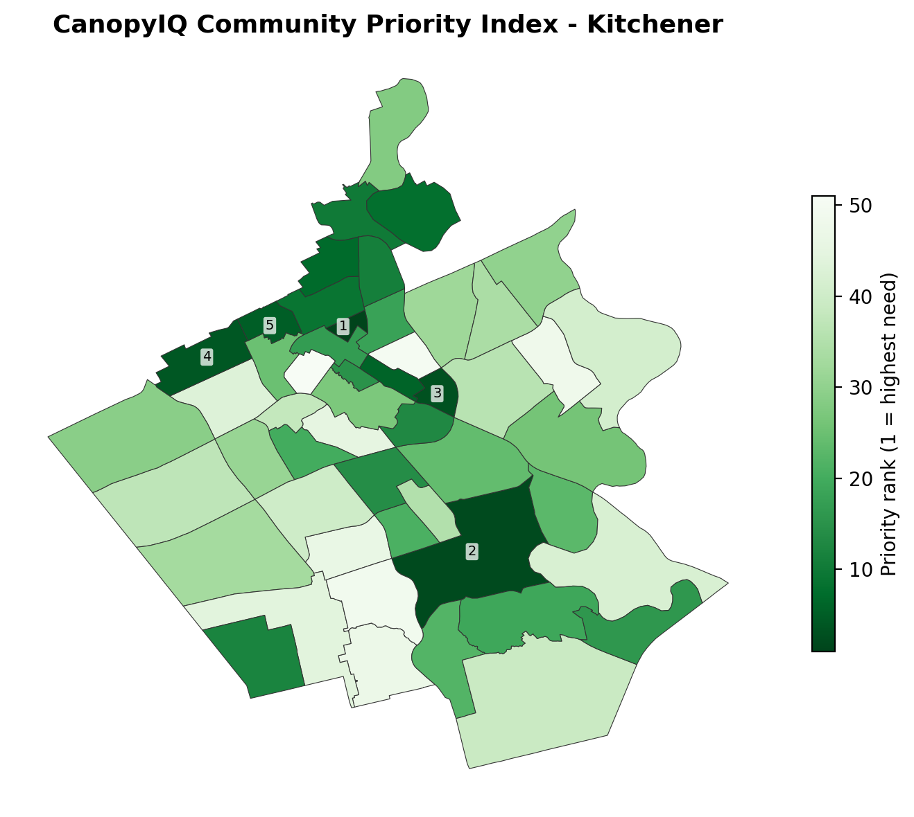
Figure 1. CanopyIQ community priority map for 51 currently rankable Kitchener communities.
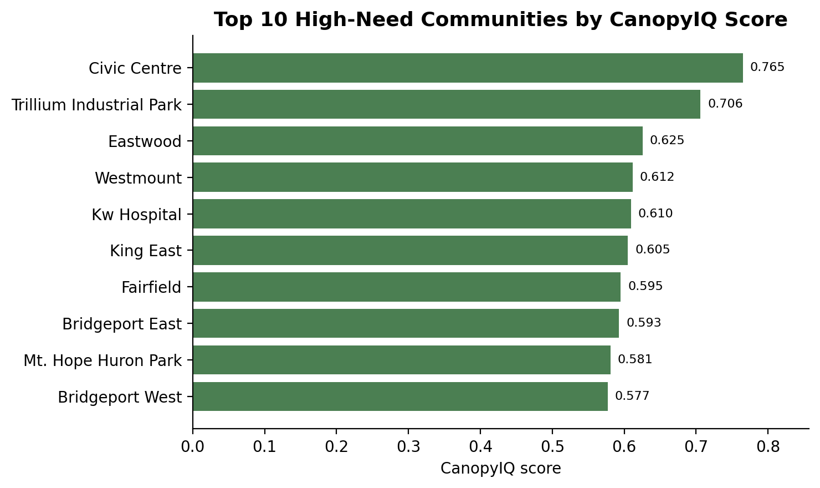
Figure 2. Top 10 high-need communities by CanopyIQ score.
The Civic Centre and Victoria Park comparison illustrates why the index is useful for communication. Civic Centre has a high inspection-backlog component of 0.938, attrition of 0.718, and monoculture score of 0.740, while Victoria Park scores low overall. Rather than simply saying one place is high priority and another is low priority, the index decomposes the ranking into reasons that planners can review, challenge, or validate with field knowledge.
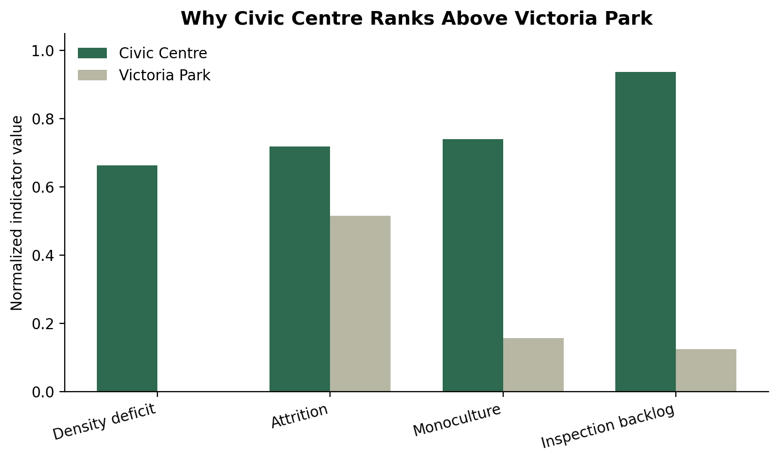
Figure 3. Component comparison between Civic Centre and Victoria Park.
The sensitivity analysis supports the stability of the index. Across 1,000 Monte Carlo weight perturbations, the median Spearman rank correlation was 0.996, the fifth percentile was 0.990, and the minimum observed value was 0.985. Every draw remained above 0.95. The median top-15 preservation rate was 100%, with a fifth percentile of 93.3%. This means that the highest-need group is not an artifact of one exact set of weights. However, the single-indicator comparison shows why the composite index is necessary: deficit-only and attrition-only rankings had low agreement with the final index, while backlog-only showed stronger but still incomplete alignment.
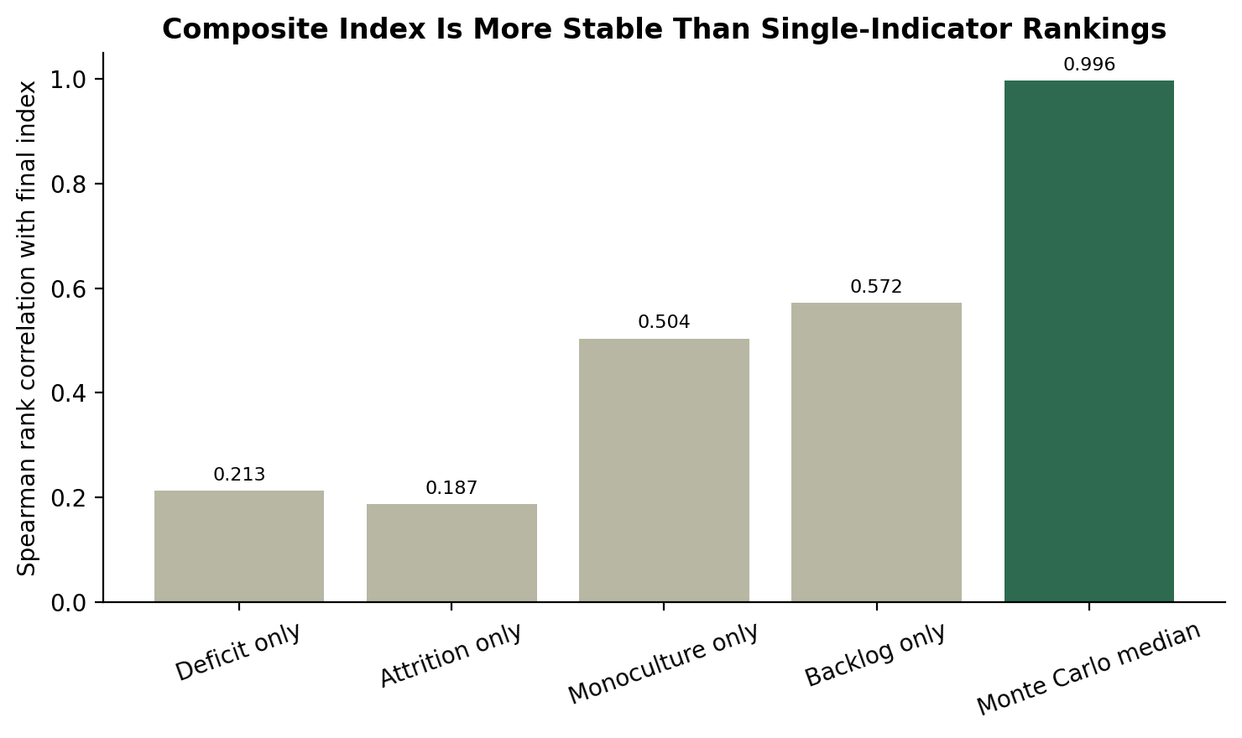
Figure 4. Rank stability of the composite index compared with single-indicator rankings.
The tree-removal classifier produced a more nuanced result than the earlier interim interpretation. The majority-class baseline achieved accuracy of 0.803 but F1 of 0.000 because it never predicted the removal class. The single Fraxinus rule performed much better, with F1 = 0.558, ROC-AUC = 0.696, and PR-AUC = 0.484. The pooled Random Forest outperformed both baselines on the key metrics, with F1 = 0.589, ROC-AUC = 0.835, and PR-AUC = 0.692. Therefore, the final evidence does not support rejecting the Random Forest outright. It suggests that the model captures useful additional information beyond the simple ash-tree rule.
Model | Accuracy | Precision | Recall | F1 | ROC-AUC | PR-AUC
Majority class baseline | 0.803 | 0.000 | 0.000 | 0.000 | 0.500 | 0.197
Fraxinus rule baseline | 0.874 | 0.913 | 0.401 | 0.558 | 0.696 | 0.484
Pooled Random Forest | 0.818 | 0.531 | 0.660 | 0.589 | 0.835 | 0.692
Random Forest without Fraxinus | 0.697 | 0.250 | 0.671 | 0.364 | 0.749 | 0.341
Kitchener -> Waterloo transfer | 0.808 | 0.548 | 0.605 | 0.575 | 0.773 | 0.650
Waterloo -> Kitchener transfer | 0.660 | 0.298 | 0.597 | 0.398 | 0.664 | 0.366
Table 4. Final classifier results from the executed model output.
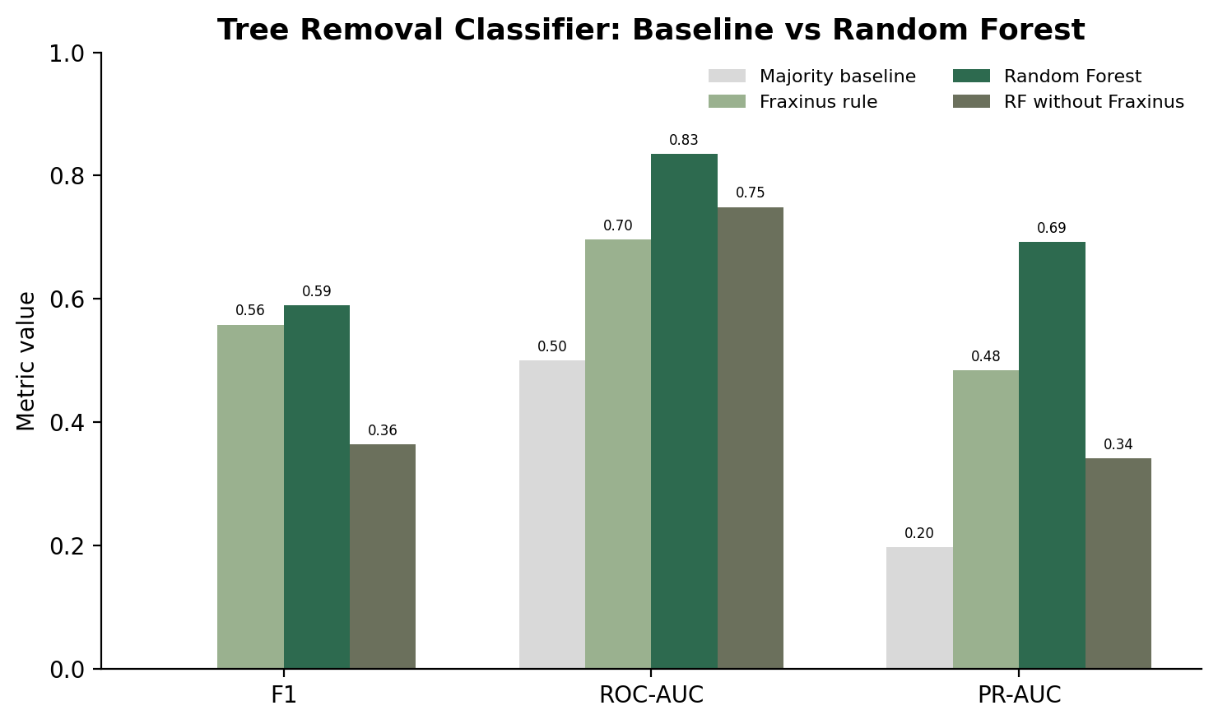
Figure 5. Classifier performance compared with majority and Fraxinus baselines.
The ablation and transfer results add caution. Removing Fraxinus records reduced the model from ROC-AUC = 0.835 and PR-AUC = 0.692 to ROC-AUC = 0.749 and PR-AUC = 0.341. This is not a total collapse, but it is a clear drop in positive-class ranking quality. Cross-city transfer was also asymmetric: a model trained on Kitchener and tested on Waterloo reached ROC-AUC = 0.773, while a model trained on Waterloo and tested on Kitchener reached ROC-AUC = 0.664. This suggests that shared regional patterns exist, but city-specific inventory practices, species distributions, and historical removal patterns matter. The appropriate conclusion is not that the classifier is useless; it is that it should be used cautiously as a planning signal and monitored over time.

5. Discussion and Conclusions
The results support the central hypothesis in a qualified way. CanopyIQ successfully integrates municipal tree inventory and planning-community data into a reproducible prioritization framework. The index identifies high-need communities using multiple interpretable criteria, and the Monte Carlo tests indicate that the ranking is stable under reasonable weight changes. The prototype also demonstrates how the output can be made usable in a live application rather than remaining buried in notebooks.
The results also refine the team's understanding of what should count as evidence. Early constructed cost and storm-risk formulas were helpful for experimentation, but final empirical claims should not depend on targets created from the same variables used as predictors. For that reason, the final research narrative prioritizes the CanopyIQ Index and the observed tree-removal classifier. This is more academically defensible and more useful for municipal users because it separates demonstrated evidence from prototype history.
Practically, the index can help planners explain budget choices in terms of community need. A single-priority map is easy to communicate, but it can be politically sensitive. The component breakdown is therefore just as important as the final score. It allows staff to say that a community ranks highly because of specific combinations such as low tree density, high attrition, high monoculture, and long inspection backlog. It also allows council, arborists, or residents to question whether those inputs are complete or whether local knowledge changes the interpretation.
The classifier has value, but it should not be oversold. Its performance improves over a simple Fraxinus rule, which means it is learning more than one obvious pest-history signal. At the same time, the no-Fraxinus and cross-city experiments show that generalization is imperfect. In a real municipal deployment, this model should trigger review, not removal. It should help build inspection queues and flag records for arborist attention, while actual field decisions remain human decisions.
The main limitations are specific. First, not every planning community can currently be scored because the final index requires all four indicators. South Plains highlights the need for explicit missing-data handling or a data-coverage confidence flag. Second, municipal inventories are not perfect representations of the entire urban forest: private trees, wooded natural areas, and under-inventoried spaces may be missing or incomplete. Third, the use of equal index weights is transparent but still value-laden. Municipal stakeholders should validate or adjust weights through a workshop or policy process. Fourth, the classifier is shaped by historical removal and pest patterns, so it can reproduce past operational decisions if those decisions were uneven.
Future work should focus on turning CanopyIQ into a field-ready pilot. The first technical improvement is to add a confidence layer that separates true low-need communities from low-data communities. The second is to include a formal weight-setting interface so planners can test scenarios without changing code. The third is to integrate inspection feedback so arborist decisions become new ground truth for retraining. The fourth is to perform a fairness review comparing proactive resource allocation against socioeconomic and heat-vulnerability indicators. Finally, the prototype should be tested with real forestry staff to evaluate whether the output is understandable, trusted, and operationally useful.

6. Ethics and Responsible AI
The core responsible-AI principle for this project is simple: CanopyIQ advises; arborists decide. The system should not authorize tree removal, deny service, or automatically allocate municipal budget without accountable human review. This principle is especially important because the data are property-adjacent. A tree-level coordinate often corresponds to a residential frontage, and a risk score attached to that point can become sensitive operational information even when it is not a traditional personal identifier.
Accessibility is also a real requirement, not a design preference. A map-only dashboard can exclude users who rely on screen readers or who cannot distinguish colour-coded priority zones. The Streamlit prototype therefore includes tabular equivalents and plain-language explanations of the score. In a municipal procurement setting, the public-facing version should be tested against WCAG requirements and should include downloadable tables for every map view.
Equity concerns appear in both data and governance. Under-inventoried communities can look like low-need areas if the system cannot distinguish between few trees and few records. Equal weighting can also seem neutral while still encoding policy choices. To reduce these risks, the final design should include a data-coverage confidence flag, an explicit stakeholder weight-setting process, and a Green Equity KPI that publicly reports whether proactive forestry spending reaches lower-income and higher-heat areas.
Privacy and security controls should be designed into the product. Socioeconomic joins should remain at aggregate geographic levels, not attached to individual tree coordinates. Public outputs should focus on community-level scores, while tree-level probabilities should remain internal to authenticated forestry operations. If the prototype later connects to Cityworks or another work-order system, integrity becomes a critical security issue because a compromised export could redirect crews and municipal budget. Role-based access control, TLS, schema validation, and immutable override logging are therefore practical requirements.
The model card in Appendix A summarizes intended use, limitations, data, metrics, and human oversight. The final ethical conclusion is not that CanopyIQ should be avoided. It is that the system is acceptable only as a decision-support tool with transparent scoring, clear limitations, human review, accessibility safeguards, and continuous monitoring. That framing is consistent with the technical evidence: the index is stable and explainable, while the classifier is useful but sensitive to species and municipality-specific patterns.

References
Breiman, L. (2001). Random forests. Machine Learning, 45, 5-32.
City of Kitchener. (n.d.). Tree Inventory. Kitchener GeoHub Open Data.
City of Waterloo. (n.d.). Street Tree Inventory. City of Waterloo Open Data.
He, H., & Garcia, E. A. (2009). Learning from imbalanced data. IEEE Transactions on Knowledge and Data Engineering, 21(9), 1263-1284.
Nesbitt, L., Meitner, M. J., Girling, C., Sheppard, S. R. J., & Lu, Y. (2019). Who has access to urban vegetation? A spatial analysis of distributional green equity in 10 US cities. Landscape and Urban Planning, 181, 51-79.
Ontario. (2011). O. Reg. 191/11: Integrated Accessibility Standards under the Accessibility for Ontarians with Disabilities Act, 2005.
Saito, T., & Rehmsmeier, M. (2015). The precision-recall plot is more informative than the ROC plot when evaluating binary classifiers on imbalanced datasets. PLOS ONE, 10(3), e0118432.
Statistics Canada. (2022). Census Profile, 2021 Census of Population.
Statistics Canada. (2023). 2021 Census boundary files.
Vogt, J. M., Hauer, R. J., & Fischer, B. C. (2015). The costs of maintaining and not maintaining the urban forest: A review of the urban forestry and arboriculture literature. Arboriculture & Urban Forestry, 41(6), 293-323.
Wirth, R., & Hipp, J. (2000). CRISP-DM: Towards a standard process model for data mining. Proceedings of the Fourth International Conference on the Practical Application of Knowledge Discovery and Data Mining.
Ziter, C. D., Pedersen, E. J., Kucharik, C. J., & Turner, M. G. (2019). Scale-dependent interactions between tree canopy cover and impervious surfaces reduce daytime urban heat during summer. Proceedings of the National Academy of Sciences, 116(15), 7575-7580.

Appendix A: Model Card
Field | CanopyIQ model card summary
Model name | CanopyIQ community index and tree-removal classifier.
Model type | Transparent four-component community index plus secondary Random Forest classifier for observed tree-removal status.
Intended use | Support municipal planning, prioritization, inspection queues, and public explanation of forestry resource allocation.
Out-of-scope use | Automated tree removal, safety certification, denial of service, or final budget allocation without human review.
Input data | Municipal tree inventories, planning-community boundaries, derived indicators, and contextual environmental/socioeconomic data.
Output | Community rank and score; classifier metrics and estimated removal-risk signal for internal planning.
Performance | Pooled Random Forest: F1 = 0.589, ROC-AUC = 0.835, PR-AUC = 0.692.
Known limitations | Missing-data sensitivity, inventory coverage gaps, species/pest-history dependency, and asymmetric cross-city generalization.
Human oversight | Certified arborists and municipal staff retain final decision authority.
Monitoring | Annual retraining, drift review, override audit logs, and fairness/equity reporting.

Appendix B: Team Contributions
Contribution area | Contributor(s)
Problem Definition & Project Concept | Emmanuel, Liggia, Zhuoran, Chao-Chung, Ce
Literature Review & Academic Research | Liggia, Chao-Chung, Emmanuel, Zhuoran, Ce
Dataset Discovery & Acquisition | Chao-Chung, Liggia, Zhuoran, Emmanuel, Ce
Data Cleaning & Quality Analysis | Chao-Chung, Ce
Cross-City Data Harmonization | Liggia, Chao-Chung
Geospatial Analysis | Chao-Chung, Emmanuel
Temperature & Socioeconomic Analysis | Liggia, Zhuoran, Chao-Chung
Feature Engineering & CanopyIQ Index | Ce
Machine-Learning Development | Chao-Chung, Emmanuel
Model Evaluation & Validation | Zhuoran
Rapid Prototyping / GenAI Work | Emmanuel
AI Integration & Architecture | Ce
Performance Management | Liggia
Ethics, Privacy, Security & Responsible AI | Emmanuel
Visualizations & UI/Dashboard | Liggia, Chao-Chung, Zhuoran, Ce
Repository & Technical Documentation | Chao-Chung
Report Writing & Editing | Emmanuel, Liggia, Chao-Chung, Ce, Zhuoran
Presentation & Demonstration | Emmanuel, Chao-Chung
Project Coordination | Emmanuel, Chao-Chung, Liggia, Zhuoran, Ce
Final QA & Submission Review | Emmanuel, Chao-Chung, Liggia, Zhuoran, Ce

Appendix C: Streamlit Prototype Evidence
The final demonstration package is a lightweight Streamlit application that uses the verified CanopyIQ outputs: community GeoJSON, index CSV, model-results JSON, metadata JSON, and a feature-importance image. The application was smoke-tested to confirm that it starts, the Kitchener map displays, all five sections work, Civic Centre appears as rank 1, Civic Centre versus Victoria Park comparison works, and the model-evaluation page shows ROC-AUC = 0.835.

