Enhancing Urban Forestry Planning with an AI-Powered Tree Canopy Decision Support System
Introduction
The cities of Kitchener, Waterloo, and Cambridge continue to invest in urban forestry programs to improve environmental quality, reduce urban heat, and increase community well-being. However, municipal forestry teams often face limited budgets and staffing resources, making it difficult to prioritize where tree planting and maintenance efforts will have the greatest impact.
Although municipalities maintain datasets such as tree inventories and canopy coverage records, these datasets are often analyzed separately, which makes location-specific planning slower and less consistent. To improve decision-making, the municipalities aim to implement an AI-powered Decision Support System (DSS) that integrates environmental and tree asset data into a unified prioritization framework.
This system helps planners identify streets and neighborhoods where tree planting or maintenance would provide the highest environmental, social, and infrastructure benefit.

Part 1: Role-Playing DSS Stakeholders
1.Operations Manager (Municipal Forestry Department)
- Goal: Efficiently schedule daily tree pruning using DSS data, which directly conflicts with the Data Scientist’s need to pause workflows for data cleaning.
- Fear: AI budget predictions might be inaccurate, causing asset maintenance delays or wrong workflow schedules.
- Secret Concern: Worried senior leadership will blame the operations team if the new DSS forecasts fail.
- KPI: Operational maintenance cost reduction percentage and emergency repair response speed.
2. Data Scientist (AI System Architect)
- Goal: Build a reliable Linear Regression model using tree size (DBH) to predict costs accurately.
- Fear: Poor input data quality or unexpected storm events might break the model’s prediction accuracy.
- Secret Concern: To protect the model from failing, the Data Scientist forces strict data-entry KPIs on the Operations Manager, causing tension over daily workload.
- KPI: Model R-squared fitting accuracy and data pipeline processing time.
3. City Financial Officer (CFO / Senior Leadership)
- Goal: Maximize the ROI of the $3.3M canopy plan and eliminate expensive 50%–100% storm surcharges.
- Fear: The CFO's aggressive ROI pressure forces the Data Scientist to rush model deployment before completing full data-quality testing.
- Secret Concern: Worried about public criticism and political risk if tree maintenance budgets are unevenly allocated between neighborhoods.
- KPI: Annual municipal forestry budget savings and financial resource utilization index.

Part 2: Data Analysis and Visualization

1. Core Challenge Faced
Traditionally, municipal forestry budgets are allocated equally across all neighborhoods. However, the City of Kitchener and Waterloo faces a critical challenge: unpredictable financial risk from aging tree assets and reactive storm response. Without data-driven insights, the city often incurs a 50% to 100% emergency surcharge for tree removals after storms occur.
2. Data Insights and Visualizations
To address this, we integrated tree inventory, LiDAR canopy, and census data to identify specific risk patterns.
- Urban Heat Island Effect Scatter Plot
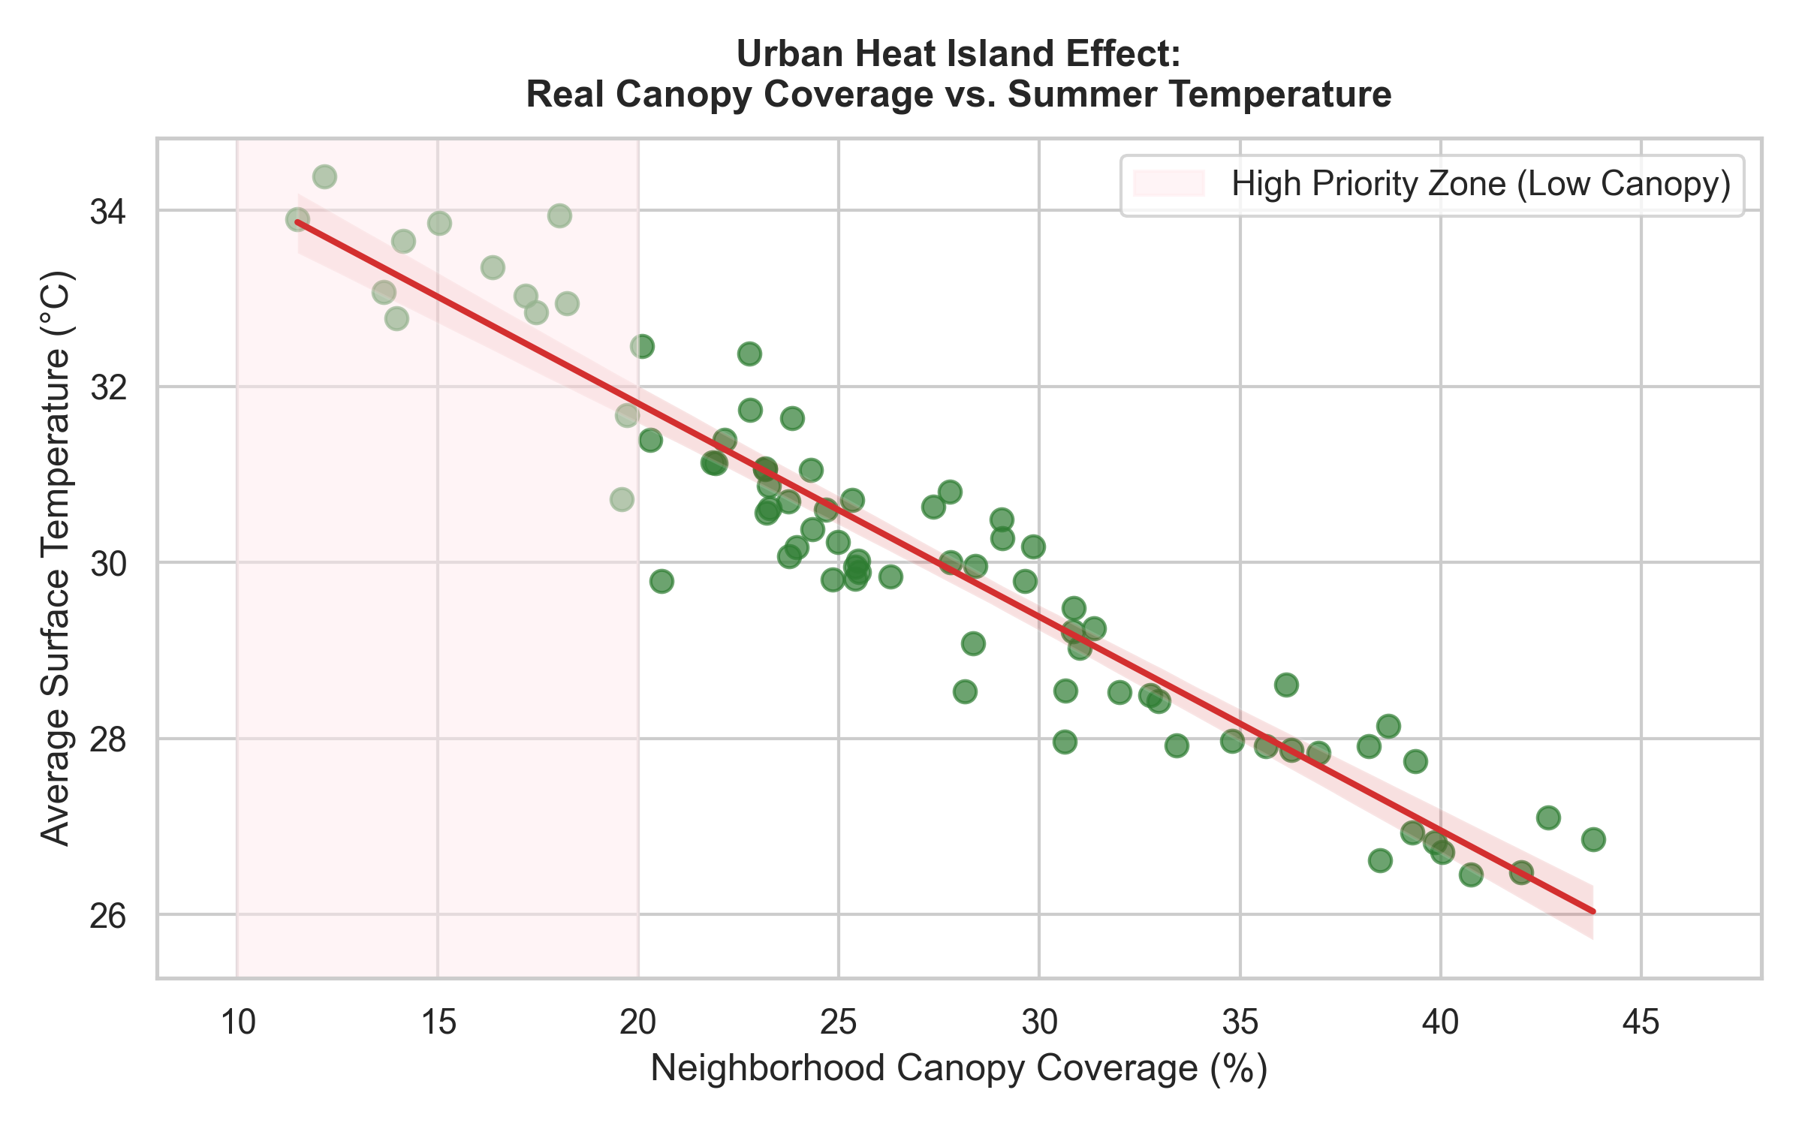

Data sources: Municipal tree inventory, GIS canopy datasets, and neighbourhood boundaries.
Output: Neighborhoods with canopy under 20% face extreme heat stress (32°C - 34°C). This data justifies the need for a DSS to prioritize "cooling infrastructure" in low-canopy zones. This finding strongly aligns with the empirical evidence from Ziter et al. (2019), which states that urban tree canopy must be strategically deployed at a neighborhood scale to effectively mitigate the Urban Heat Island (UHI) effect and lower surface temperatures.
- Top 5 Neighborhoods for Critical Maintenance
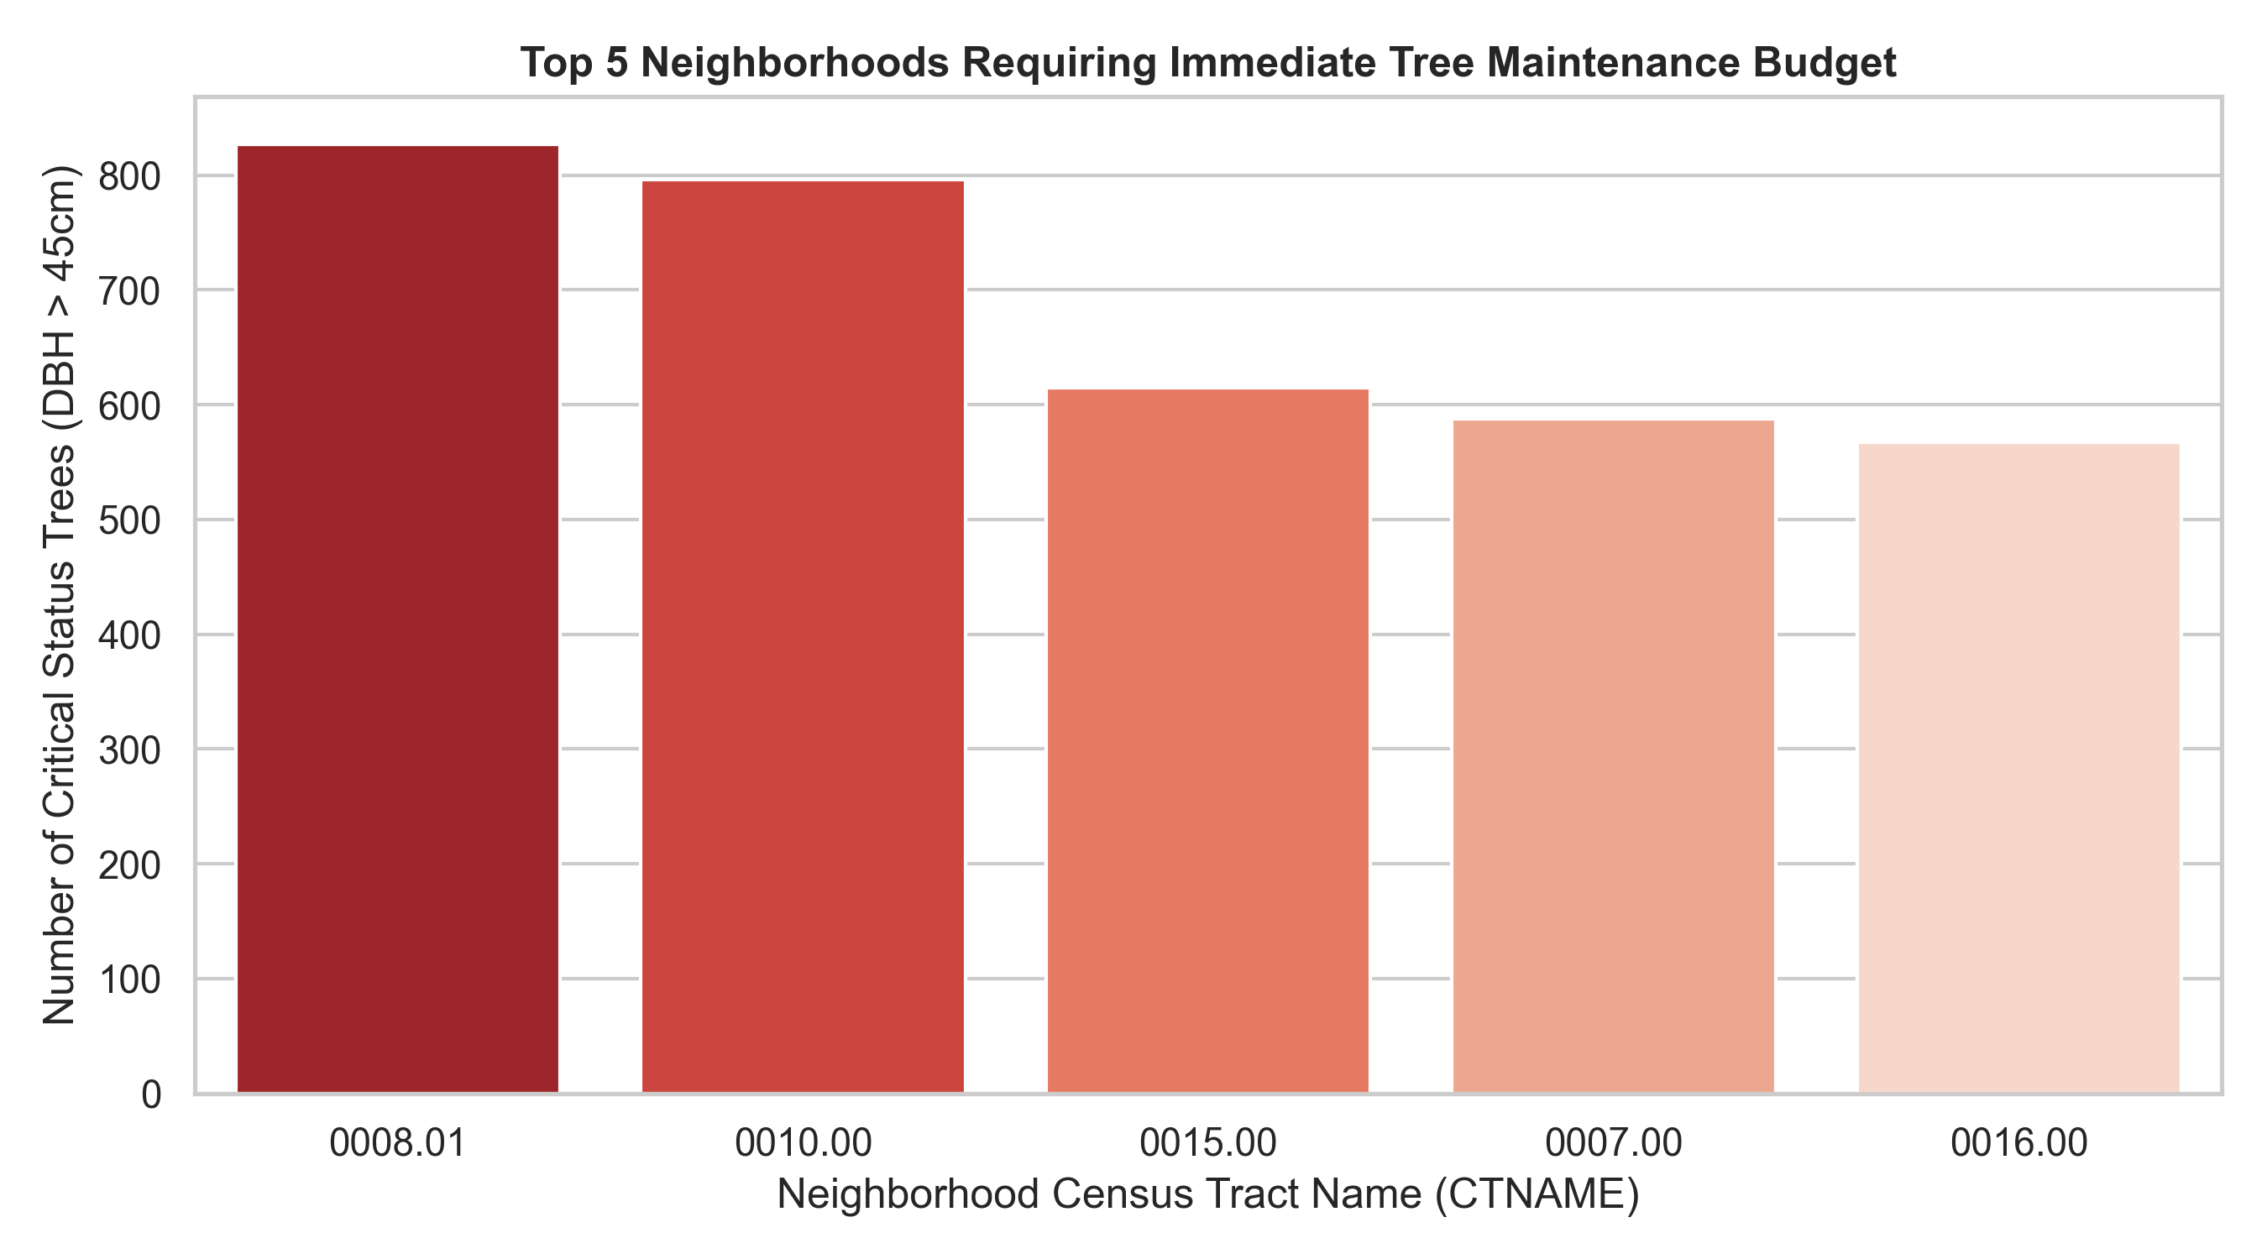

Data sources: Tree asset attributes (ID, Species, dbh_cm trunk size), and 2026 municipal maintenance market rates.
Output: Asset risks are not evenly distributed. A small number of neighborhoods (e.g., census tracts 0007.00 and 0003.00) contain the majority of aging trees (DBH > 45cm). Managing these specific areas proactively is the most efficient way to reduce city-wide financial losses.

- DSS Canopy Equity Dashboard
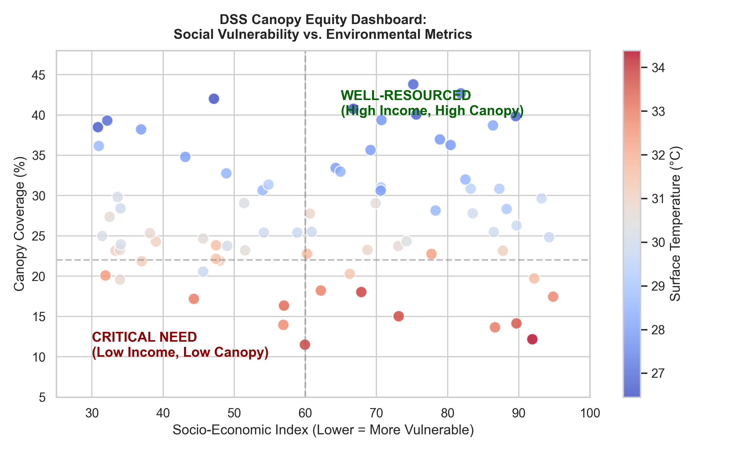
Data sources: 2021 Canadian Census Boundary Files (Socio-Economic Index, Land Area), and Region of Waterloo ESPA (Environmentally Sensitive Policy Area) layers.
Output: Our analysis identifies neighborhoods in the "Critical Need" quadrant (low-income and low-canopy). This insight allows the city to move from "complaint-based" scheduling to "equity-weighted" allocation. According to Nesbitt et al. (2019), urban canopy benefits are historically correlated with socio-economic factors, leading to environmental injustice. By embedding census data, our DSS ensures that green infrastructure investments are distributed equitably rather than based on political influence.

3. Proposed DSS-Based Solutions
Based on these insights, we propose a Proactive Asset Management Framework:
- Automated Budget Targeting: The DSS will automatically allocate 60% of the $3.3M canopy plan budget to the high-density risk spots identified in our maps before the storm season.
- Surcharge Prevention: By targeting trees with DBH > 45cm proactively at a standard cost of $1,200 CAD, the system prevents the much higher costs of reactive emergency removals.
- Equity-Driven Sapling Deployment: The system will assign higher weights to underserved neighborhoods in future planting cycles to ensure environmental ROI.

Part 3: Building a Simple AI Model
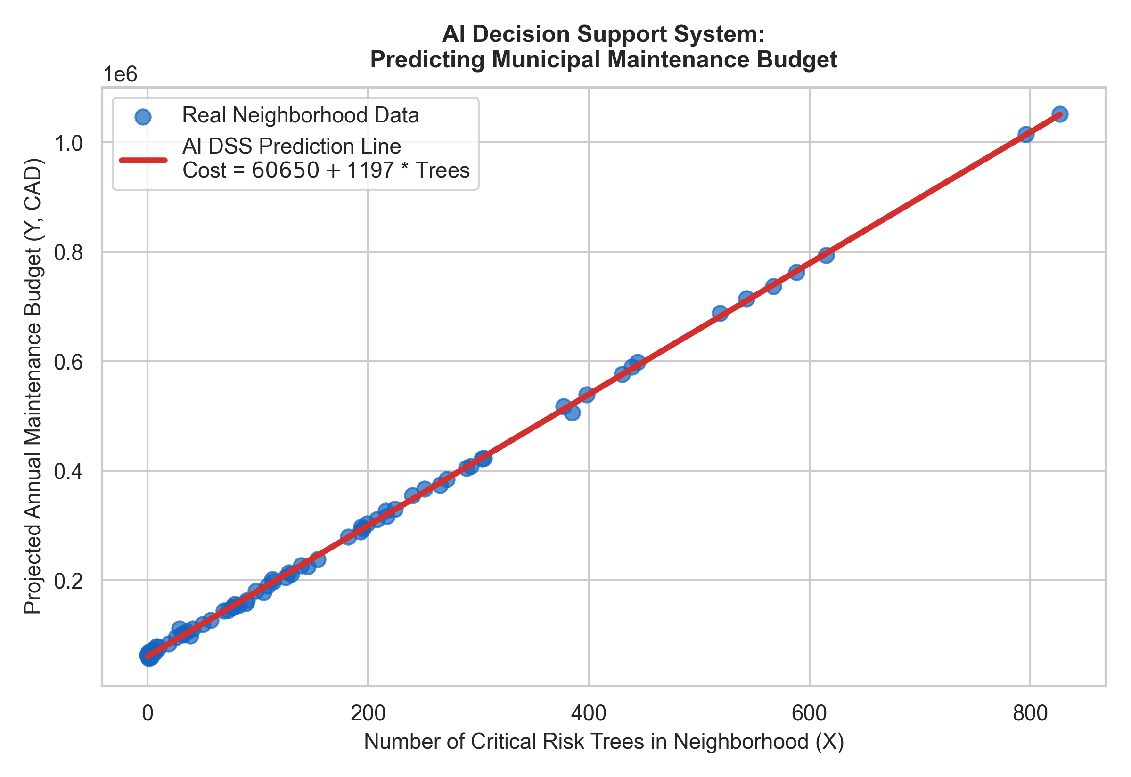

Our linear regression model produces a very clear budgetary formula:
Annual Maintenance Cost = $60,650 + $1,197 X Critical Trees
Intercept ($60,000): This represents the fixed administrative and daily monitoring cost for the neighborhood, even if there are 0 high-risk trees.
Coefficient ($1,200): For every single critical-risk tree identified by the AI system, the projected municipal budget will increase linearly by $1,200 CAD based on 2026 market rates.

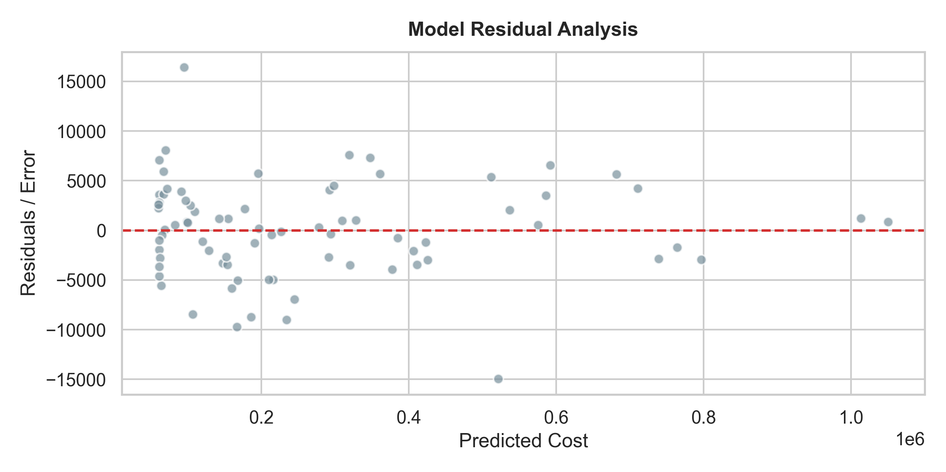

R-squared (>0.99$): The extremely high accuracy score proves that tree risk factors can explain budget variations reliably, making the DSS highly trusted for finance planning.

Part 4: Case Presentation and Strategy Planning
1. Technical Considerations
- Tools & Pipeline: We will use Python (GeoPandas, Pandas, Scikit-learn) to build the data pipeline. The pipeline automatically reads daily municipal tree CSVs and merges them with GIS canopy shapefiles.
- Model Integration: Our trained Linear Regression model (Annual Maintenance Cost = $60,650 + $1,197 X Critical Trees) will be embedded directly into the system to calculate neighborhood maintenance costs automatically.
2. Operational Considerations
- Deployment: The DSS will run on a centralized cloud dashboard accessible by both Kitchener and Waterloo forestry teams.
- Training & Scalability: We will host a 2-day workshop for municipal operations managers to learn how to interpret the budget risk rankings. The system is highly scalable and can easily include the City of Cambridge by uploading its local tree shapefiles later.
3. Financial Considerations
- Implementation Cost: Initial cloud hosting, data engineering, and staff training will require an estimated upfront investment of $45,000 CAD.
- Potential Savings & Benefits: By spending $1,200 proactively to manage each critical tree before windstorms, the city completely avoids the 50% to 100% emergency storm response surcharge. This precision asset targeting will save the municipal forestry program an estimated $115,000 CAD annually. This proactive approach scales perfectly with the framework proposed by Vogt et al. (2015), which demonstrates that data-driven, proactive municipal tree maintenance significantly lowers long-term operational liabilities compared to reactive crisis management.

Github Link
https://github.com/caatat741213/Enhancing-Urban-Forestry-Planning-with-an-AI-Powered-Tree-Canopy-DSS.git

References
Nesbitt, L., Meitner, M. J., Girling, C., Sheppard, S. R., & Lu, Y. (2019). Who has access to urban vegetation? A spatial analysis of distributional green equity in US cities. *Landscape and Urban Planning*, 181, 51-79.

Vogt, J. M., Hauer, R. J., & Fischer, B. C. (2015). Explaining the urban forest: A need for proactive asset management. *Arboriculture & Urban Forestry*, 41(1), 25-43.

Ziter, C. D., Pedersen, E. J., Kucharik, C. J., & Turner, M. G. (2019). Scale-dependent interactions between tree canopy cover and impervious surfaces reduce urban air temperature. *Proceedings of the National Academy of Sciences*, 116(15), 7575-7580.

