HTML/CSS course final assignment

(ID00CS38)

<https://caatius.github.io/corgis/> The ready page.

<https://github.com/caatius/corgis> The repo.

I used a monochromatic theme, because I wanted to use the color white as a contrast color. Even though monochromatic pallets are, well, monochromatic, they can open up a wider range of color contrasts.

I made a draft with mspaint of the page I want to create. I was thinking of making it a bit different than a usual generic site. I wanted to use text and a hard-to-forget logo for branding. A few videos would be good, a toggleable menu and to mix things up a bit, an overlay that changes a bit on every page.

The overall theme for the page came just after opening VS Code. My hobby and loved pets, corgis. I have lots of material to add to the page on my mobile.

I found the perfect picture to mold into my brand logo:

Using GIMP I turned it into this (placement follows the Fibonacci Golden Ratio):

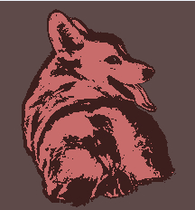

Now that I had everything ready, I started by creating the index page with a looping video in the background. I used some JS to make the menu interactive. Since I’ve always had my windows task bar on the right and hiding, I decided to do the same for the menu.

To save time, I used the index.html and style.css as a base for every other page (totaling 4 pages).

I made sure the responsiveness fits standard cell phone screen (horizontal), laptop and desktop screens. I decided to notch down the responsiveness for a mobile vertical screen, since it doesn’t do the pictures justice, although the site does work with it still.

I used some custom google fonts:

