

<Magic Clothing Printing >

Design

Revision History

|  |  |  |  |
| --- | --- | --- | --- |
| **Date** | **Issue** | **Description** | **Author** |
| <03/03/2015> | <1.0> | Document Elaboration | Marcela Sanchez  Ecaterina Galeru |
|  |  |  |  |
|  |  |  |  |
|  |  |  |  |

**Table of Contents**

1. Introduction

1.1 Purpose

2. Requirements - Use-Case – Usage Scenarios

3. High Level Design

4. Detailed Design

4.1 <Object.Name> Usage

4.2 Interaction Diagram

5. Issues, Risk and Dependencies

6. Design Alternatives

7. References

# Introduction

*Magic Clothing Printing Design Document is a document to provide design guidelines used to help in the software development process of Magic Clothing Printing Web Application. This document provides necessary details on how the application should be implemented. Magic Clothing Printing Design Document contains narrative and graphical documentation of the application design for the project including use case models, sequence diagrams, collaboration models, and other supporting requirement information.*

## Purpose

*The purpose of Magic Clothing Printing Web Application is to have an online service for our customers that want to benefit from our clothing printing service. The application enables our customers to place a printing request, view the list of previous requests and their delivery statuses. The placement of a printing requests requires the customers to choose the type of article they want to print on, how many units and upload the desired image. This way our customers have the flexibility to customize their clothes by printing on it different designs or pictures of their preference.*

# Requirements - Use-Case – Usage Scenarios

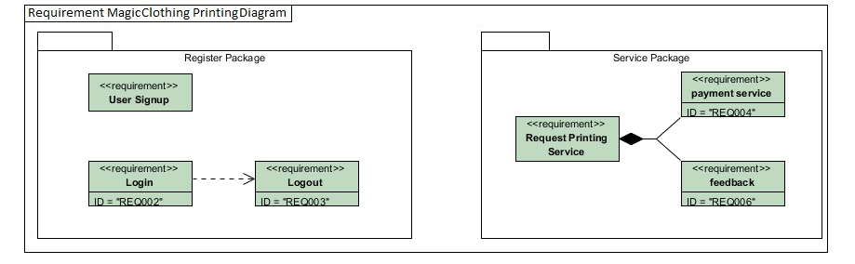

* The client wants to have the option to get customers to register on the system.
* The client wants the customers to be able to login to the system.
* The client wants the customer to be able to logout of the system.
* The client wants to have the option of creating printing services orders on the system.
* The client wants the customer to have the option to pay the printing services order he created on the system.
* The client wans to have an admin with the option of changing the status to the printing services orders the customer make on the system.

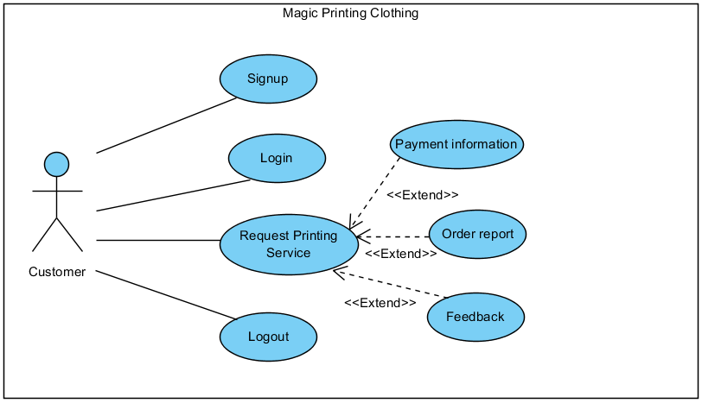

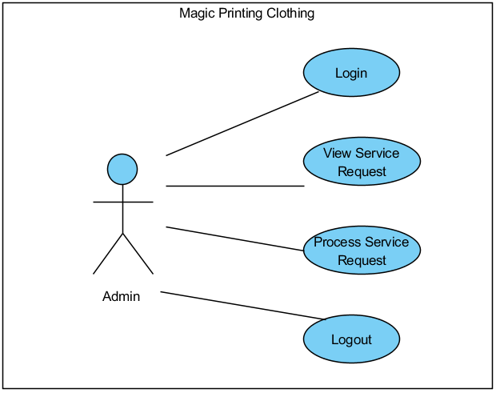

# Use Case # 1: *Signup*

|  |  |  |  |
| --- | --- | --- | --- |
| GENERAL CHARACTERISTICS | | | |
| **Author** | | MVC Unicorns | |
| **Primary Actor** | | Customer | |
| **Secondary Actors** | | None | |
| **Description** | | Customer register in Magic Clothing Printing | |
| **Preconditions** | | Browse index page | |
| **Trigger** | | Signup | |
| **Success Post Condition** | | Customer created | |
| **Failed Post Condition** | | Customer already exist | |
| MAIN FLOW | | | |
| **Step** | **Action** | | |
| 1 | The user click on signup button | | |
| 2 | The system reload the form with the fields: First Name, Last Name, email, Street, City, State, Zip code, Phone number, Password and Confirm password; and the button Sign up | | |
| 3 | The user fills the fields: First Name, Last Name, email, Street, Zip code, Phone number, Password and Confirm password and click on sign up | | |
| 4 | The system validates the values filled by the user. Alternative flow Validations | | |
| 5 | The system creates a new customer with the user’s input and forward the user to the log in page. | | |
|  | Use case ends | | |
| ALTERNATIVE FLOW Validation | | | |
| **Step** | **Branching Action** | | |
| 4.1 | The system validate that the fields: First Name, Last Name, email, Street, Zip code, Phone number, Password and Confirm password are not empty. If no error founds goes back to step 5 in the main flow otherwise, If an error is found display the message: “ field name“ must have a value. | | |
| 4.2 | The system validate that the input in password and confirm password has the same information. If no error founds goes back to step 5 in the main flow otherwise, If an error is found display the message: “password and confirm password are not the same”. | | |
| 4.3 | Alternative flow Validation ends. | | |
| RELATED INFORMATION | | | |
| **Performance** | | |  |
| **Frequency** | | |  |
| **NOTES & ISSUES** | | |  |
| **Future Considerations** | | |  |

# Use Case # 2: *Login*

|  |  |  |  |
| --- | --- | --- | --- |
| GENERAL CHARACTERISTICS | | | |
| **Author** | | MVC Unicorns | |
| **Primary Actor** | | Customer | |
| **Secondary Actors** | | Admin | |
| **Description** | | Customer or Admin logs in the system | |
| **Preconditions** | | Customer signup and Admin created in the system | |
| **Trigger** | | Login | |
| **Success Post Condition** | | Customer and Admin signs in in their sessions | |
| **Failed Post Condition** | | Email or password incorrect | |
| MAIN FLOW | | | |
| **Step** | **Action** | | |
| 1 | The user click on the login button | | |
| 2 | The system display the login form with the fields: email and password; and the log | | |
| 3 | The user fills the email and password and click on the login button. | | |
| 4 | The system validates the values filled by the user. Alternative flow Validations. | | |
| 5 | The system login the user in the system. | | |
|  | Use case ends | | |
| ALTERNATIVE FLOWS | | | |
| **Step** | **Branching Action** | | |
| 4.1 | The system validate that the email or password exist in the database system. If it doesn’t the system displays the message: “the email or password doesn’t exist in our database, please confirm the information and try again”. If the email does exist go to alternative flow 4.2 | | |
| 4.2 | The system validate that the password enter for the email has the same match in the database system. If it doesn’t the system displays the message: “The password is not correct for the email”. If the password is correct goes back to step 5 in the main flow. | | |
| 4.3 | Alternative flow Validation ends. | | |
| RELATED INFORMATION | | | |
| **Performance** | | |  |
| **Frequency** | | |  |
| **NOTES & ISSUES** | | |  |
| **Future Considerations** | | |  |

**Use Case # 3: *Request Printing Service***

|  |  |  |  |
| --- | --- | --- | --- |
| GENERAL CHARACTERISTICS | | | |
| **Author** | | MVC Unicorns | |
| **Primary Actor** | | Customer | |
| **Secondary Actors** | | None | |
| **Description** | | The customer create and order with printing services | |
| **Preconditions** | | Customer login | |
| **Trigger** | | Request printing service | |
| **Success Post Condition** | | Create a printing service order | |
| **Failed Post Condition** | |  | |
| MAIN FLOW | | | |
| **Step** | **Action** | | |
| 1 | The user logs in. | | |
| 2 | The system display the form with the fields: Select Item, Price per Unit, Select Units, Total price, Upload image and the add item, save Order, Proceed payment, Customer order history and Log out button. | | |
| 3 | The user selects the item name. | | |
| 4 | The system displays the price for the item selected by the user. | | |
| 5 | The user fills the amount of units and clicks on the add button. | | |
| 6 | The system validates the value filled by the user. Alternative flow validations. And add the item to the final order table show in the same page with the field: Items, Units, Total price and Options. | | |
| 7 | The user finishes the order and clicks the Proceed payment button. Alternative flow buttons. | | |
| 8 | The system goes to use case #4 | | |
|  | Use case ends | | |
| ALTERNATIVE FLOWS Validations | | | |
| **Step** | **Branching Action** | | |
| 6.1 | The system validate that the field Units is not empty, if it is not, goes back to step 7, if is empty display message: “Units must have a value” | | |
| 6.2 | Alternative flow Validation ends. | | |
| ALTERNATIVE FLOW *B*utton | | | |
| **Step** | **Branching Action** | | |
| 7.1 | The user clicks on the save button. | | |
| 7.2 | The system saves the order in the database. Goes to 7.3 | | |
| 7.3 | The user clicks on the Customer order history button | | |
| 7.4 | The system goes to use case #5 | | |
|  | Alternative flow button ends. | | |
| RELATED INFORMATION | | | |
| **Performance** | | |  |
| **Frequency** | | |  |
| **NOTES & ISSUES** | | |  |
| **Future Considerations** | | |  |

**Use Case #** **4: *Payment information***

|  |  |  |  |
| --- | --- | --- | --- |
| GENERAL CHARACTERISTICS | | | |
| **Author** | | MVC Unicorns | |
| **Primary Actor** | | Customer | |
| **Secondary Actors** | | None | |
| **Description** | | Customer pay an order of printing services | |
| **Preconditions** | | Order created | |
| **Trigger** | | Payment | |
| **Success Post Condition** | | User pays an printing services order | |
| **Failed Post Condition** | |  | |
| MAIN FLOW | | | |
| **Step** | **Action** | | |
| 1 | The user clicks on the check out button from the order. | | |
| 2 | The system displays the form with the fields: Order Id, Total, Payment Type and Card Number, Expiration date, Security Number: and the Log out and pay! button. | | |
| 3 | The user selects the type of payment and fills the information for the car number; and clicks on the pay! button | | |
| 4 | The system validates the value filled by the user. Alternative flow validations. | | |
| 5 | The system save the payment information and change the status to Processing. | | |
|  | Use case ends | | |
| ALTERNATIVE FLOWS | | | |
| **Step** | **Branching Action** | | |
| 4.1 | The system validate that the field Card Number is not empty. If the field is not empty goes back to step 5 in the main flow otherwise, if the field is empty display the message: “ Card Number must have a value” | | |
| 4.2 | Alternative flow Validation ends. | | |
| RELATED INFORMATION | | | |
| **Performance** | | |  |
| **Frequency** | | |  |
| **NOTES & ISSUES** | | |  |
| **Future Considerations** | | |  |

**Use Case # 5: *Order report***

|  |  |  |  |
| --- | --- | --- | --- |
| GENERAL CHARACTERISTICS | | | |
| **Author** | | MVC Unicorns | |
| **Primary Actor** | | Customer | |
| **Secondary Actors** | | None | |
| **Description** | | The customer is able to view all his previous and current requests and a detailed report for each of the orders | |
| **Preconditions** | | The user is logged into the system and is currently on the request order page | |
| **Trigger** | |  | |
| **Success Post Condition** | | The user can view all his current and previous orders | |
| **Failed Post Condition** | | No orders related to the customer. | |
| MAIN FLOW | | | |
| **Step** | **Action** | | |
| 1 | The user clicks on the order history button | | |
| 2 | The system loads the view with a table containing the columns for each order: Order Id, Total, Status, Payment, Feedback and Log out button. Each column contains details about the order | | |
| 3 | Alternative Flows: Use Case 4 - Payment Information, Use Case 6 -Feedback | | |
|  | Use case ends | | |
| ALTERNATIVE FLOWS | | | |
| **Step** | **Branching Action** | | |
|  | No alternative flow | | |
| RELATED INFORMATION | | | |
| **Performance** | | |  |
| **Frequency** | | |  |
| **NOTES & ISSUES** | | |  |
| **Future Considerations** | | |  |

**Use Case** **# 6: *Feedback***

|  |  |  |  |
| --- | --- | --- | --- |
| GENERAL CHARACTERISTICS | | | |
| **Author** | | MVC Unicorns | |
| **Primary Actor** | | Customer | |
| **Secondary Actors** | | None | |
| **Description** | | The customer gives feedback about the printing service after it has been Completed | |
| **Preconditions** | | The user must be logged in into the system on the order history page. A couple of completed orders are available | |
| **Trigger** | |  | |
| **Success Post Condition** | | The feedback has been submitted by the customer | |
| **Failed Post Condition** | | The feedback already exists | |
| MAIN FLOW | | | |
| **Step** | **Action** | | |
| 1 | The user clicks on Feedback button | | |
| 2 | The system loads the feedback page with the fields: Order Id, Rating, Feedback and Improvements and clicks on Give feedback and Log out button | | |
| 3 | The used fills all the fields from step 2 with valid data | | |
| 4 | The system validates the values filled by the user. Alternative flow Validations | | |
| 5 | The system creates a new feedback for the selected order with user input and forwards the user to the order history page. | | |
|  | Use case ends | | |
| ALTERNATIVE FLOWS | | | |
| **Step** | **Branching Action** | | |
| 4.1 | The system validates that the fields: Rating and Feedback are not empty. | | |
| 4.2 | Alternative flow Validation ends. | | |
| RELATED INFORMATION | | | |
| **Performance** | | |  |
| **Frequency** | | |  |
| **NOTES & ISSUES** | | |  |
| **Future Considerations** | | |  |

**Use Case** **# 7:** ***Logout***

|  |  |  |  |
| --- | --- | --- | --- |
| GENERAL CHARACTERISTICS | | | |
| **Author** | | MVC Unicorns | |
| **Primary Actor** | | Customer | |
| **Secondary Actors** | | Admin | |
| **Description** | | Customer is logging out from the system | |
| **Preconditions** | | Customer must be logged in into the system | |
| **Trigger** | |  | |
| **Success Post Condition** | | Customer logged out successfully | |
| **Failed Post Condition** | | Customer is not logged out | |
| MAIN FLOW | | | |
| **Step** | **Action** | | |
| 1 | The user clicks on log out button | | |
| 2 | The system loads the form with welcome page of the application. | | |
| 3 | The user is logged out of the system and has no access to order requests. | | |
| 4 | Repeat step 1 from somewhere else from into the application | | |
|  | Use case ends | | |
| ALTERNATIVE FLOWS | | | |
| **Step** | **Branching Action** | | |
|  | No alternative flow | | |
| RELATED INFORMATION | | | |
| **Performance** | | |  |
| **Frequency** | | |  |
| **NOTES & ISSUES** | | |  |
| **Future Considerations** | | |  |

**Use Case** **# 8:** ***View service request***

|  |  |  |  |
| --- | --- | --- | --- |
| GENERAL CHARACTERISTICS | | | |
| **Author** | | MVC Unicorns | |
| **Primary Actor** | | Admin | |
| **Secondary Actors** | | None | |
| **Description** | | Allows to the admin to have a view of the entire services request in the system. | |
| **Preconditions** | | Service requested | |
| **Trigger** | |  | |
| **Success Post Condition** | | The admin is able to view all requests made by the customers | |
| **Failed Post Condition** | | The admin is able to view partial or no requests made by the customer | |
| MAIN FLOW | | | |
| **Step** | **Action** | | |
| 1 | The admin logs into the system | | |
| 2 | The system reloads the form with the fields: Order Id, Customer Name, Customer Email, Status, Edit option and Log out button. | | |
| 3 | The admin clicks on Edit option | | |
| 4 | The view with list of order requests is displayed. The list contains Item name, Item Price, Item Units, Item Picture, Total Price and Request Status. Request Status has several options: Pending, Processing, Pick Up, Printing, Delivery, Completed | | |
|  | Use case ends | | |
| ALTERNATIVE FLOWS | | | |
| **Step** | **Branching Action** | | |
|  | No alternative flow | | |
| RELATED INFORMATION | | | |
| **Performance** | | |  |
| **Frequency** | | |  |
| **NOTES & ISSUES** | | |  |
| **Future Considerations** | | |  |

**Use Case** **# 9:** ***Process service request***

|  |  |  |  |
| --- | --- | --- | --- |
| GENERAL CHARACTERISTICS | | | |
| **Author** | | MVC Unicorns | |
| **Primary Actor** | | Admin | |
| **Secondary Actors** | | None | |
| **Description** | | Admin changes the status of the order | |
| **Preconditions** | | Admin logged into the system | |
| **Trigger** | |  | |
| **Success Post Condition** | | Status of the request is updated | |
| **Failed Post Condition** | | Status of the request is not updated | |
| MAIN FLOW | | | |
| **Step** | **Action** | | |
| 1 | Admin clicks on Edit option of the request from Order history list | | |
| 2 | The view with list of order requests is displayed. The list contains Item name, Item Price, Item Units, Item Picture, Total Price and Request Status. Request Status has several options: Pending, Processing, Pick Up, Printing, Delivery, Completed and Log out button | | |
| 3 | Admin changes the status of the Request and clicks on Save | | |
| 4 | The system changes the Status of the order to the one selected by the admin | | |
|  |  | | |
|  | Use case ends | | |
| ALTERNATIVE FLOWS | | | |
| **Step** | **Branching Action** | | |
|  | No alternative flow | | |
| RELATED INFORMATION | | | |
| **Performance** | | |  |
| **Frequency** | | |  |
| **NOTES & ISSUES** | | |  |
| **Future Considerations** | | |  |

# High Level Design

*[In this section, explain in a few sentences what each entity does. Describe your reasoning for defining the entities in your diagram and what their roles are.]*

**Figure 1 <** **High Level Design Diagram >**

# Detailed Design

*[This section is where your objects and object relationships are defined.*

## <Object.Name> Usage

*[This section is where your objects and object relationships are defined. Describe how the object is used and what function it serves. If an object will interface with an external object or system, it is a good idea to show the interface for the object. Most importantly, you must again describe your thought process for defining the object as you did. List the benefits and risks. If an object provides an encapsulation, describe in a sentence why the encapsulation adds value. Use your descriptions to give meaning to the diagrams.*

**Figure 2 <Class Diagram>**

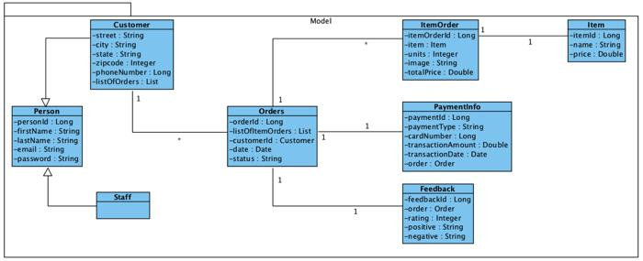

## Interaction Diagram

*[An interaction diagram shows how a set of objects or entities communicate with each other to perform a complex task.]*

**Figure 3 <InteractionDiagram.Name>**

# Design Alternatives

*[This section describes alternative designs that were considered.]*

# Issues, Risk and Dependencies

*Risk*

* *Image size too big.*

*Dependencies:*

* *User’s image upload*

# Future Considerations

* *Item management module*
* *Feedback module*
* *Image repository for clients*

# References

*[This subsection provides a complete list of all documents referenced. Identify each document by title, report number (if applicable), date, and publishing organization. Specify the sources from which the references can be obtained. This information may be provided by reference to an appendix or to another document.]*