Practical 2: Analysis of Algorithms

**Question 1: Big-O notation**

1. In proportion, so $O\left(n\right)$
2. Constant time, regardless of input $O\left(1\right)$
3. Has $5n^{3}$, so complexity is of class $O\left(n^{3}\right)$

**Question 2:**

c)

**if $B$**

**for $j←0$** **to $n-1$** **do**

$x←x+1$

**else**

**for $i←0$** **to $n-1$** **do**

**for $j←0$** **to $n-1$** **do**

$x←x+1$

It’s easy to see that the worst-case complexity is of class $O\left(n^{2}\right)$ because of the nested for loop in the **else** clause.

The exact efficiency function depends on how often $B$ happens.

Let $b$ be the probability of $B$ happening.

Then, the probability of $B$ not happening is $100\%-b\%=1-b$, where $0≤b≤1$:

* $b=0$, we say $B$ never happens
* $b=1$, we say $B$ always happens

The parameter characterising the input is the natural number $n$.

The basic operation is $x←x+1$, assuming a computation time of $c_{1}$.

We need to setup a summation:

* For the first for loop, $x←x+1$ happens, $c_{1}+c_{1}+c_{1}+…+c_{1}$, where $c_{1}$ is added to itself for as how many times the for loop runs. This depends on a $j$ going from $0$ to $n-1$. The compact way to say this in mathematical notation is:
$$\sum_{j=0}^{n-1}{c_{1}}=n⋅c_{1}$$

* To factor in the fact that this only happens if an event $B$ happens, we need to use the probability of $B$ happening (which is $b$), by multipliying with the above complexity:
$$b⋅n⋅c_{1}$$

* Do the same for the **else** clause, knowing that the probability of $B$**not** happening is $\left(1-b\right)$.

Therefore, the efficiency function $f(n)$ is:

$$f\left(n\right)=b⋅\sum_{j=0}^{n-1}{c_{1}}+\left(1-b\right)⋅\sum_{i=0}^{n-1}{\sum_{j=0}^{n-1}{c_{1}}} \\ =b⋅n⋅c_{1}+\left(1-b\right)⋅n^{2}⋅c_{1} \\ =\left(n^{2}-bn^{2}+bn\right)c_{1}$$

Since $b$ is a constant, and $c_{1}$ is the complexity of the basic operation, the worst-case time complexity is of class $O\left(n^{2}\right)$, because $n^{2}$ is the highest power here.

In a game, $50\%$ chance of winning $100, and $50\%$ chance of losing $50. If we play for a long time, we are earning an average of:

$$0.5⋅100+0.5⋅\left(-50\right)=0.5⋅50=25$$

**Question 3**: Big-O analysis of algorithms

a) Algorithm to check if an array is sorted:

**ALGORITHM** *IsSorted*($A\left[0..n-1\right]$)

**if $n≤1$**

**return** true

**else**

**for $i←0$** **to $n-2$** **do**

**if $A\left[i\right]>A\left[i+1\right]$ $c_{1}$**

**return** false

**return** true

The parameter characterising the input is the number of elements in the given array $A$, which is called $n$.

The basic operation is $A\left[i\right]>A\left[i+1\right]$.

Argue that the worst case only happens when the array **is sorted**, and that there are more than 1 element (because if there is only one element, the efficiency function would be $C_{best}\left(1\right)=1$)

For $n>2$, and the array is sorted, the full for-loop will be computed, and the complexity is:

$$C_{worst}\left(n\right)=\sum_{i=0}^{n-2}{c_{1}}=\left(n-1\right)c_{1}$$

Therefore, the time complexity is $O\left(n\right)$, since the highest power multiplying $c_{1}$ is $n$.

b) Algorithm to find the minimal separation between any two elements in an array

**ALGORITHM** *MinDistance*($A\left[0..n-1\right]$)

$$d←∞$$

**for $i←0$** **to $n-2$** **do**

**for $j←i+1$** **to $n-1$** **do**

$d←\min{(d,\left|A\left[i\right]-A\left[j\right]\right|})$

**return $d$**

Parameter characterising the size of the input is the number of elements in the given array $A$, which is called $n$.

Basic operation: $d←\min\left(d,\left|A\left[i\right]-A\left[j\right]\right|\right)$

Since there is no branching, there is only one scenario, and it is the worst case:

$$C_{worst}\left(n\right)=\sum_{i=0}^{n-2}{\sum_{j=i+1}^{n-1}{c_{1}}}$$

Firstly, find the number of times the inner for loop occurs:

$\sum_{j=i+1}^{n-1}{c_{1}}=c_{1}+c_{1}+c_{1}…+c_{1}$ ( $c_{1}$ added to itself for $n-1-\left(i+1\right)+1$ times)

$$\sum_{j=i+1}^{n-1}{c_{1}}=\left(n-i-1\right)c_{1}$$

Substitute back to the $C_{worst}\left(n\right)$:

$$C_{worst}\left(n\right)=\sum_{i=0}^{n-2}{\left(n-i-1\right)c_{1}} \\ =\sum_{i=0}^{n-2}{nc_{1}}-\sum_{i=0}^{n-2}{ic_{1}}-\sum_{i=0}^{n-2}{c_{1}} \\ =\left(n-1\right)nc_{1}-c_{1}\sum_{i=0}^{n-2}{i}-\left(n-1\right)c_{1}$$

Now we need to work out the summation with $i$:

$$\sum_{i=0}^{n-2}{i}=0+1+2+…+n-4+n-3+n-2$$

Note: If we know an arithmetic series, we will find

$$\sum_{i=0}^{n-2}{i}=\frac{\left(n-1\right)\left(n-2\right)}{2}$$

However, we can also work out the summation ourself:

$$\sum_{i=0}^{n-2}{i}=0+1+2+…+(n-4)+(n-3)+\left(n-2\right)$$

$$\sum_{i=0}^{n-2}{i}=\left(n-2\right)+\left(n-3\right)+\left(n-4\right)+…+2+1+0$$

Add the above together:

$$2\sum_{i=0}^{n-2}{i}=\left(n-2\right)+\left(n-2\right)+\left(n-2\right)+…+\left(n-2\right)+\left(n-2\right)+\left(n-2\right)$$

Since $\left(n-2\right)$ is added to itself $\left(n-2-0+1=n-1\right)$ times:

$$2\sum_{i=0}^{n-2}{i}=\left(n-1\right)\left(n-2\right)$$

Divide both sides by 2:

$$\sum_{i=0}^{n-2}{i}=\frac{\left(n-1\right)\left(n-2\right)}{2}$$

Substitute back into $C_{worst}$:

$$C_{worst}\left(n\right)=\left(n-1\right)nc_{1}-c_{1}\frac{\left(n-1\right)\left(n-2\right)}{2}-\left(n-1\right)c_{1} \\ =n^{2}c_{1}-nc_{1}-c_{1}\frac{n^{2}-3n+2}{2}-nc_{1}+c_{1} \\ =… \\ =\frac{\left(n-1\right)n}{2}c_{1}$$

From here, we can see that the highest power multiplying $c_{1}$ is $n^{2}$, therefore, the time complexity is $O\left(n^{2}\right)$.

c) Algorithm to reverse an array.

**ALGORITHM** ReverseArray($A\left[0..n-1\right]$)

**for $i←0$** **to $floor\left(\frac{n}{2}\right)-1$** **do**:

$temp←A\left[i\right]$ $c_{1}$

$A\left[i\right]←A\left[n-1-i\right]$ $c_{2}$

$A\left[n-1-i\right]←temp$ $c_{3}$

The parameter characterising the input is the number of items in the given array $A$, which we call $n$.

The basic operations are:

$temp←A\left[i\right]$

$A\left[i\right]←A\left[n-1-i\right]$

$A[n-1-i]←temp$

Or, we could also say, the basic operation is the swap, with a composition of the above basic operation.

We know that $floor\left(\frac{n}{2}\right)≤\frac{n}{2}$

This means: $floor\left(\frac{n}{2}\right)-1≤\frac{n}{2}-1$

Therefore, the worst case is when $floor\left(\frac{n}{2}\right)-1=\frac{n}{2}-1$.

$$C_{worst}\left(n\right)=\sum_{i=0}^{\frac{n}{2}-1}{\left(c_{1}+c_{2}+c_{3}\right)}=\frac{n}{2}\left(c_{1}+c_{2}+c_{3}\right)$$

Since the highest power multiplying $c_{1}$, $c_{2}$ and $c_{3}$ is $n$, the time complexity is of class $O\left(n\right)$.

**Question 5:**

namespace Empirical

{

internal class Program

{

static void Main(string[] args)

{

Console.WriteLine("Size\t|\tCount");

for (int n = 1000; n <= 20000; n += 1000)

{

int count = RunAlgorithm(n);

Console.WriteLine($"{n}\t|\t{count}");

}

}

/// <summary>

/// Run the algorithm with a random array of size

/// n.

/// </summary>

/// <param name="n">The number of elements in the array</param>

/// <returns>The number of key comparisons</returns>

static int RunAlgorithm(int n)

{

int[] arr = new int[n];

Random rnd = new Random();

for (int i = 0; i < n - 1; i++)

{

arr[i] = rnd.Next(int.MinValue, int.MaxValue);

}

return SortAnalysis(arr);

}

static int SortAnalysis(int[] arr)

{

int n = arr.Length;

int count = 0;

for (int i = 1; i <= n - 1; i++)

{

int v = arr[i];

int j = i - 1;

// Insert if statement to increase counter by one

// even if j < 0

if (j < 0) count = count + 1;

while (j >= 0 && arr[j] > v)

{

count = count + 1;

arr[j + 1] = arr[j];

j = j - 1;

}

arr[j + 1] = v;

}

return count;

}

}

}

Size | Count

1000 | 248721

2000 | 996045

3000 | 2237172

4000 | 4044519

5000 | 6162658

6000 | 8971443

7000 | 12227552

8000 | 16068650

9000 | 20190535

10000 | 25033650

11000 | 30334758

12000 | 36230987

13000 | 42083148

14000 | 48866291

15000 | 56298616

16000 | 64095426

17000 | 72483167

18000 | 81363489

19000 | 90133161

20000 | 99873978

Plot the size of the array $n$ on the $x$ axis, and the count of key comparisons on the $y$ axis. Here, we observe that the line $t=0.25n^{2}$ fits the best, so the time complexity is of class $O\left(n^{2}\right)$.

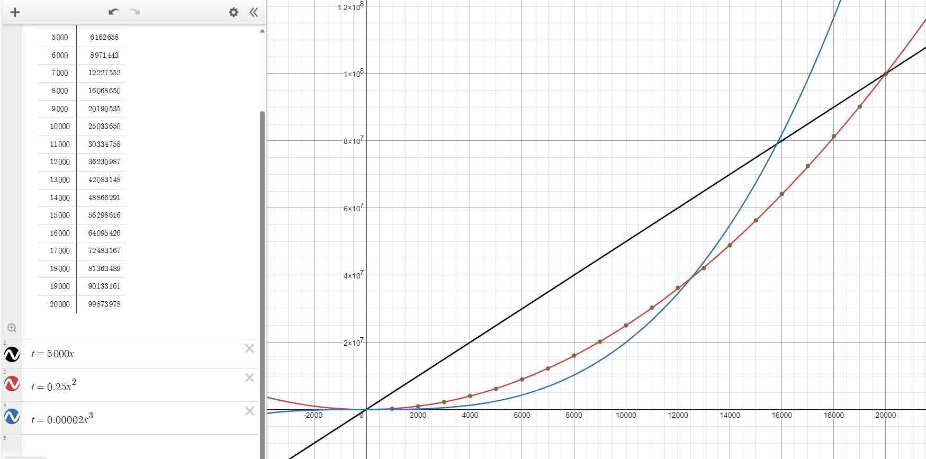

If we already assume that $t\left(n\right)=cn^{2}$, we can find $c$ by doing:

$$t\left(n\right)=cn^{2}⟹c=\frac{t(n)}{n^{2}}$$

$$t\left(2n\right)=c4n^{2}⟹c=\frac{t(2n)}{4n^{2}}$$

$$t\left(1000\right)=248721⟹c=\frac{248721}{{1000}^{2}}=0.248721≈0.25$$

If we don’t have a hypothesis to start with, i.e., unknown $t\left(n\right)$, can observe how $t\left(n\right)$ grows as $n$ grows by:

Find $t\left(n\right)$ and $t\left(2n\right)$, and divide $\frac{t(2n)}{t\left(n\right)}=\frac{t(2000)}{t\left(1000\right)}=\frac{996045 }{248721}≈4$. Since as $n$ doubles, the number of operations quadruples, which could imply a quadratic time efficiency function.

Try a few more to be sure, like $\frac{t(4000)}{t\left(2000\right)}≈\frac{t\left(6000\right)}{t\left(3000\right)}≈4$.