Workshop 2: Analysis of Algorithms

Questions

Part A: Big-O Notation

- Each of the following multiple choice questions has four (4) alternative answers. Choose one of the answers that best answers the question.
- Which of the following big-O notations represents the computation time of the algorithm grows in direct proportion to the size of the input in the worst case?
  - O(1)
  - O(n)
  - O(n²)
  - O(2^{n})
- Which of the following big-O notations represents the computation time of the algorithm does not change with the size of the input?
  - O(1)
  - O(n)
  - O(n²)
  - O(2^{n})
- Which of the following big-O classes does the efficiency function 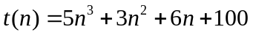belongs to?
  - O(1)
  - O(n)
  - O(n²)
  - O(n³)

Part B: Theoretical Algorithm Analysis

Identifying efficiency classes in big-O notation by inspection
For each of the pseudocode fragments below, let f(n) be its exact efficiency function with respect to input value n, assuming that the basic operation of interest is the assignment statement ‘x ← x + 1’.
For each of the following pseudocode fragments, derive its efficiency function and then determine its time complexity in the worst scenario in big-O notation.
- for j ← 0 to n − 1 do
x ← x + 1

Big-O Class: O(n)

- for i ← 0 to n − 1 do
for j ← 0 to n − 1 do
x ← x + 1
- if B
for j ← 0 to n − 1 do
x ← x + 1
else
for i ← 0 to n − 1 do
for j ← 0 to n − 1 do
x ← x + 1
- for i ← 0 to n − 1 do
x ← x + 1
for i ← 0 to n − 1 do
for j ← 0 to n − 1 do
x ← x + 1
- i ← n
while i ≥ 1 do
x ← x + 1
i ← i/2

- What is the worst-case time complexity in big-O notation for each of the following algorithms?
- ALGORITHM IsSorted(A[0..n − 1])
// Returns true if all the numbers in an array A of length n
// are sorted in nondecreasing order, false otherwise.
if n ≤ 1
return true
else
for i ← 0 to n − 2 do
if A[i] > A[i + 1]
return false
return true
- ALGORITHM MinDistance(A[0..n − 1])
// Returns the separation between the two closest numbers in a given array A
// of n numbers, or special value infinity (∞) if the array contains fewer than
// two numbers
d ← ∞
for i ← 0 to n − 2 do
for j ← i + 1 to n − 1 do
d ← min(d, |A[i] − A[j]|)
return d

- ALGORITHM ReverseArray(A[0..n − 1])
// Reverses the order of the items in an array A of length n.
for i ← 0 to ⎣n/2⎦ − 1 do
temp ← A[i]
A[i] ← A[n − 1 − i]
A[n − 1 − i] ← temp

Part C: Empirical Algorithm Analysis

- Consider the following well-known sorting algorithm, which is studied later in the book, with a counter inserted to count the number of key comparisons.

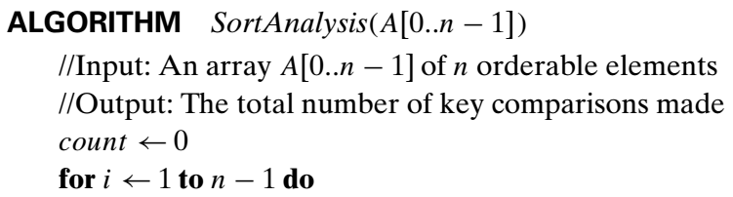
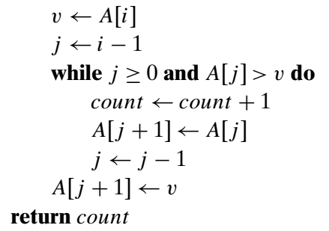

Is the comparison counter inserted in the right place? If you believe it is, prove it; if you believe it is not, make an appropriate correction.

- Perform the following tasks one by one in the order:
  - Run the program of Question 4, with a properly inserted counter (or counters) for the number of key comparisons, on 20 random arrays of sizes 1000, 2000, 3000, …, 20,000.
  - Analyse the data obtained to form a hypothesis about the algorithm’s average case efficiency.
  - Estimate the number of key comparisons we should expect for a randomly generated array of size 25,000 sorted by the same algorithm.

