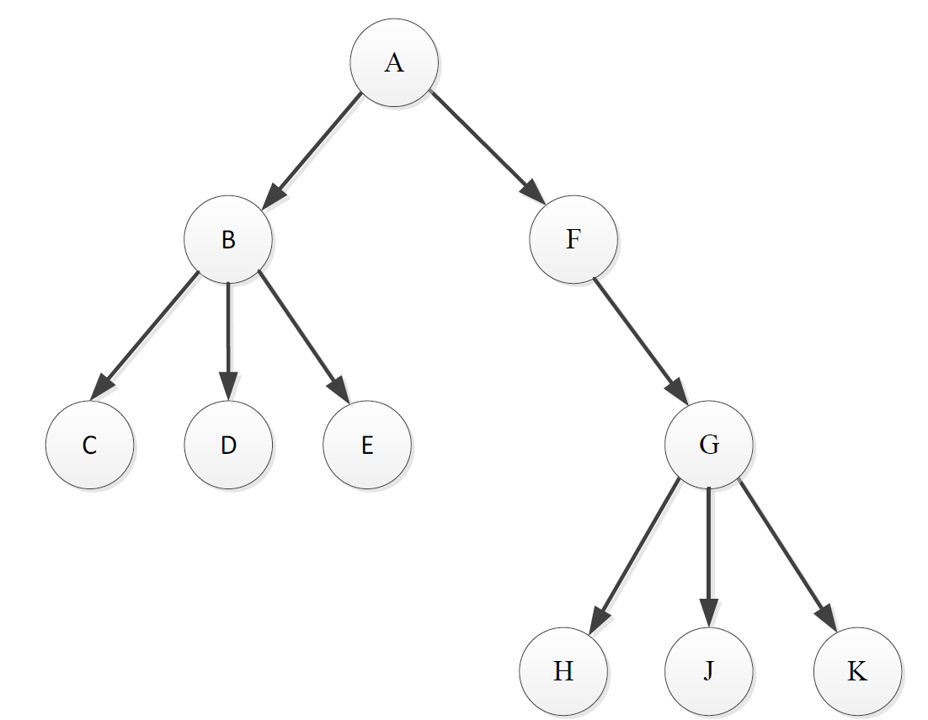

|  |  |
| --- | --- |
| $$r$$ | Description |
| Originally, q.Enqueue(A) $$q=[A]$$ | |
| $$A$$ | $$r=q.Dequeue=A$$**Visit $A$ $$r=A.firstChild=B$$** |
| $$B$$ | While $r≠null$: Add all siblings of B to the Q $$q=\left[B,F\right]$$ Exit while loop, go back $$r=q.Dequeue=B$$ **Visit $B$ $$r=B.firstChild=C$$**  Add all siblings of $C$ to the Q $$q=\left[F,C,D,E\right]$$ |
| $$F$$ | $$r=q.Dequeue=F$$**Visit $F$**  Add all children of $F$ to the Q $$q=\left[C,D,E,G\right]$$ |
| $$C$$ | $$r=q.Dequeue=C$$**Visit $C$**  Add all children of $C$ (nothing) to the Q $$q=\left[D,E,G\right]$$ |
| $$D$$ | $$r=q.Dequeue=D$$**Visit $D$**  Add all children $D$ (nothing) to the Q $$q=[E,G]$$ |
| $$E$$ | $$r=q.Dequeue=E$$**Visit $E$**  Add all children of $E$ (nothing) to the Q $$q=\left[G\right]$$ |
| $$G$$ | $$r=q.Dequeue=G$$**Visit $G$**  Add all children of $G$ ($H,J,K$) to the Q $$q=\left[H,J,K\right]$$ |
| $$H$$ | $$r=q.Dequeue=H$$**Visit $H$**  Add all children of $H$ (nothing) to the Q $$q=\left[J,K\right]$$ |
| $$J$$ | $$r=q.Dequeue=J$$**Visit $J$**  Add all children of $J$ (nothing) to the Q $$q=\left[K\right]$$ |
| $$K$$ | $$r=q.Dequeue=K$$**Visit $K$**  Add all children of $K$ (nothing) to the Q $$q=[]$$ |
| After the second while loop (that adds all the children of the last node), the queue is empty, meaning there is no element left.  Terminate.  **Order**: A B F C D E G H J K | |

Depth First Search

|  |  |
| --- | --- |
| $$r$$ | Description / Steps |
| Originally, $s.push(A)$ $$s=\left[A\right]$$ $$r=s.Pop=A$$ | |
| $$A$$ | **Visit $A$**  Push first sibling of $A$ (nothing) to stack $$r=r.firstChild=B \\ s=[]$$ |
| $$B$$ | **Visit $B$**  Push first sibling of $B$ ($F$) to stack $$r=r.firstChild=C$$ $$s=\left[F\right]$$ |
| $$C$$ | **Visit $C$**  Push first sibling of $C$ ($D$) to stack $s=[D,F]$ $r=r.firstChild=null$ $→$ Exit inner loop and get $r$ from stack $$r=s.Pop=D$$ $$s=\left[F\right]$$ |
| $$D$$ | **Visit $D$**  Push first sibling of $D$ ($E$) to stack $s=\left[E,F\right]$ $r=r.firstChild=null→$ Exiting inner loop and get $r$ from stack $$r=s.Pop=E$$ $$s=\left[F\right]$$ |
| $$E$$ | **Visit $E$**  Push first sibling of E (nothing) to stack $s=\left[F\right]$ $r=r.firstChild=null→$ Exiting inner loop and get $r$ from stack $$r=s.Pop=F$$ $$s=[]$$ |
| $$F$$ | **Visit $F$**  Pushing first sibling of $F$ (nothing) to stack $s=[]$ $$r=r.firstChild=G$$ $$s=[]$$ |
| $$G$$ | **Visit $G$**  Pushing first sibling of $G$ (nothing) to stack $s=\left[\right]$ $$r=r.firstChild=H$$ $$s=\left[\right]$$ |
| $$H$$ | **Visit $H$**  Pushing first sibling of $H$ ($J$) to stack $s=\left[J\right]$ $r=r.firstChild=null→$ Exiting from the inner while loop and get $r$ from stack $$r=s.Pop=J$$ $$s=[]$$ |
| $$J$$ | **Visit $J$**  Pushing first sibling of $J$ ($K$) to stack $s=\left[K\right]$ $r=r.firstChild=null→$ Exiting from the inner while loop and get $r$ from stack $$r=s.Pop=K$$ $$s=[]$$ |
| $$K$$ | **Visit $K$**  Pushing first sibling of $K$ (nothing) to stack $s=\left[\right]$ $r=r.firstChild=null→$ Exiting from the inner while loop and get $r$ from stack  But stack is empty… $$s=[]$$ |
| Since the stack is empty when we are trying to pop from it, it is time to stop.  Order: A, B, C, D, E, F, G, H, J, K | |

Question 3: Cat Pedigree

*This section only include the test plan. For test results, refer to section… in the Appendix.*

Cat Class

**Cat.IsValidName**: Name must not be null, and must be between 1 and 8 characters long (inclusive)

|  |  |  |
| --- | --- | --- |
| **Description** | **Input Data** | **Expected Output** |
| Name is null should return false | name = null | False |
| Name is empty should return false | “” | False |
| Name is 9 characters long should return false | “Sebastian” | False |
| Name is more than 9 characters long should return false | “Shakespeare” (11 chars) | False |
| Name is 1 character long should return true | “A” | True |
| Name is 8 characters long should return true | “Lorenzo” | True |
| Name is between 2 and 7 characters long should return true | “Dragon” (6 chars) | True |

**Cat.IsValidAge**: Age must be between 0 and 30 (inclusive)

|  |  |  |
| --- | --- | --- |
| **Description** | **Input Data** | **Expected Output** |
| Age is -1 should return false | -1 | False |
| Age is < - 1 should return false | -5 | False |
| Age is 31 should return false | 31 | False |
| Age is > 31 should return false | 39 | False |
| Age is 0 should return true | 0 | True |
| Age is 30 should return true | 30 | True |
| Age is between 1 and 29 (inclusive) should return true | 15 | True |

*Pedigree Class*

**Pedigree.AddCat**

|  |  |  |  |  |
| --- | --- | --- | --- | --- |
| **Description** | **Precondition** | **Input Data** | **Expected Output** | **Postcondition** |
| Add duplicate cats should return false | Pedigree containing Paws. | Add cat named “Paws” to the pedigree. | False. | Pedigree only contains Paws |
|  |  |  |  |  |
|  |  |  |  |  |
|  |  |  |  |  |
|  |  |  |  |  |
|  |  |  |  |  |
|  |  |  |  |  |

**Pedigree.FindCat**

|  |  |  |  |  |
| --- | --- | --- | --- | --- |
| **Description** | **Precondition** | **Input Data** | **Expected Output** | **Postcondition** |
| Find a cat in an empty pedigree should return null | Empty pedigree | Find(“Paws”) | null | Pedigree unchanged |
| Find a cat whom exists in a pedigree of one cat | Pedigree of one cat:  Paws | Find(“Paws”) | Cat with name Paws | Pedigree unchanged |
| Find a cat whom exists in a pedigree of multiple cats | Pedigree of 4 cats:  Paws  Luke  Xander  Moby | Find(“Xander”) | Cat with name Xander | Pedigree unchanged |
| Find a cat who does not exist in a pedigree of one cat | Pedigree of one cat:  Paws | Find(“Xander”) | null | Pedigree unchanged |
| Find a cat who does not exist in a pedigree of multiple cats | Pedigree of multiple cats:  Paws  Luke | Find(“Xander”) | null | Pedigree unchanged |

**Pedigree.ToArray**

|  |  |  |  |  |
| --- | --- | --- | --- | --- |
| **Description** | **Precondition** | **Input Data** | **Expected Output** | **Postcondition** |
|  |  |  |  |  |
|  |  |  |  |  |
|  |  |  |  |  |
|  |  |  |  |  |
|  |  |  |  |  |
|  |  |  |  |  |
|  |  |  |  |  |

Example Test Result:

