Question 1.

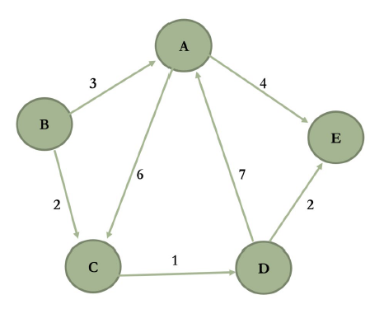

Row Column

|  |  |  |  |  |  |
| --- | --- | --- | --- | --- | --- |
|  | A | B | C | D | E |
| A |  |  |  |  |  |
| B |  |  |  |  |  |
| C |  |  |  |  |  |
| D |  |  |  |  |  |
| E |  |  |  |  |  |

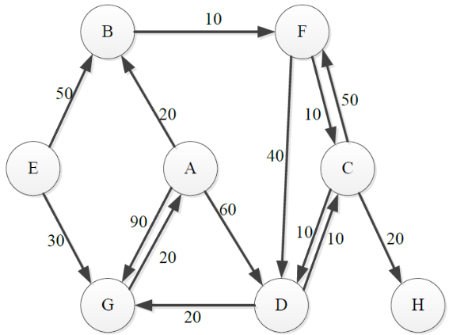Question 2. Dijkstra’s algorithm

|  |  |  |  |  |  |  |  |  |
| --- | --- | --- | --- | --- | --- | --- | --- | --- |
|  | A | B | C | D | E | F | G | H |
| A |  |  |  |  |  |  |  |  |
| B |  |  |  |  |  |  |  |  |
| C |  |  |  |  |  |  |  |  |
| D |  |  |  |  |  |  |  |  |
| E |  |  |  |  |  |  |  |  |
| F |  |  |  |  |  |  |  |  |
| G |  |  |  |  |  |  |  |  |
| H |  |  |  |  |  |  |  |  |

: Current node

: Path

Red: Closest neighbour (target for next move)

**Bold**: Recently updated

~~Crossed-out~~: Is already included in path

|  |  |  |  |  |  |  |  |  |  |  |
| --- | --- | --- | --- | --- | --- | --- | --- | --- | --- | --- |
| Step |  |  | A | B | C | D | E | F | G | H |
| 1 |  |  |  |  |  |  |  |  |  |  |
| 2 |  |  |  |  |  |  |  |  |  |  |
| 3 |  |  |  |  |  |  |  |  |  |  |
| Note:  , so is the new best path  , so is still the best path  For others: , don’t update  , so is still the best path | | | | | | | | | | |
| 4 |  |  |  |  |  |  |  |  |  |  |
| 5 |  |  |  |  |  |  |  |  |  |  |
| 6 |  |  |  |  |  |  |  |  |  |  |
| 7 |  |  |  |  |  |  |  |  |  |  |

Since the target is already in , do not visit or update. Terminate algorithm.

Shortest distances:

|  |  |  |  |  |  |  |  |
| --- | --- | --- | --- | --- | --- | --- | --- |
| A | B | C | D | E | F | G | H |
|  |  |  |  |  |  |  |  |

Paths: Backtrack:

* For each node, find where it was last updated
* Add itself to the path at that step.

Last updated in step 1, Path:

Last updated in step 3, Path:

Last updated in step 4, Path:

: Never updated, no path (as distance is )

: Last updated in step 2, Path:

: Last updated in step , Path:

: Last updated in step 4, Path:

Question 3

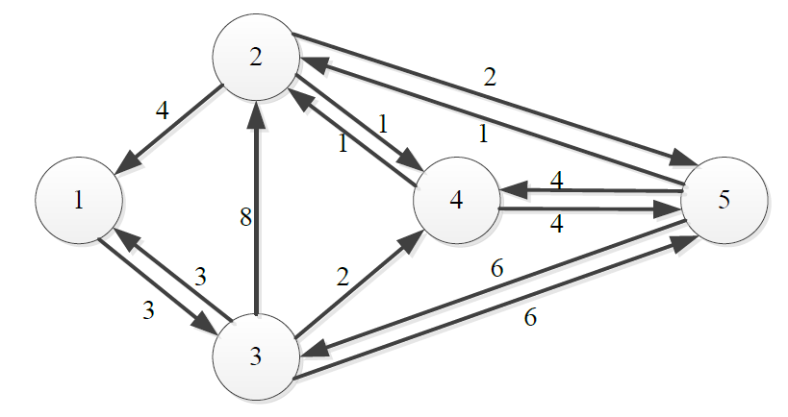

|  |  |  |  |  |  |
| --- | --- | --- | --- | --- | --- |
|  | **1** | **2** | **3** | **4** | **5** |
| **1** |  |  |  |  |  |
| **2** |  |  |  |  |  |
| **3** |  |  |  |  |  |
| **4** |  |  |  |  |  |
| **5** |  |  |  |  |  |

For each node , is it better to travel from any node to any node by going through ?

For : Highlight row 1, column 1

|  |  |  |  |  |  |
| --- | --- | --- | --- | --- | --- |
|  | **1** | **2** | **3** | **4** | **5** |
| **1** |  |  |  |  |  |
| **2** |  |  |  |  |  |
| **3** |  |  |  |  |  |
| **4** |  |  |  |  |  |
| **5** |  |  |  |  |  |

Better than , so update

Worse than , no update

Better than , so update

Tip: Only look at the intersections between rows and columns where the rows and columns are not infinities.

For : Highlight row 2, column 2

|  |  |  |  |  |  |
| --- | --- | --- | --- | --- | --- |
|  | **1** | **2** | **3** | **4** | **5** |
| **1** |  |  |  |  |  |
| **2** |  |  |  |  |  |
| **3** |  |  |  |  |  |
| **4** |  |  |  |  |  |
| **5** |  |  |  |  |  |

For

|  |  |  |  |  |  |
| --- | --- | --- | --- | --- | --- |
|  | **1** | **2** | **3** | **4** | **5** |
| **1** |  |  |  |  |  |
| **2** |  |  |  |  |  |
| **3** |  |  |  |  |  |
| **4** |  |  |  |  |  |
| **5** |  |  |  |  |  |

For

|  |  |  |  |  |  |
| --- | --- | --- | --- | --- | --- |
|  | **1** | **2** | **3** | **4** | **5** |
| **1** |  |  |  |  |  |
| **2** |  |  |  |  |  |
| **3** |  |  |  |  |  |
| **4** |  |  |  |  |  |
| **5** |  |  |  |  |  |

For :

|  |  |  |  |  |  |
| --- | --- | --- | --- | --- | --- |
|  | **1** | **2** | **3** | **4** | **5** |
| **1** |  |  |  |  |  |
| **2** |  |  |  |  |  |
| **3** |  |  |  |  |  |
| **4** |  |  |  |  |  |
| **5** |  |  |  |  |  |

The minimum distances between each node is defined in the following distance matrix:

|  |  |  |  |  |  |
| --- | --- | --- | --- | --- | --- |
|  | **1** | **2** | **3** | **4** | **5** |
| **1** |  |  |  |  |  |
| **2** |  |  |  |  |  |
| **3** |  |  |  |  |  |
| **4** |  |  |  |  |  |
| **5** |  |  |  |  |  |