CAB301 Tutorial 3

Time: 09:00 Monday, 18/03/2024

**Question 1**: Queue operations using an array

Step 0: Before any operations

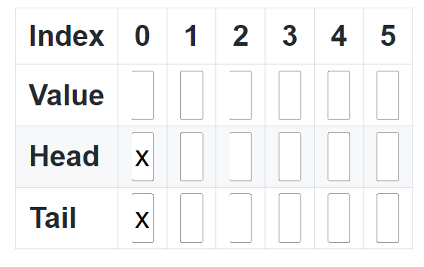

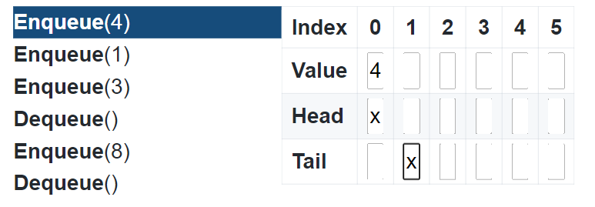

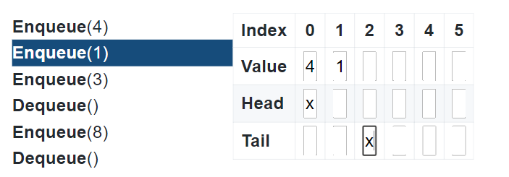

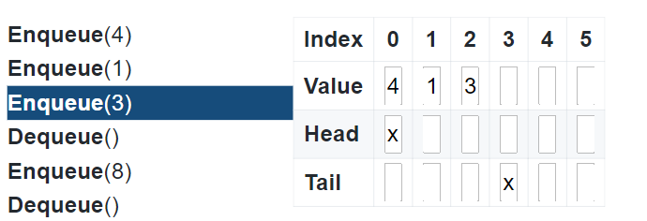

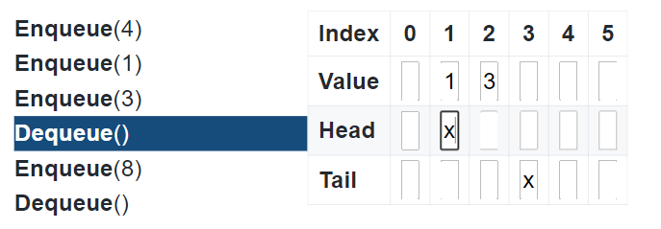

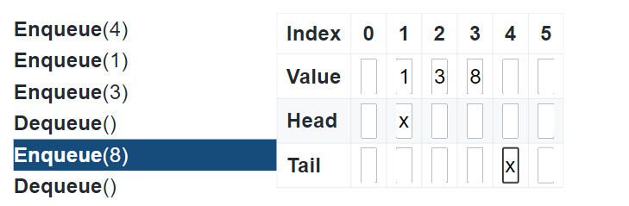

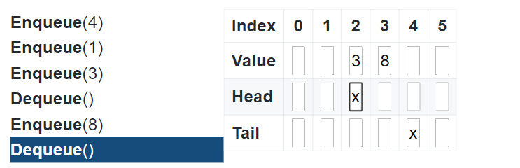

Question 2: Binary Search by Hand

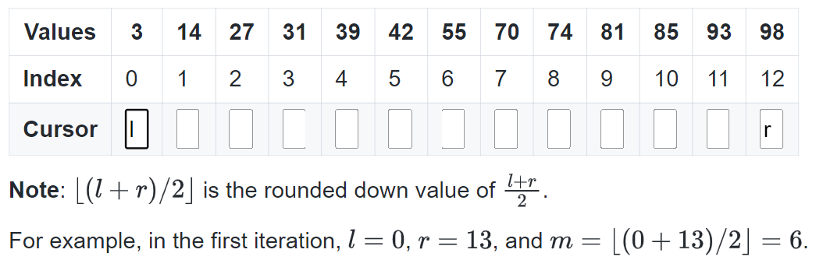

$$K=70$$

Iteration 1: $m=floor\left(\frac{l+r}{2}\right)=floor\left(\frac{0+12}{2}\right)=floor\left(6\right)=6$

$A\left[6\right]=55==70$. False

$A\left[6\right]=55<70$. True, so $l=m+1$

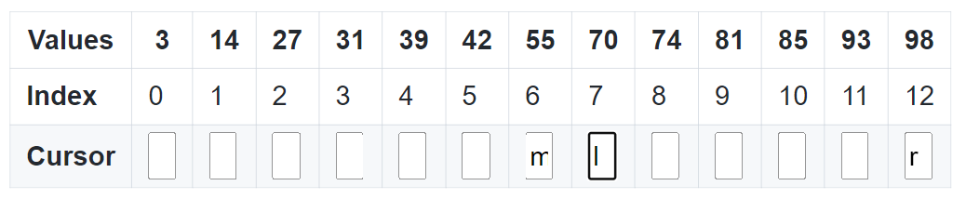

Iteration 2: $m=floor\left(\frac{7+12}{2}\right)=floor\left(9.5\right)=9$

$A\left[9\right]=81==70$. False

$A\left[9\right]=81<70$. False

Execute else: $r=m-1=8$.

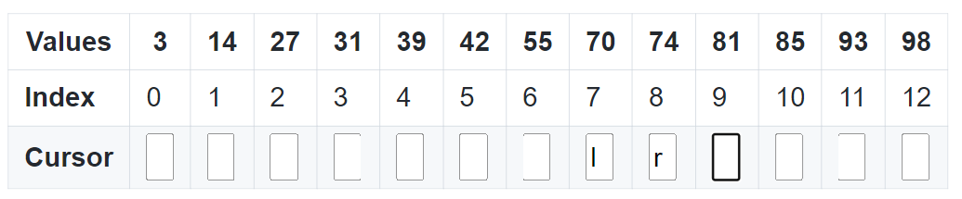

Iteration 3: $m=floor\left(\frac{7+8}{2}\right)=floor\left(7.5\right)=7$

$A\left[7\right]=70==70$. True

Return $m=7$, and 70 exists in the array at index $7$.

b) For the binary algorithm, the initial input $n$ is reduce to $\frac{n}{2}$ (cutting in half every iteration).

**Question 3**: Implementing a Stack