CAB301 Tutorial 3

Time: 11:00 Monday, 18/03/2024

Question 1: Queue Operations

Before any operation, head and tail are at positions 0.

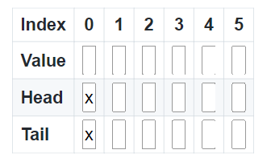

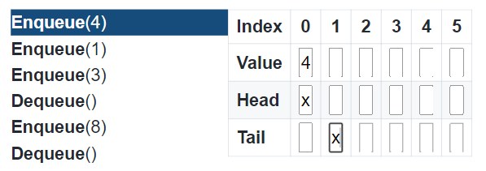

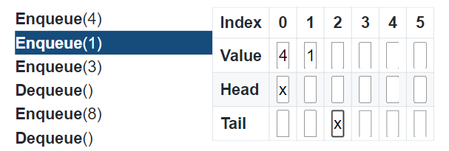

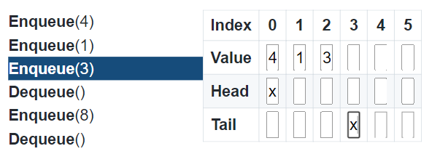

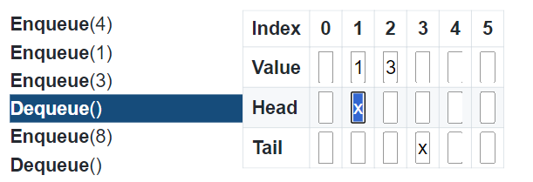

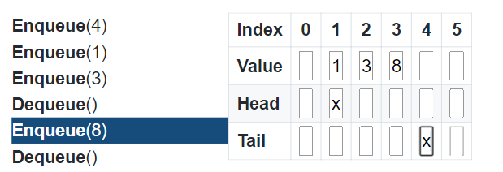

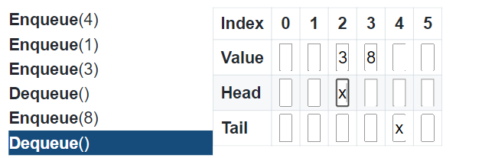

**Question 2: Binary Search**

Before search, $l=0,r=12$ (since there are 13 elements)

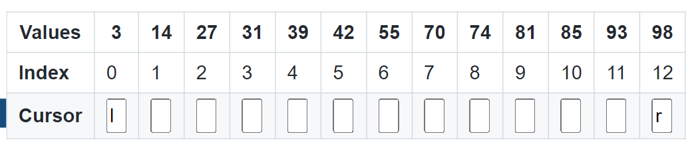

Iteration 1:

$$m←floor\left(\frac{l+r}{2}\right)=floor\left(\frac{0+12}{2}\right)=6$$

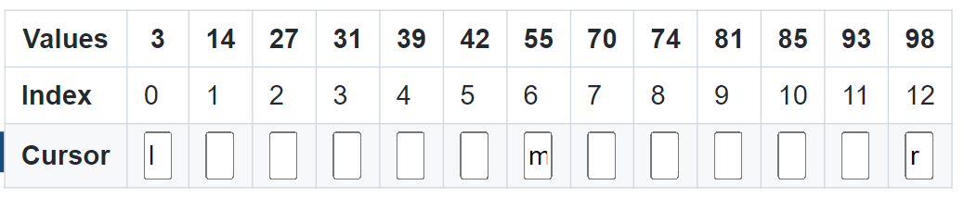

Is $A\left[m\right]=A\left[6\right]=55$ the same as the key $70$?

> False

Is $A\left[6\right]=55$ less than the key $70$?

> True, hence $l←m+1$, i.e, $l=6+1=7$

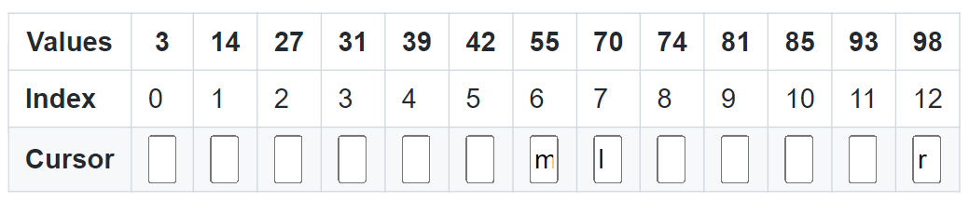

Iteration 2:

$$m=floor\left(\frac{7+12}{2}\right)=floor\left(9.5\right)=9$$

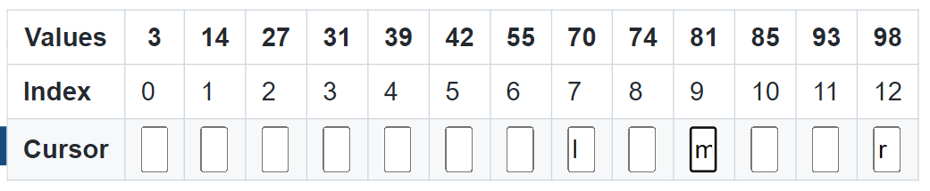

Is $A\left[m\right]=A\left[9\right]=81$ the same as the search key $70$?

> False

Is $A\left[9\right]=81$ less than the key $70$?

> False

Resort to “else”, and set $r=m-1=9-1=8$

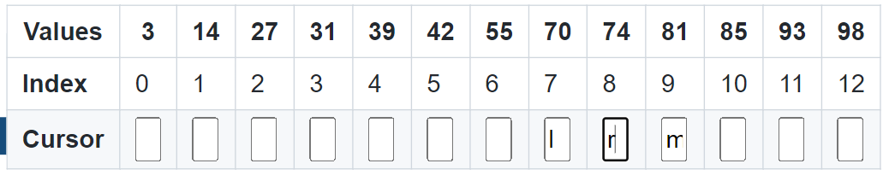

Iteration 3:

$$m=floor\left(\frac{7+8}{2}\right)=7$$

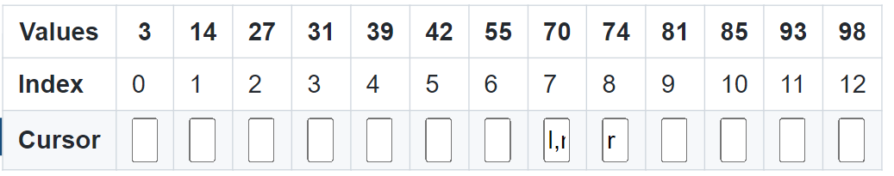

Is $A\left[m\right]=A\left[7\right]=70$ the same as the search key $70?$

> True, return $m=7$