CAB301 Tutorial 3

Time: 13:00 Monday, 18/03/2024

**Question 1:** Queue Operations

Originally, before any operation, Head and Tail are both at index 0.

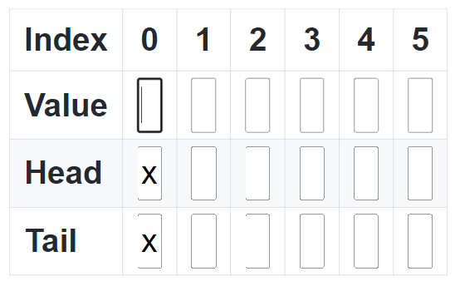

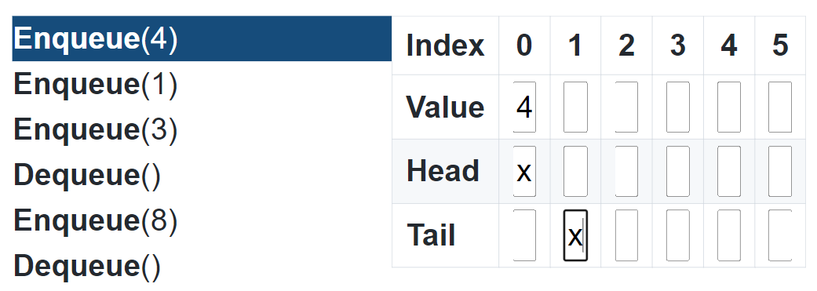

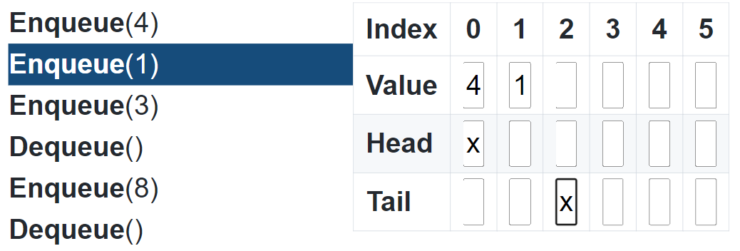

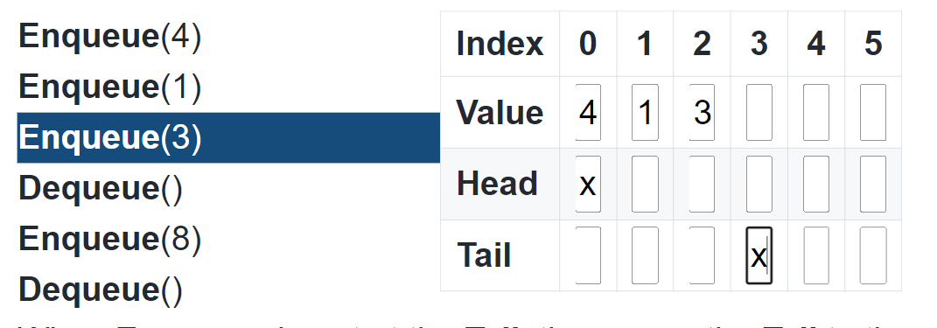

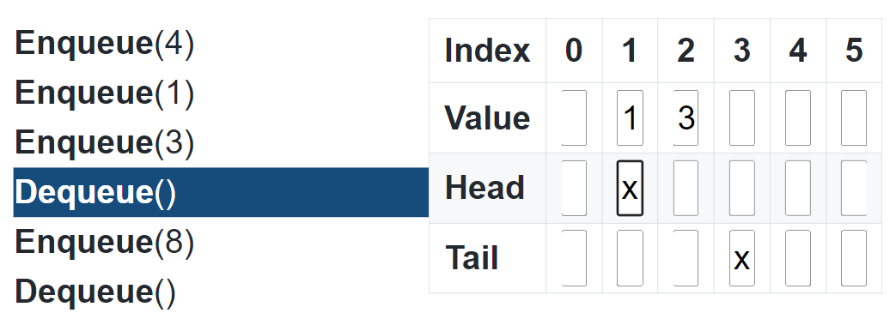

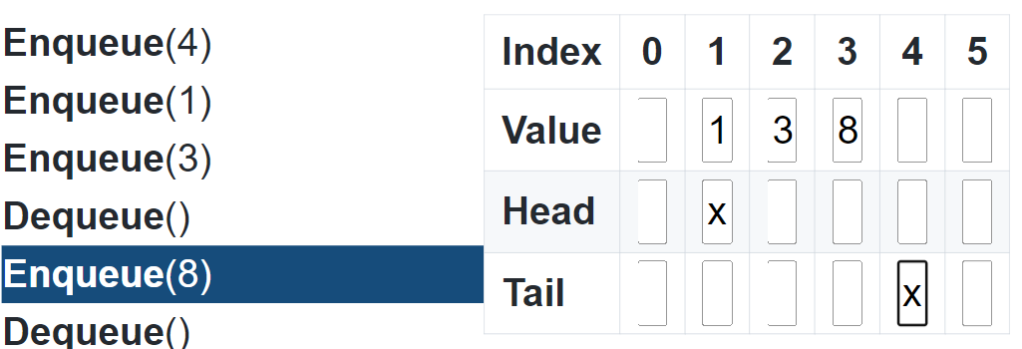

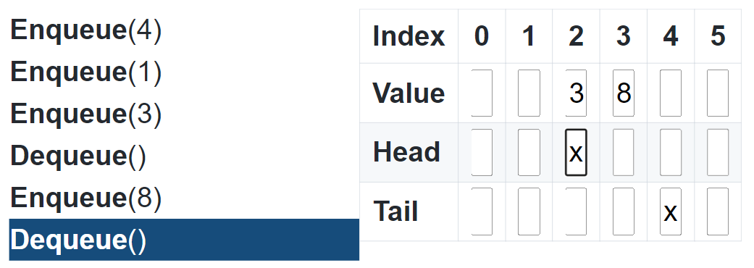

**Question 2: Binary Search**

**Search in:**

[3, 14, 27, 31, 39, 42, 55, 70, 74, 81, 85, 93, 98]

Search key $K$ = 70.

Initially, $l=0$ and $r=12$ (since there are 13 elements)

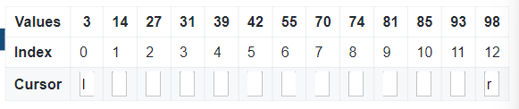

Iteration 1:

$$m=floor\left(\frac{l+r}{2}\right)=floor\left(\frac{0+12}{2}\right)=6$$

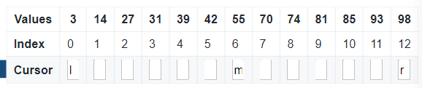

Is $A\left[m\right]=A\left[6\right]=55$ the same as 70?

> False

Is $A\left[6\right]=55$ less than $70$?

> True, $l=m+1=6+1=7$

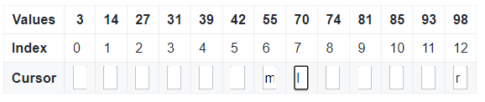

Iteration 2:

$$m=floor\left(\frac{7+12}{2}\right)=9$$

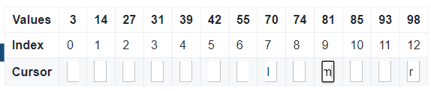

Is $A\left[9\right]=81$ the same $70$?

> False

Is $A\left[9\right]=81$ less than 70?

> False

Execute the “else”: $r=m-1=9-1=8$

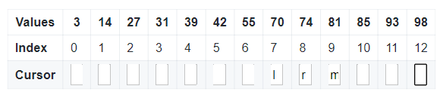

Iteration 3:

$$m=floor\left(\frac{7+8}{2}\right)=7$$

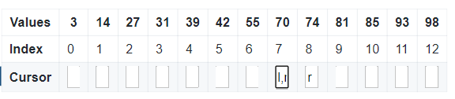

Is $A\left[7\right]=70$ the same as $70$?

> True, return $m$