Machine Learning on the RADCURE Dataset
Two-Year Mortality Prediction
  - Classical machine learning with pre-treatment clinical characteristics in patients with head and neck tumours

Author | Carlo Babo
Dataset | RADCURE Clinical Data v04
Source file | RADCURE_Clinical_v04_20241219.xlsx
Analysis | Two-year all-cause mortality prediction with classical machine learning
Date | 17 September 2026

Objective of the analysis:
to develop, compare and critically evaluate a leakage-safe classical machine-learning model for predicting two-year all-cause mortality after the start of radiotherapy, and to document the methodological decisions that lead from the raw clinical data to the final held-out result.

Table of Contents
1. Dataset and prediction question
2. Study design and machine-learning workflow
3. Target construction, outcome observability and data split
4. Leakage audit and predictor design
5. Leakage-safe preprocessing and modelling pipeline
6. Evaluation strategy and metrics
7. Baseline models and hyperparameter tuning
8. Model complementarity and final model choice
9. Training-only threshold selection
10. Final held-out evaluation
11. Final model interpretation
12. Answer to the research question and limitations
13. Conclusion and outlook

1. Dataset and prediction question
The project uses the clinical component of the RADCURE Version 4 dataset. The source workbook contains 3,346 patients and 34 variables covering demographics, smoking exposure, performance status, tumour site and TNM/stage information, treatment-related fields, follow-up and outcome documentation. The preceding exploratory-data-analysis project examined the raw data in detail; this machine-learning project deliberately reuses those data-quality findings instead of repeating the full EDA.
The modelling task is narrower than the EDA and is defined prospectively around one clinical question. The prediction landmark is immediately before radiotherapy begins, operationalised by the observed RT Start date. Only information intended to be available at or before that landmark may influence the model.
Central research question: How reliably can two-year all-cause mortality following the start of radiotherapy be predicted in patients with head and neck tumours using clinical, demographic and tumour-related characteristics available before treatment initiation and classical machine-learning methods?
The outcome is therefore treated as a fixed-horizon binary classification problem, not as a time-to-event model. The project asks whether a patient is known to have died within 730 days after RT Start, not when an event occurs. Kaplan-Meier, Cox regression and other survival methods are outside this project scope.
Aspect | Definition
Prediction landmark | Immediately before the first radiotherapy fraction; operationalised by RT Start.
Outcome horizon | 730 days (two years) after RT Start.
Event | Death on or before day 730.
Non-event | Death after day 730, or alive with at least 730 days of documented follow-up.
Unknown outcome | Alive with less than 730 days of documented follow-up; excluded from modelling.
Modelling task | Fixed-horizon binary classification with classical machine-learning methods.

2. Study design and machine-learning workflow
The analysis was organised as a chronological development cycle. The order is important because each later decision must depend only on information legitimately available at that stage. In particular, the held-out test partition is not used to choose predictors, model family, hyperparameters, preprocessing or classification threshold.
Stage | Main decision | Why it comes here
01 - Foundation | Target, cohort, leakage audit, predictors, frozen 80/20 split | Defines the scientific problem before model fitting.
02 - Baselines | Five default model families under one fixed CV design | Establishes simple references and identifies families worth tuning.
03 - Tuning | Controlled GridSearchCV for LR, RF and RBF SVC | Tests whether the shortlisted families benefit from reasonable hyperparameter search.
04 - Complementarity | OOF correlations, stacking and exploratory XGBoost; final model family chosen | Checks whether structurally different models add information or merely reproduce the same ranking.
05 - Freeze | Training-only threshold selection; final pipeline fitted on all training data | Separates model choice from operating-point choice and freezes both.
06 - Heldout | Final evaluation on the untouched 20% partition | Provides one internal estimate of generalisation within the same RADCURE cohort.
07 - Interpretation | Descriptive inspection of final coefficients | Explains the fitted model after performance is already fixed.

Two distinct meanings of “pipeline” are relevant. At project level, the seven analysis stages form a sequential artefact pipeline: each stage consumes persisted outputs from earlier stages instead of silently rebuilding or re-splitting the data. At model level, all learned preprocessing and the classifier are encapsulated in a scikit-learn Pipeline. This second pipeline is the critical leakage-control mechanism used during cross-validation, hyperparameter tuning and final fitting.

3. Target construction, outcome observability and data split
A patient can only be assigned a two-year non-event label if the dataset actually observes that patient for two years. Treating every person who is alive at the end of a shorter follow-up as a non-event would create label error: some would simply not have been observed long enough to know their two-year status. The cohort construction therefore makes outcome observability explicit.
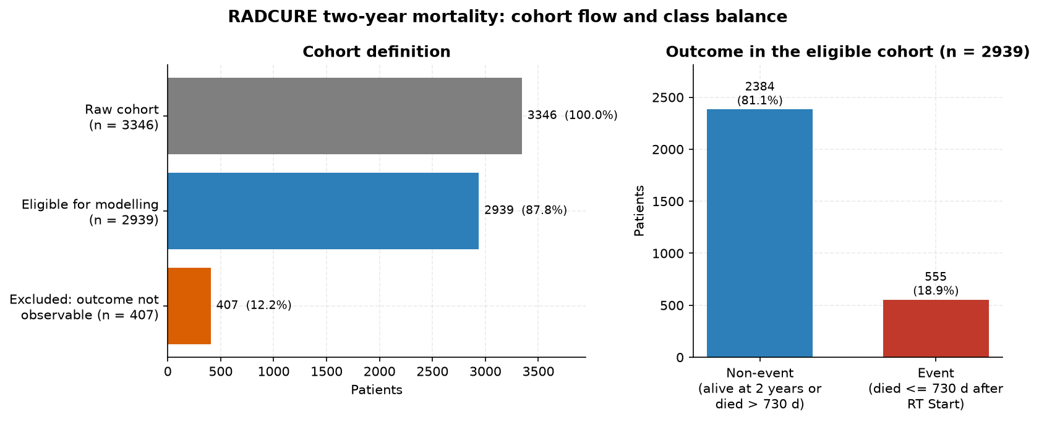
Figure 1: Construction of the fixed 730-day mortality target and the final modelling cohort.
From 3,346 raw patients, 2,939 have an observable two-year outcome. The final cohort contains 555 events and 2,384 non-events, corresponding to an event prevalence of 18.9%. A total of 407 patients are excluded because they are alive but have less than 730 days of documented follow-up. No broad clinical exclusion criteria are added beyond this outcome-observability requirement.
The two-year horizon is a pragmatic dataset-specific compromise. A one-year horizon was considered relatively short for the intended question, whereas substantially longer horizons would sharply increase the number of patients whose outcome is not observable. Two years is therefore useful here, but it is not claimed to be a universally optimal clinical horizon.

3.1 Why a temporal holdout was rejected
A chronological split was considered, but the available follow-up makes it scientifically problematic. Later treatment years contain many more patients who cannot possibly have 730 days of observed follow-up. A naive temporal test set would therefore differ from training not only by calendar time, but also by outcome observability.
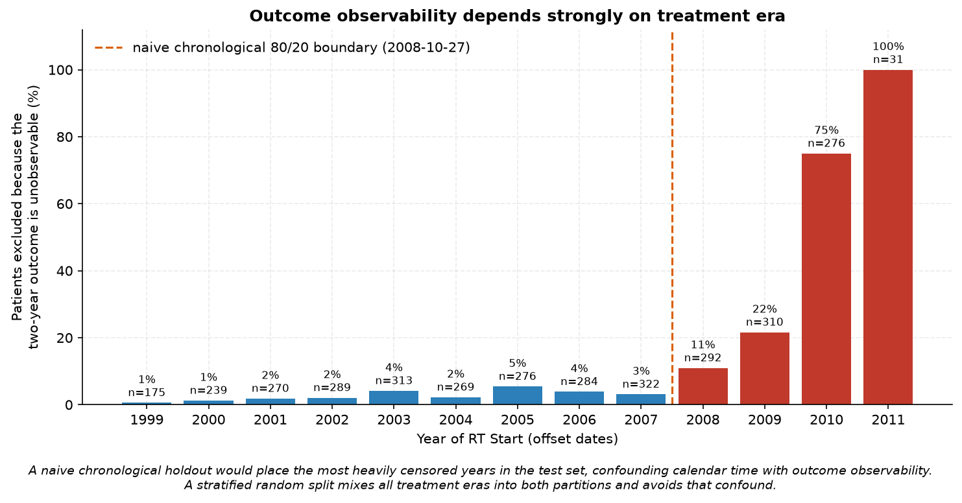
Figure 2: Outcome observability by treatment era. Insufficient two-year follow-up rises sharply in the latest years.
Exclusion for insufficient follow-up is low through the earlier years but increases markedly in the late cohort. A stratified random split was therefore chosen to mix treatment eras across both partitions while preserving the event proportion. The frozen split uses random_state 42: 2,351 patients for training (444 events) and 588 for the held-out test set (111 events). All five-fold cross-validation occurs only inside the training partition.

4. Leakage audit and predictor design
Predictor selection was intentionally separated from model performance. The eight final predictors were frozen before any model was fitted. The purpose was to prevent outcome-driven feature selection and to ensure that every predictor represented information that was conceptually appropriate for use at the prediction landmark.
The 34 raw columns were first audited for follow-up leakage, temporal availability, proxies and redundancy. Twenty-one variables were excluded at this stage. Thirteen candidates remained for predictor-design review. Five further variables were not admitted to the primary set because of information structure, redundancy, unstable availability or negligible variation. This leaves eight primary predictors.
Final predictor | Type | Reason for inclusion
Age | numeric | Basic demographic information available before treatment.
Sex | categorical | Baseline demographic characteristic.
ECOG PS | categorical | Pre-treatment functional status.
Smoking PY | numeric | Quantitative baseline smoking exposure.
Smoking Status | categorical | Complementary smoking-history information.
Ds Site | categorical | Primary disease-site information available at baseline.
T | categorical | Tumour extent at staging.
N | categorical | Regional nodal status at staging.

Not admitted to PRIMARY | Reason
M | Near-zero variation: almost all documented patients are M0, so the variable carries little useful discrimination in this cohort.
Stage | Aggregate of T/N/M information and therefore redundant with the more granular components already retained.
Subsite | High cardinality and substantial site-dependent missingness, creating a sparse and unstable representation.
Path | Dominated by SCC with many rare histologies; partially redundant with disease site and prone to unstable rare-category coefficients.
HPV | Biologically relevant, but recorded-result availability at the prediction landmark cannot be established reliably and documentation is strongly site- and era-dependent.

This funnel must not be interpreted as “34 variables reduced to the best eight by cross-validation”. The selection was based on leakage prevention, temporal plausibility, information content, redundancy, data structure and clinical interpretability. Model performance was not used to screen the raw variables.

5. Leakage-safe preprocessing and modelling pipeline
The project distinguishes deterministic semantic cleaning from learned preprocessing. Deterministic cleaning can be performed before the split because it does not estimate statistical parameters from the dataset: spelling variants are harmonised, ambiguous codes are mapped conservatively, and symbolic Smoking-PY entries that cannot be converted exactly are represented as missing. No value is clipped or changed merely for being statistically unusual.
Learned preprocessing is different. A median, a scaling mean or an encoder vocabulary depends on the data used to estimate it. These operations are therefore placed inside the modelling pipeline so that they are refitted separately within each training fold and never learn from a validation fold or the held-out test partition.
Branch | Variables | Operations learned inside the pipeline
Numeric | Age; Smoking PY | Median imputation -> StandardScaler. Age has no missing values, so median imputation is effectively a no-op for Age.
Categorical | Sex; ECOG PS; Smoking Status; Ds Site; T; N | OneHotEncoder(handle_unknown="ignore", drop=None). Explicit Missing/Unknown categories are preserved from deterministic cleaning.

The two branches are combined in a ColumnTransformer and then joined with a classifier in a scikit-learn Pipeline. Every model family receives a fresh pipeline. During cross-validation and GridSearchCV, fitting the pipeline inside a fold means that the Smoking-PY median, the scaling parameters and the categorical levels are learned only from that fold’s training subset. The same design is used for the final Logistic Regression pipeline that is fitted on the complete frozen training partition.
Pipeline component | Role in the leakage-safe workflow
Deterministic cleaning | Fixed semantic rules; estimates no statistical parameter.
ColumnTransformer | Routes numeric and categorical variables to separate preprocessing branches.
Numeric preprocessing | Learns the fold-specific median and scaling parameters.
Categorical preprocessing | Learns categories from the fold-specific training subset; unseen levels are ignored safely at transform time.
Classifier | Learns model parameters from the already transformed fold-specific training data.
Cross-validation / GridSearchCV | Refits the complete preprocessing + classifier pipeline for every training fold and every candidate configuration.

This is the key reason the project satisfies the pipeline requirement: preprocessing was not performed once on the full cohort and then reused. Instead, every baseline comparison, tuning run and training-only out-of-fold prediction was produced through the complete pipeline appropriate to that model family.

6. Evaluation strategy and metrics
All model-development comparisons use the same five-fold StratifiedKFold design with shuffle=True and random_state=42 on the 2,351-patient training partition. Stratification preserves the approximately 18.9% event proportion in every fold, while the fixed random state makes the comparisons reproducible.
Metric | Role | Why it is used
ROC-AUC | Primary | Threshold-independent discrimination: how consistently the model ranks event patients above non-event patients.
Average Precision | Secondary | More informative than ordinary accuracy for the minority event class; summarises precision-recall performance relative to the ~18.9% prevalence.
Balanced Accuracy | Supplementary | Operating-point metric that averages sensitivity and specificity and therefore gives the two classes equal weight.
Ordinary Accuracy | Not emphasised | A model can look deceptively good by predicting the majority non-event class in an imbalanced cohort.

The primary model-family choice is therefore based on ROC-AUC and supported by Average Precision. Balanced Accuracy is reported, but its value depends on the decision rule used by a model. This distinction becomes important for the tuned SVC, whose class_weight="balanced" changes its native operating point without necessarily improving threshold-independent discrimination.

7. Baseline models and hyperparameter tuning
Five model families were first evaluated at default hyperparameters under the same cross-validation design: a prior-probability Dummy classifier, Logistic Regression, a single Decision Tree, Random Forest and an RBF-kernel Support Vector Classifier. The purpose of this stage was not to declare a final winner, but to establish no-signal and simple-model references and to decide which model families deserved controlled tuning.
Default model | ROC-AUC | Average Precision | Balanced Accuracy
Dummy (prior) | 0.5000 | 0.1889 | 0.5000
Logistic Regression | 0.7897 | 0.4404 | 0.5879
Decision Tree | 0.5850 | 0.2358 | 0.5850
Random Forest | 0.7554 | 0.3815 | 0.5783
RBF SVC | 0.7285 | 0.4135 | 0.5324

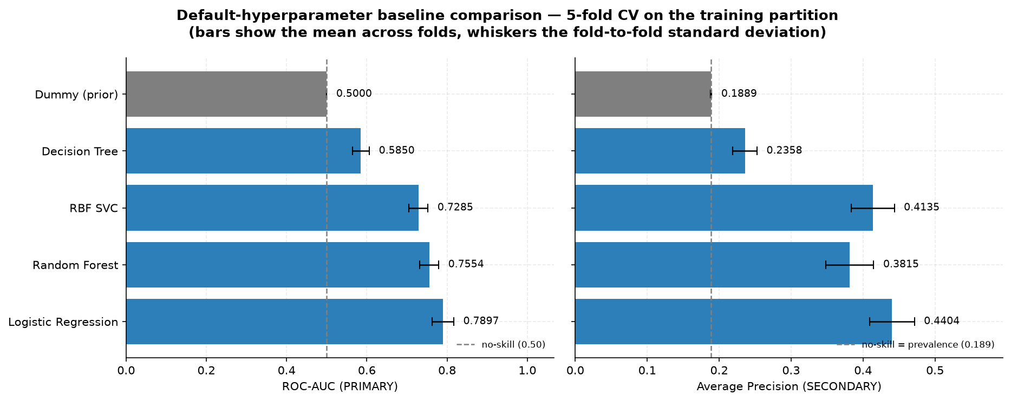
Figure 3: Five-fold training-CV comparison of the default model families. ROC-AUC is the primary metric.
The Dummy classifier behaves as expected: ROC-AUC and Balanced Accuracy are 0.50, while Average Precision is close to the training event prevalence. Logistic Regression is the strongest default candidate with mean ROC-AUC 0.7897 and AP 0.4404. Random Forest is second on ROC-AUC at 0.7554. The default RBF SVC has lower ROC-AUC (0.7285) but relatively strong AP (0.4135), indicating that the family should not be dismissed before tuning C and gamma. The single Decision Tree is substantially weaker and is not shortlisted.

7.1 Controlled hyperparameter search
Logistic Regression, Random Forest and RBF SVC were shortlisted. Each search used GridSearchCV on the complete preprocessing + classifier pipeline, with ROC-AUC as the refit metric. The held-out test partition remained unavailable throughout.
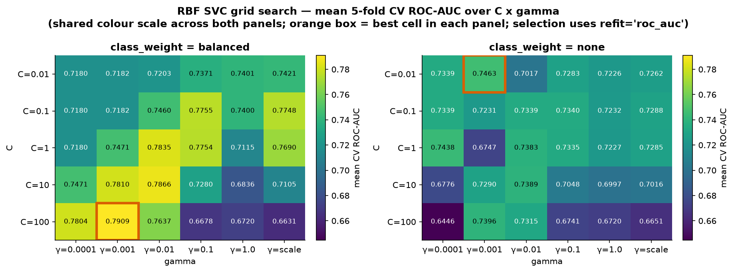
Figure 4: RBF-SVC search over C and gamma. The first search located its optimum at the edge, motivating a narrow refinement rather than an unrestricted expansion.
Logistic Regression returned to C=1 and no class weighting, effectively confirming that the default regularisation was already appropriate. Random Forest improved to ROC-AUC 0.7791 with max_depth=10, max_features="sqrt" and min_samples_leaf=2. The SVC required a second, narrower refinement because its first optimum lay at the search boundary; the final configuration was C=100, gamma=0.001 and class_weight="balanced".
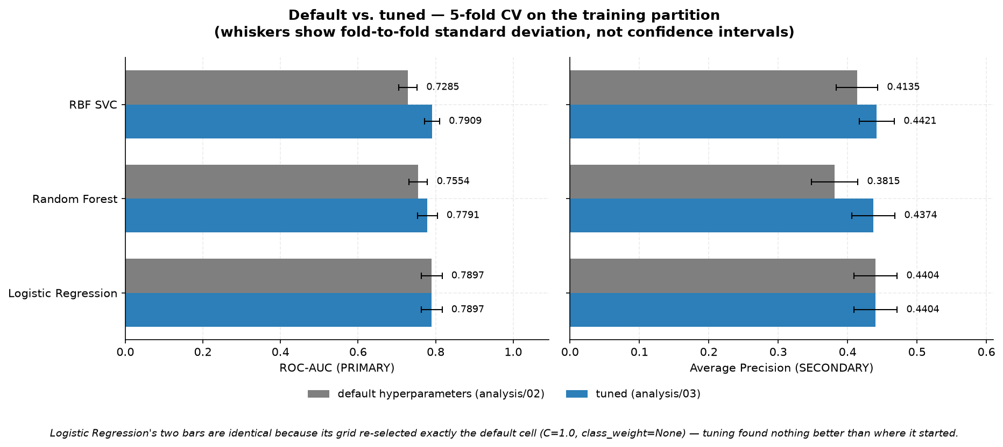
Figure 5: Default versus tuned cross-validation performance for the three shortlisted model families.
Tuning materially improved the Random Forest and especially the SVC. The tuned SVC reaches mean ROC-AUC 0.7909 and AP 0.4421, essentially matching Logistic Regression on threshold-independent discrimination. Its higher Balanced Accuracy (0.7090) should not be interpreted as evidence of a better ranking model, because the balanced class weight also shifts the native decision boundary. Model selection therefore continues to focus on ROC-AUC and AP.

8. Model complementarity and final model choice
Once LR, RF and SVC produced similar cross-validation results, the next question was whether they made different errors. If structurally different models rank the same patients differently, an ensemble may exploit complementary information. Training-only out-of-fold scores were therefore generated so that every patient’s score came from a model that had not been trained on that patient.
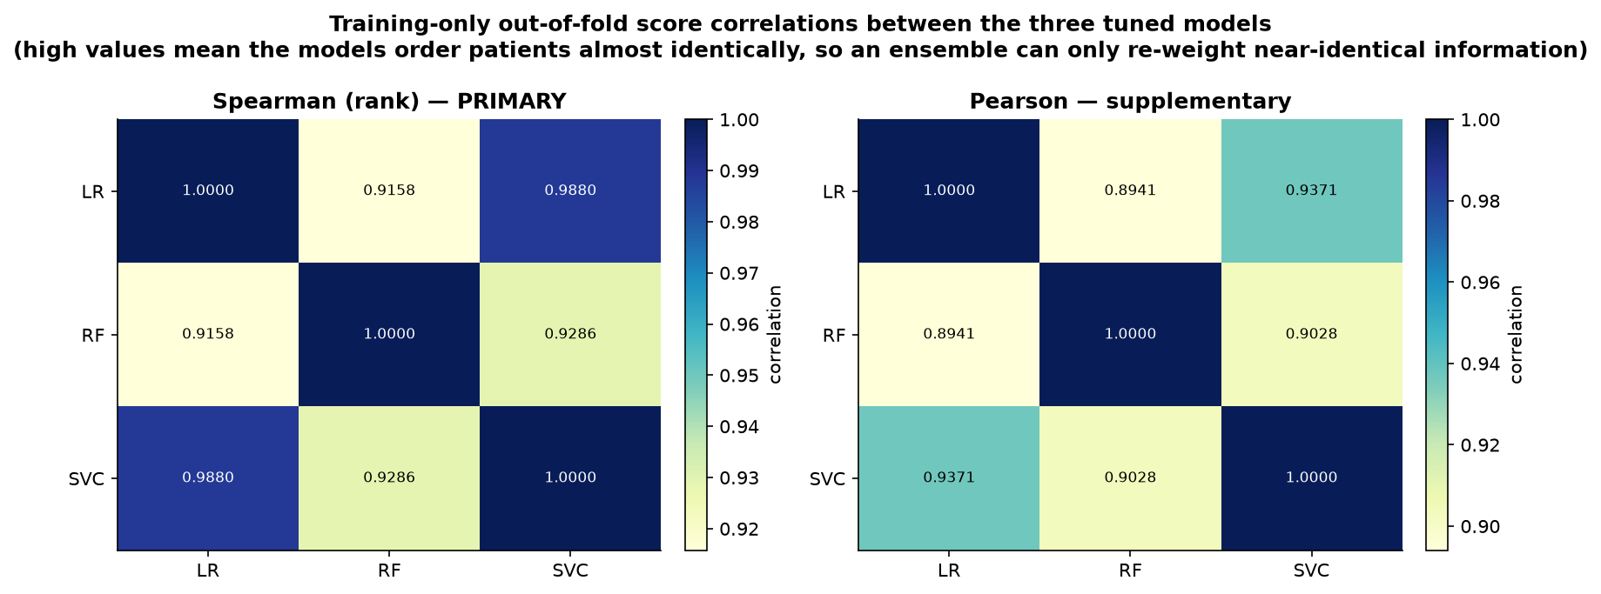
Figure 6: Correlation of training-only out-of-fold model scores. LR and SVC rank patients almost identically.
The OOF rankings are highly correlated: Spearman correlation is approximately 0.988 between Logistic Regression and RBF SVC, with Random Forest only modestly more distinct. This suggests that the model families are largely extracting the same signal from the eight predictors.
A stacking ensemble of LR + RF + SVC and two exploratory XGBoost configurations were then evaluated under the same training-only CV framework. They did not produce a meaningful gain. Across all six reported candidate configurations the ROC-AUC range is only about 0.0118; the key linear, kernel, stacking and refined-boosting approaches cluster even more tightly around 0.79. This spread is smaller than the fold-to-fold standard deviation of Logistic Regression itself (~0.027).
Candidate | Status | ROC-AUC | AP
Logistic Regression | PRESPECIFIED | 0.7897 | 0.4404
Random Forest | PRESPECIFIED | 0.7791 | 0.4374
RBF SVC | PRESPECIFIED | 0.7909 | 0.4421
Stacking (LR+RF+SVC) | EXPLORATORY | 0.7905 | 0.4424
XGBoost (1st stage) | EXPLORATORY | 0.7831 | 0.4328
XGBoost (refined) | EXPLORATORY | 0.7885 | 0.4375

The result is best interpreted as an empirical performance plateau for this predictor set and evaluation design, not as a theoretical ceiling. More algorithmic complexity does not uncover substantially more discriminatory information. Under near-equivalent discrimination, Logistic Regression is selected before threshold optimisation because it is simpler, more transparent and more parsimonious than the alternatives. It is not selected because it has the numerically highest ROC-AUC; the tuned SVC is slightly higher, but the difference is negligible relative to cross-validation variability.

9. Training-only threshold selection
Choosing a model family and choosing a classification threshold are separate decisions. ROC-AUC and Average Precision assess ranking across all possible thresholds, while an actual binary decision requires one operating point. The final Logistic Regression family was therefore chosen first; only then was its threshold selected from training-only out-of-fold probabilities.
The default probability threshold of 0.50 is poorly aligned with the minority event class in this project. On OOF training predictions it yields sensitivity 0.2185 and specificity 0.9575: very few false positives, but most two-year deaths are missed. The project therefore searches all unique OOF probability thresholds for the maximum Balanced Accuracy. This is mathematically equivalent to maximising Youden’s J because Balanced Accuracy = (1 + J) / 2.
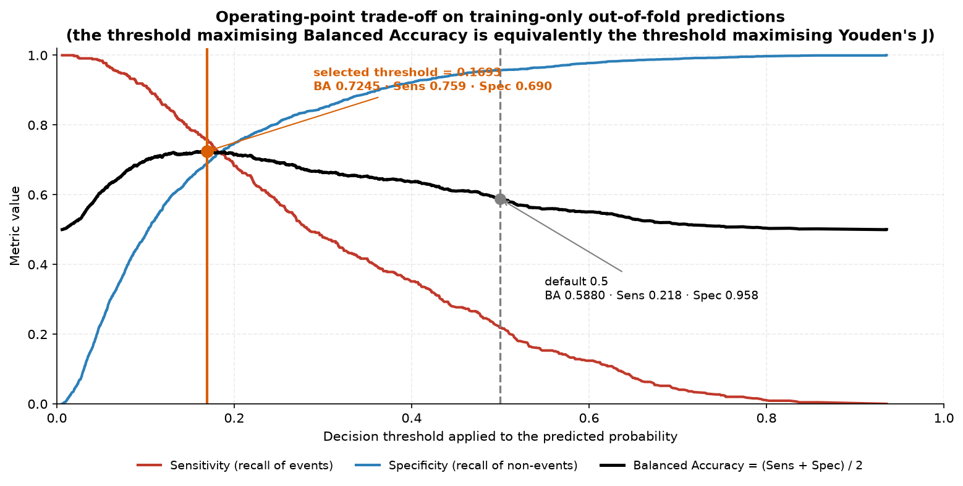
Figure 7: Training-only operating-point trade-off. The selected threshold maximises Balanced Accuracy / Youden J.
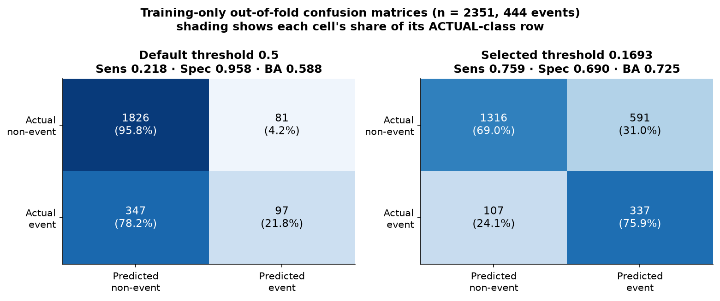
Figure 8: Training OOF confusion matrices at the default 0.50 threshold and the selected threshold.
Training OOF metric | Threshold 0.50 | Selected 0.1693
Sensitivity | 0.2185 | 0.7590
Specificity | 0.9575 | 0.6901
Precision | 0.5449 | 0.3631
F1 | 0.3119 | 0.4913
Balanced Accuracy | 0.5880 | 0.7245
Predicted positive rate | 0.0757 | 0.3947

The selected threshold is 0.16929818782414302. At this point sensitivity rises to 0.7590 and specificity falls to 0.6901, with Balanced Accuracy increasing from 0.5880 to 0.7245. This is a training-derived statistical operating point under equal weighting of sensitivity and specificity. It is explicitly not claimed to be clinically optimal because the project does not define a downstream intervention or a relative clinical cost for false negatives versus false positives.

10. Final held-out evaluation
After the predictor set, preprocessing, Logistic Regression family, hyperparameters and threshold were frozen, the persisted final pipeline was applied to the untouched 20% test partition. This is an internal held-out evaluation from the same RADCURE cohort, not external validation.
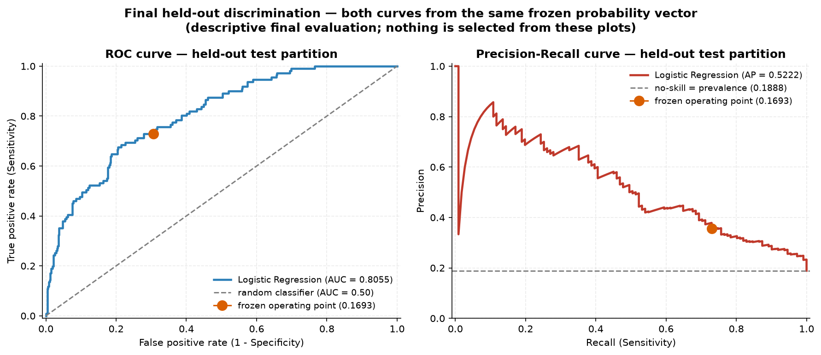
Figure 9: ROC and precision-recall curves on the frozen held-out partition (n=588; 111 events).
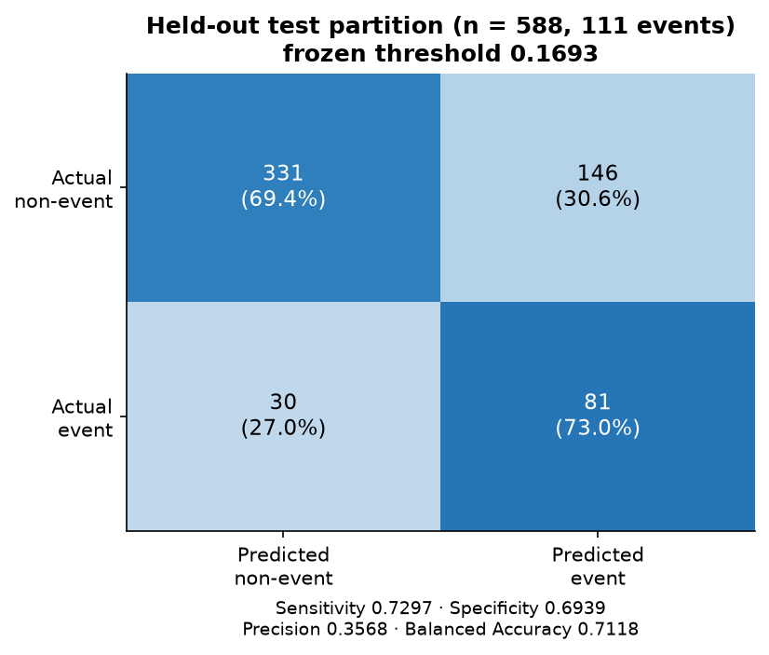
Figure 10: Held-out confusion matrix at the frozen threshold of 0.1693.
Held-out quantity | Result
Patients / events / non-events | 588 / 111 / 477
ROC-AUC | 0.8055
Average Precision | 0.5222
Sensitivity / Recall | 0.7297
Specificity | 0.6939
Precision | 0.3568
F1 | 0.4793
Balanced Accuracy | 0.7118
Confusion matrix | TN 331, FP 146, FN 30, TP 81

The held-out ROC-AUC of 0.8055 indicates useful internal discrimination: the model ranks higher-risk patients above lower-risk patients substantially better than chance. Average Precision is 0.5222, well above the approximately 18.9% event prevalence, showing meaningful enrichment of events toward the high-score end of the ranking.
At the frozen threshold, sensitivity is 0.7297 and specificity 0.6939. The model correctly identifies 81 of 111 two-year deaths but also produces 146 false-positive classifications. Precision is therefore only 0.3568: roughly one in three predicted positives is an observed two-year event in this held-out sample. This is not a contradiction. The threshold was deliberately moved toward sensitivity, so more patients are flagged positive. The result is appropriate for the chosen statistical criterion, but it is not sufficient evidence for clinical deployment.
The held-out metrics are close to the training-stage OOF operating-point metrics (Balanced Accuracy 0.7118 versus 0.7245), which is reassuring. However, the test set originates from the same dataset and the same overall data-generation process, so this agreement must not be interpreted as external validation.

11. Final model interpretation
The final persisted model is an L2-regularised Logistic Regression with C=1, class_weight=None, max_iter=5000 and random_state=42, embedded in the same preprocessing pipeline used during model development. The coefficient interpretation is descriptive: the project does not report p-values, causal effects or clinical significance tests.
The two numerical variables are standardised inside the pipeline. Their coefficients therefore correspond to a one-standard-deviation increase on the training scale. Age has coefficient +0.4378 and Smoking PY +0.1328, so higher values are associated with higher predicted log-odds of two-year mortality within the fitted multivariable model. Age shows the larger of the two standardised numeric coefficients.
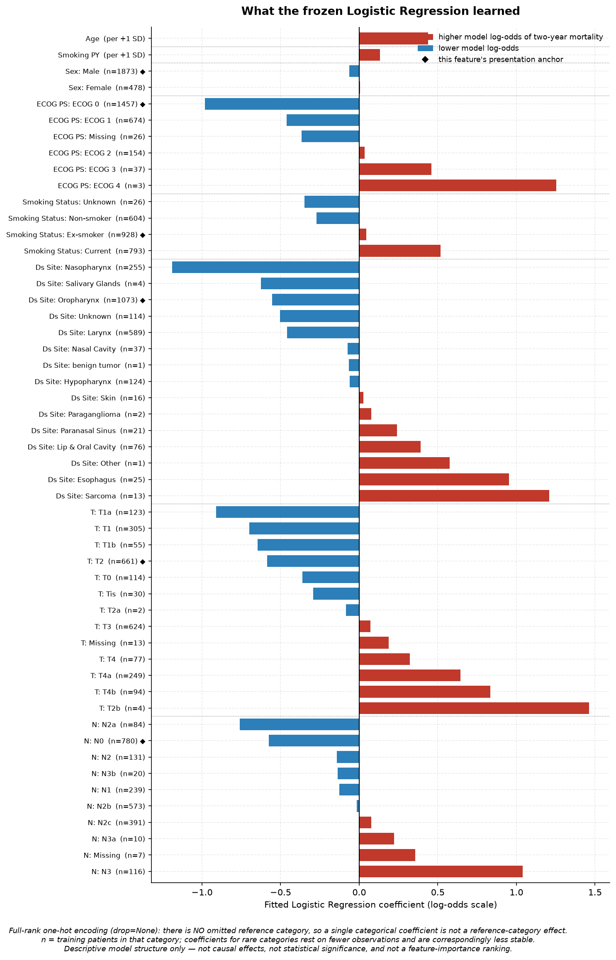
Figure 11: Final Logistic Regression coefficients, descriptive presentation anchors and category counts in the frozen training partition.
Categorical variables require more caution. OneHotEncoder uses drop=None, so every level receives its own coefficient; there is no conventional omitted reference category in the fitted model. For presentation, the most frequent training category is shown as an anchor and contrasts are reported relative to that anchor, but these anchors are descriptive aids rather than the parameterisation used by the model.
Several apparently large coefficients belong to extremely rare categories. For example, ECOG 4 has only n=3 training patients and T2b only n=4. Their large positive coefficients should therefore not be interpreted as stable population effects. L2 regularisation reduces instability but cannot create information where very few observations exist. More common patterns, such as increasing coefficients across poorer ECOG categories or a positive N3 coefficient, are more interpretable as model tendencies, but still remain descriptive associations rather than causal conclusions.

12. Answer to the research question and limitations
The research question asks how reliably two-year all-cause mortality can be predicted from eight pre-treatment clinical, demographic and tumour-related characteristics using classical machine learning. The result is neither “the model failed” nor “the model is clinically ready”. The evidence supports a more specific conclusion: these variables contain a reproducible internal risk signal, but the signal is limited and additional model complexity does not materially improve it.
Key result | Interpretation
Held-out ROC-AUC 0.8055 | Useful discrimination within an internal RADCURE test partition.
Held-out AP 0.5222 vs. ~0.189 prevalence | Events are substantially enriched among high model scores.
Sensitivity 0.7297 / specificity 0.6939 | The frozen threshold provides a deliberately balanced operating point rather than maximising one class.
Precision 0.3568 | Many flagged patients are false positives; the operating point would need clinical context before any practical use.
Six candidate configurations span only ~0.0118 ROC-AUC | Algorithm choice appears less important than the information available in the current predictor set.
Logistic Regression selected | Near-equivalent discrimination plus simplicity, transparency and parsimony.

12.1 Main limitations
• Internal validation only: the held-out patients come from the same RADCURE cohort as the training patients. Performance may differ in another institution, time period or patient population.
• The fixed predictor set intentionally uses only eight baseline clinical variables. The observed performance plateau may reflect a feature-information bottleneck, but it does not prove a theoretical maximum.
• Two-year classification ignores the exact timing of death and censoring beyond the fixed horizon; a survival model would answer a different question.
• The selected threshold maximises a statistical criterion with equal sensitivity/specificity weighting. It is not based on clinical utility, decision-curve analysis or a specified cost ratio.
• Calibration was not a primary endpoint of this project. Good discrimination does not guarantee that predicted probabilities are perfectly calibrated.
• Rare categorical levels remain in the model and can have unstable coefficients despite L2 regularisation.
• HPV was excluded from the PRIMARY model because recorded-result availability at the landmark cannot be established reliably and documentation is highly site- and era-dependent; this may omit potentially useful biology.
These limitations constrain the intended interpretation. The project demonstrates a rigorous internal modelling workflow and a meaningful predictive signal; it does not establish a deployable clinical decision tool.

13. Conclusion and outlook
The project developed a fully leakage-controlled classical machine-learning workflow for two-year mortality prediction in the RADCURE clinical cohort. The scientific sequence was fixed before the held-out evaluation: observable outcomes were defined at a two-year landmark, predictors were selected by temporal and information-design criteria rather than outcome screening, the split was frozen once, and all learned preprocessing was embedded inside scikit-learn pipelines so that cross-validation and tuning remained training-only.
The modelling results show that Logistic Regression, tuned RBF SVC, stacking and refined gradient boosting all converge near ROC-AUC 0.79 in cross-validation. This convergence is itself an important result. It suggests that, for the present predictor set, the main constraint is likely the information contained in the variables rather than the sophistication of the algorithm. Logistic Regression is therefore a defensible final choice because it reaches essentially the same discrimination with greater transparency and fewer modelling assumptions.
On the frozen held-out partition the final model reaches ROC-AUC 0.8055 and Average Precision 0.5222. At the training-derived Balanced-Accuracy threshold it achieves sensitivity 0.7297 and specificity 0.6939, but precision remains 0.3568. The final model can therefore be described as a useful internal proof of concept with moderate practical limitations, not as a clinically validated predictor.
The most meaningful next steps would be external validation on an independent cohort, explicit assessment of probability calibration and clinical utility, and investigation of whether additional reliably available baseline information can improve the feature-information bottleneck. These extensions should be evaluated without reopening the frozen held-out test set for model development.

13.1 Compact result overview
Item | Final result
Raw / eligible cohort | 3,346 / 2,939 patients
Two-year events / non-events | 555 / 2,384 (18.9% prevalence)
Train / held-out | 2,351 / 588 patients
Primary predictors | 8: Age, Sex, ECOG PS, Smoking PY, Smoking Status, Ds Site, T, N
Cross-validation | 5-fold stratified CV on training partition only
Final model | Logistic Regression, C=1, class_weight=None
Frozen threshold | 0.16929818782414302, chosen by training-only Balanced Accuracy / Youden J
Held-out ROC-AUC / AP | 0.8055 / 0.5222
Held-out sensitivity / specificity | 0.7297 / 0.6939
Held-out precision / F1 / BA | 0.3568 / 0.4793 / 0.7118
Overall interpretation | Useful internal discrimination; not externally validated and not deployment-ready.

13.2 Data source and reproducibility
The clinical source data are RADCURE Version 4 from The Cancer Imaging Archive (TCIA), DOI 10.7937/J47W-NM11. The clinical workbook is distributed under CC BY 4.0; the project repository also contains the frozen derived modelling cohort and aggregate result artefacts required to reproduce the reported workflow. Imaging and RTSTRUCT data are not part of this project and are subject to separate access conditions.
The repository pins the tested Python environment and includes automated scientific and structural tests. The final project state passed 132 tests, and the persisted cohort, split, threshold and held-out metrics are protected by explicit invariants. This reproducibility layer complements the statistical safeguards described throughout the document.

