GAME DESIGN DOCUMENT
Lakbay Salita
Journey through words: a 2D game for learning Cebuano, Ilonggo and Tagalog

Item | Detail
Document version | 1.0 (first full edition)
Date | October 2026
Project | Lakbay Salita (Capstone II)
Engine and platform | Unity 2021.3.45f2, Windows desktop (standalone)
Project status | Playable end to end. Content is draft and needs native-speaker review.
Source repository | github.com/cabaldanjehoshaphat/LAKBAY-SALITA---PHILIPPINE-LANGUAGE-2D-LEARNING-GAME-

Contents
1. Document overview 4
1.1 Purpose 4
1.2 How to read it 4
1.3 What is fact and what is a plan 4
2. Game overview 5
2.1 Concept 5
2.2 Elevator pitch 5
2.3 Game summary 5
2.4 Key numbers 5
2.5 Unique selling points 6
3. Design goals and pillars 7
4. Target audience 8
4.1 Primary players 8
4.2 Player needs and how the game answers them 8
4.3 Accessibility notes 8
5. Core loop and game flow 9
5.1 Core loop 9
5.2 Screen flow 9
6. Features in detail 11
6.1 Main menu and settings 11
6.2 Language hub 11
6.3 Topics and levels (shared by the three games) 12
6.4 Wordle 12
6.5 Crossword 14
6.6 Word Search 15
6.7 Learn cards 16
6.8 Phrasebook and Sentence builder 17
6.9 Library (dictionary) 18
6.10 Profile 19
6.11 Day streak 19
7. Content design 20
7.1 Languages and topics 20
7.2 Level structure 20
7.3 One shared word list 20
7.4 Content rules for writers 21
7.5 Content status 21
8. Progression, scoring and retention 22
9. User interface and experience 23
9.1 Screen and layout 23
9.2 Visual style 23
9.3 Interaction patterns 23
10. Audio design 24
10.1 Music 24
10.2 Sound effects 24
10.3 Sound rules 24
10.4 Tap to hear (off) 24
11. Art and asset requirements 25
12. Technical design summary 26
12.1 Technology 26
12.2 Architecture in brief 26
12.3 Module sizes 26
13. Saved data 28
13.1 PlayerPrefs keys 28
13.2 player_data.json 28
14. Quality status, known issues and risks 29
14.1 What was verified 29
14.2 Known issues 29
14.3 Risks 29
15. Roadmap 31
15.1 Ideas not yet designed in detail 31
Appendix A. Scene list 32
Appendix B. Glossary 32
Appendix C. Source of this document 32

In Word, right-click the table above and choose Update Field to refresh page numbers.

1. Document overview

1.1 Purpose
This Game Design Document (GDD) describes what Lakbay Salita is, how it plays and why it is designed this way. It is written from a full read of the project: its scenes, scripts, data files, audio and art, plus the Git history. It is the single reference for the team, for advisers and for anyone who joins the project later.

1.2 How to read it
- Sections 2 to 4 explain the idea, the audience and the design goals.
- Sections 5 and 6 describe the game flow and every feature in detail, with the rules a player meets.
- Sections 7 to 11 cover content, progression, interface, audio and art.
- Sections 12 to 15 cover the technical design, saved data, quality status, risks and the roadmap.
- The appendices list every scene, the code modules and the asset inventory.

1.3 What is fact and what is a plan
Everything marked as built exists in the project and was checked in Play mode. Items marked planned or off are described so the design is complete, but they are not part of the playable game yet (for example Tap to hear, which is built but switched off).

2. Game overview

2.1 Concept
Lakbay Salita (Tagalog and Cebuano for "journey of words") is a 2D educational word game. A player picks one of three Philippine languages, learns words on cards, practises them in three puzzle games, uses them in real phrases, and can look up any word in a built-in dictionary of 63,540 entries.

2.2 Elevator pitch
Wordle, Crossword and Word Search, but every answer is a Cebuano, Ilonggo or Tagalog word, and the game teaches the word before it tests it.

2.3 Game summary
Aspect | Description
Genre | Educational word puzzle game (language learning)
Platform | Windows standalone build. Windowed 800 x 600 to 1024 x 768, maximize to 1920 x 1080.
Perspective and art | 2D, flat menu-style user interface drawn in Unity UI, with a time-of-day sky and sea on the main menu
Languages | Cebuano (index 0), Ilonggo / Hiligaynon (index 1), Tagalog (index 2). Interface text is English.
Activities | Wordle, Crossword, Word Search, Learn cards, Phrasebook with Sentence builder, Library dictionary
Session length | A puzzle takes about 2 to 6 minutes. A Wordle level has a 5:00 timer.
Players | Single player, offline. No account, no internet.
Monetisation | None. Capstone (academic) project.
Save data | On the player's computer (PlayerPrefs and player_data.json)

2.4 Key numbers
Item | Count
Languages | 3
Dictionary entries (Library) | 63,540 (Cebuano 22,005, Hiligaynon 15,223, Tagalog 26,312)
Wordle levels | 126 (42 per language: 7 topics x 6 levels)
Crossword puzzles | 63 (21 per language: 7 topics x 3 sizes)
Word Search puzzles | 63 (21 per language: 7 topics x 3 puzzles)
Phrasebook phrases | 53 (Cebuano 18, Ilonggo 17, Tagalog 18) in 7 everyday topics
Playable scenes | 15
C# scripts | 97 files, about 20,600 lines (12 are editor tools)
Music tracks and sound effects | 7 and 25

2.5 Unique selling points
- Teach, then test. Learn cards show each word with its English meaning before the puzzle asks for it.
- One word list across three games. A word met in Wordle appears again in the Crossword and the Word Search, so repetition happens naturally.
- Three languages in one game. The same screens and rules work for Cebuano, Ilonggo and Tagalog.
- Real phrases. The Phrasebook and Sentence builder move the player from single words to sentences.
- A real dictionary built in. 63,540 words with search in English and in the native language, favorites and a word of the day.
- Calm, local feel. Bamboo, sea and boat art, marimba and kulintang style music, and a sky that changes with the time of day.

3. Design goals and pillars
Pillar | What it means | Where it shows
Learn before you are tested | A new player who knows nothing must still be able to progress. | Learn cards on every topic, English clues, hints that name a letter and its column
Low pressure | No lives system, no punishment for stopping. Time pressure only in Wordle. | Crossword and Word Search have no time limit or tries. Pause hides the Wordle board.
Same rules, three languages | Switching language never changes how the game plays. | Language chips, shared word list, one play scene per game
Words in use | Words become sentences. | Phrasebook cards and Sentence builder
Remember and revisit | The game remembers what you solved and saved. | Solved counts, day streak, Words learned, Library favorites
Easy to extend | New words, levels or a language are data changes, not code changes. | JSON files plus the Level Data Registry

4. Target audience

4.1 Primary players
- Filipinos and Filipino-heritage learners who understand one Philippine language and want to learn another (for example a Tagalog speaker learning Cebuano).
- Students aged about 12 and up who are comfortable with Wordle-style games.
- Teachers who want a classroom activity for vocabulary.

4.2 Player needs and how the game answers them
Need | Answer in the game
I do not know the word at all | Learn cards, English clue, letter hints, Library lookup
I want a quick game | Random word / puzzle buttons, short puzzles, no setup
I want to see my progress | Profile with per-language bars, streak and Words learned
I want to keep words I like | Star on every result card, Favorites in the Library
I want to speak, not only spell | Phrasebook and Sentence builder (Tap to hear is planned)

4.3 Accessibility notes
- Large text and high-contrast cream cards on a dark sky, in the Roboto font family.
- Every game works with the mouse; Wordle and Crossword also work with the physical keyboard, and Esc opens the pause window.
- Colour is never the only signal in the games: found words are struck through, and each Wordle tile also shows its letter.
- Not yet covered: screen readers, a colour-blind palette option and text size settings.

5. Core loop and game flow

5.1 Core loop
- Choose a language and a game (or open the Library or Phrasebook).
- Learn a topic's words on Learn cards (optional but recommended).
- Play a puzzle: guess, fill or find the words.
- Review the result card: the word, its meaning, time, tries and streak; star the words to keep.
- Continue to the next level or puzzle, or return to the hub. Progress is saved after each result.

5.2 Screen flow
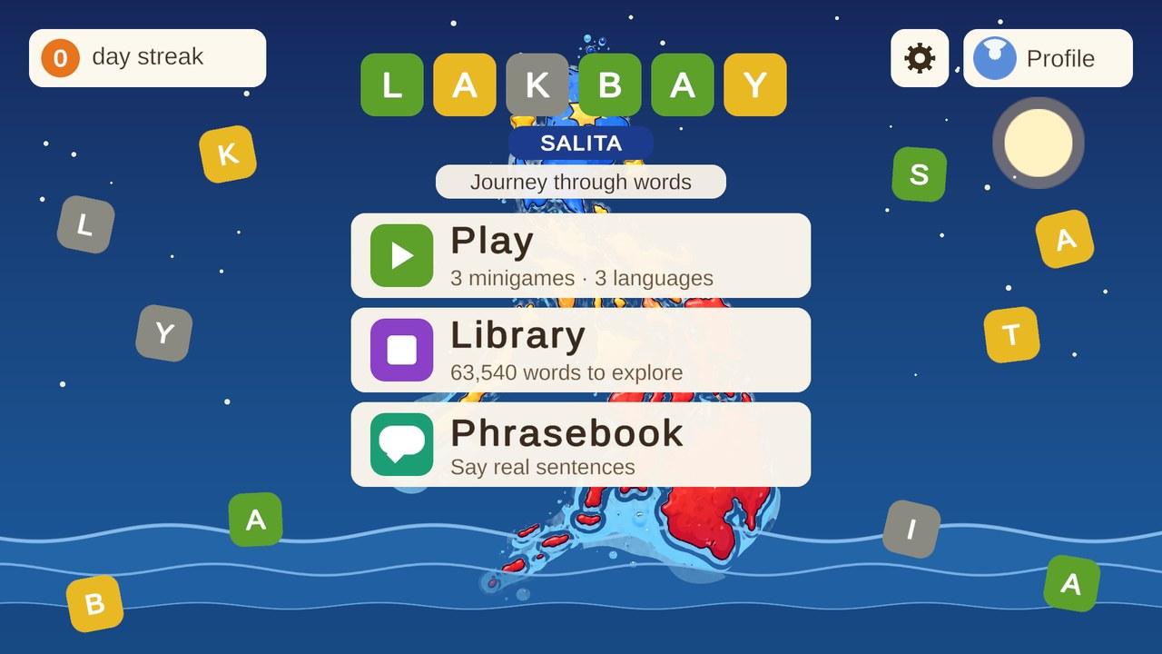
Main menu: Play, Library and Phrasebook, with the gear (settings) and Profile in the top bar
From | To | How
Main menu | Language hub | Play
Main menu | Library | Library card
Main menu | Phrasebook topics | Phrasebook card
Main menu | Profile | Profile chip (top right)
Main menu | Settings window | Gear chip (top right)
Language hub | Wordle / Crossword / Word Search start screens | Game card, in the language chosen on the right
Start screen | Learn cards | Learn button on a topic card
Start screen | Play scene | Play button, or the Random button
Play scene | Result card | Win, out of tries or out of time (Wordle)
Result card | Next level, Library, language hub | Buttons on the card
Phrasebook topics | Phrase cards or Sentence builder | Learn and Build buttons on a topic card

Every screen has a back button (top left) and responds to the Esc key. The Language hub is the central screen for the three puzzle games.

6. Features in detail

6.1 Main menu and settings
Purpose: a welcoming entry point that sets the mood and leads to everything else.
- Title "LAKBAY": letter tiles start gray and scrambled, then flip into the right order and colour.
- Three cards: Play (3 minigames, 3 languages), Library (63,540 words to explore) and Phrasebook (say real sentences).
- Top bar: day-streak chip, gear (settings), Profile chip with the avatar.
- The sky and sea change with the device clock: Morning 05:00 to 10:59, Noon 11:00 to 15:59, Afternoon 16:00 to 18:59, Night 19:00 to 04:59. Letter tiles bob, waves scroll, the boat rocks and clouds drift.
- Settings window (gear): Sound effects On / Off, and a Music volume slider with a percentage. Dragging the slider to 0 turns the music off. Both settings are saved.
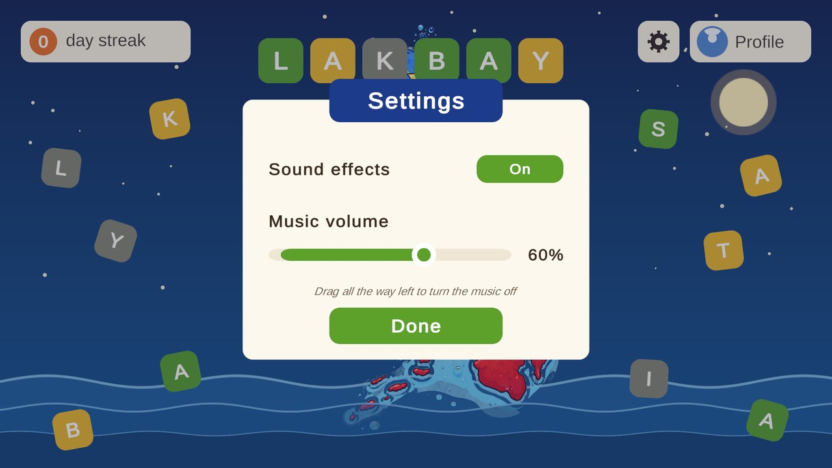
Settings window: sound effects switch and music volume slider

6.2 Language hub
Purpose: choose the game and the language in one place.
- Three game cards (Wordle, Crossword, Word Search), each with a progress tag such as "Cebuano · 1 of 21" for the selected language.
- A language selector on the right (Cebuano, Ilonggo, Tagalog). The choice is passed to the game that opens.
- Opening a game records today as played for the day streak.
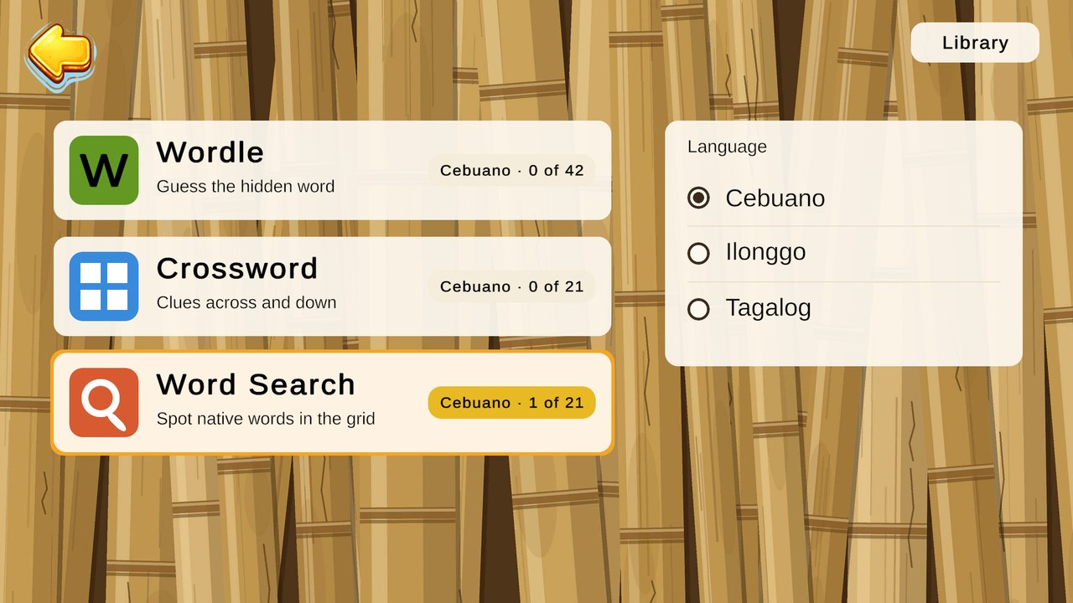
Language hub with the three game cards and the language selector

6.3 Topics and levels (shared by the three games)
- Seven topics, each with its own colour dot: Animals, Food and drink, Body, Family and people, Home and things, Nature and weather, Numbers.
- Each topic card shows a solved counter (for example "0 of 6 solved"), an arrow stepper to choose the level or size, Learn and Play buttons.
- A Random button picks a puzzle for the player. An info card explains the screen.
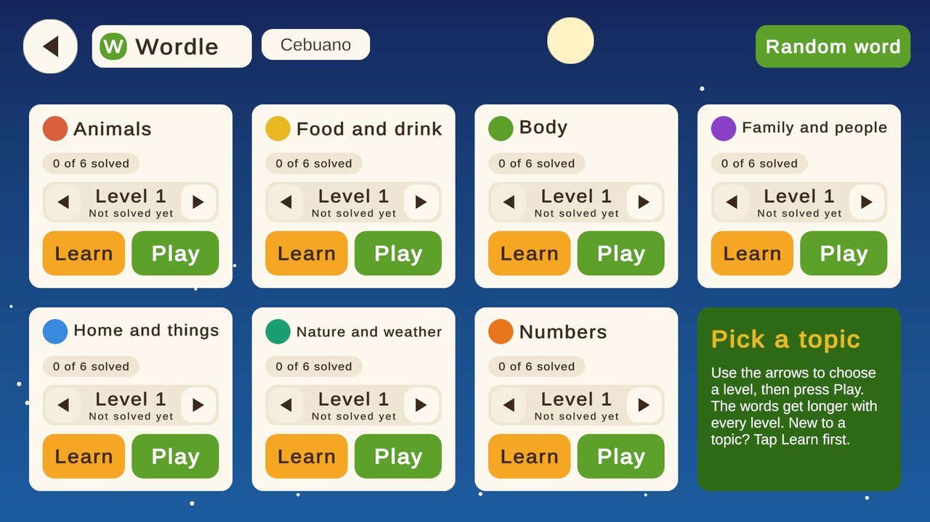
Wordle start screen: seven topics, six levels each

6.4 Wordle
Aspect | Design
Goal | Find the hidden word of the topic level (4 to 7 letters, longer with each level).
Rules | 5 tries and a 5:00 countdown. After each guess the tiles turn green (right letter, right place), yellow (letter is in the word, wrong place) or gray (not in the word).
Clue | The English meaning of the word, shown on top (for example "Frog; toad.").
Hints | 2 per puzzle. A hint names one letter the player does not have in place and its column: "Hint - Letter A is in column 2". The hint is also added to the clue line.
Input | On-screen keypad or the physical keyboard. The keypad keys are not coloured, so the player has to remember the feedback.
Timer | Turns orange in the last 10 seconds. If the time runs out or the tries run out, the result card shows the answer.
Pause | Esc, the pause button or the app losing focus. The timer stops and the board is hidden so the player cannot pause to think.
Result card | Word, meaning, time, tries used and streak. Star to save the word. Buttons: Next level, See in Library, Back to games.
Words not in the dictionary | Rejection is available but off by default (setting Reject Unknown Words), because many valid words are missing from the dictionary file.
Progress | Each solved level is saved. Solving a word counts in the Profile and adds it to Words learned.

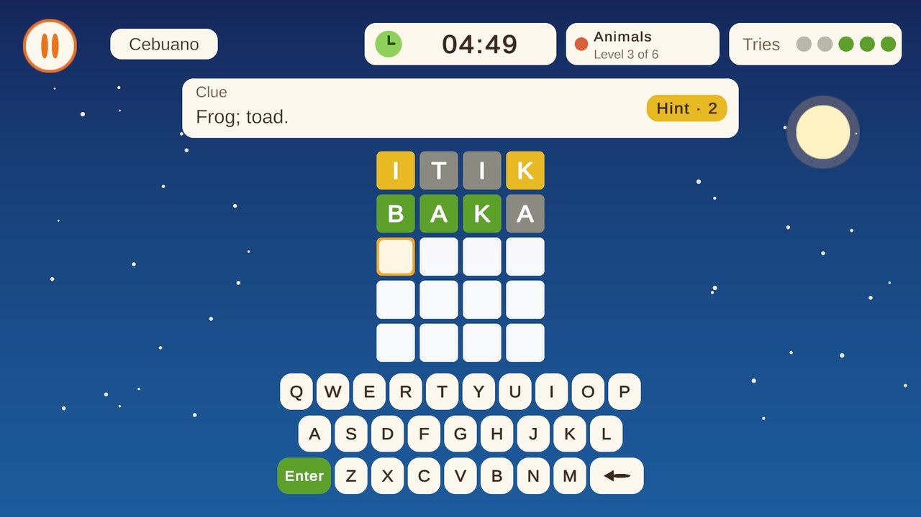
Wordle in play: clue, timer, tries and the grid
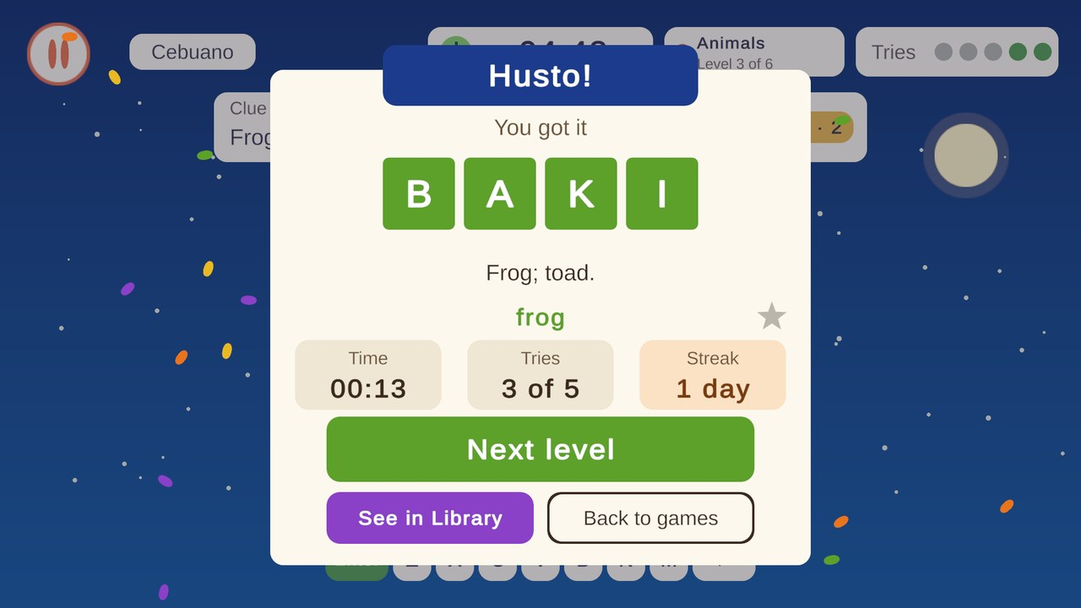
Wordle result card after finding BAKI (frog)

6.5 Crossword
Aspect | Design
Goal | Fill the grid so that every Across and Down word is correct.
Sizes | Small (5 words), Medium (8 words) and Large (11 words) per topic.
Clues | A banner shows the active clue (number, direction, letter count, text) with previous and next arrows. Across and Down tabs list all clues; solved clues are struck through.
Help | Hint: reveals one letter, 3 per puzzle. Check: marks wrong letters in the active word. Reveal: fills the active word, once per puzzle.
Input | Click a cell or a clue and type. Keypad switch (off by default, remembered) shows an on-screen keyboard.
Limits | No tries and no time limit. A stopwatch counts the time. The puzzle ends when every word is correct.
Result card | Lists every word the player learned with a star to save each one, plus time, hints used and streak.
Order | Small, Medium, Large of a topic, then the next topic.

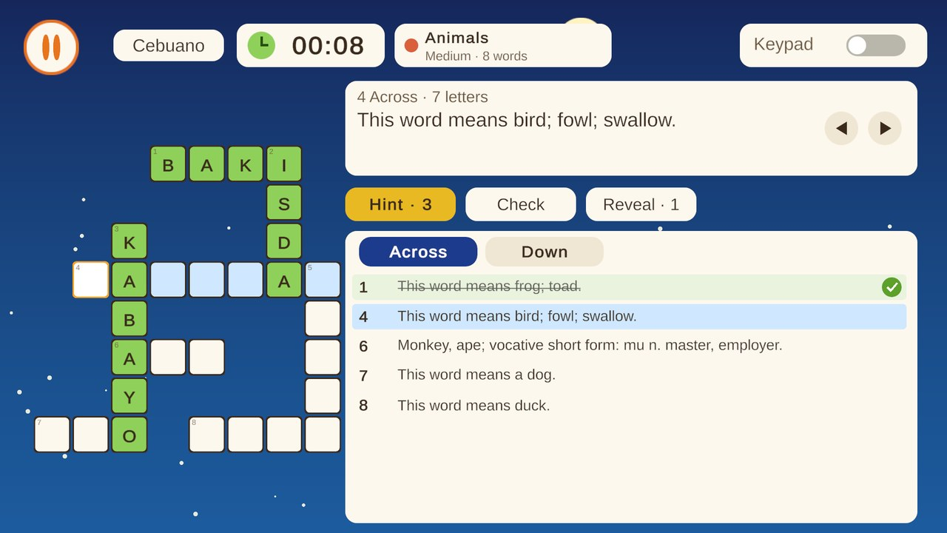
Crossword in play: grid, active clue and clue lists

6.6 Word Search
Aspect | Design
Goal | Find all the hidden native words in a 10 x 10 letter grid.
Puzzles | Three puzzles (A, B, C) per topic, 7 to 8 words each, words of 3 to 8 letters.
Placement | Words run across, down or diagonally down-right, never backwards. Words may cross where letters match. The same seed always produces the same grid.
Controls | Press on a letter and drag. The selection snaps to the nearest straight line. Release to check the word.
Word list | Shortest word first. Found words are struck through and get the colour of their capsule on the grid. A Meaning mode (list shows English meanings) exists but is switched off in the scene.
Hint | 3 per puzzle. A ring pulses on the first letter of a word that is not found yet.
Counter | "Found 4 of 8" in the top bar. No tries, no time limit.
Result card | Every word with its meaning, a star to save it, time, hints used and streak.

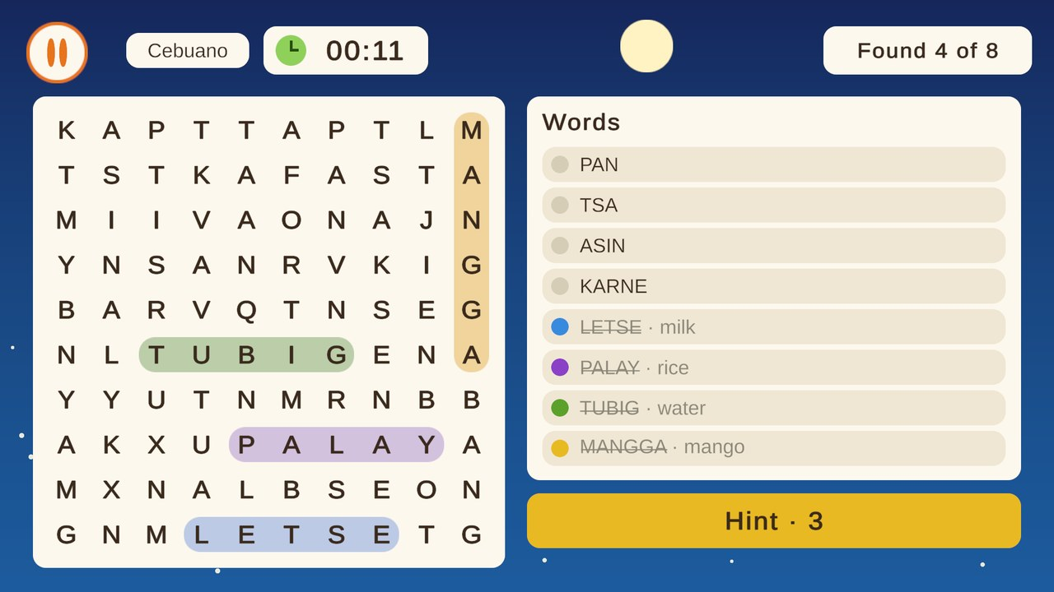
Word Search with four of eight words found

6.7 Learn cards
Purpose: meet the words before playing them. This answers the question "how does a new player know the answer?"
- One card per word: the native word large, the English meaning below, "Word 2 of 7" and a dot per word.
- Each topic has three sets (A, B, C), the same word sets as the three Word Search puzzles. Set chips switch between them.
- Back and Next move through the words. Start puzzle opens the game that called the Learn screen (Wordle: first unsolved level; Crossword: first unsolved size; Word Search: the puzzle of that set).
- Learn cards are optional, so players who know the words are not slowed down.
- A "Tap to hear" speaker button is built for this screen but switched off until recordings exist (see 10.4).
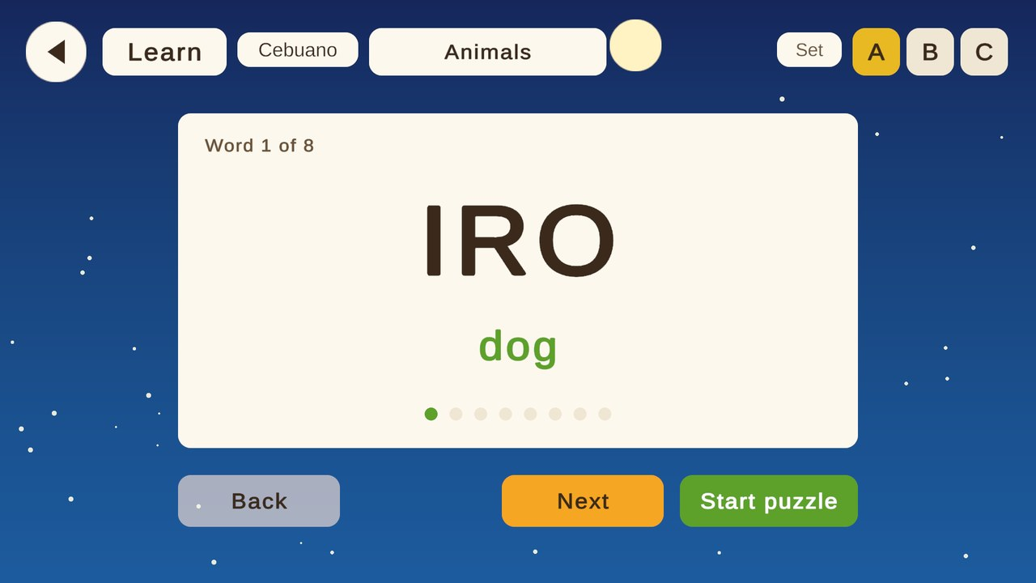
Learn card for the Cebuano word IRO (dog)

6.8 Phrasebook and Sentence builder
Purpose: use words in real sentences, the step after single words.
- Opened from the main menu. A language chip row at the top (Cebuano, Ilonggo, Tagalog) works like the Library tabs; the last choice is remembered.
- Seven topics: Greetings, Thanks and sorry, About me, Food and market, Directions, Numbers and time, Help and safety. A topic card shows "0 of 5 learned", a sample phrase, Learn and Build buttons.
- Phrase cards (Learn): English line, the phrase in the language and, when available, a tile per word with its meaning.
- Sentence builder (Build): the player sees an English sentence and taps word tiles into the right order. The bank holds the phrase's words plus one wrong word from another phrase. Tap a tile to fill the next slot; tap a filled slot to take the word back; Clear empties the slots.
- Check: a right sentence marks the phrase as learned; a wrong one costs one of 4 tries. Hint: puts the next correct word in place, 2 per sentence.
- Result card: Next sentence, See in Phrasebook, Back to topics. Learned phrases count in the Profile.
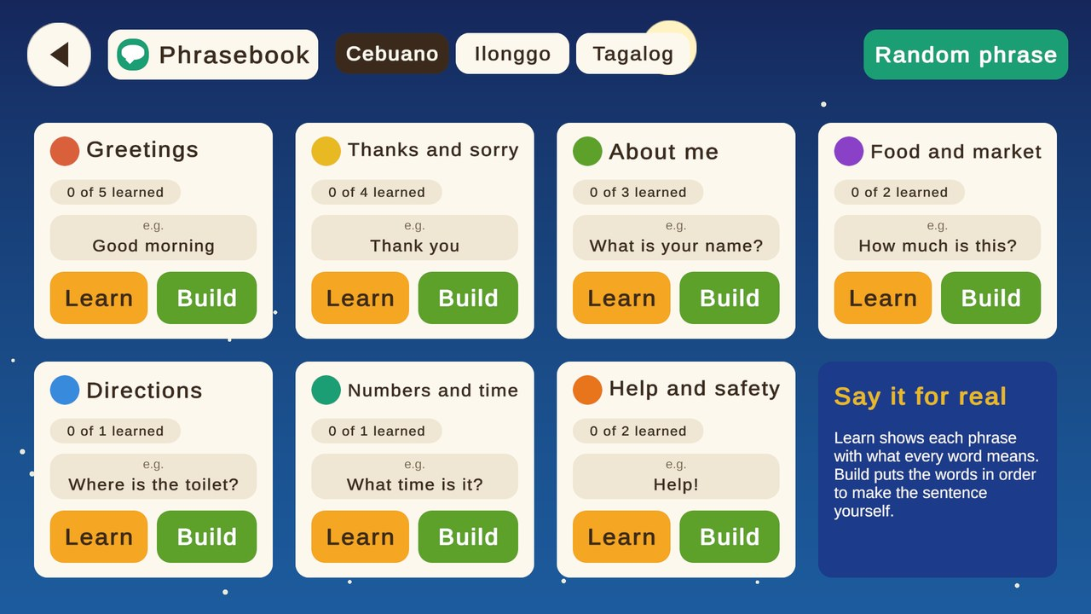
Phrasebook topics, with the language chips at the top
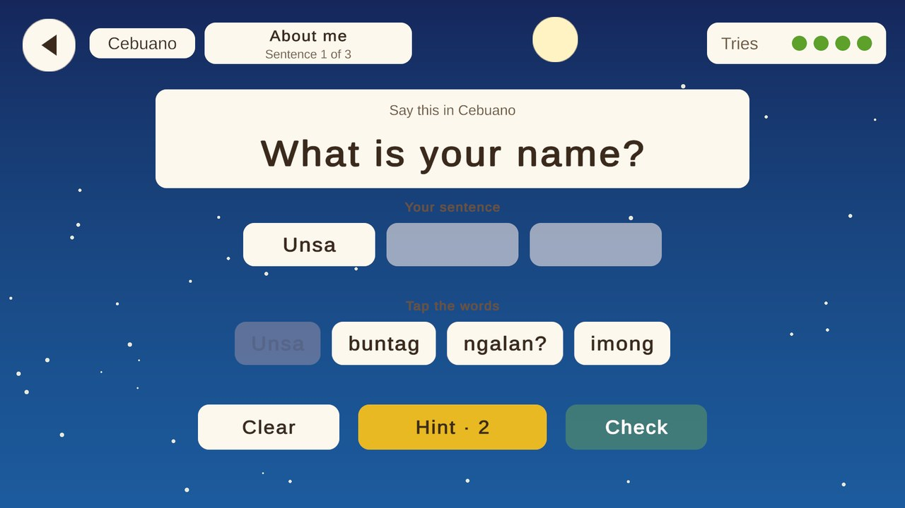
Sentence builder: "What is your name?" with word tiles

6.9 Library (dictionary)
- Loads three dictionary files: Cebuano 22,005 words, Hiligaynon 15,223 words, Tagalog 26,312 words (63,540 in total).
- Tabs: Cebuano, Hiligaynon, Tagalog and All three (side by side).
- With the search box empty: a scrollable A to Z notebook list with an A to Z jump strip and a light page for easy reading.
- With text typed: ranked results (exact headword or exact English meaning first, then prefix and whole-word matches, then definition matches), so both "house" and "balay" work. Cross-language suggestions and "did you mean" spelling help.
- Left panel: details of the opened word, the same word in other languages, word of the day, recent searches and favorites (star).
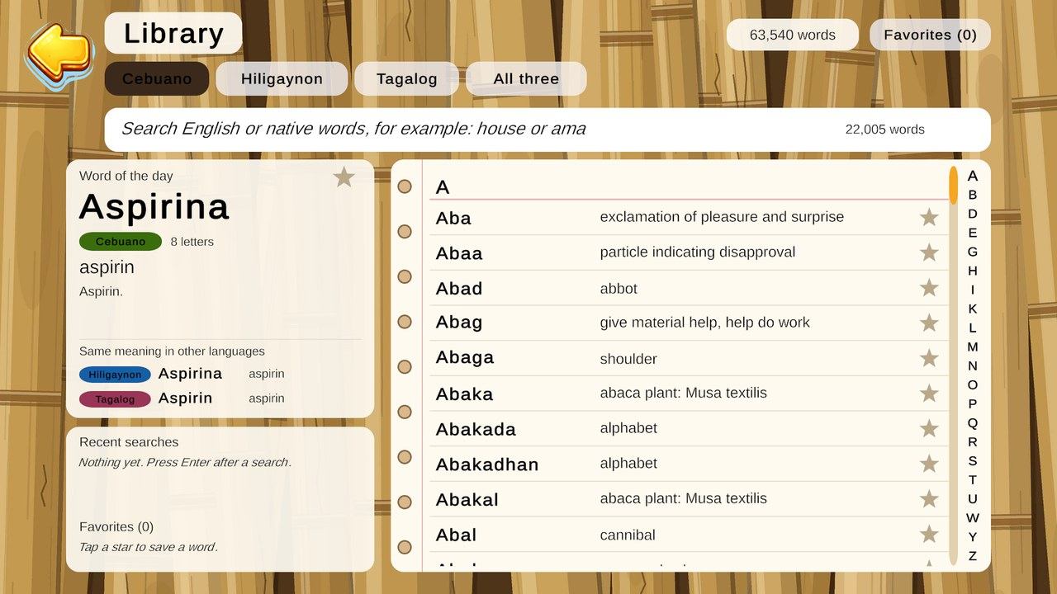
Library with the word of the day and the A to Z notebook

6.10 Profile
- Avatar (10 colours) and player name; both editable in the Edit profile dialog.
- "Learning since" date and day streak with best streak.
- One compact row per activity (Wordle, Crossword, Word Search, Phrasebook) with a count and a progress bar for each language side by side.
- Words learned card and a Favorites card that opens the Library favorites.
- Reset progress clears name, avatar, solved counts, learned phrases and the streak after a confirmation. Library favorites are kept.
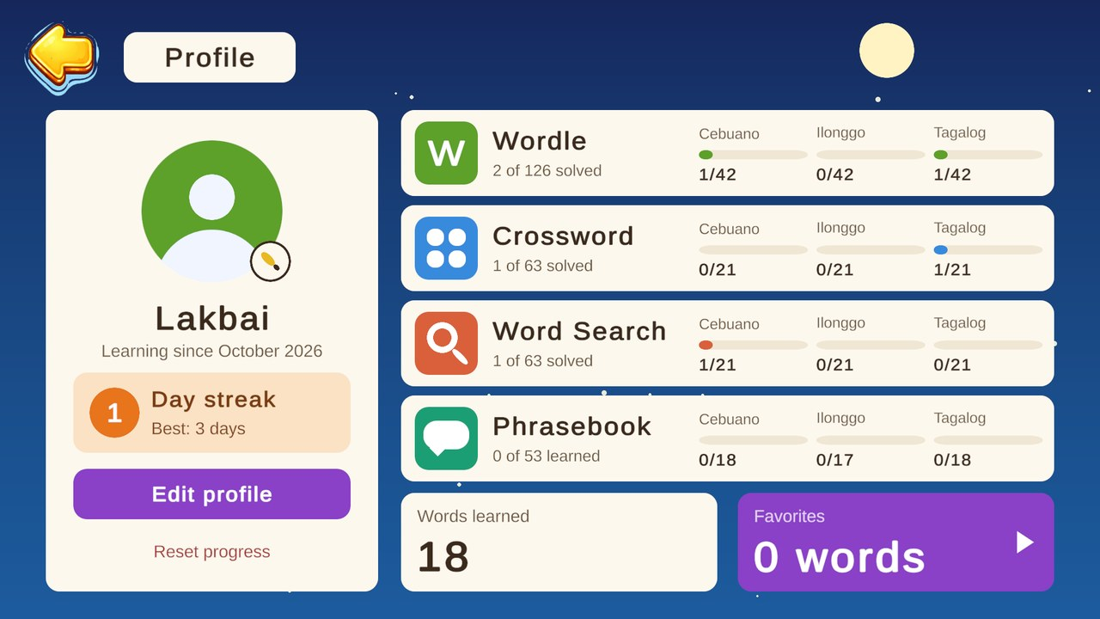
Profile screen with sample progress

6.11 Day streak
Opening any game counts the day as played. Playing on consecutive calendar days grows the streak; missing a whole day makes the next play start at 1. The streak chip on the main menu shows the current value (0 once more than a day has passed). The best streak is kept.

7. Content design

7.1 Languages and topics
Index | Language | Dictionary file | Entries
0 | Cebuano | cebuano.json | 22,005
1 | Ilonggo (Hiligaynon in the Library) | hiligaynon.json | 15,223
2 | Tagalog | tagalog.json | 26,312

# | Topic | Colour (hex-style RGB)
1 | Animals | Coral (217, 96, 59)
2 | Food and drink | Gold (232, 185, 35)
3 | Body | Green (93, 160, 42)
4 | Family and people | Purple (138, 63, 199)
5 | Home and things | Blue (55, 138, 221)
6 | Nature and weather | Teal (29, 158, 117)
7 | Numbers | Orange (232, 117, 26)

7.2 Level structure
Game | Per topic | Per language | Data file
Wordle | 6 levels (4 to 7 letters) | 42 | Data/Wordle/Levels/wordle_levels_<language>.json
Crossword | 3 puzzles (Small 5, Medium 8, Large 11 words) | 21 | Data/Crossword/Puzzles/crossword_puzzles_<language>.json
Word Search | 3 puzzles (A, B, C), 7 to 8 words | 21 | Data/Word Search/Puzzles/wordsearch_puzzles_<language>.json
Phrasebook | 1 to 5 phrases | 17 to 18 | Data/Phrasebook/phrases_<language>.json

7.3 One shared word list
The words of a topic are the same in Wordle, Crossword and Word Search. This was unified so that one meaning always maps to one word (for example frog is BAKI in all three games). There are 133 shared words per language. A player who learns a topic in Learn cards meets the same words in the three games.

7.4 Content rules for writers
- Wordle words use letters A to Z only, 4 to 7 letters, ordered shortest to longest inside a topic.
- Word Search words are 3 to 8 letters so they fit the 10 x 10 grid; each puzzle has 7 to 8 words.
- Crossword grids are generated by a tool. To change a crossword word, send the correction and rebuild the puzzle rather than editing positions by hand.
- Every word has an English meaning. Crossword clues are shown as "This word means ..." or a dictionary clue.
- Phrases keep the gloss empty or exactly one entry per word, in order.

7.5 Content status
All word lists and phrases are drafts. They were picked from the dictionary files by a script and have not been reviewed by a native speaker. Some dictionary-derived clues read roughly (for example a long clue for AMU). Native-speaker review of Cebuano, Ilonggo and Tagalog, Ilonggo phrases especially, is the most important task before release.

8. Progression, scoring and retention
- No points or levels of the player. Progress is the number of levels solved, shown as "N of M solved".
- Unlocks: none. All topics and levels are open from the start; the stepper lets a player jump to any level.
- Order: after a win, "Next level" moves to the next level of the topic, then the first level of the next topic.
- Words learned: every different word solved or met in a finished puzzle is stored per language and counted on the Profile.
- Favorites: stars on result cards and in the Library are saved and shown in the Library favorites list.
- Retention: the day streak with a best streak; the word of the day in the Library.

9. User interface and experience

9.1 Screen and layout
- All screens are designed on a 1920 x 1080 canvas (16:9), scaled to the window by the Canvas Scaler.
- Window limits (Windows): default and largest 1024 x 768, smallest 800 x 600. A window dragged outside snaps back after about a third of a second.
- Maximize: the maximize button switches to a full screen window at 1920 x 1080; Alt+Enter leaves it and returns to 1024 x 768.
- Letterbox: in any window that is not 16:9 (such as 4:3) every camera draws in the biggest 16:9 rectangle and the rest is filled with dark navy bars, so nothing overlaps.

9.2 Visual style
Element | Design
Mood | Calm sea journey: boat, waves, gulls, clouds, bamboo and jigsaw backgrounds
Cards | Cream rounded cards (253, 248, 238) on a deep blue sky
Text colours | Dark brown ink (59, 42, 26) on cream; soft brown (107, 82, 55) for secondary text
Accent colours | Green (93, 160, 42) for primary buttons, amber / gold for hints and highlights, teal for the Phrasebook, blue for the Crossword, coral for Word Search
Font | Roboto (nine weights as TextMeshPro SDF assets)
Motion | Tile flips, shake on a bad word, floating letters, scrolling waves, confetti on a win

9.3 Interaction patterns
- Every button plays a click sound; back arrows, open and close, hint and keypad buttons have their own sounds.
- Pause windows (Esc, pause button, app in the background) with Resume, a way to choose another puzzle and Back to games.
- Result cards always offer the next step: next level, Library or hub.
- Toasts give short messages ("No hints left", "Hint - Letter A is in column 2").

10. Audio design

10.1 Music
Seven original tracks, one for each screen group, generated with a Python script (BGM Ideas/make_bgm.py) from bamboo marimba, kulintang gong and bell tones. A track changes only when a scene with a different track loads; moving between Wordle start and Wordle play keeps the music playing. Music volume and mute are saved.
Screen | Track
Main menu | 01 Lakbay
Profile | 02 Ako Ni
Language hub | 03 Tulay
Library | 04 Tahimik
Wordle (start and play) | 05 Hula-Hula
Crossword (start and play) | 06 Pahalang Pababa
Word Search (start and play) | 07 Pangita

10.2 Sound effects
25 short effects (SFX Ideas/make_sfx.py), loaded by name from Resources. Connected now: every button press (ui_click, ui_back, ui_open, ui_close, hint) and the Wordle keypad (key_tap_1 to 3, key_delete, key_enter), and the toggle sound in settings. Not connected yet: typing on a physical keyboard, tile reveal, word found, word complete, timer ticks, win jingle, time up and word_invalid.

10.3 Sound rules
- One self-creating player handles all button sounds; new buttons get a sound without setup.
- Sound effects can be switched off in the settings window (saved as SfxMuted).
- Music fades out in 0.08 seconds and the next track fades in over 0.3 seconds, so tracks never overlap.

10.4 Tap to hear (off)
Tap to hear plays a recording of a word or phrase from Resources/Audio Words/<Language>/, named after the text in lower case with underscores. The system is built and installed, then switched off because there are no recordings. The speaker buttons are installed on the Learn cards, the Wordle result card and other word screens. About 551 recordings are needed (list in Mockups/audio_recording_list.md). Text-to-speech voices for these languages are not reliable, so real recordings from native speakers are the plan.

11. Art and asset requirements
Asset type | Current | Notes
Sprites | 151 PNG files | Imported as Sprite (2D and UI), no mipmaps, 100 pixels per unit. Menu art, backgrounds, icons.
Letter sprites | 104 PNG (A to Z in 4 states) | Highlighted, Normal, Plain, Wrong; referenced through the ImageContainer asset
Procedural UI sprites | Rounded card, circle, star | Drawn in code by LibraryUiKit, so most UI needs no image files
Fonts | Roboto family | Nine TextMeshPro SDF font assets
Prefabs | 11 | Wordle tile and cell, Timer, Dialog panel, Crossword cells and clue rows, Back button
Music | 7 WAV | Streamed, compressed
Sound effects | 25 WAV | Mono, ADPCM, decompress on load
Word recordings | 0 of about 551 | Optional; Tap to hear is off

12. Technical design summary
A full technical history and a step-by-step build guide are in the two companion PDFs. This section is the short version.

12.1 Technology
Item | Choice
Engine | Unity 2021.3.45f2 (LTS), built-in render pipeline, linear colour space
UI | uGUI with TextMeshPro 3.0.6; Canvas Scaler 1920 x 1080, Expand
Language | C# (scripts), JSON (content)
Data | JsonUtility on TextAsset JSON; a ScriptableObject registry lists the files
Save | PlayerPrefs and a JSON file (player_data.json)
Version control | Git and GitHub, branches main and sub
Editor automation | Unity MCP package and editor builder tools

12.2 Architecture in brief
- Session classes (static) pass the chosen language, topic and level between scenes: WordleSession, CrosswordSession, WordSearchSession, LearnSession, PhraseSession.
- Data classes load and cache the JSON of each game: WordleData, CrosswordCategoryData, WordSearchData, PhraseData, LibraryData. They find the files through LevelDataRegistry.
- Controllers run each screen: WordleGameController, CrosswordGameController, WordSearchGameController, LearnController, PhraseBuilderController and others.
- Progress stores save solved levels in PlayerPrefs; PlayerDatabase keeps the profile.
- Self-creating singletons need no scene object: BackgroundMusic, SoundEffects, ScreenFit, WordAudioPlayer.
- One play scene per game (Wordle - Play, Crossword - Play, WordSearch - Play) replaced the 30 per-level scenes of each game; the level comes from data.
- Editor builder tools (menu Tools) rebuild the scenes from code, so a design change is one menu click.

12.3 Module sizes
Module | Scripts | Lines | Responsibility
1 Menu | 12 | 1,951 | Main menu motion and theme, settings, profile, streak chip
2 Wordle | 23 | 4,457 | Grid, keyboard, verifier, timer, controller, categories
3 Crossword | 21 | 5,207 | Grid generator, cells, clue panel, input, categories
4 Word Search | 8 | 2,316 | Generator, board view, controller, start screen
5 Library | 7 | 2,195 | Dictionary data, search, notebook list, UI kit
6 Learn | 4 | 774 | Learn cards
7 Phrasebook | 7 | 1,666 | Topics, cards, Sentence builder, data
Audio | 5 | 947 | Music, button sounds, Tap to hear
Core | 10 | 1,059 | Player data, registry, navigation, streak, ScreenFit
Total | 97 | 20,572

13. Saved data

13.1 PlayerPrefs keys
Key | Content
wordle.solved.v1 | Solved Wordle levels as "language:category:level" joined with |
crossword.solved.v1 | Solved crosswords as "language:category:size"
wordsearch.solved.v1 | Solved word searches as "language:category:puzzle"
phrasebook.learned.v1 | Learned phrases as "language:topic:phrase"
phrasebook.language | Last language chosen in the Phrasebook
library.favorites.v1 | Favorite words as "language:WORD"
library.recent.v1 | Latest 8 Library searches, one per line
crossword.keypad, wordsearch.mode | Crossword keypad switch; Word Search mode (Classic or Meaning)
streak_count, streak_last_play, streak_best | Day streak
MusicVolume, MusicMuted, SfxMuted | Audio settings

13.2 player_data.json
Written by PlayerDatabase. Holds the player name, avatar index, join date, solved counts per game and per language, best crossword level and the list of learned words ("language:WORD"). An older file without the newer fields still loads; missing fields keep their defaults.

14. Quality status, known issues and risks

14.1 What was verified
- Play-mode runs of every game, the hub, Library, Learn, Phrasebook, Profile and settings with screenshots at 1920 x 1080.
- Layout checked at 1024 x 768 and 800 x 600 (letterbox) in the editor Game view.
- Scripts compile without errors.

14.2 Known issues
# | Issue | Impact | Suggested action
1 | Words and phrases are unreviewed drafts | Possible wrong or odd words, Ilonggo phrases especially | Native-speaker review
2 | Maximize and window clamp are untested in a built .exe | May behave differently from the editor | Test a Windows build
3 | Build Settings lists 75 scenes, 60 of them archived old scenes | Larger build, confusing scene list | Keep only the 15 playable scenes enabled
4 | Game-event sound effects not connected | Games feel quieter than intended | Wire the existing 18 clips
5 | No word recordings | Tap to hear is off | Record 551 words
6 | Dictionary-derived clues can read roughly | Some clues are long or unclear | Edit clues during review
7 | Legacy folders remain (Assets/Sub, per-level legacy data, 128 archived scenes) | Clutter, import time | Remove once no longer needed
8 | Some code comments are out of date (for example the registry path note) | Misleading comments | Update comments
9 | No automated tests | Regressions found only by playing | Add edit-mode tests for the data classes

14.3 Risks
Risk | Mitigation
Incorrect language content harms trust | Native-speaker review before sharing; mark draft content
Players quit because they do not know any words | Learn cards, hints, English clues; keep Learn visible on every topic
Scope growth and knowledge held by one person | Data-driven design keeps additions cheap, review comes first; this GDD, the two build PDFs and a comment on every script keep the knowledge written down

15. Roadmap
Phase | Goal | Items
Now | Review and fix | Native-speaker review of words, phrases and clues; test a Windows build; clean Build Settings
Next | Make it speak | Record or source audio for the word list; switch Tap to hear on; connect the game-event sound effects
Then | Make it grow | More levels and topics; review of missed words (daily review); difficulty options; more phrases
Later | Share it | Playtest with real learners, polish, publish the Windows build

15.1 Ideas not yet designed in detail
- Daily review: replay words the player missed.
- Word bank before Wordle and Crossword (a visible list of the topic's words).
- Mobile build (Android) with touch-friendly sizes.
- Teacher mode: choose topics for a class.

Appendix A. Scene list
Scene | Purpose
1 Main_menu | Main menu with animated sky, gear settings, Profile chip
2 Profile Icon | Profile and progress
3 Language_Selection_Menu | Language hub with the three game cards
4 Library_menu | Dictionary
Wordle - Start / Wordle - Play | Topic and level picker; the single play scene
Crossword - Start / Crossword - Play | Topic and size picker; the single play scene
CrossWord - Generate | Crossword generator scene used while preparing puzzles
WordSearch - Start / WordSearch - Play | Topic and puzzle picker; the single play scene
Learn - Cards | Learn cards
Phrasebook - Topics / Cards / Builder | Phrase topics, phrase cards, Sentence builder

Appendix B. Glossary
Term | Meaning
Lakbay | Journey (Tagalog and Cebuano)
Salita | Word
Hub | The Language Selection scene that leads to the three puzzle games
Topic | One of the seven word groups (Animals, Food and drink, ...)
Session class | A static class that hands the chosen language, topic and level from one scene to the next
Level Data Registry | A ScriptableObject in Resources that points to each game's JSON files
Builder | An editor tool (menu Tools) that creates or rebuilds scenes from code
Letterbox | Dark bars that keep a 16:9 picture inside a 4:3 window

Appendix C. Source of this document
Written from the project folder Lakbay-Salita (Assets/Main), the project settings and the Git history up to October 2026. Numbers were counted from the files. Screenshots were captured from Play mode at 1920 x 1080.

