

GOLLIS UNIVERSITY
FACULTY OF computer Studies
ICT DEPARTMENT
FINAL YEAR PROJECT

HOTEL BOOKING SYTEM

Abdisalaan Faysal Ali GU-ICT-C615
Kulmiye Mohamud Abdilaahi GU-ICT-C657
Adnan Abdirashid Mohamed GU-ICT-C572
Ayub Said Dahir GU-ICT-C701
Ahmed Abdiwasac Salah GU-ICT-C712
Mohamed Mohamud Adan GU-ICT-C624

Eng. Qalin Maal

A Final Year Project
Submitted to Faculty of Computing and Informatics, GOLLIS Institute of Technology, GOLLIS
University, in Partial fulfillment of the requirement of the Degree of Bachelor of Science in
Computer Science

GOLLIS, Bosaso
November 2025/26

Table of Contents
CHAPTER ONE 5
1.1 Background of the Study 5
1.2 Statement of the Problem 5
1.3 Objectives of the Study 6
1.3.1 General Objective 6
1.3.2 Specific Objectives 6
1.4 Feasibility Study 7
1.4.1 Technical Feasibility 7
1.4.2 Economic Feasibility 7
1.4.3 Operational Feasibility 7
1.4.4 Schedule Feasibility 7
1.5 Scope of the Study 7
1.6 Significance of the Study 7
1.7 Target Beneficiaries 8
1.8 Methodology 8
1.8.1 Data Collection Methods 8
1.8.2 System Development Process 8
1.8.3 Development Model 8
1.9 Limitations of the Study 8
CHAPTER TWO 9
2.1 Introduction 9
2.2 Existing System 9
2.3 Participants in the Existing System 9
2.4 Major Functions of the Existing System 10
2.5 Problems of the Existing System 10
2.6 Proposed System 10
2.7 Requirements of the Proposed System 10
2.7.1 Functional Requirements 10
• Manage staff information 11
• Generate system reports 11
• Display dashboard information 11
• Authenticate users, including login, registration, and password management 11
2.7.2 Non-Functional Requirements 11
Security: Ensure authentication and authorization 11
Performance: Provide fast response time 11
Usability: Ensure user-friendly interface 11
Reliability: Ensure system stability 11
Scalability: Support system growth 11
2.8 System Analysis 11
2.8.1 System Requirement Specification (SRS) 11
2.9 Summary 19
CHAPTER THREE 20
3.1 Introduction 20
3.2 System Architecture Design 20
3.2.1 Presentation Layer (User Interface) 20
3.2.2 Application Layer (Business Logic) 20
3.2.3 Data Layer (Database) 20
3.2.4 Architecture Diagram 21
3.3 System Modules Design 21
3.3.1 User Module 21
3.3.2 Admin Module 22
3.3.3 Booking Module 22
3.3.4 Payment Module 22
3.3.5 Component Diagram 22
3.4 System Design Methodology 23
3.5 Data Flow Design 23
3.5.1 Level 0 Data Flow Diagram (Context Diagram) 23
3.5.2 Level 1 Data Flow Diagram 24
3.6 Database Design 25
3.6.1 Main Tables 26
3.7 System Interface Design 29
3.7.1 User Interface 29
3.7.2 Admin Interface 29
3.8 Security Design 29
3.9 System Requirements 29
3.9.1 Hardware Requirements 29
3.9.2 Software Requirements 29
3.9.3 Deployment Diagram 30
3.10 Summary 30

LIST OF FIGURES
Figure 2.1 Use Case Model Diagram 8
Figure 2.2 Sequence Diagram for Booking Process 10
Figure 2.3 State Chart Diagram of Booking Process 11
Figure 2.4 Activity Diagram of Booking Workflow 12
Figure 2.5 Class Diagram of the System 13
Figure 2.6 Login Page 14
Figure 2.7 Hotel Dashboard 14
Figure 2.8 Booking Dashboard 15
Figure 3.1 Level 0 Data Flow Diagram 20
Figure 3.2 Level 1 Data Flow Diagram 21
Figure 3.3 Entity Relationship Diagram 24
Figure 3.4 Deployment Diagram 26

LIST OF TABLES
Table 3.1 Users Table 22
Table 3.2 Rooms Table 22
Table 3.3 Booking Table 23
Table 3.4 Payments Table 23
Table 3.5 Admin Table 24

CHAPTER ONE
INTRODUCTION

1.1 Background of the Study

The rapid advancement of information technology, particularly mobile applications and internet-based services, has significantly transformed how people access services such as travel and accommodation. Hotel booking systems have become essential tools that enable users to search, compare, and reserve hotel rooms efficiently and conveniently.
In many developing regions, including Somalia, hotel booking is still largely conducted through traditional methods such as phone calls, physical visits, and manual record-keeping. These methods are inefficient, time-consuming, and prone to errors such as double booking and inaccurate data.
Therefore, there is a need for a modern, automated, and reliable solution that improves efficiency and enhances the user experience. This study aims to develop a Hotel Booking System using PHP and MySQL to provide a fast, secure, and easy-to-use system.

1.2 Statement of the Problem

Despite the availability of many hotels, customers still face challenges when booking rooms. These challenges include a lack of accurate and up-to-date information, time-consuming booking procedures, and the risk of booking errors such as double reservations.
Additionally, there is no centralized application that allows users to easily search, compare, and book hotels in one place. In regions like Somalia, the absence of efficient digital platform further complicates the booking process and reduces service quality.
Therefore, there is a need to develop a reliable and user-friendly hotel booking system that addresses these issues and improves overall service delivery.

1.3 Objectives of the Study

1.3.1 General Objective
The main objective of this project is to design and develop a hotel booking system that simplifies and improves the process of searching and booking hotel rooms.

1.3.2 Specific Objectives
- To develop a user-friendly platform interface
- To provide hotel search and filtering features
- To implement a secure booking system
- To store and manage user and booking data
- To include a review and rating application
- To provide booking confirmation notifications

1.4 Feasibility Study

1.4.1 Technical Feasibility
The project is technically feasible because the required technologies such as PHP and MySQL are readily available and widely used. The developers also have the necessary skills to implement the system successfully.

1.4.2 Economic Feasibility
The cost of developing the system is relatively low since open-source tools are used. Additionally, the system has the potential to generate economic benefits by increasing hotel bookings and customer satisfaction.

1.4.3 Operational Feasibility
The system is easy to use and accessible, making it suitable to a wide range of users. It can be operated on mobile devices, allowing users to book hotels anytime and anywhere.

1.4.4 Schedule Feasibility
The project can be completed within the allocated academic timeframe. Proper planning and scheduling will ensure timely completion of all development phases.

1.5 Scope of the Study
The system will focus on providing core functionalities such as user registration and login, hotel search and filtering, viewing hotel details including price, location, and reviews, and booking hotel rooms. It will also allow users to manage their profiles and provide feedback through a review and rating system.
However, the system will not include advanced features such as flight booking or full online payment integration due to time and resource limitations.

1.6 Significance of the Study

This project is significant because it provides users with a convenient way to book hotel rooms quickly and efficiently. It also helps hotel owners reach more customers and improve their services. Furthermore, it offers developers practical experience in application design and development.

1.7 Target Beneficiaries
The primary beneficiaries of this project include travelers, hotel owners, tourism companies, and students interested in system development and research.

1.8 Methodology

1.8.1 Data Collection Methods
Data for this project will be collected through interviews, observation, and document review.

1.8.2 System Development Process
The development process will include problem identification, requirement analysis, system design, development, testing, and implementation.

1.8.3 Development Model
The Agile (Iterative) model will be used to allow continuous improvement and flexibility during system development.

1.9 Limitations of the Study
The system depends on internet connectivity, which may limit access in some areas. Furthermore, payment integration may not be fully implemented, and real-time updates may occasionally experience delays.

CHAPTER TWO
REQUIREMENT ANALYSIS AND SPECIFICATION

2.1 Introduction

This chapter presents the system analysis and requirements needed to develop the Hotel Booking Management System. It describes the existing system, identifies its limitations, and presents the proposed system as a solution. In addition, it outlines both functional and non-functional requirements of the new system.

2.2 Existing System
Currently, many hotels rely on manual or partially computerized systems to manage bookings and customer information. Customers typically reserve rooms through phone calls, physical visits, or paper-based records.
These traditional methods are inefficient and often lead to delays, data loss, and inaccurate information. Since there is no centralized system, managing bookings and tracking room availability becomes difficult, especially during peak seasons.

2.3 Participants in the Existing System
The current system involves the following participants:

Customer: A person who wants to book a room
Staff: Responsible for recording bookings
Hotel Manager: Oversees the overall operations
These users rely on a manual system, which results in inefficiencies and errors.

2.4 Major Functions of the Existing System
The existing system performs basic operations such as recording customer bookings, manually assigning rooms, handling payments, and maintaining records using paper-based methods. These functions are carried out without automation, which reduces efficiency and increases the risk of errors.

2.5 Problems of the Existing System
The existing system faces several major challenges. It is time-consuming and prone to human error due to manual data handling. There is no reliable database to store and manage information, making it difficult to retrieve records when needed.
Additionally, the system does not provide real-time updates, and customers are unable to easily check room availability. The absence of an online platform limits accessibility and reduces customer satisfaction. These issues lead to poor service delivery and overall customer dissatisfaction.

2.6 Proposed System
To address these challenges, a Hotel Booking Management System is proposed. This system provides an automated and user-friendly platform for managing hotel operations.
The proposed system will allow users to search for available rooms, book rooms, and process payments efficiently. It will also enable administrators to manage rooms, staff, and reports using a centralized database.
By using technologies such as PHP and MySQL, the system will ensure data accuracy, improve performance, and provide real-time access to information.

2.7 Requirements of the Proposed System

Functional Requirements
The Hotel Booking Management System shall provide the following functionalities:
- Manage rooms
- Manage room types and pricing
- Manage bookings
- Process and manage payments
- Search available rooms
- Filter rooms based on user preferences

Manage staff information

Generate system reports

Display dashboard information

Authenticate users, including login, registration, and password management

2.7.2 Non-Functional Requirements
The system should meet the following quality requirements:

Security: Ensure authentication and authorization

Performance: Provide fast response time

Usability: Ensure user-friendly interface

Reliability: Ensure system stability

Scalability: Support system growth

2.8 System Analysis

This section presents the modeling of both the existing and proposed systems using appropriate analysis techniques. These models help improve understanding of system requirements and how different components interact. Each model is directly related to the System Requirement Specification (SRS) and provides a clear representation of system functionality and behavior.

2.8.1 System Requirement Specification (SRS)

The System Requirement Specification defines the functional and non-functional requirements of the Hotel Booking Management System. These requirements are modeled using different diagrams to provide a clear understanding of the system processes and structure.

2.8.1.1 Use Case Model Diagram
The use case diagram represents the interaction between users (actors) and the system. It identifies the main functionalities that each user can perform.
Narrative Description
The main actors in the system are Customer, Admin, and Staff. The Customer can register, log in, search for rooms, make bookings, and perform payments. The admin manages rooms, staff, and reports, while Staff assists in booking management.
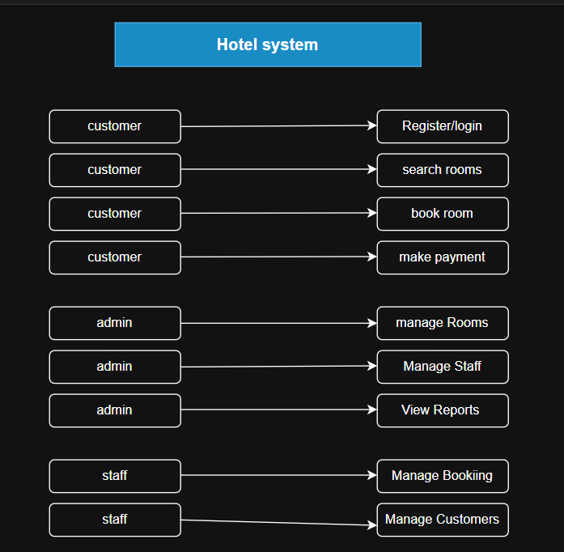
Figure 2.1 Use Case Model Diagram

2.8.1.2 Use Case Documentation
Use Case 1: User Registration
Actor: Customer
Description: The user creates a new account
Pre-condition: User does not have an account
Post-condition: User account is created successfully
Use Case 2: User Login (Security Login)
Actor: Customer / Admin / Staff
Description: The user logs into the system securely
Pre-condition: User must have a registered account
Post-condition: The user gains access to the system
Use Case 3: Book Room
Actor: Customer
Description: The user books an available room
Pre-condition: User must be logged in
Post-condition: The booking is stored in the system
Use Case 4: Make Payment
Actor: Customer
Description: The user completes payment for a booking
Pre-condition: Booking must exist
Post-condition: Payment is recorded

2.8.1.3 Sequence Diagram
The sequence diagram shows how different components interact over time during the booking process.
Narrative Description:
The user sends a request to log in, which is verified by the system. After login, the user searches for rooms, and the system retrieves available room data from the database. The user selects a room and submits a booking request. The system processes the request, stores the booking, and confirms it. Finally, the user completes payment, and the system updates the payment status.
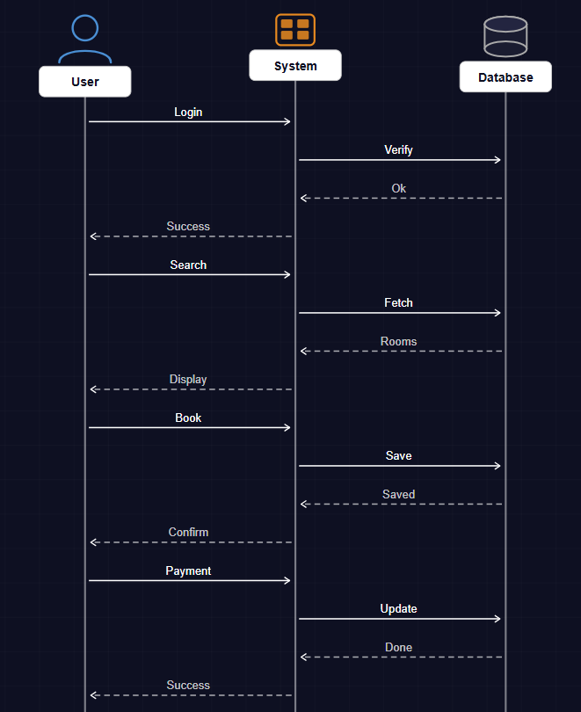
Figure 2.2 Sequence Diagram for Booking Process

2.8.1.4 State Chart Diagram
The state chart diagram represents different states of the booking process and how the system transitions between them.

Narrative Description:
A booking transitions through several states such as “Pending,” “Confirmed,” and “Completed.” Initially, when a booking is created, it is in a pending state. After payment is made, the booking is confirmed. Once the service is completed, the booking status changes to completed.
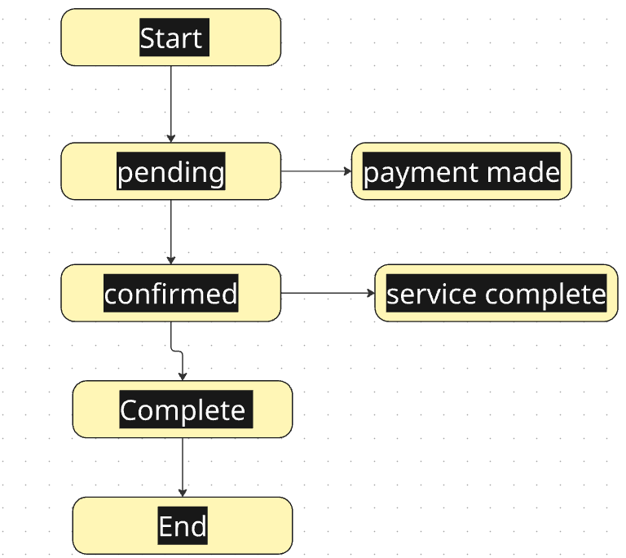
Figure 2.3 State Chart Diagram of Booking Process

2.8.1.5 Activity Diagram
The activity diagram shows the workflow of processes within the system.
Narrative Description:
The process begins when the user logs into the system. The user searches for available rooms and selects one. The system checks availability and allows the user to proceed with booking. After entering details, the user confirms the booking and completes payment. The system then records the transaction and terminates the process.

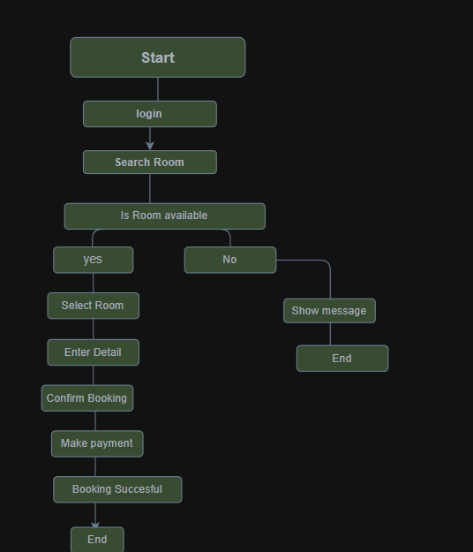
Figure 2.4 Activity Diagram of Booking Workflow

2.8.1.6 Class Diagram
The class diagram represents the structure of the system, including classes, attributes, and relationships.
Narrative Description:
The main classes in the system include Customer, Room, Booking, and Payment. Each class contains attributes such as customer details, room information, booking status, and payment details. Relationships between these classes define how data is managed within the system.

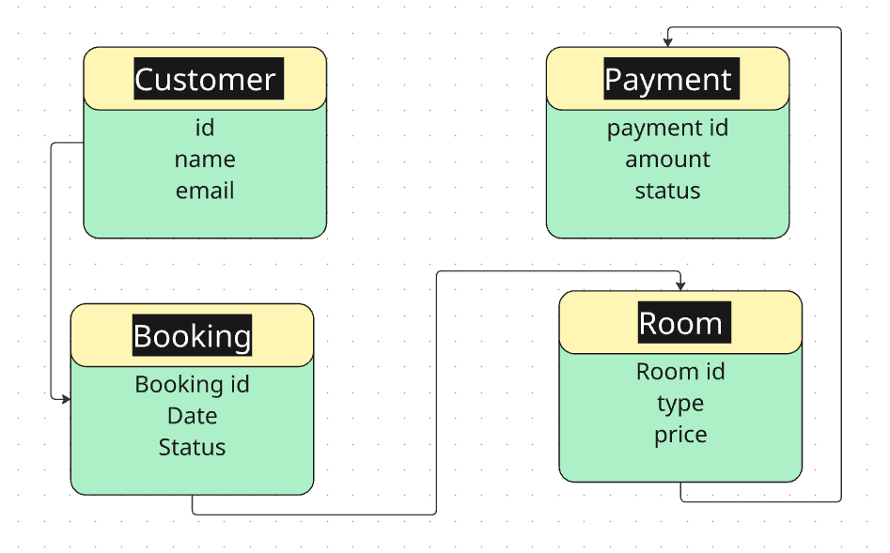
Figure 2.5 Class Diagram of the System

2.8.1.7 User Interface Prototyping

User interface prototyping provides a visual representation of how the system will look and how users will interact with it.
Narrative Description:
The system interface includes several screens such as login page, registration page, dashboard, room listing page, booking form, and payment page. These interfaces are designed to be simple, user-friendly, and easy-to-navigate.

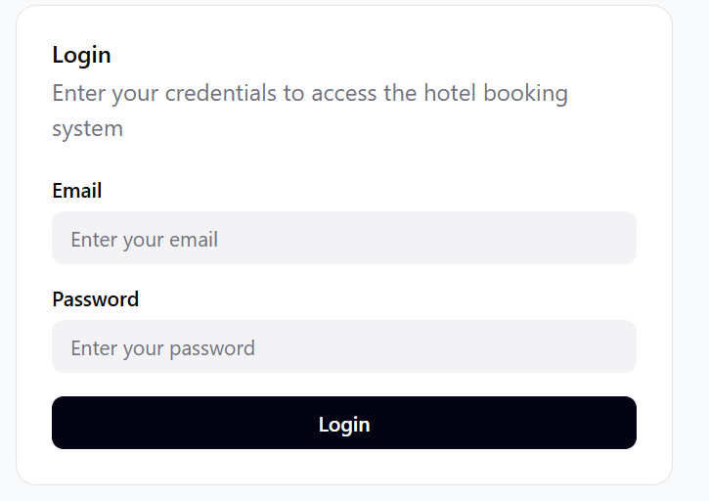
Figure 2.6 Login Page

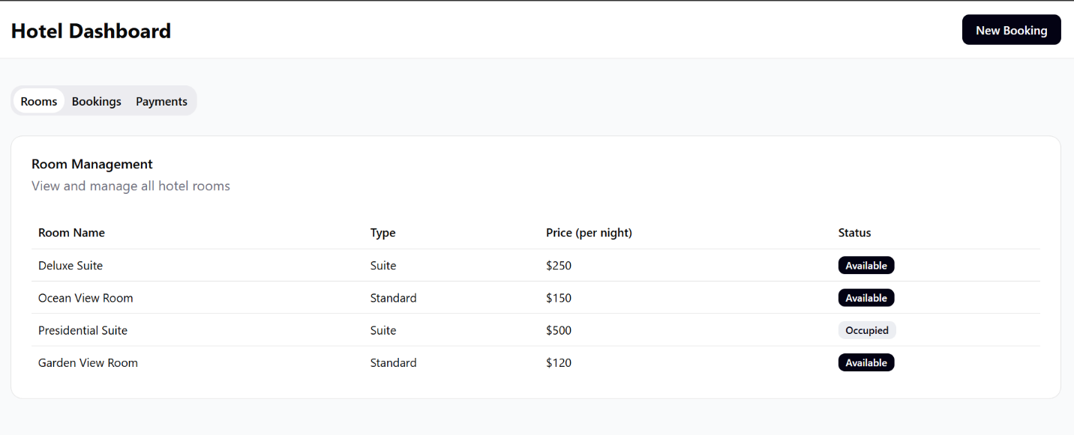
Figure 2.7 Hotel Dashboard

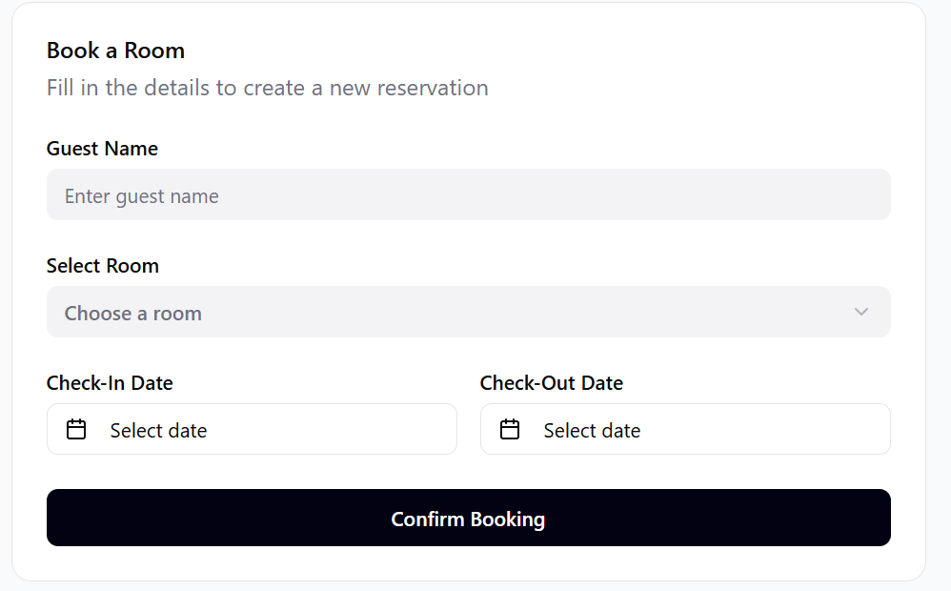
Figure 2.8 Booking Dashboard

2.9 Summary
This chapter has presented an analysis of the existing system and identified its major limitations. It also introduced the proposed system as a solution and defined both functional and non-functional requirements. Additionally, it provided an overview of system analysis to support the system design in the next chapter.

CHAPTER THREE
SYSTEM DESIGN

3.1 Introduction
This chapter presents the system design of the Hotel Booking System. System design is a crucial phase in software development that defines the architecture, components, modules, interfaces, and data flow. The main purpose of this chapter is to transform the system requirements into a structured solution that can be implemented efficiently.
The Hotel Booking System is designed to simplify the process of booking hotel rooms, manage reservations, and improve communication between customers and hotel administrators. This system ensures efficiency, accuracy, and a user-friendly interaction for both users and administrators.

3.2 System Architecture Design
The system follows a three-tier architecture consisting of the following layers:

3.2.1 Presentation Layer (User Interface)
This layer handles user interaction through the web interface and allows users to view rooms, book rooms, and manage their accounts.
- User login page
- Registration form
- Room booking interface
- Admin dashboard
The interface is designed to be simple, responsive, and user-friendly.

3.2.2 Application Layer (Business Logic)
This layer processes all core functionalities such as booking validation, payment processing, and room availability checking.
- User authentication
- Room availability checking
- Booking processing
- Payment handling logic
- Data validation

3.2.3 Data Layer (Database)
This layer is responsible for storing and retrieving data in the database, including user details, room information, bookings, and payments.
- User information
- Room details
- Booking records
- Payment records
- Admin data
The database ensures data consistency and security.

3.2.4 Architecture Diagram
The architecture diagram illustrates the three-tier structure of the system, including presentation layer, business logic layer, and database layer.
The presentation layer handles user interaction, the application layer processes business logic, and the data layer manages data storage and retrieval.
User/admin

Presentation layer

Application layer

Database

3.3 System Modules Design
The system is divided into different modules to improve maintainability and scalability.

3.3.1 User Module
This module allows users to:
- Register an account
- Log in to the system
- Search available rooms
- Book rooms
- Cancel a booking
- View booking history

3.3.2 Admin Module
This module is used by hotel administrators to:
- Manage rooms (add, update, delete)
- Manage bookings
- Manage users
- View reports
- Confirm or reject bookings

3.3.3 Booking Module
This module handles:
- Room reservation process
- Availability checking
- Booking confirmation
- Booking cancellation

3.3.4 Payment Module
This module manages:
- Payment processing
- Payment confirmation
- Receipt generation

3.3.5 Component Diagram
The component diagram illustrates how different modules such as user management, booking, payment, and reports interact through defined interfaces within the system.
user interface

Booking module

Payment module

Database module

3.4 System Design Methodology
The system was designed using the Object-Oriented Design (OOD) approach. This methodology helps organize the system into classes and objects that interact with each other.
Key principles of OOD used in the system include:
- Encapsulation
- Modularity
- Reusability
- Maintainability
- Inheritance
- Abstraction
Examples of classes used in the system include:
- User
- Admin
- Room
- Booking
- Payment

3.5 Data Flow Design
The system data flow describes how information flows within the system.

3.5.1 Level 0 Data Flow Diagram (Context Diagram)
The system interacts with two main external entities:
- Customer
- Admin
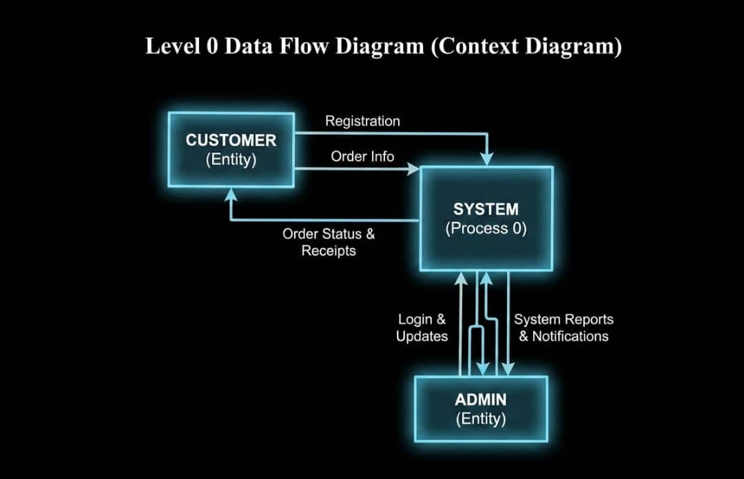
Figure 3.1 Level 0 Data Flow Diagram

Customers send booking requests, and the system responds with confirmations. The admin manages system data and receives reports.

3.5.2 Level 1 Data Flow Diagram
This includes:
- User authentication process
- Booking process
- Room management process
- Payment processing
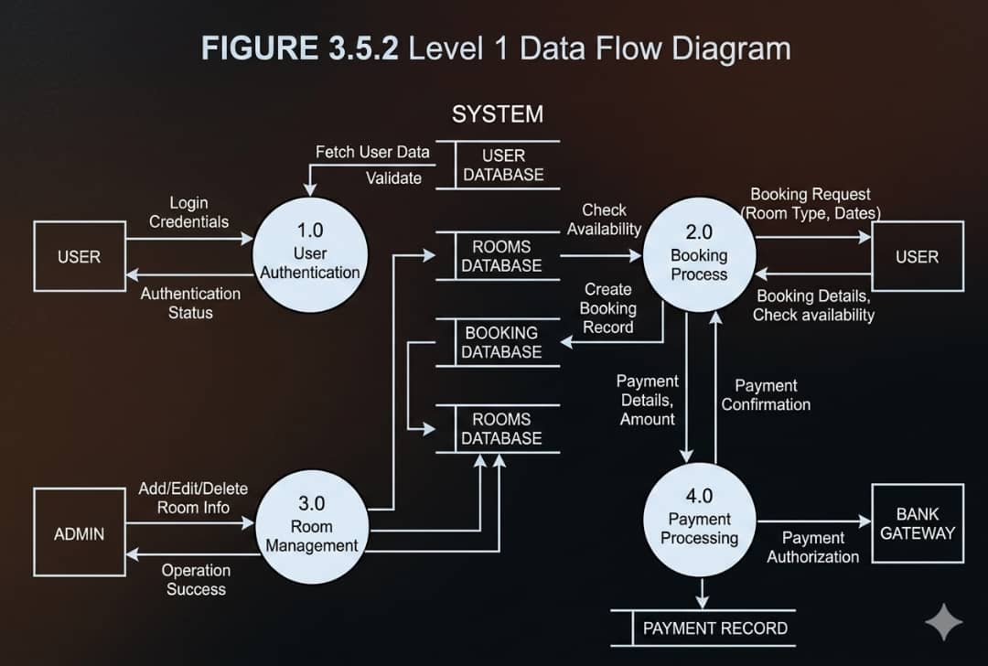
Figure 3.2 Level 1 Data Flow Diagram

3.6 Database Design
The system database is designed using relational database principles.

3.6.1 Main Tables
User Table
Field Name | Data Type | Key
UserID | INT | PK
FullName | VARCHAR
Email | VARCHAR
Phone | VARCHAR
Password | VARCHAR
Role | VARCHAR
CreatedAt | DATETIME
Table 3.1 Users Table
Table 3.2 Rooms Table
Rooms Table
Field Name | Data Type | Key
RoomID | INT | PK
RoomNumber | VARCHAR
RoomType | VARCHAR
Price | DECIMAL
Status | VARCHAR
Capacity | INT

Table 3.3 Booking Table
Booking Table
Field Name | Data Type | Key
BookingID | INT | PK
UserID | INT | FK
RoomID | INT | FK
CheckInDate | DATE
CheckOutDate | DATE
TotalAmount | DECIMAL
Status | VARCHAR

Table 3.4 Payments Table
Payments Table
Field Name | Data Type | Key
PaymentID | INT | PK
BookingID | INT | FK
Amount | DECIMAL
PaymentDate | DATETIME
Method | VARCHAR
Status | VARCHAR

Table 3.5 Admin Table
Admin Table
Field Name | Data Type | Key
AdminID | INT | PK
Name | VARCHAR
Email | VARCHAR
Password | VARCHAR

3.6.2 Entity Relationship Diagram
An Entity Relationship Diagram (ERD) is a graphical representation used to model the structure of a database system. It illustrates system entities, their attributes, and the relationships among them. ERDs are important during the database planning stage because they help developers understand how data is organized and connected before implementation.
In this system, entities such as User, Room, Booking, and Payment are connected through relationships that define how booking and payment processes are managed.
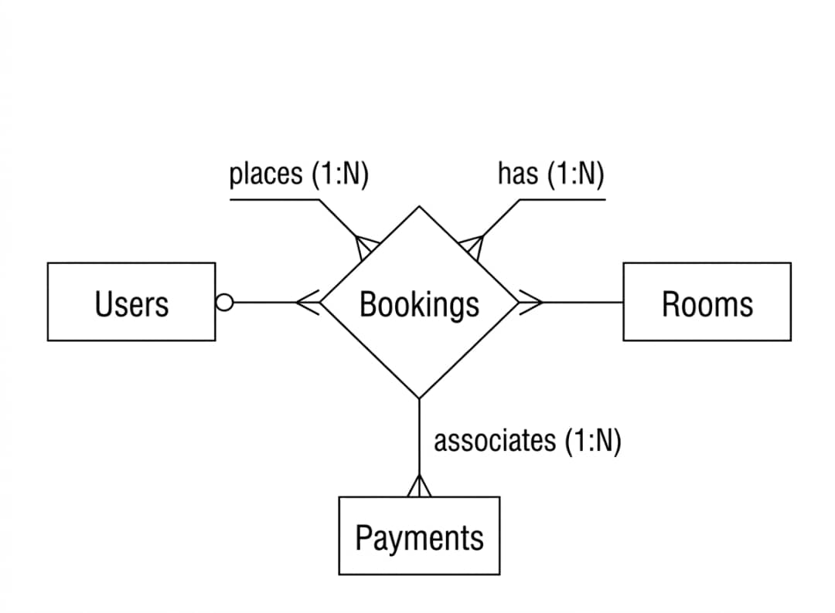
Figure 3.3 Entity Relationship Diagram

3.7 System Interface Design
The interface design focuses on usability and simplicity.

3.7.1 User Interface
- A home page displaying available rooms
- Search bar for rooms
- Booking form
- Login and registration pages

3.7.2 Admin Interface
- Dashboard showing statistics
- Room management panel
- Booking management section
- Reports section

3.8 Security Design
Security is an important part of the system. The following security measures are implemented:
- Password hashing using BCrypt
- User authentication and authorization
- Role-based access control
- Secure access to the database
- Session management
- Input validation to prevent SQL injection attacks
- HTTPS secure connection

3.9 System Requirements

3.9.1 Hardware Requirements
- Processor: Intel Core i3 or higher recommended
- RAM: 4GB minimum
- Storage: 500GB HDD or higher

3.9.2 Software Requirements
Operating System: Windows or Linux
Database: MySQL
- Programming Language: PHP
- Web Browsers: Google Chrome and Mozilla Firefox

3.9.3 Deployment Diagram
The deployment diagram explains how the system is deployed on a server, client devices, and a connected database.
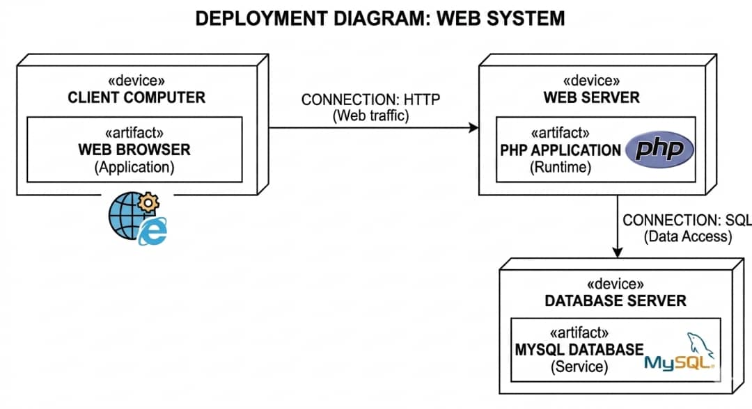
Figure 3.4 Deployment Diagram

3.10 Summary
This chapter has presented the overall system design of the Hotel Booking System. It explained the system architecture, modules, database design, interface design, and security mechanisms. The design ensures that the system is efficient, scalable, secure, and easy to use. The next chapter will focus on system implementation and testing.

