# RESEARCH strategy – EpiBioS4RX CWOW OVERALL

# 1.Significance

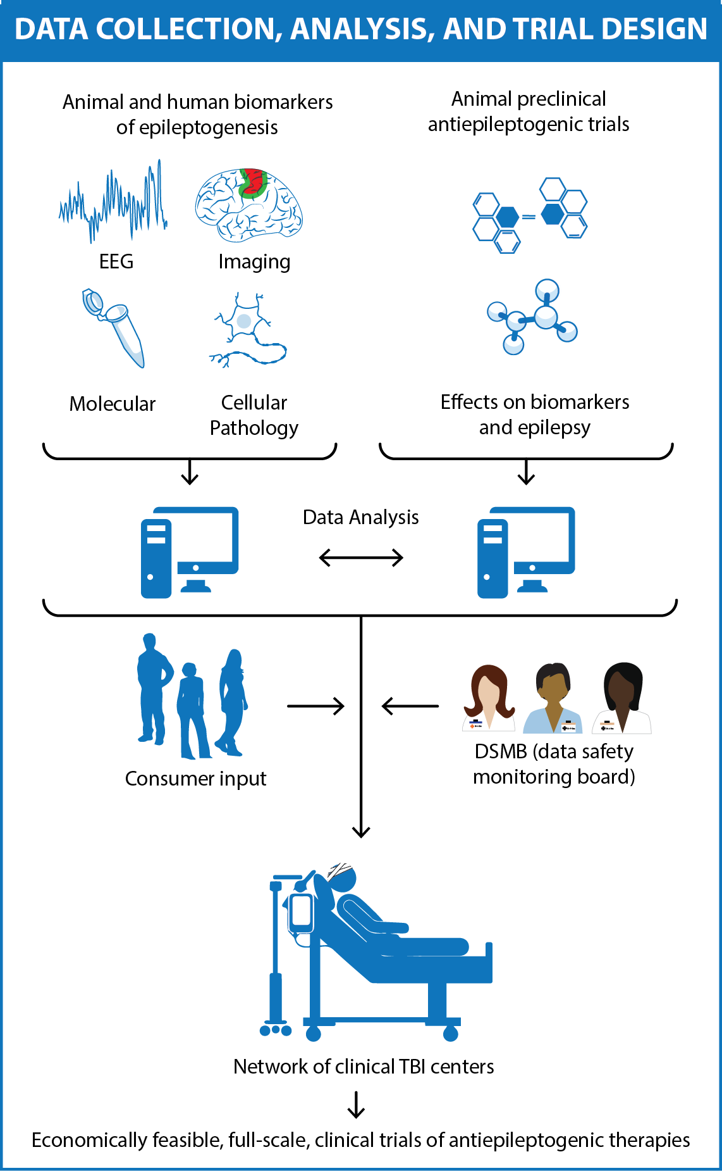Epilepsy is among the most common serious disabling disorders of the brain, and the global burden of epilepsy exerts a tremendous cost to society.5,67 Most people with epilepsy have acquired forms, and the development of antiepileptogenic interventions could potentially prevent or cure these epilepsies. The discovery of potential antiepileptogenic treatments is currently a high research priority. Clinical validation would require a means to identify populations of patients at particular high risk for epilepsy after a potential epileptogenic insult to know when to treat and to document prevention or cure. The Epilepsy Bioinformatics Study for Antiepileptogenic Therapy (EpiBioS4Rx) is a proposal for a Center Without Walls (CWOW) in response to the NINDS RFA -NS-16-012. Our overriding goal, as stated in the FOA, is to “accelerate development of disease modifying or prevention therapies for epilepsy.”

**EpiBioS4Rx Scientific Premise: Epileptogenesis after TBI can be prevented with specific treatments; the identification of relevant biomarkers and performance of rigorous preclinical trials will permit the future design and performance of economically feasible full-scale clinical trials of antiepileptogenic therapies (Fig. 1).**

We have chosen to focus on disease prevention, but results of our efforts could also inform approaches to disease modification. To this end, we have assembled a highly synergistic multidisciplinary team of basic and clinical neuroscientists to investigate the development of post-traumatic epilepsy (PTE) following traumatic brain injury (TBI) because this condition offers the best opportunity to know the time of onset of epileptogenesis in patients. We plan a translational, international, multiple project, multicenter, multidisciplinary approach to: 1) identify biomarkers of epileptogenesis in our animal model and in patients, 2) develop a standardized protocol for preclinical trials of potential antiepileptogenic therapies and identify one or more potential antiepileptogenic agent, and 3) create open shared resources for the entire epilepsy research community, including an epilepsy specific bioinformatics platform and database, a robust animal model of TBI leading to PTE, a standardized preclinical protocol for the evaluation of novel antiepileptogenic therapies, a network of TBI centers capable of carrying out future clinical trials of potential antiepileptogenic interventions, and a public engagement program committed to recruitment and retention. We anticipate this work will result in one or more candidate antiepileptogenic treatments at the end of the 5-year funding period, as well as the biomarker information, resources, expertise, and patient population to carry out an economically feasible, full-scale clinical trial.

**Figure 1.** EEG, neuroimaging, molecular, and cellular data collected following moderate-severe TBI in humans and rats will undergo bioinformatics analysis to identify a profile of potential biomarkers of epileptogenesis, and preclinical trials will identify antiepileptogenic treatments. Results will be used to design economically feasible full-scale clinical trials.

1) Identification of biomarkers and epileptogenesis in animals and patients: Even if a potential antiepileptogenic agent existed, there is no at-risk patient population in which to test its success cost effectively. Clinical trials utilizing patients after moderate to severe TBI, the most appropriate population for such studies, would require a large sample size to account for the fact that only 15-25% of these patients eventually develop PTE and at least 2 years of follow-up to identify 80-90% of them.49,91 Similarly, preclinical trials currently rely on outcomes that require 24/7 EEG monitoring over months, which is costly and labor intensive, in order to document the presence or absence of epilepsy. Such trials would be prohibitively expensive unless a profile of reliable biomarkers can be identified to enrich the trial population with high-risk subjects, permit staging of epileptogenesis to inform timing of interventions, and provide surrogate markers of outcome to shorten trial durations26,27,28,75. Identification of reliable biomarkers to diagnose epileptogenesis could also facilitate the discovery of antiepileptogenic treatments by enabling rapid through-put screening of candidate compounds, and the search for biomarkers could reveal targets for novel antiepileptogenic interventions. Much work has been published in recent years on putative imaging,14,29,35,48,59,60,72,83,103 electrophysiological,10,45,46,88,89,100 molecular, and cellular22,36,40,44,61,63 biomarkers. However, a primary obstacle in achieving this goal has been the fact that both animal and clinical studies have invariably been underpowered. Furthermore, the lack of standardized approaches has prevented definitive comparative and translational analyses among published studies. Our proposal has addressed these problems by creating a collaborative multicenter, international research effort composed of multidisciplinary teams of basic and clinical neuroscientists with access to robust, well-defined animal models, extensive patient populations, standardized protocols, and cutting-edge analytic methodology. We expect that the predictive power will likely require a combination of electrophysiological, neuroimaging, and biochemical biomarkers measured at different post-injury time points, to diagnose with high sensitivity and specificity ongoing epileptogenesis independent of the severity of brain damage. We anticipate these studies will also provide insights into the fundamental neuronal mechanisms of these processes26,28,31,62,74,80,87 and inform basic research into novel targets for antiepileptogenic interventions.

2) Standardized preclinical trials of potential antiepileptogenic therapies and identification of one or more potential antiepileptogenic agents: Scientific evidence suggests that many compounds could have antiepileptogenic potential, but adequate evidence to justify a clinical trial is lacking, in large part due to failure to reproduce promising results in more than one laboratory and difficulty translating the preclinical to the clinical condition. This failure reflects the absence of a valid animal model of human epileptogenesis and a standardized preclinical trial protocol, which adheres to the same rigid criteria used for clinical trials. There are several endophenotypes for different animal models and methodologies used for studying epileptogenesis in animals8,17,18,25,31,33,37,73,78,99. We have developed a robust standardized fluid percussion injury (FPI) rat model of TBI leading to PTE in our laboratories that replicates epileptogenesis following TBI in patients with moderate to severe TBI and have been carrying out parallel reiterative animal/human studies. We propose to use this model also to create a rigorous standardized protocol for testing potential aniepileptogenic therapies utilizing a double-blind randomized approach and the therapy-specific biomarkers as they become available in a manner that is reproducible in any laboratory that follows the standardized protocol. We anticipate that the identification and validation of antiepileptogenic treatments in the preclinical trials using the profile of identified biomarkers from the parallel animal/human research paradigms, together with the establishment of a network of TBI centers with appropriate facilities and expertise will enable preparation for a future, economically feasible, cost-effective, full-scale, clinical trial of safety and efficacy of antiepileptogenic therapies to prevent PTE.

3) Creation of open and shared resources for the entire epilepsy community*:* A key to the success of large multidisciplinary research efforts that generate “big data” is an effective shared bioinformatics approach to data storage and analysis. With the EpiBioS P20 planning grant, we have succeeded in developing a multimodality, interactive, open access bioinformatics platform specific for epilepsy and are using this resource to carry out our studies. We have achieved this short-term goal in part by leveraging programs already supported by NIH and other funding sources. We have unified the functionality between the International Electrophysiology Web Portal (iEEG.org) platform of Dr. Brian Litt, who will be providing his expertise as a consultant, and the Laboratory of Neuroimaging (LONI)96 platform of Dr. Arthur Toga. The latter has supported extensive studies of biomarkers and treatments for Alzheimer’s disease2,11,15,23,24,43,66, Parkinson’s disease79, Huntington’s disease13,102, the genetic basis of aspects of hippocampal structure,42 and the exploration of computational genomics challenges24. We are currently applying our bioinformatics algorithms to available animal and human electrophysiological and imaging data, and are collecting molecular, cellular, and other data to be integrated into this analytic process. The most comprehensive translational studies of TBI have been carried out on biomarkers for brain injury, neuroprotection, and motor and cognitive outcome, as well as early epileptic seizures93,94,95, but clinical TBI centers have not followed subjects long enough to study epileptogenesis19,53,54,55,68. The UCLA TBI program project is an exception in that animal and patient research is concerned with what happens to surviving neurons4,6,7,45,93,101. Dr. Vespa has recruited 13 TBI centers that will follow patients for two years to participate in our proposed clinical biomarker project. They will constitute a network with the facilities and expertise to perform the subsequent clinical trials once they are justified by preclinical studies and made feasible by biomarker identification. For the design of the future clinical trials, we developed an extensive public outreach program of epilepsy and TBI consumer groups committed to recruitment and retention of subjects and consumer satisfaction. We plan to make available to the greater epilepsy community all of our bioinformatics tools and resources, databank, biobank, experimental protocols for a standardized TBI/PTE animal model and preclinical evaluation of antiepileptogenic therapies, a network of TBI centers with facilities and expertise to carry out future clinical trials of antiepileptogenic interventions. To this end, collaborations have been established with a number of related programs, including Epi4K, EpGP, EPITARGET, FEBSTAT, TRACK-TBI, CENTER-TBI, ADAPT, CSR, and the VA Epilepsy Centers of Excellence to expand the patient population available for future clinical trials.

# 2. Innovation

**EpiBioS4Rx is a unique translational proposal.** It brings together human and animal epileptogenesis research on TBI with active participation of consumer advocates to provide all the necessary information, resources, expertise, and patient population to carry out an economically feasible, full-scale clinical trial of one or more antiepileptogenic therapies at the end of the 5 year funding period.

**EpiBioS4Rx has integrated existing interactive multimodality bioinformatics platforms.** The unique combined platform is capable of acquiring, storing, and analyzing electrophysiological, imaging, molecular, and cellular data from animal and clinical studies that have not been used to study epileptogenesis previously, and that will constitute an open-access, epilepsy-specific database and analytics resource.

**EpiBioS4Rx will develop the first validated multimodal biomarker panel for preclinical and clinical antiepileptogenesis trials.**

**EpiBioS4Rx will develop the first rigorous preclinical multicenter therapy-development pipeline for promising antiepileptogenic treatments to facilitate their testing in a future antiepileptogenesis clinical trial in patients with TBI.** We propose to screen 5 treatment protocols for their effect on modifying PTE biomarkers in our animal model of TBI, test the leading compound for its efficacy in preventing PTE and thus prepare for a future clinical trial of the leading compound.

**EpiBioS4Rx will identify at least one compound that shows an anti-epileptogenic effect in a rigorous, long-term, multicenter pre-clinical trial that is ready to proceed to be tested in a clinical trial utilizing the EpiBioS4Rx clinical TBI centers and biomarkers.**

**EpiBioS4Rx has enlisted the enthusiastic participation of 13 advanced clinical TBI programs.** These programs have not studied epilepsy as part of their research in the past, will use the data from their extensive subject populations to identify likely biomarkers of epileptogenesis, will validate biomarkers identified in animal TBI studies, and will establish a network of advanced TBI centers with continuous EEG monitoring and other resources, expertise, and patient populations to carry out future full-scale clinical trials of antiepileptogenic agents identified in this study or others.

**EpiBioS4Rx will utilize common data elements, and a rigorously designed, standardized protocol for preclinical trials of potential antiepileptogenic agents.** This unique paradigm will employ therapy specific biomarkers identified in animal and human studies to identify one or more antiepileptogenic agents for full-scale clinical trials.

**Our Public Engagement Core will, for the first time, bring together epilepsy and TBI advocacy and consumer groups to address common interests and concerns.** This effort will not only involve patients with PTE but also patients at risk for developing PTE and will facilitate recruitment and retention of subjects for future clinical trials.

**EpiBioS4Rx has developed a Charter and Publication Policy that not only establishes a code of equity among investigators but also outlines how our data, tools, and resources will be made available to the entire epilepsy community**.

# 3. Approach

## 3.1. *Preliminary work:*

3.1.1. Workshops: 4 **workshops were held during the first two years of the P20 award and Workshop Reports are in Appendix 1.** The first workshop was concerned with creating the multimodality epilepsy-specific bioinformatics platform and sharing agreements, and this primary objective of the P20 proposal has been achieved. The second dealt with controversies concerning the end point of TBI induced epileptogenesis17,18,25 in an effort to define “what is a seizure?” Several issues remain unresolved concerning whether certain EEG and behavioral events following TBI accurately reflect PTE, as discussed in the workshop report. As a result, it was decided to limit the animal studies used for EpiBioS4Rx to the least controversial TBI model. In addition, EEG data from 10 animal laboratories were collected to determine whether our bioinformatics analysis can distinguish among: normal events that look like epileptic seizures, epileptic events that naturally occur in rats unrelated to TBI, exacerbation of normal and naturally occurring epileptic events by TBI, and focal TBI induced epileptic events that mimic PTE in patients. This work is in progress, and we anticipate positive findings to constitute a major contribution to the field. The last two workshops concerned issues of collecting, storing, and analyzing EEG, imaging, molecular, and cellular data necessary for the focused Research Projects proposed for EpiBioS4Rx. Based on these discussions, we have designed an overall approach that addresses specific epileptogenic mechanism, treatments, and translational biomarkers in order to find one or more antiepileptic treatments for PTE (**Fig. 2**).

3.1.2. Bioinformatics platform: The bioinformatics platform consists of a web-based URL that allowed integrated access to LONI and IEEG.org during initial development, which resulted in preliminary results based on the multi-modal data. However, the EEG database and tools are now being recreated entirely within LONI with unified functionality between the two platforms. Automated tools will be used to extract features from time series and imaging data for storage in arrays accessible through toolboxes in MATLAB, PYTHON, and R (both extant and under development) for statistical and engineering analyses. Data are linked through uniform identifiers so that data from all contributing sites are harmonized. Access to the EpiBioS4Rx portal utilizes existing LONI tools for tracking data provenance, analyses, and controlling access to all data and results. Permissions and accounts will be maintained for all collaborating investigators centrally by EpiBioS4Rx staff. This structure is designed for international data sharing and collaboration with built in tools for data viewing, annotation, analysis, and results tracking so that all experiments can be repeated and tracked. More details of these platforms and their features are available in the Informatics and Analytics Core. As analyses are performed and results published, data will be released internationally for sharing. The system is constructed so that all functionality is available to those granted access, and sharing within the scientific community is performed by checking a box on the data access panel. Universal data formats for images and time series are used for all data entered into the database: DICOM for images and MEF for electrophysiology. As noted above, toolboxes interfacing with the EpiBioS4Rx platform will make all data available to investigators in MATLAB, Python, or R arrays for analysis, bypassing any proprietary formats at data gathering centers.

3.1.3. Preclinical studies: We have successfully created a standardized FPI rat model of PTE in Kuopio, Melbourne, and UCLA, and are in the process of replicating it at Einstein. Harmonization of EEG acquisition, MRI imaging, and data analysis among the 4 sites has been achieved with laboratory visits to UCLA during EpiBioS workshop and teleconferences. Importantly, EEG studies have identified pathological high-frequency oscillations (pHFOs) localized to the FPI lesion and repetitive HFOs and spikes (rHFOSs), which may be noninvasively recorded as potential biomarkers of epileptogenesis **(Appendix 2)**9,80 and will be tested in EpiBios4Rx in a larger animal cohort. Use of CDEs is already being implemented in Kuopio, which will share the experience with the three other sites to facilitate their implementation in EpiBIoS4Rx. EEG and structural MRI files have been downloaded to LONI, which is now running preliminary analyses, demonstrating the feasibility of the approach. Kuopio and Melbourne have developed experimental study designs to run preclinical antiepileptogenesis studies after TBI. Melbourne generated a large amount of preliminary data on two compounds to be used in preclinical screening study. Einstein has developed a rigorous model for screening of new treatments for epilepsy guided by pharmacokinetic modeling. Kuopio has established microRNA laboratory analysis methodologies and bioinformatics data analysis with the Kuopio bioinformatics center. These preparatory activities facilitate the implementation of procedures which will produce 1) a unimodal/multimodal biomarker platform which will be (a) validated in an independent animal cohort, (b) in TBI patients, and (c) applied in a preclinical treatment trial to demonstrate its power to predict treatment outcome, 2) A semi-high throughput preclinical test platform to perform an initial assay of new treatments or those already in use in other clinical indications to prevent epileptogenesis, 3) The first preclinical multi-center antiepileptogenesis trial to provide the data needed to move to a clinical trial.

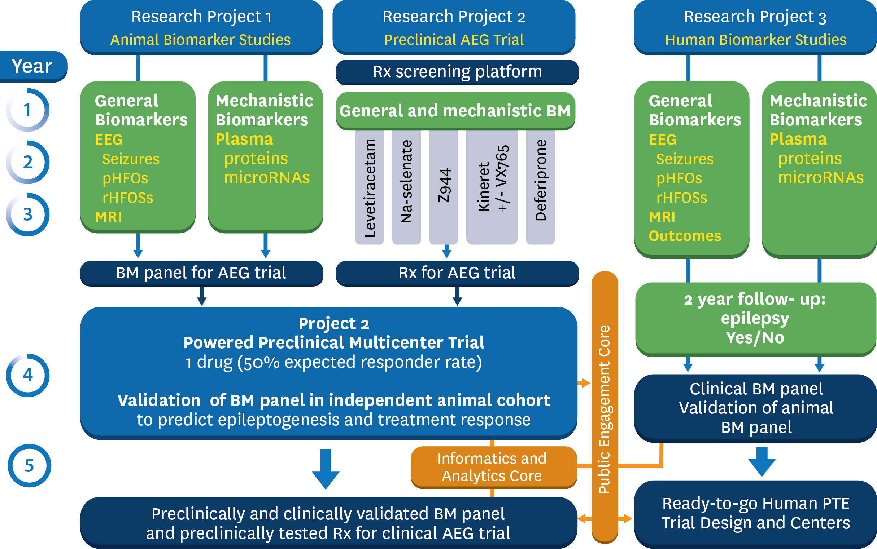

**Figure 2.** Responsibilities and interactions of Research Projects over the 5 year period.

## 3.1.4. Clinical TBI consortia: The human study will be empowered by a close working collaboration with 13 TBI centers, all of which have expertise in human acute TBI research, continuous EEG in the ICU, and biomarker research. This approach searches for biomarkers of epileptogenesis after TBI in patients, translates the scientific discoveries from Animal Projects 1 and 2 to provide validation of biomarkers in humans, and establishes the timing of epileptogenesis in humans. The clinical project will collaborate with the 3 existing funded biomarker studies in TBI including TRACK-TBI, CENTER, and ADAPT and incorporates both adults and children.

3.1.5. Preliminary data: Data sets currently being analyzed include a cohort of human patients with severe TBI from UCLA (imaging and EEG) and cohorts of animals from models of epileptogenesis, including perforant path stimulation, intrahippocampal kainate, intraperitoneal pilocarpine and others, as well as TBI models. Details of preliminary data are described in the individual Research Projects. **Table 1** summarizes some accomplishments of the P20 grant.

Table 1. Some Accomplishments of EpiBioS

* Creation of an epilepsy-specific bioinformatics platform by adding EEG to the LONI/ADNI portal.
* Establishment of a standardized FPI/TBI/PTE rat model at four centers.
* Identification of pHFOs and rHFOs as potential EEG biomarkers of epileptogenesis after TBI in rats.
* Preliminary EEG and imaging biomarker discovery using our bioinformatics platform on pilot human and animal data from multiple sites.
* Coordination of 13 TBI centers to participate in a study of epileptogenesis.
* Establishment of a consortium of TBI and epilepsy consumer advocate and professional groups.
* Creation of the EpiBioS Charter and Publication Policy.

3.1.6. Common data elements (CDEs): EpiBioS4Rx will use the epilepsy and TBI CDEs designed for preclinical (<http://www.ninds.nih.gov/research/tbi/index.htm>) and clinical ([https://commondataelements.ninds.nih.gov/TBI.aspx - tab=Data\_Standards](https://commondataelements.ninds.nih.gov/TBI.aspx" \l "tab=Data_Standards)) TBI and pre-clinical epileptogenesis studies (EPITARGET CDEs <http://www.epitarget.eu>) will be utilized to harmonize the methodologies between 3 preclinical study sites and between pre-clinical and clinical studies. A joint AES/ILAE Task Force is also developing CDEs for animal studies which might be appropriate for future studies. We will prepare tailor-made EpiBioS4Rx CDEs for animal studies, which will be available on the EpiBioS4Rx website to harmonize the methodologies between the four preclinical sites (Kuopio, Melbourne, UCLA, and Einstein) and the clinical studies.

3.1.7. Charter and publication policy: **An EpiBioS4Rx Charter and a Publication Policy have been developed and are described in the Administrative Core**. This CWOW will be an open shared resource with co-investigators and consultants who will receive funding to carry out proposed focused research and unfunded consultants who will be members of EpiBioS4Rx, contribute advice and data, and have full access to the EpiBioS4Rx informatics tools and resources, patient protocols, database, and biobank for their own investigations. We anticipate that EpiBioS4Rx members will use these opportunities to pursue related research, publish papers, and seek additional funding through supplements, R01s, and other granting mechanisms. These activities are intended to greatly amplify the productivity of EpiBioS4Rx as governed by the Charter and Publication Policy.

3.1.8. Public Engagement: Considerable effort has been focused on establishing a coalition of epilepsy and TBI consumer groups and soliciting their participation in realizing effective clinical trials, as described in the Public Engagement Core.

## 3.2. EpiBioS4Rx organization:

**EpiBioS4Rx is a federated consortium of international research centers organized into an Administrative Core for logistical support, an Informatics and Analytics Core (IAC) for analytic support, which will house a shared database and biobank, a Public Engagement Core for patients and their families, and 3 focused complementary Research Projects. Collaboration with extramural research and advocacy organizations is integral to EpiBioS4Rx goals and objectives. (Figure 3)**

3.2.1. Administrative Core (Engel/Toga): The EpiBioS4Rx Administrative Core will provide leadership and expertise regarding the Center’s charter, universal protocols, regulatory provisions, and plans for a data sharing program. It will facilitate collaboration within and between the Center’s Cores and Research Projects, promote the career development of trainees and young investigators, coordinate collaboration with other NINDS- and non-NINDS-funded programs, stimulate and evaluate new collaborative research beyond the current EpiBioS4Rx proposal, and support activities of the Public Engagement Core. The Administrative Core will also provide reports of Center activities to NINDS and to relevant oversight committees, facilitate and provide logistical support for presentations of data at scientific meetings, publications, and the preparation of additional research proposals.

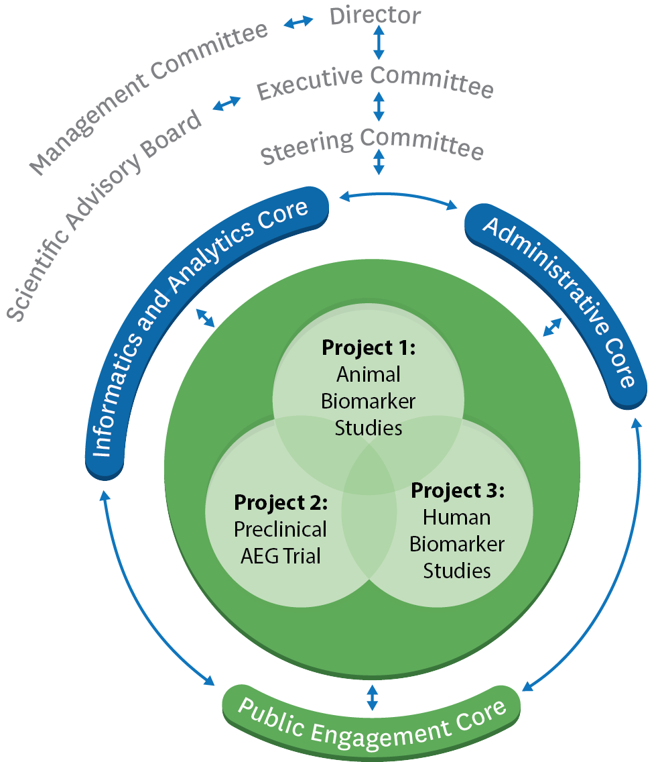

**Figure 3.** Organizational structure of EpiBioS4Rx

3.2.2. Informatics and Analytics Core (Toga): This core will provide comprehensive statistical expertise in the areas of experimental design, data processing, statistical modeling, and results interpretation. We will also develop and apply multivariate, machine learning techniques to analyze and visualize the presence of focal alteration in subject brains after acute TBI and track epileptogenesis. We will carry out these activities by pursuing the following Specific Aims: 1) Provide leading-edge computational data analysis resources and support to EpiBioS4Rx project investigators, 2) Develop and apply novel image processing and statistical analysis, 3) Employ multi-feature EEG classification and temporal modeling methods, and 4) Enable data integration, graphical representation, and inference. The Shared Resource Facility within the IAC will provide critical infrastructure support for all CWOW investigators, collaborators, and the broader epilepsy clinical and research community. Our goals for this core include: 1) Data Integration & Management: we will develop and deploy capabilities for translating and importing heterogeneous multimodal data, for linking data across modalities and sites, and for searching for the database on content (metadata, data, annotations, relationships), 2) Create a co-registering, bio-banking, and common spatio-temporal reference system: all data and specimens collected in this CWOW will be entered into a common spatio-temporal and model-based reference frame defined by a variety of variables, and 3) Browsing data and visualizing experiments: we will develop intuitive navigation and data selection in a “Google-search” environment, along with graphical tools to create and represent data as well as customized user-interfaces to run complex experiments across sites and heterogeneous data types.

3.2.3. Public Engagement Core (Moshé/Jette): The overarching goal of the Public Engagement Core is to actively engage and partner patients and the public with investigators in the development of effective strategies to successfully design and complete clinical research studies including future trials of prevention therapy in epilepsy. We have formed a consortium of consumer groups, health organizations, scientific (professional) societies, and investigators to allow the public to be involved in the design of antiepileptogenic clinical trials, including research strategies, successful enrollment, and retention. We anticipate that the identified effective strategies and knowledge transfer plans will be assessed and hopefully adopted and implemented by other groups involved in similar outcomes research as well as governmental and non-governmental health organizations.

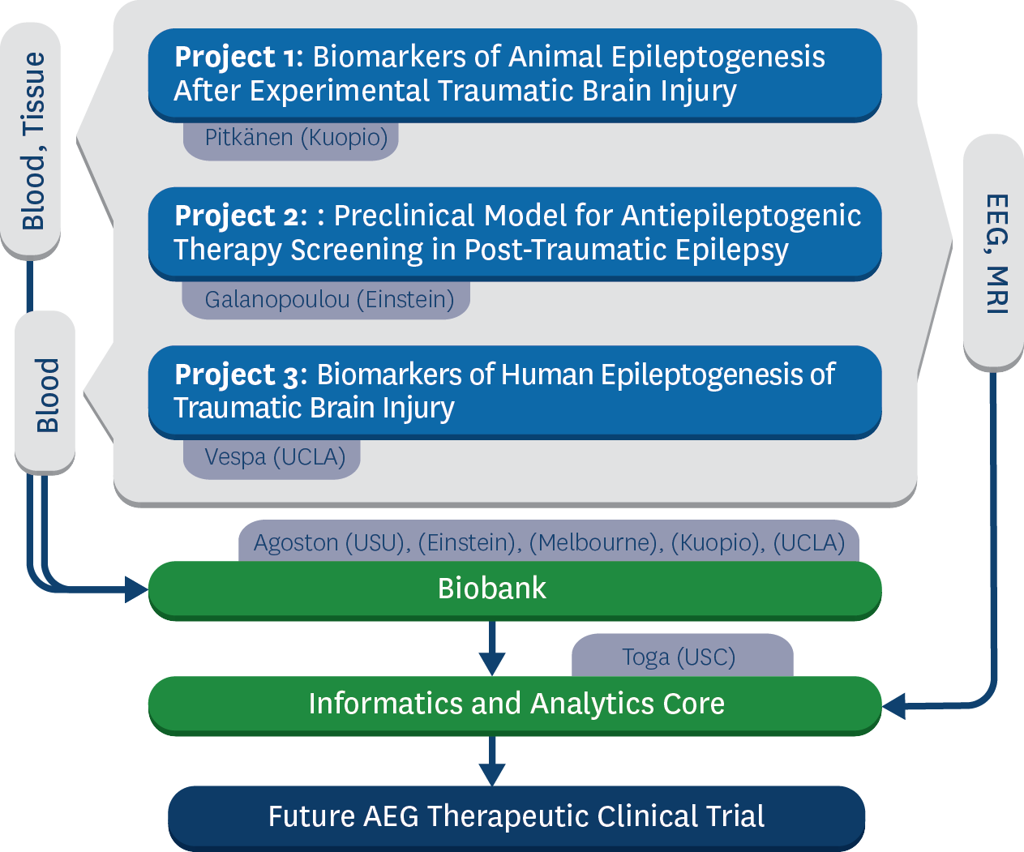

**Figure 4.**  Flow of data and biological samples from Research Projects to Cores.

## 3.2.4. Research Projects: The relationships among Research Projects and Cores is illustrated in Figure 4. Table 2. Demonstrates how data derived from the individual Research Projects are interrelated.

|  |  |  |  |
| --- | --- | --- | --- |
| Project | Goals | Hypothesis | Deliverables |
| 1 | 1,2 | Temporal lobe TBI in the rat will result in electrophysiological(pHFOs, rHFOSs) abnormalities in the perilesional cortex and hippocampus which predict epileptogenesis | B, C |
| 1 | 1,2 | Temporal lobe TBI in the rat will result in structural pathology in entorhinal-hippocampal, septo-hippocampal, and thalamo-cortical networks detectable with MRI, which predict epileptogenesis | B, C |
| 1 | 1,2 | TBI will induce changes in plasma proteins and/or microRNAs, which signal about neuronal/glial degeneration, axonal and dendritic injury, neuroinflammation, and metabolic changes and predict epielptogenesis and inform of potential treatment targets | B, C |
| 2 | 2,3,4 | A multi-modality rapid screening platform for target relevance and engagement, modification of early stage post-TBI seizures, EEG and plasma biomarkers and persistence of effects beyond treatment exposure helps select optimal treatment protocols for candidate antiepileptogenic treatments for PTE | A, B, C |
| 2 | 2,3,4 | Early stage treatments that have long-lasting modifying effects on relevant targets and MRI/EEG/plasma TBI biomarkers can also have antiepileptogenic effects for PTE. | A, B, C |
| 3 | 1,5,6 | Early post-traumatic epileptic EEG activity (seizures, pHFOs, rHFOSs) indicates the presence of an epileptogenic process in patients after moderate to severe TBI. | B, C, D |
| 3 | 1,5,6 | Acute structural/functional disconnections abnormalities within hippocampal or thalamo-cortical networks circuits are associated with epileptogenesis after severe TBI. | B, C, D |
| 3 | 1,5,6 | Specific epileptogenic pathways amenable to therapeutic interventions will generate biomarkers that can be monitored in the post-traumatic patient. | B, C, D |
| 3 | 1,5,6 | Prospective implementation of high resolution advanced EEG methods among our TBI-ICU-EEG-study sites will enable the selection of an enriched population of patients at high risk based of developing PTE that can be targeted in a future interventional trial. | B, C, D |
| **Overall Goals**:   1. Identify early mechanistic biomarkers of post-traumatic epileptogenesis 2. Identify early biomarkers of treatment response 3. Discover mechanistic targets to develop candidate early antiepileptogenic treatments 4. Validate candidate early antiepileptogenic treatments for disease prevention 5. Validate treatment specific biomarkers that are present in humans after TBI 6. Develop methods and practices to identify, track and treat patients at high risk for PTE 7. Design, with consumer guidance, a rigorous, economically feasible, large-scale clinical trial | | | |
| **Overall Deliverables**:  A. Validate one of more candidate early antiepileptogenic treatments for PTE that is ready for a clinical trial  B. Create EEG, MRI, or blood biomarker methods to identify and monitor patients ready for a clinical trial  C. Create an open source database and BioBank to enable identification of other candidate treatments from other groups  D. Facilitate public engagement that can help execute the clinical trial | | | |
| **Table 2**: Overall hypotheses, goals, and deliverables for this CWOW | | | |

Research Project 1 (Pitkánen/O’Brien/Staba) Biomarkers of epileptogenesis after experimental TBI. This experimental project has 2 major objectives: (1) to create a standardized methodology to investigate a model of temporal lobe TBI across multiple laboratories and utilize prospective plasma, EEG, and MRI measures to validate its relevance to clinical TBI by the parallel construction with human studies in Project 3 and (2) to identify non-invasive plasma, electrophysiological, and imaging biomarkers to (a) diagnose PTEand (b) predict treatment outcome. Unbiased plasma microRNA-seq analysis in project 1 may provide novel potential treatment targets for antiepileptogenic drug-development. Furthermore, Project 1 will provide plasma protein and microRNA-seq, electrophysiological, and imaging datasets from over 200 well-phenotyped rats with TBI to the IAC to be made available for analysis by EpiBioS4Rx Partners and over 1,000 blood samples to the IAC for blood biomarker analysis.

## Research Project 2 (Galanopoulou/Pitkánen/O’Brien) Preclinical model for antiepileptogenic therapy screening in post-traumatic epilepsy. This project utilizes a step-wise, multi-modality rigorous approach to identify lead compounds with anti-epileptogenic potential in the lateral fluid percussion model of post-traumatic epilepsy in adult male rats. We have selected to test treatment protocols, based on existing evidence that their targets are relevant to TBI and/or PTE, and that they have already undergone testing in humans for other indications and demonstrated a favorable safety profile. This will facilitate rapid translation into clinical trials for compounds shown to have an antiepileptogenic effect in the preclinical trials. We will first define in exploratory studies the relevant treatment windows for the targets, optimize treatment protocols using studies on pharmacokinetic and target engagement, test the effect of treatments on early stage biomarkers (EEG and plasma). We will then select the lead compound, to advance into a multicenter preclinical trial testing its efficacy in modifying the non-invasive electrophysiological, imaging, and plasma biomarkers identified in *Project 1 and 2* and preventing post-traumatic epileptogenesis in the animal model, using rigorous, unbiased and clinically relevant standards of study design, data collection and analysis30,31,32,52,56,77,86. A Data Safety Monitoring Board (DSMB) has been invited to monitor progress and, with additional input from the *Public Engagement* *Core*, will advise on strategies and clinical relevance issues. The results of this project will inform *Project 3* on the best design for a future clinical antiepileptogenesis trial to test the successful compound.

**Research Project 3 (Vespa/Engel):** Biomarkers of epileptogenesis after human TBI (Vespa). This is a multicenter observational study to establish a protocol for utilizing patients with moderate-severe TBI with and without PTE to identify and validate biomarkers of epileptogenesis, and to develop highly qualified clinical trial sites with expertise in EEG monitoring and other biomarker monitoring for an interventional clinical trial of antiepileptogenesis, starting acutely after TBI. *Project 3* investigators and the IAC will facilitate all data management. Protocols have been carefully harmonized with Research *Projects 1 and 2*, which will inform the optimal blood biomarker to be studied in years 4 and 5.

## 3.2.7. Data elements for analysis:

Electrophysiological studies: Noninvasive epileptiform and nonepileptiform EEG patterns derived from scalp and depth electrodes in Projects 1, 2, and 3 will be studied. Drs. Duncan, Staba, and Gotman will supervise this analysis. Studies will fall into two categories. Primary epileptiform biomarkers will consist of interictal spikes, bursts, spindles, slowing, seizures, and focal frequency band features (delta, gamma, theta, beta, and alpha). In addition, a variety of other features will be scanned using algorithms that our groups have found to be of utility in analyzing epileptiform and neurophysiologic signals (see IAC methods). Algorithms published for detecting this activity by our PIs and collaborative groups will be deployed to collect activity of different types, cluster this activity, and then classify the various types of epileptiform and nonepileptiform activity in automatic, unsupervised ways (see the IAC as well as the individual research projects for more detail). Because human EEG will be primarily scalp recorded, and animal studies will mimic these studies with epidural screw electrodes, we do not expect to see high frequency oscillations (HFOs). We will, however have access to a limited number of intracranial electrode recordings from patients, as well as animal data from another NINDS supported TBI study at UCLA (R01 NS33310). As HFOs are believed to be biomarkers of epileptogenicity81,88,89 and are also likely to be biomarkers of epileptogensis,9,10,81 we will take advantage of every opportunity to include them in our analyses.

Imaging studies: Patterns of corticothalamic and hippocampal structure and functional connectivity will be analyzed. Studies will be performed on both humans and animals. Statistical parametric mapping (SPM) of voxel based morphometry (VBM), which has demonstrated differing patterns of hippocampal atrophy, as well as extensive areas of neocortical atrophy and thalamic involvement in MTLE will be used53,54,66. Furthermore, automated shape analysis will be used as a more sensitive measure to distinguish changes in the MRI16,71,84. This imaging approach can now be applied to animals at UCLA, Kuopio, and Melbourne. Prospective MRI studies in 300 moderate-severe TBI patients are planned (Project 3). The objective of this focus will be to determine if there are common areas of atrophy that exist across epilepsy conditions, which might then predict epileptogensis. Other neuroimaging features that have been implicated as biomarkers and will be examined with our bioinformatics platform include: 1) hippocampal T2 signal changes,35,70 2) EEG-fMRI changes,57 3) structural connectivity using diffusion tensor imaging (DTI),50,65 and 4) resting state functional connectivity MRI (fcMRI).38,39 Animal model surveys have the advantage that they can be obtained at intervals following the epileptogenic insult and can be correlated with concurrent long-term video-EEG monitoring results (e.g.,47,51).

Blood Biomarker Studies: We will perform a prospective follow-up of plasma protein and microRNAs changes after TBI. Epileptogenesis in each animal is verified by electrophysiology. The selected plasma protein markers signal about the ongoing brain pathology, including neuronal/glial damage, axonal/myelin/dendritic injury, neuroinflammation, and metabolic abnormalities which have been well-described in the TBI literature34. Our goal is to pinpoint those protein markers or their combinations which do not only signal the injury severity but specifically associate with the development of increased excitability either alone or in combination with electrophysiological and MRI markers. The magnitude of plasma biomarker abnormality will be correlated with structural damage in grey and white matter quantified with microstructural MRI in the same animal. We will also perform an unbiased plasma biomarker discovery by analyzing plasma microRNA-seq, which has already provided a promising tool in non-TBI –related epilepsy97,98. Animal findings will be validated by analyzing blood and CSF obtained from TBI subjects.76,77 As the progression of brain damage varies between the animals (and humans), we will analyze plasma markers in two ways: 1) relative to the time from TBI, 2) based on the severity of brain injury in MRI in a given animal. The goal is to discover plasma biomarkers for different stages of posttraumatic epileptogenesis: immediate/acute (hours-days), subacute (that often include the latent period, days-weeks) and chronic epileptic (weeks-months).80 These studies are critical to characterizing the “stage” of epileptogenesis that may be observed with clinically feasible blood, CSF sampling, noninvasive imaging, or EEG.

Genetics are important because of the possibility that biomarker profiles could be determined in part by the existence of certain susceptibility genes58. Although genetic screening is not one of our Specific Aims, blood will be collected from all patients for future DNA analysis and these data will eventually be incorporated into the database and used to begin an investigation of susceptibility genes in collaboration with the Epi4K genetics Center without Walls and the Epilepsy Genome Phenome (EpGP) project.

3.2.8. **Preclinical Trial Protocols and Potential Antiepileptogenic Therapies:** *Project 2* investigators have selected 5 treatment protocols to test in the lateral fluid percussion model, based on prior evidence for relevance to known TBI / PTE pathologies and availability of compounds that have undergone clinical trials for other indications demonstrating their safety profile in humans: anti-inflammatory drugs targeting the Interleukin-1 pathway1,41,82, preventing hemosiderin deposits seen in hemorrhagic lesions in TBI patients3, preventing hyper-phosphorylated tau)85. We also selected levetiracetam used commonly in clinical practice (levetiracetam)30,90,92,104, and a T-channel blocker with antiepileptogenic potential in a different model1*2*, due to the relevance to the dysfunction in corticothalamic network seen in PTE (see Projects 1 and 3). We will screen these compounds for target relevance and engagement and select the lead compound based on best efficacy in modifying early stage EEG and molecular biomarkers of PTE. We will then perform a rigorous multicenter preclinical antiepileptogenesis trial using a blinded, vehicle-controlled randomized study design, under the guidance of a DSMB, to determine the antiepileptogenic effect of the lead compound. The results of this project and the advice from the DSMB clinical trialists, will inform on the best design of a future clinical antiepileptogenesis trial for successful drugs.

## 3.3. Program coordination

**3**.3.1. Principal Investigators: EpiBioS4Rx will have 7 Principal Investigators (PIs) who are all leaders in complementary overlapping fields essential to the successful completion of the Specific Aims and long-term objectives of this CWOW (see also the section on Multiple PIs). We realize that it is unusual to have 7 PIs; however, the complexity of EpiBioS4Rx makes it essential that we have leadership expertise for all of the diverse areas of effort, ranging from clinical observation studies, to animal models, to preclinical and clinical drug development, to molecular and cellular analysis, to detailed bioinformatics that includes EEG as well as neuroimaging, molecular, and cellular data, to public outreach. We have carefully organized the leadership structure under a single Director, who will have overall responsibility for meeting the EpiBioS4Rx goals and objectives and defined roles for each of the other 6 PIs**.** Jerome Engel, Jr., MD, PhD, Director of the UCLA Seizure Disorder Center, is highly regarded fro his leadership abilities, and will be Overall Director and Project Lead (PL) of the Administrative Core. He is a clinical epileptologist and basic neuroscientist with extensive experience in research on epileptogenesis and biomarkers in patients and experimental models of human epilepsy, including TBI/PTE. Asla Pitkänen, MD, PhD, a basic scientist at the University of Eastern Finland, has been a pioneer in the development and study of animal models of TBI and PTE and is currently acknowledged as the preeminent investigator in this field. Dr. Pitkänen will be PL on Research Project 1. Aristea Galanopoulou, MD, PhD, Director of the Laboratory of Developmental Epilepsy at Einstein College of Medicine and an expert in epileptogenesis in animals has been engaged in developing rigorously standardized preclinical protocols for trials of potential anti-seizure and anti-epileptogenic compounds and will be PL on Research Project 2. Terence O’Brien, MD, Head of the Department of Medicine and the Epilepsy and Neuropharmacology Research Group at the Royal Melbourne Hospital, University of Melbourne, is expert on all aspects of experimental TBI and PTE, including molecular biology and experimental and clinical pharmacology and also a highly regarded clinical epileptologist. He has a track record in successfully taking novel therapies from pre-clinical to clinical trials and will play a leadership role when Projects 1 and 2 combine efforts to begin preclinical trials. Paul Vespa, MD, Director of the UCLA NeuroICU, is a neurologist and neurointensivist with a background in clinical neurophysiology and epilepsy. He has focused his research on clinical TBI, including seizures, is a recognized leader in the TBI and neurointensivist community, and will be PL of Research Project. Arthur Toga, PhD, Director of the Laboratory of Neuro Imaging (LONI) at USC, will be the Contact PI and PL of the Informatics Analytics Core. LONI developed the bioinformatics platform to identify biomarkers for ADNI as well as several other multicenter projects on Parkinson’s disease, Huntington’s disease, and other brain disorders. LONI is currently the most sophisticated bioinformatics program for biomarker studies in the world; with work done during the P20 planning grant, LONI now also includes EEG, making it an epilepsy-specific bioinformatics platform. Solomon Moshé, MD, Director of Clinical Neurophysiology at Einstein College of Medicine, a neurologist who is highly regarded for animal and clinical research, is well connected with patient advocacy groups through his leadership role in national and international epilepsy organizations. He will be PL of the Public Engagement Core. The 7 PIs represent the forefront of research in every discipline needed to accomplish the Specific Aims and long-term objectives of EpiBioS4Rx. Importantly, the planning grant enabled the group to coalesce into an integrated and productive team working together towards a common purpose. All PIs share responsibility and authority for leading and directing the work within their components as well as the overall center. Note that all Research Projects have multiple co-PLs, and that the PIs have overlapping responsibilities.The Director is responsible for communication among the NINDS, PIs, and co-investigators within the components. PIs and Directors can be changed according to the wishes of the component leadership with the advice and consent of the Executive Committee and the Steering Committee. An annual meeting of all EpiBioS4Rx investigators is a crucial component of this organizational structure.

3.3.2. Leadership: **EpiBioS4Rx will be governed by Management, Executive, and Steering Committees as well as a Scientific Advisory Board as defined in the Charter** (See the *Administrative Core*). The Executive Committee will consist of the 7 co-PIs and the NINDS Scientific Program Officer. It will be chaired by the Director of the Administrative Core and will be responsible for the overall logistical direction of EpiBioS4Rx. Because this group is too large for managing most day-to-day affairs, routine business will be carried out by the Director aided by a Management Committee to include the Contact PI, the NINDS Program Officer, and a fourth member rotated every year among the other 5 co-PIs. The Steering Committee will consist of the Executive Committee plus the PLs of each of the Research Projects and Cores. The Steering Committee will be responsible for decisions regarding all strategic and operational activities of EpiBioS4Rx, and will also be chaired by the Director. The Steering Committee can establish subcommittees made up of members of the Steering Committee or other co-investigators of EpiBioS4Rx. A Scientific Advisory Board will consist of prominent investigators in relevant fields and at least one lay advocate. This will include PIs of other NINDS- and non-NINDS-funded research consortia that have agreed to collaborate with EpiBioS4Rx. The Scientific Advisory Board will assist in ensuring a high standard of research and will take part in the annual EpiBioS4Rx meetings.

3.3.3. Guiding Principles: The EpiBioS4Rx Charter (see Administrative Core) describes how the individual components will be coordinated in order to achieve common goals and to insure that all individual investigators receive adequate acknowledgement and compensation for their contributions to the overall effort. Collaboration with non-EpiBioS4Rx members and programs is encouraged, and the development of new EpiBioS4Rx projects and related grant proposals, particularly by young investigators, will be promoted.

# 3.4. Extramural collaboration

## 3.4.1. TBI Consortia: see 1.4.1.3.

3.4.2. NINDS CWOWs: We are aware that certain EEG, neuroimaging, and/or molecular features might only be biomarkers of epileptogenesis in the presence of specific susceptibility genes and that we will ultimately need to understand the genetic substrate of our patient populations. We are not planning to do genetic studies as part of this proposal but rather have established a relationship with Epi4K investigators to utilize their resources and expertise for this purpose in the future once our data suggest testable genetic hypotheses. Dr. Daniel Lowenstein, one of the 3 PIs of Epi4K will be a consultant to EpiBioS4Rx. We will also collaborate with Dr. Lowenstein’s other NINDS-funded project, EpGP. Dr. Engel is a co-investigator of the Center for SUDEP Research (CSR). Although there currently are no common specific research interests between our biomarker studies and the SUDEP studies of the CSR, there are similarities in the multicenter organization, informatics approaches, and outreach programs that ensure we will have much to learn from each other.

3.4.3 Consumer groups and other health organizations: The primary objective of the Public Engagement Core is to facilitate interactions and communication among the scientific community, including our investigators, consumers and consumer groups, scientific societies, and health organizations to promote participatory action research effectively. To achieve a solid grounding among concept, practice, and action, we have recruited several constituencies in the planning and decision making processes: **Epilepsy advocacy and consumer groups**: Epilepsy Foundation (EF), International Bureau for Epilepsy (IBE), European Task force of the International League Against Epilepsy (ILAE), and IBE (JTF); **Service and Advocacy Group for patients with TBI:** Brain Injury Association of America (BIAA) and TBI Model Systems (TBIMS); **Veteran organizations:** VA Epilepsy Centers of Excellence; **Professional societies**: ILAE, American Epilepsy Society (AES), and National Neurotrauma Society (NNS); **Health Organizations:** World Health Organization (WHO) and Pan American Health Organization (PAHO). We anticipate that the identified effective strategies and knowledge transfer plans we develop for participatory research in clinical therapeutic trials will be assessed, adopted, and eventually implemented by governmental and non-governmental health organizations world-wide.

## 3.4.5. Interest and support from other research projects (users):

Several projects that are completed, underway, or planned involve collection of data during epileptogenesis that could benefit from our bioinformatics analytic approach and preclinical trials. The PIs of these projects have indicated an interest in utilizing our analytic tools and resources to search for biomarkers and potential targets for novel antiepileptogenic interventions that may be the same as or different from those identified for TBI/PTE. A brief description serves to underline the potential value of the EpiBioS4Rx program for the greater epilepsy community.*These studies are not part of this proposal.*

**3**.4.5.1. EPITARGET (Merab Kokaia): This large multicenter European Commission-funded study has goals and objectives similar to those of EpiBioS4Rx. EpiBioS4Rx co-Project Lead, Dr. Asla Pitkänen, is a project PI of EPITARGET, and consultant Dr. Merab Kokaia is the Director of EPITARGET. Dr. Engel is a member of the EPITARGET Scientific Advisory Board. A cost saving for future research would be realized if the USA and Europe collaborated on multicenter data collection and analysis of biomarker and antiepileptogenic intervention studies between EPITARGET and EpiBioS4Rx.

3.4.5.2. FEBSTAT (Shlomo Shinnar): This NINDS funded study (R01NS043209) to characterize the development of epilepsy after febrile status epilepticus in children has MRI, EEG, and molecular data available for bioinformatics analysis.35

3.4.5.3. Cerebral Malaria (Gretchen Birbeck): This NINDS funded study (R01NS0774409) to investigate if levetiracetam has an antiepileptogenic effect in children with cerebral malaria has EEG and molecular data available for bioinformatics analysis.

## 3.4.5.4. Neurocysticercosis (Hector Garcia and Oscar Del Brutto): A recent R21 NINDS workshop identified neurocysticercosis as a model to study epileptogenesis in humans,69 and an R21 proposal has been submitted to study the time course of epileptogenesis in a large cohort of subjects with single cysts that would provide MRI, EEG, and molecular data for bioinformatics analysis.20,21 Dr. Engel is a co-investigator on this project.

3.4.5.5. The Human Epilepsy Project (Jacqueline French): The privately funded Human Epilepsy Project (HEP), <http://humanepilepsyproject.org>, intends to enroll 500 patients with new-onset epilepsy from 26 academic centers to identify clinical characteristics and biomarkers that predict disease progression. Data will be available to compare features of epileptogenesis after an initial insult with those that underlie epileptogenic progression once spontaneous seizures occur.

## 4. Timeline

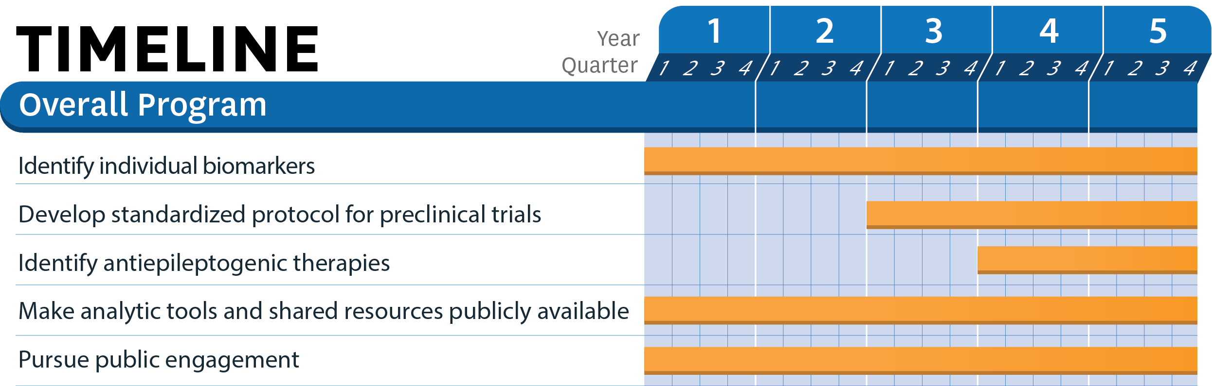

**5. Milestones**

**