# RESEARCH STRATEGY – PUBLIC ENGAGEMENT CORE – Epibios4rx

# 1. Significance

The Public Engagement Core is designed to advance participatory action research and accelerate knowledge transfer in patients with traumatic brain injury (TBI) both civilian and non-civilian (veterans). These populations require extended monitoring, because the disease is biphasic and the second phase (epilepsy) often occurs months or years after the initial injury. The Pubic Engagement Core will, for the first time, bring together epilepsy and TBI patients and caregivers (“consumers”) and consumer groups to address common interests and concerns, not only of patients with epilepsy, but especially for patients at risk of developing epilepsy. **The scientific premise of EpiBioS4Rx is: Epileptogenesis after traumatic brain injury (TBI) can be prevented with specific treatments; the identification of relevant biomarkers and performance of rigorous preclinical trials will permit the future design and performance of economically feasible full-scale clinical trials of antiepileptogenic therapies.** The purpose of EpiBioS4Rx is to create a rigorous multicenter preclinical and clinical platform to identify candidate antiepileptogenic treatments for post-traumatic epilepsy and to develop strategies and infrastructures (including the identification of biomarkers) that will enable future clinical antiepileptogenesis trials. The role of the Core is to utilize and, if necessary, develop programs to educate patients and their families about the importance of research on epileptogenic mechanisms, to learn from patients and their families about their most pressing needs and concerns about research, and to encourage their participation in clinical antiepileptogenesis studies. Several organizations representing diverse interested populations have agreed to participate. The partners in the Core will work together toward stated goals, contributing to ongoing adjudication of the project’s progress by providing feedback and critical assessment to accomplish the specific aims and assess the implementation of identified knowledge transfer strategies. Future implementations will require cooperation with state-based agencies and health organizations, not only in the USA but worldwide, to translate the EpiBioS4Rx findings into effective policies to ultimately prevent epileptogenesis.

Our proposal is also build on an integrated knowledge transfer strategy. Successful knowledge translation requires an interactive, dynamic approach that involves key stakeholders (e.g. and consumer groups), throughout the study.13 Therefore, our research approach engages key stakeholders as partners in the research process, from question inception through to dissemination. We have incorporated the International Association for Public Participation (IAP2) core values6 as they help to define the expectations and aspirations of the stakeholder participation process. This should ensure that the results are relevant to end-users and improve uptake of the findings, their sustained use, and ongoing renewal. This proposal is also guided by the knowledge-to-action cycle4 (see **Figure 1**) in that existing knowledge will be incorporated (e.g. qualitative interviews/focus groups with patients) which will lead to the development of knowledge tools/products for consumers (and consumer groups). Subsequently, these tools will be assessed (e.g. access barriers and facilitators to their use), improved, implemented, and outcomes subsequently evaluated. Given that our findings will be of interest to the broader research community, we will also use traditional knowledge transfer strategies to disseminate the findings, including peer-reviewed publications and presentations and through public media outlets.

# 2. Innovation

The innovation of our Public Engagement Core for EpiBioS4RX can be found in four areas. First, we developed the goals with the active participation of consumer groups and researchers. The consumer groups include organizations advocating either for people with epilepsy or with TBI, often the initial precipitating event for the development of epilepsy. This is the first time that such groups are working together to identify the means to prevent epileptogenesis after a brain injury. Second, we are involving veterans groups who deserve better treatments in terms of disease prevention or modification and whose occupations and service put them at a higher risk for TBI and PTE. Third, we include international organizations to give our approaches greater universal applicability with additional feedback from other countries that have large populations with different attitudes regarding epilepsy and TBI. Fourth, we anticipate that the identified effective strategies and knowledge transfer plans will be assessed and, we hope, adopted and implemented by governmental and non-governmental health organizations world-wide including the World Health Organization (WHO) and the Pan American Health Organization (PAHO). To achieve our goals, EpiBioS4RX has established collaborative relationships with several organizations listed below*.* All these organizations are already engaged in patient education and outreach. Rather than “recreate the wheel,” we will utilize programs that already exist, and help these organizations work together with us to develop unified programs and resources focused on relevant aspects of the search for disease-modifying and prevention therapies in epilepsy.

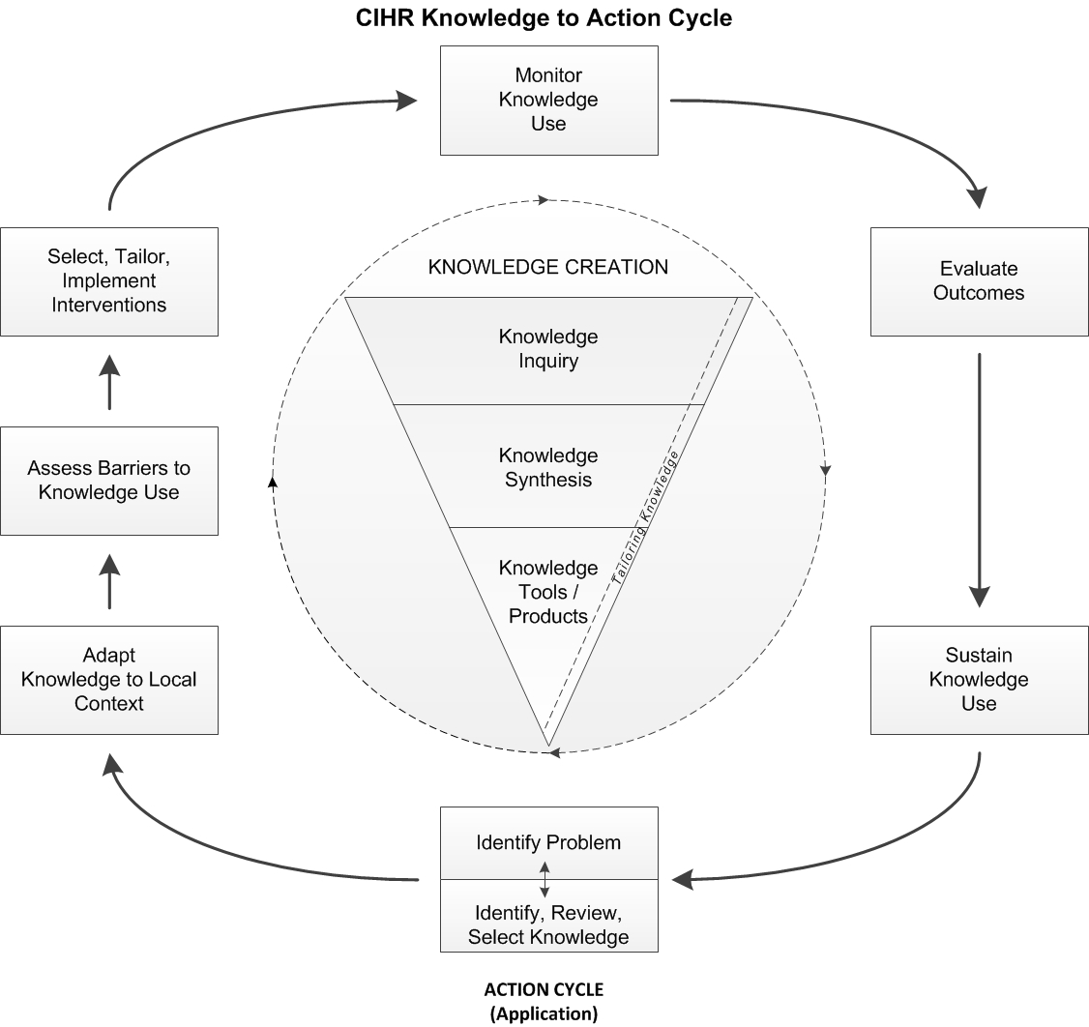

Figure 1 – Knowledge to Action Cycle 1 (Adapted from3)

# 3. Approach

3.1. Specific Aim 1: Create a consortium of consumers and consumer organizations, scientific (professional) societies, health organizations and EpiBioS4Rx investigators to assist with public outreach to facilitate interactions and communication among our partners to effectively promote participatory action research. To achieve a solid grounding between concept, practice and action, we have recruited several constituencies in the planning and decision making processes:

## Epilepsy advocacy and consumer groups:

* Epilepsy Foundation ([www.epilepsy.com](http://www.epilepsy.com))
* International Bureau for Epilepsy (IBE) ([www.ibe.epilepsy.org](http://www.ibe.epilepsy.org))
* European Task force of the International League Against Epilepsy (ILAE) and IBE (<http://www.epilepsycongress.org/epilepsy-advocacy-europe-joint-task-force-of-ilae-and-ibe/>)

## Service, Advocacy and Research Groups for patients with TBI:

* Brain Injury Association of America (BIAA) ([www.biausa.org](http://www.biausa.org))
* TBI Model Systems (TBIMS) ([www.tbindsc.org/](https://www.tbindsc.org/))

## Veteran organizations:

* VA Epilepsy Centers of Excellence ([www.epilepsy.va.gov](http://www.epilepsy.va.gov)).

## Professional societies:

* International League Against Epilepsy (ILAE) ([www.ilae.org](http://www.ilae.org))
* American Epilepsy Society (AES) ([www.aesnet.org](http://www.aesnet.org))
* National Neurotrauma Society (NSS) ([www.neurotrauma.org](http://www.neurotrauma.org))
* International Neurotrauma Society (INS) ([www.ints2014.com](http://www.ints2014.com))

## Health Organizations:

* World Health Organization (WHO) ([www.who.int](http://www.who.int))
* Pan American Health Organization ([www.paho.org](http://www.paho.org))

3.1.1. Strategies: The Core has a Project Coordinating Committee (PCC) overseeing and driving its activities. The members are:

* Solomon L. Moshé (Chair)
* Nathalie Jette (Co-Chair, Participatory Action Research Expert)
* Angela M. Ostrom: Epilepsy Foundation
* Susan H. Connors: Brain Injury Association of America
* Phil Gattone: Epilepsy Foundation and International Bureau for Epilepsy
* Dennis Dlugos: American Epilepsy Society, The Epilepsy Study Consortium
* Karen Parko: National VA Epilepsy Centers of Excellence
* Ryan Rieger: National VA Epilepsy Centers of Excellence, Education Workgroup
* David Thurman: Chair, ILAE Epidemiology Commission Epilepsy Prevention Task Force
* Robert G. Kowalski, TBI Model Systems National Data and Statistical Center
* Mary Jo Pugh: Program Director for the San Antonio Polytrauma Node of the TBI Model Systems.

The PCC will have bimonthly web-based communications with minutes and action points to assess progress and obtain feedback to achieve solutions emphasizing incremental learning and adaptation through experiential engagement. It will create subgroups, led by a member of the PCC, with specific-time tables, composed of professionals and consumers, to handle discreet tasks. The Core will provide access to easy communication through a dedicated online software service to obtain world-wide participation in tele-conferences.

3.1.2. Deliverables:

3.1.2.1. Formation of a working group to address the importance of research questions to consumers and consumer groups**:** Consistent with the principles of participatory action research, the working group will be comprised of consumers, consumer groups and researchers who will be tasked with designing and facilitating focus groups and one-on-one interviews with consumers and consumer groups to inform and guide the subsequent phases of this project. Preliminary areas potentially to be explored include: (a) defining important issues to the individuals at risk, their families and related community-based organizations; (b) best methods in research methodology, recruitment and retention from the consumer’s perspective and (c) engaging the public in large collaborative studies comparing human and basic science data for the development of biomarkers that may guide future trials. These interviews/focus groups will also address the type of educational materials and content that should be provided on our website (see step 2 below). Importantly, additional research questions/areas deemed important by the working group will also be assessed.

Evaluation Plan: Once the working group has been formed, the team will develop a *logic model* to establish opportunities for ongoing evaluation and reflection of progress and objectives over the course of the project. A logic model will link the strategies and activities of this project with their corresponding objectives and will stay current with changing priorities and new understanding gained through the preliminary areas explored.

A satisfaction survey(as in10, 12) will be used as an additional evaluative metric six months after the formation of the working group to ascertain engagement and satisfaction with the working group. The survey will be designed and implemented by a subset of working group members including at least one consumer, one researcher and one consumer group representative. Utilizing themes from the Canadian Institutes of Health Research Patient Engagement Framework, members will be invited to anonymously complete a survey covering the following themes: 1) Application of inclusive mechanisms and processes, 2) Respectful collaboration, 3) Experiential knowledge of patients is valued and evidenced as part of the research process, 4) Research is informed and co-directed by patients, and 5) Shared goals of implementation of research.

Findings from the survey will be shared with the working group and any concerns or suggested changes in processes will be addressed in revised Terms of References. The survey will be readministered at appropriate intervals as determined by the group with specified targets and performance indicators (e.g. 100% of working group members believe there are inclusive mechanisms and processes).

The working group will include at least one other member with qualitative expertise and will be responsible for delivering webinar training on qualitative research methodologies and analyses for all members of the working group. The three primary groups represented on the working group will co-design focus group/interview guides, determining: structure (open ended versus semi-structured), target or priority subgroups, and the scripts and questions to be posed to participants. All sessions will be audiotaped and transcribed verbatim. Each tape will be assigned a unique identifier. The goal will be to transform data from the focus groups into common, interactive themes. This process includes coding, categorizing and conceptualizing. The transcripts will be analyzed using an organizational coding tool such as Nvivo. An open coding structure will be applied to the transcripts to identify priority themes2 and subthemes. The team, including consumers will actively contribute to the coding process engaging in iterative discussion related to data themes, gaps and saturation. After preliminary analysis the data will be brought back for further input from stakeholder organizations in the working group.

Upon completion of the analysis of the focus groups and interviews, we will host a *Knowledge Exchange Forum* with our stakeholders to share our findings, present priority aims for EpiBioS4RX and review implication and opportunities for the next phase of the study. There will be an interactive dialogue facilitated through a *World Café3****, 5, 11*** Method whereby attendees will organize into small groups to discuss areas related to the study. Each of the small working groups will be facilitated/supported by a member of the working group. This will allow the team to obtain meaningful feedback from stakeholders and ensure the objectives identified from this first step resonate with them. Ultimately, the goal of the first phase is to ensure the specific aims of EpiBioS4RX are aligned with, and meet the needs of patients and their families, according to qualitative data findings, and increase awareness of EpiBioS4RX while building effective partnerships and ensuring buy-in from consumers (starting in Year 1 and completed by Year 3).

Deliverables: (1) Formation of the working groups, (2) Training of working group members in qualitative methodology and Participatory Action Research and eventual release of Webinar on Participatory Action Research as an online publicly available resource, (3) Public outreach and engagement with consumers and consumer groups, (4) Development of a conceptual strategy for recruitment and retention, (5) Knowledge Exchange Forum with patients and stakeholder groups, and (6) Publications describing the findings from the above qualitative interviewers/focus groups.

3.1.2.2. Development of public outreach kit explaining in lay-terms the scientific goals of EpiBioS4Rx and other key information: Public outreach materials will drive visitors to the EpiBioS4Rx website. The content for the educational materials will be informed by the focus groups/qualitative interviews carried out in step 1 above, but also re-purposed from existing information and may include content pertaining to symptom recognition, differential diagnosis, treatment/medication protocols, meaningful use of biomarkers, advantages of large scale studies and findings from EpiBioS4Rx studies. The kit may include press releases, print ads, infographics, video messages, and/or templates for newsletter articles, webpage and social media content. The PCC will recruit and supervise the research assistant to collect available material (using multiple ascertainment sources e.g. experts, existing websites, educational information from our consumer partner agencies, etc.) and develop new ones where gaps exist, with oversight from the PCC members. Consumers and consumer groups will be engaged prior to launch to ensure their needs and perspectives are reflected on the website and in the educational materials. Once a prototype is developed, usability testing by the postdoctoral fellow will identify its strengths and weaknesses from the perspective of end users, assessing public outreach materials and content and ensuring the website is accessible and user-friendly. The team will recruit a convenience sample of 12-16 potential end users representing a cross section of experiences from people with TBI, PTE, family members, and consumer groups. Usability testing will occur over two parts. First, participants will interact with the website to complete a series of actions/tasks including navigating different pages, opening educational materials, and reading content, while verbalizing their thoughts aloud regarding the website. The second component will consist of semi-structures interviews to more deeply explore their experiences of using the website, including their perceived strengths and weaknesses of the site. The entire process is expected to be approximately one hour and all discussion will be audio-recorded and transcribed for analyses to identify recurring themes6 related to accessibility and usability, content, materials, appearance, and design. Refinements will be made based on this feedback. Subsequent usability testing will be undertaken until no new themes are identified. Generally, sampling 5-8 individuals identifies 80% of usability issues.9,14

The final materials will be provided to members of the consortium for redistribution through their networks. PCC member distribution will be tracked, and we will monitor and correlate (if possible) increases in website visitors with the timing of specific distributions. We expect to gain insights into which educational materials and messages are most relevant to subpopulations (e.g., those with PTE, those at risk of PTE, civilian, military, caregivers, providers, outside investigators) and which formats are mostly likely to be distributed by voluntary organizations. We will report what we learn to the PCC committee members and to the EpiBioS4Rx investigators. Periodic updates on the project as well as educational materials tailored to subpopulations will be developed, distributed and tracked. Lessons learned about messages, formats, and timing (i.e., what prompts action and when) will add to the body of knowledge in both epilepsy and TBI (starting in Year 1 and completed by the end of Year 2).

Evaluation Plan: We will assess: dissemination of the materials and website link to consumers, consumer organizations and other key stakeholders; uptake of these materials; website data such as number of visits to website, geographic location of website users, which pages are visited most, and duration of visits; and online feedback from consumer and consumer representatives to guide future improvements of the website, including additional strategies for outreach to promote the website. This work will be facilitated through the use of Google Analytics and other website performance software.

Deliverables:(1) Development of educational materials and website pages for consumer and consumer groups and (2) Publication describing the findings from the usability testing.

3.1.2.3. Determination of the effectiveness of web-based recruitment of subjects: Members of the consortium have already begun these efforts through epilepsy.com and organizations such as [Human Epilepsy Research Opportunities](http://www.epilepsyhero.org/) ([www.epilepsyhero.org](http://www.epilepsyhero.org)). We will include the information developed in the EpiBioS4Rx website. Although the risk of epilepsy is highest following a penetrating or other severe TBI, it is also distinctly elevated in patients hospitalized for less severe TBI, many or most of whom are not enrolled in TBI Model Systems or veterans studies. To better represent these groups, the EpiBioS4Rx website will develop an online website registration platform with the collaboration of the Brain Injury advocacy organizations participating in the Core.

The VA Epilepsy Centers work in close partnership with the VA Polytrauma Centers and can identify Veterans at risk for developing epilepsy. The VA has developed a veteran-specific internet platform that allows Veterans with epilepsy to connect with each other and share experiences through a partnership with Patients Like Me ([www.patientslikeme.com/join/poem](http://www.patientslikeme.com/join/poem)). This platform allows public engagement outside of a physician/health care setting, serves as a support network, and also can provide realtime feedback from veterans regarding issues they are facing in their own epilepsy care.

Being responsive to concerns of the people at risk for or suffering from PTE will aid EpiBioS4Rx in designing effective therapeutic trials with a high level of cooperation and retention. Additionally, the EpiBioS4Rx web-based platform will ask consumers and consumer groups to design a ‘mock’ therapeutic trial on their own, and these suggestions will be evaluated in refining the site. The Consortium will also submit to the Public Engagement Core specific items they want to Core to advise upon. A Delphi-like1,7 approach (which may require several rounds) will be used to reach consensus regarding the final items and recruitment strategy for the trials. The Delphi rounds will include consumer, consumer organizations and study investigators (starting in Year 2 and completed by Year 4).

Evaluation Plan: The data will be analyzed by determining the number and quality of changes proposed by the consumer/consumer groups that will be successfully incorporated in the design of future clinical EpiBioS4Rx trials as well as the number of Delphi-like rounds required to reach consensus. Subsequently, after a future trial is completed, the data will be reassessed to determine the impact of the incorporated suggestions in recruitment and retention.

Deliverables: (1) Development of a mock therapeutic trial by the consumers/consumer groups, (2) Comparison of mock therapeutic trial designed by consumers/consumer groups to existing therapeutic trials, (3) Comparison of mock therapeutic trail designed by consumers/consumer groups to the preliminary trial designed by EpiBioS4Rx, and (4) Through comparisons and with input from professionals, come to consensus on final design of the therapeutic trial.

3.1.2.4. A working group will be established to determine the ongoing effectiveness of the tools we develop in steps 1-3 above: Consumer satisfaction questionnaires will be sent to active participants and continually adjusted and updated, incorporating advances in communication capability (such as support group meetings with the participation of investigators via social networks). One approach will be to create a chat room in the EpiBioS4Rx website, moderated by the research assistant under the supervision of a member of the PCC. Periodic qualitative analyses will be conducted by the postdoctoral fellow to identify issues of importance to consumers, clinicians, and researchers. Additionally, questionnaires employed via Survey Monkey will be another avenue for consumers, consumer groups and researchers to provide feedback on the website and associated communication activities. This approach has been effectively used by one of our members of the consortium (BIAA). The consumer satisfaction questionnaires will be developed with input from the working group in step 1 above and though literature reviews to ensure content validity. The questionnaires will be piloted in a convenience sample of 10-15 participants (consumers, caregivers, consumer organization members of different educational level) in order to assess face validity and clarity. The questionnaire will be revised if necessary after the pilot testing. The questionnaire will be written at a grade 6 reading level, as assessed by the Automated Readability Index (using the following formula to calculate readability: (.37 x average sentence length) + (5.84 x average word length) -26.018) (starting in Year 2 and completed by Year 4).

Evaluation Plan:The success in accomplishing the tasks will be assessed by the PCC annually through metrics such as recruitment rates; number of questionnaires completed; new and continued participation in the chat rooms and website visitation rates. Each year the PCC will establish targets and benchmarks for each performance indicator. We anticipate that through these intensive interactions, the EpiBioS4Rx investigators and the consumer organizations will be able to develop a blueprint of how to perform intervention studies supported by solid research data that meet the requirements of regulatory agencies.

Deliverable**s:**(1) Development of a number of consumer satisfaction questionnaires co-designed with members of the working groups, (2) Publication of findings from patient satisfaction questionnaires, and (3) Improvement in recruitment and retention over time through improvement in the tools developed in the above steps.

3.2. Specific Aim 2: Develop and test strategies for involving both consumers (actual patients and their caregivers) and consumer groups in the design of studies: While there exist strategies and methods for effective participatory action research across multiple disciplines, what is unique about our proposed patient engagement is the preventative nature of this study. We are seeking to involve patients who have suffered TBI and are considered to be at risk of developing epilepsy, but do not currently have the condition. We are seeking patient involvement in the development of recruitment strategies for clinical trials for epileptogenesis, which the patients may or may not develop. Individuals with TBI may not be concerned about epilepsy, since epilepsy may not occur until many years following TBI. With prevention studies, clinical seizures have not yet developed, so physical risks and psychosocial consequences of seizures are theoretical, not tangible, to patients. For disease modification studies one should separate the effect on reducing seizures (which is often the measurable outcome in current anti-seizure drug trials) from the multifaceted effects of epilepsy. Key questions to be addressed (with additional questions to be guided by consumers and consumer groups from the qualitative data in Specific Aim 1) are:

* When is the optimal time to begin discussing risks of epilepsy following TBI, given the physical and psychological challenges TBI patients face, even without or before the development of seizures?
* Which patients with TBI risk factors are most appropriate for a study on epilepsy prevention?
* In studies of chemoprevention of epilepsy, what safety and tolerability side effects would be appropriate?
* How will physical, cognitive, and behavioral consequences of TBI affect eligibility for prevention studies?
* Should some studies of epilepsy prevention after TBI begin after an acute seizure or after the first seizure has occurred? If so, early recognition and diagnosis of seizures is essential, and we will work with the professional societies to develop methodology to more accurate detect seizures.
* What are the barriers and facilitators to improve early diagnosis of seizures following TBI?
* As both TBI and epilepsy are associated with behavioral challenges such as anxiety, depression, and PTSD, what are the interactions between behavioral therapies and antiepileptogenesis treatments? How do these methods interact after epilepsy develops?
* What is the optimal way to incorporate patient-oriented organizations into the outcome assessment objectives of the trials, including improved quality of life, increased independence, and increased employment, and how are these best integrated with traditional regulatory study outcome measures, such as delay to first seizure or next seizure, or percent seizure reduction?

**3.2.1 Educate investigators and consumers on how to best engage in, and practice participatory action research**: The research assistant will conduct literature reviews to identify best practices for similar participatory action research (e.g. disease prevention studies) and provide training (via a recorded webinar) to study personnel involved in EpiBioS4Rx followed by pre and post-tests to demonstrate mastery of concepts. Thereafter, we will have separate training (via a recorded webinar) for consumers associated with the Core and, refined for use with actual studies.

Usability testing will be undertaken on the educational materials to ensure clarity and evaluate accessibility and user-friendliness before the webinar is disseminated. The team will recruit a convenience sample of 5-8 potential end users per group10, 11 (one patient or caregiver; one consumer group, one study personnel group). Usability testing, to be done by the post-doctoral fellow, will occur over two parts – first, participants will interact with the website to complete a series of actions/tasks including navigating different pages; opening educational materials; and reading content, while verbalizing their thoughts aloud regarding the educational materials and webinar. The second component will consist of semi-structures interviews to more deeply explore their experiences of using the educational material and webinar, including their perceived strengths and weaknesses of the training module. The entire process is expected to be approximately 1 hours and all discussion will be audio-recorded and transcribed for analyses to identify recurring themes2 related to accessibility and usability; content and materials; and appearance and design. This will be done as in step 1 of Specific Aim 1 with the help of members of our working group who will be trained in qualitative methods). Refinements will be made to the prototype based on end-user feedback. Subsequent usability testing will be undertaken until no new themes are identified. Generally, sampling 5-8 individuals identifies 80% of usability issues10 (starting in Year 1 and completed by Year 3).

Evaluation Plan:The effectiveness of the educational and training materials on the methodology of Participatory Action Research, after the usability testing, will be determined via a satisfaction survey to PCC members to ascertain their level of familiarity and comfort of key principles prior to the formation of the working group. Moreover, the effectiveness of the training and the ability to translate essential components of the methodology into practice will be assessed after the survey to working group members as discussed in step 1.

Deliverables: (1) Development of an online webinar and educational materials regarding participatory action research for study personnel, consumers and consumer groups and (2) Publication of study findings from usability testing and results of pre-post surveys demonstrating improved knowledge from webinars.

 3.2.2. Surveys for additional consumer input via the EpiBioS4Rx website:Although the questions below will be evaluated through the qualitative analyses (focus groups and one on one interviews) proposed under Specific Aim 1, Step 1, additional input from outside investigators and a larger range of consumers will be sought through the development of an online questionnaire. Similar questionnaire development methodology will be followed as described under Specific Aim 1, Step 4. We will also use *Survey Monkey* surveys. Under the direction of the PIs and in consultation with PEC committee members, the research assistant will co-design, analyze and prepare reports on key data points to collect from consumers and outside investigators. Potential questions for consumers (stratified by multiple variables, including respondent demographics such as age, gender, race, socioeconomic status, and education) will include:

* When is the right time to discuss risks?
* Who is the right person to discuss risks?
* What prevents you from participating in research studies?
* What would entice you to participate?
* What do you need to know about a study before agreeing to participate?
* Have you ever declined to participate in the past? Why?
* What is the best way to inform you of upcoming studies?
* What is the best way to get information about you?
* Did someone help you answer these questions? Who?

While there is a concern that the sample would be self-selected and not random, it will still provide additional key baseline data. Subsequently, the postdoctoral fellow may select a random sample from survey respondents to conduct in-depth interviews for deeper insights following the qualitative methods described under Specific Aim 1, Step 1. (Started Year 2 and completed Year 4).

Evaluation Plan:The delivery of an additional survey to stakeholders for input presents an opportunity to assess the progress of a number of our objectives in this study. Namely, the response rates for our survey will be an indicator for the effectiveness of our public outreach activities and the breadth of networking achieved via the PCC and the working group during the focus groups, Knowledge Exchange Forum and the website activities. Furthermore, thematic analysis of survey responses will indicate to the study team if data saturation is attained or whether there are potential areas/themes yet to be fully identified and explored through data collection in step 1.

**Deliverables:** (1) Publications aiming at improving subject participation in soundly-designed studies and (2) Dissemination of information to other groups developing studies with consumer participation, advice, and consent.

3.3.3. Consultation with key partners including the Epilepsy Study Consortium (ESC; [http://epilepsyconsortium.org](http://epilepsyconsortium.org/)). ESC has expertise in all aspects of epilepsy-related clinical trials and serves as a consultant to EpiBioS4Rx, including membership on the Core Project Coordinating Committee. ESC is a group of scientific investigators from more than 20 academic medical research centers who are dedicated to accelerating the development of new therapies in epilepsy. ESC has several years of experience in building partnerships between academics, industry and regulatory agencies to optimize clinical trial methodology in order to responsibly speed new treatments to patients. Public engagement regarding future clinical trials will be more productive if discussed in the context of what regulatory agencies will accept, and what sponsors (academic and industry) are likely to study. While the primary outcome of future trials will be driven by the science and the regulatory climate, secondary outcomes will certainly be influenced by engagement with consumer and consumer groups. To this end, the Investigators of the individual projects of EpiBioS4Rx will consult with the Public Engagement Core before making their final decisions regarding items to include in the future clinical trial. For example, the consumer groups may make suggestions on the choice of biomarkers in the panel used to determine antiepileptogenesis, advocate for the selection of a specific lead treatment protocol based on existing phase 1 data, and recommend addition of other outcomes of interest which could be studied through parallel or separate studies (e.g., cognitive, behavioral) (starting in Year 4 and completed by Year 5)

Evaluation Plan: Sustained engagement with partners and stakeholders will be assessed by compiling results of the evaluation plans associated with each step during the life of the study and metrics such as website visitation rates and satisfaction scores for produced outreach materials.

The final evaluative variables will be determined as in collaboration with the PCC and the working group(s) but may include indicators such as length of participation or service on working groups, and number of attendees at events such as the Knowledge Exchange Forum.

Deliverables: Increased engagement with key partners, which will improve future collaborations (as demonstrated by ongoing engagement by these partners and co-author publications).

3.3.4. Prepare a PCORI grant for a future trial of antiepileptogenesis in TBI using the meaningful outcome measures, the successful enrollment and retention strategies determined in this Core, and data from the scientific component of the EpiBioS4Rx CWOW (**Year 5)**.

Evaluation Plan and Deliverables: Evidence of submission to funding agencies and funding success to enhance the work being proposed in the Public Engagement Core project.

# 4. Timeline

**Figure 2.** The timing for initiating and completing each deliverable.

**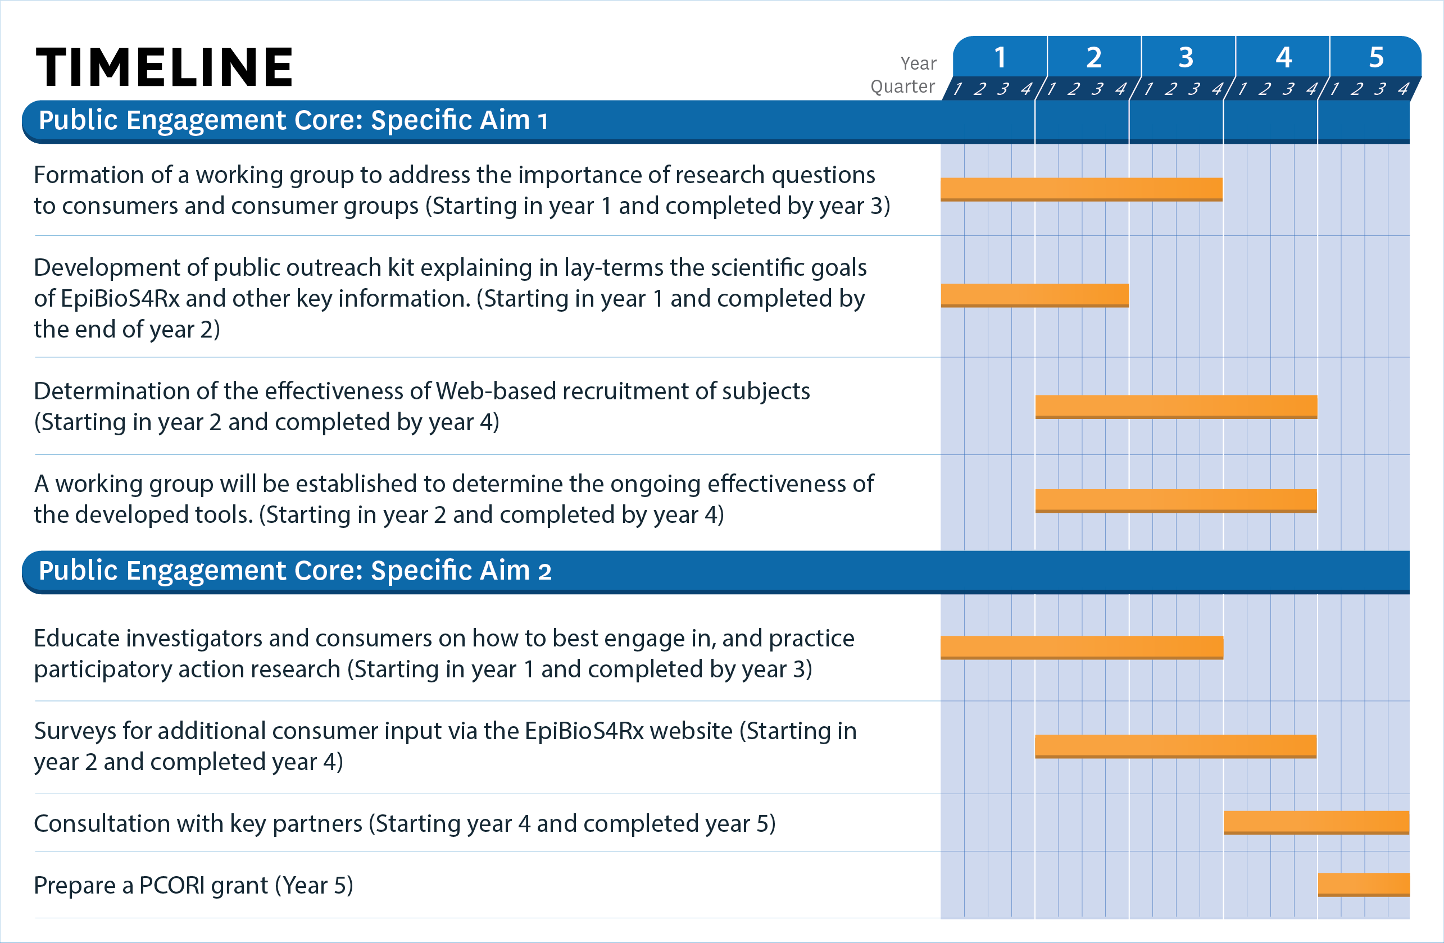**

## 5. MILESTONES

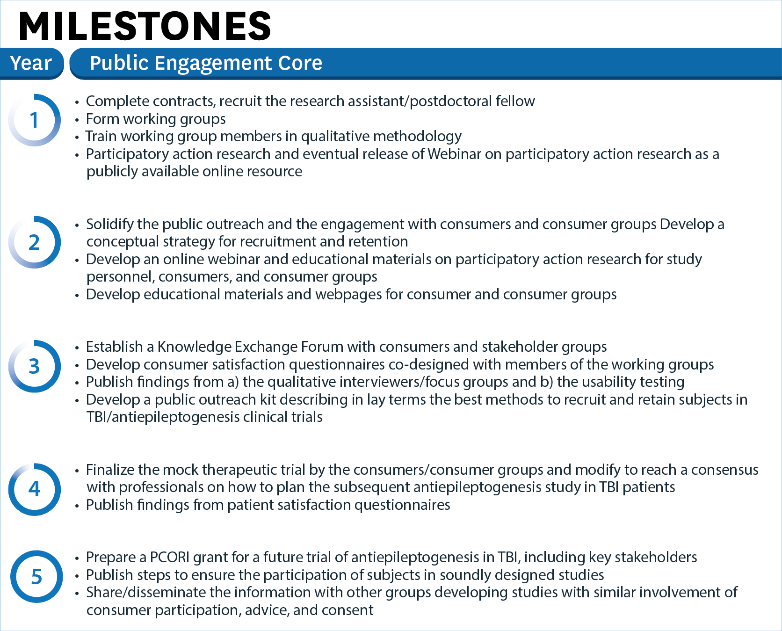

## 6. FUTURE DIRECTIONS

After a successful intervention trial, we will seek to involve worldwide governmental and non-governmental organizations in the translation and implementation of treatments and policies based on our findings . To explore clinical research regulations across countries, we will use the National Institute of Allergy and Infectious Diseases (NIAID) newly released online database ([http://clinregs.niaid.nih.gov](http://clinregs.niaid.nih.gov/)). In the USA, we will follow approaches described in the Institute of Medicine (IOM) report on Epilepsy ([http://www.iom.edu/Activities/Disease/Epilepsy.aspx](http://www.iom.edu/Activities/Disease/Epilepsy.aspx" \t "_blank)), followed by the initiatives by Vision 20-20 (a cooperative group of consumer, health professional, and advocacy organizations concerned with the epilepsies; (<https://www.aesnet.org/about_aes/epilepsy_partners/patient_family_advocacy_groups>). Internationally, we will build on initiatives developed by the ILAE and IBE when Dr. Moshé was the ILAE president (2009-13). These include an ongoing collaboration with the European Joint Task Force of the ILAE and IBE that was successful in advancing the care of Epilepsy in Europe through the European Parliament that endorsed the European Written Declaration on Epilepsy in 2011. The calls of the declaration (<http://www.ilae-epilepsy.org/visitors/initiatives/EuropeanDeclaration.cfm>) are similar to the goals of EpiBioS4Rx: to encourage research and innovation in the areas of prevention and early diagnosis and treatment of epilepsy; to prioritize epilepsy as a major disease that imposes a significant burden across Europe; to take initiatives to encourage Member States to ensure equal quality of life, including in education, employment, transport and public healthcare, for people with epilepsy, e.g. by stimulating the exchange of best practice; and to encourage effective health impact assessments on all major EU and national policies. In addition, the ILAE and IBE and the WHO have formed the Global Campaign Initiative ([www.who.int/.../globalepilepsycampaign/en/](http://www.who.int/.../globalepilepsycampaign/en/))m which allows for communication with governmental organizations world-wide with specific steps already developed for the Americas through the World Health Organization (WHO) and the PanAmerican Health Organization (PAHO) ([http://new.paho.org/hq/index.php?option=com\_content&task=view&id=5272&Itemid=3841&lang=en](http://new.paho.org/hq/index.php?option=com_content&task=view&id=5272&Itemid=3841&lang=en" \t "_blank)). The WHO and PAHO are the leading organizations that can translate EpiBioS4Rx data into policy (*letters of support* attached). Indeed, as a result of these effective collaborations, on May 26, 2015,the WHO passed a resolution on steps how to strengthen care in epilepsy ([www.who.int/mediacentre/news/releases/2015/wha-26-may-2015/en](http://www.who.int/mediacentre/news/releases/2015/wha-26-may-2015/en)). The resolution calls on the WHO Secretariat to continue to lead and coordinate support to Member States in addressing the global burden of epilepsy so that people with epilepsy can receive timely treatment and can benefit from educational and occupational opportunities, free from stigma and discrimination.

Additionally, knowledge from the science and the public engagement components of EpiBioS4Rx may inform future studies addressing other conditions that may predispose to epilepsy, such as: depression, stroke, dementia, and childhood illnesses such as encephalitis, hypoxic ischemic encephalopathy, or genetic disorders that can be diagnosed before epilepsy emerges.

We anticipate that with the close collaboration of consumer groups and professionals, the EpiBioS4Rx Public Engagement Core will generate key data on successful outcomes of future studies in disease prevention or modification, will provide a blueprint for similar Cores, and will promote collaboration and cooperation among EpiBioS4Rx and other CWOWs.

**References**

1. Bennett DA, Brayne C, Feigin VL, et al. Development of the Standards of Reporting of Neurological Disorders (STROND) checklist: A guideline for the reporting of incidence and prevalence studies in neuroepidemiology. Neurology. 2015;85:821-8.
2. Braun V, Clarke V. Using thematic analysis in psychology. Qual Res Psychol 2006;3:93.
3. Cafe to Go. [online]. Available at: http://www.theworldcafe.com. Accessed February 7, 2016.
4. Graham ID, Logan J, Harrison MB, et al. Lost in knowledge translation: time for a map? J Contin Educ Health Prof. 2006;26:13-24.
5. Holroyd-Leduc J, McMillan J, Jette N, et al. Stakeholder meeting: addressing the gap in provision of evidence-informed caregiver supports by utilizaing an integrated knowledge translation approach. Can J Aging. 2016, (under review).
6. IAP2 spectrume of public participation. [online]. Available at: http://www.iap2.org/associations/4748/files/IAP2 Spectrum\_vertical.pdf Accessed February 7, 2016.
7. Jette N, Quan H, Tellez-Zenteno JF, et al. Development of an online tool to determine appropriateness for an epilepsy surgery evaluation. Neurology. 2012;79:1084-93.
8. Kincaid JP, Fishburne RPJ, Rogers RL, et al. Derivation of new readibility formulas (Automated Readibility Index, Fog Count and Flesch Reading Ease Formula) for navy enlisted personnel. Chief of Naval Technical Training: Naval Air Station Memphis. 1975.
9. Nielsen J. Estimating the number of subjects needed for a thinking aloud test. Int J Human-Comp Studies. 1994;41:385-97.
10. Roberts JI, Sauro K, Jette N, et al. Using a standardized assessment tool to measure patient experience on a seizure monitoring unit compared to a general neurology unit. Epilepsy Behav. 2012;24:54-8.
11. Sauro K, Holroyd-Leduc J, Wiebe S, et al. Knowledge translation of an online tool to determine candidacy for an epilepsy surgery evaluation. Neurol Clin Practice. 2016, (in press).
12. Sauro KM, Krassman C, Jette N, et al. Experience and satisfaction of staff working in a seizure monitoring unit. Can J Neurosci Nurs. 2012;34:33-8.
13. Straus SE, Tetroe J, Graham I. Defining knowledge translation. CMAJ 2009;181:165-8.
14. Virzi RA. Reining the test phase of usabiity evaluation: How many subjects is enough? Human Factors: The J of the Human Factors and Erognomics Society. 1992;34:457-68.