**Midterm**

**ERD and Business Rules**

1. Given the following business rules, finish the business rule and create the appropriate Crow’s Foot ERD. *Paste the ERD from Visio into this document*.

1. A COMPANY operates many DEPARTMENTs.
2. Each DEPARTMENT employs one or more EMPLOYEEs.
3. Each of the EMPLOYEEs might or might not have one or more DEPENDENTs.
4. Each EMPLOYEE might or might not have an EMPLOYEE_HISTORY.  
   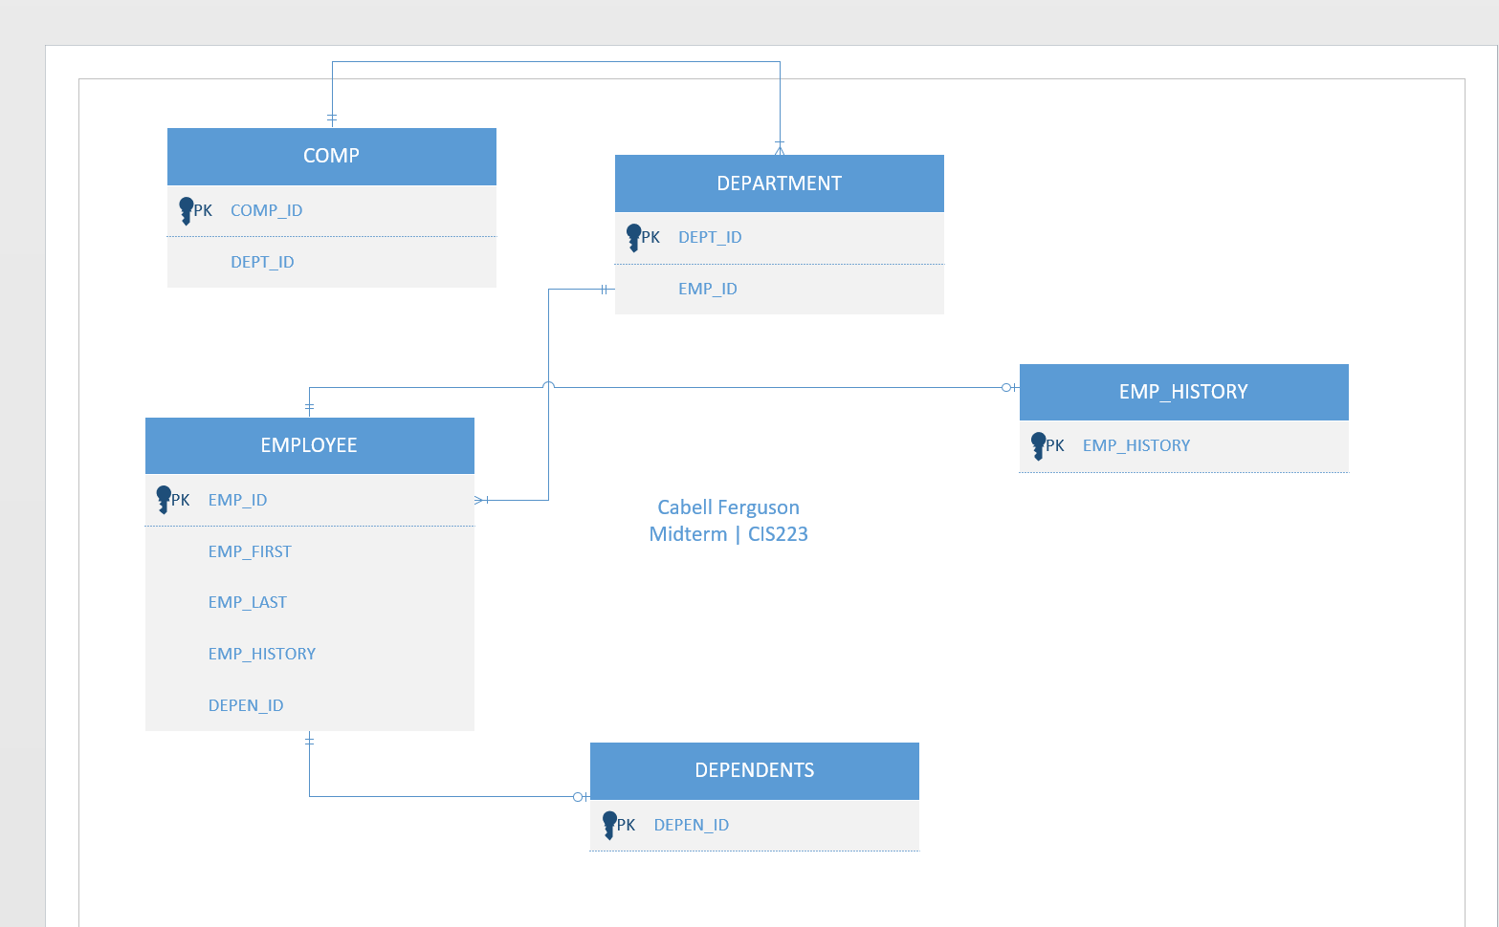
5. Given the following Crow’s Foot ERD, create the appropriate business rules.   
   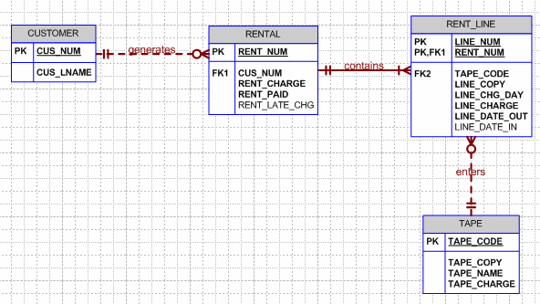  
     
   **Only one customer can have many rentals.**

**Every rental must contain at least 1 line.**

**Many lines can enter only 1 tape**

* 1. List the required attributes for each entity in the above ERD.  
     **CUS_NUM, RENT_NUM, LINE_NUM, TAPE_CODE**
  2. List the strong relationship(s) in the above ERD.  
     **RENTAL AND RENT_LINE**
  3. List the weak relationship(s) in the above ERD.  
     **CUSTOMER AND RENTAL,RENT_LINE AND TAPE**
  4. List the weak entity in the above ERD.

**RENT_LINE**