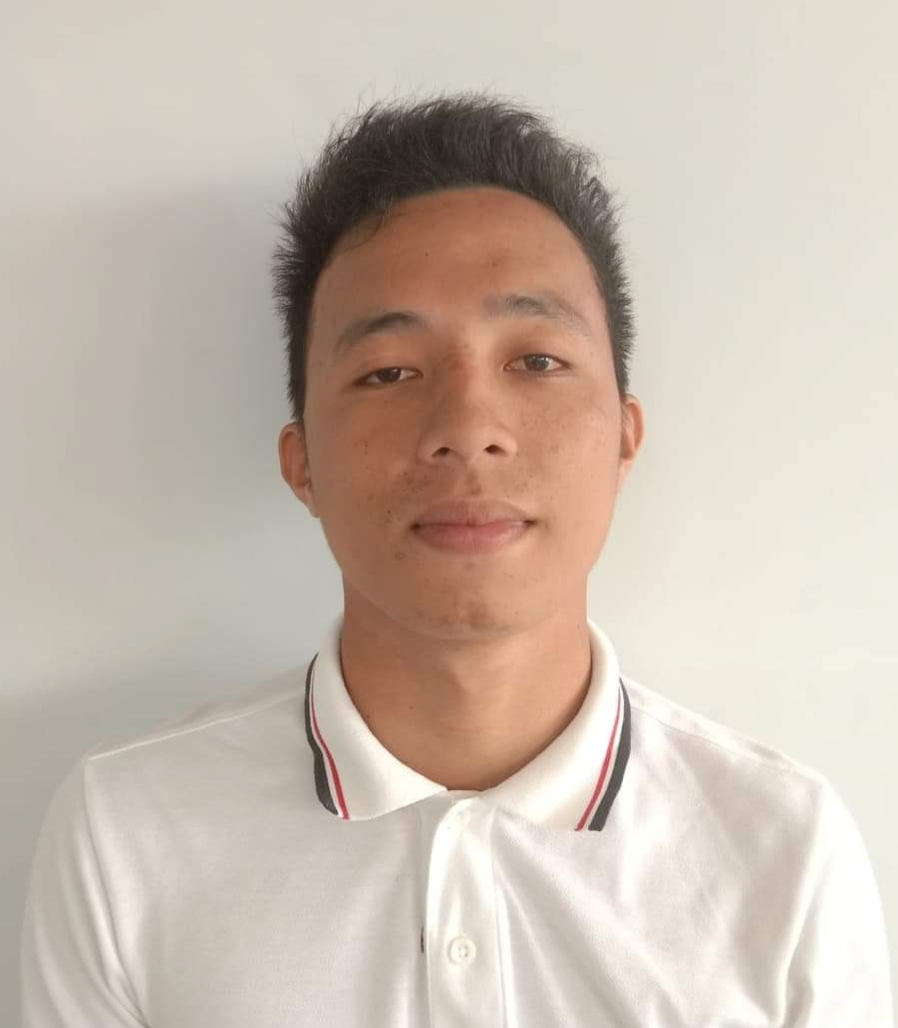

**JASSEN D. CABILANGAN**

Email Address : jassencabilangan@gmail.com

Cellular No. : +63(9162422713)

Objective : Highly flexible individual with analytical skills and B.S. in Computer Science,

Looking for a challenging role in a reputable organization to utilize my skill including technical, database, and management for the growth of the organization as well as to enhance my knowledge about new and emerging trends in the IT sector.

PERSONAL DATA

Age : 21 years old

Birth date : May 11, 1999

Place of Birth : Brgy. Ladia, Sultan Kudarat,Maguindanao

Weight : 65kilograms

Height : 5”7’

Religion : Islam

Father’s Name : Mastura S. Cabilangan

Mother’s Name : Tuwanbai S. Dilangalen

EDUCATIONAL ATTAINMENT

Tertiary

2015-present Bachelor of Science in Computer Science

Notre Dame of Midsayap College

Quezon Avenue, Midsayap, North Cotabato

Secondary

2011-2015 Midsayap Dilangalen National High School

Poblacion 1, Midsayap, North Cotabato

Primary

2005-2011 Dilangalen Central Elementary School

Poblacion 1, Midsayap, North Cotabato

SKILLS

* Experience in Python, Django framework, HTML (Hyper-text Mark-up Language Programming Languages), CSS (Cascading Style Sheet), JavaScript (ES5, ES6), Bootstrap, .NET, Microsoft SQL Server, GitHub, AutoCad, Computer troubleshooting and Database Management.
* Oriented in Linux-based operating system.
* Have a high sense of responsibility with good interpersonal and organizational skills.

SEMINARS AND WORKSHOP ATTENDED

**Certificate of Participation**

Cinematography Basics –Vegas Pro Seminar Training & Workshop

Notre Dame of Midsayap College, Fr.Sullivan Building, Computer Laboratory

December 15, 2017

**Certificate of Participation**

Computer Hardware Servicing (CHS)

Notre Dame of Midsayap College, Fr.Sullivan Building, Network Laboratory

December 16, 2017

**Certificate of Participation**

Computer System Servicing Installation (CSSI)

Notre Dame of Midsayap College, Fr.Sullivan Building, Network Laboratory

December 17, 2017

ORGANIZATIONS

Affiliation: Member (2017-2018)

PSITS (Philippine Society of Information Technology Students)

Notre Dame of Midsayap College

CHARACTER REFERENCES

Mark C. Candidier

Full Stack Web Developer

+63(9502183818)

Michaelangelo S. Serrano, MIM

Faculty, College of Information Technology Engineering

+63(9300286853)

Gaubert B. Espe

Faculty, College of Information Technology Engineering

+63(9095433738)

*I hereby certify that the above information is true and correct at the best of my knowledge and honesty.*

**JASSEN D. CABILANGAN**

*Applicant*