HealthConnect Clinic Experience Lab
Week 5 — Analysis, KPI Development & Business Insights
Data Analytics Track: Initial HealthConnect Analytics Report

1. Week 4 Foundation Review
This section briefly revisits the foundation established in Week 4 before moving into this week's practical analysis.
- Problem defined: HealthConnect Clinic needs to understand why patients miss appointments and how data can help reduce no-shows and improve patient support.
- Week 4 approach: Review the dataset and data dictionary, assess data quality, define business questions, and propose 3–5 KPIs linked to those questions, without yet calculating or visualising them.
- Relevant resources: HealthConnect_Appointment_Data.csv (5,000 records, 18 fields) and the HealthConnect Data Dictionary.
- Key assumptions/limitations from Week 4: the dataset is fictional and anonymized; missing values in reminder channel, distance, and waiting time were judged explainable rather than data errors; the dataset appeared clean with no duplicates or invalid records.
- Proposed Week 5 focus (from Week 4): calculate and validate the five proposed KPIs, break each down by relevant segments, confirm the strongest patterns statistically, and begin shaping a simple risk indicator.

2. Data Preparation
Work was carried out entirely in Power BI (Power Query Editor), using the original HealthConnect_Appointment_Data.csv as the source. The original file was not modified — all cleaning and transformation steps were applied within Power Query and stored as query steps, keeping the source file intact.

Steps taken
- Data types corrected: date fields set to Date, distance and waiting time set to Decimal Number, identifiers (appointment_id, patient_id) kept as Text, and age_group correctly kept as Text since it holds category labels, not numeric values.
- Missing values reviewed: reminder_channel was blank for 1,366 records (27%) — this was expected, since it is blank exactly where no reminder was sent, and was not altered. distance_to_clinic_km and waiting_time_minutes had a small number of missing values (around 1–2%); these were left as blank rather than replaced with zero, since a zero would incorrectly imply 'no distance' or 'no wait' rather than 'not recorded'.
- Duplicates checked: no duplicate rows or duplicate appointment IDs were found.
- New columns created for analysis: Lead Time Band (0-7 / 8-30 / 31+ days), Distance Band (Under 5km / 5-15km / 15km+, with an 'Unknown' category for missing distance values), and Prior No-Show Flag (Has prior no-shows / No prior no-shows).
- Data quality observation: once the distance-band logic was tested, an error was found affecting records with missing distance values (comparisons against a blank value fail in Power Query). This was resolved by explicitly classifying missing distance values as 'Unknown' rather than letting them error out of the calculation.

3. Exploratory Data Analysis
The analysis investigated appointment attendance and no-show patterns across appointment characteristics, patient characteristics, previous appointment history, reminders, distance to clinic, and appointment outcomes overall.
- Booking lead time showed the strongest relationship with no-shows: the no-show rate rises from 27.8% (0–7 days) to 40.2% (8–30 days) to 60.5% (31+ days).
- Prior no-show history was the second strongest factor: patients with at least one previous no-show missed again 55.4% of the time, versus 43.5% for patients with no such history.
- Distance to the clinic showed a moderate, fairly consistent upward trend: 46.5% (Under 5km) to 47.3% (5-15km) to 54.1% (15km+). Records with missing distance data also showed an elevated no-show rate of 52.2%.
- Reminders showed a real but modest effect: 51.4% no-show rate with no reminder sent, versus 47.4% when a reminder was sent.
- Appointment outcomes overall: 48.5% No-Show, 46.3% Attended, 5.3% Cancelled.
- A monthly trend view revealed the no-show rate is not flat over time: it dips as low as 42.2% in November and rises sharply to around 53.9% in December, suggesting a seasonal pattern around the year-end period.

4. KPI Development
The following five KPIs were selected from the KPIs proposed in Week 4. Each is defined, justified, calculated using the prepared dataset, linked to a business question, and interpreted below.
KPI 1 — Overall No-Show Rate
Definition: Total no-shows as a share of all appointments.
Why it matters: Establishes the baseline scale of the missed-appointment problem, against which any future improvement is measured.
Business question: How can HealthConnect reduce missed appointments overall?
Calculated result & interpretation: 48.46% — confirms almost half of all scheduled appointments are missed, confirming this is a large-scale operational issue rather than a marginal one.
KPI 2 — Repeat No-Show Rate
Definition: Share of patients with at least one prior no-show who go on to miss another appointment.
Why it matters: Tests whether past behaviour predicts future behaviour, supporting a simple patient risk-flagging approach.
Business question: Does a patient's no-show history predict future no-shows?
Calculated result & interpretation: 55.41% — Confirmed as one of the strongest single predictors found; patients with a prior no-show are considerably more likely to miss again than patients with a clean record (43.51%).
KPI 3 — Reminder Effectiveness Gap
Definition: The percentage-point difference in no-show rate between patients who received a reminder and those who did not.
Why it matters: Tells the clinic, in one figure, whether reminders are worth the cost and effort of sending.
Business question: Does sending a reminder reduce the likelihood of a no-show?
Calculated result & interpretation: 4.03 percentage points (51.39% no reminder vs 47.36% with a reminder) — reminders help, but the effect is real rather than dramatic; reminders alone will not solve the no-show problem.
KPI 4 — Average Booking Lead Time (No-Show vs Attended)
Definition: Average number of days between booking and the appointment date, compared across outcome groups.
Why it matters: The clearest gap found in the data; flags lead time as the leading scheduling risk factor.
Business question: What characteristics are most strongly associated with no-shows?
Calculated result & interpretation: 34.53 days for no-shows, notably higher than for attended appointments — the longer the gap between booking and the appointment, the more likely a patient is to miss it.
KPI 5 — Average Distance to Clinic (No-Show vs Attended)
Definition: Average distance travelled to the clinic, compared across outcome groups.
Why it matters: A smaller but real gap; tracks whether travel burden is a factor worth addressing.
Business question: Does distance to the clinic influence attendance?
Calculated result & interpretation: 10.53km for no-shows, moderately higher than for attended appointments — distance plays a real but secondary role compared to lead time and prior history.

5. Dashboard
An initial analytical dashboard was built in Power BI, using the prepared dataset described above. The dashboard presents the five KPIs as headline cards, alongside supporting charts breaking each key finding down by category, an appointment outcome breakdown, and a monthly no-show rate trend. Two slicers (Appointment Type and Age Group) allow interactive filtering.
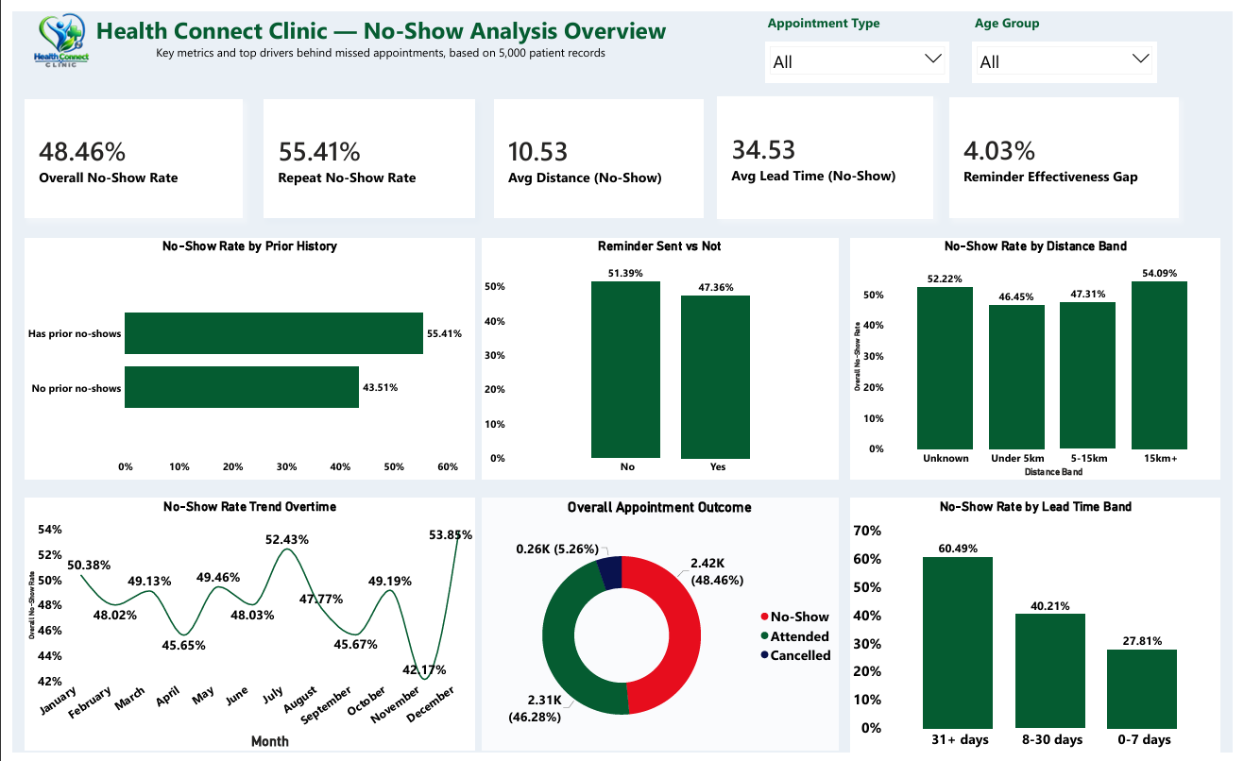
Figure 1: HealthConnect Clinic — No-Show Analysis Overview dashboard (Power BI).

6. Key Findings & Business Insights
- 1. Booking lead time is the single strongest driver of no-shows. Patients booked 31+ days in advance miss appointments more than twice as often (60.5%) as those booked within a week (27.8%). This suggests scheduling policy, not just patient behaviour, materially affects attendance.
- 2. A patient's own history is highly predictive. Patients with a previous no-show are considerably more likely to miss again (55.4% vs 43.5%), making this one of the most reliable signals available for early intervention.
- 3. Distance to the clinic has a real but secondary effect. No-show rates rise steadily from 46.5% (under 5km) to 54.1% (15km+), pointing to travel burden as a genuine, if smaller, contributor.
- 4. Reminders help, but modestly. The 4-point gap between reminded and non-reminded patients confirms reminders are a low-cost, worthwhile intervention, but not sufficient on their own.
- 5. Missing distance data correlates with a higher no-show rate (52.2%). This is a new insight from Week 5: patients with incomplete intake records show an elevated no-show rate close to the highest distance band, suggesting incomplete records may themselves be a marker of a disengaged patient rather than a purely administrative gap.
- 6. No-show rates show a seasonal pattern. The monthly trend dips to around 42% in November and rises sharply to around 54% in December, suggesting year-end scheduling conflicts or holiday disruption may be driving a seasonal spike.

7. Business Recommendations
Tackle long booking lead times first
This is the strongest lever identified. Consider capping how far in advance non-urgent appointments can be booked, or adding a confirmation step for appointments booked 30+ days out.
Build a simple risk flag from no-show history
Patients with a prior no-show could be flagged at booking time for extra follow-up (e.g. a phone call rather than a text) rather than treating every patient identically.
Keep sending reminders, and treat them as one part of a wider fix
Reminders show a real, measurable effect, but should be paired with the lead-time and history interventions above rather than relied on alone.
Investigate the December spike specifically
Given the seasonal pattern found, HealthConnect could examine whether staffing, holiday closures, or patient availability around year-end is driving the December increase, and plan targeted outreach for that period.
Treat missing distance records as a data-quality priority
Since incomplete distance data correlates with a higher no-show rate, improving intake data capture may itself double as an early indicator of disengaged patients.

8. Cross-Track Collaboration
Track interacted with: Data Science.
What was exchanged: the five calculated KPIs, the confirmed key drivers of no-shows (booking lead time, prior no-show history, distance), and the engineered categorical fields (Lead Time Band, Distance Band, Prior No-Show Flag) built during this week's data preparation.
Why this was relevant: the Data Science track's baseline model needs a defined target variable and candidate features; the patterns and engineered fields confirmed here give a validated starting point rather than requiring the Data Science track to re-run the same exploratory work independently.
What changed or improved as a result: the Data Science track can prioritise booking lead time, prior no-show count, and distance as leading candidate features for their baseline model, rather than testing all variables with equal weight.

9. Assumptions, Limitations, Risks & Dependencies

Still relevant from Week 4
- The dataset is fictional and anonymized; findings are illustrative of the approach rather than real clinical fact.
- Missing reminder channel data remains explainable (no reminder sent) rather than an error.

Resolved or clarified this week
- Confirmed handling for missing distance and waiting time values: left blank rather than replaced with zero, to avoid artificially lowering averages.
- Resolved a data-quality error in the Distance Band calculation caused by missing values, by explicitly classifying them as "Unknown" instead of letting the calculation fail.

New this week
- The "Unknown" distance category itself turned out to be analytically interesting (52.2% no-show rate) rather than just a data-quality footnote.
- A seasonal pattern (December spike) was identified that was not part of the original Week 4 business questions and may warrant its own follow-up analysis.

Limitations
- This is a descriptive, initial-stage analysis; no formal statistical significance testing has yet been applied to confirm which relationships are strongest beyond visual/percentage comparison.
- The dashboard reflects the dataset as a snapshot; it does not yet account for combined/interacting risk factors (e.g. long lead time and prior no-show together).
- Being a fictional dataset, real-world validation of these patterns against an actual clinic's data would be required before any recommendation is operationalised.

