Milestone 5: Development Phase (Coding and Testing)

Implementation Plan
The Kanban process will be used for management of this project. Progress will be tracked through the use of a task board on Trello, where each task can be moved between columns (Backlog, To Do, In Progress, Complete). The following table represents current progress.

Use Case /User Story | List of Development Tasks | Estimate (hrs.) | Actual (hrs.) | Percent Complete
Preparation & Setup | PCB layout/design | 20 | 12 | 100%
Preparation & Setup | PCB Manufacturing | 0 (vendor) | 0 | 100%
Preparation & Setup | PCB Assembly/Testing | 20 | 22 | 100%
Insert & Removal | PoC Test Fixture | 30 | 31 | 100%
Insert & Removal | Test Fixture final design/printing | 5 | 0 | 100%
Firmware loading | Import existing project code | 5 | - | -
Firmware loading | Customization to imported code | 10 | - | -
Firmware loading | UI development | 15 | - | -
Hardware Verification
- Turn on power | PoC for power management | 10 | 3 | 100%
- Turn on power | Firmware to turn on module power | 5 | 8 | 100%
- Validate current consumption | PoC for current measurement | 10 | 6 | 100%
- Validate current consumption | Firmware to test current values and return results | 5 | 5 | 100%
- Diagnostic mode | Firmware to set I/O pins | 5 | 6 | 100%
- Test CV inputs | PWM-to-analog POC | 10 | 5 | 100%
- Test CV inputs | Firmware to set CV values and read results | 5 | 3 | 100%
- Test OPT pins | Firmware to set I/O pins and read results | 5 | 4 | 100%
- Test sampling rates | Firmware to set I/O pins and read results | 5 | 6 | 100%
- Test tap temp | Firmware to send timed pulses and read results | 5 | 4 | 100%
- Test audio | Audio multiplexer PoC | 10 | 7 | 100%
- Test audio | Firmware to stimulate all audio inputs and observe all audio outputs | 5 | - | -
- Test memory | Firmware to set module mode, send inputs and observe delayed output | 5 | - | -
- Turn off power | Firmware to turn module power off | 5 | 1 | 100%
Results Management | Develop PC code to process results | 20 | 10 | 50%
Stock Management | Integrate software with enterprise server/database | 10 | - | -
User Control/Notification | Develop UI that allows users to start, stop and view test results | 5 | 8 | 75%
Percent of User Stories complete for this iteration: 100%
Percent of User Stories complete for entire project: 72%

Mapping of Functional Requirements

The following table provides a mapping between use cases/user stories, test cases and the architecture design document.

(Use Case/User Story) | (Architecture Plan)  Page or section where designed | (Code Module)  Class and Method where implemented | (Test Case)  Test Case number from the Test Plan
Preparation & Setup | Pg 4 (Hardware) | (N/A) | (N/A)
Insert & Removal | Pg 4 (Hardware) | (N/A) | 5
Firmware loading | Pg 5 (Software) | TBD | 11
Turn on power | Pg 8 (Pseudocode) | Util.cpp:  void relayPowerOn() | 2
Validate current consumption | Pg 8 (Pseudocode) | Util.cpp:  void relayPowerOn() | 1
Diagnostic mode | Pg 8 (Pseudocode) | Verify.cpp  verifyDiagStream() | 16
Test CV inputs | Pg 8 (Pseudocode) | Verify.cpp  verifyVCSettings() | 17
Test OPT pins | Pg 8 (Pseudocode) | Verify.cpp  verifyOptionSwitches() | 18
Test sampling rates | Pg 8 (Pseudocode) | Verify.cpp  verifySamplingRates() | 19
Test tap temp | Pg 8 (Pseudocode) | Verify.cpp  verifyTapTempo() | 20
Test audio | Pg 8 (Pseudocode) | Verify.cpp  verifyAudioPassthrough() {not yet implemented} | 21
Test memory | Pg 8 (Pseudocode) | Verify.cpp  verifyMemory()  {not yet implemented} | 22
Turn off power | Pg 8 (Pseudocode) | Util.cpp:  void relayPowerOff() | 2
Results Management | Pg 5 (Software), Pg 13 (Configuration), Pg 22, Sequence Diagram), Pg 23 (Server API’s) | TBD | 8, 25
Stock Management | Pg 5 (Software), Pg 22 (Sequence Diagram), Pg 23 (Server API’s) | TBD | 8, 24
User Control/Notification | Pg 5 (Software/User Interface Mockups), Pg 20-22 (User Interface Diagrams) | CT3680TestPlatformGUI.html | 10

Code Listing

Microcontroller Code:
GitHub: https://github.com/cabintech/CT3680TestPlatformFirmware.git
Description:
C code: CT3680TestPlatformGUI.ino – contains the main loop() and setup() functions to control the program.
CT3680TestPlatformGUI.h/Util.h/Verify.h: define all public method signatures, constants, etc. to be used throughout the program.
Util.cpp: provides all utility functions needed to build up higher level tests, such as powerOn/Off, readDiagnosticStream, etc.
Verify.cpp: holds the code for each of the hardware verification tests

PC Code:
GitHub: https://github.com/cabintech/CT3680TestPlatformUI.git
Description:
Servlet: TestCom.java – tests the communication between the PC and the microcontroller by sending power on/off commands
HTML: CT3680TestPlatformGUI.html – contains all HTML code for the user interface. Currently contains the script as well, although that will later be moved to its own file
CSS: testPlatform.css – contains all styling rules for the user interface

PCB Design:
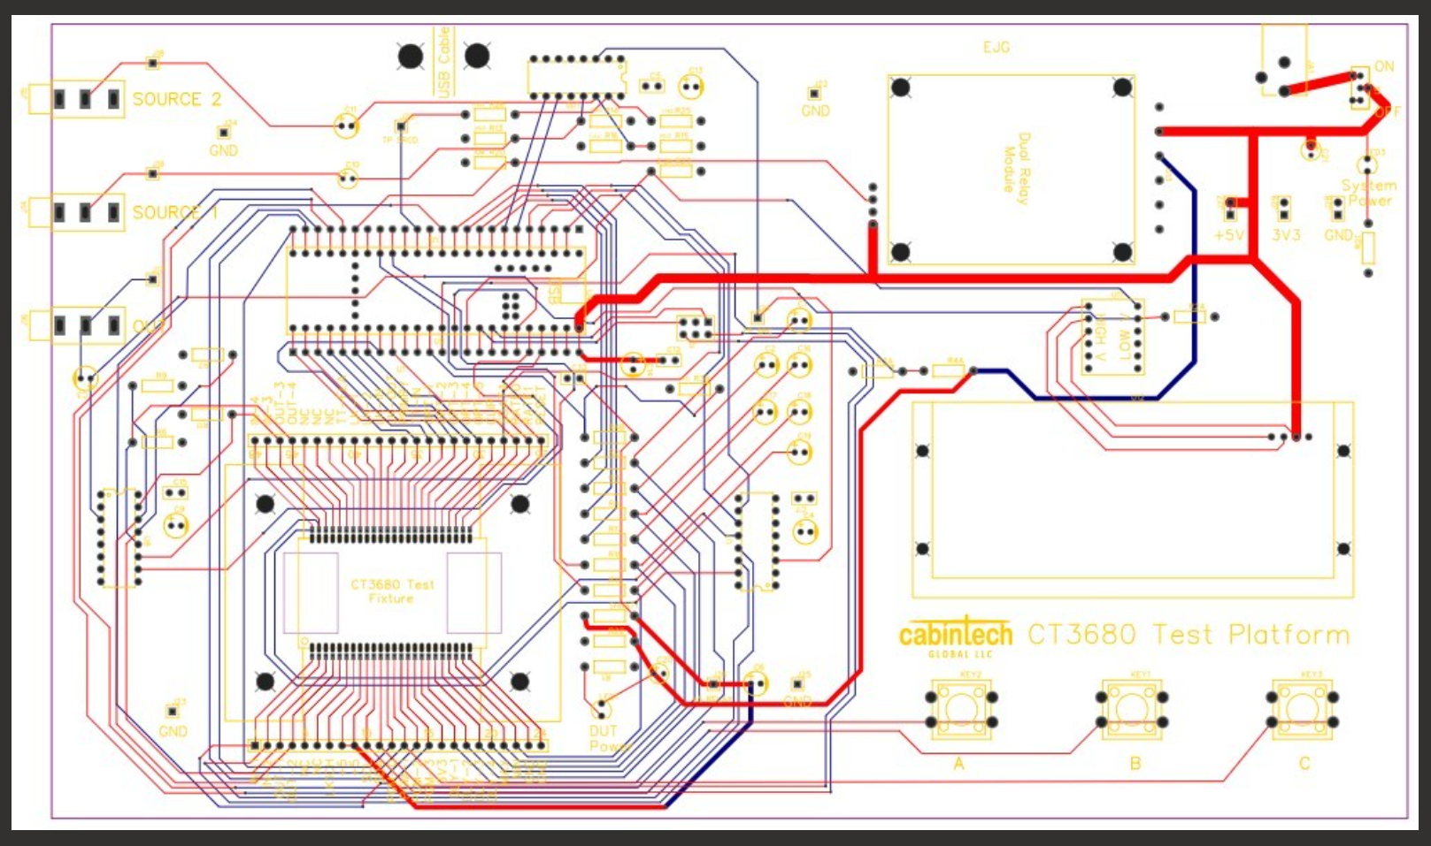
This diagram shows the electrical routing between the various components on the PCB.

Schematics - Base Fixture:
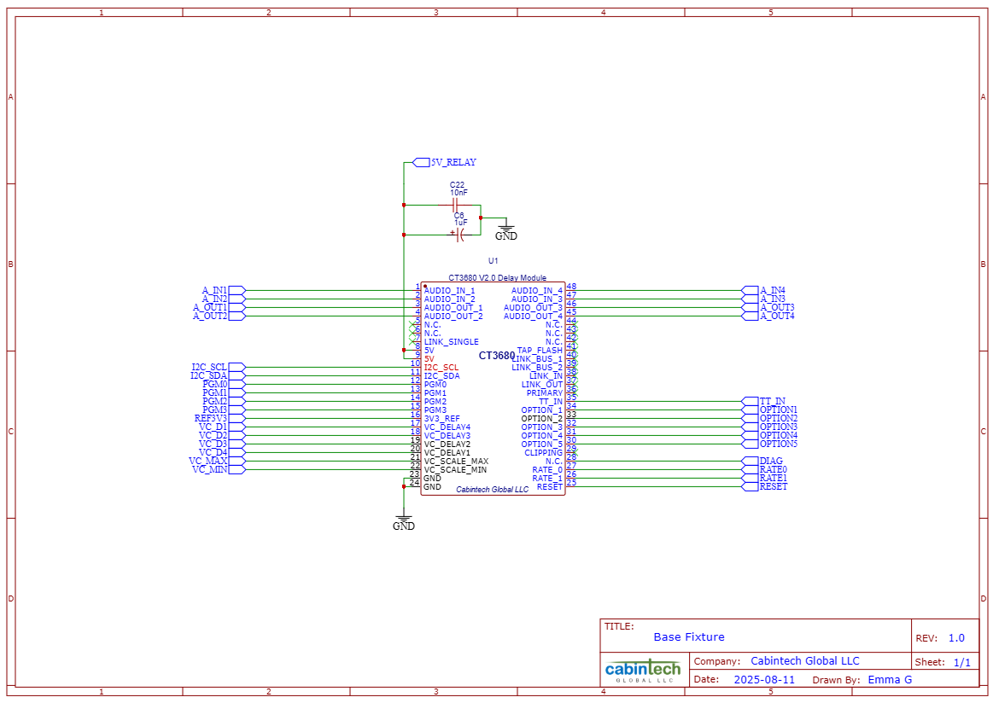
This diagram shows the circuits connected to each of the module pins.

Schematics - LCD Display:
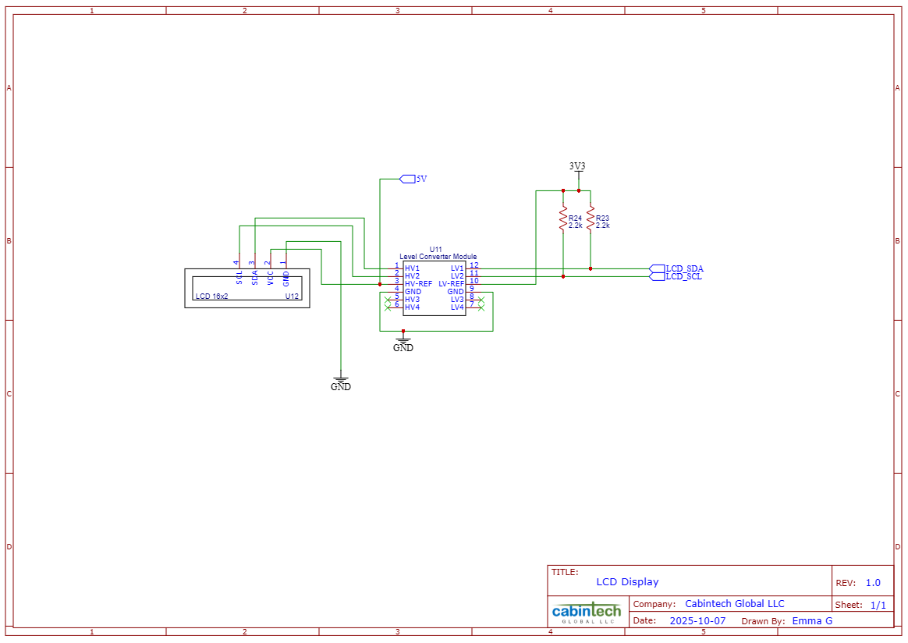
This diagram shows the circuitry associated with the LCD display.

Schematics – Main Page:
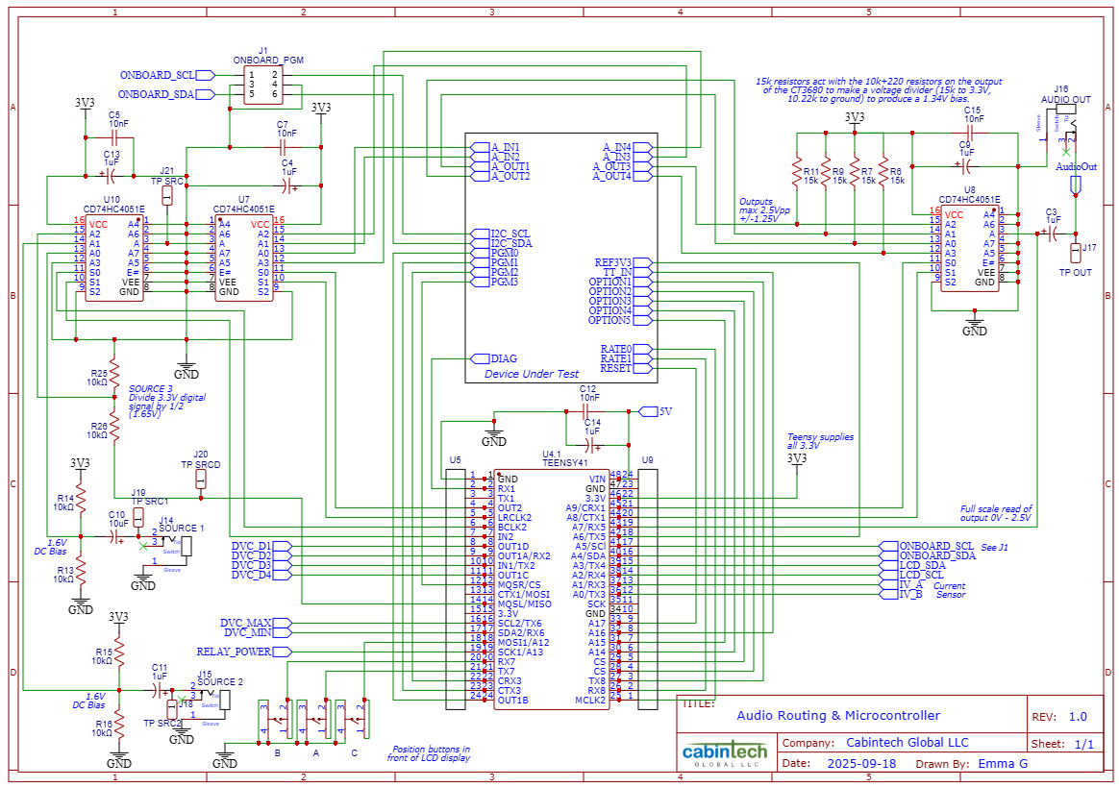
This is the primary page that shows how each of the components on the PCB is electrically connected to each other.

Schematics – Power Control:
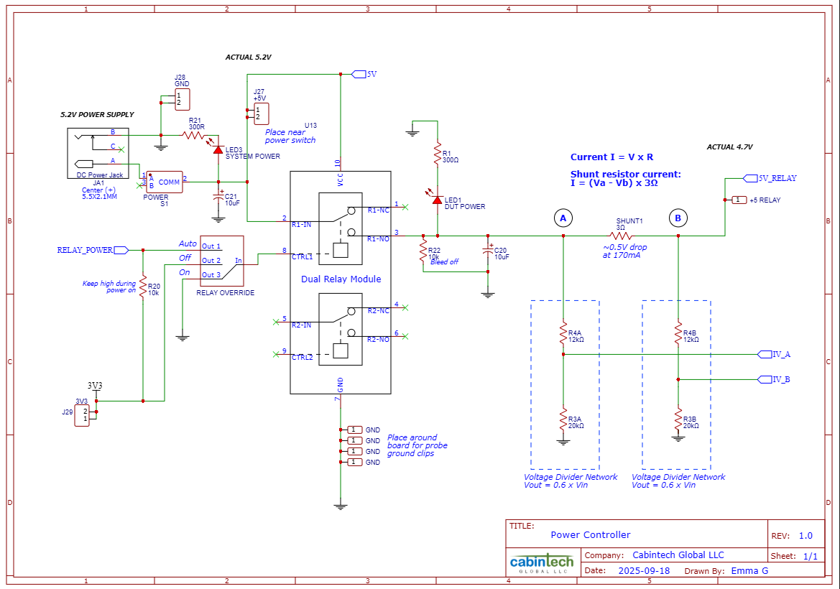
This diagram shows the circuitry associated with the power relay, which turns power on and off to the module.

Schematics – PWM to Analog Converter:
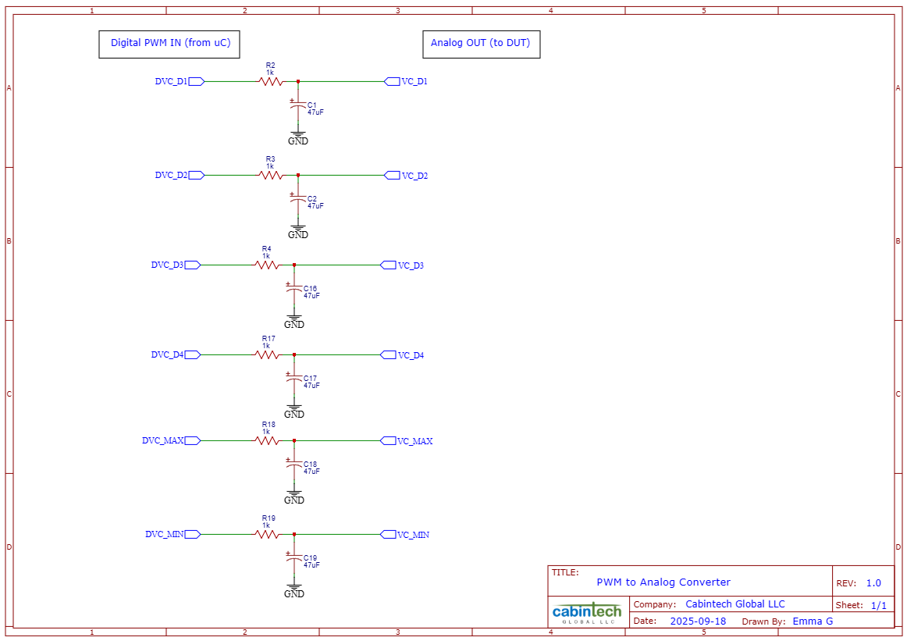
These resistor/capacitor pairs convert PWM signals from the microcontroller to analog signals

Test Fixture

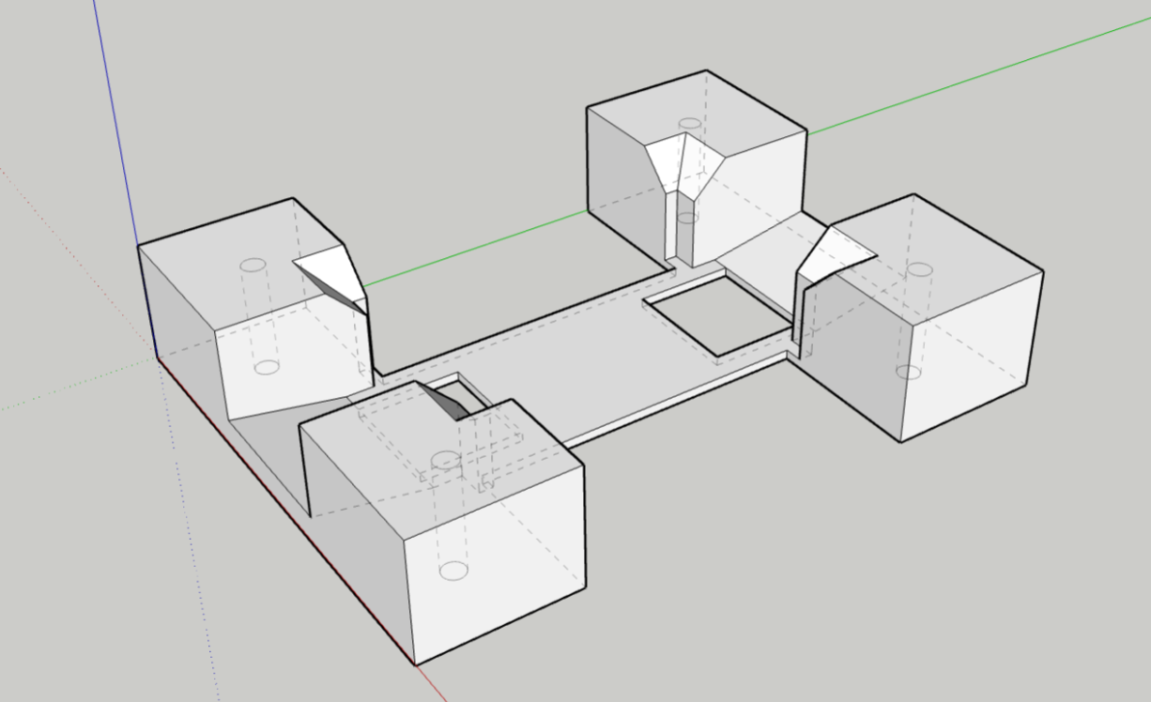
This 3D image shows the current design of the test fixture. This is the third and final iteration.
Test Plan and Test Cases
System Tests
Id: 1
Test Case Name: Current Detection Circuit
System: Hardware
Test Objective: Verify that current detection system works as expected
Step |  | Test Steps |  | Test Data | Expected Results  (Pass/Fail) |  | Actual Results
1 |  | Create short circuit and verify that the module fails |  | Two voltage readings pre/post resistor | Out of range (fail) |  | (test not yet run)
2 |  | Create open circuit and verify that the module fails |  | Two voltage readings pre/post resistor |  |  | (test not yet run)
3 |  | Test a known good module and verify that it passes |  | Two voltage readings pre/post resistor | In range (pass) |  | (test not yet run)

Id: 2
Test Case Name: Power Control
System: Hardware
Test Objective: Verify that power control system works as expected
Step |  | Test Steps |  | Test Data | Expected Results  (Pass/Fail) |  | Actual Results
1 |  | Turn power on |  | Two voltage readings at module’s power and ground pins | Module has power |  | Pass (module has power)
2 |  | Verify that PCB has power |  | Two voltage readings at module’s power and ground pins |  |  | Pass (module has power)
3 |  | Turn power off |  | Two voltage readings at module’s power and ground pins | Module does not have power |  | Pass (module does not have power)
4 |  | Verify that PCB does not have power |  | Two voltage readings at module’s power and ground pins |  |  | Pass (module does not have power)

Id: 3
Test Case Name: Audio Multiplexing
System: Hardware
Test Objective: Verify that audio multiplexing system works as expected
Step |  | Test Steps  (For each of the 4 input channels) |  | Test Data | Expected Results  (Pass/Fail) |  | Actual Results
1 |  | Connect input source |  | Listening for audio on each channel
2 |  | Route signal to each of the 4 outputs (1 at a time) |  | Listening for audio on each channel
3 |  | Verify audio on output channel |  | Listening for audio on each channel | Clear audio present |  | (test not yet run)
4 |  | Verify absence of audio on other channels |  | Listening for audio on each channel | No audio/static noise |  | (test not yet run)

Id: 4
Test Case Name: PWM to Analog Conversion
System: Hardware
Test Objective: Verify that PCB circuitry correctly converts PWM signals to analog
Step |  | Test Steps |  | Test Data | Expected Results  (Pass/Fail) |  | Actual Results
1 |  | Produce PWM signals via the microcontroller |  | Electrical signal readings observed with oscilloscope | Smooth wave form showing on oscilloscope (pass) |  | (test not yet run)
2 |  | Measure signal between capacitor and module input pin to verify a smooth, consistent signal |  | Electrical signal readings observed with oscilloscope |  |  | (test not yet run)

Id: 5
Test Case Name: Module Insert/Removal
System: Hardware
Test Objective: Verify that module can be easily inserted and removed without causing damage
Step |  | Test Steps |  | Test Data | Expected Results  (Pass/Fail) |  | Actual Results
1 |  | Insert module into test fixture |  | Time and ease of insert and removal, pin connections | Module insert/removal is quick and easy, and does not damage any of the components (module, pins, fixture, etc.) |  | Pass
2 |  | Verify that it makes reliable connections to all pins |  | Time and ease of insert and removal, pin connections |  |  | Pass
3 |  | Remove the module from the test fixture |  | Time and ease of insert and removal, pin connections |  |  | Pass
4 |  | Repeat 3 times and check for damage to pins, module and fixture |  | Time and ease of insert and removal, pin connections |  |  | Pass

Id: 6
Test Case Name: Correct pass/fail categorization of modules
System: Software
Test Objective: Verify that good modules pass and bad modules are correctly detected
Step |  | Test Steps |  | Test Data | Expected Results  (Pass/Fail) |  | Actual Results
1 |  | Insert a known good module |  | Test cycle results | Module categorized as good (pass) |  | (test not yet run)
2 |  | Run hardware testing cycle |  | Test cycle results |  |  | (test not yet run)
3 |  | Replace good module with known bad module |  | Test cycle results | Module categorized as bad (fail) |  | (test not yet run)
4 |  | Run hardware testing cycle |  | Test cycle results |  |  | (test not yet run)

Id: 7
Test Case Name: Insert new module into database
System: Software
Test Objective: Verify that new modules are successfully inserted into the database
Step |  | Test Steps |  | Test Data | Expected Results  (Pass/Fail) |  | Actual Results
1 |  | Execute code to insert a new module into the database |  | Database query results | New module exists in database (pass) |  | (test not yet run)
2 |  | Query the database for the new module and verify that it was inserted |  | Database query results |  |  | (test not yet run)

Id: 8
Test Case Name: Correct pass/fail handling of modules
System: Software
Test Objective: Verify that the correct actions are performed in the database based on test results
Step |  | Test Steps |  | Test Data | Expected Results  (Pass/Fail) |  | Actual Results
1 |  | Insert a passing module into the database |  | Two database observations (before/after) | Registration table is updated with the new module’s serial number/results and stock count is incremented by one |  | (test not yet run)
2 |  | Observe changes in stock count and registration |  | Two database observations (before/after) |  |  | (test not yet run)
3 |  | Insert a failing module into the database |  | Two database observations (before/after) | Registration table is updated but stock count remains the same |  | (test not yet run)
4 |  | Observe changes in stock count and registration |  | Two database observations (before/after) |  |  | (test not yet run)

Id: 9
Test Case Name: Database handling of re-tested modules
System: Software
Test Objective: Verify that re-tested modules are correctly updated in the database
Step |  | Test Steps |  | Test Data | Expected Results  (Pass/Fail) |  | Actual Results
1 |  | Attempt to insert an already registered module into the database |  | Two database observations (before/after) | Insert fails due to duplicate serial number |  | (test not yet run)
2 |  | Attempt to update the existing record with most recent results |  | Two database observations (before/after) | Record is updated with most recent results and date/timestamp |  | (test not yet run)

Id: 10
Test Case Name: UI Handling of re-tested modules
System: Software
Test Objective: Verify that re-test verification screen is displayed and that the appropriate response is taken
Step |  | Test Steps |  | Test Data | Expected Results  (Pass/Fail) |  | Actual Results
1 |  | Insert a registered module into the test fixture and start test cycle |  | UI Display | UI returns to start page |  | (test not yet run)
2 |  | Verify UI informs the user that the module is already registered, click cancel on verification page |  | UI Display |  |  | (test not yet run)
3 |  | Verify that UI returns to start page, click start again |  | UI Display |  |  | (test not yet run)
4 |  | Click proceed on re-test verification page |  | UI Display | Testing cycle is initialized |  | (test not yet run)
5 |  | Verify that testing continues |  | UI Display |  |  | (test not yet run)

Id: 11
Test Case Name: Module Firmware Update
System: Software
Test Objective: Verify that the firmware update feature works as expected
Step |  | Test Steps |  | Test Data | Expected Results  (Pass/Fail) |  | Actual Results
1 |  | Insert module |  |  | Firmware is successfully updated (pass) |  | (test not yet run)
2 |  | Run update process and observe results |  |  |  |  | (test not yet run)
3 |  | Remove module |  |  | Firmware update fails |  | (test not yet run)
4 |  | Run update process again and observe results |  |  |  |  | (test not yet run)

Id: 12
Test Case Name: Network Failure Handling
System: Software
Test Objective: Verify that the software does not break when network connection fails
Step |  | Test Steps |  | Test Data | Expected Results  (Pass/Fail) |  | Actual Results
1 |  | Disconnect PC from internet |  | Observe how the program handles the failure | Firmware update fails |  | (test not yet run)
2 |  | Insert module and attempt to update firmware |  | Observe how the program handles the failure |  |  | (test not yet run)

Id: 13
Test Case Name: Software/Firmware integration
System: Software/Firmware
Test Objective: Verify that PC application can connect, send and receive data from microcontroller
Step |  | Test Steps |  | Test Data | Expected Results  (Pass/Fail) |  | Actual Results
1 |  | Run PC/microcontroller code |  | Application Log | Log verifies communication between PC and microcontroller |  | (no log in place yet other than the console, but commands over the COM port are successfully processed)
2 |  | Observe PC application log |  | Application Log

Id: 14
Test Case Name: PC error handling for unexpected/missing response
System: Software
Test Objective: Verify that the software does not break when microcontroller fails to respond as expected
Step |  | Test Steps |  | Test Data | Expected Results  (Pass/Fail) |  | Actual Results
1 |  | Start test cycle |  | PC response to faulty communication with microcontroller | PC handles the failure gracefully (displays error message, returns to start screen, tries to reestablish connection, etc.) |  | (test not yet run)
2 |  | Turn off power supply |  | PC response to faulty communication with microcontroller |  |  | (test not yet run)
3 |  | Observe PC response |  | PC response to faulty communication with microcontroller |  |  | (test not yet run)

Id: 15
Test Case Name: Cancel Test
System: Software
Test Objective: Verify that testing cycle is abandoned if the user clicks cancel
Step |  | Test Steps |  | Test Data | Expected Results  (Pass/Fail) |  | Actual Results
1 |  | Start test cycle |  | UI interaction and observation | Upon clicking cancel, test procedures are halted and the UI returns to the start screen |  | (test not yet run)
2 |  | Click cancel from the progress screen |  | UI interaction and observation |  |  | (test not yet run)
3 |  | Start a new test cycle |  | UI interaction and observation | New cycle starts successfully and performs all tests |  | (test not yet run)
4 |  | Verify that all tests are correctly performed |  | UI interaction and observation |  |  | (test not yet run)

Unit Tests
Id: 16
Test Case Name: Unit test of Hardware Verification Step 1 (Diagnostic Testing Mode)
System: Firmware
Test Objective: Verify that a module can be put in diagnostic testing mode
Step |  | Test Steps |  | Test Data | Expected Results  (Pass/Fail) |  | Actual Results
1 |  | Construct a firmware test harness to run this step of hardware verification |  | Observation of results before and after creating the fault | Hardware functions correctly (pass) |  | Hardware functions correctly and passes verification
2 |  | Run test harness and observe results |  | Observation of results before and after creating the fault |  |  | Hardware functions correctly and passes verification
3 |  | Create hardware fault |  | Observation of results before and after creating the fault | Hardware does not function correctly (fail) |  | (test not yet run)
4 |  | Re-run test harness and observe results |  | Observation of results before and after creating the fault |  |  | (test not yet run)

Id: 17
Test Case Name: Unit test of Hardware Verification Step 2 (Control Voltage Inputs)
System: Firmware
Test Objective: Verify that all 6 control voltage inputs work as expected
Step |  | Test Steps |  | Test Data | Expected Results  (Pass/Fail) |  | Actual Results
1 |  | Construct a firmware test harness to run this step of hardware verification |  | Observation of results before and after creating the fault | Hardware functions correctly (pass) |  | Testing has been run using some starter code but is not yet fully implemented
2 |  | Run test harness and observe results |  | Observation of results before and after creating the fault
3 |  | Create hardware fault |  | Observation of results before and after creating the fault | Hardware does not function correctly (fail) |  | (test not yet run)
4 |  | Re-run test harness and observe results |  | Observation of results before and after creating the fault |  |  | (test not yet run)

Id: 18
Test Case Name: Unit test of Hardware Verification Step 3 (Digital Option Inputs)
System: Firmware
Test Objective: Verify that all 5 digital option inputs work as expected
Step |  | Test Steps |  | Test Data | Expected Results  (Pass/Fail) |  | Actual Results
1 |  | Construct a firmware test harness to run this step of hardware verification |  | Observation of results before and after creating the fault | Hardware functions correctly (pass) |  | Hardware functions correctly and passes verification
2 |  | Run test harness and observe results |  | Observation of results before and after creating the fault |  |  | Hardware functions correctly and passes verification
3 |  | Create hardware fault |  | Observation of results before and after creating the fault | Hardware does not function correctly (fail) |  | (test not yet run)
4 |  | Re-run test harness and observe results |  | Observation of results before and after creating the fault |  |  | (test not yet run)

Id: 19
Test Case Name: Unit test of Hardware Verification Step 4 (Module Firmware Programs)
System: Firmware
Test Objective: Verify that all 16 module firmware programs work as expected
Step |  | Test Steps |  | Test Data | Expected Results  (Pass/Fail) |  | Actual Results
1 |  | Construct a firmware test harness to run this step of hardware verification |  | Observation of results before and after creating the fault | Hardware functions correctly (pass) |  | Hardware functions correctly and passes verification
2 |  | Run test harness and observe results |  | Observation of results before and after creating the fault |  |  | Hardware functions correctly and passes verification
3 |  | Create hardware fault |  | Observation of results before and after creating the fault | Hardware does not function correctly (fail) |  | (test not yet run)
4 |  | Re-run test harness and observe results |  | Observation of results before and after creating the fault |  |  | (test not yet run)

Id: 20
Test Case Name: Unit test of Hardware Verification Step 5 (Sampling Rates)
System: Firmware
Test Objective: Verify that all four sampling rates work as expected
Step |  | Test Steps |  | Test Data | Expected Results  (Pass/Fail) |  | Actual Results
1 |  | Construct a firmware test harness to run this step of hardware verification |  | Observation of results before and after creating the fault | Hardware functions correctly (pass) |  | Hardware functions correctly and passes verification
2 |  | Run test harness and observe results |  | Observation of results before and after creating the fault |  |  | Hardware functions correctly and passes verification
3 |  | Create hardware fault |  | Observation of results before and after creating the fault | Hardware does not function correctly (fail) |  | (test not yet run)
4 |  | Re-run test harness and observe results |  | Observation of results before and after creating the fault |  |  | (test not yet run)

Id: 21
Test Case Name: Unit test of Hardware Verification Step 6 (Tap Tempo)
System: Firmware
Test Objective: Verify that tap tempo works as expected
Step |  | Test Steps |  | Test Data | Expected Results  (Pass/Fail) |  | Actual Results
1 |  | Construct a firmware test harness to run this step of hardware verification |  | Observation of results before and after creating the fault | Hardware functions correctly (pass) |  | Hardware functions correctly and passes verification
2 |  | Run test harness and observe results |  | Observation of results before and after creating the fault |  |  | Hardware functions correctly and passes verification
3 |  | Create hardware fault |  | Observation of results before and after creating the fault | Hardware does not function correctly (fail) |  | (test not yet run)
4 |  | Re-run test harness and observe results |  | Observation of results before and after creating the fault |  |  | (test not yet run)

Id: 22
Test Case Name: Unit test of Hardware Verification Step 7 (Audio Passthrough)
System: Firmware
Test Objective: Verify that audio passthrough works as expected on all 4 channels
Step |  | Test Steps |  | Test Data | Expected Results  (Pass/Fail) |  | Actual Results
1 |  | Construct a firmware test harness to run this step of hardware verification |  | Observation of results before and after creating the fault | Hardware functions correctly (pass) |  | (test not yet run)
2 |  | Run test harness and observe results |  | Observation of results before and after creating the fault |  |  | (test not yet run)
3 |  | Create hardware fault |  | Observation of results before and after creating the fault | Hardware does not function correctly (fail) |  | (test not yet run)
4 |  | Re-run test harness and observe results |  | Observation of results before and after creating the fault |  |  | (test not yet run)

Id: 23
Test Case Name: Unit test of Hardware Verification Step 8 (Internal Memory)
System: Firmware
Test Objective: Verify that internal memory works as expected
Step |  | Test Steps |  | Test Data | Expected Results  (Pass/Fail) |  | Actual Results
1 |  | Construct a firmware test harness to run this step of hardware verification |  | Observation of results before and after creating the fault | Hardware functions correctly (pass) |  | (test not yet run)
2 |  | Run test harness and observe results |  | Observation of results before and after creating the fault |  |  | (test not yet run)
3 |  | Create hardware fault |  | Observation of results before and after creating the fault | Hardware does not function correctly (fail) |  | (test not yet run)
4 |  | Re-run test harness and observe results |  | Observation of results before and after creating the fault |  |  | (test not yet run)

Id: 24
Test Case Name: Unit test of Enterprise API (Stock Management System)
System: Firmware
Test Objective: Verify correct integration with Stock Management System
Step |  | Test Steps |  | Test Data | Expected Results  (Pass/Fail) |  | Actual Results
1 |  | Construct a test harness for PC/Server interaction |  | Observation of results | PC integrates smoothly with Stock Management System |  | (test not yet run)
2 |  | Run test harness and observe results |  | Observation of results |  |  | (test not yet run)

Id: 25
Test Case Name: Unit test of Enterprise API (Registration)
System: Firmware
Test Objective: Verify that internal memory works as expected
Step |  | Test Steps |  | Test Data | Expected Results  (Pass/Fail) |  | Actual Results
1 |  | Construct a test harness for PC/Server interaction |  | Observation of results | PC integrates smoothly with Registration |  | (test not yet run)
2 |  | Run test harness and observe results |  | Observation of results |  |  | (test not yet run)

Acceptance Testing
Completion of system testing will constitute a successful acceptance test

Application Demonstration
The following video demonstrates a functioning sequence of tests, showing the results of each test being sent back to the PC over the COM port. The testing sequence includes powerOn, verifyDiagnosticStream, verifyOptionSwitches, verifyProgramSelection, verifySamplingRates, verifyTapTempo and powerOff.
https://youtu.be/dcvhrOSyPiM

