

**TCL Setup Guide for TDKB Agent**

|  |  |
| --- | --- |
| Version | 1.0 |
| Version Date | 29th April 2016 |

**All information contained in this document is CONFIDENTIAL to Comcast**

**Revision History**

|  |  |  |
| --- | --- | --- |
| **Release No.** | **Date** | **Revision Description** |
| 1.0 | 29 April 2016 | Initial Revision |

**TABLE OF CONTENTS**

1. TEST SETUP FOR TCL EXECUTION USING TDK-B Agent 3

2. TEST SETUP REQUIREMENTS: 3

3. SOFTWARE AND INITIAL SETTINGS: 4

4. CREATING WIFI PROFILE 4

5. TEST CONFIGURATION FILE: 5

6. SAMPLE CONFIGURATION FILE (Config_RDKB) 5

7. CREATE DEVICE IN TDK-B TEST MANAGER GUI: 8

8. UPLOAD CONFIGURATION FILE: 8

9. EXECUTING TCL SCRIPT: 9

10. TCL EXECUTION FLOW WITH TDKB TEST AGENT: 10

**TABLE OF FIGURES**

Figure 1 - RDK-B Test Setup 3

Figure 2 – RDK-B Device Creation 8

Figure 3 – RDK-B Upload Configuration File 9

Figure 4 – RDK-B Script Execution 10

Figure 5 - TCL Execution Flow with TDKB Test Agent 10

# TEST SETUP FOR TCL EXECUTION USING TDK-B Agent

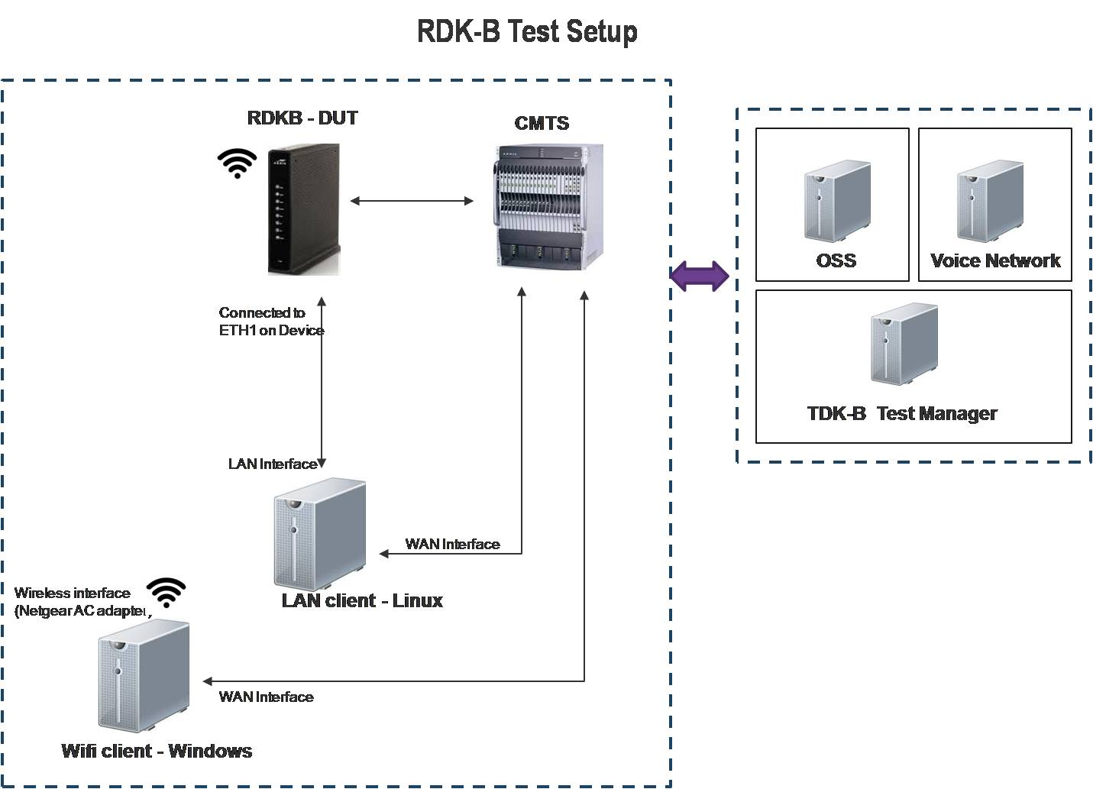

Figure - RDK-B Test Setup

# TEST SETUP REQUIREMENTS:

* Need one RDK-B based gateway device upgraded with latest build and should be enabled with TDKB test agent, which is required for device discovery by test manager and for TR-181 data model access.
* Require 2 Client machines (One Linux – CentOS 6 or higher, One windows – Windows7/8 with Netgear AC Wi-Fi adapter connected to it)
* Linux machine should be connected to Ethernet Port 1 on the RDK-B based gateway device via LAN cable.
* In this Setup, Linux machine will act as Ethernet Client and Windows machine will act as WLAN/Wi-Fi Client.
* Linux machine should have 2 interfaces in which one will be WAN interface and the other will be LAN interface ( Connected to device via Ethernet cable)

# SOFTWARE AND INITIAL SETTINGS:

* Install XAMPP on both Windows and Linux machine with the latest version.
* In Windows open XAMPP Control Panel and start Apache and Filezilla modules. If default http service (port 80) is running, stop it by giving **Taskkill /PID (*processID*) /F** *(find the process ID by giving netstat –ao).* After that we need to create a text file named **test1.txt** in C:\XAMPP\htdocs\ folder and also create an ftp username and password for Filezilla.
* In Linux while XAMPP is running we have to stop the default http and ftp services if running by giving commands **service httpd stop** and **service vsftpd stop.**
* Start Xampp service in Linux by giving command **sudo /opt/lampp/lampp start.** Like in Windows machine we have to create a text file named **test.txt** in the directory **cd /opt/lampp/htdocs/** and create an ftp user.
* Telnet service should be installed and started on Linux machine.
* **wget** software should be installed on both Linux and Windows.
* We also require one WAN machine which is already on the network to send traffic from Wi-Fi Client and check. Same Configurations should be there which we made on WLAN client like XAMPP etc.
* For Wi-Fi SSID Connectivity, we require 6 xml files to be placed in the Windows machine and sample profiles are attached below. For Ex. If a user is created on windows machine as rdkb, the files should be placed in the directory as shown C:\Users\rdkb\Repository.



# CREATING WIFI PROFILE

There are 6 sample xml files under the Repository folder. Please create these 6 files for your setup using the following steps.

Wireless.xml

1. Set SSID to RDKB-2.4, password as wifitest123 & Security mode as WPA2-Personal on the device GUI. (http://<CM_IP>/)
2. Connect Windows WiFi client to RDKB-2.4.
3. Use the command **netsh wlan export profile name=”RDKB-2.4”** (in windows cmd) and an XML file will be created in the current folder. Copy this as Wireless.xml in C:\Users\{user}\Repository\

Create other 5 profiles using the following values.

**Wireless-5GHz** (RDKB-5, wifitest123, WPA2-Personal)

**Wireless-5GHz-invalid**  (RDKB-5, wifitest1234, WPA2-Personal)

**Wireless-invalid** (RDKB-2.4, wifitest1234, WPA2-Personal)

**Wireless-open-2.4**      (RDKB-2.4, open)

**Wireless-open-5**      (RDKB-5, open)

# TEST CONFIGURATION FILE:

The configuration file is named according to the device name configured in TDK-B test manager GUI. Eg: If the Device Name is RDKB, then the name of Configuration File will be Config_RDKB.

The configuration file needs to be updated with the setup details like IP address, Credentials of Windows & Linux machines, RDK-B gateway device details etc which will be explained in detail below. Once the details are updated, the Configuration file needs to be uploaded in TDK-B GUI.

Below we have explained a sample configuration file on what details need to be updated. First word on each line defines the Variable names that are used throughout the TCL scripts and second word indicates the value which we need to update.

Ex. telnetIP 10.255.42.162 telnetIP – Variable name and 10.255.42.162 – Value

# SAMPLE CONFIGURATION FILE (Config_RDKB)



#Java files path (Automatically updated when **Config_RDKB** file is uploaded in Test Manager)

**class com.broadband.rdk.TclSocketExecutor**

**classPath /opt/tomcat/apache-tomcat-7.0.62/webapps/rdk-test-tool/WEB-INF/lib/*:/opt/tomcat/apache-tomcat-7.0.62/webapps/rdk-test-tool/WEB-INF/classes/**

#Device Details - Cable Modem

cmIP  **xx.xxx.xxx.xx** (Update the CM IP address of RDK-B device)

SerialNo **xx:xx:xx:xx:xx:xx** (Update the CM MAC address of RDK-B device)

DeviceType **RGW**

OUI **0000CA**

#SSID Name Details for 2.4GHZ and 5GHZ Radio.

SSID2 **RDKB-2.4** (RDKB-2.4 is the unique SSID name for 2.4GHz radio that we have used)

SSID5 **RDKB-5** (RDKB-5 is the unique SSID name for 5GHz radio that we have used)

#SSID and Radio Index details for 2.4GHZ and 5GHZ Radio.

RadioIndex2 **1** (1 is the default instance for 2.4GHz radio and 2 for 5GHz radio)

SSIDIndex2 **1**

RadioIndex5 **2**

SSIDIndex5 **2**

#Ethernet PC connected to the Cable Modem - Details

telnetIP **xx.xxx.x.x** (Linux machine IP address)

UserName **xxxx** (Linux machine Username)

Password **xxxx** (Linux machine Password)

OsName1 **linux** (OS)

#Wireless LAN PC Details

WlanIP **xx.xxx.x.x** (Windows machine IP)

WlanName **xxxx** (Windows machine Username)

WlanPassword **xxxx** (Windows machine Password)

WlanInterfaceName **Wireless_Network_Connection_6** (Wireless interface)

WlanAdminName **Administrator**

WlanAdminPassword **xxxx**

ProfilePath **C:\Users\(username)\Repository** (User’s Path where the xml files are kept)

Interface **6** (Wireless Connection Interface number)

#WAN Machine Details (Require one WAN PC to send traffic from WLAN client and check)

WanIP **xx.xxx.x.x** (WAN PC (windows) – IP address)

WanName **xxxx** (WAN PC username)

WanPassword **xxyy** (WAN PC password)

#Lan ftp details

FtpIP **xx.xxx.x.x** (Linux IP address)

FtpName **xxxx** (FTP username Configured on Linux and Windows)

FtpPassword **xxxx** (FTP Password)

#Wan ftp details

WanFtpIP **xx.xxx.x.x**

WanFtpName **xxxx** (WAN FTP Username)

WanFtpPassword **xxxx** (WAN FTP Password)

# CREATE DEVICE IN TDK-B TEST MANAGER GUI:

* Login to TDK-B Test manager GUI.
* In Device Page, Right Click on Devices in the Left panel.
* Select “Add New RDK-B Device”
* Provide the Device details and click on “create” button.
  1. Gateway Name: Name of the gateway device.
  2. Gateway IP: IP address of the gateway device.
  3. Serial No: MAC address of the gateway device.
* Device will be created successfully.

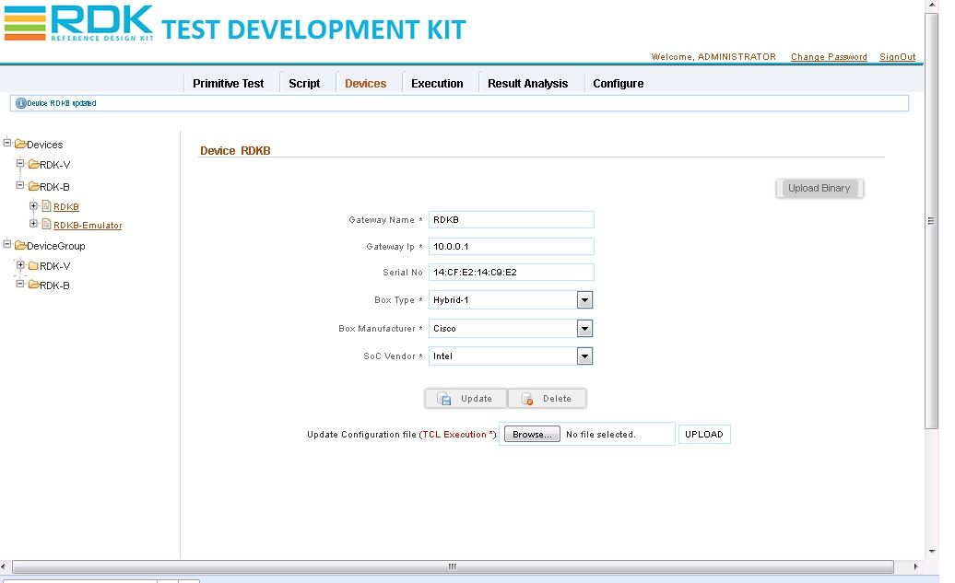

Figure – RDK-B Device Creation

# UPLOAD CONFIGURATION FILE:

* Click on the “Browse” button to select the configuration file (Config_RDKB) from your local directory.
* After selecting the configuration file, click on the “UPLOAD” button to upload the file.

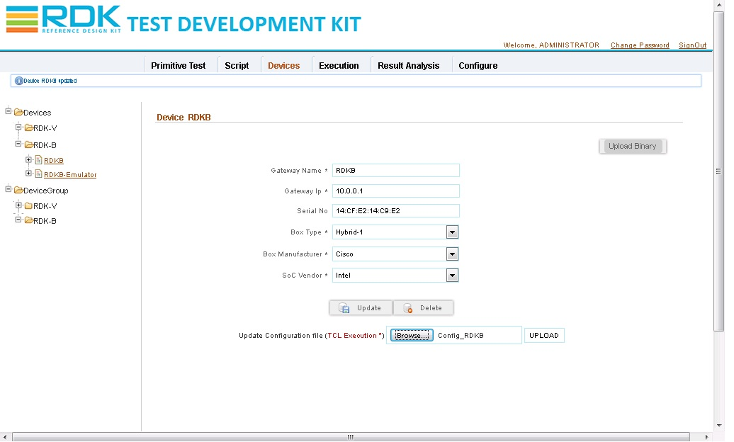

Figure – RDK-B Upload Configuration File

# EXECUTING TCL SCRIPT:

* Ensure that TCL is installed on the TDK-B Test manager machine were the TCL scripts will be executed. Below is the procedure to execute the TCL script.
* Click on the Execution tab and Go to the “Execution” page.
* In the left panel, list of RDK-B devices configured will be displayed.
* The device “RDKB” which we created should be now online with the “Green” indicator.
* Select the RDKB device.
* In the Right side panel, select the “Select Type” as “TestSuite” to trigger full suite execution else “SingleScript” to execute single TCL script.
* Select the “Select Script Type” as “TCL”.
* Click on the “Select Script” text box to select the TCL script to be executed.
* Click on the “Execute” button to trigger the TCL execution.
* Result can be found in the “Execution History”.

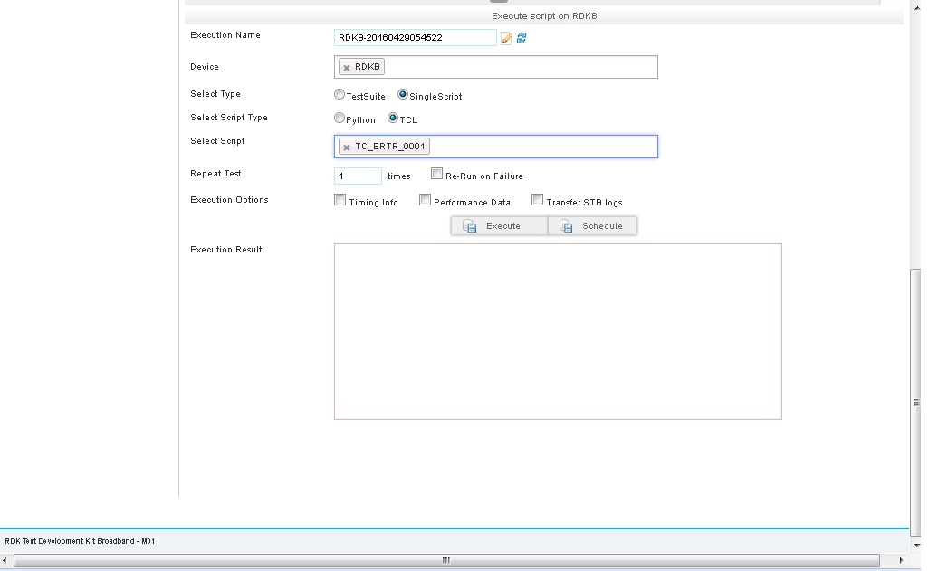

Figure – RDK-B Script Execution

# TCL EXECUTION FLOW WITH TDKB TEST AGENT:

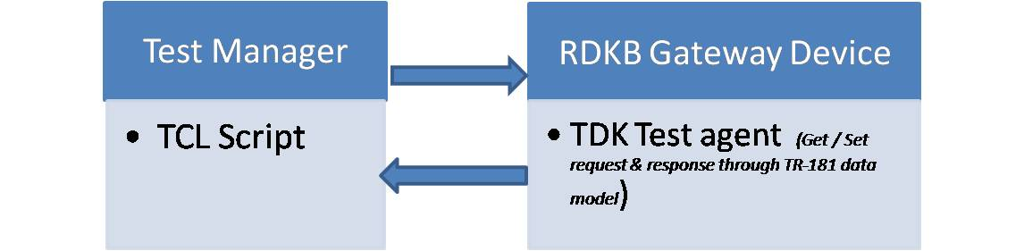

Figure - TCL Execution Flow with TDKB Test Agent