HW 4

Caitlin Bolz

3/16/2021

library(rpart)

## Warning: package 'rpart' was built under R version 4.0.4

library(party)

## Warning: package 'party' was built under R version 4.0.4

## Loading required package: grid

## Loading required package: mvtnorm

## Loading required package: modeltools

## Loading required package: stats4

## Loading required package: strucchange

## Warning: package 'strucchange' was built under R version 4.0.4

## Loading required package: zoo

## Warning: package 'zoo' was built under R version 4.0.4

##   
## Attaching package: 'zoo'

## The following objects are masked from 'package:base':  
##   
## as.Date, as.Date.numeric

## Loading required package: sandwich

## Warning: package 'sandwich' was built under R version 4.0.4

# Code for reading subset.txt into R

vartype = rep("numeric",638)  
vartype[c(1,2,4,6,8,10,12,14,16,18,20,22,23,24,25,26,27,29,31,33,34,35,37,39,  
 41,43,45,47,49,52,54,56,58,60,62,64,66,68,70,72,73,74,75,76,77,78,79,  
 80,82,84,86,88,89,90,92,94,96,97,98,99,100,102,104,106,108,109,110,  
 111,112,113,114,115,116,118,119,120,122,123,124,125,126,128,130,131,  
 132,133,135,137,139,303,304,305,306,307,308,309,310,311,312,313,314,  
 315,316,317,318,319,321,323,325,331,333,407,409,410,411,453,454,456,  
 458,460,462,464,465,466,467,468,470,472,474,476,477,478,479,482,484,  
 486,488,490,492,494,496,497,498,499,500,502,504,506,508,510,512,514,  
 516,518,520,522,524,526,528,530,532,534,536,538,540,542,544,546,548,  
 550,552,554,556,558,560,562,564,566,568,570,572,574,576,578,580,582,  
 584,585,586,588,590,592,594,596,598,600,602,604,606,608,610,612,614,  
 616,618,620,622,624,626,628,630,632,635,637)] = "factor"  
z = read.table("subset.txt",header=TRUE,colClasses=vartype)

# Question 1

tmp = rep(NA,nrow(z))   
tmp[z$INTRDVX_ == "C"] = 0   
tmp[z$INTRDVX_ == "D" | z$INTRDVX_ == "T"] = 1   
z$INTRDVX_ = tmp ### convert INTRDVX to binary variable   
### regression tree without INTRDVX and FINLWT21   
rp = rpart(INTRDVX_ ~ . - INTRDVX - FINLWT21, data=z, method="anova")   
plot(rp,compress=TRUE,margin=0.1)   
text(rp) ### plot is on next page

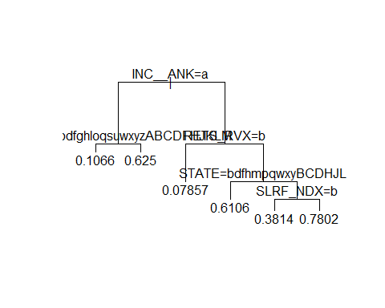

p = predict(rp) ### predicted prob(INTRDVX_ = 1)   
w = z$FINLWT21   
y= z$INTRDVX   
gp = !is.na(y)   
ipw = sum(w[gp]*y[gp]/p[gp])/sum(w[gp]/p[gp])   
print(ipw)

## [1] 4442.648

# Question 2

rp2 = rpart(INTRDVX ~ . - INTRDVX_, weight = FINLWT21, data = z, method = "anova")  
plot(rp2, compress = T, margin = 0.1)  
text(rp2)

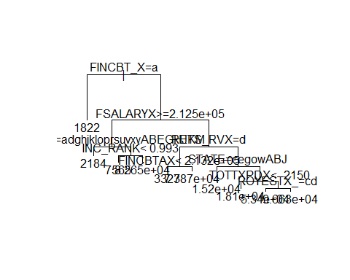

y = z$INTRDVX  
w = z$FINLWT21  
miss = is.na(y) ## obs with missing INTRDVX  
yhat = predict(rp2, newdata = z)  
popmean = (sum(w[!miss]*y[!miss])+sum(w[miss]*yhat[miss]))/sum(w)  
print(popmean)

## [1] 3996.971

# Question 3

## CTREE

tmp = rep(NA,nrow(z))   
tmp[z$INTRDVX_ == "C"] = 0   
tmp[z$INTRDVX_ == "D" | z$INTRDVX_ == "T"] = 1   
z$INTRDVX_ = tmp

## CFOREST