# Dojo Etiquette

How it’s done in Kodakan, the home of judo

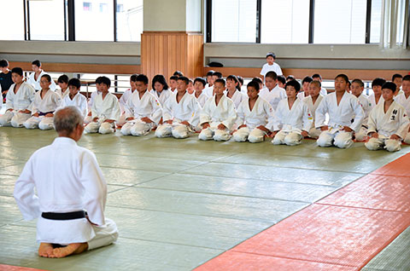

# Dojo dos and don’ts

Judo is a contact sport so always ensure that

1. You and your suit (gi) are clean before your judo lesson
2. Keep your finger and toenails short and clean to prevent injury/scratches
3. Always have a pair of flip-flops or crocs on your feet when you are off the mat
4. Always bow to the teacher (sensei) and your opponent or before leaving the mat
5. Always pay close attention to the teacher says and follow instructions for safety
6. Kneel at the side of the mat (do not lie down) when not involved in play to avoid injury
7. Be humble in victory and gracious in defeat showing respect to your opponent

*And remember to enjoy the lesson and your new friends!*

# Dojo Etiquette (visual guide)

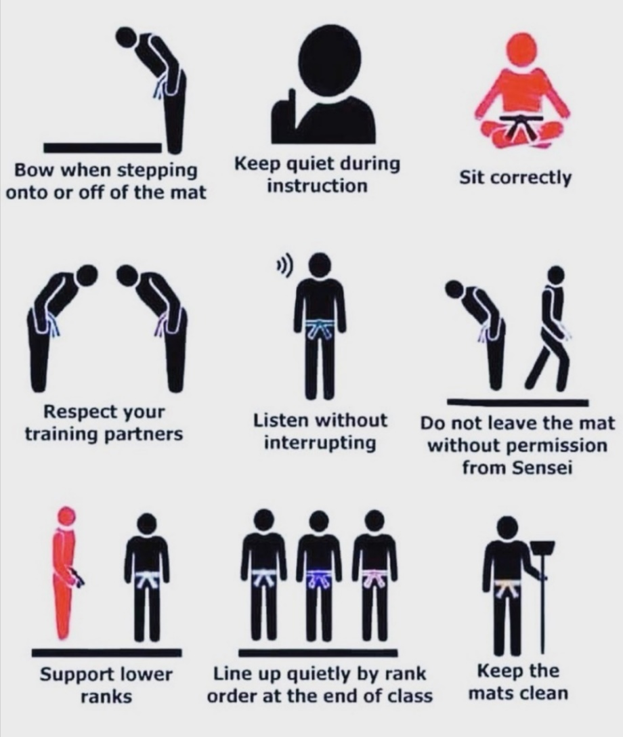

**Judo Etiquette Visual Guide**