# IJA Grading Syllabus (part 1: fundamental skills)

Progression in judo is based on a system of coloured belts (obi) which have been introduced into modern judo.

In traditional judo there was only one belt colour, white, which became blacker and blacker over time as the tradition is not to wash a judo belt.

The [IJA website](https://irishjudoassociation.ie/) has a [document](https://irishjudoassociation.ie/wp-content/uploads/2019/01/Irish-Judo-Grading-Information-1st-January-2019-1.pdf) detailing the grading and pathways for judo players (judoka) in Ireland

## IJA Junior Grading System

The grading for junior players is summarised in the following table where ages are minimum ages for indicative purposes

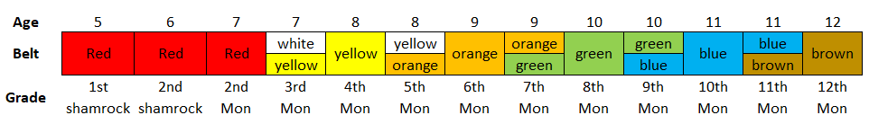

## Fundamental Skills (Graded)

A non-exhaustive list of [fundamental skills](https://www.youtube.com/watch?v=9IK2STdYBlo) that can be tested for all children’s gradings under 14 years are shown in the table below (click on links in each box for associated videos)

|  |  |  |
| --- | --- | --- |
| **Technique/Video** | **Technique/Video** | **Technique/Video** |
| Balance on one leg | [Bunny Hops](https://www.youtube.com/watch?v=0zVjil1z8dw) | [Closed Guard](https://www.youtube.com/watch?v=3s8i1dpRB2w) |
| Hop on One Leg | [Bear Crawl](https://www.youtube.com/watch?v=Q5ibn8kBhyU) | [Press Up](https://www.youtube.com/watch?v=x-bWOeFFQvk), [Squat](https://www.youtube.com/watch?v=8R_17mEoIgw), [Plank](https://www.youtube.com/watch?v=yeKv5oX_6GY) |
| [Monkey Crawl](https://www.youtube.com/watch?v=_PWBhQBI-cY) | [Roll and Sit through](https://www.youtube.com/watch?v=NcBo0wRDCCE) | [Double Lapel Roll](https://www.youtube.com/watch?v=YGQLcVvu-o4) |
| [Monkey Roll](https://www.youtube.com/watch?v=E2TfplHu7Z0) | [Ebi (Shrimping)](https://www.youtube.com/watch?v=STuWSIYrEeg) | [Log Roll](https://www.youtube.com/watch?v=MdGgWfOKp2Y) |
| Walk a line toe to heel | [Gyaku Ebi](https://www.youtube.com/watch?v=STuWSIYrEeg&t=25s) (reverse) | Log Roll Arms/feet |
| [Tsugi Ashi](https://www.youtube.com/watch?v=13IosWG27AA) Movement | [Forward Roll](https://www.youtube.com/watch?v=2CLBeDR6kcM) | [Backward roll](https://www.youtube.com/watch?v=2new-eDu13o) |
| [Right and Left Stance](https://www.youtube.com/watch?v=9IK2STdYBlo) | [Forward Roll to Straddle](https://www.youtube.com/watch?v=gg8T-6_QuN8) | [Turtle Guard](https://www.youtube.com/watch?v=hMQyQDlsN2g) |
| [Right and Left Gripping](https://www.youtube.com/watch?v=-uT6w-yH-eM) | [Cartwheel](https://www.youtube.com/watch?v=97RVWQ7FBt4) | [Beanbag Walk](https://www.youtube.com/watch?v=vqgiJWWqVHE) |
| [Tsukiage (Bridge / bump roll)](https://www.youtube.com/watch?v=wCBSQNF_Lng) | [Tai Sabaki](https://www.youtube.com/watch?v=zY0ocg0aWWI) Movement | Belly down (flat guard) |

These videos cover multiple techniques: [video1](https://www.youtube.com/watch?v=KG3AO6lJ4BQ), [video2](https://www.youtube.com/watch?v=14BjRxE7f1o), [video3](https://www.youtube.com/watch?v=uO8u_3Jmiqw), [video4](https://www.youtube.com/watch?v=aHVR2FnTpdk)