**“Canteen Monitoring Portal and Administrative Evaluation for PRMSU Iba Campus.”**

**Researchers:**

Erjaed Cruz

Raul Daniel Baldeo

John Mark Cabreros

Keigo Miguel Lequigan

Andrei Leighton Calaycay

**Course & Section:**

4A-BSINFOTECH

**Adviser:**

Joseph Juliano

**CHAPTER I**

**INTRODUCTION**

**BACKGROUND OF THE STUDY**

School canteens play a vital role in providing accessible and affordable food options for students and staff. However, managing canteen operations—particularly in large campuses like the President Ramon Magsaysay State University (PRMSU) Iba Campus—requires efficient monitoring, proper documentation of payments, and adherence to food safety standards. Traditionally, these responsibilities are handled manually, resulting in time-consuming processes, communication delays, and inconsistencies in record-keeping.

To address these challenges, this study proposes the development of a **Canteen Monitoring Portal and Administrative Evaluation System** designed specifically for PRMSU Iba Campus. The system aims to streamline the canteen management process by allowing auditors and administrators to monitor food safety practices, record and evaluate payments, and communicate directly with canteen owners. It serves as a centralized platform where payment records can be uploaded and validated, pending payments can be tracked, and audit logs regarding food quality and safety can be documented.

This digital solution is expected to improve the transparency, accountability, and efficiency of canteen operations without the need for cashless payment integration. By leveraging a simple messaging feature and manual proof-of-payment uploads, the system ensures that the communication between stakeholders is well-documented and organized.

**RATIONALE OF THE STUDY**

The increasing demand for effective monitoring and evaluation of canteen operations in academic institutions highlights the need for a system that simplifies administrative tasks while maintaining transparency and accountability. At PRMSU Iba Campus, the current manual processes used for auditing food safety and tracking payments from canteen owners are time-consuming, prone to human error, and difficult to verify over time.

This study is undertaken to address these operational gaps by introducing a digital portal that organizes audit records, tracks payment statuses, and facilitates communication between canteen owners and auditors. Unlike other systems that rely on cashless or online transactions, this system is designed to work without financial integration, focusing instead on manual documentation of payments through submitted proofs.

By providing a structured and centralized platform, this system empowers administrators and auditors to evaluate canteen compliance more accurately, respond to issues promptly, and improve the efficiency of administrative workflows. The rationale for this study stems from the urgent need for a more organized and responsive approach to managing canteen operations at the university level.

**Research Locale**

This study was conducted at **President Ramon Magsaysay State University – Iba Campus**, located in Iba, Zambales, Philippines. PRMSU Iba Campus is the main campus of the university and houses various academic departments and administrative offices, including several canteen concessionaires that serve students, faculty, and staff.

The selection of this campus as the research locale is based on the identified need for a more efficient and organized system for monitoring canteen operations, particularly in terms of food safety compliance, payment tracking, and communication between canteen owners and university auditors. The administrative offices involved in auditing and evaluating canteen operations are key stakeholders in this study, as well as the registered canteen operators who are the primary users of the system’s communication and payment submission features.

The study focuses solely on this campus and does not extend to other PRMSU branches or external institutions.

**Purpose and Description**

The purpose of this Capstone Project is to develop a **Canteen Monitoring Portal and Administrative Evaluation System** for **PRMSU Iba Campus**, aimed at improving how canteen operations are monitored and managed by the university’s administrative and auditing staff. The system is designed to address the current challenges of manual record-keeping, lack of centralized communication, and difficulty in tracking the payment compliance of canteen owners.

The primary function of the system is to serve as a digital platform where **auditors can log food safety and quality evaluations**, **track payment records**, and **communicate directly with canteen owners**. At the same time, canteen owners can **submit proof of payment**, **receive updates from auditors**, and stay informed of their compliance status.

This project directly benefits the **university administrators, auditors, and canteen owners**. For administrators and auditors, the system helps organize reports, monitor responsibilities, and reduce paperwork. For canteen owners, it offers a clear and accessible channel for submitting documents and maintaining communication.

SYSTEM FEATURES AND CAPABILITIES

The proposed **Canteen Monitoring Portal and Administrative Evaluation System** for PRMSU Iba Campus will include the following key features and functions:

1. **Food Safety and Quality Audit Module**
   * Allows auditors to record and update inspection reports on canteen cleanliness, food preparation, hygiene, and compliance with safety standards.
   * Stores historical audit data for future reference and review.
2. **Payment Monitoring System**
   * Records the payment status of each registered canteen owner (e.g., Paid, Pending, Unpaid).
   * Enables administrators and auditors to filter or sort records based on payment status.
3. **Proof of Payment Submission**
   * Canteen owners can upload documents or images (e.g., receipts, deposit slips) as proof of payment.
   * Auditors can view, validate, and mark each proof of payment as accepted or rejected.
4. **Messaging and Communication Feature**
   * Enables direct messaging between canteen owners and auditors/administrators within the system.
   * Ensures that all communication is documented and traceable.
5. **User Role Management**
   * Distinct user roles for **Admin/Auditor** and **Canteen Owner** to ensure appropriate access and system control.
   * Admins have full access to evaluation and monitoring features, while canteen owners have access to their own records and communication tools.
6. **Dashboard Overview**
   * Provides a summary view of audit schedules, payment statuses, and system notifications for administrators and auditors.
7. **Secure Login and Authentication**
   * Ensures that only authorized users can access their respective accounts and features.

The rationale behind this project stems from the need to modernize and streamline campus-level canteen monitoring in a way that remains practical and low-cost—especially for institutions that do not implement cashless payment systems. The timeliness of the system aligns with the increasing shift toward digital record-keeping and contactless administrative processes, particularly post-pandemic, where organized digital monitoring is becoming a standard practice. Its relevance lies in promoting **transparency**, **efficiency**, and **accountability** in managing school-based food services.

**Objective of the Study**

**General Objective:**

To develop a Canteen Monitoring Portal and Administrative Evaluation System for PRMSU Iba Campus to assist administrators and auditors in managing food safety audits, payment tracking, and communication with canteen owners.

**Specific Objectives:**

* To design a module that records canteen audits related to food safety and quality.
* To develop a feature that tracks the payment status (paid, pending, unpaid) of each canteen owner.
* To implement a messaging system that facilitates direct communication between the auditor and canteen owner.
* To allow canteen owners to upload proof of payment for manual verification.

**Scope and Limitation of the study**

This study aims to develop a **Canteen Monitoring Portal and Administrative Evaluation System** for **PRMSU Iba Campus**, which will assist campus auditors and administrators in efficiently monitoring food safety compliance, evaluating canteen operations, and tracking payments. The system is specifically designed for use by **canteen owners**, **auditors**, and **school administrators** of PRMSU Iba Campus. The development and testing of the system will be conducted during the **Academic Year 2024–2025**.

The proposed system includes the following main features:

* A **Food Audit Log** for documenting sanitation and safety inspections.
* A **Payment Monitoring Module** to track paid, pending, or unpaid statuses of canteen owners.
* A **Proof of Payment Submission** feature for uploading receipts or deposit slips.
* A **Messaging System** to enable direct communication between canteen owners and auditors.
* A **Dashboard Interface** for administrators and auditors to view records at a glance.

**Limitations of the Study:**

* The system **does not support online or cashless payment methods**; all payments must be done externally, and only proof of payment can be uploaded.
* The study is **limited to the PRMSU Iba Campus only** and does not apply to other branches or external institutions.
* The system will be accessible **only to registered users**, meaning unauthorized persons cannot access its features.
* The functionality of the system **relies on user compliance**, such as timely uploading of payment proofs and regular use by auditors for logging inspections.
* The project is developed and tested within a fixed academic timeline, which may limit its ability to address long-term scalability or unforeseen operational challenges.

**CHAPTER II**

**REVIEW RELATED LITERATURE/SYSTEMS**

**TECHNICAL BACKGROUND**

Technological advancements have impacted auditing and data management processes in a great way. Manual auditing techniques based on paper records and spreadsheets have been inefficient in managing huge amounts of data. The introduction of visual analytics has transformed auditing through real-time visualization of data, detection of anomalies, and support for decision-making Yuan, J., Chen (2021)..

Visual analytics combines interactive data visualization and analytical thinking to help stakeholders discover trends, patterns, and inconsistencies in financial accounts without needing to review them all at once. Business intelligence tools such as Power BI, Tableau, and other data analysis tools have found extensive application in financial auditing, validating the strength of visual analytics in providing real-time monitoring and transparency Lombe, M. (2025). The proposed Visual Analytics-Based Auditing System shall integrate these emerging technologies to the canteen operations of PRMSU Iba Campus, with the aim to enhance financial monitoring, anomaly detection, and operational efficiency.

The application of visual analytics in auditing systems has contributed a great deal to the efficiency and effectiveness of monitoring and optimizing operations in most industries, including canteen and food service operations. Between 2020 and 2025, various studies and applications have shown the potential of such technologies to optimize processes, comply with regulations, and improve overall performance of operations.

**Related Literature**

Data analytics and visual analytics have emerged as integral tools in contemporary auditing, enhancing efficiency, security, and accuracy in financial procedures. Suttipun and Ditkaew (2023) investigated the impact of audit data analytics on audit quality and audit review continuity in Thailand.

Their work focused on the role of cybersecurity in safeguarding electronic information and data systems against risk, with the use of audit data analytics playing a role in promoting financial transparency and security. Similarly, the Institute of Chartered Accountants in England and Wales (ICAEW) (2025) outlined the competencies auditors must develop in order to utilize artificial intelligence and data analytics in the modern auditing profession, reiterating the growing importance of technology adaptation.

The Journal of Accountancy (Higginbotham, Nash, & Demeré, 2021) described how data visualization heavily benefits audits since it allows for the detection of trends and for easy communication of results to clients, thus making the audit more effective. In the same vein, Lombe (2025) argued that traditional audit practice like statistical sampling and manual examination are being made less useful by the rampant growth in data analytics, which today provides large-scale data analysis as well as timely information. The transition towards automation and big-data analytics is further supported by GetApp's review of audit software in 2025 when it pointed out visual analytics tools enhance operational excellence by automating audits and improving compliance and safety.

The application of predictive analytics in auditing and operational monitoring has also been investigated in other industries.Cheng et al. (2022) conducted a systematic review of visual analytics for predictive maintenance in manufacturing, demonstrating its effectiveness in anomaly detection, planning, and exploratory data analysis. Yuan et al. (2021) have also reviewed how visual analytics can be utilized to enhance machine learning models so that predictive and anomaly detection tools are more interpretable and beneficial for auditing processes.

KPMG's report Audit 2025: The Future is Now highlighted the importance of process automation, cognitive technologies, and emerging innovations in auditing. The report pointed out that auditors need to change to accommodate new tools and technologies to address changing client expectations and enhance audit quality (KPMG, 2025). Rodríguez-Quintero et al. (2021) further examined the use of process mining and visual analytics to identify fraud in point-of-sale systems within the hospitality sector. Their findings support the utilization of data-driven audit tools for financial transparency and fraud identification.

**Related Studies**

Visual analytics use is not limited to financial auditing but influences other operational processes, including canteen and food service operations. Medina et al. (2024) explored the relationship between operations management practices and student satisfaction in Mabolo National High School canteen. According to their research, students were mostly satisfied with the treatment of the personnel, the presence of fresh and healthy items, and the quality control measures adopted within the canteen. In addition, their work provided a significant correlation between effective operations management and student satisfaction, supporting the necessity for organized and properly monitored food service operations.

Khaing, Myat (2023). even conducted a pilot study in Australia, New South Wales, to evaluate the influence of menu auditing and e-labeling on improved healthier food intake. In line with their studies, the introduction of audit and feedback interventions accompanied by electronic labeling significantly enhanced the healthier food consumption of students, validating the significance of evidence-informed interventions towards canteen management. Similarly, the Glimpse Team (2021) studied video auditing of restaurants and bars, which established that automated review of video increases employee behavior, detects theft, and improves efficiency in operations through verification of sales records and services.

Kim, J. (2020)presented MetricsVis, a visual analytics system that assesses and compares individual, team, and organizational performance in public safety agencies.Their studies highlight the extensive application of visual analytics in work force evaluation and efficiency improvement. Wang et al. (2023) proposed an integrated risk-based internal audit planning method with multi-objective optimization, describing how tailored audit programs assist in augmenting fraud identification and operational monitoring in food business units.

The groundbreaking impact of data analytics and visual analytics in auditing, construction, healthcare, and supply chain management has been widely documented. The research in general deals with the increasing need for experts to learn new analytical techniques and technology to allow greater operational effectiveness, decision-making, and performance. The application of these techniques in PRMSU auditing and canteen operations would enable greater transparency, fraud verification, and service quality, upholding the superiority of embracing advanced auditing tools in schools.

**Synthesis**

The literature review also identifies the increased application of visual analytics and auto-auditing systems in finance management. Most studies have proven that real-time tracking, visualization of data, and auto-auditing improve financial accuracy and operational efficiency.

The suggested Visual Analytics-Based Auditing System is not a replica of existing work but an advancement based on identified gaps. While previous studies have been successful in applying business intelligence tools and automation, few of them have undertaken canteen operations in schools.

This research seeks to bridge this gap by developing and applying a real-time data-driven auditing framework for the canteen operations of PRMSU. The framework will incorporate data visualization, anomaly detection, and financial tracking to support better decision-making, financial transparency, and optimal operating efficiency.

**CHAPTER III**

**METHODOLOGY**

This chapter discusses the requirements, requirement documentation, and the design of the software, system, and processes for the development of the Visual Analytics-Based Auditing System for Canteen Operations at PRMSU Iba Campus.

**Requirement Analysis**

The proponent conducted an in-depth analysis of the current canteen auditing system to understand how operations are carried out. This includes examining the following aspects:

* **Who?**  
  Canteen personnel, cashiers, inventory staff, and administrative auditors are the main users and stakeholders of the system.
* **What?**  
  The business activities include sales monitoring, inventory tracking, reporting, and manual audit logging.
* **Where?**  
  All operations occur within the PRMSU Iba Campus canteen environment.
* **When?**  
  Sales and inventory reports are generated daily, weekly, and monthly. Audits are typically performed at the end of each week and month.
* **How?**  
  Transactions are manually recorded on paper logs or spreadsheets. Inventory checks are done physically, and audit summaries are created by compiling reports manually.

The proponent studied how the existing system is being used and evaluated its limitations. A **Data Flow Diagram (DFD)** was prepared to illustrate the step-by-step procedures of the current system and identify areas of improvement for automation and analytics.

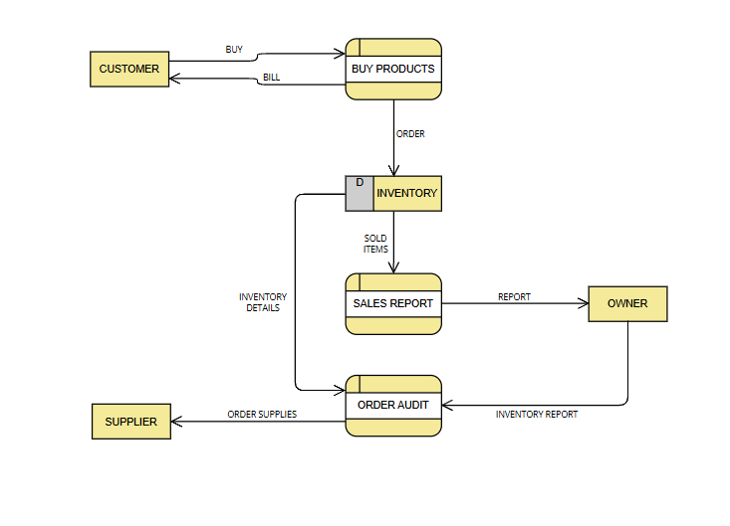

**Figure 1. Manual Auditing Process of Canteen Operations**

This figure illustrates the manual process used at PRMSU Iba Campus for managing and auditing canteen operations. Canteen staff manually record sales and inventory on paper, while auditors later review these documents line-by-line to validate financial accuracy. Administrators rely on compiled paper reports to generate summaries and make decisions. This method is prone to errors, time-consuming, and lacks transparency and efficiency.

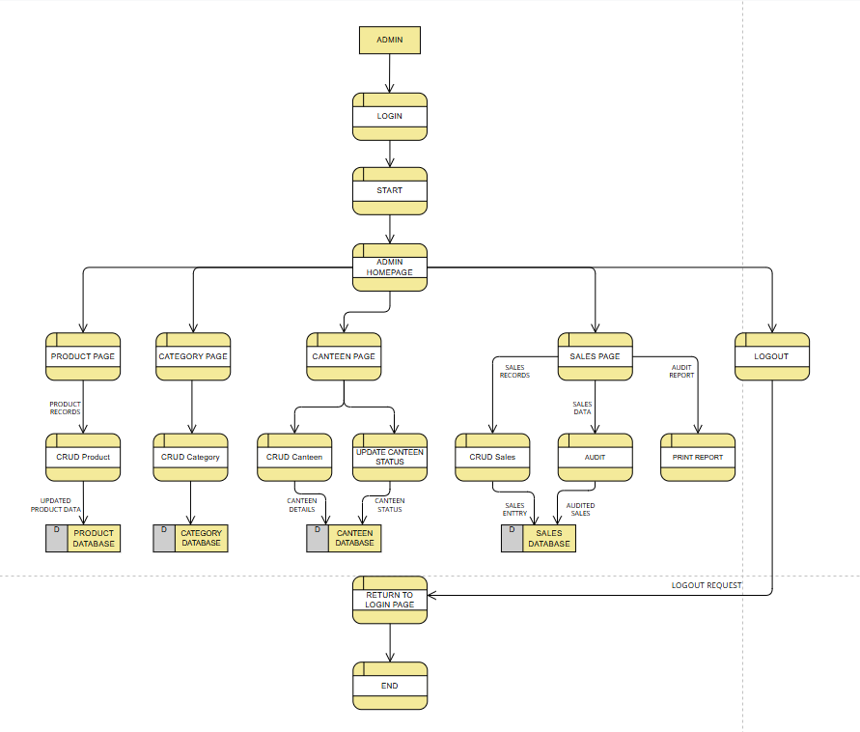

**Figure 2. Proposed Auditing System Process (admin)**

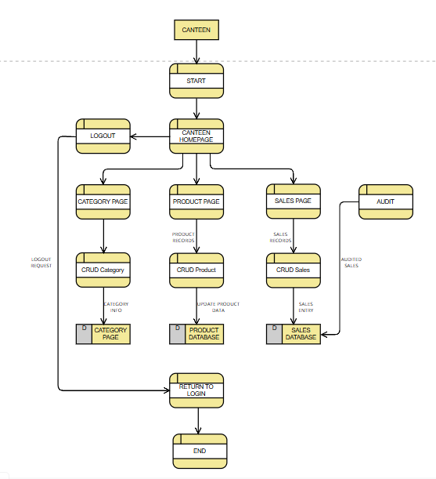

**Figure 3. Proposed Auditing System Process (canteen)**

These diagrams represents the Admin's process within the system, starting from login and navigating to various modules including canteen management, product and category pages, sales data, and auditing. Users can view, add, edit, delete, or activate/deactivate data related to products, categories, and canteens. Audit and print functions are integrated within the total sales module. Each action is linked to its respective database (Product, Category, Canteen, and Sales). After completing operations, users can return to the homepage or log out.

**Requirement Documentation**

**Functional Requirements of the system**

* **User Authentication** Secure login for different roles (Canteen Staff, Auditor, Administrator) to ensure access control and data protection.
* **Data Entry** Allows Canteen Staff to input daily sales and inventory records efficiently and accurately.
* **Auditing Feature** Provides tools for auditors to cross-check transactions and flag inconsistencies or irregularities in records.
* **Report Generation** The system automatically generates sales, inventory, and audit reports in downloadable formats.
* **Dashboard with Visual Analytics** Real-time charts and tables using tools like Chart.js to display trends and summaries for decision-makers.

**Non-Functional Requirements of the System**

* **Usability**  
  A user-friendly interface designed using Bootstrap for easy navigation and minimal training.
* **Performance**  
  The system handles multiple simultaneous users and large datasets without lag.
* **Security**  
  Role-based access and encrypted data to safeguard sensitive financial and transaction records.
* **Reliability**  
  The system must have minimal downtime and support regular backups to ensure data integrity.
* **Scalability**  
  Designed to handle more users and data as the system expands across other departments or campuses.

**Design of Software, System, Product and/or Process**

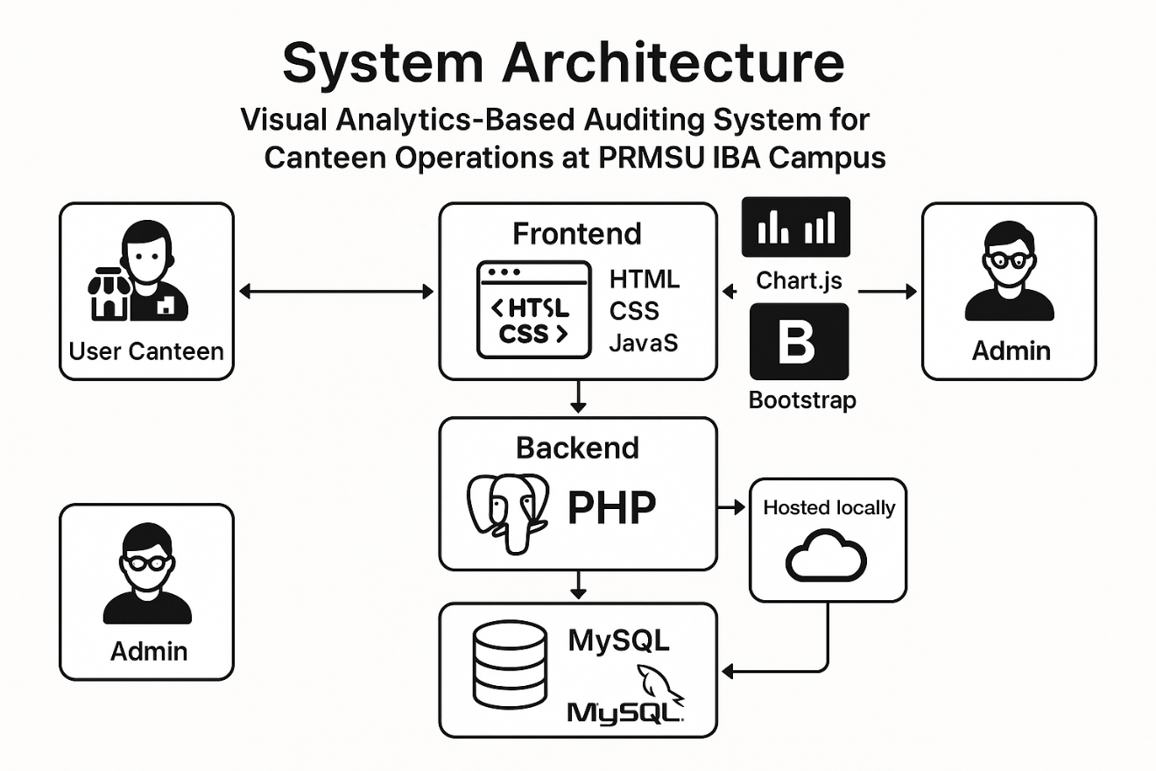

**Figure 4. System Architect Diagram**

The system uses a web-based architecture. The frontend is built with HTML, CSS, and JavaScript; the backend is developed in PHP; and data is managed using MySQL. The system is hosted locally using XAMPP for initial testing, and can later be deployed to a live server. Chart.js is used for visual analytics and Bootstrap is used for responsive design.

**Conceptual Framework**

**INPUT**

**PROCESS**

**OUTPUT**

ISO/ IEC 25010:2011

in terms of:

1. Level of Acceptability

1.1 Functionality; and

1.2 Performance

2. System Quality Metrics:

2.1 Functional Suitability;

2.2 Performance Efficiency;

2.3 Compatibility;

2.4 Interaction Capability;

2.5 Reliability;

2.6 Security;

2.7 Maintainability; and

2.8 Safety.

Data Gathering Tools

1. Survey Questionnaire

2. Planning Analysis and Design

3. Logical and physical design of the system

System Development

1. Coding/ Programming

Visual Analytics-Based Auditing System for

Canteen Operations at PRMSU IBA Campus

**Figure 5. Conceptual Framework**

The framework illustrates user interaction with the system via a client-server model. Inputs are processed in real-time with outputs visualized through the dashboard. All modules (login, data entry, auditing, reports) are interconnected within the framework for smooth integration.

**Development and Testing**

The development follows the **Agile methodology**, which allows frequent iterations and adjustments based on feedback from users (canteen operators, auditors, and administrators).

**Software Development Methodology**

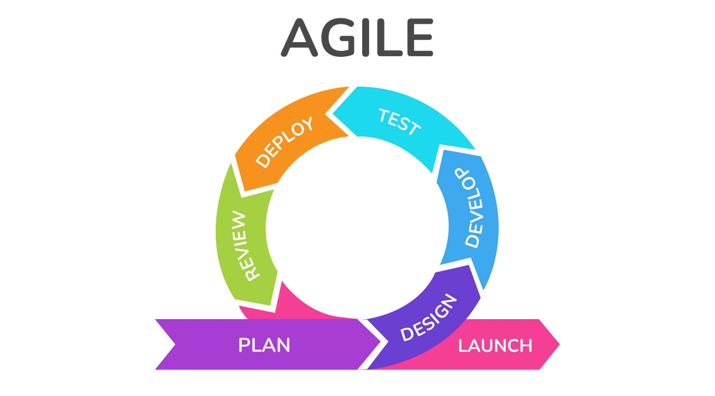

**Figure 6. Agile Development Process (by**[**Jose Luis Amoros**](https://www.krasamo.com/author/jl/) **May 31, 2022)**

Agile development is used to ensure responsiveness to changing requirements. The phases include planning, development, testing, evaluation, and deployment, with ongoing feedback loops at every iteration.

**Development Tools**

* **IDE**: Visual Studio Code
* **Database**: MySQL with phpMyAdmin
* **Backend**: PHP
* **Frontend**: HTML, CSS, JavaScript, Bootstrap
* **Version Control**: GitHub
* **Local Server**: XAMPP
* **Visualization Library**: Chart.js

**Testing Strategies**

* **Unit Testing**: Ensures individual modules (e.g., login, data entry) function as expected.
* **Integration Testing**: Checks smooth interaction between modules.
* **User Acceptance Testing (UAT)**: Conducted by real users to validate that the system meets practical needs and usability standards.

**Data Analysis Plan**

The data gathered from UAT and evaluation surveys will be processed using the following methods:

1. **Frequency and Percentage Distribution**

Used to determine how many users rate specific features as acceptable or not, segmented by role.

1. **Weighted Mean**

Evaluates overall system quality and acceptability using a Likert scale (1–4).

* + **Likert Scale on Acceptability**

| **Numerical Value** | **Range** | **Descriptive Rating** |
| --- | --- | --- |
| 4 | 3.25 – 4.00 | Highly Acceptable |
| 3 | 2.50 – 3.24 | Acceptable |
| 2 | 1.75 – 2.49 | Slightly Acceptable |
| 1 | 1.00 – 1.74 | Not Acceptable |
|  |  |  |

* + **Likert Scale on System Quality**

| **Numerical Value** | **Range** | **Descriptive Rating** |
| --- | --- | --- |
| 4 | 3.25 – 4.00 | Excellent |
| 3 | 2.50 – 3.24 | Very Good |
| 2 | 1.75 – 2.49 | Good |
| 1 | 1.00 – 1.74 | Poor |

1. **Population and Sampling Techniques** **Convenience Sampling**

is used due to ease of access. Sample includes canteen staff, PRMSU auditors, and IT experts. This approach gathers quick insights for evaluating system performance.

1. **Research Instrument**

* A survey questionnaire adapted from **ISO/ IEC 25010:2011** will be used to assess software quality (e.g., functionality, usability, reliability).

1. **Research Locale**

The study and testing will be conducted on-site at PRMSU Iba Campus, specifically within the campus canteen and auditing office.

Reference

Cheng, X., Chaw, J. K., Goh, K. M., Ting, T. T., Sahrani, S., Ahmad, M. N., Abdul Kadir, R., & Ang, M. C. (2022). Systematic Literature Review on Visual Analytics of Predictive Maintenance in the Manufacturing Industry. Sensors, 22(17), 6321. <https://doi.org/10.3390/s22176321>

Chishtie, J. A., Marchand, J. S., Turcotte, L. A., Bielska, I. A., Babineau, J., Cepoiu-Martin, M., Irvine, M., Munce, S., Abudiab, S., Bjelica, M., Hossain, S., Imran, M., Jeji, T., & Jaglal, S. (2020). Visual analytic tools and techniques in population health and health services research: Scoping review. Journal of Medical Internet Research, 22(12), e17892. <https://doi.org/10.2196/17892>

Ditkaew, K., & Suttipun, M. (2023). The impact of audit data analytics on audit quality and audit review continuity in Thailand. Asian Journal of Accounting Research, 8(3), 269-278. <https://doi.org/10.1108/AJAR-04-2022-0114>

Eilifsen, A., Kinserdal, F., Messier, W. F., Jr., & McKee, T. E. (2020). An exploratory study into the use of audit data analytics on audit engagements. Accounting Horizons, 34(4), 75–103. <https://doi.org/10.2308/HORIZONS-19-121>

GetApp. (2025, March). Best audit software with visual analytics 2025. <https://www.getapp.com/security-software/audit-compliance/f/visual-analytics/>

Glimpse Corp. (2021, March 15). An introduction to video auditing for bars and restaurants. Glimpse Corp. <https://www.glimpsecorp.com/video-auditing-restaurant-and-bar/>

Higginbotham, N., Nash, L., & Demeré, W. (2021, May 1). Making audits more effective through data visualization. Journal of Accountancy. <https://www.journalofaccountancy.com/issues/2021/may/make-audits-more-effective-through-data-visualization.html>

Hazarika, K., Shobana, A., & Agrawal, A. (2023). Visual analytics. In Data Science and Analytics (pp. 1–15). CRC Press. <https://doi.org/10.1201/9781003050827-1>

ICAEW Insights. (2025, March 7). Data analytics for auditors: Five essentials. ICAEW. <https://www.icaew.com/insights/viewpoints-on-the-news/2025/mar-2025/data-analytics-for-auditors-five-essentials>

Jahani, H., Jain, R., & Ivanov, D. (2023). Data science and big data analytics: A systematic review of methodologies used in the supply chain and logistics research. Annals of Operations Research. <https://doi.org/10.1007/s10479-023-05390-7>

Khaing, Myat & Thant, Khin & Aung, Thet & Tin, Hlaing Htake Khaung. (2023). Enhancing Healthy Food Choices in a University Canteen Exploring the Influence of Menu Labeling. Open Access Journal of Waste Management & Xenobiotics, 6, 1-8. https://doi.org/10.23880/oajwx-16000190

Kim, J. (2020). Visual analytics for operation-level construction monitoring and documentation: State-of-the-art technologies, research challenges, and future directions. Frontiers in Built Environment, 6, 575738. <https://doi.org/10.3389/fbuil.2020.575738>

KPMG LLP. (2017). Audit 2025: The future is now. KPMG. <https://assets.kpmg.com/content/dam/kpmg/us/pdf/2017/03/us-audit-2025-final-report.pdf>

Lombe, M. (2025). How data analytics is making traditional audit obsolete. AtISACA Newsletter, 2025(4). <https://www.isaca.org/resources/news-and-trends/newsletters/atisaca/2025/volume-4/how-data-analytics-is-making-traditional-audit-obsolete>

Medina, A., Aguilon, S., Pepito, C. B., Enopequez, A. M., Polinar, M., Rabanes, B., & Mahipos, A. (2024). Exploring the Relationship between Operations Management Practices and Students’ Satisfaction in the Canteen at Mabolo National High School. International Journal of Multidisciplinary: Applied Business and Education Research, 5(7), 2636-2644. <http://dx.doi.org/10.11594/ijmaber.05.07.21>

Rodríguez-Quintero, J.-F., Sánchez-Díaz, A., Iriarte-Navarro, L., Maté, A., Marco-Such, M., & Trujillo, J. (2021). Fraud Audit Based on Visual Analysis: A Process Mining Approach. Applied Sciences, 11(11), 4751. <https://doi.org/10.3390/app11114751>

Sarikaya, A., Correll, M., & Fisher, D. (2023). Strategies for evaluating visual analytics systems: A systematic review. Information Visualization. Advance online publication. <https://doi.org/10.1177/14738716231212568>

Wang, X., Ferreira, F. A. F., & Yan, P. (2025). A multi-objective optimization approach for integrated risk-based internal audit planning. Annals of Operations Research, 346, 1811–1840. <https://doi.org/10.1007/s10479-023-05228-2>

Yuan, J., Chen, C., Yang, W., Liu, M., Xia, J., & Liu, S. (2021). A survey of visual analytics techniques for machine learning. Computational Visual Media, 7(1), 3–36. <https://doi.org/10.1007/s41095-020-0191-7>