G06.000-vegetation-survey-field-trip-report.R

justin.mccann

2024-01-19

# Title: G06.000 vegetation survey field trip report  
# Author details: Justin McCann  
# Script and data info: This script loads, pre-processes, and visualises data for the vegetation survey group of methods  
# Data obtained from Sharepoint exports out of Echo

list datasets

All data

all.echo.data %>% select(sessionID, method_code) %>% group_by(sessionID) %>% distinct(method_code) %>% arrange(sessionID) %>% print_as_table_for_word()

| sessionID | method_code |
| --- | --- |
| 2007_Spring | m04_020_soil_surface_quadrat |
| m06_080_vegetation_quadrat_species |
| m06_090_vegetation_intercept |
| 2008_Spring |
| 2009_Spring | m04_020_soil_surface_quadrat |
| m06_080_vegetation_quadrat_species |
| 2010_Spring | m04_020_soil_surface_quadrat |
| m06_080_vegetation_quadrat_species |
| m06_090_vegetation_intercept |
| 2011_Spring | m04_020_soil_surface_quadrat |
| m06_040_photo_points |
| m06_050_recruitment |
| m06_080_vegetation_quadrat_species |
| m06_090_vegetation_intercept |
| 2011_Summer | m06_050_recruitment |
| 2015_Spring | m04_020_soil_surface_quadrat |
| m06_040_photo_points |
| m06_050_recruitment |
| m06_080_vegetation_quadrat_species |
| m06_090_vegetation_intercept |
| 2016_Spring | m04_020_soil_surface_quadrat |
| m06_050_recruitment |
| m06_080_vegetation_quadrat_species |
| m06_090_vegetation_intercept |
| 2016_Summer | m04_020_soil_surface_quadrat |
| m06_040_photo_points |
| m06_050_recruitment |
| m06_080_vegetation_quadrat_species |
| m06_090_vegetation_intercept |
| 2020_Summer | m04_020_soil_surface_quadrat |
| m06_040_photo_points |
| m06_050_recruitment |
| m06_080_vegetation_quadrat_species |
| m06_090_vegetation_intercept |
| 2022_Spring | m04_020_soil_surface_quadrat |
| m06_040_photo_points |
| m06_050_recruitment |
| m06_071_tree_health_quadrat |
| m06_080_vegetation_quadrat_species |
| m06_090_vegetation_intercept |
| 2022_Summer | m04_020_soil_surface_quadrat |
| m06_040_photo_points |
| m06_050_recruitment |
| m06_071_tree_health_quadrat |
| m06_080_vegetation_quadrat_species |
| m06_090_vegetation_intercept |
| 2023_Spring | m04_020_soil_surface_quadrat |
| m06_040_photo_points |
| m06_050_recruitment |
| m06_071_tree_health_quadrat |
| m06_080_vegetation_quadrat_species |
| m06_090_vegetation_intercept |

This session

session.data %>% select(sessionID, method_code) %>% group_by(sessionID) %>% distinct(method_code) %>% arrange(sessionID) %>% print_as_table_for_word()

| sessionID | method_code |
| --- | --- |
| 2022_Spring | m04_020_soil_surface_quadrat |
| m06_040_photo_points |
| m06_050_recruitment |
| m06_071_tree_health_quadrat |
| m06_080_vegetation_quadrat_species |
| m06_090_vegetation_intercept |
| 2022_Summer | m04_020_soil_surface_quadrat |
| m06_040_photo_points |
| m06_050_recruitment |
| m06_071_tree_health_quadrat |
| m06_080_vegetation_quadrat_species |
| m06_090_vegetation_intercept |

check all transect lengths

session.data %>%   
 group_by(method_code) %>%  
 distinct(length_m) %>%   
 print_as_table_for_word()

| method_code | length_m |
| --- | --- |
| m04_020_soil_surface_quadrat | 50 |
| m06_040_photo_points |
| m06_050_recruitment |
| m06_071_tree_health_quadrat |
| m06_080_vegetation_quadrat_species |
| m06_090_vegetation_intercept |

# Make a field trip summary ####

Summary variables

## The c("2022_Summer", "2022_Spring") vegetation monitoring session at Scottsdale Reserve ran from 2022-11-14 to 2022-12-14

## We undertook a total of 6 vegetation survey methods during this time, at 22 sites

## The vegetation survey methods used were c("m04_020_soil_surface_quadrat", "m06_040_photo_points", "m06_050_recruitment", "m06_071_tree_health_quadrat", "m06_080_vegetation_quadrat_species", "m06_090_vegetation_intercept")

Soil surface summary ##### Count of quadrat function grouped by target

m04_020_soil_surface_quadrat_analysis_join_parent_child %>%   
 group_by(site_target_name) %>%   
 count(quadrat_function) %>%   
 ggplot(aes(x = quadrat_function, y = n)) +  
 facet_wrap(~site_target_name) +  
 geom_col() +  
 theme(axis.text.x = element_text(angle = 50, hjust = 1, vjust = 1))

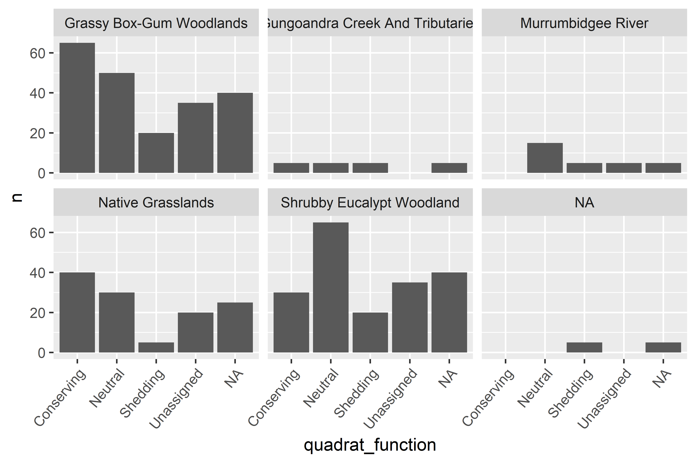

boxplots of soil data

Standard soil metrics

soil_surface_data_for_plot %>%   
 filter(!str_detect(name, groups_2_3)) %>%   
 veg_plot()

## Warning: Removed 1380 rows containing non-finite values (`stat_boxplot()`).

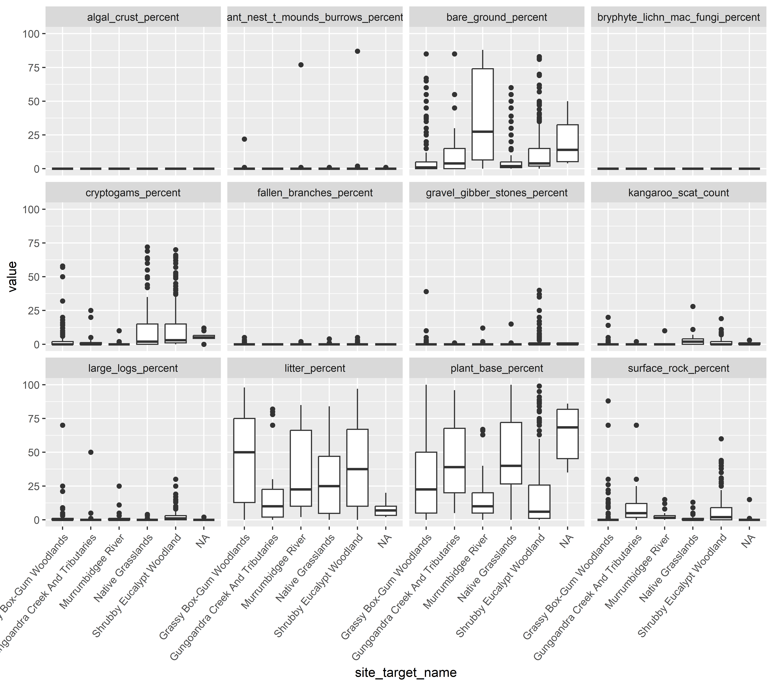

Cover life history

soil_surface_data_for_plot %>%   
 filter(str_detect(name, groups_2_3),  
 !str_detect(name, group_3)) %>%   
 veg_plot()

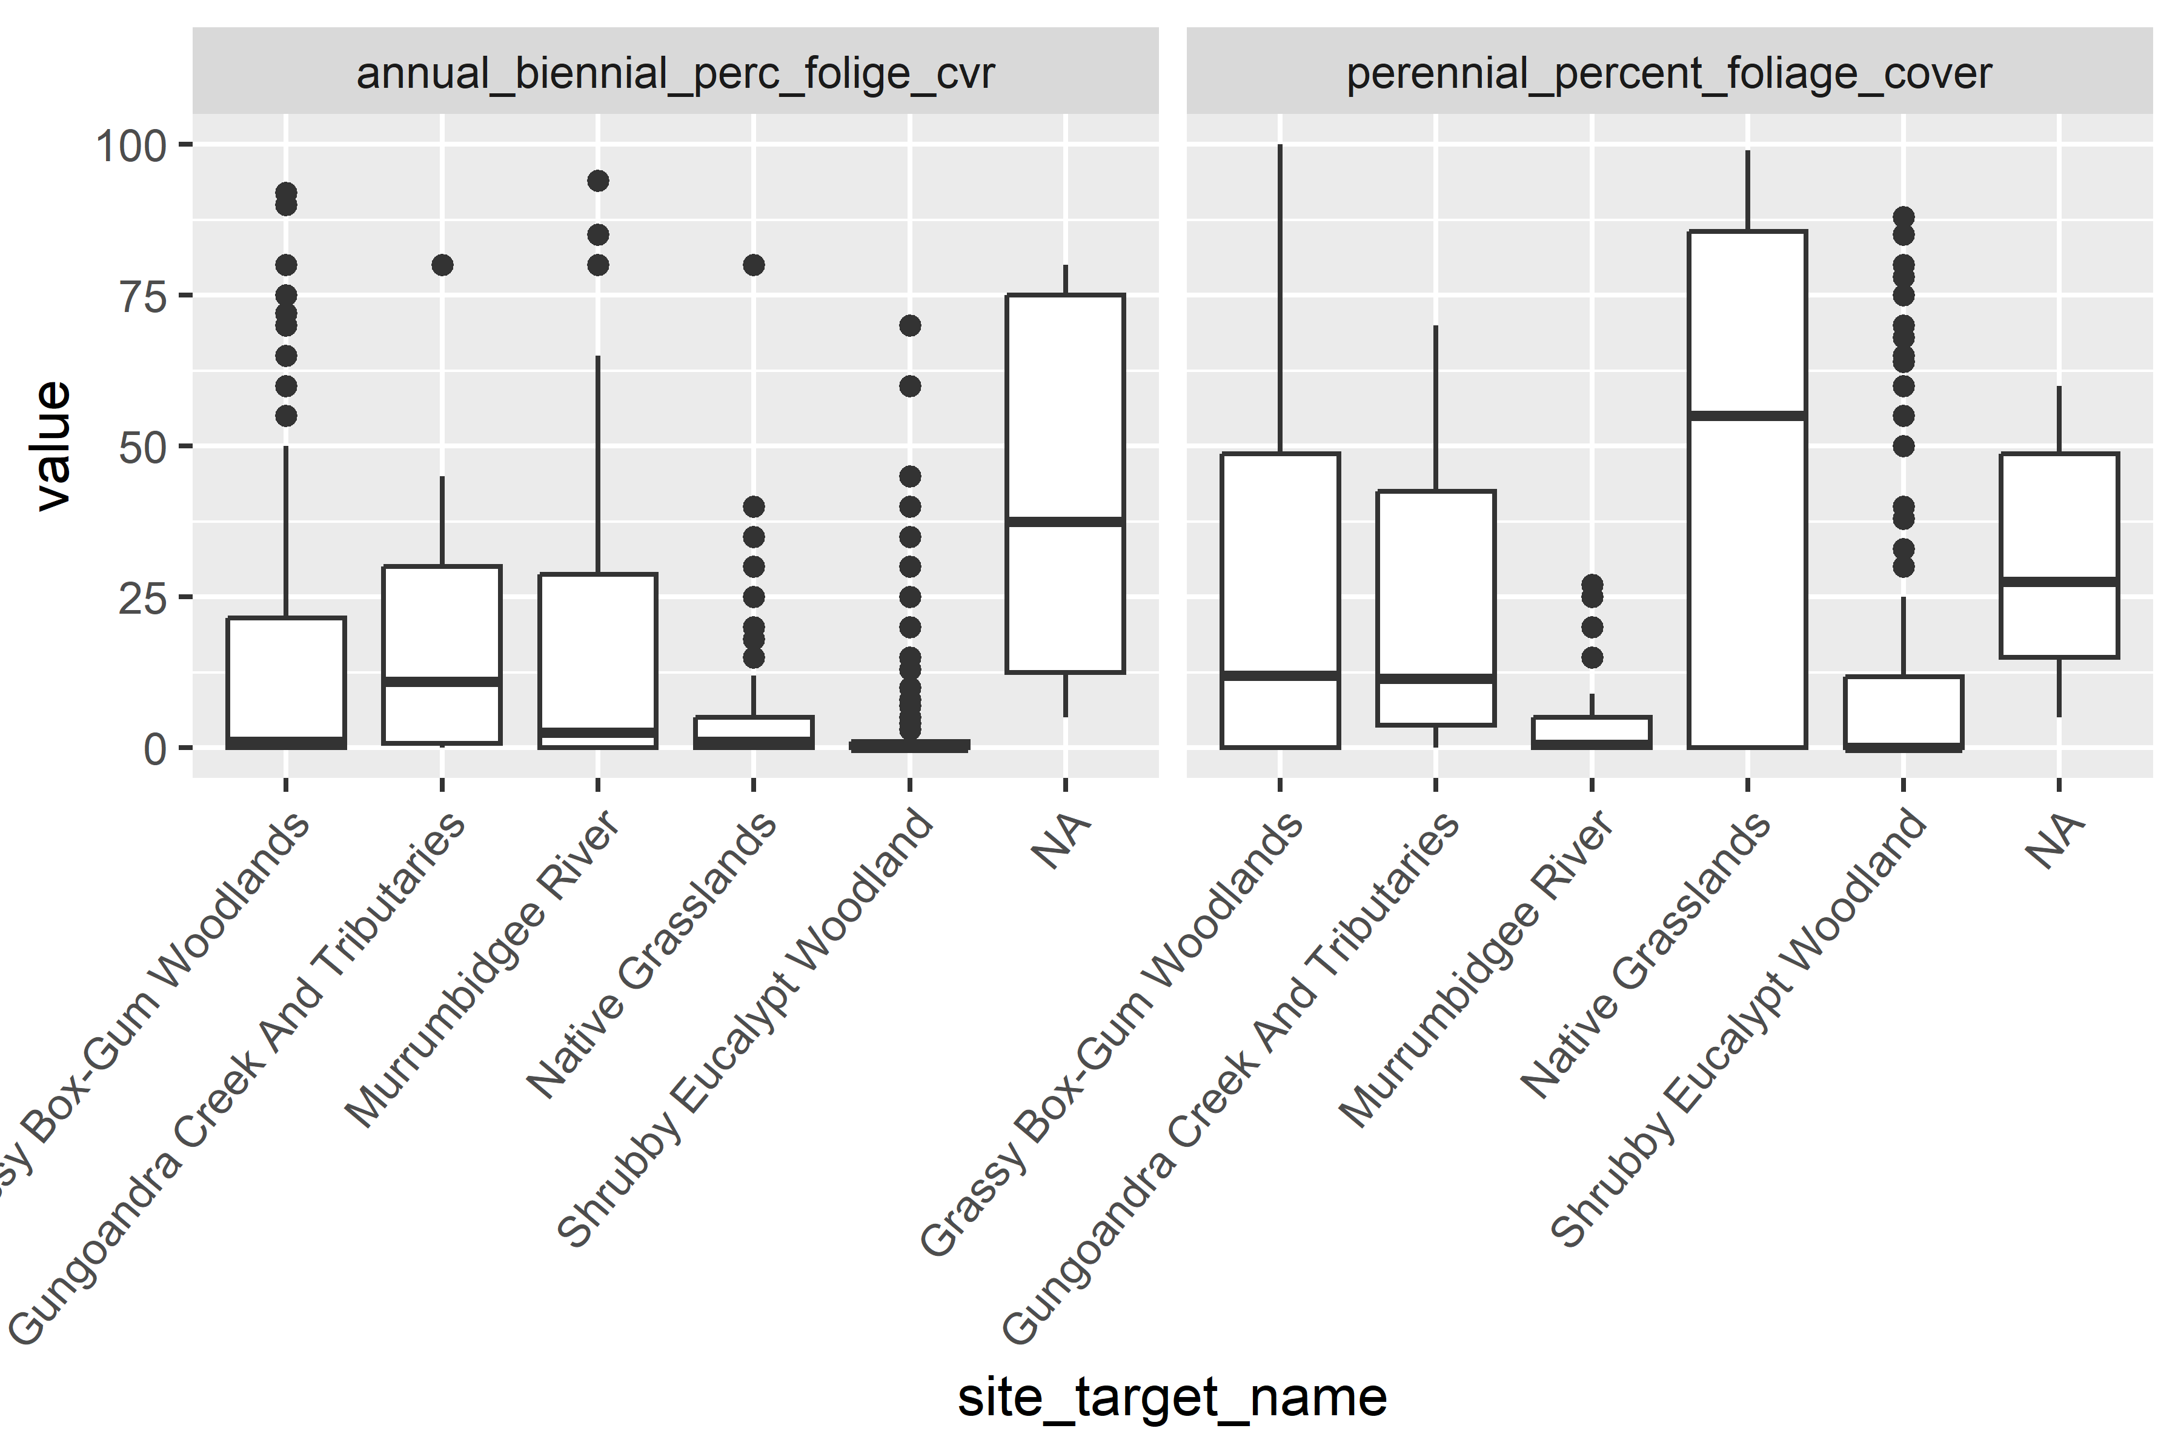

Cover weediness

soil_surface_data_for_plot %>%   
 filter(str_detect(name, groups_2_3),  
 str_detect(name, group_3)) %>%   
 veg_plot()

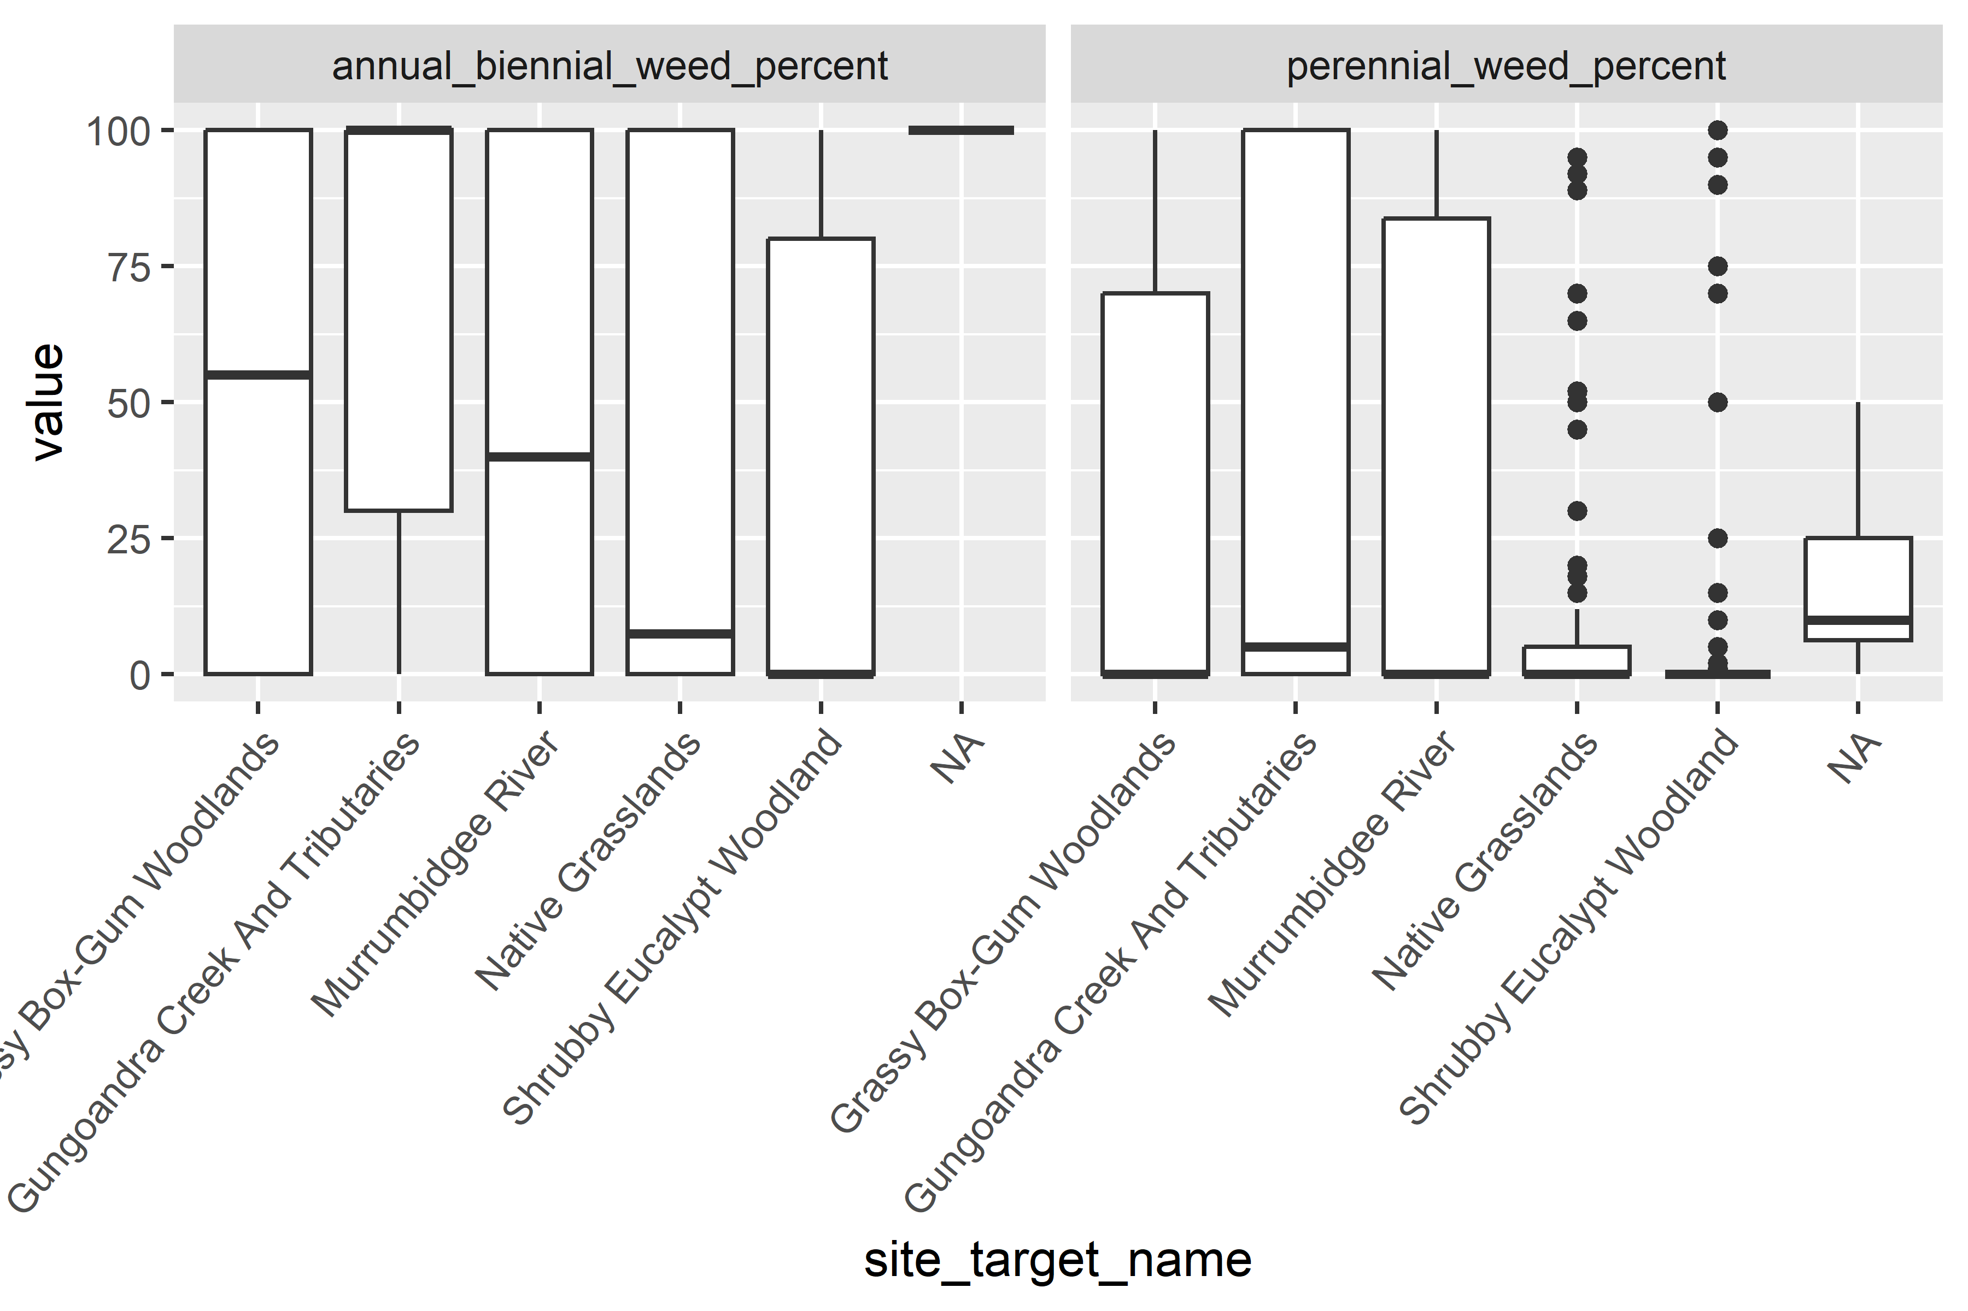

Recruitment species list - Count of species grouped by site

Below is a table of recruitment observed at each site

| site_target_name | site_id | scientific_name | english_name | n |
| --- | --- | --- | --- | --- |
| Gungoandra Creek And Tributaries | SCT018 | Bursaria spinosa | Sweet Bursaria | 1 |
| Native Grasslands | SCT020 | Callitris endlicheri |  |
| Eucalyptus bridgesiana | Apple Gum, Apple Box (ex E. saxicola) |
| Shrubby Eucalypt Woodland | SCT003 | Callitris endlicheri |  |
| Cassinia longifolia | Shiny Cassinia, Dogwood, Cauliflower Bush |
| Cassinia quinquefaria |  |
| Eucalyptus bridgesiana | Apple Gum, Apple Box (ex E. saxicola) |
| Eucalyptus rossii | Scribbly gum |
| Kunzea ericoides | Burgan |
| SCT004 | Cassinia longifolia | Shiny Cassinia, Dogwood, Cauliflower Bush |
| SCT005 | Callitris endlicheri |  |
| Cassinia longifolia | Shiny Cassinia, Dogwood, Cauliflower Bush |
| SCT006 |
| Eucalyptus bridgesiana | Apple Gum, Apple Box (ex E. saxicola) |
| Lissanthe strigosa subsp. subulata | Peach Heath |
| Pultenaea procumbens | Healthy bush-pea |
| SCT007 | Acacia doratoxylon | Currawang |
| SCT008 | Bursaria spinosa | Sweet Bursaria |
| Callitris endlicheri |  |
| Eucalyptus bridgesiana | Apple Gum, Apple Box (ex E. saxicola) |
| SCT014 | Callitris endlicheri |  |
| Cassinia quinquefaria |
| SCT030 | Done by FOG volunteers - on paper |

The following sites have no species listed, and are assumed to have no recruitment.

session.data.na <- session.data %>%  
 filter(str_detect(method_code, "m06_050_recruitment")) %>%   
 filter(is.na(scientific_name)) %>% # assess records without a species record  
 group_by(site_target_name, site_id) %>%  
 relocate(site_target_name) %>%   
 distinct(observation_status)

| site_target_name | site_id | observation_status |
| --- | --- | --- |
| Grassy Box-Gum Woodlands | SCT001 | Observation recorded |
| Native Grasslands | SCT002 |
| Grassy Box-Gum Woodlands | SCT009 |
| SCT010 |
| SCT012 |
| Native Grasslands | SCT015 |
| Murrumbidgee River | SCT017 |
| Native Grasslands | SCT019 |

The following is an analysis of vegetation transects: Richness (total number of species across all sites)

| site_target_name | Count of species scientific names (richness) |
| --- | --- |
| Grassy Box-Gum Woodlands | 4 |
| Gungoandra Creek And Tributaries | 3 |
| Murrumbidgee River | 6 |
| Native Grasslands | 3 |
| Shrubby Eucalypt Woodland | 21 |
|  | 2 |

Cover per site (not accounting for overlap)

| site_target_name | intercept_strata | site_id | sum_of_cover | cover_percent |
| --- | --- | --- | --- | --- |
| Grassy Box-Gum Woodlands |  | SCT009 | 4.29 | 8.58 |
| SCT011 | 31.39 | 62.78 |
| SCT012 | 13.10 | 26.20 |
| SCT013 | 9.90 | 19.80 |
| Gungoandra Creek And Tributaries | SCT018 | 4.36 | 8.72 |
| Murrumbidgee River | SCT017 | 42.56 | 85.12 |
| Native Grasslands | SCT020 | 9.82 | 19.64 |
| Shrubby Eucalypt Woodland | SCT003 | 16.58 | 33.16 |
| SCT004 | 0.50 | 1.00 |
| SCT005 | 26.40 | 52.80 |
| SCT006 | 37.01 | 74.02 |
| SCT007 | 34.29 | 68.58 |
| SCT008 | 23.31 | 46.62 |
| SCT014 | 8.90 | 17.80 |
| SCT030 | 33.78 | 67.56 |
|  | Other | 0.32 | 0.64 |

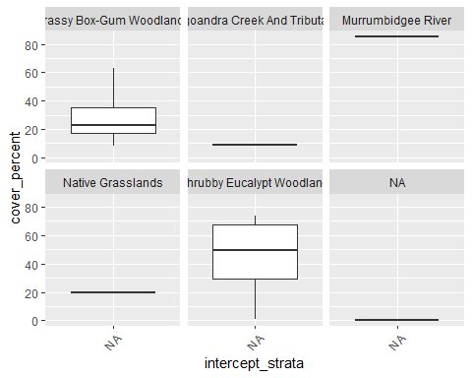

Average cover per target

| site_target_name | intercept_strata | mean_percent |
| --- | --- | --- |
| Grassy Box-Gum Woodlands |  | 29 |
| Gungoandra Creek And Tributaries | 9 |
| Murrumbidgee River | 85 |
| Native Grasslands | 20 |
| Shrubby Eucalypt Woodland | 45 |
|  | 1 |

mean height

session.data %>%  
 filter(str_detect(method_code, "m06_090")) %>%   
 # remove_empty(which = "cols") %>% # Scottsdale data did not record intercept_strata  
 group_by(site_target_name, intercept_strata) %>%   
 summarise(min_height = round(min(height)),  
 mean_height = round(mean(height)),  
 max_height = round(max(height))) %>%   
 print_as_table_for_word()

## `summarise()` has grouped output by 'site_target_name'. You can override using  
## the `.groups` argument.

| site_target_name | intercept_strata | min_height | mean_height | max_height |
| --- | --- | --- | --- | --- |
| Grassy Box-Gum Woodlands |  | 1 | 12 | 18 |
| Gungoandra Creek And Tributaries | 3 | 4 |
| Murrumbidgee River | 15 |
| Native Grasslands | 0 | 5 | 12 |
| Shrubby Eucalypt Woodland | 3 | 15 |
|  | 0 | 0 |

Species diversity table all veg methods ##### Number of unique species names grouped by method and target

| method_code | site_target_name | n |
| --- | --- | --- |
| m06_040_photo_points | Grassy Box-Gum Woodlands | 1 |
| Gungoandra Creek And Tributaries |
| Murrumbidgee River |
| Native Grasslands |
| Shrubby Eucalypt Woodland |
|  |
| m06_050_recruitment | Grassy Box-Gum Woodlands |
| Gungoandra Creek And Tributaries |
| Murrumbidgee River |
| Native Grasslands | 3 |
| Shrubby Eucalypt Woodland | 11 |
| m06_071_tree_health_quadrat | Grassy Box-Gum Woodlands | 3 |
| Murrumbidgee River | 2 |
| Native Grasslands | 1 |
| Shrubby Eucalypt Woodland | 7 |
| m06_080_vegetation_quadrat_species | Grassy Box-Gum Woodlands | 82 |
| Gungoandra Creek And Tributaries | 38 |
| Murrumbidgee River | 28 |
| Native Grasslands | 77 |
| Shrubby Eucalypt Woodland | 114 |
|  | 31 |
| m06_090_vegetation_intercept | Grassy Box-Gum Woodlands | 4 |
| Gungoandra Creek And Tributaries | 3 |
| Murrumbidgee River | 6 |
| Native Grasslands | 3 |
| Shrubby Eucalypt Woodland | 21 |
|  | 2 |

Number of unique species names grouped by method and target for all years

species_count_veg_methods_all_echo_data %>%   
 ggplot(aes(x = survey_year, y = unique_species, colour = method_code)) +  
 geom_line() +  
 geom_point() +  
 facet_wrap(~ site_target_name) +  
 theme_bw() +  
 theme(legend.position = "bottom") +  
 guides(colour = guide_legend(nrow = 3))

