Project Document
StarUML Sample
:UCS
Usecase Specification Document


PLASTIC SOFTWARE INCORPORATION
http://www.staruml.com
Document Revision History
Rev# | Date | Affected Section | Author
1

Table of Contents
1. Introduction 7
1.1. Objective 7
1.2. Overall Description 7
2. Use-Case Diagram 8
2.1. Prijava klijnta na server Diagram 8
2.2. Plugin poruke Diagram 8
2.3. Diagram 8
2.4. Prijava klijenta na server - prvi put Diagram 8
2.5. Prijava klijnta na server - drugi put Diagram 9
2.6. Zahtev za pluginovima Diagram 9
3. Actor Specification 11
3.1. Klijent 11
3.1.1. Description 11
3.2. Bae, Rankyoung 11
3.2.1. Description 11
3.3. Klijent 11
3.3.1. Description 11
4. Use-Case Specification 12
4.1. Send GetId 12
4.1.1. Description 12
4.1.2. Flow of Events 12
4.1.3. Pre-Conditions 12
4.1.4. Post-Conditions 12
4.2. Wait for Id 12
4.2.1. Description 12
4.2.2. Flow of Events 12
4.2.3. Pre-Conditions 12
4.2.4. Post-Conditions 12
4.3. Klijent šalje ID koji je dobio prvi put 13
4.3.1. Description 13
4.3.2. Flow of Events 13
4.3.3. Pre-Conditions 13
4.3.4. Post-Conditions 13
4.4. Klijent šalje da nema ID 13
4.4.1. Description 13
4.4.2. Flow of Events 13
4.4.3. Pre-Conditions 13
4.4.4. Post-Conditions 13
4.5. Lim, Heejin 14
4.5.1. Description 14
4.5.2. Flow of Events 14
4.5.3. Pre-Conditions 14
4.5.4. Post-Conditions 14
4.6. Proces smešta poruku u poštansko sanduče 14
4.6.1. Description 14
4.6.2. Flow of Events 14
4.6.3. Pre-Conditions 14
4.6.4. Post-Conditions 14
4.7. Proces uzima soket 15
4.7.1. Description 15
4.7.2. Flow of Events 15
4.7.3. Pre-Conditions 15
4.7.4. Post-Conditions 15
4.8. Server dodeljuje ID 15
4.8.1. Description 15
4.8.2. Flow of Events 15
4.8.3. Pre-Conditions 15
4.8.4. Post-Conditions 15
4.9. Server otvara mail box za klijenta 16
4.9.1. Description 16
4.9.2. Flow of Events 16
4.9.3. Pre-Conditions 16
4.9.4. Post-Conditions 16
4.10. Server proverava ID 16
4.10.1. Description 16
4.10.2. Flow of Events 16
4.10.3. Pre-Conditions 16
4.10.4. Post-Conditions 16
4.11. Soket se smesta u red 17
4.11.1. Description 17
4.11.2. Flow of Events 17
4.11.3. Pre-Conditions 17
4.11.4. Post-Conditions 17
4.12. Zahtev za pluginovima 17
4.12.1. Description 17
4.12.2. Flow of Events 17
4.12.3. Pre-Conditions 17
4.12.4. Post-Conditions 17
4.13. neko treba da preuzme poruku i proveri da li je sistemska 18
4.13.1. Description 18
4.13.2. Flow of Events 18
4.13.3. Pre-Conditions 18
4.13.4. Post-Conditions 18

List of Figure
Figure 1 – Use-Case Diagram of Prijava klijnta na server 8
Figure 2 – Use-Case Diagram of 8
Figure 3 – Use-Case Diagram of Plugin poruke 8
Figure 4 – Use-Case Diagram of Prijava klijenta na server - prvi put 9
Figure 5 – Use-Case Diagram of Prijava klijnta na server - drugi put 9
Figure 6 – Use-Case Diagram of Zahtev za pluginovima 10

Introduction

Objective
This document is Usecase Specification Document generated from UCS template document by StarUML Generator.

Overall Description
This document describes….

Use-Case Diagram

Prijava klijnta na server Diagram

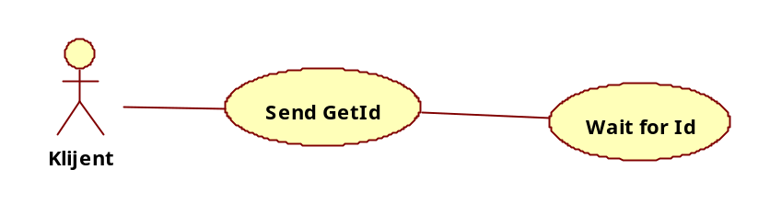
Figure 1 – Use-Case Diagram of Prijava klijnta na server

Plugin poruke Diagram

Diagram

Figure 2 – Use-Case Diagram of

Figure 3 – Use-Case Diagram of Plugin poruke

Prijava klijenta na server - prvi put Diagram

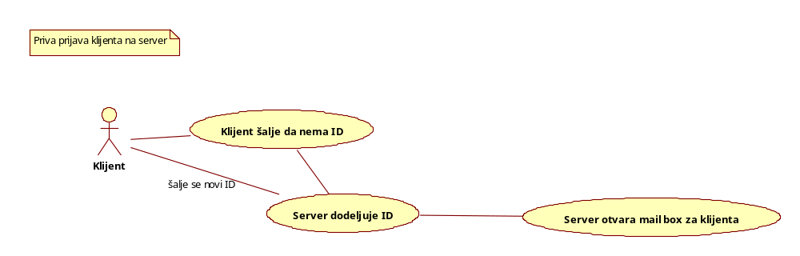
Figure 4 – Use-Case Diagram of Prijava klijenta na server - prvi put

Prijava klijnta na server - drugi put Diagram

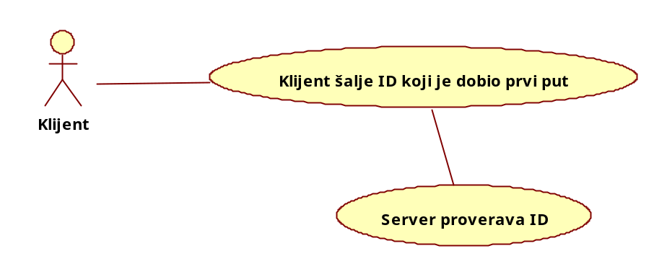
Figure 5 – Use-Case Diagram of Prijava klijnta na server - drugi put

Zahtev za pluginovima Diagram

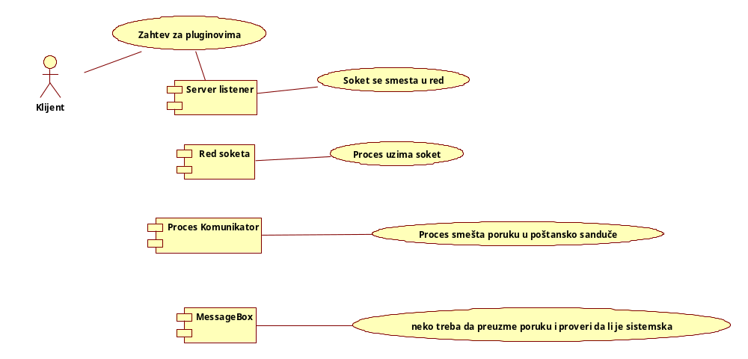
Figure 6 – Use-Case Diagram of Zahtev za pluginovima

Actor Specification

Klijent

Description

Bae, Rankyoung

Description

Klijent

Description

Use-Case Specification

Send GetId

Description

Flow of Events

Basic Flow

Alternative Flow

Pre-Conditions

Post-Conditions

Wait for Id

Description

Flow of Events

Basic Flow

Alternative Flow

Pre-Conditions

Post-Conditions

Klijent šalje ID koji je dobio prvi put

Description

Flow of Events

Basic Flow

Alternative Flow

Pre-Conditions

Post-Conditions

Klijent šalje da nema ID

Description

Flow of Events

Basic Flow

Alternative Flow

Pre-Conditions

Post-Conditions

Lim, Heejin

Description

Flow of Events

Basic Flow

Alternative Flow

Pre-Conditions

Post-Conditions

Proces smešta poruku u poštansko sanduče

Description

Flow of Events

Basic Flow

Alternative Flow

Pre-Conditions

Post-Conditions

Proces uzima soket

Description

Flow of Events

Basic Flow

Alternative Flow

Pre-Conditions

Post-Conditions

Server dodeljuje ID

Description

Flow of Events

Basic Flow

Alternative Flow

Pre-Conditions

Post-Conditions

Server otvara mail box za klijenta

Description

Flow of Events

Basic Flow

Alternative Flow

Pre-Conditions

Post-Conditions

Server proverava ID

Description

Flow of Events

Basic Flow

Alternative Flow

Pre-Conditions

Post-Conditions

Soket se smesta u red

Description

Flow of Events

Basic Flow

Alternative Flow

Pre-Conditions

Post-Conditions

Zahtev za pluginovima

Description

Flow of Events

Basic Flow

Alternative Flow

Pre-Conditions

Post-Conditions

neko treba da preuzme poruku i proveri da li je sistemska

Description

Flow of Events

Basic Flow

Alternative Flow

Pre-Conditions

Post-Conditions

Index

Ｂ
Bae, Rankyoung 11
Ｋ
Klijent 11
Klijent šalje da nema ID 13
Klijent šalje ID koji je dobio prvi put 13
Ｌ
Lim, Heejin 14
Ｎ
neko treba da preuzme poruku i proveri da li je sistemska 18
Ｐ
Plugin poruke 8
Prijava klijenta na server - prvi put 8, 9
Prijava klijnta na server 8
Prijava klijnta na server - drugi put 9
Proces smešta poruku u poštansko sanduče 14
Proces uzima soket 15
Ｓ
Send GetId 12
Server dodeljuje ID 15
Server otvara mail box za klijenta 16
Server proverava ID 16
Soket se smesta u red 17
Ｗ
Wait for Id 12
Ｚ
Zahtev za pluginovima 9, 10, 17

