CIS530 HW2: Submission Example

2.1 All-complex (4 points)

Results
- Train Set:
  - Precision: 0.4328
  - Recall: 1.0000
  - F-score: 0.6041
- Dev Set:
  - Precision: 0.4180
  - Recall: 1.0000
  - F-score: 0.5896

2.2 Word-length baseline (6 points)

Results
- Train Set:
  - Precision: 0.6007
  - Recall: 0.8440
  - F-score: 0.7019
- Dev Set:
  - Precision: 0.6054
  - Recall: 0.8660
  - F-score: 0.7126

Threshold Analysis
- Range of thresholds tested: [1-21]
- Best threshold: 7

Precision-Recall Curve

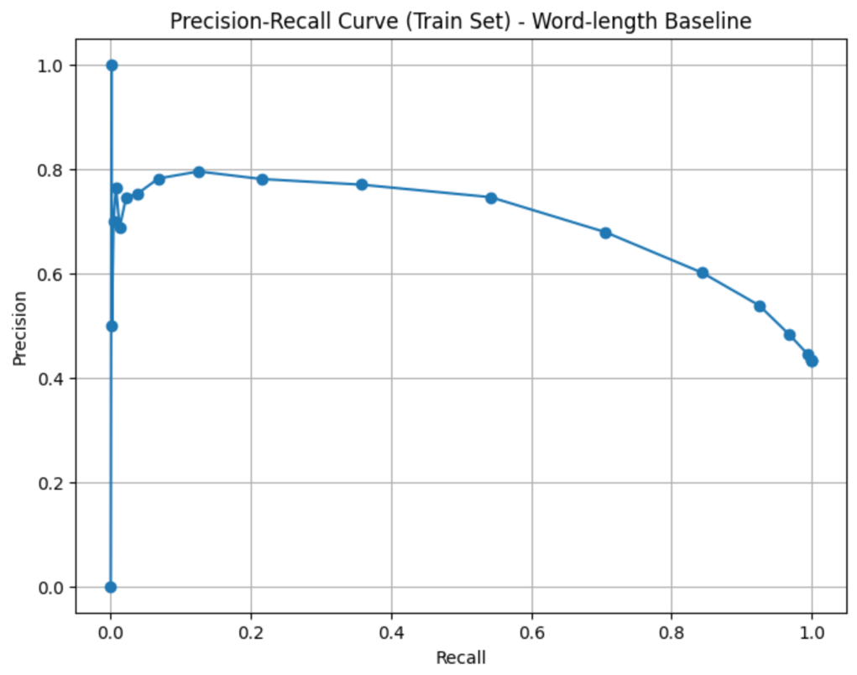

P-R Curve Analysis
The Precision-Recall (P-R) curve for the word-length baseline on the training set shows the following trend:
- Recall spans a wide range, starting near 1.0 at very low thresholds (e.g., threshold = 1) and gradually decreasing to 0.0 as the threshold increases since I guess fewer words are predicted as complex.
- Precision behaves inversely to recall since it starts low when the threshold is small (possibly many false positives) and increases as the threshold increases and the classifier becomes more conservative.
- There is a clear trade-off since high recall also comes at the cost of low precision, and vice versa. Hight recall is not always good ;)
- As mentioned in the lectures, the curve reflects that longer words are more likely to be complex, but it seems setting the threshold too high leads to many complex words being missed, reducing recall.
As we learned on the class material, this behavior is expected for a simple heuristic like word length, which captures some signal but doesn't fully distinguish complexity on its own.

2.3 Word-frequency baseline (6 points)

Results
- Train Set:
  - Precision: 0.4459
  - Recall: 0.2571
  - F-score: 0.3261
- Dev Set:
  - Precision: 0.4188
  - Recall: 1.0000
  - F-score: 0.5904

Threshold Analysis
- Range of thresholds tested: [0 - 47376829651]
- Best threshold: 478553835

Precision-Recall Curve

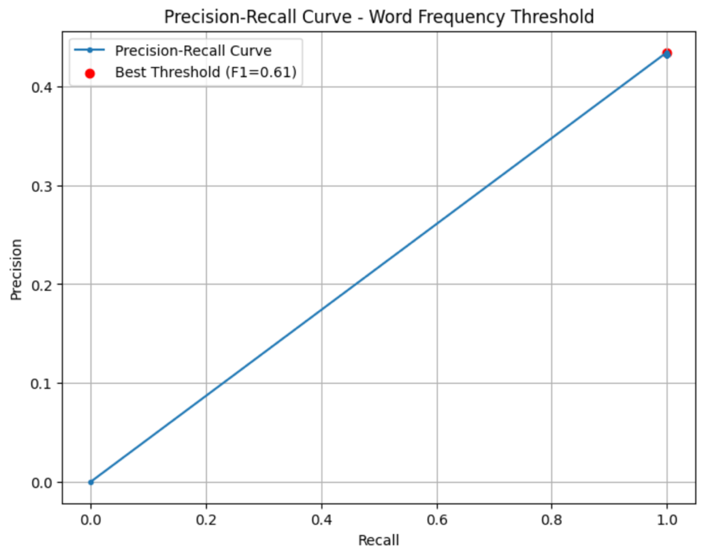

P-R Curve Analysis
The P-R curve for the word-frequency baseline on the training set exhibits the following trend:
Recall Range: Recall spans a wide range from 0 to 1. This shows that the classifier is able to identify all complex words at some threshold.
Precision vs. Recall: The curve shows a linear inverse relationship in which as recall increases, precision decreases. At very high recall near to 1, precision is very low, and vice versa.
Best Threshold Highlight: The red dot marks the best threshold (F1=0.61), showing the point of best balance between precision and recall. This lies where both metrics are moderate, but neither is maximized.
Overall Trend: The curve is simple and steep, indicating that this model has only a few useful thresholds, likely because word frequency is a coarse and noisy indicator of word complexity.

Discussion

In general terms, the word-length baseline outperforms the word-frequency baseline in both precision and recall, producing a better-shaped P-R curve and higher F1 score. This makes it a more reliable feature for identifying complex words in this task.
Probably, the reason why the word-length baseline outperforms is that word length is a strong proxy for complexity and longer words tend to be more complex across many domains. Another aspect is that word frequency is noisy. For instance, common but complex words such as “although” and “however” occur frequently but are still semantically difficult. Finally, the word-frequency curve suggests that it cannot clearly separate simple from complex words, while word-length does so more reliably. Now let’s talks about the performance evidence we can observe in the two curves:

Word-Frequency Baseline Graph:
- Precision-recall curve is nearly linear, with very limited shape.
- The best F1 score is only 0.61, indicating poor balance between precision and recall.
- Very low precision and recall across most thresholds, suggesting poor discriminative power from frequency alone.

Word-Length Baseline Graph:
- Curve is much more informative and varied.
- Maintains high precision (~0.7 to 0.85) for a wide range of recall.
- Shows a clear optimal tradeoff zone, making it more effective for classification.
- This curve leads to much higher F1 scores across a broad threshold range.

3.1 Naive Bayes (4 points)

Results
- Train Set:
  - Precision: 0.4950
  - Recall: 0.9798
  - F-score: 0.6577
- Dev Set:
  - Precision: 0.4693
  - Recall: 0.9689
  - F-score: 0.6323

3.2 Logistic Regression (4 points)

Results
- Train Set:
  - Precision: 0.7250
  - Recall: 0.6580
  - F-score: 0.6899

- Dev Set:
  - Precision: 0.7268
  - Recall: 0.6938
  - F-score: 0.7099

3.3 Discussion on NB and LR (6 points)

Model Comparison

Based on the evaluation results, the Logistic Regression classifier outperformed the Naive Bayes model on both the training and development datasets. It achieved higher precision, recall, and F1-score, indicating better overall classification accuracy in identifying complex words.

Performance Analysis

The performance gap can be attributed to the underlying assumptions and learning mechanisms of the two models. Naive Bayes assumes that the input features (word length and word frequency) are conditionally independent given the class label. However, in practice, these features are likely correlated (e.g., longer words often tend to be less frequent), violating the independence assumption and leading to suboptimal probability estimates.

In contrast, Logistic Regression makes no such assumption. As a discriminative model, it directly optimizes the decision boundary between classes by modeling the conditional probability of the label given the features. This allows it to better adapt to the structure in the data, especially when features interact or correlate. Therefore, Logistic Regression is more flexible and expressive, leading to superior performance in this binary classification task.

4.1 Own model's performance (6 points)

Dev Set Performance
- Precision: 0.7744
- Recall: 0.7392
- F1-score: 0.7564

4.2 Own model's analysis (15 points)

Model Description

To solve the task of identifying complex words, I experimented with multiple models including Naive Bayes, Logistic Regression, and a custom feature-enhanced Logistic Regression model. The best performance was achieved by the final model: a Logistic Regression classifier trained on three engineered features. This model consistently outperformed all baselines and earlier classifiers in terms of F1-score on the development dataset.

Features Description
The final model used the following features:
- Word Length: The number of characters in a word. Longer words tend to be more complex.
- Word Frequency: Unigram frequency from Google NGram data. Less frequent words are typically more difficult.
- Syllable Count: Estimated using the syllables library. Words with more syllables are generally harder to process.
These features were normalized using z-score normalization to improve model convergence and ensure comparability.

Feature Selection Justification
Initially, I evaluated models using only word length and frequency. While this performed decently, error analysis revealed many misclassified polysyllabic words. To address this, I added syllable count as a third feature. This led to a noticeable improvement in F1-score on the dev set. Each feature captures a different signal of linguistic complexity, and the combination allowed the model to generalize better across edge cases. Logistic Regression was chosen because of its robustness and ability to learn from continuous, correlated features without the independence assumptions that limited Naive Bayes.

Performance Examples

Correctly Classified:
- True Complex: predicament, unprecedented, philanthropy
- True Simple: dog, sun, school

Incorrectly Classified:
- False Complex (Simple words predicted as complex): chef, bike, taxi
- False Simple (Complex words predicted as simple): equivocate, juxtaposition, reconciliation

Error Analysis

Category 1: Low-frequency short words
- Examples: chef, zen, visa
- Potential reason: These words are short (and appear simple), but are relatively rare or domain-specific, leading the model to flag them as complex due to low frequency despite their simplicity.

Category 2: High-frequency complex words
- Examples: however, although, because
- Potential reason: These are function words that are very frequent in natural text, which misleads the model into classifying them as simple, even though their usage can involve subtle discourse relations that are conceptually complex.

