**Pascal Compiler Final Report**

**By: Christopher Cartagena**

**Introduction:**

In these two projects, the goal was to first perform type and scope checking. This would be done by adding semantic decoration to the existing syntax structure, that was created in the previous project. In the second project the memory of all the variables was computed, this was done being wary of the scope, so the memory numbering was restarted after every new scope and resumed at the close of the scope.

**Methodology:**

In order to get started talking about project 3, the previous projects should be explained in some small detail. The methodology for the first project consisted of creating several finite state machines by paper first to see ways in which to parse for tokens. After defining the state machines, several macros define statements were added to the header file. These defined numbers that specified a type, or the attribute for a token. The state machines where then created, and then tested using several text files to see that they were parsed correctly, and that the program was able to catch all lexical errors that were implemented. The way the next project was implemented was to start out by performing the following massaging operations, these consisted of the following:

1. Removal of ambiguity (except the dangling else ambiguity)

2a. Elimination of nullable productions

2b. Elimination of immediate and deep left recursion

1. Left factoring

The first operation was performed in a word document, and all the eligible grammars were massaged. The second was done by copying from the resulting grammar of the first, and then copied into a new word document, and then all the eligible grammars were massaged. The third operation was done by copying from the resulting grammar of the second, and then copied into a new word document, and then all the eligible grammars were massaged. The fourth operation was done by copying from the resulting grammar of the third, and then copied into a new word document, and then all the eligible grammars were massaged.

After the final massaging operation was completed the first and follow of all the variables was found and stored into an excel file. Following this procedure, the parse table of the grammar was created, and stored into an excel file. A python script was then created that would read in the excel file and output the recursive decent parser in C syntax. The resulting syntax analyzer was then incorporated into the previously created Lexical Analyzer.

The process that was followed in project 3 was to decorate by hand, this was done by creating parse trees of all the grammar, and then decorating using paper and pencil. I first started with declaration processing, as it seemed it would be the easiest to implement, I then continued to type checking. In order to do this, I had to start from the bottom up, because of the way the grammars call itself, this means the last symbols in the grammar to be called would be at the very bottom. Scope checking was the final decoration to be added to the grammar.

In order to add

The following are images of the results of the hand decorations done.

**Implementation:**

One of the first things that needed to be created for the project were the structs that were to be used to define a token. The token was defined using a struct and a union. The struct defined the line number that the token was to be found at, the lexeme of the token, its type and the union attrib, which defined the attribute, finally there was a pointer to the next token. The attrib union defined the attribute of the token as either an integer value which would be the case for most tokens, or a pointer to an integer which would be the case for an id, where the pointer was to the memory address where the id was stored. The lines were counted using a global variable that incremented every time a new line was read in. To keep track of the reserved words for the pascal language, a text file with all of them was created, and then fed into a linked list. Then to check for a match the linked list was iterated over, and every reserved word compared to the pulled lexeme. The reserved words that were used were the following:

|  |  |
| --- | --- |
| **if** | **else** |
| **then** | **while** |
| **program** | **do** |
| **var** | **or** |
| **array** | **div** |
| **of** | **mod** |
| **integer** | **and** |
| **real** | **not** |
| **procedure** | **call** |
| **begin** |  |
| **end** |  |

The first machine that was implemented was the whitespace machine, which basically just moved the index of the buffer that contained the current line, past the white space, tabs, or new line characters. The next machine that was implemented was the id state machine which would read in an alphabetical character first, and then read in the following alphanumerical characters that followed. This state machine capped off at 10 characters and generated an error if it saw a longer id.

The next machine was the relational operator machine, this machine first tried to look for the longer relational operators like the not equals, greater than or equals, or less than or equal to first. Then after that it looked for the rest of the relational operators. The machine that looked for numbers, first looked to see if the number was a long real, if it did not find it, then it checked if it was a short real, and if it did not find it then assumed that it was an integer. This machine then passed the parsed number to separate smaller machines that handled each case where it was either an integer, a short real, or a long real.

Aside from the above state machines, other function where also implemented in order to check for lexical errors, or add a token to the token linked list, to covert the macros used to string for details, or to print the token, and listing output.

After the massaging operations were performed in pencil and paper, a python script was created to write the recursive decent parser. The way this was done was by first importing the excel file the parse table was written in. The first row was stored to signify all the available terminals. The first column was also stored, and these were all the variables. Furthermore, a file which contained all the terminals and their associated macro defined numbers was also used. This was so that case statements could be used to reference the defined numbers and as a means of cross referencing them in the python script.

The python script then goes through all the variables parse table values, and checks if any of they are terminals. If they are not terminals then the script will call the function, if not then a match statement is called with the parameter of the terminal. All the functions that are used for the variables have been defined at the very top of the file. The synch set is then used in the default in order to synch any syntax errors that could be encountered. Any syntax errors that are generated in the middle of processing are stored into a linked list for syntax errors, and their line numbers are also stored.

Once the parsing has been completed, either as a result of the end of file token being correctly encountered, or a result of too many syntax errors, the listing file is created. The way in which the listing file is created is that for each line that is printed, the linked list for the syntax analyzer is traversed to see if there were any syntax errors at that line, if so, it will print them out.

In order to implement the semantic decorations in the current syntax analyzer, they were added in between function calls. Furthermore, several of the functions that were called in the program were changed from void to returning an integer. This was to incorporate the attribute behavior that many of them had. Not just that, but for several of the functions, a parameter had to be added to its function definition, this was in order to mimic the inherited attribute behavior that they would have.

Furthermore, a new file was created for this project, that would have all the functions necessary to perform the semantic analysis. In order to perform the table checking behavior of the grammar, several if statements were used. The errors that would be reported in the grammar were only reported one time, to make sure there would not be a cascading of errors that were all trying the report the same one.

In order to perform the scope checking part of the behavior what needed to be done was that there would have to be a close scope function that would close the parameters currently in the infrastructure that would be used to check for scope. To assign for memory adding function was added almost alongside of the scope checking. This memory was done by having a global memory counter, and any time a new variable was declared then it would be continued. Also, anytime that a new scope was created then it would be reset to 0. This memory allocation had the added the feature that it would restart the numbering from the last place that the last scope had left it off. This is because a stack was used to store the previous memory numbering before it was reset to 0, when a new scope was reached.

**Discussions and Conclusions:**

The first part was built in a way that a further machine could receive all the tokens in a linked list, which makes it helpful for implementing the second part of this project, in which a syntax analyzer is used. The conclusion of this project was a program that could extract tokens related to the pascal language from a text file, and furthermore be able to identify some of the lexical errors that could occur and give details about them.

The second part was built using a recursive decent parser from a massaged LL1 grammar. The massaging operation was probably the harder part of this assignment, while not very complex in the process, it was a bit tedious. Once this was done however, the recursive decent parser code was easily created with the help of a python script that was created. There was also a debugging portion that was done, to find a couple of problems mostly with the way that the parse table in the excel file, this was mainly due to incorrect grammar being placed, basic human error. The resulting syntax analyzer is now ready for semantic decoration.

The final part of this project was to declaration processing, type/scope checking, and memory allocation. This was all done by decorating the previous grammar with semantic decorations. Furthermore, some of the previous functions had to be changed to return integers, and this was due to having to return attributes, and to pass inherited attributes.

**Appendix I: Sample Inputs and Outputs**

**Sample program:**

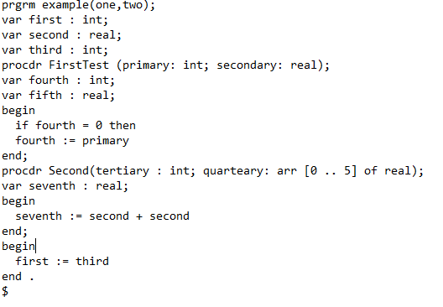

**Listing Output:**

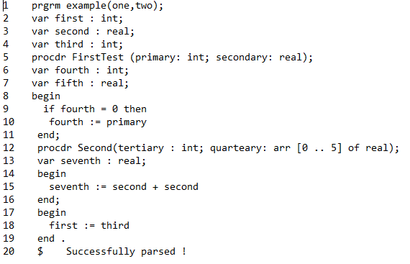

**Appendix II:**

**Token Output:**

Line Lexeme Token Type Attribute

1 prgrm 3 PROGRAM 0 NULL

1 example 20 ID B1A0E0 NULL

1 ( 80 OPEN_PARENTHESES 0 NULL

1 one 20 ID B19ED0 NULL

1 , 82 COMMA 0 NULL

1 two 20 ID B1A170 NULL

1 ) 81 CLOSED_PARENTHESES 0 NULL

1 ; 79 SEMICOLON 0 NULL

2 var 4 VAR 0 NULL

2 first 20 ID B1A0F0 NULL

2 : 75 COLON 0 NULL

2 int 7 INT 0 NULL

2 ; 79 SEMICOLON 0 NULL

3 var 4 VAR 0 NULL

3 second 20 ID B1A120 NULL

3 : 75 COLON 0 NULL

3 real 8 REAL 0 NULL

3 ; 79 SEMICOLON 0 NULL

4 var 4 VAR 0 NULL

4 third 20 ID B1A1B0 NULL

4 : 75 COLON 0 NULL

4 int 7 INT 0 NULL

4 ; 79 SEMICOLON 0 NULL

5 procdr 9 PROCEDURE 0 NULL

5 FirstTest 20 ID B1AB80 NULL

5 ( 80 OPEN_PARENTHESES 0 NULL

5 primary 20 ID B1ADC0 NULL

5 : 75 COLON 0 NULL

5 int 7 INT 0 NULL

5 ; 79 SEMICOLON 0 NULL

5 secondary 20 ID B1ACD0 NULL

5 : 75 COLON 0 NULL

5 real 8 REAL 0 NULL

5 ) 81 CLOSED_PARENTHESES 0 NULL

5 ; 79 SEMICOLON 0 NULL

6 var 4 VAR 0 NULL

6 fourth 20 ID B1AC00 NULL

6 : 75 COLON 0 NULL

6 int 7 INT 0 NULL

6 ; 79 SEMICOLON 0 NULL

7 var 4 VAR 0 NULL

7 fifth 20 ID B1AC40 NULL

7 : 75 COLON 0 NULL

7 real 8 REAL 0 NULL

7 ; 79 SEMICOLON 0 NULL

8 begin 10 BEGIN 0 NULL

9 if 1 IF 0 NULL

9 fourth 20 ID B1BF90 NULL

9 = 160 RELOP 124 EQU

9 0 7 INT 22 VALUE

9 then 2 THEN 0 NULL

10 fourth 20 ID B1C020 NULL

10 := 163 ASSIGNOP 0 NULL

10 primary 20 ID B1C160 NULL

11 end 11 END 0 NULL

11 ; 79 SEMICOLON 0 NULL

12 procdr 9 PROCEDURE 0 NULL

12 Second 20 ID B1BF50 NULL

12 ( 80 OPEN_PARENTHESES 0 NULL

12 tertiary 20 ID B1C230 NULL

12 : 75 COLON 0 NULL

12 int 7 INT 0 NULL

12 ; 79 SEMICOLON 0 NULL

12 quarteary 20 ID B1C210 NULL

12 : 75 COLON 0 NULL

12 arr 5 ARRAY 0 NULL

12 [ 84 OPEN_BRACKET 0 NULL

12 0 7 INT 22 VALUE

12 .. 83 DOUBLE_PERIOD 0 NULL

12 5 7 INT 22 VALUE

12 ] 85 CLOSED_BRACKET 0 NULL

12 of 6 OF 0 NULL

12 real 8 REAL 0 NULL

12 ) 81 CLOSED_PARENTHESES 0 NULL

12 ; 79 SEMICOLON 0 NULL

13 var 4 VAR 0 NULL

13 seventh 20 ID B1D370 NULL

13 : 75 COLON 0 NULL

13 real 8 REAL 0 NULL

13 ; 79 SEMICOLON 0 NULL

14 begin 10 BEGIN 0 NULL

15 seventh 20 ID B1D570 NULL

15 := 163 ASSIGNOP 0 NULL

15 second 20 ID B1D450 NULL

15 + 161 ADDOP 71 ADD_SYMBOL

15 second 20 ID B1D620 NULL

16 end 11 END 0 NULL

16 ; 79 SEMICOLON 0 NULL

17 begin 10 BEGIN 0 NULL

18 first 20 ID B1D680 NULL

18 := 163 ASSIGNOP 0 NULL

18 third 20 ID B1E110 NULL

19 end 11 END 0 NULL

19 . 78 PERIOD 0 NULL

20 $ 200 EOF 0 NULL

**Memory Allocation:**

