Forw, hazard, beq4 | PC | 1 | 2 | 3 | 4 | 5 | 6 | 7 | 8 | 9 | 0 | 1 | 2 | 3 | 4 | 5 | 6 | 7
Add r1,r2,r2 | 0 | F | D | E | M | W | 4
Lw r1,0(r1) | 4 |  | F | D | E | M | W | 1 |  |  |  | F | D | E | M | W | 1
Beq r1,r8,-3 | 8 |  |  | F | D | D | E | M | - |  |  |  | F | D | D | E | M | W
Add R1,r1,r1 | c |  |  |  | F | F | D | E | M | W | 2 |  |  | F | F | D | E | M
Beq r1,r8,-3 | 10 |  |  |  |  |  | F | D | E | M | - |  |  |  |  | F | D | E
Beq r2,r2,-5 | 14 |  |  |  |  |  |  | F | D | E | M | - |  |  |  |  | F | D
Sub r6,r4,r2 | 18 |  |  |  |  |  |  |  | F | D | E | M | W |  |  |  |  | F
Or r7,r5,r1 | 1c |  |  |  |  |  |  |  |  | F | D
And r9,r7,r3 | 20 |  |  |  |  |  |  |  |  |  | F
 | 24

Forw,hazard, beq 2 sem forward e hazard | PC | F | D | E | M | W
Add r1,r2,r2 | 0 | 1 | 2 | 3 | 4 | 5 | R1=4
Lw r1,0(r1) | 4 | 2,9 | 3,10 | 4,11 | 5,12 | 6,13 | R1=1,0
Beq r1,r8,-3 | 8 | 3,10,16... | 4,5, 11,12 | - | - | - | f
Add R1,r1,r1 | 12 | 4,5, 11,12 | 6,13 | 7,14 | 8,15 | 9,16 | 2,0
Beq r1,r8,-3 | 16 | 6,13 | 7,14 | - | - | - | F
Beq r2,r2,-5 | 20 | 7.14 | 8,15 |  |  |  | T
Sub r6,r4,r2 | 24 | 8 | - | - | - | -
 | 28
 | 32
 | 36

 | PC | 1 | 2 | 3 | 4 | 5 | 6 | 7 | 8 | 9 | 0 | 1 | 2 | 3 | 4 | 5 | 6 | 7
 | 0
 | 4
 | 8
 | c
 | 10
 | 14
 | 18
 | 1c
 | 20
 | 24

F,h,Beq2 com F,H | PC | F | D | E | M | W
Add r1,r2,r2 | 0 | 1 | 2 | 3 | 4 | 5
Lw r1,0(r1) | 4 | 2,11 | 3,12 | 4 | 5 | 6
Beq r1,r8,-3 | 8 | 3,12 | 4,5,6,  13,14,15 | hazard | beq |  | F
Add R1,r1,r1 | 12 | 4,5,6  13,14,15 | 7forw | 8 beq | 9 | 10
Beq r1,r8,-3 | 16 | 7 | 8,9H
Beq r2,r2,-5 | 20 | 8,9 | 10
Sub r6,r4,r2 | 24 | 10
 | 28
 | 32
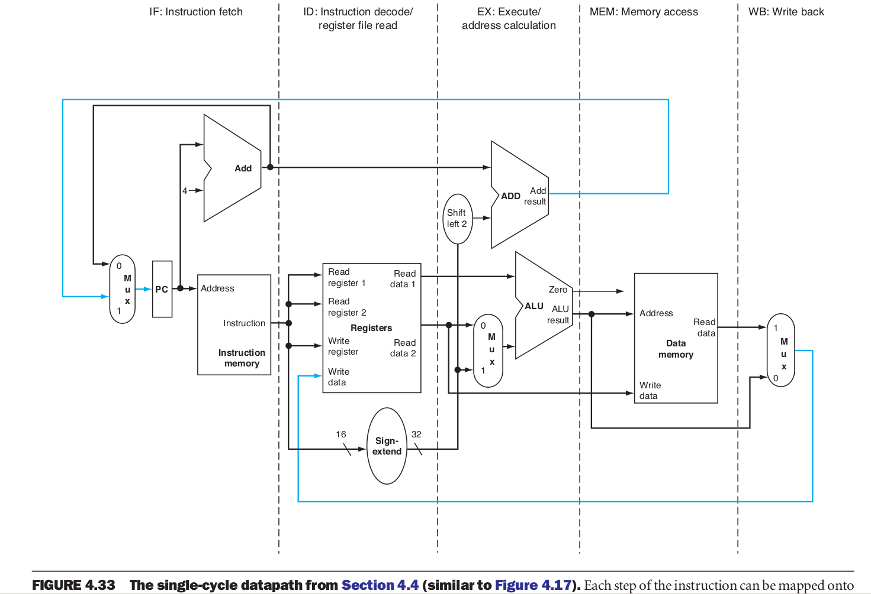

DUAL | PC | F | D | E | M | W
Add r1,r1,r1 | 0 | 1,5,9 | 2,6,10 r1=4 | 3,7 | 4,8 | 5,9 | R1=2,4
Lw r4,0(r8) | 0 | 1.5,9 | 2,6,10 | 3,7 | 4,8 | 5,9 | r4=2
Sub r2,r3,r1 | 4 | 2,6,10 | 3,7r1=5 | 4,8 | 5,9 | 6,10 | r2=-2
Sw r1,4(r8) | 4 | 2,6,10 | 3,7r1=5 | 4,8 | 5,9 | 6,10 | m3=5
Addi r1,r1,4 | 8 | 3,7 | 4,8r1=6 | 5,9 | 6,10 | 7,11 | r1=10
Beq r2,r2,-3 | 8 | 3,7 | 4,8 | - | - | - | 8+4  -3*4=0
ORi r1,r1,4 | 12 | 4,8 | 5,9 r1=2 | 6,10 | 7,11 | 8,12 r1=6 | Sempre  exec.
NOP | 12

