Example
0: 00210820; // add r1,r1,r1 1+1=2
4: 00210820; // add r1,r1,r1 2+2=4
8: 00210820; // add r1,r1,r1 4+4=8
c: 00210820; // add r1,r1,r1 8+8=16
10:8c010000; // lw r1,0(r0) r1=0
14:00210820; // add r1,r1,r1 0+0=0 – Stall 1 cycle
18:ac010000; // sw r1,0(r0) 0
1c:20010001; // addi r1,r0,1 0+1=1
20:01e1102a; // slt r2, r15, r1 15 < 1 < 2 < 4 < 8 < 16
24:00210820; // add r1,r1,r1 1+1=2
28:1040fffd; // beq r2,r0, -3 branch r2==0 to 0x28+4-12= 32+8+4-12=32=0x20
// stall 3 cycles 4 times,
// 5 cycles + 8 (addi) + 5x3 loop + 4*3 stalls = 40 cycles

Example
5add

add R1,R2,R3
add R3,R2,R0
add R4,R2,R0
add R5,R2,R0
add R6,R2,R0

3addForward

ADD r2,r1,r3
ADD r3,r2,r1 //EXE HAZARD
ADD r1,r3,r2 //EXE HAZARD

addSLTBEQ

ADD r1,r1,r1
SLT r2, r15, r1
BEQ r2,r0, -5

lwINCsw

lw R1,4(R0)
add R1,R1,R1
sw R1,4(R0)

ex_m1_plus_m2_to_m3

Lw R1,4(R4)
Lw R2,8(R4)
add R3,R1,R2
Sw R3,12(R4)

Recordando:
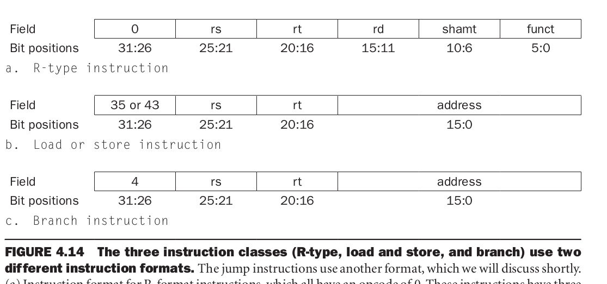
Suponha o código 35 para Load, 43 para Store, 4 para BEQ, 0 para R-type com func=32 para ADD, SUB (func=34), AND (func=36), OR (func=37). Opcode 8 para ADDI.
SLT R1,R2,R3; R1 = ( R2 < R3) com opcode 0 e func=42.
Jump com opcode 2.

A pasta test tem vários arquivos com ASM e o HEX prontos
t0001-final_value.fv.asm
----------------- FILE CONTENTS ---------------------
addi $v0, $zero, 0
addi $v1, $zero, 1
addi $t0, $zero, 2
addi $t1, $zero, 3
addi $t2, $zero, 4
addi $t3, $zero, 5
addi $t4, $zero, 6
addi $t5, $zero, 7
addi $t6, $zero, 8
addi $t7, $zero, 9

t0005-branch.asm
----------------- FILE CONTENTS ---------------------

#
# t0005-branch.asm
#
# Perform branches (beq, bne) which would create hazards
# and see if they are handled correctly.
#

# initial values
addi $t0, $zero, 1
addi $t1, $zero, 2

# increment $t0 so it equals $t1
addi $t0, $t0, 1

beq $t0, $t1, skip1

# these shouldn't get added
# If they do, the third hex digit will be 1
addi $t0, $t0, 256
addi $t1, $t1, 256

skip1:

add $t0, $t0, $t1 # 2 + 2 = 4
add $t1, $t0, $t1 # 4 + 2 = 6

bne $t0, $t1, skip2

# these shouldn't get added
# If they do, the fourth hex digit will be 1
addi $t0, $t0, 4096
addi $t1, $t1, 4096

skip2:

# $t0 = 4, $t1 = 6

# so the values show up in the dump
add $t0, $zero, $t0
add $t1, $zero, $t1

t0005-branch.fv.asm
----------------- FILE CONTENTS ---------------------

#
# t0005-branch.fv.asm
#
# Perform branches (beq, bne) which would create hazards
# and see if they are handled correctly.
#

# initial values
addi $t0, $zero, 1
addi $t1, $zero, 2

# increment $t0 so it equals $t1
addi $t0, $t0, 1

beq $t0, $t1, skip1

# these shouldn't get added
# If they do, the third hex digit will be 1
addi $t0, $t0, 256
addi $t1, $t1, 256

skip1:

add $t0, $t0, $t1 # 2 + 2 = 4
add $t1, $t0, $t1 # 4 + 2 = 6

bne $t0, $t1, skip2

# these shouldn't get added
# If they do, the fourth hex digit will be 1
addi $t0, $t0, 4096
addi $t1, $t1, 4096

skip2:

# $t0 = 4, $t1 = 6

t0006-jump.fv.asm
----------------- FILE CONTENTS ---------------------

#
# Test the jump operation.
#

# start: $t0 = 1
addi $t0, $zero, 1

# should skip adding 256 to $t0
j skip1
addi $t0, $t0, 256
skip1:

# $t0 = 2
addi $t0, $t0, 1

# should skip adding 512 to $t0
j skip2
addi $t0, $t0, 512
skip2:

# $t0 = 3
addi $t0, $t0, 1

t0011-operators.fv.asm
----------------- FILE CONTENTS ---------------------

#
# Test some binary operators.
#

# initial values
addi $t0, $zero, 6 # (0110)
addi $t1, $zero, 11 # (1011)

# do some operations
xor $t2, $t0, $t1 # 0110 ^ 1011 = 1101
and $t3, $t0, $t1 # 0110 & 1011 = 0010
or $t4, $t0, $t1 # 0110 | 1011 = 1111
nor $t5, $t0, $t1 # ~(0110 | 1011) = 0000

# $t0 = 6, $t1 = 11 (0xb), $t2 = 13 (0xd), $t3 = 2, $t4 = 15 (0xf), $t5 = 0

t0020-stall.fv.asm
----------------- FILE CONTENTS ---------------------

#
# Test whether operations which require a stall and
# forward work correctly.
#

# initial values
addi $t0, $zero, 5
addi $t1, $zero, 7
addi $t2, $zero, 9

# store words in memory
sw $t0, 0($zero) # 5
sw $t1, 4($zero) # 7

# read the memory and perform an operation
# *** stall and forward required ***
lw $t2, 4($zero) # 7
add $t3, $t0, $t2 # 5 + 7 = 12

# $t0 = 5, $t1 = 7, $t2 = 7, $t3 = 12 (0x0c)

t0021-stall.fv.asm
----------------- FILE CONTENTS ---------------------

#
# Operations which are dependent on the results of previous operations
# will require a stall or some other action to avoid a mis-calculation.
#
# Perform these dependent operations and see if they work.
#

# initial values
addi $t0, $zero, 1
addi $t1, $zero, 5
addi $t2, $zero, 7

add $t0, $t0, $t1 # $t0 = 1 + 5 = 6
add $t1, $t0, $t1 # $t1 = 6 + 5 = 11
add $t2, $t1, $t0 # $t2 = 11 + 6 = 17
add $t0, $t2, $t1 # $t0 = 17 + 11 = 28

# $t0 = 28 (0x1c), $t1 = 11 (0x0b), $t2 = 17 (0x11)

t0030-lw_sw.fv.asm
----------------- FILE CONTENTS ---------------------

#
# Test the lw, and sw opertions.
#

addi $t0, $zero, 5
addi $t1, $zero, 9

sw $t0, 0($zero) # 5
sw $t1, 4($zero) # 9

lw $t0, 4($zero) # 9
add $t0, $t0, $t1 # 9 + 9 = 18

# $t0 = 18 (0x12), $t1 = 9

