1. doc: D:\namorlize\5.2 Documentation Updates
2. **Normalize installation:**
   1. Prepare
3. new 2 windows 2012 VM （one for SQL/ORA database, one for Normalize)
4. harddisk:100g
5. memory:(nl:8g,db:10g)
6. cup: 4 (at least)
7. win 2012 installation type： starndar server with GUI)
8. after vm created, ip set, but not connected. to fix: vm - edit setting - natwork adapter - network label (choose on available network, not the default here, very very importan.)
9. close firewall, enable remote connecting (pc- properties - remote setting), install .net 3.5, iis from control pannel - Turn Windows features on or off - features
   1. install DB servers on 11.183
10. SQL2014 : \\192.168.8.25\iso\APP\MicrosoftSQLServer\SQL2014 (installed)
11. ORA12.1.0.2: \\192.168.8.25\installer\Windows\Oracle\Database12.1.0.2 (installed)
12. SQL2016 : \\192.168.8.25\iso\APP\MicrosoftSQLServer\SQL2016
13. PatchForSQL2016: \\192.168.8.25\installer\Windows\Microsoft\SQLServer\KB2919355-x64.msu
    1. install DB client on 11.184
    2. Install DP.
14. Installer: \\192.168.8.25\installer\BDNA\Normalize5.5\test
15. 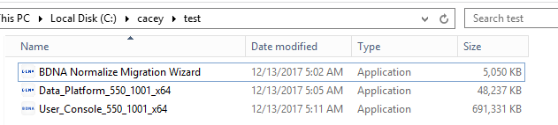
16. Install and uninstall DP once manually, in order to know what extra services needed to be installed before running the install scripts.

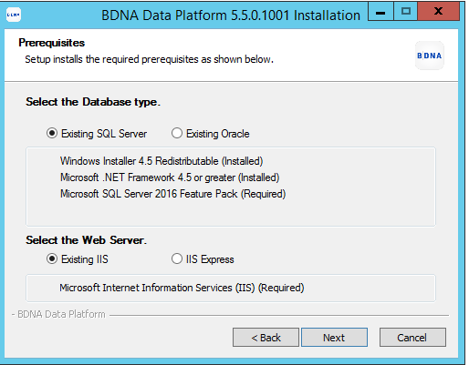

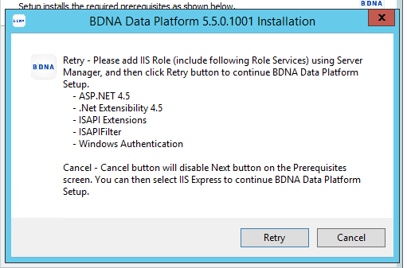

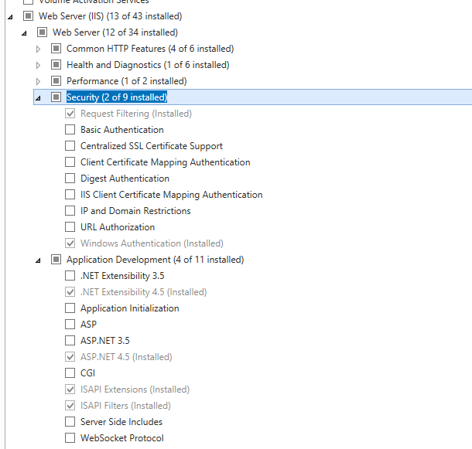

1. Install failed, need sqlncli:
2. 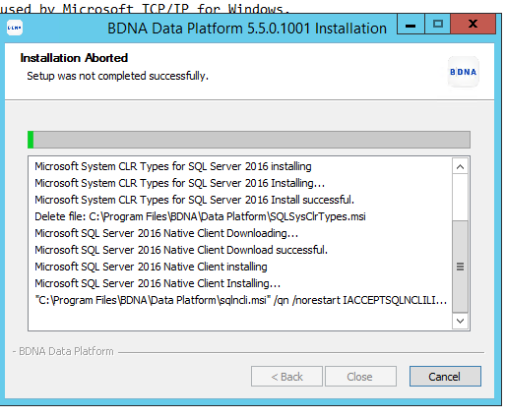
3. Install: \\192.168.8.25\app\BDNA\Components\SQL2016_sqlncli_x64_ENU.msi
4. Install DP again. Last step, you are required to activation key, means installation is OK. Cancel it.
5. Uninstall DP. (control panel)
   1. Configure script files. (script folder need to be put under root directory C:\InstallScript)
6. Scripts:

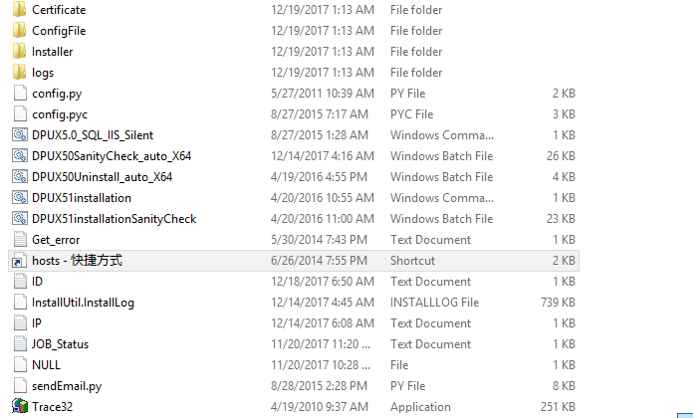

1. DPUX50SanityCheck_auto_X64.bat, 修改安装版本，安装类型，选好配置文件
2. 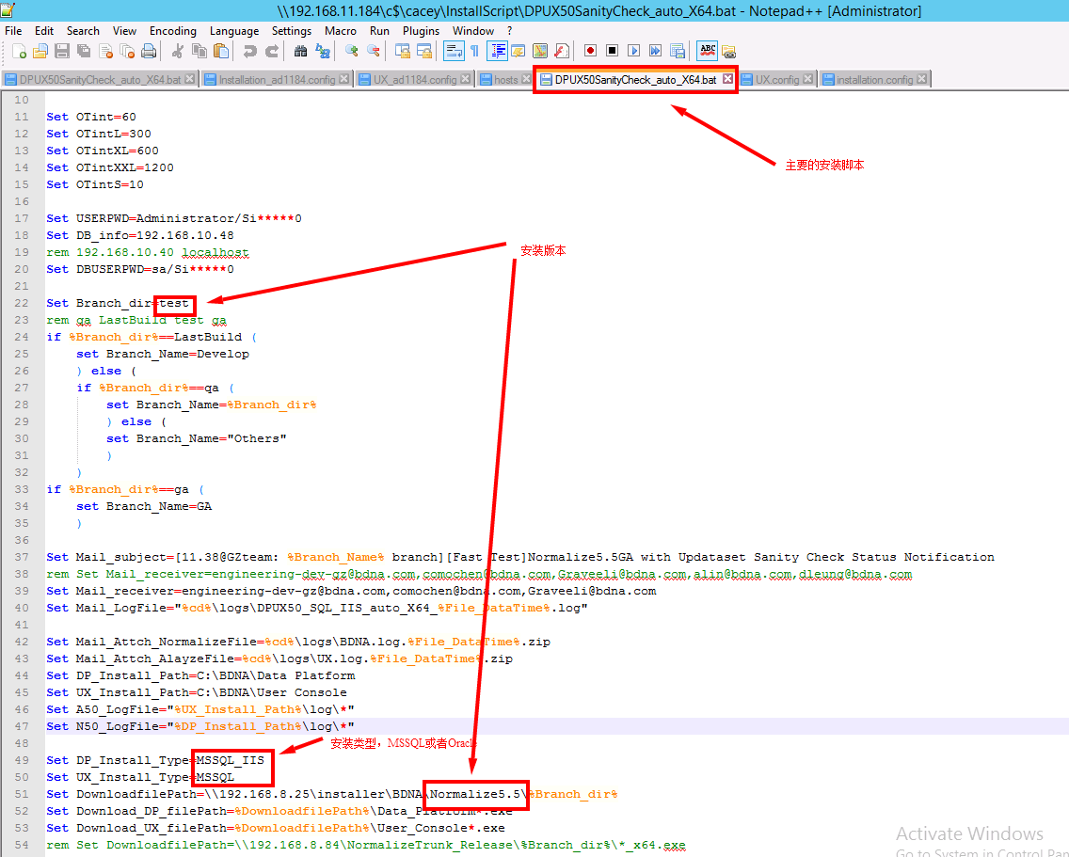
3. 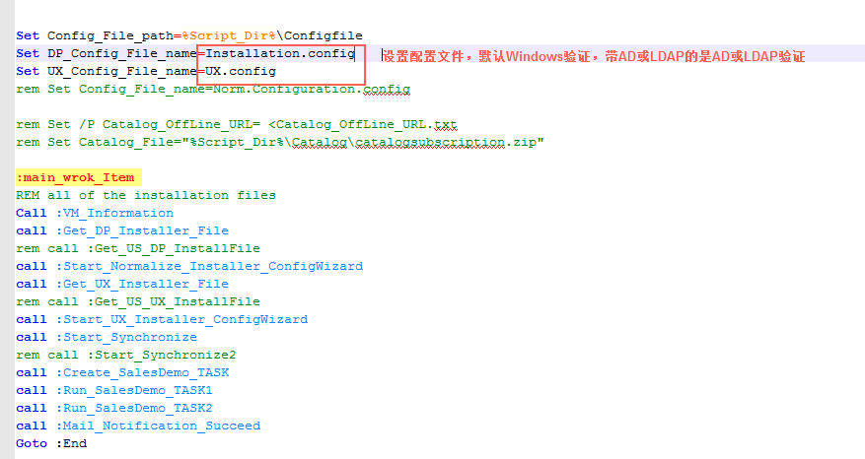
4. installation.config改数据库ip, 你设置了哪个installation.config就改哪个

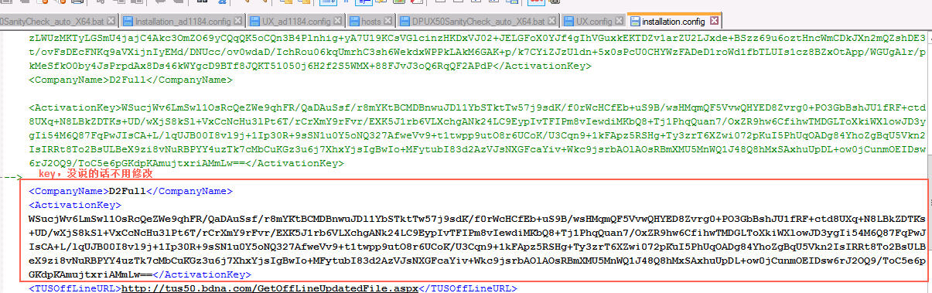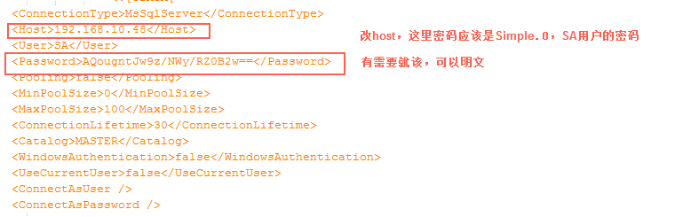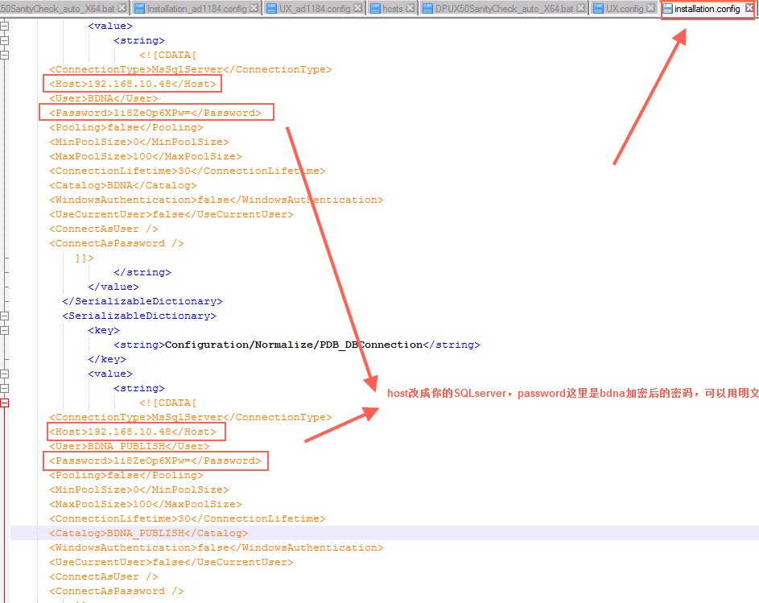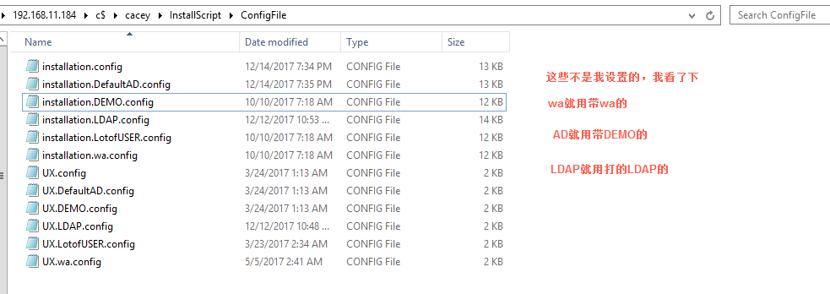

1. license path : update UX.config

<string>C:\InstallScript\Certificate\BDNA_20180317.nbilic</string>

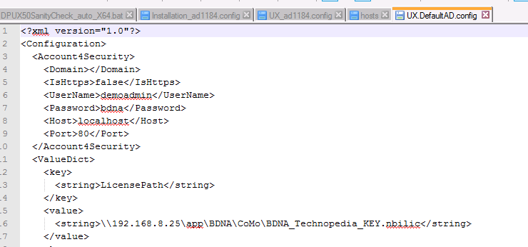

1. Modify file ‘hosts - 快捷方式‘ to design which size package we will load (full or small).
2. 改好，点DPUX5.0_SQL_IIS_Silent.cmd开始安装.
3. logs

C:\BDNA\User Console\Logs

C:\BDNA\Data Platform

C:\InstallScript\logs

1. 脚本出错，打开尝试手动跑/测试



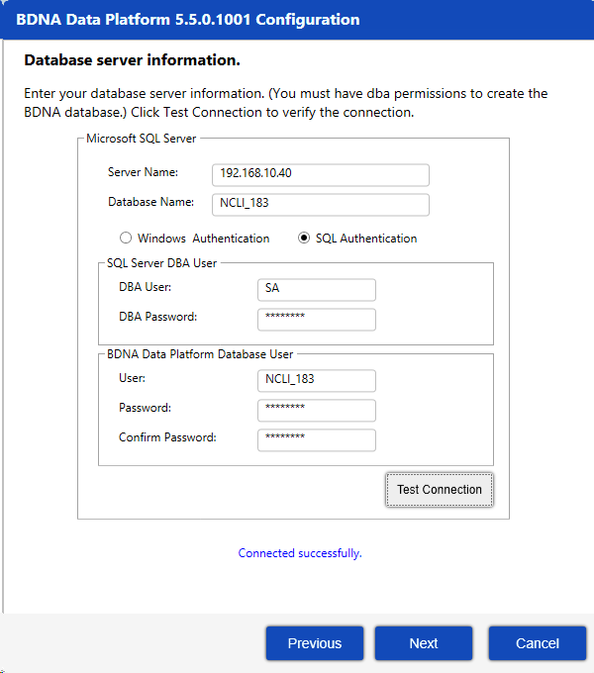

1. Incorrect license path，you can ignore this and open this tool to modify it manually.

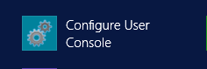

1. IIS error:

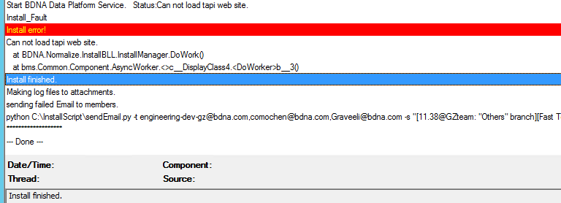

1. Method to fix this error: delete process related to User Console. (cause: not uninstall user console clearly.)

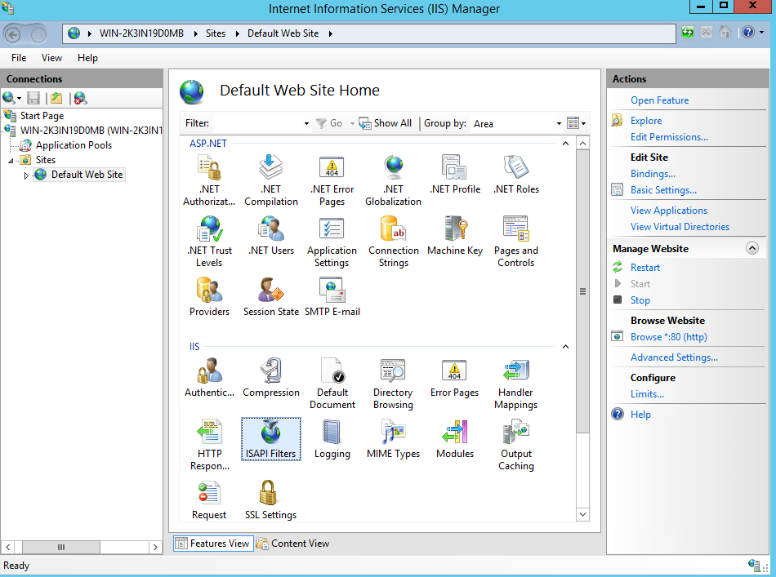

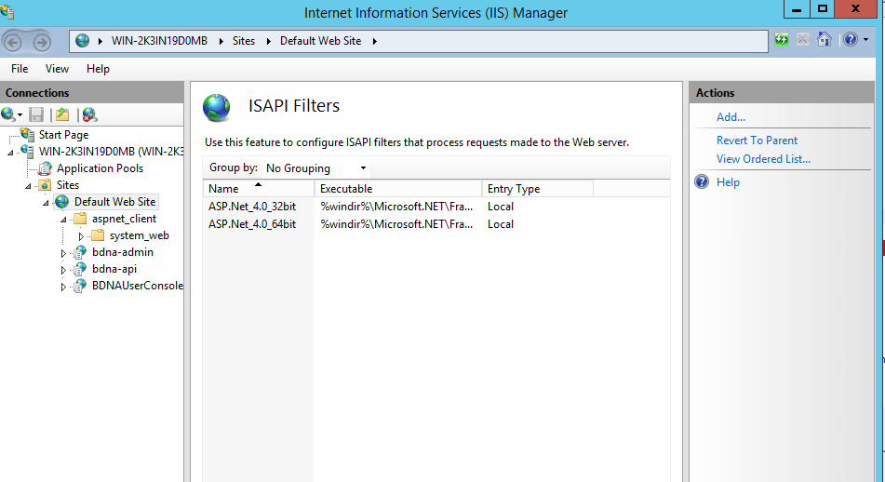

* 1. Open admin UI create tasks:

1. Click ‘T ‘ on right up corner -> click Start Catalog Sync -> you see words “last update”, means Sync finished.
2. Create Task -> back to Normalize tasks page (clicking ‘N’ on right up side) -> Create Process -> IT Discovery Tool -> next ->Select IT Discovery Tool ->Others: Normalize zip File ->Next

-> zip file (C:\InstallScript\CACEY\HPUD.zip)

c. How to delete inventory:

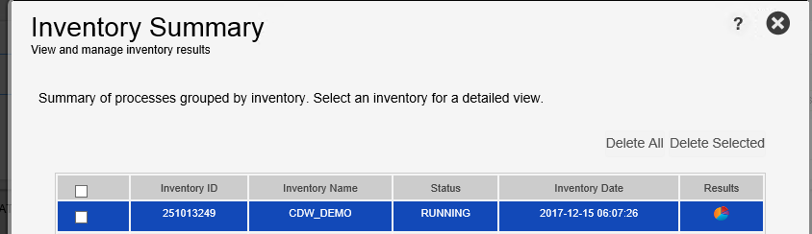

1. Available fields (210) for IT 的报告怎么看？
2. Create task for po (second choice) with csv file “C:\InstallScript\CACEY\CDW_DEMO.csv“, with user console host and credential (demoadmin/bdna).

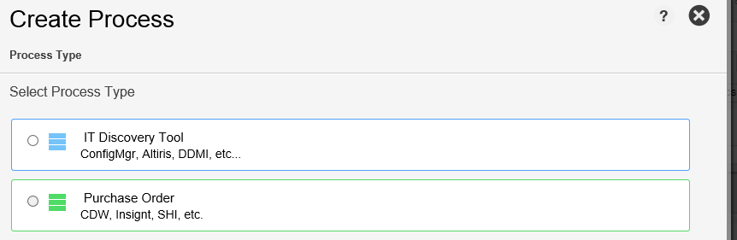

1. User Console:

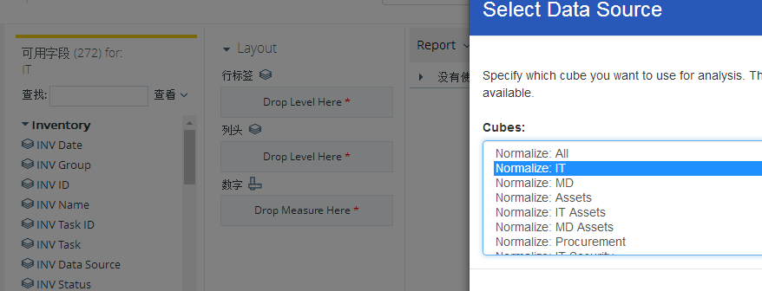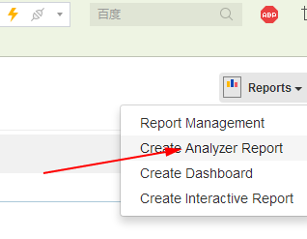

1. 1. Sql

SELECT * FROM BDNA_A_OBJ_ATT_METADATA$ WHERE ATT_OBJ_NAME LIKE '%SP';

SELECT * FROM BDNA_A_OBJ_METADATA$ WHERE P_OBJ_NAME LIKE '%SP';

select * from DIM_N_SYSTEM$ where [SYS_IS_DEDUPED] ='-';

select * from DIM_N_SYSTEM where [SYS_IS_DEDUPED] ='-';

select count(*) from DIM_N_SYSTEM$

select count(*) from DIM_N_SYSTEM;

* 1. Refresh all

<http://192.168.11.184/bdna/Home>

tool

* 1. Patch set:

Structure:

[bdna@VMDC8245 AnalyzePatchSet]$ ls

Installer Patch Readme.txt updater.config

Installer: same file as the source code (replace).

Patch: modified or new (hotfix).

Readme.txt: description for bugs.

updater.config:

1. Backup original files: backup dir for 'Rollback', one dir one node.

2. Run SQL: these sql for different DBType will be run while installing the patchset. (take effect right now, called hotfix, can be modified files or new files)

3. Update files: just the modified file, file in the installer. if the new file in 'Run SQL' was not included in source code, ignore it here.

3.1. 'Goto="end"' should be set in the last node, otherwise it will end earier.

4. Restore original files: if there are multiple node needed 'Rollback', 'id="Rollback" should be unique and in the first node.

4.1. 'ExitCode="1"' should be in the last Rollback node.

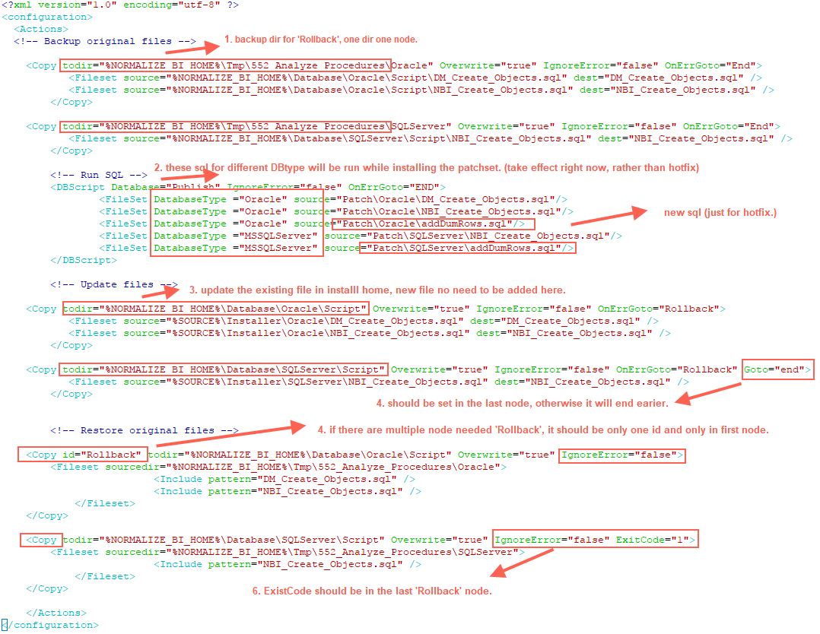

* 1. Zip Package (no itself sub folder)

[bdna@VMDC8245 AnalyzePatchSet]$ ls

Installer Patch Readme.txt updater.config

[bdna@VMDC8245 AnalyzePatchSet]$ zip -p -r AnalyzePatchSet.zip ./*

adding: Installer/ (stored 0%)

adding: Installer/Oracle/ (stored 0%)

adding: Installer/Oracle/NBI_Create_Objects.sql (deflated 92%)

adding: Installer/Oracle/DM_Create_Objects.sql (deflated 89%)

adding: Installer/SQLServer/ (stored 0%)

adding: Installer/SQLServer/NBI_Create_Objects.sql (deflated 92%)

adding: Patch/ (stored 0%)

adding: Patch/Oracle/ (stored 0%)

adding: Patch/Oracle/addDumRows.sql (deflated 72%)

adding: Patch/Oracle/NBI_Create_Objects.sql (deflated 92%)

adding: Patch/Oracle/DM_Create_Objects.sql (deflated 89%)

adding: Patch/SQLServer/ (stored 0%)

adding: Patch/SQLServer/addDumRows.sql (deflated 71%)

adding: Patch/SQLServer/NBI_Create_Objects.sql (deflated 92%)

adding: Readme.txt (deflated 23%)

adding: updater.config (deflated 78%)

[bdna@VMDC8245 AnalyzePatchSet]$ ls

AnalyzePatchSet.zip Installer Patch Readme.txt updater.config

[bdna@VMDC8245 AnalyzePatchSet]$

* 1. Patch set test:

C:\BDNA\User Console>.\Bin\Updater.exe /File=c:\AnalyzePatchSet.zip

Extracting...Done [OK]

Initialize Actions...Done [OK]

Executing action [0][CopyAction]...Done [OK]

Executing action [1][CopyAction]...Done [OK]

Executing action [2][DBScriptAction]...Done [OK]

Executing action [3][CopyAction]...Done [OK]

Executing action [4][CopyAction]...Done [OK]