ComplyVerse AI for Banking & Financial Services

Governance. Risk. Compliance. Unified by Intelligence.

The Banking GRC Challenge
Financial institutions face the most demanding regulatory environment of any industry. A mid-market bank simultaneously manages compliance across SBP (State Bank of Pakistan) regulations, PCI DSS for payment card security, ISO 27001 for information security management, SOX for financial reporting controls, OCC/FDIC requirements, Basel III capital standards, GLBA, and BSA/AML obligations.
Multi-entity structures — holding companies with subsidiary banks, wealth management divisions, and insurance arms — multiply this complexity, with each entity potentially subject to different regulatory requirements.
The result: internal audit departments executing 25–50 engagements annually, compliance teams manually mapping overlapping controls across 8+ frameworks, and examination preparation consuming weeks of senior staff time.

Platform Overview
ComplyVerse AI is an enterprise-grade, AI-native GRC platform that unifies audit management, compliance tracking, enterprise risk management, vulnerability management, IT asset governance, and evidence management into a single, multi-tenant platform.
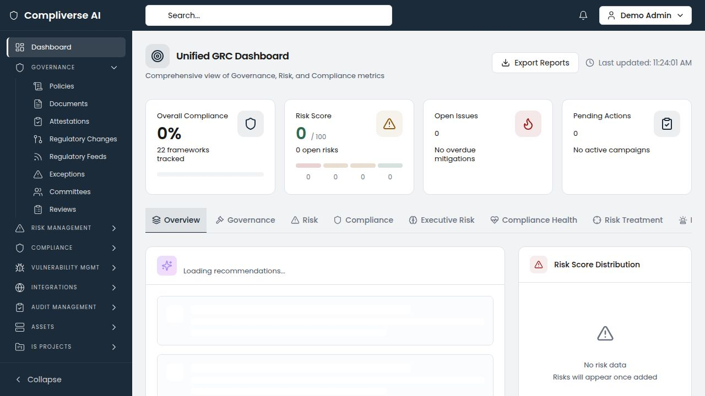

Banking-Specific Capabilities

Multi-Framework Control Mapping
Upload SBP regulations, PCI DSS, ISO 27001, and any other frameworks your institution must track. ComplyVerse AI's semantic similarity engine automatically identifies overlapping controls across all frameworks, creating unified control groups that eliminate duplicate mapping and evidence collection.
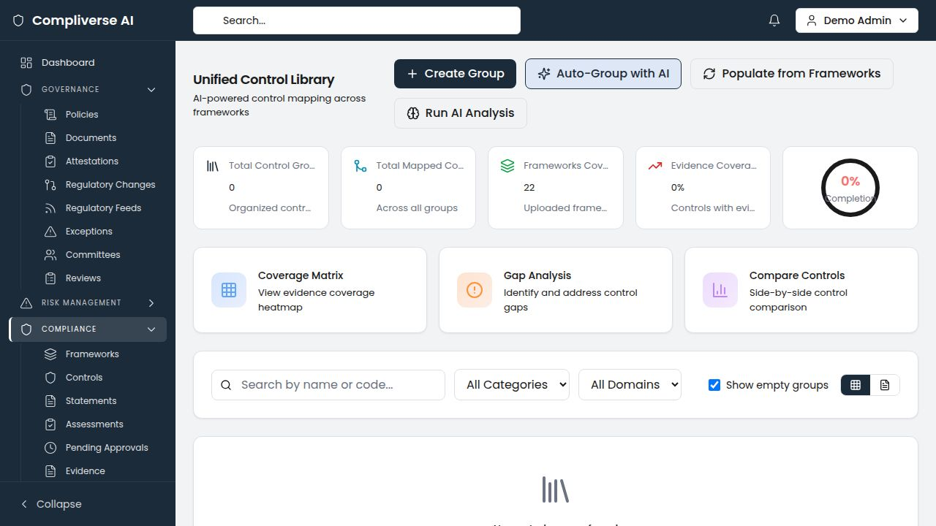
Banking Impact: A bank tracking SBP, PCI DSS, and ISO 27001 typically identifies 300+ cross-framework control mappings automatically — reducing mapping effort by 80%.

Prior-Audit Intelligence for Examination Readiness
Regulatory examiners specifically scrutinize whether previously identified deficiencies have been remediated. ComplyVerse AI automatically cross-references findings across all historical engagements, identifying recurring findings with severity trends.
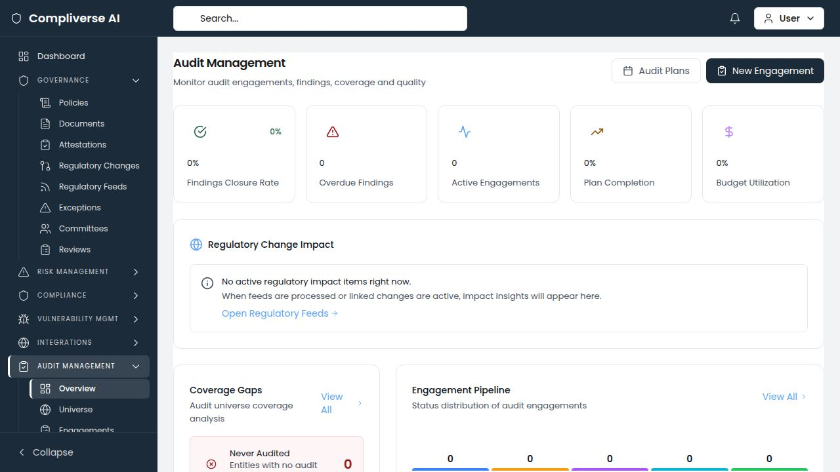
Banking Impact: When an OCC examiner asks "Has this finding appeared before?" — the answer is instant, documented, and defensible.

Statistical Sampling with Audit Trail
Built-in sampling with three methodologies (random, monetary unit, attribute) at configurable confidence levels. Sample calculations are linked directly to workpapers, providing the statistical rigor regulatory examiners expect.


Complete Audit Lifecycle
Annual audit planning with risk-based audit universe scoring, engagement management, fieldwork tracking, digital workpaper management, finding tracking with action plans, and automated notification system for deadlines and overdue items.


Risk Heat Maps for Board Reporting
Interactive risk heat maps with configurable likelihood and impact matrices, inherent and residual risk scoring, and department-level risk ownership. Board-ready risk dashboards available on demand — not after days of manual compilation.
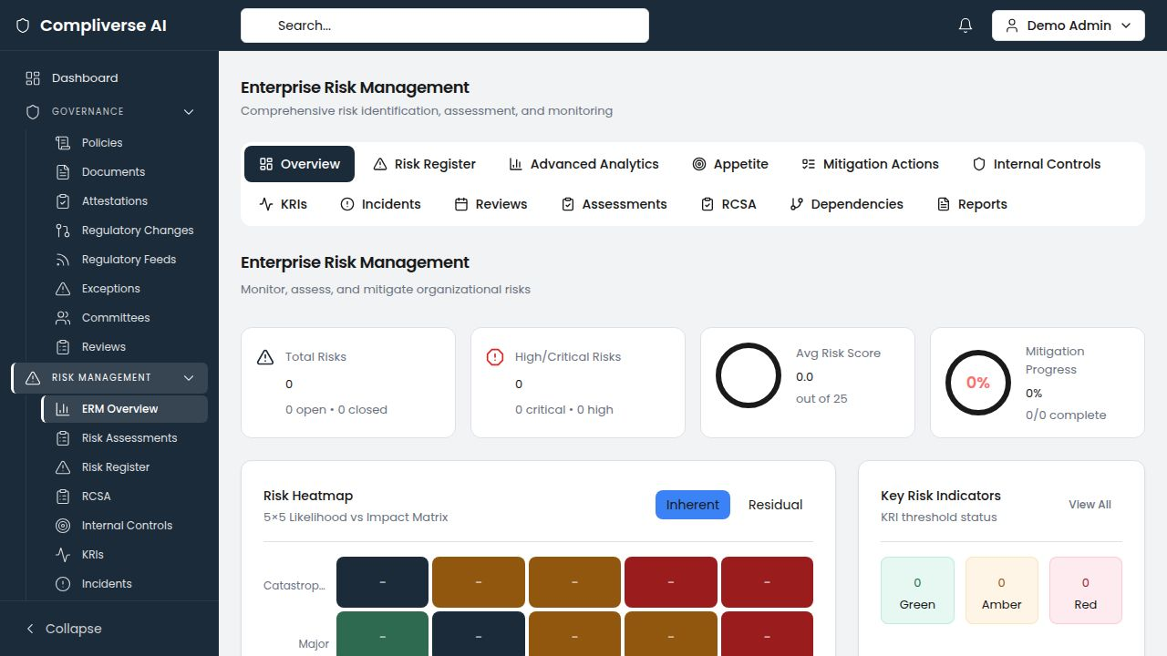

Vulnerability Management with Compliance Context
Track vulnerabilities across the banking IT environment with CVE/CWE tracking, CVSS scoring, SLA compliance monitoring, and direct linkage to the controls and assets they affect.
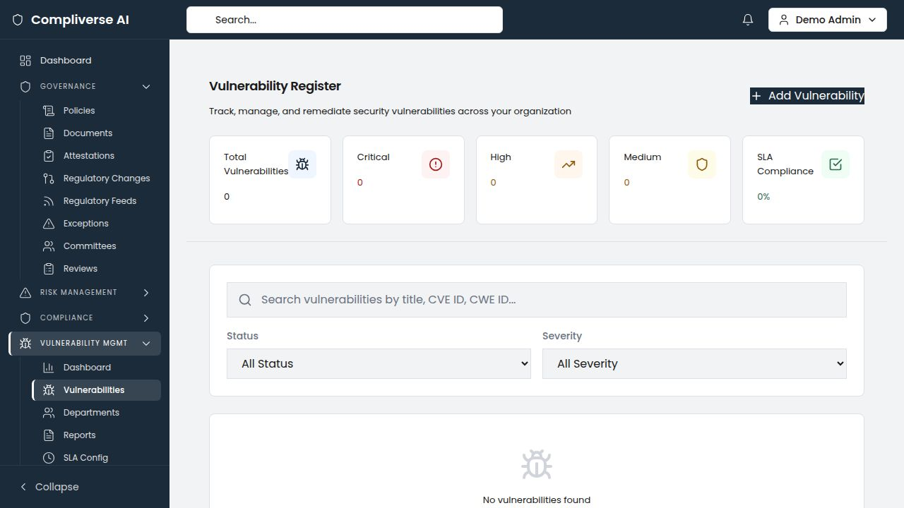

IT Asset Governance
Complete asset inventory across core banking applications, ATM networks, payment infrastructure, cloud services, and third-party vendor systems. CIA triad ratings ensure data confidentiality obligations are tracked alongside availability requirements.
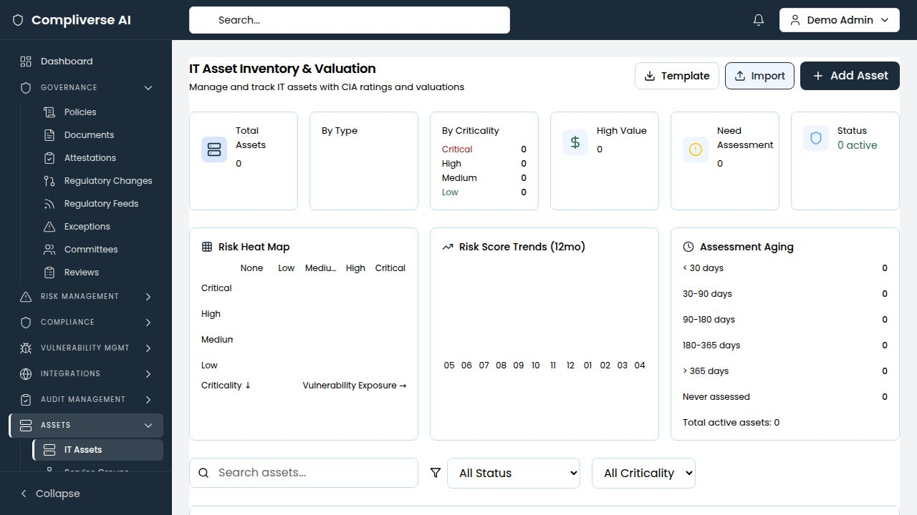

Banking Compliance Frameworks Supported
Framework | Coverage
SBP (State Bank of Pakistan) Regulations | Full framework upload and control mapping
PCI DSS v4.0 | Full control library with evidence mapping
ISO 27001:2022 | Full Annex A controls with cross-framework mapping
SOX (Sarbanes-Oxley) | Financial reporting control tracking
OCC/FDIC Requirements | Regulatory examination readiness
Basel III | Capital and liquidity requirement tracking
GLBA | Customer data protection controls
BSA/AML | Anti-money laundering compliance
FFIEC CAT | Cybersecurity assessment framework

Key Metrics for Banking
Metric | Impact
Examination preparation time | 50–65% reduction
Cross-framework control mapping effort | 80–90% reduction
Prior finding identification | Automated (previously manual/ad hoc)
Board report preparation | From 3–5 days to same-day
Annual GRC tooling cost | 40–60% reduction

Getting Started
- Discovery Call — Assess your current regulatory landscape and GRC tooling
- Framework Upload — Import SBP, PCI DSS, ISO 27001, and other framework controls
- AI Analysis — Run cross-framework mapping and identify coverage gaps
- Operational Rollout — Configure audit plans, migrate evidence, and go live
Typical time to first value: 2–4 weeks
Schedule Your Demo: [demo-link]
Contact: info@[company-domain].com
ComplyVerse AI — Governance. Risk. Compliance. Unified by Intelligence.

