RemoteIQ User Guide: PWA Monitoring Platform

What is RemoteIQ?
RemoteIQ is a modern, high-performance monitoring platform designed to give you real-time visibility into your IoT devices and industrial equipment. Whether you are managing a fleet of engines, pump stations, or other critical infrastructure, RemoteIQ provides the data you need to ensure operational efficiency and minimize downtime.

Key Capabilities
- Real-Time Monitoring: View engine speed (RPM), operating hours, temperature, and oil pressure as it happens.
- Fuel Management: Track fuel levels and rates to optimize replenishment schedules.
- Location Tracking: Integrated GPS data tells you exactly where your equipment is located.
- Remote Control: Start or stop engines directly from the app (on supported hardware).
- Custom Branding: Optimized for multiple service brands, such as Sage Rental Services, ensuring a familiar experience for your specific workflow.
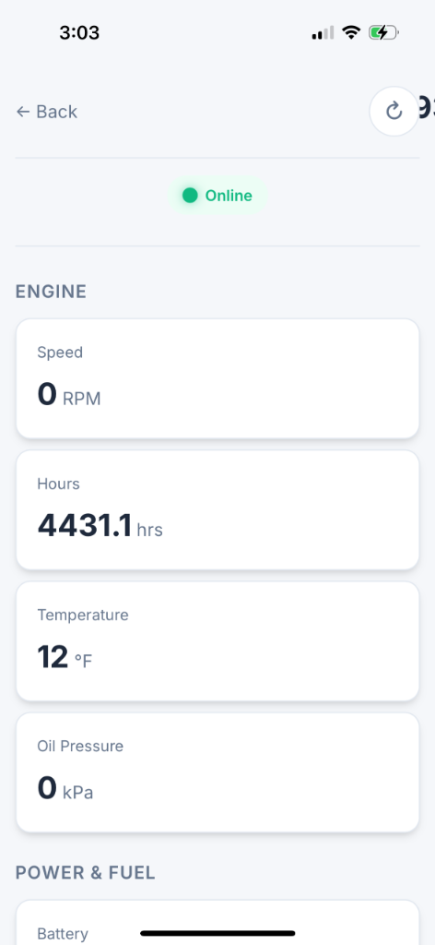
Monitoring Engine Details
Typical engine monitoring view showing RPM, Hours, Temperature, and Oil Pressure.

What is a Progressive Web App (PWA)?
RemoteIQ is delivered as a Progressive Web App (PWA). This means it is a website that "progresses" into a full app experience once you save it to your home screen.

Benefits vs. Native Apps
- Instant Access: No need to search the App Store or Google Play. Just visit the URL and you're ready to go.
- Always Up-to-Date: You never have to manually download an "update." The app refreshes itself every time you open it.
- Low Storage: PWAs take up significantly less space on your phone than traditional apps.
- Cross-Platform: The same app works perfectly on iPhone, Android, and Desktop.

A Native App Experience
Despite being web-based, RemoteIQ feels exactly like a native app:
- Home Screen Icon: Launch it directly from your home screen just like Instagram or Maps.
- Full Screen: Once installed, the browser address bar and navigation buttons disappear, giving you a full-screen experience.
- Speed: Built-in caching ensures the app loads instantly, even on slower connections.
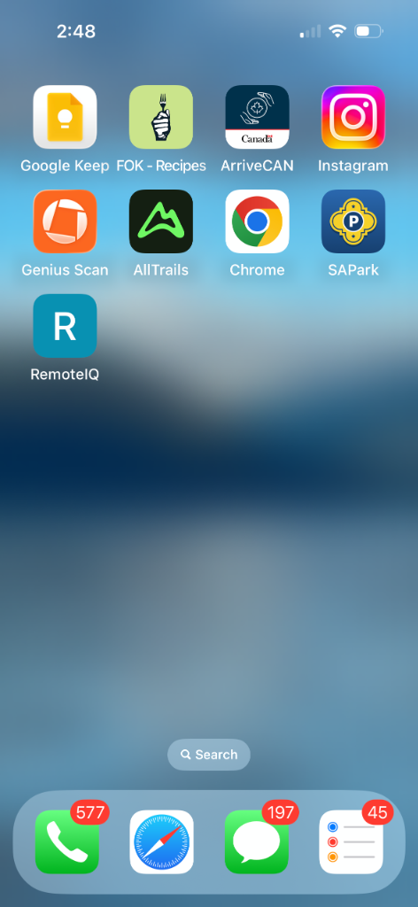
Home Screen Experience
RemoteIQ sits right alongside your other favorite apps.

How to Add RemoteIQ to Your Home Screen
Follow these simple steps to install RemoteIQ on your device.

For iPhone (Safari)
- Open Safari and navigate to your RemoteIQ URL.
- Sign In: Enter your credentials to access your dashboard.
- Tap Share: Tap the "Share" icon at the bottom of the screen (the square with an arrow pointing up).
- Add to Home Screen: Scroll down the menu and tap "Add to Home Screen."
- Confirm: Tap "Add" in the top right corner.
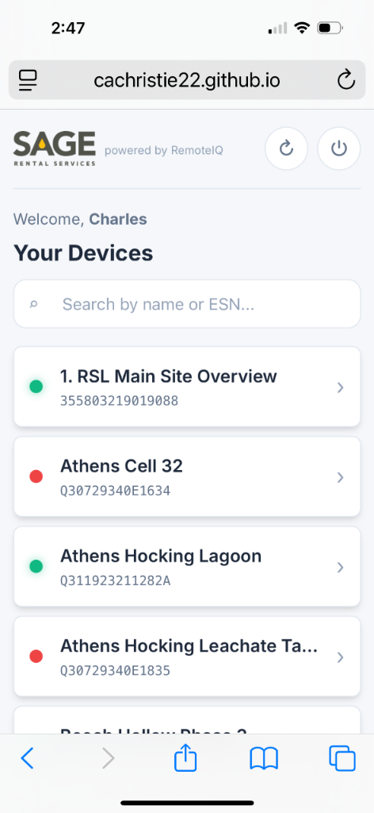
Installation Step
Locate the Share button at the bottom of your Safari browser.

For Android (Chrome)
- Open Chrome and navigate to your RemoteIQ URL.
- Tap Menu: Tap the three vertical dots (menu) in the top right corner.
- Install App: Tap "Install app" or "Add to Home screen."
- Confirm: Follow the on-screen prompts to finish.

Need Help?
For further assistance, contact your system administrator or visit the Cattron Global support portal.
*RemoteIQ** — *A service of Cattron Global

