Homework #2

7112056080 鍾期安

(a)

Input and espresso result ignore the don't-care



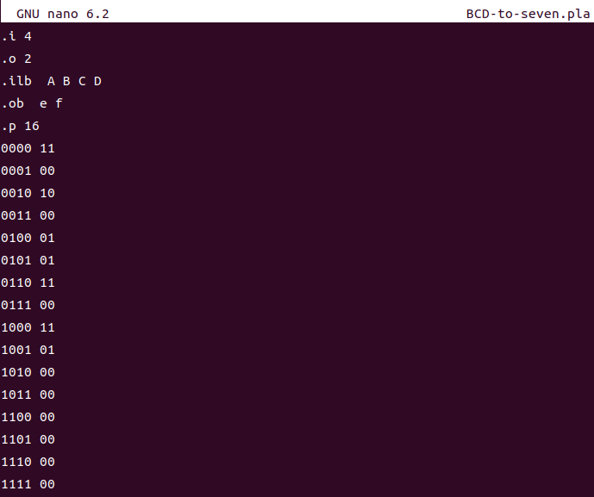



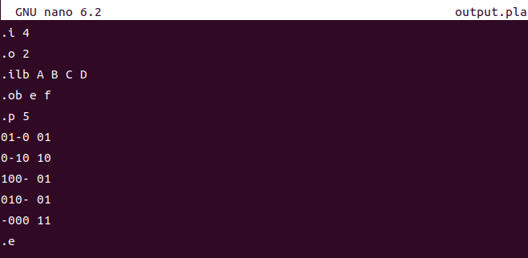

Input and espresso result exploit the don't-care

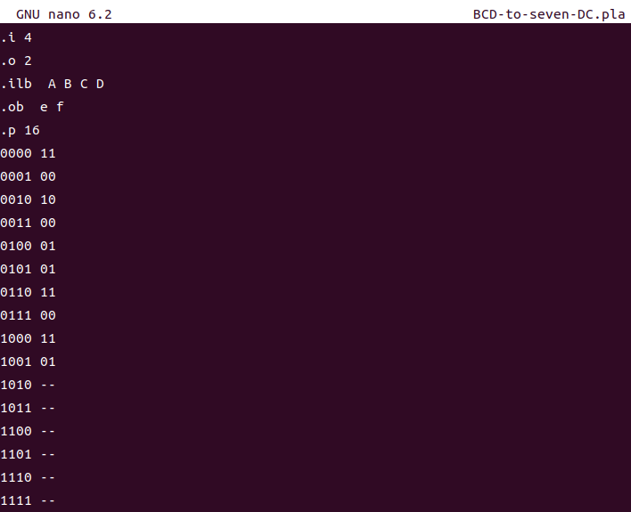



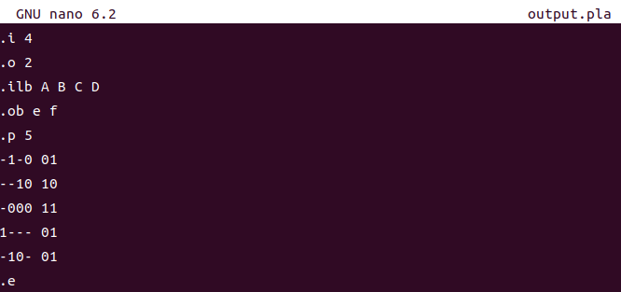

(b)

可以，

e的卡諾圖：

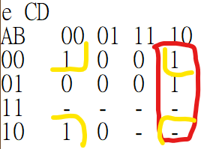

簡化結果：CD’+B’D’

espresso: CD'+B'C'D'

f的卡諾圖：

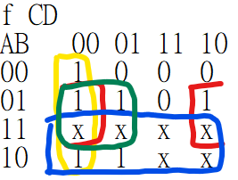

簡化結果：BD’+C’D’ +A+BC’

espresso: BD’+B’C’D’+A+BC’

(c)

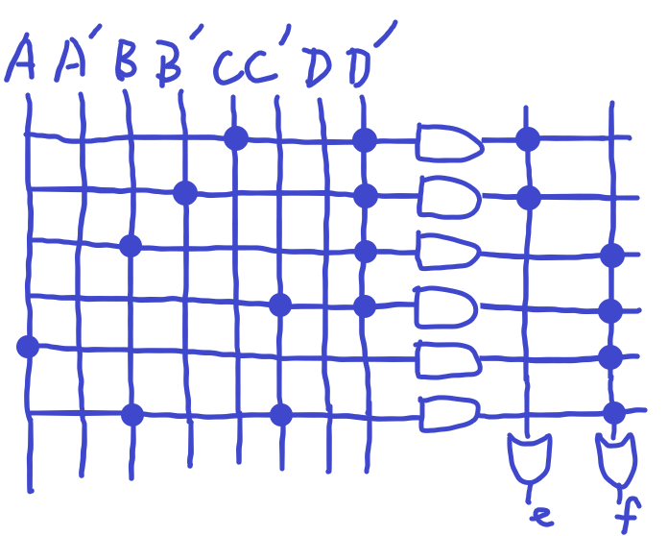

1. no option

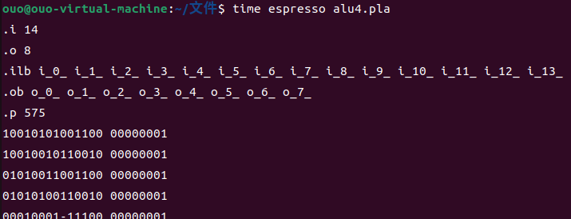

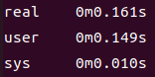

1. QM algorithm

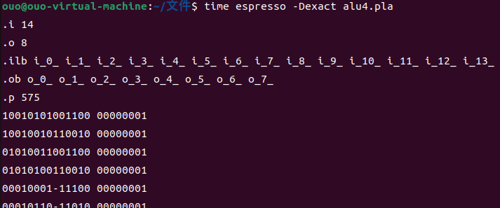  
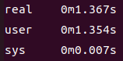

Machine: Ubuntu 22.04.3 LTS (VMware)