Installation instructions for building a container for the Intelligent Robotics course.

The following instructions should be performed on the Ubuntu 20.04 operating system or higher and in which a container can be built using Docker and if you have a dedicated graphics card have nvidia-docker2 installed.

The folder Intelligent_robotics_practice has the following files:
- The folder src that contains the code of this project.
- The Dockerfile to build the container.

Instructions for building the container

  - Access the folder:

cd Intelligent_robotics_practice

  - Build the Docker container (it can take several minutes):

sudo docker build -t intelligent_robotics .

  - When you have finished building the Docker, you need to run the following command to enable the graphical interface inside the container:

xhost +local:

  - Run the container with the following command:

sudo docker run --shm-size=1g --privileged --ulimit memlock=-1 --ulimit stack=67108864 --rm -it --net=host -e DISPLAY=$DISPLAY --user=root -v /tmp/.X11-unix:/tmp/.X11-unix:rw -v /dev:/dev --name container --gpus all --cpuset-cpus=0-3 intelligent_robotics

  - Execute the next commands inside the docker:

source devel/setup.bash

roslaunch intelligent_robotics load_scene.launch

After the steps have been carried out, 3 windows should appear on the screen to check that the container has been built correctly.

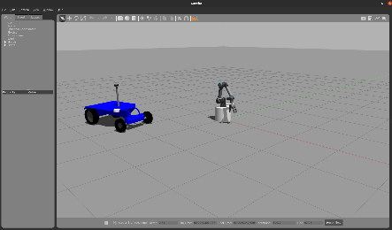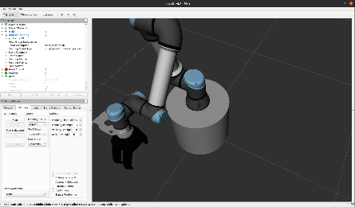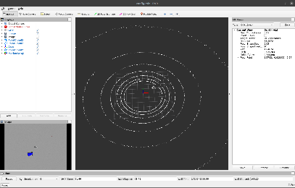
Figure 1 Windows after running the command roslaunch robotica_inteligente load_scene.launch

IMPORTANT: After checking that the windows in Figure 1 are displayed, the container can be closed. To do this, close each window and press Ctrl+c to close the process inside the container. Finally, type the exit command to exit the container.

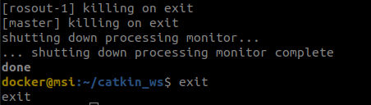

Note: If you do not have a dedicated graphics card or do not have nvidia-docker2 installed, you should run the container without the --gpus all flag:

sudo docker run --shm-size=1g --privileged --ulimit memlock=-1 --ulimit stack=67108864 --rm -it --net=host -e DISPLAY=$DISPLAY --user=root -v /tmp/.X11-unix:/tmp/.X11-unix:rw -v /dev:/dev --name container --cpuset-cpus=0-3 intelligent_robotics

Installing NVIDIA drivers inside the container

The practice can be run either on a computer with or without a dedicated graphics card. The use of a dedicated graphics card can speed up some of the GUI processing inside the container. Therefore, if you have a dedicated graphics card, it is recommended that you install the necessary drivers so that the NVIDIA drivers can be used inside the container. It should also be remembered that many neural network processes use GPU and CUDA-enabled programs in order to speed up training or predictions. Here is how to install the drivers for NVIDIA inside the container.

The following steps are taken from the link:
https://docs.nvidia.com/datacenter/cloud-native/container-toolkit/latest/install-guide.html

- Configure the production repository

curl -fsSL https://nvidia.github.io/libnvidia-container/gpgkey | sudo gpg --dearmor -o /usr/share/keyrings/nvidia-container-toolkit-keyring.gpg \
&& curl -s -L https://nvidia.github.io/libnvidia-container/stable/deb/nvidia-container-toolkit.list | \
sed 's#deb https://#deb [signed-by=/usr/share/keyrings/nvidia-container-toolkit-keyring.gpg] https://#g' | \
sudo tee /etc/apt/sources.list.d/nvidia-container-toolkit.list

- Update the packages list from the repository:

sudo apt-get update

- Install the NVIDIA Container Toolkit packages:

sudo apt-get install -y nvidia-container-toolkit

- Install Nvidia-docker2:

sudo apt-get install -y nvidia-docker2

- Restart the Docker daemon:

sudo systemctl restart docker

- Check if you have the drivers inside the Docker:
It is recommended to check if the drivers work inside the Docker container:

sudo docker run --rm --gpus all nvidia/cuda:11.0-base nvidia-smi

The output should be similar to the following one:

