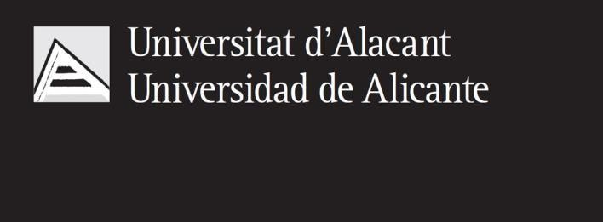



Predicting Hospital Readmission for Diabetes Patients

Master’s degree in Artificial Intelligence

Machine Learning Techniques
Author:
Cristian Andrés Córdoba Silvestre
Teacher:
Juan Ramón Rico

December 2025

