Escu Predicting Hospital Readmission for Diabetes Patients

Machine Learning Techniques

Author
Cristian Andrés Córdoba Silvestre

Teacher
Juan Ramón Rico


Master’s degree in Artificial Intelligence


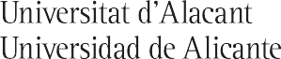
Escuela
Politécnica  Superior

ALACANT, December 2025

