1. **OLTP**
2. **Table Creation Script**

| CREATE TABLE IF NOT EXISTS countries (  id SERIAL PRIMARY KEY,  location TEXT PRIMARY KEY,  iso_code TEXT NOT NULL,  continent TEXT,  population FLOAT,  population_density FLOAT,  median_age FLOAT,  aged_65_older FLOAT,  aged_70_older FLOAT,  gdp_per_capita FLOAT,  extreme_poverty FLOAT,  cardiovasc_death_rate FLOAT,  diabetes_prevalence FLOAT,  female_smokers FLOAT,  male_smokers FLOAT,  handwashing_facilities FLOAT,  hospital_beds_per_thousand FLOAT,  life_expectancy FLOAT,  human_development_index FLOAT  );  CREATE TABLE IF NOT EXISTS cases (  id SERIAL PRIMARY KEY,  location TEXT REFERENCES countries(location),  date TEXT NOT NULL,  total_cases BIGINT,  new_cases BIGINT,  new_cases_smoothed FLOAT,  total_cases_per_million FLOAT,  new_cases_per_million FLOAT,  new_cases_smoothed_per_million FLOAT  );  CREATE TABLE IF NOT EXISTS deaths (  id SERIAL PRIMARY KEY,  location TEXT REFERENCES countries(location),  date TEXT NOT NULL,  total_deaths BIGINT,  new_deaths BIGINT,  new_deaths_smoothed FLOAT,  total_deaths_per_million FLOAT,  new_deaths_per_million FLOAT,  new_deaths_smoothed_per_million FLOAT  );  CREATE TABLE IF NOT EXISTS hospitals (  id SERIAL PRIMARY KEY,  location TEXT REFERENCES countries(location),  date TEXT NOT NULL,  icu_patients BIGINT,  icu_patients_per_million FLOAT,  hosp_patients BIGINT,  hosp_patients_per_million FLOAT,  weekly_icu_admissions BIGINT,  weekly_icu_admissions_per_million FLOAT,  weekly_hosp_admissions BIGINT,  weekly_hosp_admissions_per_million FLOAT  );  CREATE TABLE IF NOT EXISTS tests (  id SERIAL PRIMARY KEY,  location TEXT REFERENCES countries(location),  date TEXT NOT NULL,  total_tests BIGINT,  new_tests BIGINT,  total_tests_per_thousand FLOAT,  new_tests_per_thousand FLOAT,  new_tests_smoothed FLOAT,  new_tests_smoothed_per_thousand FLOAT,  positive_rate FLOAT,  tests_per_case FLOAT,  tests_units TEXT  );  CREATE TABLE IF NOT EXISTS vaccinations (  id SERIAL PRIMARY KEY,  location TEXT REFERENCES countries(location),  date TEXT NOT NULL,  total_vaccinations BIGINT,  people_vaccinated BIGINT,  people_fully_vaccinated BIGINT,  total_boosters BIGINT,  new_vaccinations BIGINT,  new_vaccinations_smoothed FLOAT,  total_vaccinations_per_hundred FLOAT,  people_vaccinated_per_hundred FLOAT,  people_fully_vaccinated_per_hundred FLOAT,  total_boosters_per_hundred FLOAT,  new_vaccinations_smoothed_per_million FLOAT,  new_people_vaccinated_smoothed FLOAT,  new_people_vaccinated_smoothed_per_hundred FLOAT  ); |
| --- |

1. **List of Tables**

1. **Schema for each table**

**Cases**

**Countries**

**Deaths**

**Hospitals**

**Tests**

**Vaccinations**

1. **Count of rows for each table**

1. **OLAP**
2. **Table Creation Script**

| CREATE TABLE IF NOT EXISTS dim_locations (  id INT PRIMARY KEY UNIQUE,  location TEXT UNIQUE,  iso_code TEXT NOT NULL,  continent TEXT,  population FLOAT,  population_density FLOAT,  median_age FLOAT,  aged_65_older FLOAT,  aged_70_older FLOAT,  gdp_per_capita FLOAT,  extreme_poverty FLOAT,  cardiovasc_death_rate FLOAT,  diabetes_prevalence FLOAT,  female_smokers FLOAT,  male_smokers FLOAT,  handwashing_facilities FLOAT,  hospital_beds_per_thousand FLOAT,  life_expectancy FLOAT,  human_development_index FLOAT  );  CREATE TABLE IF NOT EXISTS dim_dates (  date TEXT PRIMARY KEY,  year INT NOT NULL,  month INT NOT NULL,  day INT NOT NULL  );  CREATE TABLE IF NOT EXISTS fact_cases (  location TEXT REFERENCES dim_locations(location),  date TEXT REFERENCES dim_dates(date),  total_cases BIGINT,  new_cases BIGINT,  new_cases_smoothed FLOAT,  total_cases_per_million FLOAT,  new_cases_per_million FLOAT,  new_cases_smoothed_per_million FLOAT,  primary key(location, date)    );  CREATE TABLE IF NOT EXISTS fact_deaths (  location TEXT REFERENCES dim_locations(location),  date TEXT REFERENCES dim_dates(date),  total_deaths BIGINT,  new_deaths BIGINT,  new_deaths_smoothed FLOAT,  total_deaths_per_million FLOAT,  new_deaths_per_million FLOAT,  new_deaths_smoothed_per_million FLOAT,  primary key(location, date)  );  CREATE TABLE IF NOT EXISTS fact_hospitals (  location TEXT REFERENCES dim_locations(location),  date TEXT REFERENCES dim_dates(date),  icu_patients BIGINT,  icu_patients_per_million FLOAT,  hosp_patients BIGINT,  hosp_patients_per_million FLOAT,  weekly_icu_admissions BIGINT,  weekly_icu_admissions_per_million FLOAT,  weekly_hosp_admissions BIGINT,  weekly_hosp_admissions_per_million FLOAT,  primary key(location, date)  );  CREATE TABLE IF NOT EXISTS fact_tests (  location TEXT REFERENCES dim_locations(location),  date TEXT REFERENCES dim_dates(date),  total_tests BIGINT,  new_tests BIGINT,  total_tests_per_thousand FLOAT,  new_tests_per_thousand FLOAT,  new_tests_smoothed FLOAT,  new_tests_smoothed_per_thousand FLOAT,  positive_rate FLOAT,  tests_per_case FLOAT,  tests_units TEXT,  primary key(location, date)  );  CREATE TABLE IF NOT EXISTS fact_vaccinations (  location TEXT REFERENCES dim_locations(location),  date TEXT REFERENCES dim_dates(date),  total_vaccinations BIGINT,  people_vaccinated BIGINT,  people_fully_vaccinated BIGINT,  total_boosters BIGINT,  new_vaccinations BIGINT,  new_vaccinations_smoothed FLOAT,  total_vaccinations_per_hundred FLOAT,  people_vaccinated_per_hundred FLOAT,  people_fully_vaccinated_per_hundred FLOAT,  total_boosters_per_hundred FLOAT,  new_vaccinations_smoothed_per_million FLOAT,  new_people_vaccinated_smoothed FLOAT,  new_people_vaccinated_smoothed_per_hundred FLOAT,  primary key(location, date)  ); |
| --- |

1. **List of Tables**

1. **Schema for Each Table**

**dim_dates**

**dim_locations**

**fact_cases**

**fact_deaths**

**fact_hospitals**

**fact_tests**

**fact_vaccinations**

1. **NoSQL**
2. **Python code for adding the items (See tweet_data.py)**

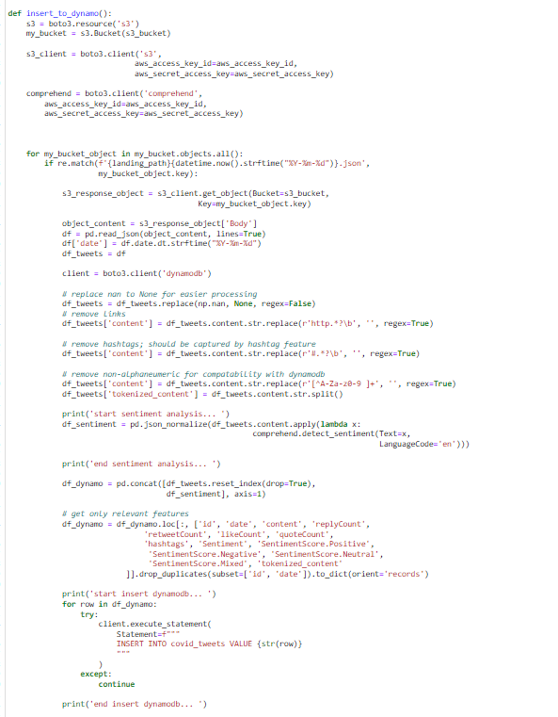

1. **Output of the contents of the table**

**Count**: 14989

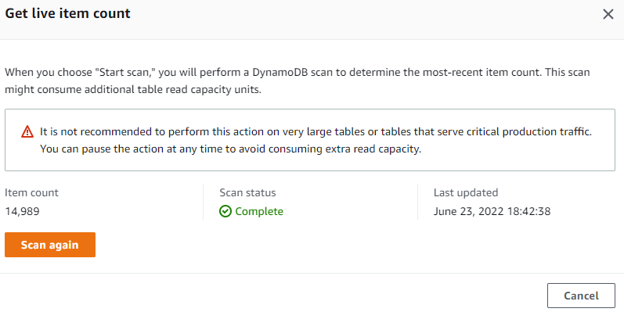

**Columns**

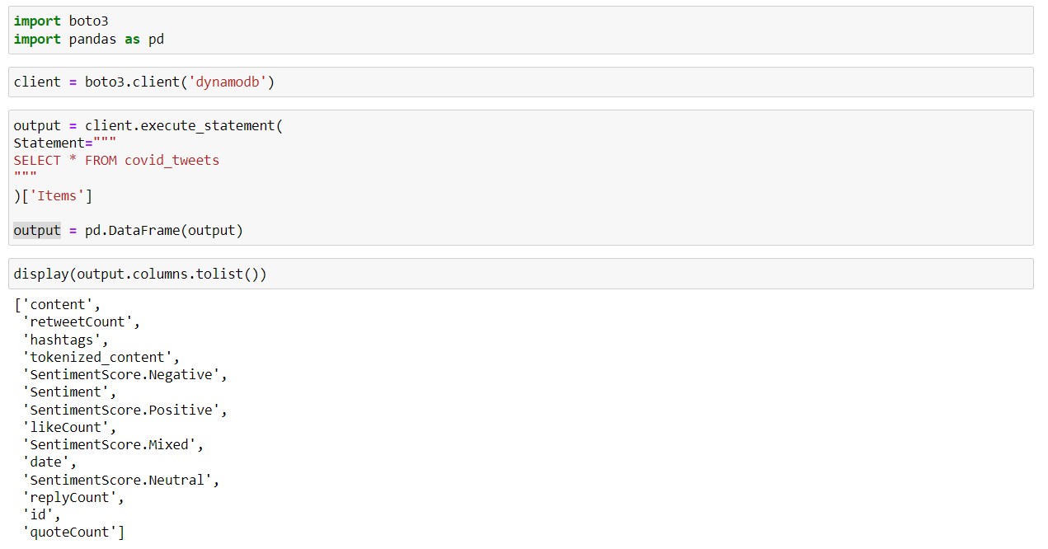

**covid_tweets sample table items**

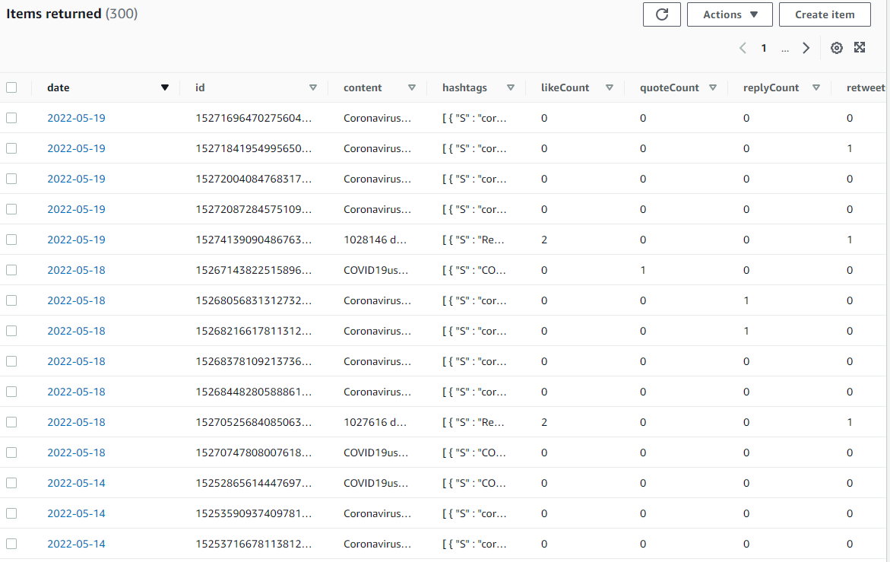

1. **Screenshot of each tab of the console of the DynamoDB table**

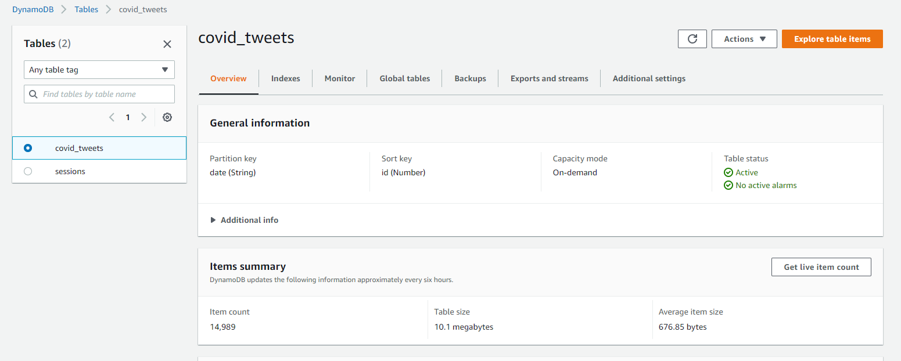

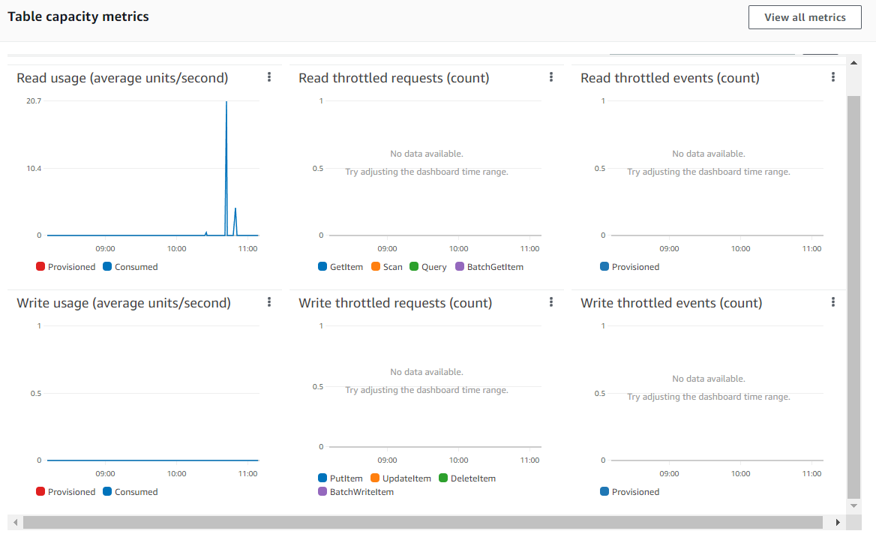

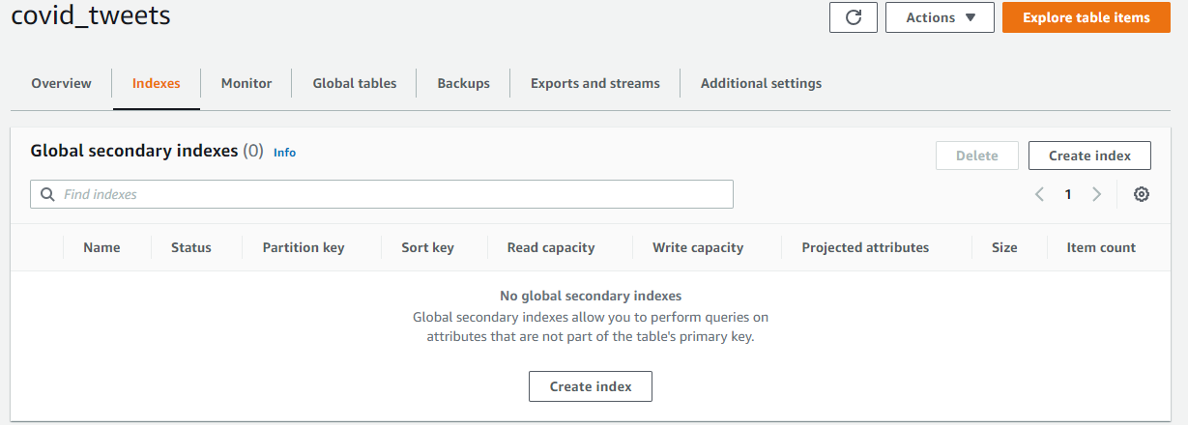

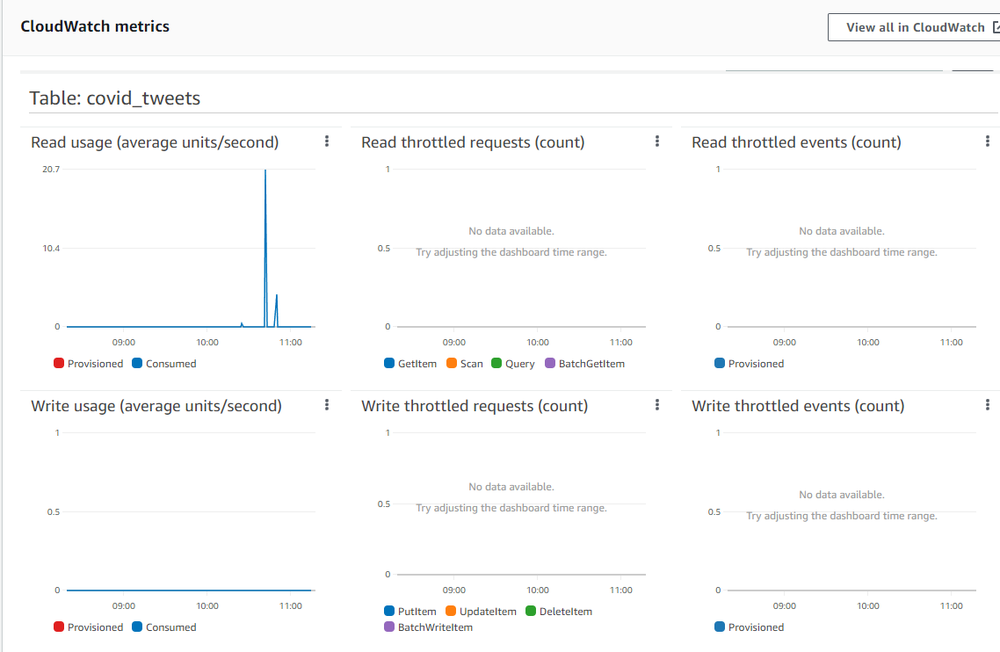

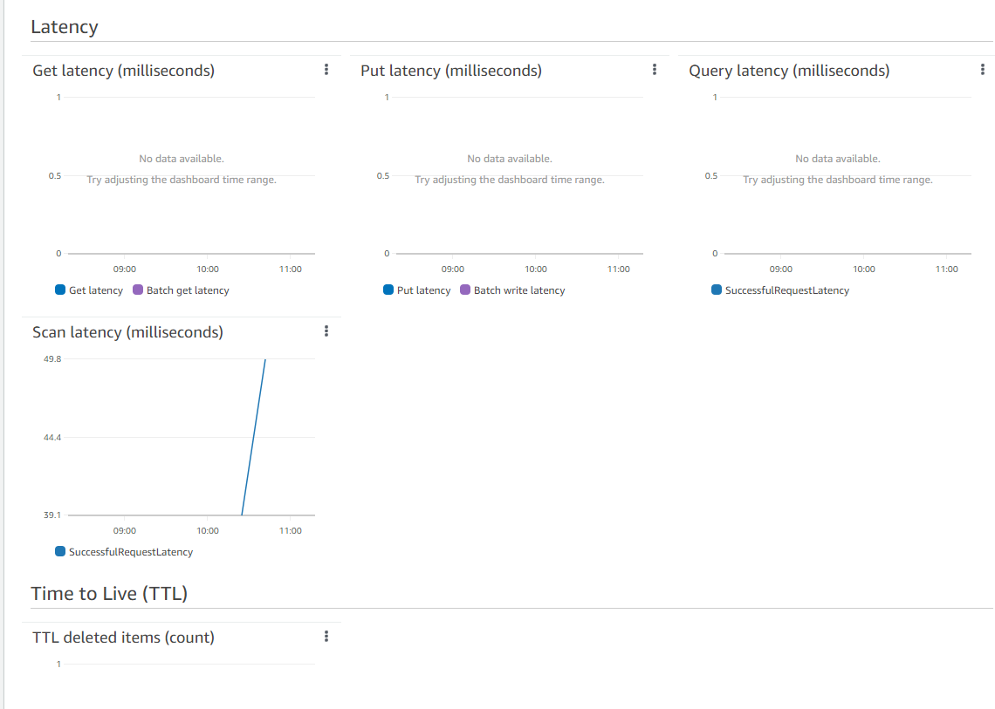

1. **Data Lake**
2. **Document detailing the S3 buckets**

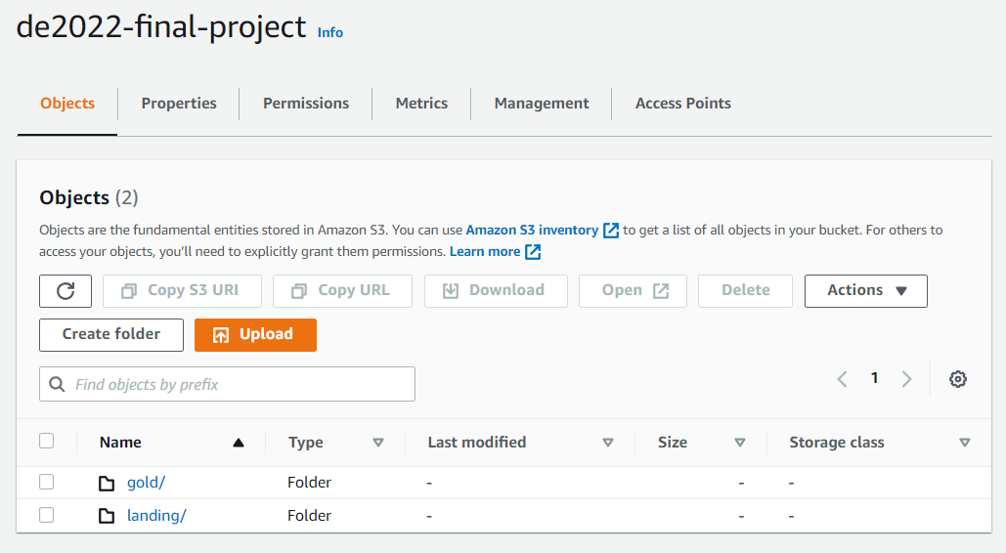

1. **Directory Hierarchy**

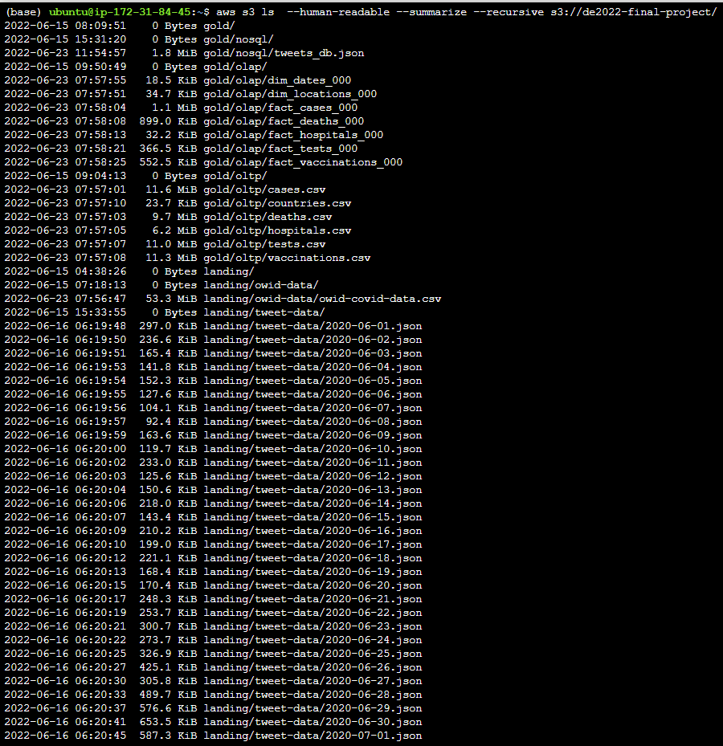

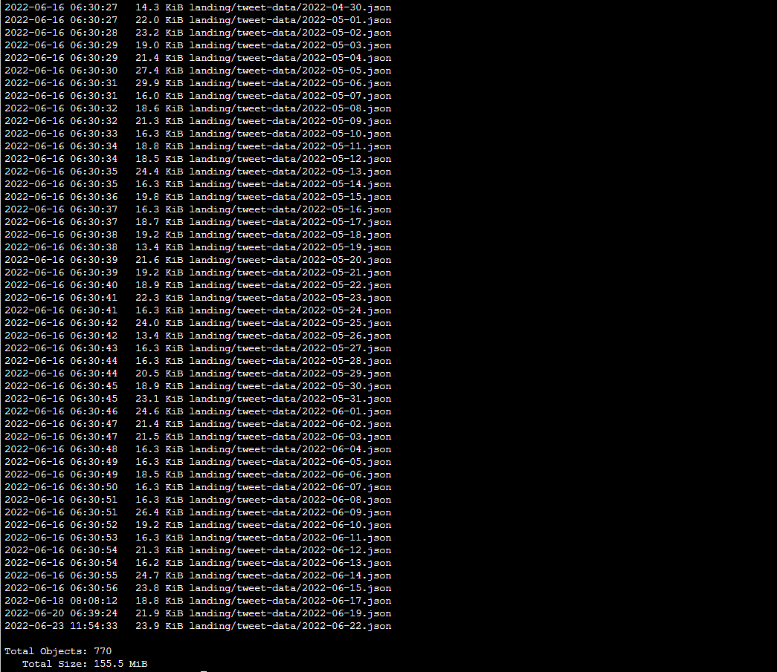

1. **Policies**

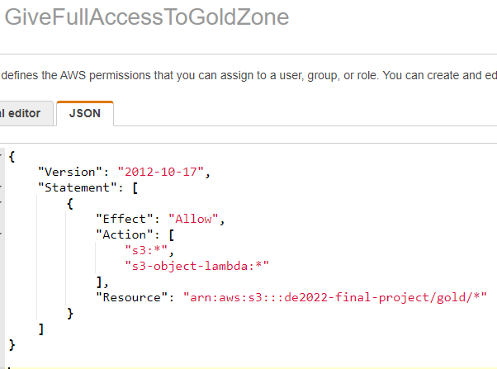

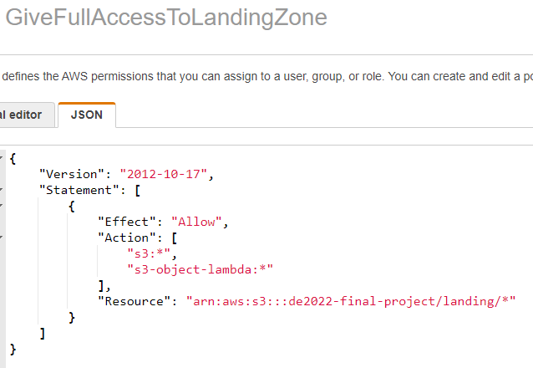

1. **User Groups**

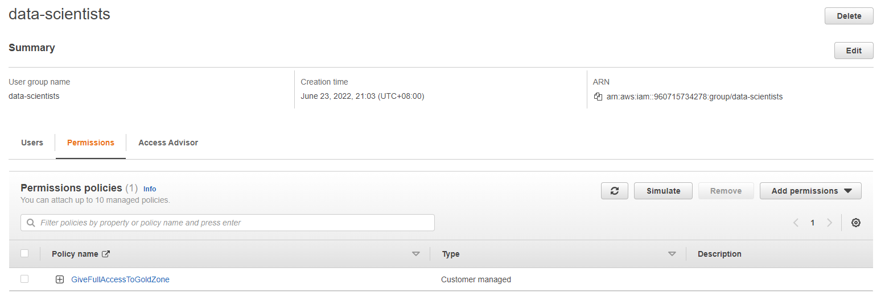

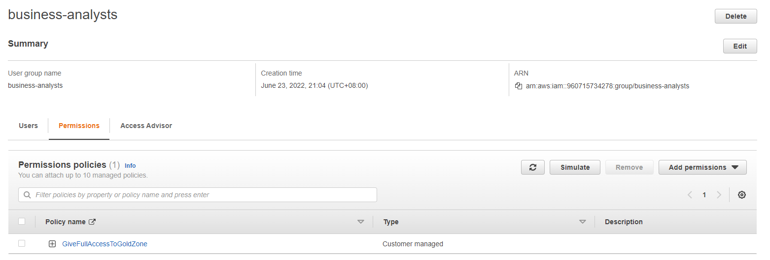

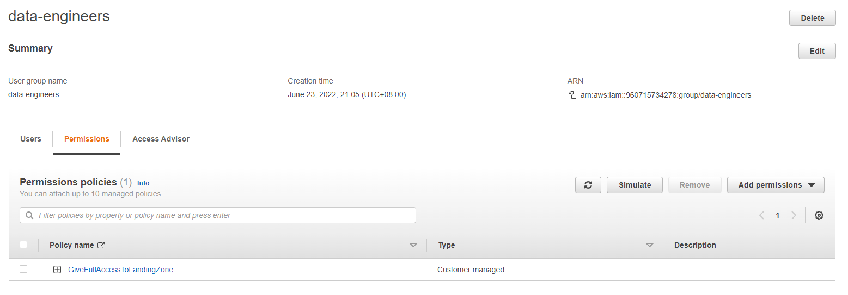

1. **ETL Jobs**
2. **Dag for extracting COVID data and updating the OLTP and OLAP databases**
3. **Airflow Script**

Please see attached file extract_covid_data.py

1. **DAG Details Screenshots**

1. **Success Runs**

1. **Dag for scraping tweets and inserting them into a DynamoDB table**
2. **Airflow Script**

Please see attached file tweet_data.py and main_dag_tweet.py.

1. **DAG Details Screenshots**

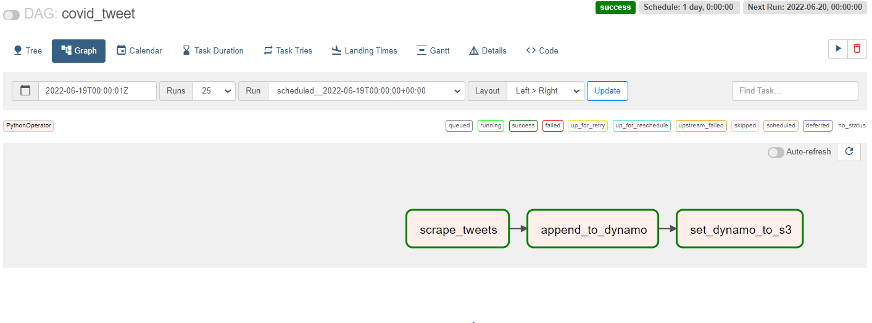

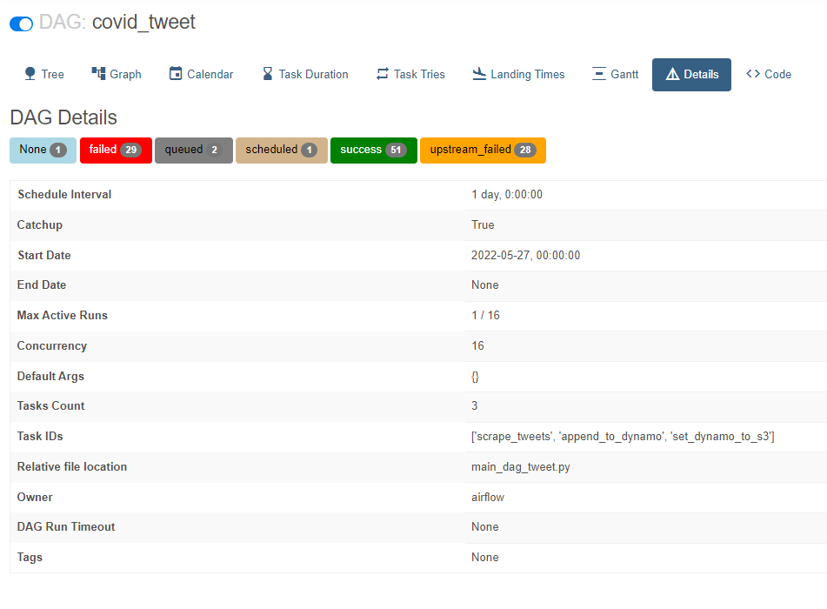

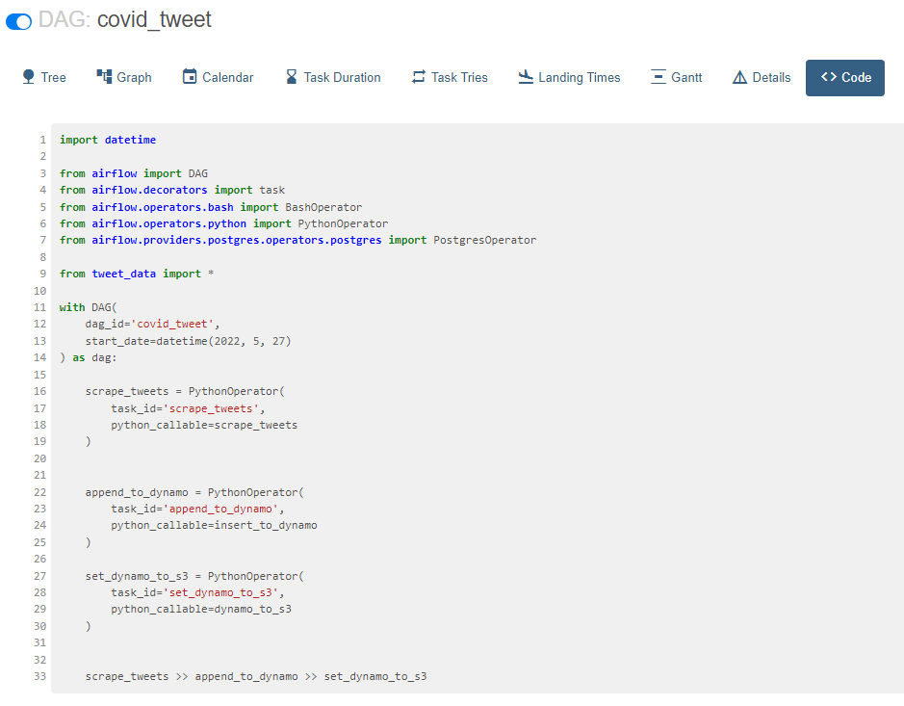

1. **Success Runs**

