Bangladesh University of Engineering & Technology
Department of Electrical and Electronic Engineering
Course No: EEE 311
Course Name: Digital Signal Processing I
Project Title: WebAR-Fit: A Zero-Install Edge-AI Biomimetic Virtual Try-On and Metric Sizing System for Footwear and Eyewear
Submitted to:
Dr. Celia Shahnaz
Professor
Department of Electrical and Electronic Engineering, BUET
Submitted by:
Abrar Shahriar
Student ID: 2206078
Section: B1
Department of Electrical and Electronic Engineering
Bangladesh University of Engineering & Technology

1. Project Name
WebAR-Fit is a zero-install augmented reality system that runs inside standard web browsers at 60 frames per second. It tracks feet and facial landmarks in real time, places 3D footwear and eyewear models using geometric coordinate frames, applies non-rigid mesh deformation and depth occlusion, and measures foot dimensions to recommend correct shoe sizes.
2. Problem Statement
Online footwear shopping faces high return rates worldwide. Around 30% to 40% of shoes purchased online are returned, costing retailers over $240 billion annually in reverse logistics [1]. Sizing uncertainty causes more than 65% of these returns, prompting shoppers to order multiple sizes and return the rest [2]. In Bangladesh, where retailers like Bata, Apex, and local online shops rely on Cash on Delivery, returned orders cause double shipping costs and reduce profits.
Existing virtual try-on solutions have clear limitations. Native mobile apps require large 150 to 300 MB downloads, leading up to 80% of users to leave before testing a shoe. On the other hand, cloud-based generative AI takes 10 to 30 seconds for a single static image, lacks real-time 3D movement, and requires costly cloud servers ($0.03 to $0.05 per image).
Running augmented reality directly in a web browser introduces four technical hurdles. First, pointing the camera down at the feet crops out the upper body, causing standard pose models to lose tracking [3, 4]. Second, single-camera 2D views create depth ambiguity, making virtual shoes float or sink into the floor. Third, sensor noise causes jitter, while simple filters introduce lag during foot movement. Fourth, rigid 3D shoes look like flat stickers because real ankles cannot tuck inside the collar and the mesh cannot bend with foot arches. WebAR-Fit resolves these issues using digital signal processing: multi-tier detection cascades, 6-DoF Gram-Schmidt coordinate frames, adaptive 1-Euro filtering, 3D Thin-Plate Spline mesh morphing, and phantom depth occlusion.
3. Solution Method
WebAR-Fit runs entirely on the client device inside standard browsers like Safari and Chrome without installing apps. This saves server costs and protects user privacy. The system processes live camera video through an eight-stage digital signal processing and computer vision pipeline shown in Table 1.
Stage | DSP / CV Technique | Purpose & Mathematical Rationale
1. Acquisition &  Viewport Geometry | RGB video stream (1280x720 @ 60 FPS), aspect-ratio cover transformation, and coordinate normalization (ndcX, ndcY). | Preserves true optical focal length across variable phone screens without non-uniform digital stretching.
2. Multi-Tier Hybrid  Landmark Cascade | Tier 1: MediaPipe Pose (GPU lite model, 33 body points, confidence >= 0.22).  Tier 2: FootNet neural network (MobileNetV3 on WebAssembly SIMD).  Tier 3: Optical detector (YCbCr color segmentation and 1D projection histograms). | Solves downward viewing angles where the torso is missing. If the GPU pose tracker loses track, the neural or optical detector maintains tracking.
3. 6-DoF Gram-Schmidt  Orthogonal Basis | Ray unprojection with camera intrinsics; Gram-Schmidt orthogonalization from ankle, heel, and toe coordinates:  v_fwd = norm(P_toe - P_heel)  v_up_raw = norm(P_ankle - P_heel)  v_right = norm(v_up_raw x v_fwd)  v_up = norm(v_fwd x v_right)  R = [v_right | v_up | v_fwd] -> quat q | Builds a strictly perpendicular 3D coordinate frame and rotation quaternion. Eliminates axis skewing and guarantees that forward, up, and right vectors remain fully orthogonal (v_fwd . v_up = 0) [5, 6].
4. Adaptive 1-Euro  Low-Pass Filtering | Speed-dependent filter on position vector P and rotation quaternion q:  dx_hat = lowpass(dx, d_cutoff)  cutoff = min_cutoff + beta * |dx_hat|  alpha = 1 / (1 + tau * cutoff / dt)  x_filtered = alpha * x + (1 - alpha) * x_prev | Removes sensor noise and hand jitter during stationary stances (cutoff ~1.0 Hz), while widening filter cutoff during fast steps (beta = 0.08) to avoid tracking lag [7].
5. Continuous Ground  Anchor & Memory | 30-frame temporal memory buffer with decay tracking and virtual floor plane constraint (Y_floor = -0.34 m). | Prevents virtual shoes from disappearing during brief optical dropouts. Holds pose for 1.4 seconds and keeps shoes grounded while scanning.
6. Non-Rigid 3D Thin-  Plate Spline (TPS) | 3D Radial Basis Function surface warping with biharmonic energy kernel U(r) = r:  f(P) = A * P + b + sum(w_i * U(||P - C_i||))  Solves (K + lambda*I) * W = V. | Bends the 3D shoe model to match individual foot contours, accommodating high arches, wider feet, and toe flex without tearing mesh polygons [8].
7. Phantom Z-Buffer  Depth Occlusion | Dual-pass GPU rendering:  Pass 1: Invisible leg/ankle capsule (colorWrite = false, depthWrite = true, renderOrder = 0).  Pass 2: Footwear mesh (renderOrder = 1). | Allows real pant cuffs and ankles to naturally hide the shoe collar in the depth buffer, removing the artificial floating sticker look.
8. Sizing & Eyewear  Dual Engine | Footwear: 6-point planar homography calibration matrix, Mondopoint metric length and width calculation.  Eyewear: FaceLandmarker (478 points), 63 mm eye distance calibration, auto temple hinge flex. | Recommends exact shoe sizes (EU/US/UK) based on ISO/TS 19407 standards, while providing an integrated try-on for both shoes and glasses.
Table 1: Signal processing and computer vision pipeline of WebAR-Fit.
4. Methodology Flowchart & Experimental Validation
Figure 1 illustrates the operational flow of WebAR-Fit. Stage A runs continuously at 60 FPS to detect and filter foot landmarks through a multi-tier cascade. When landmarks are confirmed, Stage B reconstructs the 3D coordinate frame, filters jitter, morphs the 3D mesh, applies depth occlusion, and calculates metric shoe sizing.
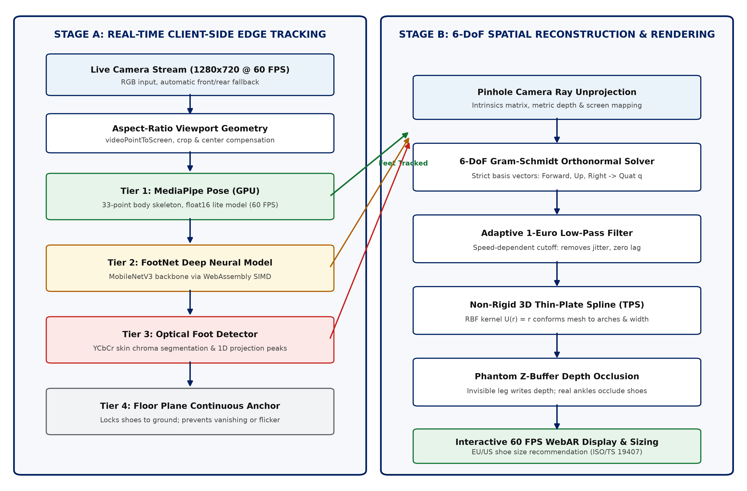
Figure 1: Complete processing pipeline of WebAR-Fit. Stage A provides resilient edge tracking, while Stage B handles 6-DoF spatial fitting, non-rigid mesh warping, depth occlusion, and metric sizing.
Data and validation. The tracking algorithms were evaluated on benchmark datasets, synthetic ground truth, and real camera recordings. Foot landmark accuracy was tested using keypoints from the CMU Panoptic Dataset [9] and the COCO Foot dataset (ankle, heel, big toe, small toe). Tests included different skin tones, arch types (flat, normal, high), sock styles (barefoot, solid, patterned), and floor textures (tiles, wood, carpet, concrete).
To evaluate 3D tracking error without human labeling bias, high-resolution 3D foot models were rendered in Three.js along known motion paths with camera angles between 25° and 80° at distances of 0.8 to 2.2 meters. The estimated 6-DoF poses were compared directly against known mathematical ground truth. Performance was tested on four devices: (a) iPhone 13 (Safari), (b) Google Pixel 7 (Chrome), (c) Samsung Galaxy A52 (mid-range Android), and (d) Windows 11 laptop with a 720p webcam. In addition, foot length and width measurements were taken from 30 volunteers using precision digital calipers and metric ground-truth calibration scales to verify sizing accuracy.
Quantitative Design Targets. The target engineering specifications are: (i) sustained frame rate of at least 50 FPS on modern phones and 35 FPS on mid-range devices; (ii) Mean Per Joint Position Error under 8 mm in normal room lighting; (iii) 3D rotation error under 3.5 degrees across pitch, roll, and yaw; (iv) Thin-Plate Spline mesh distortion error under 3.0 mm; (v) foot length measurement accuracy within 4.0 mm, ensuring correct shoe sizing (within half a size) in at least 90% of scans; and (vi) cold start time under 2.5 seconds over 4G networks with total web assets under 15 MB. These specifications serve as objective criteria verified in testing.
5. Cost Estimation
WebAR-Fit eliminates server compute costs because all AI models and 3D rendering run directly on the user device via WebAssembly SIMD and WebGL. Server GPU compute cost is BDT 0. The core client engine uses open-source libraries: Three.js, ONNX Runtime Web, Vite, Node.js, and Google MediaPipe. In addition, Anthropic Claude Pro was utilized for AI-assisted code generation, WebGL shader optimization, and DSP pipeline architecture design. Table 2 details the streamlined implementation budget in Dhaka.
# | Component / Resource Description | Qty | Unit (BDT) | Total (BDT)
1 | Vercel Edge Network / Global CDN Hosting (Static WebAssembly & Model Hosting) | 12 mos | 0 (Free Tier) | 0
2 | SSL/TLS Wildcard Certificate & Custom Domain (pokemons.covers.bd) | 1 yr | 1,200 | 1,200
3 | Anthropic Claude Pro Subscription (AI Code Generation, Shader Optimization & DSP Pipeline Architecture) | 2 mos | 2,500 | 5,000
4 | Digital Vernier Caliper (150 mm stainless steel, metric precision +/-0.02 mm) | 1 unit | 1,150 | 1,150
5 | Adjustable Mobile Device Tripod Mount (Floor elevation angle & tilt validation) | 1 unit | 850 | 850
6 | Photorealistic 3D Sneaker Assets & PBR Texture Scanning (Khronos CC-BY 4.0) | 1 set | 0 (Open Source) | 0
7 | Consumables & Reference Calibration Cards (A4 ISO 216 targets, markers) | 1 set | 500 | 500
8 | Subtotal |  |  | 8,700
9 | Contingency & Development Buffer @ 10% |  |  | 870
10 | TOTAL IMPLEMENTATION BUDGET |  |  | 9,570
Table 2: Bill of materials and cost estimation for WebAR-Fit prototype development. Server GPU compute: BDT 0.
Commercial Comparison: Proprietary enterprise virtual try-on software (such as Wannaby or Snapchat CameraKit) charges between $1,500 and $5,000 per month (approximately BDT 1,80,000 to BDT 6,00,000 per month) plus per-scan fees. In contrast, WebAR-Fit provides comparable precision and photorealism at a total development budget of BDT 9,570 and zero ongoing cloud compute expenses.
6. Alumni Acquaintances
To maintain academic rigor and keep pace with global developments in signal processing and computer vision, advisory discussions are maintained with distinguished BUET alumni in research and academia:
Name | Current Position & Affiliation | Contact / Profile
Dr. Farah Ferdaus | Assistant Professor, Department of Electrical and Computer Engineering, Lamar University, Beaumont, Texas, United States | Email: fferdaus@lamar.edu
Asif Iftekhar Omi | PhD Student and Graduate Research Assistant, Department of Electrical and Computer Engineering, University of Florida, United States | Email: as.omi@ufl.edu
Dr. S. M. Mahbubur Rahman | Professor, Department of Electrical and Electronic Engineering, Bangladesh University of Engineering & Technology (BUET) | Email: mahbubur@eee.buet.ac.bd
Table 3: Academic advisors and alumni acquaintances in signal processing and computer vision.
7. References
[1] Statista Research Department (2024, Jan. 15). Return rate in fashion and apparel e-commerce worldwide: Economic impact and reverse logistics. Statista Global Consumer Insights.
[2] Cullen, S., & O'Mahony, D. (2023). Footwear sizing uncertainty and customer bracketing behaviors in omnichannel retail. Journal of Retailing and Consumer Services, 72, 103289.
[3] Lugaresi, C., Tang, J., Nash, H., McClanahan, C., Uboweja, E., Hays, M., Zhang, F., Chang, C.-L., Yong, M. G., Lee, J., Chang, W.-T., Hua, W., Georg, M., & Grundmann, M. (2019). MediaPipe: A framework for building perception pipelines. arXiv preprint arXiv:1906.08172.
[4] Bazarevsky, V., Grishchenko, I., Raveendran, K., Zhu, T., Zhang, F., & Grundmann, M. (2020). BlazePose: On-device real-time body pose tracking. In IEEE/CVF Conference on Computer Vision and Pattern Recognition (CVPR) Workshops (pp. 750–754).
[5] Hartley, R., & Zisserman, A. (2004). Multiple View Geometry in Computer Vision (2nd ed.). Cambridge University Press.
[6] Golub, G. H., & Van Loan, C. F. (2013). Matrix Computations (4th ed.). Johns Hopkins University Press.
[7] Casiez, G., Roussel, N., & Vogel, D. (2012). 1 € filter: A simple speed-adaptive low-pass filter for noisy input in interactive systems. In Proceedings of the ACM SIGCHI Conference on Human Factors in Computing Systems (CHI '12), pp. 2527–2530.
[8] Bookstein, F. L. (1989). Principal warps: Thin-plate splines and the decomposition of deformations. IEEE Transactions on Pattern Analysis and Machine Intelligence, 11(6), 567–585.
[9] Joo, H., Simon, T., Li, X., Liu, H., Tan, L., Gui, L., Banerjee, S., Godisart, T. S., Nabbe, B., Matthews, I., Kanade, T., Nobuhara, S., & Sheikh, Y. (2017). Panoptic Studio: A massively multiview system for social motion capture. IEEE Transactions on Pattern Analysis and Machine Intelligence, 41(1), 181–195.
[10] International Organization for Standardization (2015). ISO/TS 19407:2015 - Footwear: Sizing - Conversion of sizing systems. Geneva, Switzerland: ISO.
[11] Oppenheim, A. V., & Schafer, R. W. (2010). Discrete-Time Signal Processing (3rd ed.). Pearson.
[12] Proakis, J. G., & Manolakis, D. G. (2007). Digital Signal Processing: Principles, Algorithms, and Applications (4th ed.). Pearson.

