Influence of Temperature, Relative Humidity, and Seasonal Variability on Ambient Air Quality in a Coastal Urban Area of Eastern India

First Author,a Second Author,a,b Third A. Author,b etc.

a First affiliation, City, State/Territory, Country (if outside U.S.)

b Second affiliation, City, State/Territory, Country (if outside U.S.)

etc.

*Corresponding author*: Author Name, author@address.com

ABSTRACT

This study analyses the influence of temperature and relative humidity on ambient SO2, NOx, total suspended particulate matter (SPM), and respirable suspended particulate matter (RSPM) concentrations in North Chennai, a coastal city in eastern India, during the monsoon, post-monsoon, summer, and pre-monsoon seasons of 2010–2011 using regression analysis. The results show that both SO2 and NOx were negatively correlated with temperature during the summer season (r2 = 0.25 and r2 = 0.15, respectively) and moderately positively correlated during the post-monsoon season (r2 = 0.32 and r2 = 0.51, respectively). RSPM and SPM concentrations were positively correlated with temperature during all seasons except the post-monsoon season. These findings indicate that temperature has a much stronger influence on gaseous pollutants (SO2 and NOx) in summer compared to other seasons, likely due to higher summer temperature ranges. In contrast, correlations between temperature and particulate pollution showed the opposite trend. Statistically significant negative correlations were also found between relative humidity and the concentrations of particulate pollutants (RSPM and SPM) during all four seasons, but the strengths of the correlations were moderate during the monsoon period (r2 = 0.51 and r2 = 0.41, respectively) compared to other seasons, and no significant correlations were found between relative humidity and SO2 or NOx. These observations suggest that relative humidity has a limiting effect on the atmospheric concentrations of particulate pollutants in the studied coastal region.

SIGNIFICANCE STATEMENT

Insert text here

1. Introduction

Air pollutants are emitted to the atmosphere from a variety of sources, and their ambient concentrations depend not only on emission amounts but also on their adsorption and dispersal in the atmosphere. Therefore, understanding the influence of meteorological variables, such as wind speed, wind direction, and temperature, is important for air pollution research (Wexlet, 1961). This is especially true in India, where no specific ambient air quality (AAQ) standards were available before the enforcement of the Air (Prevention and Control of Pollution) Act 1981, adopted in November 1982 and subsequently revised in April 1994 and November 2009 (National Ambient Air Quality Standards, 2009). Importantly, pollution concentrations in urban areas are a function of atmospheric mixing depth, wind speed, and urban extent. To further complicate matters, average wind speeds tend to vary between locations, diurnally and seasonally (Holzworth, 1967), and seasonal weather variations consequently influence pollutant concentrations. For example, the concentrations of particulate pollutants in the urban region of Kolkata, northeastern India, are consistently higher in winter, irrespective of location, because of the longer particulate residence times in the atmosphere due to light winds and shallow mixing heights (Karar et al., 2006). Seasonal air pollution patterns have also been observed in Haridwar, North India, with high concentrations of pollutants occurring in winter compared to the summer and monsoon seasons (Chauhan et al., 2010).

Dominick et al. (2012) studied the influence of a range of meteorological parameters, such as temperature, relative humidity, and wind speed, on average daily concentrations of PM10 and NO2 at three sites in Malaysia, reporting that PM10 was positively correlated with temperature but negatively correlated with relative humidity. Zaharim et al. (2009) also reported a positive correlation between particulates and temperature in Malaysia. In the Kathmandu Valley in Nepal, Giri et al. (2008) found that rainfall and relative humidity are negatively correlated with PM10 concentrations, and also linked wind speeds to average PM10 concentrations. Finally, in Morogoro, Tanzania, Mkoma and Mjemah (2011) found that concentrations of particulate matter are not only affected by emission sources but also meteorological conditions including relative humidity, precipitation, and wind speed and direction.

Coastal atmospheric conditions can significantly differ from those inland due to land-sea interface effects, temperature contrasts, and the consequent development of local circulations (Yerramilli et al., 2008). For example, on the west coast of the Korean Peninsula, strong land breezes occur in the early morning followed by strong sea breezes in the afternoon, which gradually weaken into the evening; these patterns are associated with vortex depths of approximately 350 and 1,000 m in the early morning and afternoon, respectively, land breeze penetration lengths of approximately 25–30 km, and sea and land suction lengths of approximately 15–20 and 10–15 km, respectively (Pokhrel and Lee, 2011).

This study examines the influences of temperature and relative humidity on the seasonal patterns of SO2 and NOx concentrations, total suspended particulate matter (SPM), and respirable suspended particulate matter (RSPM) in North Chennai for the period 2010–2011.

2. Material and Methods

a. Description of Study Area

Chennai is one of the four major metropolitan cities, located on the south east coast of India. The city is 25.6 km in length and extends inland to about 11 Km and the total area is 174 Km2. The geographical coordinates of the study area are 13°10′04′′N latitude and 80°15′43′′ E longitude and it is located at an average altitude of 6.7 metres from the sea level [12]. The central Chennai is the commercial hub, and the south and west Chennai are mostly residential areas. North Chennai is the base for petrochemical industries, refinery, fertilizer, and thermal power plants. The northern coast of state Tamil Nadu experiences summer from April to June, followed by pre-monsoon season from July to September. The periods October to December are the Monsoon season and post-monsoon period is from January to March [13]. The study area experienced heavy precipitation and cyclone between October and December during Northeast monsoon.

b. Meteorological, Ambient Air Quality Data, and Analysis

The Tamil Nadu State Pollution Control Board is operating three Continuous Ambient Air Quality Monitoring Stations (CAAQS) in the study area. One continuous monitoring station is located in Manali, and another one is at Kathivakkam and the third one is at Thiruvotriyur. (Please see Figure 1).

The concentration levels of pollutants in the ambient air such as sulphur di oxide (SO2), nitrogen oxides (NOx), total suspended particulate matter (SPM), and respirable suspended particulate matter (RSPM) are being monitored by the State Pollution Control Board. Data related to ambient air quality were obtained from the State Pollution Control Board for this study. The meteorological parameters such as wind speed, wind direction, temperature, and relative humidity were obtained from the Indian Meteorological Department (IMD). In the present study, regression analysis procedure was attempted.

The maximum and minimum monthly average concentrations, during the period from July 2010 to June 2011, varied between 36.3 *μ*g/Nm3 and 8.1 *μ*g/Nm3 for SO2, 50.3 *μ*g/Nm3 and 11.7 *μ*g/Nm3 for NOx, 309 *μ*g/Nm3 and 29 *μ*g/Nm3 for RSPM, and 46 *μ*g/Nm3 to 585 *μ*g/Nm3 for SPM, respectively.

The maximum and minimum concentration level of sulphur di oxide (SO2) nitrogen oxides (NOx), total suspended particulate matter (SPM), and respirable suspended particulate matter (RSPM) recorded at the Manali, Kathivakkam and Thiruvottiyur Continuous Ambient Air Quality Monitoring Stations during pre-monsoon, monsoon, post-monsoon, and summer season from July 2010 to June 2011 are presented Table 1.

3. Results and Discussion

a. Influence of temperature on pollutant concentrations

The temperatures recorded in the study area ranged were in the ranges of 21–33.2 °C, 21–33.4 °C, 29–37.2 °C, and 25.2–36.2 °C during the monsoon, post-monsoon, summer, and pre-monsoon seasons, respectively. The minimum recorded temperature (21 °C) occurred in January 2011 and the maximum recorded temperature (37.2 °C) occurred in May 2011. Monthly minimum and maximum temperatures recorded between July 2010 and June 2011 are shown in Figure 2. To examine the seasonal effects of temperature on the concentrations of SO2, NOx, RSPM, and SPM, data for the monsoon, post-monsoon, summer, and pre-monsoon seasons are shown in Figure 3 and the results of the regression analysis are shown in Table 2. This revealed that during the summer, SO2 and NOx were weakly negatively correlated with temperature (r2 = 0.25 and r2 = 0.15, respectively). During this season, near-surface temperatures are highest, which enhances vertical mixing and increases the mixing height. Furthermore, as the uneven heating of land and sea during the day is enhanced during the summer, sea breezes are quickly established by the afternoon, which controls the temperature of the coastal region and minimizes vertical mixing.

During the monsoon season, the correlations between SO2 and NOx and temperature were negative (r2 = 0.11 and r2 = 0.01, respectively) but significantly positive during the post-monsoon season (r2 = 0.32 and r2 = 0.51, respectively). Despite the similar temperature ranges during these seasons (21–33.4 °C and 21–33.4 °C, respectively), these apparently conflicting correlations are attributed to the washing of pollutants out of the atmosphere during the monsoon season by rain. Furthermore, slightly lower temperature ranges during the post-monsoon seasons likely reduce vertical mixing and lower the mixing height, establishing moderate positive correlations between temperature and SO2 and NOx. For example, Gamo et al. (1994) observed shallow winter-time mixing heights in New Delhi, India, in association with very low sensible heat flux from the ground surface, with the opposite trend observed during the hotter seasons. Thus, solar heating of the Earth’s surface during summer induces thermal turbulence and increases the mixing height, enhancing the dispersal of SO2 and NOx.

Both RSPM and SPM concentrations were positively correlated with temperature during the summer (r2 = 0.24 and r2 = 0.26), pre-monsoon (r2 = 0.25 and r2 = 0.37), and monsoon seasons (r2 = 0.53 and r2 = 0.45) but weakly negatively correlated during the post-monsoon season (r2 = 0.03 and r2 = 0.16). Although the lowest temperatures occur during the monsoon season, atmospheric pollutants are subjected to a rain-driven “scrubbing” process during this season, enhancing the removal of particulates. Conversely, pollutant concentrations tend to be higher on dry days during the monsoon season, when this rain scrubbing mechanism cannot operate. This likely contributed to the moderately positive correlations between RSPM and SPM concentrations and temperature during the monsoon and pre-monsoon seasons. For example, Bhaskar and Mehta (2010) also observed that SPM and PM10 concentrations were negatively correlated with rainfall in Ahmedabad in western India.

The impacts of rainfall and relative humidity on particulate matter are likely limited during the dry summer and pre-monsoon seasons compared to the wetter monsoon and post-monsoon seasons. Furthermore, the positive correlations observed between temperature and RSPM and SPM during the summer and pre-monsoon seasons indicate that temperature increases elevate ambient particulate concentrations. In Delhi, Jayaraman (2007) also observed that SPM is positively and significantly associated with temperature.

b. Influence of relative humidity on pollutant concentrations

Relative humidity in the study area was in the range of 79–96%, 64–98%, 44–89%, and 54–88% during the monsoon, post-monsoon, summer, and pre-monsoon seasons, respectively; the minimum (44%) and minimum (98%) relative humidity values were recorded during the summer and post-monsoon seasons, respectively. Monthly maximum and minimum relative humidity data for the period between July 2010 and June 2011 are shown in Figure 4. Seasonal variations in relative humidity in association with the concentrations of SO2, NOx, RSPM, and SPM are shown in Figure 5 along with the results of the regression analysis in Table 3.

Concentrations of SO2 were positively correlated with relative humidity during the summer, monsoon, and post-monsoon seasons, while no correlation was found during the pre-monsoon season. The moderate positive correlation observed during the post-monsoon season (r2 = 0.35) may reflect the formation of an inversion layer, whereby an increase in atmospheric relative humidity reduces the amount of solar radiation reaching the Earth’s surface, reducing near-surface temperatures and, consequently, limiting the dispersal of near-surface pollutants by rising air currents (Abed El-Raoof, 2009).

The concentrations of RSPM and SPM were negatively correlated with relative humidity during all four seasons, with the strongest relationships occurring during the monsoon season (r2 = 0.51 and r2 = 0.41, respectively; Table 3). This might reflect a higher rate of particulate absorption under higher relative humidity conditions alongside particulate removal by monsoonal rains. In comparison, Bathmanaban (2010) examined seasonal effects on particulate concentrations and observed higher concentrations during the post-monsoon and winter seasons, with higher coarse particulate accumulation rates compared to the summer. Indeed, given the lower relative humidity range in summer, its influence on particulate concentrations is likely limited during this season, giving rise to relatively weak correlations with RSPM and SPM (r2 = 0.15 and r2 = 0.24, respectively). In Delhi, North India, Jayaraman (2007) observed that SPM concentrations were inversely related to relative humidity during all seasons, and in Kathmandu, Nepal, Giri et al. (2008) also found that increases in relative humidity were associated with a reduction in particulate matter concentrations.

4. Conclusions

Based on the results of this study, the following conclusions can be drawn: (i) in North Chennai, concentrations of SO2 and NOx were negatively correlated with temperature during the summer and monsoon seasons but positively correlated during the pre- and post-monsoon seasons; (ii) the impact of rain and relative humidity on the concentrations of SO2 and NOx was limited during the summer compared to other seasons; (iii) the influence of temperature on SO2 and NOx was greatest during the summer due to higher temperature ranges; (iv) RSPM and SPM concentrations were positively correlated with temperature during the summer, pre-monsoon, and monsoon seasons but showed very weak and negative correlations during the post-monsoon season. These relationships are attributed to the scrubbing effect of rain, although high particulate concentrations occurred during the monsoon period on dry days when this mechanism was inefficient. Furthermore, higher summer temperatures were associated with higher concentrations of particulate pollutants; and (v) statistically significant negative correlations were found between particulate concentrations and relative humidity during all four seasons, with this effect likely enhanced in coastal regions.

Acknowledgments

Paste your acknowledgments here.

Data Availability Statement.

Paste your data availability statement here. For more information about data availability statements please see the [Data Policy and Guidance page](https://www.ametsoc.org/ams/index.cfm/publications/ethical-guidelines-and-ams-policies/data-policy-and-guidelines/#data-availability-statement): <https://www.ametsoc.org/index.cfm/ams/publications/ethical-guidelines-and-ams-policies/data-policy-and-guidelines/>

REFERENCES

NAAQS, *National Ambient Air Quality Standards (NAAQS)*, Gazette of India, New Delhi, India, 2009.

H. Wexler, “The role of meteorology in air pollution,” *Air Pollution*, vol. 46, pp. 49–61, 1961.

G. C. Holzworth, “Mixing depths wind speed and air pollution potential for selected locations in the United States,” *Journal of Applied Meteorology*, vol. 6, pp. 1039–1044, 1967.

K. Karar, A. K. Gupta, A. Kumar, and A. K. Biswas, “Seasonal variations of PM10 and TSP in residential and industrial sites in an urban area of Kolkata, India,” *Environmental Monitoring and Assessment*, vol. 118, no. 1–3, pp. 369–381, 2006.

A. Chauhan, M. Powar, R. Kumar, and P. C. Joshi, “Assessment of ambient air quality status in urbanization, industrialization, and commercial centers of Uttarakhant (India),” *Journal of American Science*, vol. 6, no. 9, pp. 565–568, 2010.

D. Dominick, M. T. Latif, H. Juahir, A. Z. Aris, and S. M. Zain, “An assessment of influence of meteorological factors on PM10 and NO2 at selected stations in Malaysia,” *Sustainable Environment Research*, vol. 22, no. 5, pp. 305–315, 2012.

A. Zaharim, M. Shaharuddin, M. J. M. Nor, O. A. Karim, and K. Sopian, “Relationships between airborne particulate matter and meteorological variables using non-decimated wavelet transform,” *European Journal of Scientific Research*, vol. 27, no. 2, pp. 308–312, 2009.

D. Giri, V. Krishna Murthy, and P. R. Adhikary, “The influence of meteorological conditions on PM10 concentrations in Kathmandu Valley,” *International Journal of Environmental Research*, vol. 2, no. 1, pp. 49–60, 2008.

S. L. Mkoma and I. C. Mjemah, “Influence of meteorology on ambient air quality in morogoro Tanzania,” *International Journal of Environment Science*, vol. 1, pp. 1107–1115, 2011.

A. Yerramilli, V. S. Challa, J. Indracanti et al., “Some observational and modeling studies of the atmospheric boundary layer at Mississippi Gulf Coast for air pollution dispersion assessment,” *International Journal of Environmental Research and Public Health*, vol. 5, no. 5, pp. 484–497, 2008.

R. Pokhrel and H. Lee, “Estimation of the effective zone of sea/land breeze in a coastal area,” *Atmospheric Pollution Research*, vol. 2, no. 1, pp. 106–115, 2011.

V. Jayanthi and R. Krishnamoorthy, “Key airborne pollutants—impact on human health in Manali, Chennai,” *Current Science*, vol. 90, no. 3, pp. 405–413, 2006.

K. Sivaramasundaram and P. Muthusubramanian, “A preliminary assessment of PM10 and TSP concentrations in Tuticorin, India,” *Air Quality, Atmosphere and Health*, vol. 3, no. 2, pp. 95–102, 2010.

M. Gamo, P. Goyal, M. Kumari, U. C. Mohanty, and M. P. Singh, “Mixed-layer characteristics as related to the monsoon climate of New Delhi, India,” *Boundary-Layer Meteorology*, vol. 67, no. 3, pp. 213–227, 1994.

B. V. Bhaskar and V. M. Mehta, “Atmospheric particulate pollutants and their relationship with meteorology in Ahmedabad,” *Aerosol and Air Quality Research*, vol. 10, no. 4, pp. 301–315, 2010.

G. Jayaraman, “Seasonal variation and dependence on meteorological condition of roadside suspended particles/pollutants at Delhi,” *Environmental Science*, vol. 2, no. 2, pp. 130–138, 2007.

S. Abed EI-Raoof, “Diurnal and seasonal variation of air pollution at Al-Hashimeya town, Jordan,” *Jordan Journal of Earth and Environmental Science*, vol. 2, no. 1, pp. 1–6, 2009.

S. Bathmanaban, “Analysis of interpretation of particulate matter-PM10, PM2.5 and PM1 emission from the heterogeneous traffic near an urban roadway,” *Atmospheric Pollution Research*, vol. 1, pp. 184–194, 2010.

TABLES

**Table 1** Range of pollutant concentrations indicating season wise trend.

|  |  |  |  |  |  |  |  |  |  |  |  |  |  |  |  |  |  |  |  |  |  |  |  |  |  |  |  |  |  |  |  |  |  |  |  |  |  |  |  |  |  |  |  |  |  |  |  |  |  |  |  |  |  |  |  |  |  |  |  |  |  |  |  |  |  |  |  |  |  |  |  |  |  |  |  |  |  |  |  |  |  |  |  |  |  |  |  |  |  |  |  |  |  |  |  |  |  |  |  |  |  |  |  |  |  |  |  |  |  |  |  |  |  |  |  |  |  |  |  |  |  |  |  |  |  |  |  |  |  |  |
| --- | --- | --- | --- | --- | --- | --- | --- | --- | --- | --- | --- | --- | --- | --- | --- | --- | --- | --- | --- | --- | --- | --- | --- | --- | --- | --- | --- | --- | --- | --- | --- | --- | --- | --- | --- | --- | --- | --- | --- | --- | --- | --- | --- | --- | --- | --- | --- | --- | --- | --- | --- | --- | --- | --- | --- | --- | --- | --- | --- | --- | --- | --- | --- | --- | --- | --- | --- | --- | --- | --- | --- | --- | --- | --- | --- | --- | --- | --- | --- | --- | --- | --- | --- | --- | --- | --- | --- | --- | --- | --- | --- | --- | --- | --- | --- | --- | --- | --- | --- | --- | --- | --- | --- | --- | --- | --- | --- | --- | --- | --- | --- | --- | --- | --- | --- | --- | --- | --- | --- | --- | --- | --- | --- | --- | --- | --- | --- | --- | --- | --- |
| |  |  |  |  |  |  |  |  |  |  | | --- | --- | --- | --- | --- | --- | --- | --- | --- | --- | | Pollutants | Continuous monitoring station | Pre-monsoon season | | Monsoon | | Post-monsoon season | | Summer season | | | Min *μ*g/Nm3 | Max *μ*g/Nm3 | Min *μ*g/Nm3 | Max *μ*g/Nm3 | Min *μ*g/Nm3 | Max *μ*g/Nm3 | Min *μ*g/Nm3 | Max *μ*g/Nm3 | | SO2 | Kathivakkam | — | — | — | — | — | 36.3 | — | 27.6 | | Manali | — |  | 8.6 | — | — | — | — | — | | Thiruvottiyur | 8.1 | 17.4 | — | 15.7 | 8.1 | — | 8.5 | — | | NOx | Kathivakkam | — | — | — | — | 11.9 | — | — | — | | Manali | — | — | 11.8 | — | — | — | — | — | | Thiruvottiyur | 12.5 | 30.8 |  | 23.1 | — | 33.1 | 11.7 | 50.3 | | RSPM | Kathivakkam | 29 | — | 31 | — | — | — | — | 309 | | Manali | — | — | — | — | — | 225 | — | — | | Thiruvottiyur | — | 243 | — | 292 | 40 |  | 35 |  | | SPM | Kathivakkam | 46 | 386 | 72 | 298 | — | 372 | — | 565 | | Manali | 46 |  | — | — | — | 372 | — | — | | Thiruvottiyur | — | — | — | — | 103 |  | 76 | — | |

**Table 2** Correlation coefficient and the regression equation between temperature and pollutants.

|  |  |  |  |  |  |  |  |  |  |  |  |  |  |  |  |  |  |  |  |  |  |  |  |  |  |  |  |  |  |  |  |  |  |  |  |  |  |  |  |  |  |  |  |  |  |  |  |  |  |  |  |  |  |  |  |  |  |  |  |  |  |  |  |  |  |  |  |  |  |  |  |  |  |  |  |  |  |  |
| --- | --- | --- | --- | --- | --- | --- | --- | --- | --- | --- | --- | --- | --- | --- | --- | --- | --- | --- | --- | --- | --- | --- | --- | --- | --- | --- | --- | --- | --- | --- | --- | --- | --- | --- | --- | --- | --- | --- | --- | --- | --- | --- | --- | --- | --- | --- | --- | --- | --- | --- | --- | --- | --- | --- | --- | --- | --- | --- | --- | --- | --- | --- | --- | --- | --- | --- | --- | --- | --- | --- | --- | --- | --- | --- | --- | --- | --- | --- |
| |  |  |  |  |  |  |  |  |  |  | | --- | --- | --- | --- | --- | --- | --- | --- | --- | --- | |  | | | | | | | | | | | Season | Temperature range in °C | SO2 | | NOx | | RSPM | | SPM | | | r2 | Equation | r2 | Equation | r2 | Equation | r2 | Equation | |  | | | | | | | | | | | Monsoon season | 21–33.2 | 0.11 | SO2 = −0.11*T* + 14.25 | 0.01 | NOx = −0.042*T* + 17 | 0.53 | RSPM = 8.25 − 115.9 | 0.45 | SPM = 13.55 – 189.7 | | Post-monsoon season | 21–33.4 | 0.32 | SO2 = −0.69*T* – 5.3 | 0.51 | NOx = 0.90*T* – 4.85 | 0.03 | RSPM = −1.41*T* + 146.2 | 0.16 | SPM = −6.15*T* + 382.1 | | Summer season | 29–37.2 | 0.25 | SO2 = −2.26*T* + 88.18 | 0.15 | NOx = −2.25*T* + 76.63 | 0.24 | RSPM = 19.47 – 539.2 | 0.26 | SPM = 29.6*T* – 767.51 | | Pre-monsoon season | 25.2–36.2 | 0.17 | SO2 = 0.56*T* – 4.978 | 0 | NOx = 0.0435*T* + 17.0 | 0.25 | RSPM = 15.2*T* – 379.9 | 0.38 | SPM = 32.9*T* – 821.6 | |

**Table 3** Correlation coefficient and the regression equation between humidity and pollutants.

|  |  |  |  |  |  |  |  |  |  |  |  |  |  |  |  |  |  |  |  |  |  |  |  |  |  |  |  |  |  |  |  |  |  |  |  |  |  |  |  |  |  |  |  |  |  |  |  |  |  |  |  |  |  |  |  |  |  |  |  |  |  |  |  |  |  |  |  |  |  |  |  |  |  |  |  |  |  |  |
| --- | --- | --- | --- | --- | --- | --- | --- | --- | --- | --- | --- | --- | --- | --- | --- | --- | --- | --- | --- | --- | --- | --- | --- | --- | --- | --- | --- | --- | --- | --- | --- | --- | --- | --- | --- | --- | --- | --- | --- | --- | --- | --- | --- | --- | --- | --- | --- | --- | --- | --- | --- | --- | --- | --- | --- | --- | --- | --- | --- | --- | --- | --- | --- | --- | --- | --- | --- | --- | --- | --- | --- | --- | --- | --- | --- | --- | --- | --- |
| |  |  |  |  |  |  |  |  |  |  | | --- | --- | --- | --- | --- | --- | --- | --- | --- | --- | |  | | | | | | | | | | | Season | Humidity range in % | SO2 | | NOx | | RSPM | | SPM | | | r2 | Equation | r2 | Equation | r2 | Equation | r2 | Equation | |  | | | | | | | | | | | Monsoon season | 79–96% | +13 | SO2 = 0.109*H* + 1.42 | 0 | NOx = −0.027*H* + 20.06 | −51 | RSPM = −7.29*H* + 115.9 | −41 | SPM = −11.72*H* + 1231 | | Post-monsoon season | 64–98% | +35 | SO2 = 0.7947*H* – 52.76 | +5 | NOx = 0.330*H* − 8.01 | −1 | RSPM = −0.272*H* + 130.8 | −22 | SPM = −7.894*H* + 872.9 | | Summer season | 44–89% | +7 | SO2 = −0.1006*H* + 5.73 | 0 | NOx = −0.044*H* + 22.8 | −16 | RSPM = −2.68*H* + 297.4 | −24 | SPM = −4.968*H* + 572.1 | | Pre-monsoon season | 54–88% | 0 | SO2 = 0.029*H* – 9.48 | 0 | NOx = 0.229*H* + 16.23 | −8 | RSPM = −2.08*H* + 224.6 | −3 | SPM = −2.458*H* + 336.5 | |

FIGURES

  
**Figure 1** Map of the study area.

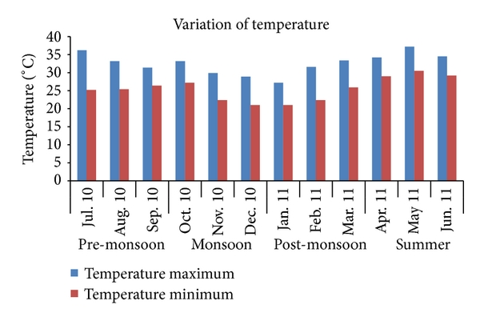  
**Figure 2** Monthly temperature variation between July 2010 and June 2011 in North Chennai.

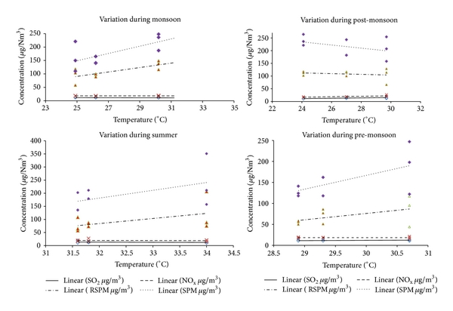  
**Figure 3** Correlations between temperature and SO2, NOx, RSPM, and SPM in North Chennai.

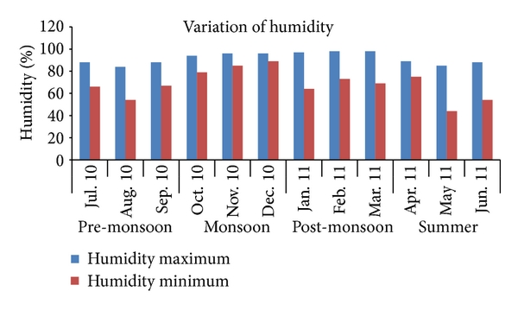  
**Figure 4** Monthly relative humidity variation between July 2010 and June 2011 in North Chennai.

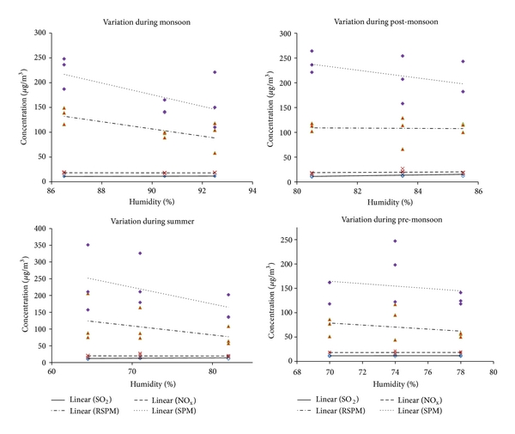  
**Figure 5** Correlations between relative humidity and SO2, NOx, RSPM, and SPM in North Chennai.