**Modeling and optimization of chemical oxygen demand removal from oil refinery wastewater using response surface methodology and a dissolved air flotation system**

Author One1, Author Two2,*

1 Affiliation One, Postal Address, Country, Country Code

2 Affiliation Two, Postal Address, Country, Country Code

* Correspondence: Author Initials; Email: xxxx

ORCIDs of all authors: Author One Initials, xxxx; Author Two Initials, xxxx

**ABSTRACT**

In this study, the dissolved air flotation (DAF) system was investigated for the treatment of Kermanshah Oil Refinery wastewater to explore an advanced clarification option for addressing the urgent need of managing high volumes of oil–water waste from this refinery. The effects of three parameters of flotation efficiency, namely flow rate (outflow from the flotation tank), saturation pressure, and coagulant dosage on chemical oxygen demand (COD) removal, were examined experimentally. All experiments were carried out for 3 min durations, and after final testing, a maximum COD removal efficiency of 67.86% was obtained. Next, a response surface methodology (RSM) model was applied to model oil refinery wastewater COD removal as a function of flow rate, saturation pressure, and coagulant dosage. Coefficient of determination results (R2) showed that the RSM model could explain the variation with an accuracy of 0.996, indicating a strong correlation. Moreover, process optimization was performed to predict the best operating conditions using RSM, which resulted in the maximum COD removal of the oil refinery wastewater, estimated to be 67.87% under the operational conditions of flow rate at 3.76–3.86 L/min, saturation pressure at 4.99–5 bar, and coagulant dosage at 24.16–24.79 mg/L.

**Keywords:** COD removal; oil refinery wastewater; response surface methodology; wastewater treatment

**1. Introduction**

Dissolved air flotation (DAF) is a wastewater treatment process that clarifies wastewater (or other water) by the removal of suspended matter (Diya’uddeen et al. 2011; Wang et al. 2004). Dissolved air flotation has been used for several decades in wastewater treatment as an alternative clarification method to sedimentation, owing to its higher efficiency in removing turbidity, chemical oxygen demand (COD), color, and suspended particles from wastewater (Han et al. 2009). In the DAF system, such removal is achieved by dissolving air into the water or wastewater under pressure and then releasing the air at atmospheric pressure in a flotation tank or basin. The amount of air released into the system can then be calculated based on Henry's law, using the saturation pressure and amount of recycled fluid flow.

Zouboulis and Avranas (2000) investigated the treatment of oil/water (O/W) emulsions containing n-octane by DAF. Their results showed that the utilization of polyelectrolytes was not able to effectively treat the emulsions, whereas the addition of ferric chloride and the subsequent use of DAF were found to be very efficient. In another study, Al-Shamrani et al. (2002) investigated the roles of aluminum and ferric sulfates as destabilizing agents for O/W emulsions that were stabilized by a non-ionic surfactant in terms of oil removal. They found that relatively low average mixing speeds for coagulation and flocculation were essential for efficient operation. Similarly, the physicochemical treatment of cutting oil emulsion using coupling coagulation and DAF was investigated by Bensadok et al. (2007). In their study, under the optimal conditions (i.e., air microbubbles with an average diameter of 50 μm and saturation pressure equal to 6.5 bars), optimal flotation effectiveness could be achieved. Tansel and Pascual (2011) also successfully used DAF to remove emulsified fuel oils from brackish and pond water, indicating that the DAF process could be effective both with and without the use of coagulants for removing petroleum hydrocarbons from that environment. In another emulsion study, Karhu et al. (2014) applied DAF for treatment of highly concentrated O/W emulsions. Their results showed that COD decreased by 70% with an optimal coagulant polydiallyldimethylammonium chloride dosage of 200 ppm with the TSC value being relatively neutralized. In further research, the removal of chromium from aqueous solutions and plating wastewater using DAF was studied by Esmaeili et al. (2014), who successfully removed 98% chromium from aqueous solution and plating wastewater for poly aluminum chloride. Younker and Walsh (2014) also studied chemical coagulation with ferric chloride (FeCl3) and organic adsorption in a completely stirred tank reactor configuration as a pretreatment for DAF for the removal of dissolved and dispersed oils from produced water. After pretreatment, they successfully reduced concentrations of dispersed oil in clarified water as well as concentrations of naphthalene.

Based on these research developments, we herein consider the Kermanshah Oil Refinery (Iran), which is known for producing large amounts of oily wastewater annually as a case study. The refinery is located in the city of Kermanshah, lacks appropriate technology, and causes considerable environmental pollution. Hence, the development of novel and advanced methods for refinery wastewater treatment is an urgent requirement. In this work, the effects of input variables such as flow rate, saturation pressure, and coagulant dosage on the DAF process were investigated. Further, response surface methodology (RSM) was used for modeling the COD removal data.

**2. Materials and Methods**

2.1. Principle underlying the dissolved air flotation (DAF) system

The dissolved air flotation system is based on the dissolution of air in water under pressure, followed by the release of the air at atmospheric pressure in a flotation tank. In this process, air microbubbles are introduced near the bottom of the basin containing the water to be treated. The increase in the dissolved air concentration in water at elevated pressure is the fundamental principle underlying the formation of microbubbles (Al-Shamrani et al. 2002; Haarhoff and Bezuidenhout 1999). As the bubbles move upward through the water, they become attached to particulate matter and floc particles, and the buoyant force of the combined particle and air bubbles causes the particles to rise to the surface, where they may then be removed by a skimming device (Amato and Wicks 2009; Crossley and Valade 2006; Edzwald 2007). In this way, particles that have a higher density than the liquid can be made to float. After removing surface particles for further processing as residuals, the now clear liquid may be filtered to remove any residual particulate matter (Edzwald 2010).

2.2. Materials and analytical tests

Wastewater samples used in this study were obtained from Kermanshah Oil Refinery, and some characteristics of the wastewater are shown in Table 1. For the coagulant, polyaluminum chloride (PAC) with a purity of 30% was supplied by Foodchem Company, China. Sulfuric acid (purity of 98%), potassium dichromate, silver sulfate, mercury sulfate, and potassium hydrogen phthalate were purchased from Merck Company (Germany) and used to measure COD. A spectrophotometer (UV-2100, Unico, USA) was used to analyze the samples.

**Table 1.** Characteristics of the wastewater used in this study

|  |  |
| --- | --- |
| **Characteristic** | **Amount** |
| pH | 8 |
| Chemical oxygen demand (mg/L) | 452 |
| Color (PtCo unit) | 2250 |
| Turbidity (NTU) | 106 |
| Dissolved oxygen (mg/L) | 1.3 |
| Suspended solids (mg/L) | 120 |
| Alkalinity (mg/L as CaCO3) | 7100 |
| Ammoniacal nitrogen (mg/L) | 1010 |
|  |  |

2.3. Experimental apparatus

The experimental apparatus is presented schematically in Figure 1. It consists of an 8L stainless steel saturation vessel and a flotation tank (a Plexiglas column with 9cm diameter and 80cm height). Saturation vessel was attached through plastic tubes and two pressure relief valves to flotation tank. Air was supplied to the bed from the bottom by an air compressor (Air-Tech euro 210/24, Italy). A high pressure pump (PM series, Pentax, Italy) supplied required pressure into saturation vessel. Also, a pressure gauge (DP GUGG, WIKA, Germany) for measurement of the pressure into saturation vessel and flow meter (F-2000, Blue-White, USA) for measurement of wastewater flow rate were used.

2.4. Experimental procedures

For each experiment, 3 Liters of wastewater was poured into the flotation tank. Then, the high pressure pump was operated until wastewater was pumped in saturation vessel. To adjust the pressure in saturation vessel compressor was turned on, and then the flow rate was regulated by two pressure relief valves (in a determined value). Wastewater with a certain flow rate was under aeration for 3 min until the resulting system was steady state. Finally, COD of samples were measured and analyzed by the ASTM-D5220 method (closed reflux, colorimetric method) mentioned in "Standard Methods" [17].

2.5. Experimental design

The software Design Expert (Design Expert 7.0.0.1, Stat-Ease, USA) was used for the experimental design, statistical analysis of data, development of regression models, and optimization of process conditions. The RSM model was used for fitting a quadratic surface and to analyze the interactions among the parameters. Chemical oxygen demand removal was selected as the studied response, while flow rate, saturation pressure, and coagulant dosage were chosen as the studied factors. All three factors were at each of the three levels. The most appropriate design to conduct such a 3-factor-3-level set of experiments was the 17-trial set of Box–Behnken design (BBD) combined with RSM (Table 2). The detailed processing conditions are summarized in Table 3.

**Table 2.** Levels of independent parameters chosen for BBD

|  |  |  |  |  |  |
| --- | --- | --- | --- | --- | --- |
| **Variables** | **Unit** | **Symbols** |  | **Coded Levels** |  |
| -1 | 0 | +1 |
| Flow rate | L/min | X1 | 2 | 3 | 4 |
| Saturation pressure | bar | X2 | 3 | 4 | 5 |
| Coagulant dosage | mg/L | X3 | 20 | 25 | 30 |

**Table 3.** Experimental design using the BBD method

|  |  |  |  |  |  |
| --- | --- | --- | --- | --- | --- |
| **Experiments** |  | **Parameters** |  | **COD removal (%)** | |
|  | **X1** | **X2** | **X3** | **Experimental** | **RSM** |
| 1 | 2 | 3 | 25 | 60.10 | 60.15 |
| 2 | 2 | 4 | 20 | 61.68 | 61.57 |
| 3 | 2 | 4 | 30 | 60.12 | 59.95 |
| 4 | 2 | 5 | 25 | 62.40 | 62.63 |
| 5 | 3 | 3 | 20 | 62.86 | 62.92 |
| 6 | 3 | 3 | 30 | 61.24 | 61.36 |
| 7 | 3 | 4 | 25 | 65.44 | 65.52 |
| 8 | 3 | 4 | 25 | 65.73 | 65.52 |
| 9 | 3 | 4 | 25 | 65.39 | 65.52 |
| 10 | 3 | 4 | 25 | 65.42 | 65.52 |
| 11 | 3 | 4 | 25 | 65.60 | 65.52 |
| 12 | 3 | 5 | 20 | 66.19 | 66.07 |
| 13 | 3 | 5 | 30 | 65.31 | 65.25 |
| 14 | 4 | 3 | 25 | 63.49 | 63.26 |
| 15 | 4 | 4 | 20 | 65.12 | 65.29 |
| 16 | 4 | 4 | 30 | 64.40 | 64.51 |
| 17 | 4 | 5 | 25 | 67.86 | 67.81 |

The following second-order polynomial equation (Eq. [1]) was utilized to predict the chosen responses as a function of independent variables and the interactions among them (Montgomery 2012):

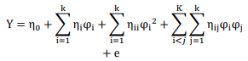 (1)

where y is the predicted dependent variable, *η0* is a constant, *ηi* is the linear effect of *φ*i, *ηii* is the linear interaction between *φ*i and *φj, ηij* is the quadratic effect of interactions between *φi* and *φj*, and e is the statistical error.

The 33 BBD was employed to determine the simple and combined effects of three operational variables on COD removal. The variations in COD removal under different combinations are presented in Table 3. The F-statistics test and p-value probability were utilized for statistical testing of various models to predict the desired model. Selection of adequate models is shown in Table 4. If p > F-value was less than 0.05, the model was considered to be statistically significant; further, the higher the value of the correlation coefficient (R2, adj R2, and pred R2), the higher the desirability of the model to describe the relationship between variables. The significant model for COD removal is quadratic and a value of R2 equal to 0.996 shows that 0.4% of variations in COD removal can be explained by the model. Moreover, adj-R2 and coefficient of variation (CV) were estimated to check the model adequacy. A high adj-R2 for COD removal demonstrates that non-significant terms have not been included in the model. Analysis of variance (ANOVA) was also performed for statistical testing of the selected model to identify the significant terms in the model. The ANOVA table for the reduced quadratic model for COD removal is shown in Table 4. F-values of 200.51 show that the models are significant. Low CV values indicate the precision and reliability of the experimental runs. Another factor, adequate precision (Adeq), measures the signal-to-noise ratio (S/N), with a ratio greater than 4 being desirable. For the proposed models, Adeq was 48.227, which suggests a very good S/N ratio. The comparison between predicted and actual values for the response variables also indicated that the proposed quadratic regression models were suitable to determine optimum formulations for COD removal.

**Table 4.** ANOVA analysis for COD removal

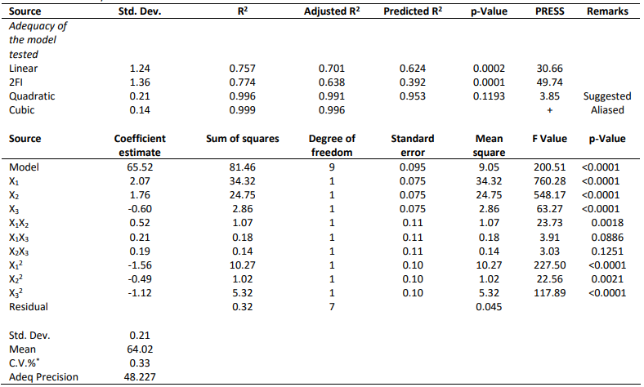+Case(s) with leverage of 1.0000: PRESS statistic not defined.

*C.V.% is the coefficient of variation.

The final mathematical models for COD removal, which can be used for prediction within the same design space in terms of coded factors, are given as follows:

COD removal (%) = +65.52 +2.07X1 +1.76X2 -0.60X3 +0.52X1X2 +0.21X1X3 +0.19X2X3 -1.56X12 -0.49X22 -1.12X32 (2)

From the above equation, it can be seen that the linear terms (X1, X2, X3), interactive term (X1X2), and quadratic terms (X12, X22, X32) have the largest effects on COD removal due to their higher F-values as well as lower p-values.

**3. Results and Discussion**

3.1. Experimental results

Figure 2 shows the response surface indicating the influence of flow rate and saturation pressure on the COD removal at the fixed coagulant dosage. At a certain pressure, the COD removal improved with the growth of flow rate, most likely due to the increased mass transfer rate (Ross et al. 2000). Moreover, pressure exhibited a positive linear effect on COD removal. Generally, the effect of pressure depends on the solubility of the gases used in liquids because more gases are soluble in liquid at higher pressures than at lower pressures, i.e., extra gases dissolve at a higher pressure and discharge when the pressure is reduced (Esmaeili et al. 2014; Féris and Rubio 1999). In this study, there was appreciable interaction between flow rate and saturation pressure. At low flow rates, the saturation pressure was low when the COD removal decreased. However, at higher flow rates, saturation pressure was higher when the COD removal was highest (Eq. 2).

Figure 3 shows the response surface depicting the influence of flow rate and coagulant dosage on the COD removal at a constant saturation pressure. At low coagulant dosage values, the COD removal improved as the coagulant dosage increased, most likely due to the production of small and light flocs. However, when the coagulant dosage exceeded the optimum value, the COD removal reduced as the coagulant dosage increased, most likely due to colloids, which may have restabilized (Aziz et al. 2007) and produced larger, heavier flocs.

Figure 4 shows the response surface implying the effect of saturation pressure and coagulant dosage on the COD removal at a constant flow rate. At lower saturation pressures, the coagulant dosage was higher when the COD removal approached its maximum value (Féris and Rubio 1999). However, at higher saturation pressures, the coagulant dosage was lower when the COD removal attained its highest measure (Ross et al. 2000).

3.2. Process optimization

Following the experiments, conditions were optimized based on the best combination of factor levels that obtained maximum amounts for the studied response. The two chosen criteria for optimization goals were “maximize” for response (COD removal) and “in range” for input factors. Among 25 proposed solutions, the top 23 solutions were expressed with higher desirability. The optimal conditions were a flow rate of 3.76–3.86 L/min, saturation pressure of 4.99–5 bar, and coagulant dosage of 24.16–24.79 mg/L, with the peak desirability value of 100%. With these conditions, the maximum COD removal was 67.87%.

The predictability of the optimized model was then evaluated using five independent experimental runs. Table 5 summarizes the results and indicates excellent agreement between the predicted and measured values.

**Table 5.** Predictability of the optimized model using five independent experimental runs

|  |  |  |  |  |  |  |  |  |
| --- | --- | --- | --- | --- | --- | --- | --- | --- |
| **Run** | | **Parameters** | | | | | **COD removal (%)** | |
|  | | **X1** | **X2** | | **X3** | | **Experimental Predicted** | |
| 1 |  | 2 | 3 | 20 | |  | 59.60 | 60.02 |
| 2 |  | 2 | 4 | 25 | |  | 62.56 | 61.88 |
| 3 |  | 3 | 3 | 25 | |  | 63.45 | 63.26 |
| 4 |  | 4 | 3 | 20 | |  | 63.66 | 62.71 |
| 5 |  | 4 | 4 | 25 | |  | 66.09 | 66.02 |

**4. Conclusions**

Chemical oxygen demand removal from Kermanshah Oil Refinery wastewater using the DAF system was investigated to address urgent requirements for advancing oil–water treatments by clarification at this refinery, which is known to produce high volumes of waste. All the experiments were carried out using PAC as the coagulant and the following factors were studied: flow rate, saturation pressure, and coagulant dosage. Based on experimental results, an RSM model was then applied to model wastewater COD removal as a function of the factors of interest, and optimization conditions of the COD removal process were identified.

The following conclusions can be drawn from this experimental study:

* Flow rate has a significant impact on the reduction of the coagulant.
* Any increase in the saturation pressure will improve COD removal.
* In the case of coagulant dosage, it was found that COD removal increased with the coagulant dosage until it reached a peak value, after which it began to reduce as coagulant dosage was increased. Based on our results, the optimum coagulant dosage for Kermanshah Oil Refinery wastewater treatment was found to be 25 mg/L.
* Maximum COD removal of the oil refinery wastewater was achieved at 67.87% under the operational conditions of flow rate at 3.76–3.86 L/min, saturation pressure at 4.99–5 bar, and coagulant dosage at 24.16–24.79 mg/L.

Overall, our findings suggest that the DAF system could be a promising clarification method for advancing the treatment of high volumes of oil–water waste from the Kermanshah Oil Refinery under the optimal operational conditions identified by the RSM model. This model could also be applied for further exploration of treatments by clarification for other types of wastewater, including emulsions, thereby expanding the application of the DAF system to address growing demands for efficient industrial wastewater treatment.

**Declarations**

Funding

[Insert statement here.]

Conflicts of Interest

[Insert statement here.]

Availability of Data and Material

[Insert statement here.]

Code Availability

[Insert statement here.]

Author’s Contributions

[Insert statement here—optional.]

**References**

1. Wang, L. K., Hung, Y. T., Lo, H. H., Yapijakis, C. (Eds.). (2004). *Handbook of industrial and hazardous wastes treatment*. CRC Press.
2. Diya’uddeen, B. H., Daud, W. M. A. W., Aziz, A. A. (2011). Treatment technologies for petroleum refinery effluents: a review. *Process safety and environmental protection*, *89*(2), 95-105.
3. Amato, T., Wicks, J. (2009). The practical application of computational fluid dynamics to dissolved air flotation, water treatment plant operation, design and development. *Journal of water supply: Research and technology-AQUA*,*58*(1), 65-73.
4. Crossley, I. A., Valade, M. T. (2006). A review of the technological developments of dissolved air flotation. *Journal of water supply: Research and technologyaqua*, *55*(7-8), 479-491.
5. Edzwald, J. K. (2007). Developments of high rate dissolved air flotation for drinking water treatment. *Journal of water supply: Research and technologyaqua*, *56*(6-7), 399-409
6. Edzwald, J. K. (2010). Dissolved air flotation and me. *Water research*, *44*(7), 2077-2106.
7. Han, M., Kim, T. I., Kwak, D. (2009). Measurement of bubble bed depth in dissolved air flotation using a particle counter. *Journal of water supply: Research and technology-aqua*, *58*(1), 57-63.
8. Al-Shamrani, A. A., James, A., Xiao, H. (2002). Separation of oil from water by dissolved air flotation. *Colloids and surfaces A: Physicochemical and engineering aspects*, *209*(1), 15-26.
9. Haarhoff, J., Bezuidenhout, E. (1999). Full-scale evaluation of activated sludge thickening by dissolved air flotation. *Water SA*, *25*(2), 153-166.
10. Zouboulis, A. I., Avranas, A. (2000). Treatment of oil-inwater emulsions by coagulation and dissolved-air flotation. *Colloids and surfaces A: Physicochemical and engineering aspects*, *172*(1), 153-161.
11. Al-Shamrani, A. A., James, A., Xiao, H. (2002). Destabilisation of oil–water emulsions and separation by dissolved air flotation. *Water research*, *36*(6), 15031512.
12. Bensadok, K., Belkacem, M., Nezzal, G. (2007). Treatment of cutting oil/water emulsion by coupling coagulation and dissolved air flotation. *Desalination*, *206*(1), 440-448.
13. Tansel, B., Pascual, B. (2011). Removal of emulsified fuel oils from brackish and pond water by dissolved air flotation with and without polyelectrolyte use: Pilotscale investigation for estuarine and near shore applications. *Chemosphere*, *85*(7), 1182-1186.
14. Karhu, M., Leiviskä, T., Tanskanen, J. (2014). Enhanced DAF in breaking up oil-in-water emulsions. *Separation and purification technology*, *122*, 231-241.
15. Esmaeili, A., Hejazi, E., Hassani, A. H. (2014). Removal of chromium by coagulation-dissolved air flotation system using ferric chloride and poly aluminum chloride (PAC) as coagulants. *Water, air & soil pollution*, *225*(10), 1-8.
16. Younker, J. M., Walsh, M. E. (2014). Bench-scale investigation of an integrated adsorption–coagulation– dissolved air flotation process for produced water treatment. *Journal of environmental chemical engineering*, *2*(1), 692-697.
17. Lenore, S.C., Arnold, E.G., & Andrew, D.E., (1999). Standard Methods for the Examination of Water and

Wastewater. 20th ed., American Public Health Association, Washington, D.C.

1. Montgomery, D.C., 2012. Design and Analysis of Experiments. 8th ed., John Wiley and Sons, New York.
2. Ross, C. C., Smith, B. M., Valentine, G. E. (2000). Rethinking dissolved air flotation (DAF) design for industrial pretreatment. *Proceedings of the water environment federation*, *2000*(5), 43-56.
3. Féris, L. A., Rubio, J. (1999). Dissolved air flotation (DAF) performance at low saturation pressures. *Filtration and separation*, *36*(9), 61-65.
4. Aziz, H. A., Alias, S., Adlan, M. N., Asaari, A. H., Zahari, M. S. (2007). Colour removal from landfill leachate by coagulation and flocculation processes. *Bioresource technology*, *98*(1), 218-220.

**Figure Captions:**

**Fig. 1** Schematic of the experimental scale DAF apparatus

**Fig. 2** Surface plot (COD removal, flow rate, and saturation pressure)

**Fig. 3** Surface plot (COD removal, flow rate, and coagulant dosage)

**Fig. 4** Surface plot (COD removal, saturation pressure, and coagulant dosage)

**Figures (to be submitted as separate files)**

Figure 1:

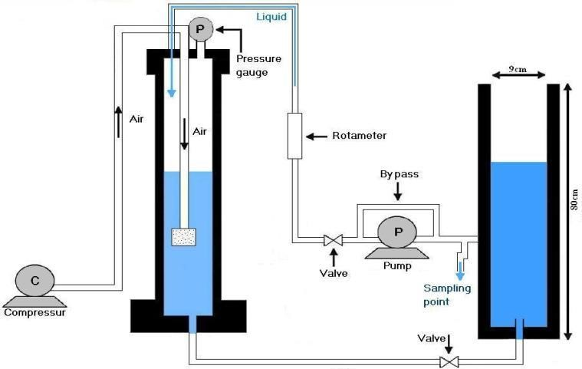

Figure 2:

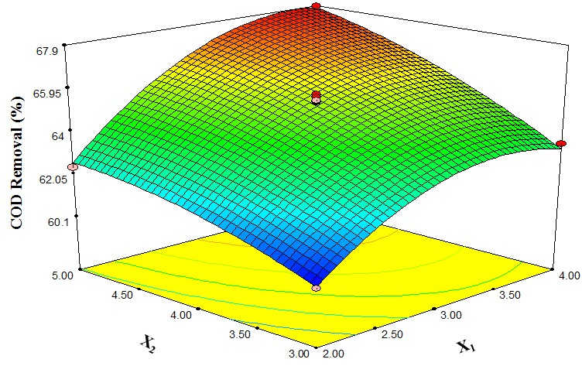

Figure 3:

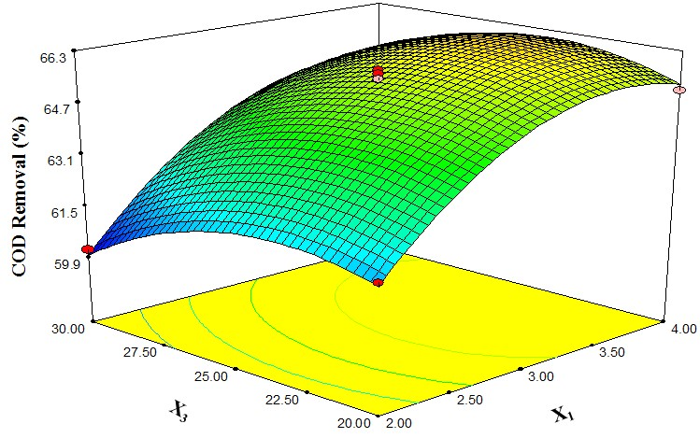

Figure 4:

